


PROJECT PROPOSAL

Project Title: Smart Banking System

Group Members
Muhammad Awais-(029) Uzair Faraz- (050) Muhammad Ateeb-(023) Muhammad Hasnain-(33)

DEPARTMENT: Department of Computer Science Bahria University



INTRODUCTION & OBJECTIVES
Introduction

The banking sector is rapidly evolving towards automation and enhanced security. Traditional Automated Teller Machines (ATMs) and Cash Deposit Machines (CDMs) rely heavily on physical cards and PINs, which are susceptible to theft, skimming, and "shoulder surfing." Furthermore, traditional CDMs count currency but often lack advanced computer vision capabilities.

This project proposes a Smart Banking System Replica—a desktop-based application that simulates next-generation banking. It replaces traditional PINs with a Face Recognition Biometric Login System (DeepFace). Additionally, it integrates Computer Vision (ORB Feature Matching) to accurately classify currency notes (500, 1000, and 5000 denominations) and track transaction details, providing an enhanced digital audit trail.

Objectives
The primary objectives of this project are:
- System Simulation: To design a GUI-based application that simulates the complete workflow of both an ATM and a CDM. (No Change)
- Face Recognition Security: To implement a secure login system allowing authentication only via for both initial login and high-security transactions (e.g., withdrawal).
- Currency Classification: To deploy a Computer Vision Model (ORB Feature Matching) capable of accurately classifying currency notes (500, 1000, and 5000) within the Cash Deposit Module (CDM).
- Digital Auditing: To log and maintain a robust ledger of users and transactions using Pandas DataFrames, capturing the denomination of each deposited note and ensuring user data integrity using SHA-256 Hashing.

2. WORKFLOW / FLOWCHART
The system operates in two main phases: Authentication and Transaction (ATM/CDM).

System Flow Description
• Cash Deposit Machine (CDM) Process:
- UPDATE: The prediction step. Change the description from "ML Model (CNN) predicts denomination" to: "Computer Vision Model (ORB Feature Matching) analyzes the note and classifies its denomination (500, 1000, 5000)."
• ATM Withdrawal Process (High-Security):
- ADD: A mandatory security step before cash is dispensed.
- New Step: After the user enters the withdrawal amount, the system performs a security check by requiring Face Recognition AND sending a One-Time Password (OTP) to the user’s registered email address. The user must successfully enter the OTP before the transaction is finalized.

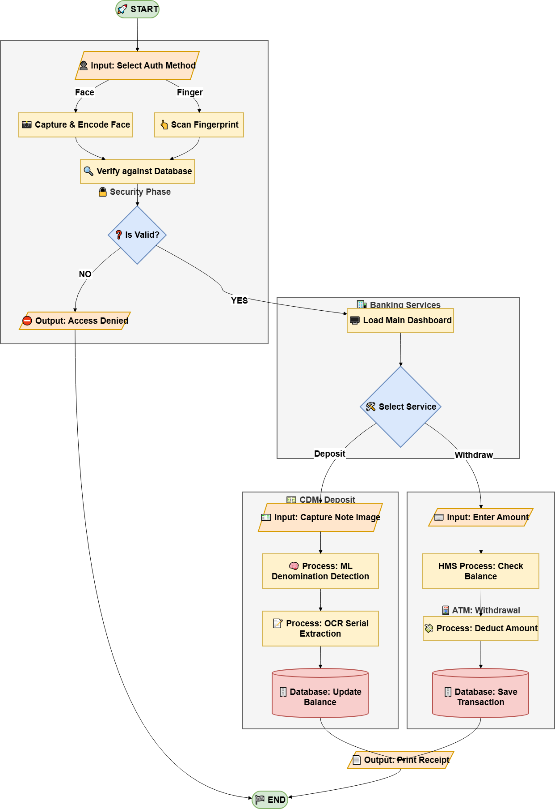
Visual Flow Representation

3. ALGORITHM / PSEUDOCODE

Biometric Authentication (Revised Description):
The system relies solely on Face Recognition for verification, implemented via the DeepFace library. The authentication process uses the ArcFace model for robust feature embedding and the retinaface detector for accurate face localization. This single, high-security modality replaces the multi-modal (Fingerprint/Face) approach initially proposed.

CDM Processing & Currency Classification (Revised Description):
The core classification module has been changed from a CNN to a Computer Vision (CV) approach using ORB Feature Matching.
- Reference Loading: The system loads pre-trained reference images for valid denominations (500, 1000, 5000 notes).
- Feature Detection: The live camera feed captures the deposited note. The cv2.ORB_create() algorithm detects distinct key points and descriptors on both the live and reference images.
- Classification: A Brute-Force Matcher (cv2.BFMatcher) is used, coupled with a Ratio Test, to find the best match between the live note's features and the stored reference features. The note is classified as the denomination with the highest number of "good matches."

Data Management & Security:
- The system manages all user and transaction data locally using Pandas DataFrames which are persisted as CSV files (accounts.csv, transactions.csv).
- User PINs are not stored directly. They are secured using the SHA-256 Hashing Algorithm before storage, providing cryptographic security against unauthorized access.
- The system relies on the smtplib module for sending time-sensitive One-Time Passwords (OTP) required for high-security transactions like withdrawals, adding a second factor of authentication.

OUTPUT SCREENSHOTS / GRAPHS (Expected)
Note: These are descriptions of the interface layouts to be developed.

Figure 1: Main Login Screen
  - Menu Options (Text-based)
  - User Login (PIN is masked)
  - Admin Login
  - Exit

Figure 2: User Login
- Check Balance
- Deposit Amount (CDM)
- Withdraw Amount (High Security)
- Change PIN
- Display Transaction History
- Logout

Figure 3: Admin Login:
- Create New Account
- View All Accounts (Accesses accounts.csv)
- Search Account (By ID or Name)
- Manage Account (Block/Delete)
- Add Amount (Manual Deposit)
- Change User PIN (Visible Input for admin convenience)
- View User Transactions (Accesses transactions.csv)
- Logout

RESULTS & DISCUSSION (Expected)

Face Recognition
- Face Recognition: Is expected to reject unauthorized users with a strict tolerance threshold (0.4 - 0.5 distance).

CONCLUSION & FUTURE WORK
Conclusion
This project presents a functional software prototype of a next-generation banking terminal. By moving away from hardware sensors to Computer Vision and Machine Learning, and by replacing PINs with Multi-Modal Biometrics, the system offers a more secure and audit-friendly banking experience. The inclusion of Serial Number Extraction specifically addresses the industry need for better tracking of physical currency notes.

Future Work
- Fake Currency Detection: The current ML model detects denomination. Future work involves training a model specifically to detect UV security features to identify counterfeit notes.
- Cloud Integration: Moving the database from local CSV files to a cloud- based SQL server (e.g., Firebase or AWS) for real-time remote banking.
- Mobile App Integration: Allowing users to view their "Note Inventory" and transaction history via a mobile application.

END OF PROPOSAL !

