Team Project Final Report
As part of Database (420-231-VA) at Vanier College
Submitted to Nagat Drawel
Work by Mathieu Bernardin and Kiavash Emrani
Table of Contents

Introduction
This project’s goal was to design a database for a non-descript dentist office. Sample management tools, such as views and procedures and views, were also to be included in the database design. The database was to be designed using MS SQL Server, the language which we have studied in this course this semester. Additionally, this project was intended as a general review of all course material this semester, and a chance to practice out teamwork abilities.

Conceptual Design of the Database
After all changes to the database, below is the final entity relationship diagram of the database, with foreign keys excluded for brevity. An alternate version of this diagram is available in this project repository under /Deliverable3/finalErDiagramWithForeignKeys3NF.jpg for documentational purposes.
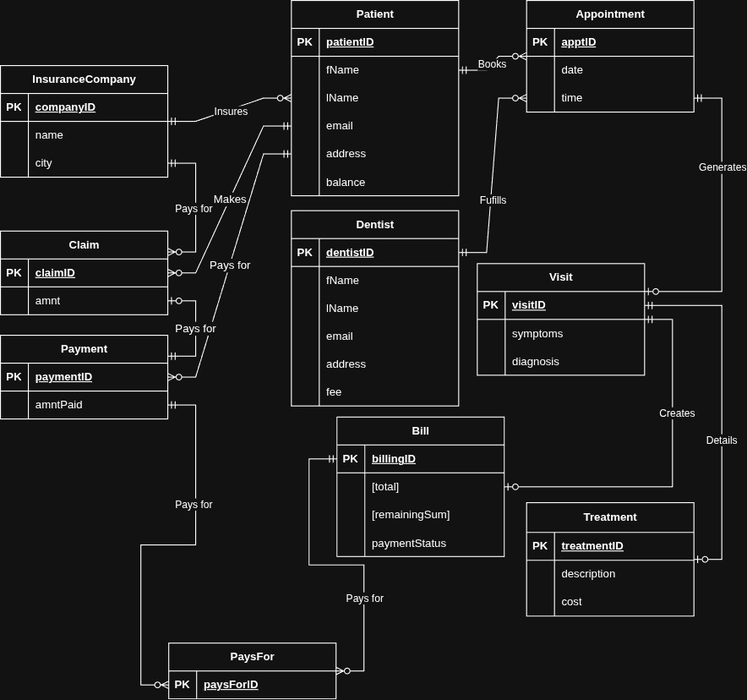Figure 1: Entity Relationship Diagram

Logical Database Schema

