420-231-VA: Database
LIA – Deliverable 1
Mathieu Bernardin
Kiavash Emrani

Entity Relation Diagram:
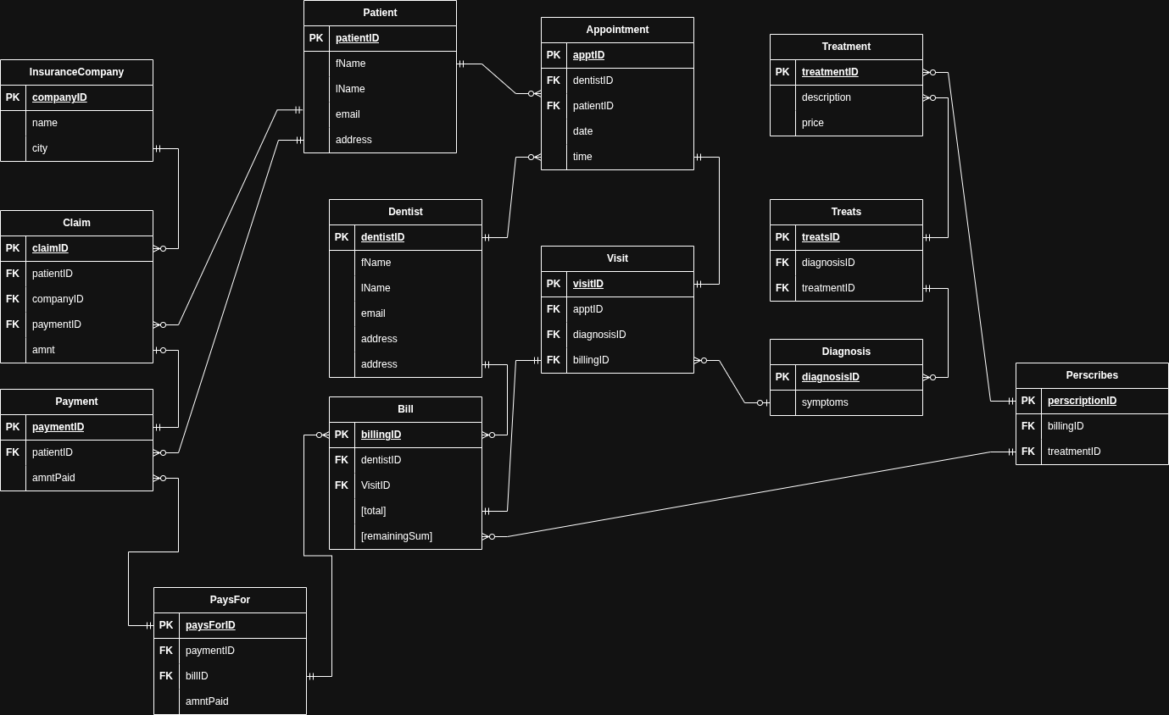

Relational Schema:

Teamwork Summary:
ERD – Mathieu
RS – Kiavash

Difficulties Faced:
While working on this project, we faced many difficulties. One major difficulty was deciding how to implement the insurance component exactly, as we saw many methods to do so. Another was coordinating and deciding what parts should be done by who. However, a major factor in this issue was one of our teammates dropping the course without letting us now, therefore leaving us unsure as to what to do.

