RADIAN - RADar-based Intelligent Activity moNitoring
Matthew Blackwell
Mitch Hoffman
Wyatt Johnson

Frame & Trial Specification

Frame & Trial Specification
for
RADIAN

Team 60

Approved by:

_____________________________
Matthew Blackwell Date

Change Record
Rev. | Date | Originator | Approvals | Description
1 | 01/29/2026 | Matthew Blackwell |  | Draft Release

Table of Contents
1. Introduction 7
1.1. Purpose 7
1.2. System Overview 7
1.3. Defintions 7
2. Frame and Data Structure 7
2.1. Metadata 7
2.2. Center of Mass Data 7
3. Trial Structure 8
3.1. Trial Length 8
4. Dataset Organization 9
4.1. Folder Structure 9
4.2. Units and Coordinate Conversions 9
5. Assumptions and Limitations 9
6. Example Data 9

List of Tables
List of Figures

Introduction

Purpose
The purpose of this document is to define the official data format for the RADIAN radar-based motion detection and fall detection trials. This will ensure that the data is consistent, reproducible, and usable for the Data subsystem’s algorithm development and machine learning. This specification is frozen for the initial trials, and future extensions must remain backwards-compatible.

System Overview
The sensor type is a radar-based human detection system using Wireless’s TI board to receive the radar data. The output rate is ____. The primary task of the machine learning algorithm is to classify human motion correctly and accurately, including but not limited to standing, walking, sitting, and falling. The target for running the ML algorithm is a Raspberry Pi 3, specifically running a 1D CNN model.

Defintions
This section will go over a few definitions needed to understand the use of this document.
Frame: A single radar snapshot at one timestamp, producing a detected center of mass.
Trial: A sequence of consecutive frames representing one continuous human action and is assigned a single class label.
Timestep: One timestep corresponds to one frame

Frame and Data Structure
Each of the frames must contain each of the following fields

Metadata
- frame_id (int): Monotonically increasing frame index
- timestamp (float): Time in seconds since the trial start

Center of Mass Data
- x_c (float): Center of mass position in the x-axis (meters)
- y_c (float): Center of mass position in the y-axis (meters)
- z_c (float): Center of mass position in the z-axis (meters)

  - Center Tracking Rule
If the center of mass cannot be reliably detected in a given frame, then the most recent valid (x_c, y_c, z_c) value shall be reused. This event may be flagged internally, but will not invalidate the frame.

  - Derived Frame-Level Features
These features are going to be specifically computed numerically from consecutive frames. Derived features are optional to store but must be computable from stored data.

    - Velocity Components
- v_x = dx_c / dt
- v_y = dy_c / dt
- v_z = dz_c / dt

    - Speed Magnitude
- |v| = sqrt(v_x^2 + v_y^2 + v_z^2)

Trial Structure

Trial Length
A trial will consist of 100 consecutive frames or roughly 10 seconds of data (N = 10 frames per second)

  - Trial Label
Each trial is assigned exactly one label:
- Standing
- Walking
- Sitting
- Crawling
- Falling
- Other (Add on later)

  - Trial Boundaries
A trial will begin:
- At the start of a movement or posture

A trial will end:
- When the action completes or transitions into another class

Dataset Organization

Folder Structure
The folder will be structured in this format:
data/
standing/
sitting/
walking/
crawling/
falling/

Units and Coordinate Conversions
Distance will be measured in meters (m). Time will be measured in seconds (s). Velocity will be measured in meters per second (m/s). To coordinate the frame origin and orientation, it will be defined by the radar mounting configuration.

Assumptions and Limitations
Only a single human is tracked per frame and will not have any other human shaped objects in the room. Occlusions may cause a temporary center reuse. Fine-grained posture details will not be captured at the frame level, at least with the data directly given from the radar

Example Data
Below is an example of a single frame stored in JSON format. This represents one timestamp of radar data:
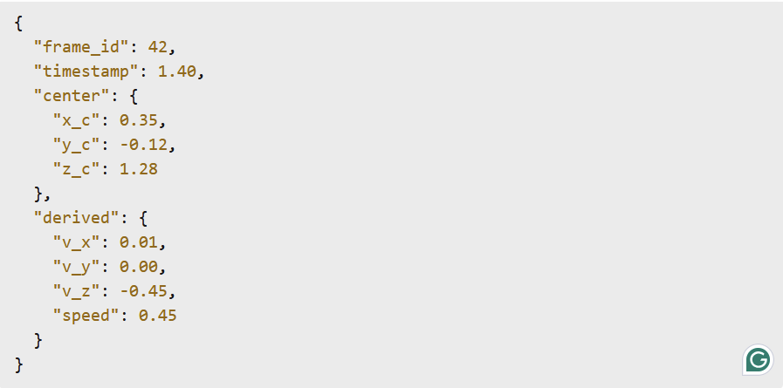

Notes:
- Positions are given in meters
- Velocities are computed using finite differences between consecutive frames
- Negative v_z indicates a downward motion

Below is an example of a complete trial consisting of multiple frames and a single label:

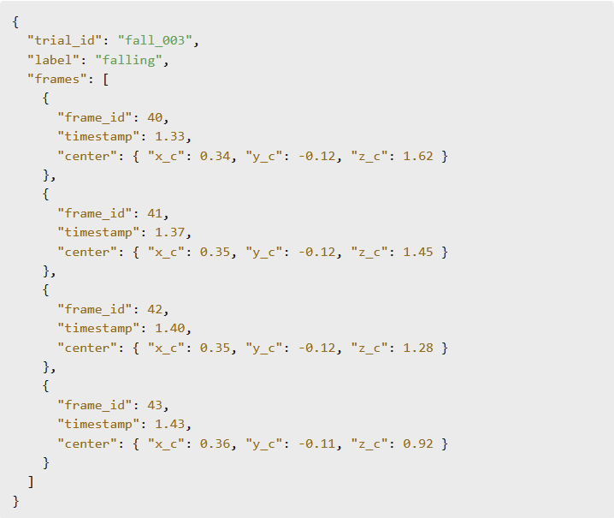

Notes:
- All frames in a trial are consectutive in time
- A single label applies to the entire trial
- Derived features may be stored per frame or computed during preprocessing

