RADIAN - RADar-based Intelligent Activity moNitoring
Matthew Blackwell
Mitch Hoffman
Wyatt Johnson

Concept of Operations

Concept of Operations
for
RADIAN

Team 60

Approved by:

_____________________________
Matthew Blackwell Date

_____________________________
Prof. Jang Date

_____________________________
Roman Venegas Date

Change Record
Rev. | Date | Originator | Approvals | Description
1 | 09/09/25 | Matthew Blackwell |  | Baseline Release
2 | 09/20/25 | Matthew Blackwell |  | Microcontroller Switch
3 | 10/04/25 | Matthew Blackwell |  | MCU removal, SMS removal, and other edits from ICD
4 | 12/05/25 | Wyatt Johnson |  | Document formating

Table of Contents
Table of Contents 3
List of Figures 4
1. Executive Summary 5
2. Introduction 6
2.1. Background 6
2.2. Overview 6
2.3. Referenced Documents and Standards 6
3. Operating Concept 8
3.1. Scope 8
3.2. Operational Description and Constraints 8
3.3. System Description 8
3.3.1. Physical Design 8
3.3.2. Wireless Design 9
3.3.3. Data Design 9
3.4. Modes of Operations 9
3.5. Users 9
3.6. Support 10
4. Scenario(s) 11
4.1. Fall Detection 11
4.2. Normal Activity Monitoring 11
4.3. Multi-Room Monitoring 11
5. Analysis 12
5.1. Summary of Proposed Improvements 12
5.2. Disadvantages and Limitations 12
5.3. Alternatives 12
5.4. Impact 12

List of Figures
Figure 1: High-Level Block Diagram for RADIAN system ………………………………………6

Executive Summary
Falls are a leading cause of injury among elderly individuals, often resulting in severe health consequences. Existing monitoring solutions on the market, such as wearable devices and camera-based systems, suffer from significant drawbacks. Wearable devices rely on user compliance, and camera-based systems compromise privacy. To address these drawbacks, this project proposes the development of a low-cost, AI-enabled fall detection system using a millimeter wave (mmWave) radar marketed for the elderly at risk of falls.

The RADIAN system uses a commercially available mmWave radar sensor to continuously monitor human activity within an indoor environment, such as a living room or bedroom. The use of mmWave technology allows for privacy to be preserved while still providing adequate protection. The data from the radar will be processed through an embedded microcontroller on the mmWave Radar board and then passed to a Raspberry Pi, where AI algorithms will classify motion patterns to detect falls. In the event of a fall, the RADIAN system will automatically send a wireless alert to a caregiver’s smartphone via Wi-Fi, as well as set off an alarm on the device itself to alert anyone inside the house. The budget approved for the RADIAN group is $375, keeping the project low-cost.

Introduction
The RADIAN (RADar-based Intelligent Activity moNitoring) system will detect human falls within an enclosed space, specifically in a household or office setting, using radar-based systems. The RADIAN system will detect a fall using AI-based machine learning algorithms and send an alert to a cellular device, ensuring that the fall is caught quickly and accurately.

Background
The leading cause of injury-related death among adults ages 65 and older is falls [1]. Many current solutions rely on vision-based systems or a wearable device, both of which suffer from limitations such as user compliance, privacy concerns, and coverage gaps. A millimeter-wave radar preserves privacy, a non-contact, and reliable means of monitoring human activity indoors.

Overview
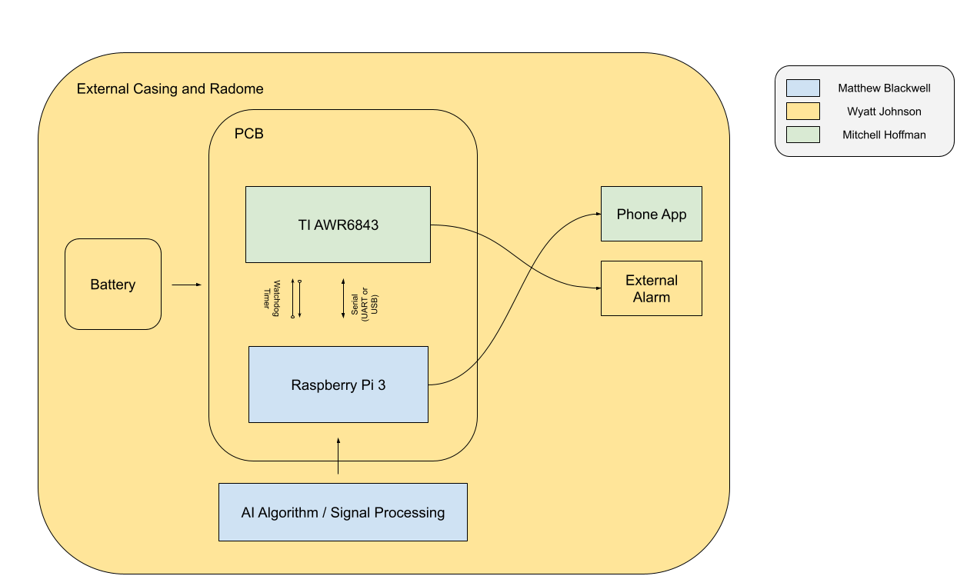
Figure 1: High-Level Block Diagram for RADIAN system

A mmWave Radar Sensor will be used to monitor human movement in a room. Data from the radar is processed using AI algorithms to detect falls in real time. Once a fall is detected, the device will activate an alarm as well as send a remote wireless notification to a mobile device via Wi-Fi.

Referenced Documents and Standards

- IEEE 802.11 Wi-Fi standards
- IEEE 802.15.4 for wireless communications
- IEEE 521-2002 Standard Letter Designations for Radar-Frequency Bands
[1] “Falls Data & Research.” Centers for Disease Control and Prevention, Accessed at
https://www.cdc.gov/falls/data-research/index.html#:~:text=Deaths%20from%20older%20adult%20falls,.cdc.gov/STEAD

Operating Concept

Scope
The RADar-based Intelligent Activity moNitoring (RADIAN) system is designed to enhance the safety of elderly and physically disabled individuals by providing timely alerts in the event of a fall within a monitored room. Once installed, the RADIAN system will continually monitor a closed room for human presence and movement. Fall events are identified by an in-house-developed artificial intelligence (AI) and machine learning algorithm, based on extensive testing by the RADIAN group. When the AI determines that a fall has occurred, a wireless signal will transmit to a dedicated mobile application developed by the RADIAN group, alerting those most important to the monitored individual. In addition, there will be an audible alarm system to alert those in the building to the fall. By combining real-time monitoring with reliable alerting mechanisms, the RADIAN system allows for peace of mind for at-risk individuals and their families.

Operational Description and Constraints
The RADIAN system is designed to be used in closed rooms of varying sizes, both in room area and ceiling height. The RADIAN system is designed to be relatively easy to use for the user, both in the setup of the radar as well as the alert system and its GUI. A RADIAN system will be set up in the corner of a room, with the sensor and radome facing down at a 45° angle to ensure that the RADIAN system is scanning the entire room. The GUI (Graphical User Interface) will ask what room the RADIAN system is set up in to organize each RADIAN system and to understand what furniture and other objects could be scanned. As the RADIAN system scans the room, the raw data will be processed through the microcontroller embedded in the RADIAN system and then sent to an AI algorithm to analyze the room. If the AI detects a fall, then a signal will be sent to the microcontroller to then alert the GUI that a fall was detected through an app notification.

Here are the resulting constraints of the RADIAN system for it to operate properly according to the description:
- The RADIAN system must not be blocked by any object
- The RADIAN system has to be placed in a high vantage point at a 45° downward angle
- The RADIAN system’s radome must be directed towards the largest area of the room
- The RADIAN system must be powered via battery
- The RADIAN system must be small in size (e.g., wall-mountable, no larger than a shoebox) to ensure user-friendliness during installation, thus limiting the complexity of parts that can be used
- The RADIAN group has a budget of $375, further constraining the complexity of the RADIAN system

System Description

3.3.1. Physical Design
The radar board, which includes a TI AWR6842ISK and a Raspberry Pi, will all be connected to the battery system on a custom-designed PCB (Printed Circuit Board) designed in-house by the RADIAN group. This PCB design will enhance the RADIAN system's reliability during installation, as no components can be removed. The RADIAN group will also study and implement the power management in this subsystem, ensuring that the correct voltage and current are being provided to the various components of the RADIAN system. The battery casing will also be screwed to the board and include a removable housing and leads to facilitate battery replacement when needed, ensuring the continued reliability of the RADIAN system.

3.3.2. Wireless Design
The radar chip will be hand-selected through thorough research and trade studies by the RADIAN group to guarantee reliability and affordability for the consumer and users of the RADIAN system. The TI radar board will be programmed to collect the raw data from the radar chip and convert it into usable data for the AI algorithm stored on the Raspberry Pi. Once the AI algorithm has detected a fall, a signal will be sent to an external alarm connected to the RADIAN system. The wireless design subsystem will also be responsible for the application's GUI, providing both a frontend and a backend to ensure that the application is easy to use and runs smoothly.

3.3.3. Data Design
The AI algorithm is the primary focus of the data subsystem, utilizing a simple AI model developed by the RADIAN group to predict fall occurrences. The RADIAN group will do extensive testing and training of the AI model to ensure that false positives and true negatives do not send alerts. The application may have various options to select where the RADIAN system is placed, to help the AI algorithm understand what objects may or may not be in a room. Some examples include a bed present in a bedroom, but not in a living or dining room. Having these distinctions allows for fewer false alarms when the user is lying down vs. falling. The data subsystem will also be responsible for communicating with the cloud server to send the push notifications. A wireless Wi-Fi communication will be sent from the Raspberry Pi 3 to the Gotify cloud to alert those not in proximity of the audible alarm using the RADIAN phone application.

Modes of Operations
The RADIAN system will only have one operating mode, as the radar has to constantly sweep a room due to the random nature of human movements. Within this mode, the user will be able to define what room the RADIAN system is placed in to aid the AI algorithm in understanding what may or may not be in the room. When operating in the mode, the radar will constantly detect the room and the objects around the room, sensing for motion and a potential fall. If a fall is detected by the RADIAN system and its AI algorithm, then an alert will be sent to the desired device, as well as set off an audible alarm for those in proximity.

Users
The RADIAN system will be marketed to the high-risk individuals who greatly benefit from a fall detection system in their home without having to worry about privacy infringement with camera-based detection systems. Our product will allow users and their loved ones to have peace of mind when it comes to the health and safety of the user.

The RADIAN system can also double as a simple motion detection device that can be used in various security applications, including home security, business security, and preventing deaths in the back of motor vehicles.

Support
The RADIAN group will provide an extensive manual detailing the installation of the RADIAN system, battery replacement, and a simple explanation of how the RADIAN system works at the highest level. Within the RADIAN application, detailed step-by-step guides will be provided to guide the user through the setup and operation of the device.

Scenario(s)

Fall Detection
An elderly person falls in their bedroom or living room. The RADIAN system will use mmWave radar technology to record and process the elderly person's fall. This mmWave radar data will then be sent to an AI model that will then classify the event as a fall, triggering an alarm and notifying the caretaker. This notification will be sent to a caregiver's smartphone through an app. The caregiver will then be able to check on the individual quickly and allow for the necessary response as soon as possible.

4.2. Normal Activity Monitoring
The RADIAN system user can be walking, sitting, or lying down in their bedroom. The radar will detect all of these events, but the AI model will classify these events as “safe”. No alerts will be sent in these events, and will allow the user to continuously monitor their environment for hazardous falls without invading their privacy.

4.3. Multi-Room Monitoring
The user is capable of monitoring a whole house or a nursing home. The user will install multiple RADIAN systems in each room that they would like to monitor. Each RADIAN system will individually monitor the room in which it is. If the RADIAN system detects a fall, it will notify the caregiver of the event and also provide the location of the room in which it occurred. While one room is triggered, the other rooms will be continuously monitored. All of the data from the rooms can be examined in the RADIAN smartphone app by the caregiver, providing complete protection of the whole building.

Analysis

Summary of Proposed Improvements
The RADIAN system will be battery-powered, providing wireless capabilities and flexible placement without requiring a constant wired connection. The radar subsystem will monitor human activity without capturing images, which allows for the protection of the privacy of users while still detecting falls. The AI model constantly monitors the radar subsystem’s data to detect falls and then sends notifications. Alerts will be sent directly to the caregivers or emergency responders, allowing for a quick response time to accidents. The RADIAN system will operate autonomously, allowing users to have minimal interaction with the device.

Disadvantages and Limitations
Due to the limited power, since it will be battery-powered, this can restrict our complexity for our AI algorithm, which could lead to false alarms and/or missing scenarios that should trigger the alarm. Depending on the mmWave radar settings and wireless communication frequency, this can cause the battery life to be significantly reduced. In complex environments (cluttered rooms, multiple people, animals, children), the RADIAN system could produce more false positives. Depending on the size of the room, the RADIAN systems may not be able to detect falls in the outer areas of a large room. For the RADIAN system to effectively communicate with emergency services, it will need to depend on reliable network connectivity.

Alternatives
PIR Motion Sensors are used for simple movement/presence detection, are cheap and easy to use, but can not detect falls. Camera-Based Monitoring can provide a visual view of the room and verify if a fall occurs, offers more data for an AI model and could be used to create a better model without the need for complex data or high-resolution cameras, but raises privacy concerns for bedrooms and living spaces and requires high processing power, and storage could be an issue, leading to a high price point. A wearable device is capable of detecting a fall with an onboard sensor and is more accurate with little complexity, but it requires the user to wear a device constantly, and it may be uncomfortable, or the user could forget to wear the device, making it not as reliable.

Impact
Environmental Impact: The RADIAN device has low energy consumption. Minimal waste since the device will be compacted.

Society Impact: Increases safety for the elderly by providing rapid fall detection without invading privacy. Reduces the response times for caregivers and/or emergency services. Enables the elderly to live independently without sacrificing safety.

Ethical concerns: Allows for privacy due to no audio or video recording

