RADIAN - RADar-based Intelligent Activity moNitoring
Matthew Blackwell
Mitch Hoffman
Wyatt Johnson

Functional System Requirements

Functional System Requirements
for
RADIAN

Team 60

Approved by:

_____________________________
Matthew Blackwell Date

_____________________________
Prof. Jang Date

_____________________________
Roman Venegas Date

Change Record
Rev. | Date | Originator | Approvals | Description
1 | 10/04/2025 | Matthew Blackwell |  | Draft Release
2 | 12/05/2025 | Wyatt Johnson |  | Document formatting

Table of Contents
1. Introduction 6
1.1. Purpose and Scope 6
1.2. Responsibility and Change Authority 6
2. Applicable and Reference Documents 8
2.1. Applicable Documents 8
2.2. Reference Documents 8
2.3. Order of Precedence 8
3. Requirements 9
3.1. System Definition 9
3.2. Characteristics 10
3.2.1. Functional / Performance Requirements 10
3.2.2. Physical Characteristics 11
3.2.3. Electrical Characteristics 12
3.2.4. Environmental Requirements 13
4. Support Requirements 14
4.1. Wi-Fi Connection 14
4.2. Wi-Fi or Cellular Data Connection 14
4.3. Battery Maintenance 14
Appendix A: Acronyms and Abbreviations 15

List of Tables

Table 1: Subsystem Responsibility 7
Table 2: Applicable Documents for the RADIAN System 7
Table 3: Reference Documents for the RADIAN System 7

List of Figures
Figure 1: RADIAN Conceptual Image 1
Figure 2. Block Diagram of Radian System 4

Introduction

Purpose and Scope
Falls are a leading cause of injury among elderly individuals, often resulting in severe health consequences. Existing monitoring solutions on the market, such as wearable devices and camera-based systems, suffer from significant drawbacks. Wearable devices rely on user compliance, and camera-based systems compromise privacy. The RADIAN system will provide a low-cost, non-invasive, privacy-preserving fall detection system. The RADIAN system will use mmWave radar and AI algorithm technology to monitor human activity and detect falls in indoor environments, such as bedrooms and living rooms.

The RADIAN system will continuously monitor a room for motion patterns and classify them into fall/non-fall events in real time. Once a fall is detected, the RADIAN system will trigger an audible alarm and send a wireless alert to a caregiver’s smartphone. Figure 1 shows the RADIAN system that is proposed in CONOPS.

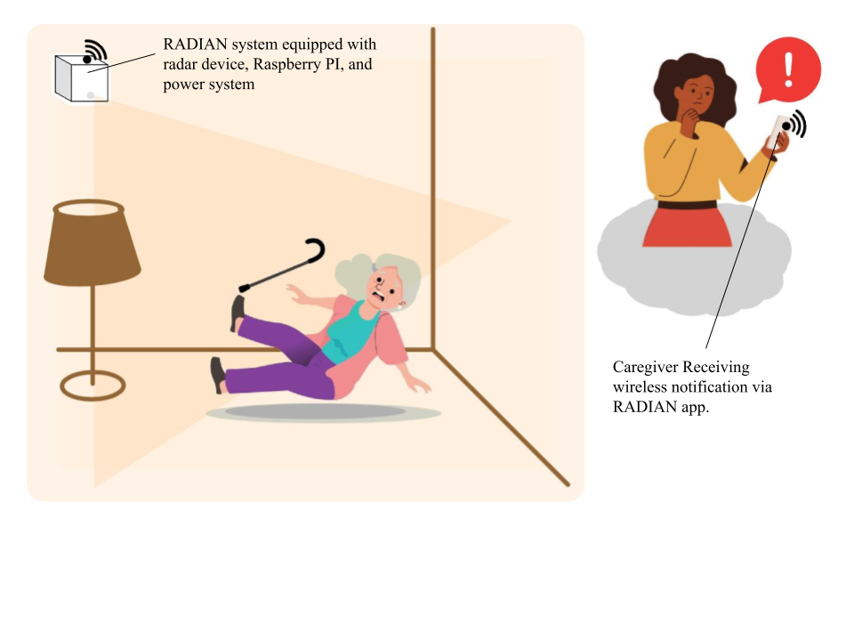
Figure 1: RADIAN Conceptual Image

This document describes detailed requirements for the RADIAN system, including the requirements for each subsystem (Physical, Wireless, and Data). The verification process for the RADIAN system will be described in a separate Validation Plan.

Responsibility and Change Authority
Matthew Blackwell, RADIAN’s team leader, will be responsible for ensuring that all requirements are met for the RADIAN system. These requirements can only be changed with approval from Matthew Blackwell and Professor Arya Menon, the RADIAN faculty Contact.

Subsystem | Responsibility
AI Model and Communication | Matthew Blackwell
Radar Sensing and App Development | Mitchell Hoffman
Power System and Physical Enclosure | Wyatt Johnson
Table 1: Subsystem responsibility

Applicable and Reference Documents

Applicable Documents
The following documents, of the exact issue and revision shown, form a part of this specification to the extent specified herein:

Document Number | Revision/Release Date | Document Title
IPC/WHMA-A-620E | January 2022 | Requirements and Acceptance for Cable and Wire Harness Assemblies
UL 1977 | December 7, 2022 | Component Connectors for Use in Data, Signal, Control, and Power Applications
Table 2: Applicable Documents for the RADIAN System

Reference Documents
The following documents are reference documents utilized in the development of this specification. These documents do not form a part of this specification and are not controlled by their reference herein.

Document Number | Revision/Release Date | Document Title
IEEE 802.11 | Jan. 23, 1996 | IEEE Standard for Information Technology – Telecommunications and Information Exchange between Systems
Table 3: Reference Documents for the RADIAN System

Order of Precedence
In the event of a conflict between the text of this specification and an applicable document cited herein, the text of this specification takes precedence without any exceptions.

All specifications, standards, exhibits, drawings, or other documents that are invoked as “applicable” in this specification are incorporated as cited. All documents that are referred to within an applicable report are considered to be for guidance and information only, except ICD,s which have their relevant documents considered to be incorporated as cited.

Requirements

System Definition
The RADIAN system is an all-in-one, designed system to help protect the elderly and high-risk individuals with quick and accurate alerts when the user has fallen. This allows the caregiver, whether a health care professional or loved one, to feel comfort knowing that their loved one is safe. The RADIAN system will comprise three overarching subsystems, each with further design requirements that must be met for the RADIAN subsystem. These three subsystems include Physical, Data, and Wireless.
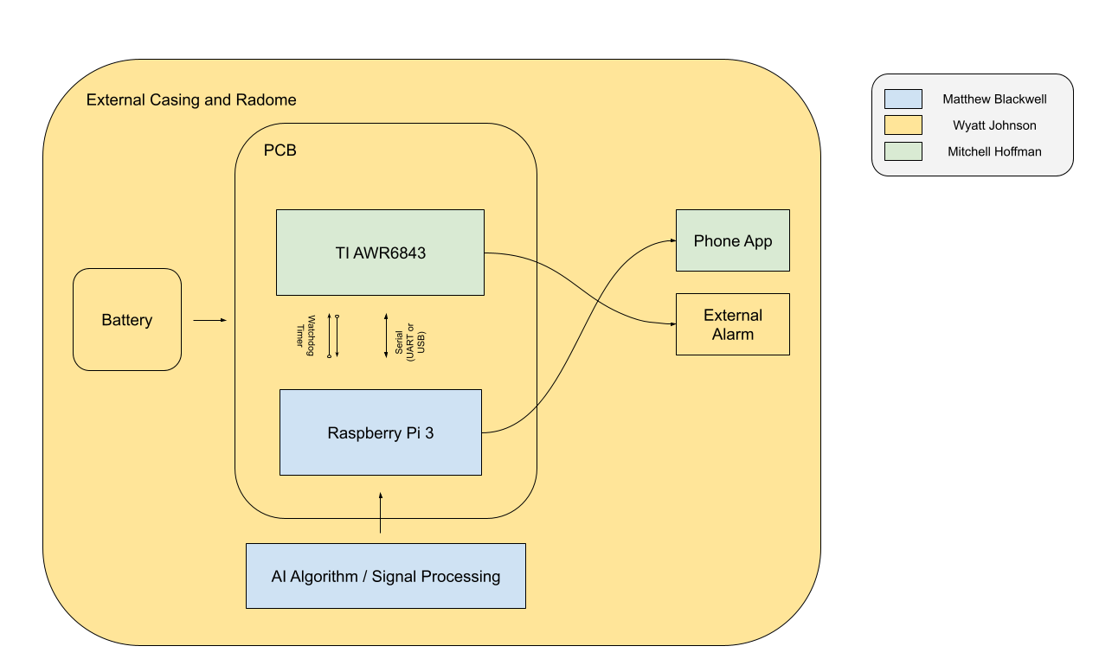
Figure 2. Block Diagram of Radian System

The entire RADIAN system is powered through two 3.7V rechargeable batteries, powering both the TI AWR6843ISK board and the Raspberry Pi 3, which are needed for the system to function. The rechargeable battery pack allows the user to easily charge the RADIAN system while maintaining maneuverability around the room. Both the TI board and Raspberry Pi 3 are connected to the custom-designed PCB, allowing for efficient connections and reduced risk of electrical connection failure between the subsystems. The ML model and AI algorithm are stored and run through the Raspberry Pi 3, where they will then communicate with an external phone application designed by the RADIAN group via a Gotify server. An external alarm will also be connected to the RADIAN system to alert anyone in the home while also alerting the caregiver’s device.

The RADIAN system may have a feature that will trigger a sleep mode on the Raspberry Pi 3 to conserve power when no motion is detected in the room. Once motion is detected of an elderly or high-risk individual, the radar will continuously scan the room, sending the processed data to the Raspberry Pi 3. Through its AI algorithm and ML model, the Raspberry Pi 3 will be able to compute in real-time the position, velocity, acceleration, and other fall parameters of the individual. If the ML model decides that a true fall has occurred based on a variety of parameters and decisions, the Raspberry Pi will send a message. The Gotify server will receive this new message and create a WebSocket, allowing for the message to travel in real time to the phone application. The custom-designed application will then receive this message and send a push notification to the caregiver, alerting them of the fall.

By combining these three subsystems, RADIAN provides a portable, intelligent, and connected solution for fall detection, balancing energy efficiency with reliable caregiver communication.

Characteristics

Functional / Performance Requirements

Fall Detection Accuracy
The RADIAN system shall detect falls with a minimum of 90% accuracy under normal indoor conditions (room temperature, clear view of the falling subject, unobstructed view, within 5 meters).

Rationale: The system will need to have a high fall detection accuracy to verify its capabilities for detecting falls reliably, which will also increase user trust.

Detection latency
Once a fall is detected, the RADIAN system will send an alert and sound an alarm within five seconds of a fall.

Rationale: It is critical that caregivers or emergency responders act as soon as possible, reducing the chance of an injury worsening.

Battery Life
The RADIAN system shall operate for a minimum of 3 hours on battery power without recharging.

Rationale: This amount of time will allow the system to stay functioning while the second battery is charging.

Communication Reliability
The RADIAN system shall send an alert over the Gotify server with a minimum success rate of 95%.

Rationale: A reliable communication system will ensure that fall events reach caregivers promptly, allowing for fast response times.

Local Alert Functionality
The RADIAN system will be equipped with a local audible alert system that, upon a fall being detected, a minimum of a 70 dB alarm will be activated.

Rationale: Having the local alert system will provide an alert to the user and nearby individuals that a fall has occurred. This will also allow for locating the victim quickly.

      - Autonomous Operation
The RADIAN system will operate autonomously, allowing users to have minimal interaction with the device.

Rationale: Autonomy ensures there will be continuous monitoring and timely alerts without the user needing to worry about maintaining the device.

Physical Characteristics

Radar Scan Area
The RADIAN system will operate in a standard room of 20 to 30 square meters with an angle of 45 degrees facing down.

Rationale: The RADIAN system is intended to operate in any standard household room, including but not limited to dining rooms, living rooms, and bedrooms. However, the RADIAN system is not rated for the bathroom.

Mass
The mass of the RADIAN System shall be less than or equal to 0.8 kilograms.

Rationale: A lighter system will be able to be mounted on walls without requiring heavy-duty hardware and support.

Volume Envelope
The volume envelope of the RADIAN System shall be less than or equal to 5 inches in height, 8 inches in width, and 14 inches in length.

Rationale: A compact system will be able to be mounted on walls, ceiling, or furniture, allowing for portability & relocation.

Mounting
The mounting information will be available in the RADIAN group’s ICD as well as their user guide.

Rationale: The RADIAN system must be placed at a certain angle and height to capture the entirety of the room it is placed in.

Installation
The instructions for installing the RADIAN system are available for reference in the provided user guide. The installation required by the user will be mounting and battery charging/installation, as the phone application will already be installed and set up.

Rationale: The ease of installation allows the user to mount the RADIAN system and use it, ensuring that anyone can use the system.

Electrical Characteristics

Inputs
- The presence or absence of any combination of the input signals in accordance with ICD specifications applied in any sequence shall not damage the RADIAN system, reduce its life expectancy, or cause any malfunction, either when the unit is powered or when it is not.

- No sequence of commands shall damage the RADIAN System, reduce its life expectancy, or cause any malfunction.

Rationale: By design, it should limit the chance of damage or malfunction by user/technician error.

Power Consumption
The maximum peak power of the system shall not exceed 18 watts.

Rationale: Lower power draw will allow the system to run longer, while a high wattage will shorten the runtime.

Input Voltage Level
The input voltage level for the RADIAN system shall be 5.0V.

Rationale: This is the required voltage for devices used in the RADIAN system

Outputs

Data Output
The RADIAN system shall include a phone application interface compatible with the data system.

Rationale: The RADIAN system will pass information, specifically if a fall was detected, to a phone app designed for the caregiver of the high-risk individual.

Diagnostic Output
The RADIAN system may include a diagnostic interface for errors that occur within the system and debugging techniques for the system.

Rationale: This will provide a way for the use of the phone app to locate the error and provide solutions for fixing the error.

Wireless Communication Output
The RADIAN system shall wirelessly communicate with the phone application to alert if a fall is detected, using the Gotify server.

Rationale: Wireless communication will allow the caregiver to be notified, even if they are not present in the home to hear the audible alarm.

Cloud Data Storage
The RADIAN system will include a cloud storage option to upload data 4 seconds before the fall, during the fall, and 10 seconds after the fall.

Rationale: Cloud storage allows for first responders to know exactly when a fall occurs and the extent of the severity of the fall.

Connectors
The RADIAN System shall follow UL 1977 (2022), Component Connectors for Use in Data, Signal, Control, and Power Applications.

Rationale: Following UL 1977 will ensure that we use safe techniques and correctly rated connectors
for lower power systems.

Wiring
The RADIAN System shall follow the guidelines outlined in IPC/WHMA-A-620 Class 1 safety requirements.

Rationale: Class 1 establishes basic workmanship for general, low-voltage products.

Environmental Requirements
The RADIAN System shall be designed to withstand and operate in the environments and laboratory tests specified in the following section.

Rationale: The RADIAN system will need to function in an indoor setting similar to the common home, with constant pressure and slight variations in temperature

Thermal
The RADIAN System will be able to operate in an environment between 50 °F and 80 °F

Rationale: The average temperature of many homes and buildings is between 50 °F and 80 °F, so the system must accommodate these varying temperatures

Support Requirements

Wi-Fi Connection
The RADIAN system requires a Wi-Fi connection to communicate with the Gotify server to send the REST POST notification. The user will provide the Wi-Fi connection to support the wireless connection of the RADIAN system.

Rationale: The system will need a Wi-Fi connection for the Raspberry Pi 3 to communicate with the Gotify cloud server. The Raspberry Pi 3’s Wi-Fi connection can be changed remotely without having to view the GUI of the device.

Wi-Fi or Cellular Data Connection
The caregiver will be required to have a Wi-Fi or Cellular Data connection to receive the push notification from the RADIAN phone application.

Rationale: This allows the push notification to be communicated wirelessly over any distance.

Battery Maintenance
The user or caregiver must maintain the RADIAN system by occasionally changing the rechargeable batteries. They must also charge the depleted batteries to ensure there is always a backup for the system.

Rationale: Having battery maintenance allows the system to operate without protruding cables and will work if a power outage occurs.
  - Requirements for Customer
The RADIAN system requires a Wi-Fi connection to post an alert to the Gotify cloud server properly. Due to the system's nature, the caretaker will also need to download the phone application to receive push notifications indicating a fall has occurred. The user will have to provide the Wi-Fi connection, but this should not be an issue, as the majority of homes and buildings have some sort of Wi-Fi connection. The caretaker must have a wireless connection, either Wi-Fi or Cellular Data, to receive the push notifications.

Appendix A: Acronyms and Abbreviations

GUI Graphical User Interface
RADIAN RADar Intelligent Activity moNitoring

