RADIAN - RADar-based Intelligent Activity moNitoring
Matthew Blackwell
Mitch Hoffman
Wyatt Johnson

Interface Control Document

Interface Control Document
for
RADIAN

Team 60

Approved by:

_____________________________
Matthew Blackwell Date

_____________________________
Prof. Jang Date

_____________________________
Roman Venegas Date

Change Record

Rev. | Date | Originator | Approvals | Description
1 | 10/04/2025 | Matthew Blackwell |  | Draft Release
2 | 12/05/2025 | Wyatt Johnson |  | Document formatting and updated Electrical Power System

Table of Contents
Table of Contents 3
List of Tables 5
List of Figures 6
1. Overview 7
2. References and Definitions 8
2.1. References 8
2.2. Definitions 8
3. Physical Interface 9
3.1.Weight 9
3.2. Dimensions 9
3.2.1. Dimensions of Data Subsystem 9
3.2.2. Dimensions of Physical Subsystem 9
3.2.3. Dimensions of Wireless Subsystem 9
3.3. Mounting 9
3.3.1. Height 9
3.3.2. Angle 9
3.3.3. Locations 10
4. Thermal Interface 11
5. Electrical Interface 12
5.1. Primary Input Power 12
5.1.1 Electrical 12
5.1.2 Connector 12
5.1.3 Wiring 12
5.2. Charging Interface 12
5.2.1 Input 12
5.2.2 Connectors 12
5.3. Grounding and ESD 13
5.3.1 Ground 13
5.3.2 ESD 13
5.4. User Control Interface 13
6. Communications / Device Interface Protocols 14
6.1. Wi-Fi Communication 14
6.2. Cellular Data 14
6.3. Internet Protocols 14
6.4. UART Serial Interface 14
7. Mobile Application Interface 15
7.1 Communication Flow 15
7.2 User Interface 15
7.3 Platform Compatibility 15
7.4 Notification Delivery 15
7.5 Performance Requirements 15

List of Tables

Table 1: Data Subsystem Dimensions 8
Table 2: Physical Subsystem Dimensions 8
Table 3: Wireless Subsystem Dimensions 8

List of Figures
Figure 1: Electrical Power System 9

1. Overview
This Interface Control Document (ICD) will cover the inputs, outputs, controls, and connections between the Physical, Data, and Wireless subsystems of the RADIAN system. This document will be continuously reviewed and updated as the RADIAN group continues to build, test, and integrate each subsystem. The ICD will include descriptions of each component being used in the system, how they interact with one another, and what data is output from each. The electrical connections and wireless interfaces, and protocols will be described in detail to ensure correct integration for success as described in the Concept of Operations (ConOps).

2. References and Definitions

2.1. References
IEEE 802.11
IEEE Standard for Information Technology – Telecommunications and Information Exchange between Systems
Jan. 23, 1996

2.2. Definitions
3GPP 3rd Generation Partnership Project
API Application Programming Interface
A Ampere
AI Artificial Intelligence
CPU Central Processing Unit
ConOps Concept of Operations
g Grams
GUI Graphical User Interface
FSR Functional System Requirements
HTTP Hypertext Transfer Protocol
ICD Interface Control Document
IEEE Institute of Electrical and Electronics Engineers
ML Machine Learning
mm Millimeter
REST Representational State Transfer

3. Physical Interface

3.1.Weight
The total weight of the RADIAN system, not including the Android device, will be less than or equal to 0.8 kilograms. This weight requirement enables the system to be properly mounted on the chosen room's wall without requiring heavy-duty hardware and support. Given that each subsystem has only a few components, the weight should not exceed the RADIAN group’s given design.

3.2. Dimensions

3.2.1. Dimensions of Data Subsystem

Component | Length | Width | Height | Weight
Raspberry Pi 3 | 85.6 mm | 56.5 mm | 17 mm | 41.2 g
Table 1: Data Subsystem Dimensions

3.2.2. Dimensions of Physical Subsystem

Component | Length | Width | Height | Weight
6.8Ah Power Board | 135.38 mm | 90.46 mm | <2 mm | <90 g
Radome | 190 mm | 120 mm | 55 mm | <230 g
Table 2: Physical Subsystem Dimensions

3.2.3. Dimensions of Wireless Subsystem

Component | Length | Width | Height | Weight
TI AWR6843ISK | 103 mm | 57 mm | 16 mm | 91 g
Table 3: Wireless Subsystem Dimensions

3.3. Mounting

3.3.1. Height
The RADIAN system will need to be mounted at a minimum of 2 meters off the ground. This allows the system to properly scan the room, have good line-of-sight, and detect if a fall has occurred.

3.3.2. Angle
The RADIAN system must be mounted to the wall at a 45-degree angle to allow for the maximum amount of area to be scanned by the radar. Having the system parallel to the ground may prevent certain areas of the room from being scanned and, therefore, prevent proper detection.

3.3.3. Locations
The RADIAN system can be located in any common room of a home or building, including but not limited to living rooms, dining rooms, bedrooms, and kitchens. The RADIAN system is not rated for humidity or water exposure, so it cannot be used in the bathroom.

4. Thermal Interface
With the Raspberry Pi 3 and TI AWR6843 chip being enclosed in a 3D printed structure, the added thermal heat could cause reliability issues as the RADIAN system runs. Because the system runs continuously, this further increases the chance for potential failures due to overheating. To mitigate these risks, a small heatsink will be added to the Raspberry Pi 3 to ensure that it remains cool as it handles the data and accurately predicts if a fall occurred. A small 30 mm fan will also be installed to provide airflow across both the Raspberry Pi 3 and the AWR6843 chip. These solutions will allow the RADIAN system to run reliably and efficiently.

5. Electrical Interface
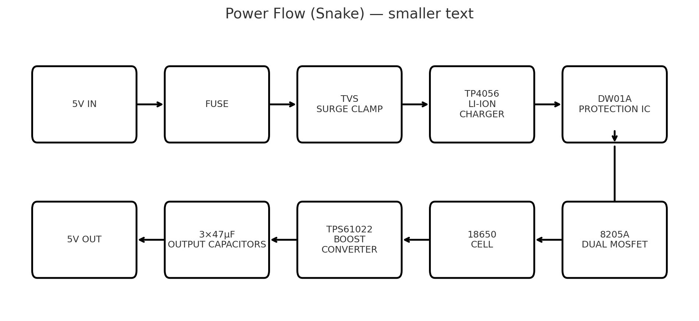
Figure 1: Electrical Power System

5.1. Primary Input Power

5.1.1 Electrical
The primary input power of the system will be two 18650 Li-ion cells in parallel, 3.7 V nominal each, for a 7 Ah total capacity. The battery voltage will be stepped up to 5V using a boost converter with a maximum continuous current of 2-3 A.

5.1.2 Connector
4-pin locking connector with two positive terminals and two negative terminals for the Raspberry Pi 3 and TI AWR6843.
Pinout (example): 1 = BAT+, 2 = BAT+, 3 = GND, 4 = GND.

5.1.3 Wiring
18–20 AWG wiring between the power board and the Raspberry Pi 3/ TI AWR6843. (Target ≤2% drop on the 5 V rail.)

5.2. Charging Interface

5.2.1 Input
The battery system will be charged using a 5V, 1A wall adapter barrel jack. Charging at a low current will keep the batteries from overheating and ensure safety.

5.2.2 Connectors
The battery system will receive its power through a 5V barrel jack connected to a wall adapter.

5.3. Grounding and ESD

5.3.1 Ground
Single ground plane located on the power PCB.

5.3.2 ESD
TVS diodes on the barrel jack and on external connectors.

5.4. User Control Interface
The RADIAN system will come with a custom-designed phone application where the caregiver will be able to receive push notifications that a fall has been detected. The app may include a simple battery monitoring system to alert the user when the batteries need to be recharged.

6. Communications / Device Interface Protocols

6.1. Wi-Fi Communication
The Raspberry Pi 3 will use the IEEE 802.11b/g/n Wi-Fi standards through its onboard communication chip. These standards apply to Wi-Fi 1, Wi-Fi 3, and Wi-Fi 4, each offering new advancements in performance.

6.2. Cellular Data
The Gotify server will communicate with the phone application by 5G cellular data, given by the 3GPP standards for 5G wireless communication.

6.3. Internet Protocols
The Raspberry Pi 3 will post the alert message through the standard HTTP REST API protocol, allowing the message to be communicated from the Raspberry Pi 3 to the Gotify server.

6.4. UART Serial Interface
A UART serial interface will connect the Raspberry Pi 3 to the TI AWR6843ISK. Data shall be exchanged using packets containing radar object data. The Raspberry Pi shall use these packets and convert the radar output into the AI algorithm, which is then sent to the Gotify server.

7. Mobile Application Interface

7.1 Communication Flow
The Raspberry Pi 3 shall send event data to the Gotify server using an HTTP POST request. The Gotify server will then relay the data to the mobile app via WebSocket connection to receive messages in real time.

7.2 User Interface
The app shall display incoming alerts and system messages, battery life, and previous alerts, if any, in a custom-designed user interface.

7.3 Platform Compatibility
The app will be developed using Flutter for the user interface and Dart for the programming language. This gives the ability for the app to be run on Android devices.

7.4 Notification Delivery
The app shall generate a push notification when it has received an alert message from the Gotify server. The notifications will be displayed using the notification system of the Android device, to ensure the notifications are visible when the app is not open.

7.5 Performance Requirements
The alerts shall be delivered to the app within 5 seconds of the Raspberry Pi sending the alert to the Gotify server, under normal network conditions.

