DMSP Partial Solution for Exercise Sheet 8
Merlin Brandt

1 a)
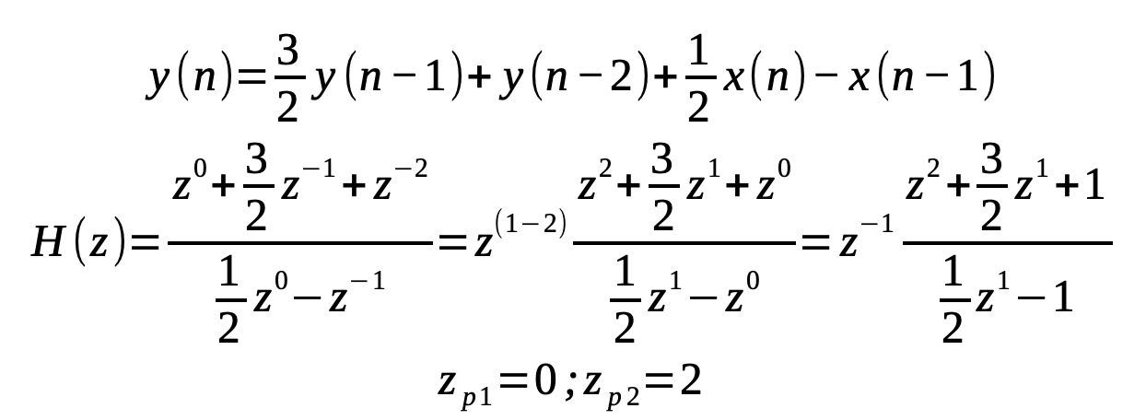

Since y(n) is a causal signal, the ROC of H(z) is the exterior of a circle. Since H(z) has a pole at z_{p1} = 0 and z_{p2} = 2, its ROC is outside the range |z| < 2. Thus it does not contain the unit circle |z|=1. Thus the system is not BIBO-stable.

2a)
y(n)=x(n+1)+2x(n)+x(n−1)
Impulse response h(n):
h(m) = 0 for all m < -1
h(-1) = 1
h(0) = 2
h(1) = 1
h(m) = 0 for all m > 1

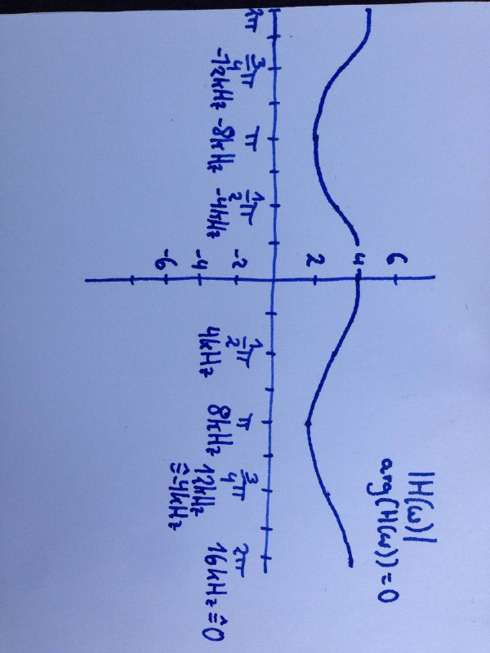

H(ω) = 1e^{-jω(-1)} + 2e^{-jω(0)} + 1e^{-jω(1)} = e^{jω} + 2 + e^{-jω} = 2 + 2cos(ω)

2b)
y(n) = x(n−1) + 2x(n−2) + x(n−3)
Impulse response h(n):
h(m) = 0 for m < 1
h(1) = 1
h(2) = 2
h(3) = 1
h(m) = 0 for m > 3

H(ω) = 1e^{-jω(1)}+2e^{-jω(2)}+1e^{-jω(3)} = e^{-jω}+2e^{-2jω}+e^{-3jω} = cos(ω)+jsin(ω)+2cos(2ω)+j2sin(2ω)+cos(3ω)+jsin(3ω)
= cos(ω)+2cos(2ω)+cos(3ω)+jsin(ω)+j2sin(2ω)+jsin(3ω)

3)
y(n) = x(n-N)
a)
H(z) = z^{-N}

