Supplementary Information
  - Recreation (Recreation from Home and Recreation from Lodging)
Matt Braaksma
Spencer Wood
Lifeng Ren
Ryan McWay
Table of contents

1. Ecosystem Service Description
Recreation ecosystem services encompass the benefits people derive from engaging with natural environments for leisure, exercise, and tourism activities. We distinguish between two types of nature-based recreation: Recreation from Home represents visits to natural areas by local residents traveling from their homes, while Recreation from Lodging captures visits by tourists staying at accommodation facilities. Both forms of recreation depend critically on the quality and accessibility of natural ecosystems, generating substantial economic and social value through improved physical and mental health, cultural connections to nature, and tourism-related economic activity.
The valuation approach recognizes that high-quality natural environments, including forests, grasslands, protected areas, and water bodies, in combination with appropriate accessibility infrastructure create opportunities for meaningful human-nature interactions. These recreation opportunities generate measurable economic value through the time and travel costs people willingly incur to visit natural areas, reflecting their preferences for ecosystem-based recreation experiences.
Within the SEEA EA framework, this service corresponds to the final non-material recreation-related ecosystem services. It captures the direct contributions of ecosystems that enable individuals to experience, enjoy, and benefit from their natural surroundings. These benefits are realized through activities such as walking, wildlife observation, and nature-based tourism, in which ecosystems provide the setting and biophysical qualities essential for the experience itself. As a final ecosystem service, recreation represents the end point of ecosystem contributions before human use or enjoyment, linking ecological conditions directly to cultural, social, and economic well-being. > “Recreation-related services are contributions of ecosystems, in particular through their biophysical characteristics and qualities, that enable people to use and enjoy the environment through direct, in situ, physical and experiential interactions with the environment. These include services both to locals and to non-locals (i.e. visitors, including tourists). Recreation-related services may also be supplied to those engaging in recreational fishing or hunting. These are final ecosystem services.” (United Nations and others 2021)

2. Methods

2.1 Overview
The recreation valuation framework consists of three main steps, shown in Figure 1. First, we map high-quality recreation areas using geospatial suitability analysis that combines environmental attractiveness with accessibility factors. Second, we apply a zonal travel cost method to estimate visit frequencies to these areas from both residents (recreation from home) and visitors (recreation from lodging). Finally, we calculate economic values using distance-based travel costs as a proxy for willingness to pay. The approach is builds on the European Commission’s Integrated Natural Capital Accounting (INCA) framework (Zulian et al. 2024).
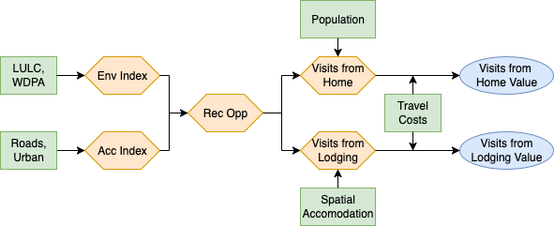
Figure 1: Workflow Overview

2.2 Estimating Recreation Opportunity
The identification of recreation opportunities requires filtering observations to focus on areas that combine high natural quality with appropriate accessibility for recreational activities.

2.2.1 Environmental Index
We quantify the intrinsic recreational attractiveness of different landscapes by assigning scores to land use/land cover (LULC) types based on their natural recreation appeal (ESA-CCI) (ESA 2017). The environmental index combines weighted LULC shares with protected area status to create a composite measure of ecosystem-based recreation potential. Scores are adapted from the European CORINE Land Cover Data to fit the ESA-CCI Land Cover data (Vallecillo et al. 2019).
Table 1: Environmental Index Scores
LULC Class | Score
Cropland | 0.4
Forest | 1.0
Grassland | 0.7
Other Natural | 0.85
Water | 1.0
Urban | 0.05
Other | 0.0
Protected Areas | 1.0

The environmental index is calculated as:
$$\text{Environmental Score}=∑\left(\text{LULC share}×\text{LULC score}\right)+\left(\text{Protected Area share}×1.0\right)$$
Areas are then classified into four environmental quality categories (0-3) based on combined scores, where higher values indicate greater natural recreation potential.

2.2.2 Accessibility Index
We measure accessibility to recreational opportunities by combining road network density (GRIP4) (Meijer et al. 2018) and urban development levels (urban share ESA-CCI LULC) (ESA 2017). This index captures how built infrastructure enables recreation access, recognizing that both roads and urban services are essential for facilitating nature-based recreation.
Table 2: Accessibility Index Thresholds
Category | Share of Urban | Road Density (m/km²)
High | (0.9, 1) | (100000, ∞)
Medium-High | (0.5, 0.9] | (33819, 100000]
Medium | (0.1, 0.5] | (13326, 33819]
Medium-Low | (0.001, 0.1] | (5453, 13326]
Low | [0, 0.001) | [0, 5453)

Table 3: Urban-Road Accessibility Matrix (columns represent Road Score)
Urban Score | Low | Medium-Low | Medium | Medium-High | High
Low | 1 | 1 | 2 | 3 | 4
Medium-Low | 1 | 1 | 2 | 3 | 4
Medium | 2 | 2 | 2 | 4 | 5
Medium-High | 3 | 3 | 4 | 5 | 5
High | 3 | 4 | 5 | 5 | 5

2.2.3 High-Quality Area Identification
We combine environmental and accessibility indices using a matrix approach to create a comprehensive ranking of recreation areas. This classification system balances natural attractiveness with accessibility needs to identify areas with different recreation potential.
Table 4: Recreation Area Ranking (columns represent Accessibility Score)
Environmental Score | Low | Medium-Low | Medium-High | High
Low | 1 | 1 | 4 | 7
Medium-Low | 1 | 4 | 4 | 7
Medium | 2 | 2 | 8 | 8
Medium-High | 3 | 5 | 5 | 9
High | 3 | 6 | 6 | 9

Areas scoring 9 in the ranking are identified as high-quality recreation sites, representing locations that combine high natural value with appropriate accessibility for recreation activities.

2.3 Recreation from Home Analysis

2.3.1 Visit Estimation (Zonal Travel Cost Model)
Recreation from home visits are estimated using a zonal travel cost approach where visit frequency decreases with travel distance to high-quality recreation areas. The model uses gridded population data (Worldpop) (WorldPop 2020) and applies distance-decay functions calibrated from the UK’s Monitor of Engagement with the Natural Environment (MENE) study and used in the INCA method (Natural England 2016).
$$N=\sum_{i=1}^{4}{\frac{\left(1+k_{i}\right)}{\left(k_{i}+e^{−α_{i}×{\text{Pop}}_{i}}\right)}}$$
where $N$ represents the number of weekly visits flowing into a high-quality recreation site, measured in 1km grid cells. To get annual estimates, the result is multiplied by 52.
Table 5: Mobility Function Parameters
Distance Band | $k_{i}$ | $α_{i}$
Distance 1 (<1 km) | 0.0132 | 0.00155
Distance 2 (1–2 km) | 0.0267 | 0.00115
Distance 3 (2–3 km) | 0.0518 | 0.00098
Distance 4 (3–4 km) | 0.1067 | 0.00067

2.3.2 Economic Valuation
The economic value of recreation from home is estimated using the travel cost method, where the cost of traveling to recreation sites serves as a proxy for willingness to pay. Values are calculated as:
$$\text{Annual Value}=\text{Annual Visits}×c_{i}×\text{Travel Cost per Visit}$$
The travel cost $c_{i}$ is based on average fuel costs per kilometer, assumed to be equal within a country (GlobalPetrolPrices.com 2025; International Energy Agency (IEA) 2020, 2021). This assumes that the mode of transportation comes through ground transportation using motor vehicles. We estimate the value of these visits based on the travel cost incurred by visits to high-quality recreation areas.

2.4 Recreation from Lodging Analysis

2.4.1 Visitor Location Modeling
Recreation from lodging demand is modeled by spatially allocating national overnight stay statistics using accommodation infrastructure as a proxy for visitor distribution. We combine:
- National Tourism Data: UNWTO annual overnight stay statistics (domestic and international) (UNWTO 2023)
- Accommodation Infrastructure: Delta Check georeferenced hotel and accommodation points (Delta Check 2023)
This generates country-level overnight stays distributed proportionally to hotel density.

2.4.2 Visits Estimation (Zonal Travel Cost)
Recreation from lodging visits to high-quality recreation sites are estimated using the same zonal travel cost framework as recreation from home, but with overnight stay data as the population proxy instead of residential population. This approach assumes that visitors at lodging facilities visit recreation sites based on their accommodation location, with visit probability decreasing with distance.

2.4.3 Economic Valuation
We estimate the economic value using the same zonal travel cost framework as recreation from home, but with overnight stay data as the population proxy instead of residential population. These estimates capture only the value represented by local travel costs and do not capture international travel or other expenditures that may be related to nature-based tourism.

2.5 Variables and Datasets
Table 6: Key Variables and Datasets
Variable | Dataset | Source | Resolution
Land Cover | ESA-CCI Land Cover | (ESA 2017) | 300m
Protected Areas | World Database on Protected Areas (WDPA) | (UNEP-WCMC and IUCN 2024) | Vector
Road Network Density | GRIP4 Global Roads Dataset | (Meijer et al. 2018) | Vector
Population | WorldPop Constrained Population | (WorldPop 2020) | 1km
Tourism Statistics | Annual Overnight Stays | (UNWTO 2023) | Country-level
Accommodation Points | Delta Check Hotel Database | (Delta Check 2023) | Point locations
Fuel Costs | Country Fuel Price Data | (GlobalPetrolPrices.com 2025; International Energy Agency (IEA) 2020, 2021) | Country-level

3. Validation
[Validation in progress]

4. Areas for Improvement

4.1 Estimating Recreation Opportunity
The categories used for identifying areas for recreation potential, including the environmental inde and accessibility index, need additional validation from the literature.

4.2 Zonal Travel Cost Model
The zonal travel cost method relies heavily on the values for $k_{i}$ and $α_{i}$, sourced from he UK’s Monitor of Engagement with the Natural Environment (MENE) (Natural England 2016). The assumption implies that recreation preferences are consistent across the globe, for both residents and visitors, which is unlikely. The recreation team is researching ways to improve this measure. Specifically, the approach may be to rely on one of the scaling laws of human mobility to handle global values for $k_{i}$ and $α_{i}$ (Hooftman et al. 2023).

5. Results

5.1 Spatial Distribution of Recreation Values
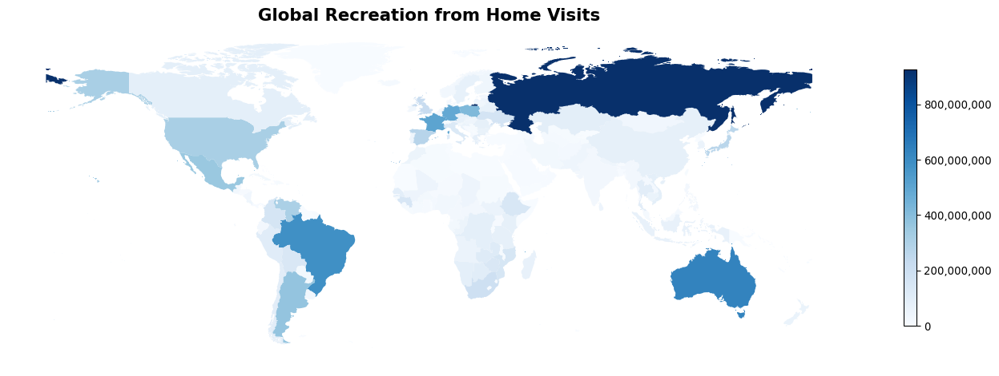
Figure 2: Global Recreation from Home Visits
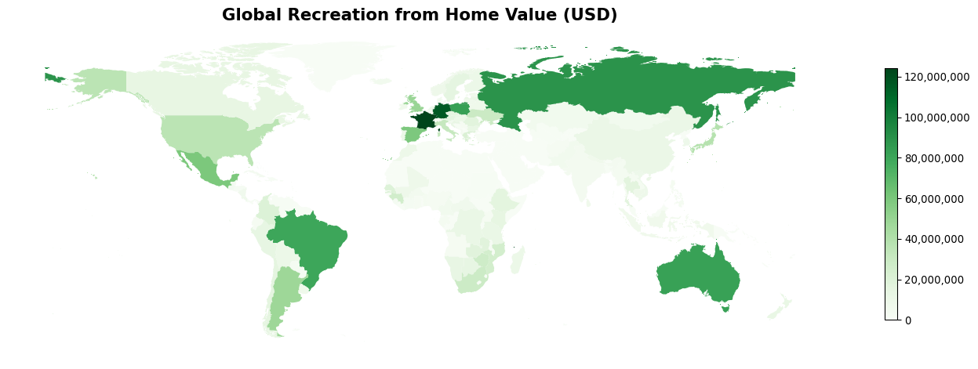
Figure 3: Global Recreation from Home Value (USD)
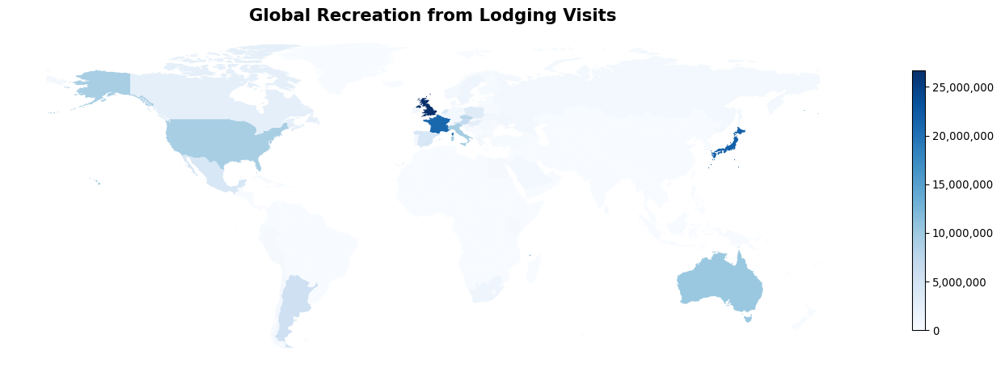
Figure 4: Global Recreation from Lodging Visits
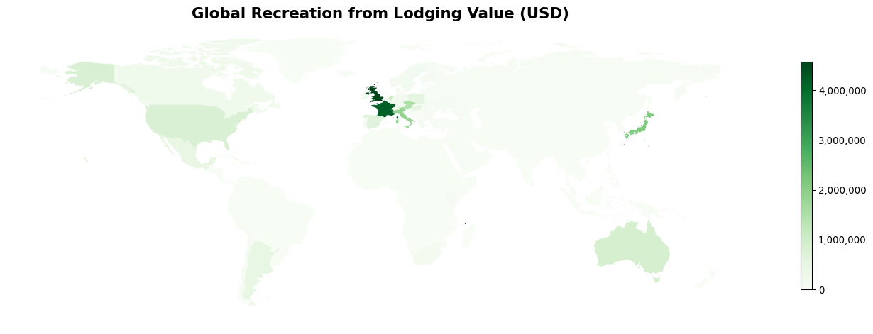
Figure 5: Global Recreation from Lodging Value (USD)
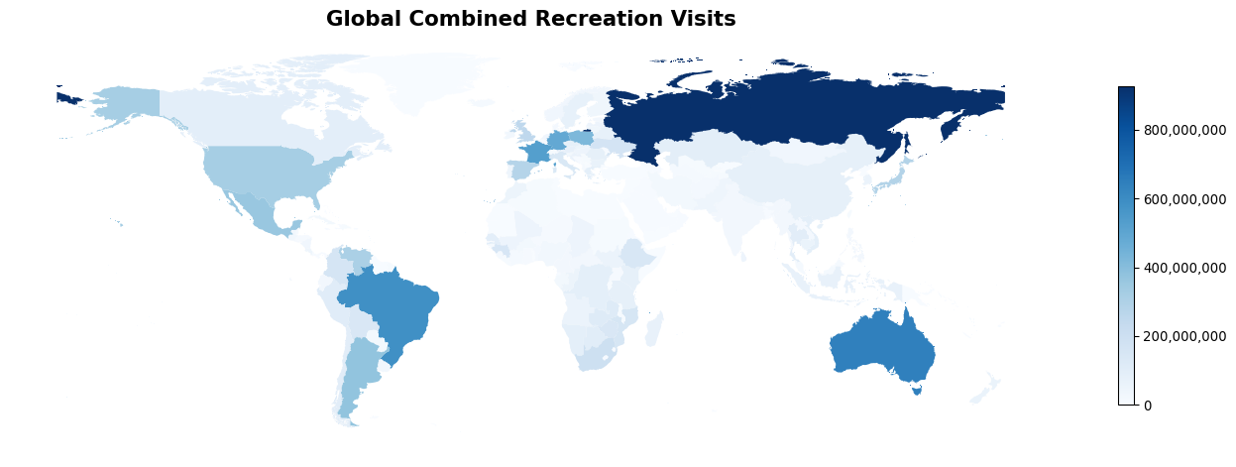
Figure 6: Global Combined Recreation Visits
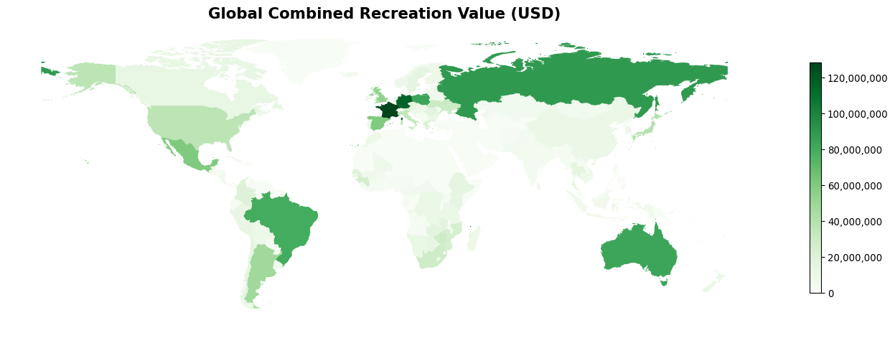
Figure 7: Global Combined Recreation Value (USD)

5.2 Results by Country
Table 7: Country-Level Recreation Results (Sorted by Total Value)
Country | Recreation from Home Visits | Recreation from Home Value (USD) | Recreation from Lodging Visits | Recreation from Lodging Value (USD) | Total Visits | Total Value (USD)
FRA | 506,145,312 | 124,359,776 | 21,080,928 | 4,173,084 | 527,226,240 | 128,532,856
DEU | 487,618,848 | 115,864,992 | 630,962 | 153,426 | 488,249,824 | 116,018,416
RUS | 926,554,432 | 88,933,800 | 650,879 | 45,198 | 927,205,312 | 88,979,000
POL | 418,170,496 | 82,588,392 | 3,321,556 | 538,666 | 421,492,064 | 83,127,056
AUS | 633,280,640 | 82,163,200 | 10,290,885 | 892,700 | 643,571,520 | 83,055,904
BRA | 584,660,736 | 79,668,032 | 0 | 0 | 584,660,736 | 79,668,032
MEX | 355,437,888 | 59,476,352 | 4,178,870 | 484,839 | 359,616,768 | 59,961,192
ESP | 278,016,640 | 58,929,348 | 4,230,787 | 649,391 | 282,247,424 | 59,578,740
GBR | 224,096,688 | 49,288,656 | 26,727,496 | 4,573,247 | 250,824,192 | 53,861,904
ARG | 370,669,760 | 48,070,760 | 5,628,310 | 479,061 | 376,298,080 | 48,549,820
JPN | 267,418,368 | 38,176,212 | 21,813,622 | 2,140,189 | 289,232,000 | 40,316,400
USA | 315,819,968 | 36,311,428 | 9,224,978 | 786,449 | 325,044,960 | 37,097,876
ITA | 131,200,096 | 32,018,776 | 9,469,544 | 1,845,971 | 140,669,632 | 33,864,748
UKR | 164,982,720 | 29,590,640 | 776,608 | 91,909 | 165,759,328 | 29,682,550
ZAF | 194,714,560 | 28,602,184 | 1,276,706 | 131,043 | 195,991,264 | 28,733,226
ZWE | 143,058,464 | 27,655,272 | 39,565 | 6,827 | 143,098,032 | 27,662,098
GIN | 149,734,224 | 25,766,756 | 0 | 0 | 149,734,224 | 25,766,756
MOZ | 153,821,792 | 25,038,702 | 14,556 | 2,045 | 153,836,352 | 25,040,746
GRC | 86,572,648 | 21,490,662 | 779,019 | 130,565 | 87,351,664 | 21,621,228
COL | 162,050,848 | 19,972,992 | 0 | 0 | 162,050,848 | 19,972,992
SEN | 90,953,504 | 19,713,424 | 0 | 0 | 90,953,504 | 19,713,424
ZMB | 116,227,192 | 17,660,758 | 16,563 | 2,780 | 116,243,752 | 17,663,538
ROU | 82,851,456 | 17,096,128 | 382,741 | 50,672 | 83,234,200 | 17,146,800
AUT | 70,288,632 | 15,514,582 | 7,029,146 | 1,531,787 | 77,317,776 | 17,046,368
THA | 100,773,056 | 16,561,874 | 1,618 | 267 | 100,774,672 | 16,562,141
CZE | 72,684,496 | 14,835,500 | 7,786,349 | 1,561,382 | 80,470,848 | 16,396,882
ETH | 147,562,736 | 16,170,649 | 0 | 0 | 147,562,736 | 16,170,649
CHL | 98,615,312 | 15,917,402 | 582,886 | 68,198 | 99,198,200 | 15,985,600
SWE | 74,882,872 | 15,234,898 | 1,158,575 | 191,933 | 76,041,448 | 15,426,831
KEN | 80,532,688 | 14,217,938 | 388,729 | 59,047 | 80,921,416 | 14,276,985
BWA | 103,253,352 | 14,064,691 | 37,677 | 3,613 | 103,291,032 | 14,068,304
PER | 105,330,880 | 13,804,210 | 331,135 | 31,413 | 105,662,016 | 13,835,623
CAN | 89,355,344 | 13,259,671 | 2,538,434 | 263,547 | 91,893,776 | 13,523,218
HRV | 61,064,604 | 12,906,472 | 770,608 | 126,779 | 61,835,212 | 13,033,251
NAM | 89,946,448 | 12,698,436 | 0 | 0 | 89,946,448 | 12,698,436
NZL | 60,283,800 | 11,940,364 | 0 | 0 | 60,283,800 | 11,940,364
BGR | 66,713,488 | 11,859,653 | 222,564 | 33,789 | 66,936,052 | 11,893,442
SVK | 52,879,760 | 11,482,258 | 430,003 | 90,350 | 53,309,764 | 11,572,608
TZA | 82,032,608 | 11,465,384 | 1,306 | 290 | 82,033,912 | 11,465,674
COD | 89,428,192 | 11,248,352 | 0 | 0 | 89,428,192 | 11,248,352
LVA | 49,152,800 | 10,804,054 | 223,153 | 48,658 | 49,375,952 | 10,852,712
CHN | 81,603,072 | 10,744,572 | 0 | 0 | 81,603,072 | 10,744,572
PRT | 41,812,792 | 10,146,912 | 532,976 | 99,195 | 42,345,768 | 10,246,107
MDG | 70,599,680 | 10,095,184 | 0 | 0 | 70,599,680 | 10,095,184
HUN | 45,142,472 | 9,502,445 | 2,632,903 | 547,848 | 47,775,376 | 10,050,293
BOL | 141,587,104 | 9,584,270 | 24,392 | 1,369 | 141,611,488 | 9,585,639
NLD | 31,308,912 | 8,393,136 | 4,011,244 | 1,083,558 | 35,320,156 | 9,476,694
FIN | 37,648,216 | 9,276,012 | 295,009 | 59,130 | 37,943,224 | 9,335,142
MAR | 52,563,828 | 9,147,454 | 59,089 | 7,158 | 52,622,916 | 9,154,612
KOR | 57,227,916 | 8,553,709 | 0 | 0 | 57,227,916 | 8,553,709
VNM | 89,535,464 | 8,550,237 | 0 | 0 | 89,535,464 | 8,550,237
KHM | 58,506,116 | 8,192,646 | 0 | 0 | 58,506,116 | 8,192,646
NOR | 32,376,864 | 8,009,124 | 674,071 | 134,402 | 33,050,934 | 8,143,527
MLI | 47,393,464 | 8,020,748 | 7,496 | 1,262 | 47,400,960 | 8,022,010
URY | 31,436,396 | 7,611,922 | 79,829 | 10,905 | 31,516,224 | 7,622,826
IRL | 29,874,186 | 7,337,087 | 831,483 | 162,582 | 30,705,670 | 7,499,669
BLR | 73,900,448 | 7,479,724 | 146,263 | 14,340 | 74,046,712 | 7,494,064
LTU | 36,682,696 | 7,273,584 | 130,027 | 24,336 | 36,812,724 | 7,297,920
CRI | 45,399,464 | 7,181,222 | 0 | 0 | 45,399,464 | 7,181,222
LKA | 47,594,344 | 6,698,328 | 405,329 | 58,826 | 47,999,672 | 6,757,154
NPL | 46,163,688 | 6,731,211 | 0 | 0 | 46,163,688 | 6,731,211
IDN | 71,408,944 | 6,715,968 | 0 | 0 | 71,408,944 | 6,715,968
EST | 28,399,588 | 6,450,870 | 11,867 | 2,829 | 28,411,456 | 6,453,698
CAF | 26,520,030 | 6,116,116 | 0 | 0 | 26,520,030 | 6,116,116
NIC | 35,398,768 | 5,832,313 | 658 | 121 | 35,399,428 | 5,832,434
MNG | 34,774,252 | 5,749,883 | 0 | 0 | 34,774,252 | 5,749,883
KAZ | 96,359,448 | 5,487,635 | 85,287 | 2,900 | 96,444,736 | 5,490,536
DNK | 18,319,704 | 4,950,212 | 933,561 | 204,466 | 19,253,264 | 5,154,678
PAK | 43,321,816 | 5,027,417 | 0 | 0 | 43,321,816 | 5,027,417
ISL | 16,290,912 | 4,954,966 | 74,419 | 21,819 | 16,365,331 | 4,976,785
CMR | 27,950,654 | 4,955,877 | 18,611 | 2,652 | 27,969,266 | 4,958,529
SVN | 23,495,158 | 4,890,531 | 175,322 | 32,543 | 23,670,480 | 4,923,074
BFA | 25,127,604 | 4,676,254 | 0 | 0 | 25,127,604 | 4,676,254
GTM | 32,198,004 | 4,320,936 | 1,117 | 284 | 32,199,120 | 4,321,220
BEL | 16,671,706 | 3,706,347 | 675,599 | 159,060 | 17,347,304 | 3,865,408
CUB | 24,270,950 | 3,824,222 | 336,633 | 32,316 | 24,607,584 | 3,856,538
IND | 26,551,256 | 3,788,192 | 0 | 0 | 26,551,256 | 3,788,192
ALB | 15,019,954 | 3,745,053 | 79,706 | 19,606 | 15,099,660 | 3,764,659
MMR | 27,729,952 | 3,251,377 | 87,899 | 4,887 | 27,817,850 | 3,256,264
BEN | 20,614,702 | 3,150,874 | 0 | 0 | 20,614,702 | 3,150,874
PHL | 27,487,954 | 3,055,650 | 0 | 0 | 27,487,954 | 3,055,650
GAB | 22,989,476 | 2,964,319 | 0 | 0 | 22,989,476 | 2,964,319
LAO | 18,589,374 | 2,952,441 | 0 | 0 | 18,589,374 | 2,952,441
CIV | 15,247,760 | 2,793,012 | 6,626 | 1,445 | 15,254,386 | 2,794,457
BLZ | 12,357,276 | 2,632,523 | 33,897 | 5,436 | 12,391,173 | 2,637,958
PRY | 23,377,742 | 2,616,056 | 0 | 0 | 23,377,742 | 2,616,056
SLE | 14,674,640 | 2,455,217 | 6,033 | 1,085 | 14,680,673 | 2,456,302
AGO | 57,147,772 | 2,402,468 | 0 | 0 | 57,147,772 | 2,402,468
UGA | 13,147,968 | 2,269,211 | 98 | 25 | 13,148,066 | 2,269,236
ECU | 25,750,606 | 2,200,054 | 263,128 | 13,644 | 26,013,734 | 2,213,698
GHA | 11,771,546 | 2,182,412 | 0 | 0 | 11,771,546 | 2,182,412
CHE | 7,906,972 | 2,035,873 | 419,075 | 108,094 | 8,326,047 | 2,143,966
SRB | 9,614,024 | 2,106,444 | 23,966 | 4,957 | 9,637,990 | 2,111,400
NGA | 29,460,604 | 2,058,297 | 0 | 0 | 29,460,604 | 2,058,297
AFG | 18,131,372 | 1,957,898 | 0 | 0 | 18,131,372 | 1,957,898
MWI | 10,340,136 | 1,857,846 | 0 | 0 | 10,340,136 | 1,857,846
HKG | 5,092,772 | 1,803,184 | 0 | 0 | 5,092,772 | 1,803,184
HND | 14,453,736 | 1,802,123 | 0 | 0 | 14,453,736 | 1,802,123
CYP | 7,615,724 | 1,482,856 | 198,688 | 38,291 | 7,814,412 | 1,521,147
SLV | 12,067,246 | 1,469,069 | 102,712 | 11,139 | 12,169,958 | 1,480,208
VEN | 308,066,496 | 1,406,410 | 0 | 0 | 308,066,496 | 1,406,410
LUX | 5,442,485 | 1,169,299 | 263,155 | 56,080 | 5,705,640 | 1,225,379
LBR | 10,652,337 | 1,210,270 | 0 | 0 | 10,652,337 | 1,210,270
UZB | 9,486,315 | 1,179,326 | 16,220 | 1,491 | 9,502,535 | 1,180,817
GEO | 8,209,526 | 1,167,612 | 804 | 78 | 8,210,331 | 1,167,690
DOM | 7,444,698 | 1,131,503 | 122,111 | 12,476 | 7,566,810 | 1,143,979
TWN | 8,521,040 | 1,003,263 | 1,073 | 181 | 8,522,113 | 1,003,444
JAM | 6,411,988 | 935,644 | 305,986 | 36,132 | 6,717,974 | 971,776
ARM | 5,714,579 | 921,496 | 118,332 | 11,951 | 5,832,910 | 933,447
MYS | 14,629,116 | 882,555 | 0 | 0 | 14,629,116 | 882,555
MKD | 4,727,482 | 826,854 | 171,886 | 27,993 | 4,899,368 | 854,847
HTI | 6,261,848 | 852,384 | 0 | 0 | 6,261,848 | 852,384
MDA | 4,773,579 | 816,242 | 7,395 | 1,256 | 4,780,974 | 817,498
TKM | 15,492,988 | 810,108 | 0 | 0 | 15,492,988 | 810,108
LSO | 5,659,970 | 786,237 | 0 | 0 | 5,659,970 | 786,237
SDN | 8,180,971 | 716,241 | 0 | 0 | 8,180,971 | 716,241
BIH | 3,865,144 | 680,954 | 26,220 | 4,283 | 3,891,365 | 685,237
BGD | 5,151,655 | 608,082 | 0 | 0 | 5,151,655 | 608,082
SWZ | 4,080,213 | 582,362 | 0 | 0 | 4,080,213 | 582,362
MNE | 2,779,503 | 573,317 | 4,903 | 1,112 | 2,784,406 | 574,429
PAN | 4,560,148 | 516,578 | 5,010 | 588 | 4,565,158 | 517,167
AZE | 6,286,700 | 511,014 | 21,694 | 1,393 | 6,308,394 | 512,406
BDI | 2,921,920 | 484,387 | 0 | 0 | 2,921,920 | 484,387
TGO | 3,219,168 | 477,671 | 0 | 0 | 3,219,168 | 477,671
IRQ | 5,316,012 | 417,720 | 0 | 0 | 5,316,012 | 417,720
SAU | 4,722,176 | 357,752 | 566,558 | 30,168 | 5,288,734 | 387,920
BTN | 4,106,346 | 386,845 | 12,045 | 775 | 4,118,391 | 387,620
TUR | 2,095,906 | 329,198 | 231,580 | 21,821 | 2,327,486 | 351,019
KGZ | 3,078,563 | 334,305 | 27,469 | 2,474 | 3,106,032 | 336,779
DZA | 7,415,952 | 324,552 | 8,514 | 381 | 7,424,467 | 324,933
OMN | 4,041,108 | 309,298 | 80,820 | 3,476 | 4,121,927 | 312,775
ISR | 1,287,668 | 294,497 | 16,405 | 3,963 | 1,304,073 | 298,460
RWA | 1,538,555 | 244,969 | 0 | 0 | 1,538,555 | 244,969
SGP | 1,063,038 | 240,146 | 0 | 0 | 1,063,038 | 240,146
SUR | 1,674,729 | 235,436 | 0 | 0 | 1,674,729 | 235,436
TUN | 2,018,970 | 205,041 | 23,488 | 2,288 | 2,042,459 | 207,329
GUY | 1,900,476 | 193,379 | 0 | 0 | 1,900,476 | 193,379
TTO | 1,152,110 | 160,052 | 0 | 0 | 1,152,110 | 160,052
PRI | 1,382,258 | 154,041 | 0 | 0 | 1,382,258 | 154,041
SSD | 57,305,592 | 136,397 | 0 | 0 | 57,305,592 | 136,397
EGY | 2,575,312 | 122,590 | 373,109 | 9,667 | 2,948,422 | 132,257
LCA | 708,658 | 111,688 | 0 | 0 | 708,658 | 111,688
BHS | 579,555 | 100,910 | 5,840 | 968 | 585,395 | 101,877
LBN | 1,119,194 | 99,103 | 0 | 0 | 1,119,194 | 99,103
COG | 51,733,976 | 98,946 | 0 | 0 | 51,733,976 | 98,946
IRN | 24,038,190 | 90,586 | 0 | 0 | 24,038,190 | 90,586
MLT | 367,645 | 63,808 | 79,048 | 14,946 | 446,692 | 78,754
FJI | 444,444 | 62,254 | 12,504 | 1,403 | 456,948 | 63,657
MUS | 360,857 | 59,536 | 11,499 | 1,942 | 372,355 | 61,478
NER | 13,415,535 | 61,040 | 1,179 | 0 | 13,416,714 | 61,040
GLP | 3,376,628 | 51,173 | 34,121 | 7,387 | 3,410,749 | 58,561
DMA | 339,245 | 55,618 | 0 | 0 | 339,245 | 55,618
GNB | 14,789,684 | 51,243 | 0 | 0 | 14,789,684 | 51,243
TJK | 9,020,142 | 47,735 | 0 | 0 | 9,020,142 | 47,735
GRD | 299,352 | 42,353 | 0 | 0 | 299,352 | 42,353
TCD | 50,287,548 | 34,940 | 0 | 0 | 50,287,548 | 34,940
PSE | 595,718 | 32,499 | 2,253 | 595 | 597,971 | 33,094
GUF | 9,895,709 | 32,806 | 4,820 | 0 | 9,900,529 | 32,806
XKX | 616,465 | 26,259 | 0 | 0 | 616,465 | 26,259
MYT | 120,788 | 25,537 | 1,056 | 264 | 121,844 | 25,800
CUW | 144,085 | 18,890 | 0 | 0 | 144,085 | 18,890
GNQ | 4,794,185 | 18,545 | 0 | 0 | 4,794,185 | 18,545
AND | 84,327 | 16,505 | 11,063 | 1,966 | 95,390 | 18,470
ABW | 92,749 | 14,305 | 13,085 | 2,350 | 105,834 | 16,655
CYM | 100,416 | 16,155 | 0 | 0 | 100,416 | 16,155
ARE | 173,121 | 14,406 | 7,080 | 480 | 180,201 | 14,887
JOR | 72,628 | 13,689 | 616 | 184 | 73,244 | 13,874
PRK | 167,327 | 12,645 | 0 | 0 | 167,327 | 12,645
GMB | 1,580,992 | 8,912 | 0 | 0 | 1,580,992 | 8,912
MCO | 53,152 | 6,877 | 10,502 | 1,640 | 63,654 | 8,517
SYC | 45,167 | 6,655 | 10,608 | 1,780 | 55,775 | 8,435
LIE | 26,302 | 6,566 | 1,375 | 285 | 27,677 | 6,851
CPV | 38,215 | 6,330 | 513 | 43 | 38,729 | 6,372
QAT | 88,370 | 5,963 | 330 | 14 | 88,700 | 5,977
MRT | 123,223 | 5,712 | 0 | 0 | 123,223 | 5,712
TLS | 3,204,590 | 5,249 | 0 | 0 | 3,204,590 | 5,249
GIB | 60,367 | 5,224 | 0 | 0 | 60,367 | 5,224
BRB | 23,206 | 4,756 | 0 | 0 | 23,206 | 4,756
ERI | 4,105,648 | 3,187 | 0 | 0 | 4,105,648 | 3,187
MTQ | 2,829,418 | 686 | 161,075 | 0 | 2,990,493 | 686
REU | 2,200,778 | 619 | 43,170 | 0 | 2,243,948 | 619
BES | 235,185 | 492 | 36,967 | 0 | 272,152 | 492
KWT | 10,647 | 424 | 0 | 0 | 10,647 | 424
BRN | 238,276 | 98 | 0 | 0 | 238,276 | 98
YEM | 521,349 | 0 | 0 | 0 | 521,349 | 0
VGB | 43,899 | 0 | 0 | 0 | 43,899 | 0
UMI | 0 | 0 | 0 | 0 | 0 | 0
GGY | 10,480 | 0 | 0 | 0 | 10,480 | 0
SXM | 3,907 | 0 | 0 | 0 | 3,907 | 0
MAF | 95,934 | 0 | 0 | 0 | 95,934 | 0
AIA | 22,630 | 0 | 0 | 0 | 22,630 | 0
NCL | 3,494,974 | 0 | 0 | 0 | 3,494,974 | 0
ESH | 0 | 0 | 0 | 0 | 0 | 0
SGS | 0 | 0 | 0 | 0 | 0 | 0
BLM | 52,676 | 0 | 0 | 0 | 52,676 | 0
MSR | 15,669 | 0 | 0 | 0 | 15,669 | 0
CXR | 27,753 | 0 | 0 | 0 | 27,753 | 0
LBY | 0 | 0 | 0 | 0 | 0 | 0
SOM | 4,226 | 0 | 0 | 0 | 4,226 | 0
MAC | 0 | 0 | 0 | 0 | 0 | 0
DJI | 111,381 | 0 | 55 | 0 | 111,436 | 0
JEY | 135,803 | 0 | 0 | 0 | 135,803 | 0
PYF | 0 | 0 | 0 | 0 | 0 | 0
NIU | 133,704 | 0 | 0 | 0 | 133,704 | 0
KIR | 0 | 0 | 0 | 0 | 0 | 0
BVT | 0 | 0 | 0 | 0 | 0 | 0
TON | 59,534 | 0 | 0 | 0 | 59,534 | 0
CCK | 0 | 0 | 0 | 0 | 0 | 0
HMD | 0 | 0 | 0 | 0 | 0 | 0
IOT | 0 | 0 | 0 | 0 | 0 | 0
SJM | 0 | 0 | 0 | 0 | 0 | 0
NRU | 0 | 0 | 0 | 0 | 0 | 0
VUT | 61,474 | 0 | 0 | 0 | 61,474 | 0
PLW | 106,033 | 0 | 12,807 | 0 | 118,841 | 0
MNP | 0 | 0 | 0 | 0 | 0 | 0
PNG | 2,783,523 | 0 | 0 | 0 | 2,783,523 | 0
TUV | 0 | 0 | 0 | 0 | 0 | 0
FRO | 39,630 | 0 | 0 | 0 | 39,630 | 0
KNA | 321,910 | 0 | 0 | 0 | 321,910 | 0
FSM | 0 | 0 | 0 | 0 | 0 | 0
VCT | 118,550 | 0 | 0 | 0 | 118,550 | 0
STP | 963,614 | 0 | 0 | 0 | 963,614 | 0
BHR | 0 | 0 | 0 | 0 | 0 | 0
SLB | 0 | 0 | 0 | 0 | 0 | 0
GUM | 37,403 | 0 | 0 | 0 | 37,403 | 0
MHL | 0 | 0 | 0 | 0 | 0 | 0
PCN | 0 | 0 | 0 | 0 | 0 | 0
SPM | 0 | 0 | 0 | 0 | 0 | 0
VAT | 0 | 0 | 0 | 0 | 0 | 0
IMN | 257,208 | 0 | 0 | 0 | 257,208 | 0
ASM | 3,684 | 0 | 0 | 0 | 3,684 | 0
SHN | 38,448 | 0 | 0 | 0 | 38,448 | 0
COK | 75,327 | 0 | 0 | 0 | 75,327 | 0
COM | 1,532,708 | 0 | 0 | 0 | 1,532,708 | 0
NFK | 0 | 0 | 0 | 0 | 0 | 0
SMR | 0 | 0 | 0 | 0 | 0 | 0
WSM | 41,348 | 0 | 0 | 0 | 41,348 | 0
SYR | 0 | 0 | 0 | 0 | 0 | 0
TKL | 0 | 0 | 0 | 0 | 0 | 0
BMU | 0 | 0 | 0 | 0 | 0 | 0
GRL | 0 | 0 | 0 | 0 | 0 | 0
ATF | 0 | 0 | 0 | 0 | 0 | 0
ATG | 365,883 | 0 | 0 | 0 | 365,883 | 0
TCA | 179,494 | 0 | 0 | 0 | 179,494 | 0
ALA | 25,034 | 0 | 0 | 0 | 25,034 | 0
VIR | 199,161 | 0 | 18,498 | 0 | 217,659 | 0
MDV | 0 | 0 | 0 | 0 | 0 | 0
FLK | 27,769 | 0 | 0 | 0 | 27,769 | 0
WLF | 0 | 0 | 0 | 0 | 0 | 0

6. References
[References to be added]
Delta Check. 2023. “Delta Check Hotel and Accommodation Database.” Online database. https://www.deltacheck.com.
ESA. 2017. “Land Cover CCI Product User Guide Version 2.” Technical Report. European Space Agency. http://maps.elie.ucl.ac.be/CCI/viewer/download/ESACCI-LC-Ph2-PUGv2_2.0.pdf.
GlobalPetrolPrices.com. 2025. “Gasoline Prices, Octane-95.” Online database; GlobalPetrolPrices.com. https://www.globalpetrolprices.com/gasoline_prices/.
Hooftman, Danny A. P., Lucy E. Ridding, John W. Redhead, and Simon Willcock. 2023. “National Scale Mapping of Supply and Demand for Recreational Ecosystem Services.” Ecological Indicators 154: 110779. https://doi.org/https://doi.org/10.1016/j.ecolind.2023.110779.
International Energy Agency (IEA). 2020. “Global Fuel Price Changes, 2005–2019.” Online data portal; International Energy Agency. https://www.iea.org/data-and-statistics/charts/global-fuel-price-changes-2005-2019.
———. 2021. “Global Fuel Economy Initiative 2021: Executive Summary.” International Energy Agency. https://www.iea.org/reports/global-fuel-economy-initiative-2021/executive-summary.
Meijer, Johan R., Mark A. J. Huijbregts, Kees C. G. J. Schotten, and Aafke M. Schipper. 2018. “Global Patterns of Current and Future Road Infrastructure.” Environmental Research Letters 13 (6): 064006. https://doi.org/10.1088/1748-9326/aabd42.
Natural England. 2016. “Monitor of Engagement with the Natural Environment: Survey – Purpose and Results.” Natural England. https://www.gov.uk/government/collections/monitor-of-engagement-with-the-natural-environment-survey-purpose-and-results.
UNEP-WCMC, and IUCN. 2024. “Protected Planet: The World Database on Protected Areas (WDPA).” https://www.protectedplanet.net/.
United Nations and others. 2021. System of Environmental-Economic Accounting—Ecosystem Accounting (SEEA EA). New York, USA: United Nations. https://seea.un.org/ecosystem-accounting.
UNWTO. 2023. “Tourism Statistics Database.” Madrid, Spain: United Nations World Tourism Organization. https://www.unwto.org/tourism-statistics.
Vallecillo, Sara, Alessandra La Notte, Grazia Zulian, Silvia Ferrini, and Joachim Maes. 2019. “Ecosystem Services Accounts: Valuing the Actual Flow of Nature-Based Recreation from Ecosystems to People.” Ecological Modelling 392: 196–211. https://doi.org/https://doi.org/10.1016/j.ecolmodel.2018.09.023.
WorldPop. 2020. “Unconstrained Global Mosaics 2000–2020 (1 Km Resolution).” WorldPop; https://hub.worldpop.org/geodata/listing?id=64. https://hub.worldpop.org/geodata/listing?id=64.
Zulian, Grazia, Alessandra La Notte, Ioanna Grammatikopoulou, and Mayra Zurbaran Nucci. 2024. “Nature-Based Tourism Accounting.” JRC138538. EUR 32029 EN. Luxembourg: Publications Office of the European Union. https://doi.org/10.2760/762803.

