**Background**

Social networks (Facebook, Twitter, WhatsApp etc) are very common these days and people from all walks of life are using them for variety of purposes. Behind the scene, the data of any social network is modelled as a graph (see example below), where each person serves as a node (node id may be roll number of a student) and relationship between any two persons is represented as an edge.

In this assignment, your job is to apply the concepts of OOP learnt in the class to solve following problems.

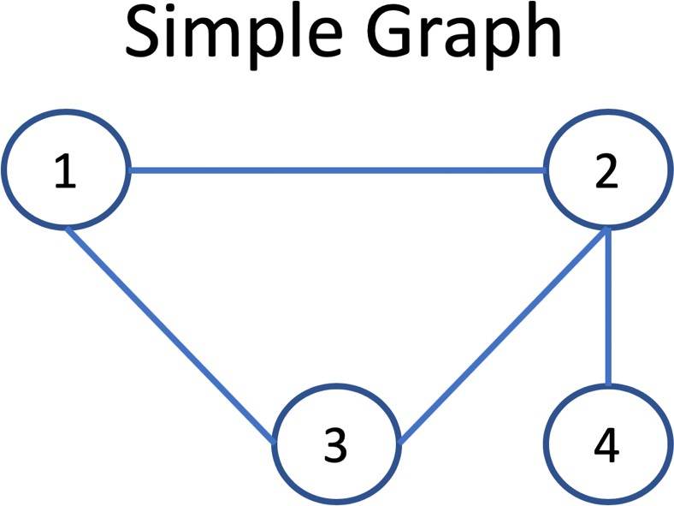

**Classes to be created**

|  |  |  |
| --- | --- | --- |
|  | **SimpleGraph.cpp** | **SimpleNode.cpp** |
| **Member Data** | “numNodes” of type int to store total  number nodes | 1. “nodeId” of type int to store id of a node object. 2. ”NeighborCount” of type int to store count neighbors of that node. 3. An Array, named “arrNeighbors”, of type “SimpleNode” to store the   neighbors of each a node. |
| “numEdges” of type int to store total  number of edges |
| “allnodes” An array of type “SimpleNode” to store all the created nodes |
| **Member Functions** | **Overloaded Constructor** to initialize the member data. A message should be printed for this action. | **Constructor** to initialize the member data. A message should be printed for this action.  **Overloaded Constructor:** to initialize the private members |
| **Destructor** to drop the graph object. A  message should be printed for this action. | **Destructor** to drop the node object. A  message should be printed for this action. |
| **Name**: addNode() **Parameter**: nodeId **Return Type**: void  **Purpose**: creates an object of type SimpleNode and assign nodeId to object | **Name**: addEdge()  **Parameter**: const SimpleNode& n  **Return Type**: void  **Purpose**: adds an edge between caller  and a node passed as parameter. An edge is stored in “arrNeighbors” |
| **Name**: addEdge() **Parameter**: nodeid1, nodeid2 **Return Type**: void  **Purpose**: To get the objects of An edge  against Node id’s from SimpleNode array, and call addEdge() of SimpleNode class. | **Name**: getneighborcount()  **Parameter**: None  **Return Type**: int  **Purpose:** to get the count of neighbor |
| **Name**: printNeighbors() **Parameter**: Node id **Return Type**: none  **Purpose**: prints all the neighbors of an input nodes. | **Name**: getneighbor()  **Parameter**: None  **Return Type**: SimpleNod type  **Purpose:** to get the arrneighbor |
| **Name**: printGraphData() **Parameter**: none **Return Type**: none  **Purpose**: prints all the nodes along with their neighbors.[**\*Hint:** you can use print  neighbor functionality ] | Create setter and getter functions for the private data memebers |

## Question No.1:

Implement the above mentioned classes and their member functions. Make separate class.h, class .cpp, and main.cpp file for the question. [Also ensure to use correct access modifier/access specifier for each class] Create an object of type SimpleGraph in main function

Execute a loop which asks the user to enter node id as an integer value like “cin>>nodeId1”

1. Create an object of type Node using constructor and **addNode**() for nodeId1
2. Create an object of type Node using constructor and **addNode**() for nodeId2 and so on..

Call **addEdge** function in **main.cpp** multiple times to create an edge between any 2 of created nodes. Call **printNeighbors** function in **main.cpp** with different Nodeid’s to print its neighbors.

Call **printGraphData** function in **main.cpp** to print all the created nodes of class SimpleNode along with their neighbors.

[You can use this link for initializing of array of object with overloaded constructor]

*[https://www.includehelp.com/code-snippets/initialization-of-array-of-objects-with-parameterized-constructor-in-cpp-](https://www.includehelp.com/code-snippets/initialization-of-array-of-objects-with-parameterized-constructor-in-cpp-program.aspx) [program.aspx](https://www.includehelp.com/code-snippets/initialization-of-array-of-objects-with-parameterized-constructor-in-cpp-program.aspx)

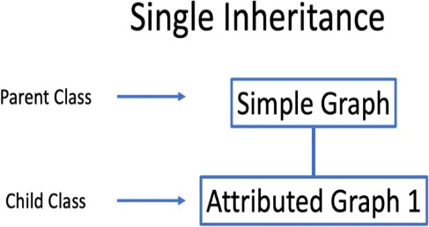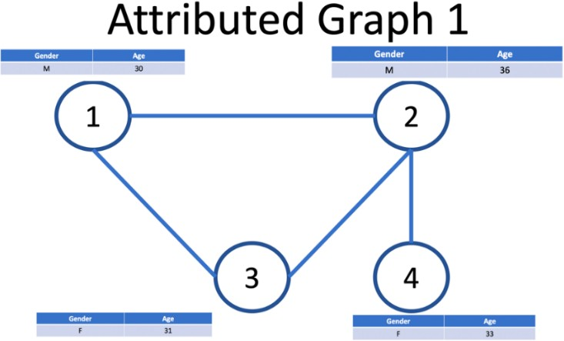

|  |  |  |
| --- | --- | --- |
|  | **AttributedGraph1.cpp** | **AttributedNode1.cpp** |
| **Purpose** | Create a class AttributeGraph1 that extends the SimpleGraph | Create a class named AttributedNode1.cpp |
| **Member Data** | An array of type “AttributedNode1” to store all the created nodes | Char variable to store Gender Int variable to store Age |
| **Member Functions** | **Overloaded Constructor** to initialize the  member data. A message should be printed for this action | **Constructor** to initialize the member  data. A message should be printed for this action. |
|  | **Destructor** to drop the graph object. A message should be printed for this action. | **Destructor** to drop the node object. A  message should be printed for this action. |
|  | **Name**: appendAttributes ()  **Parameter**: None  **Return Type**: void  **Purpose**: iterate a loop over array of SimpleNode to read the NodeID’s and ask user to add attributes (Gender, Age) into  “AttributeNode1” array on same index as of SimpleNode array. | Create **setter** and **getter** functions for the private data memebers |
|  | **Name**: printGraphData() **Parameter**: none **Return Type**: none  **Purpose**: prints data of all nodes of AttributedGraph1 along with their neighbors. |  |

## Question No.2:

Implement the above mentioned classes and their member functions. Make separate class.h, class .cpp and main.cpp for the question. [* Also ensure to use correct access modifier/access specifier for each class]

1. Create **setter** and **getter** functions of data members.
2. Create an object of type AttributedGraph1 (child class) in main function and **check the order of constructors and destructors** in 1 level inheritance. Also use this object to add nodes & edges using SimpleGraph’s methods.
3. Call **appendAttribute**()function in **main.cpp** to add the age and gender to already created Nodeid’s.
4. Call **printGraphData** function in **main.cpp** to print the data of all nodes of **AttributeGraph1** along with their neighbors.[* Apply runtime polymorphism for printGraphData() which override the SimpleGraph’s function]

**Note:** [Identify the issue and resolve it accordingly when the object that the pointer is pointing to is deleted, it calls base class destructor instead of the derived class destructor]

|  |  |  |  |
| --- | --- | --- | --- |
|  | |  | |
|  | **AttributeGraph2.cpp** | | **AttributedNode2.cpp** |
| **Purpose** | Create a class AttributeGraph2 that  extends the SimpleGraph | | Create a class named AttributedNode2.cpp |
| **Member Data** | An array of type “AttributedNode2”  to store all the created nodes | | String variable to store Profession String variable to store CityName |
|  | Create a class AttributeGraph2 that  extends the SimpleGraph | |
| **Member** | **Constructor** to initialize the | | **Constructor** to initialize the member data. A |
| **Functions** | member data. A message should be | | message should be printed for this action. |
|  | printed for this action. | |  |
|  | **Overloaded Constructor** to | |  |
|  | initialize the member data. A | |  |
|  | message should be printed for this | |  |
|  | action **[\***You have to maintain order of | |  |
|  | overloaded constructors for both the based | |  |
|  | and derived class **]** | |  |
|  | **Destructor** to drop the graph  object. A message should be printed for this action. | | **Destructor** to drop the node object. A message should be printed for this action. |
|  | **Name**: appendAttributes () | | Create **setter** and **getter** functions for the private |
| **Parameter**: none | | data memebers |
| **Return Type**: void | |  |
| **Purpose**: iterate a loop over array of | |  |
| SimpleNode to read the NodeID’s | |  |
| and ask user to add attributes | |  |
| (Profession, location) into | |  |
| “AttributeNode2” array on same | |  |
| index as of SimpleNode array. | |  |
|  | **Name**: printData() **Parameter**: none **Return Type**: none  **Purpose**: prints all the nodes along with their neighbors and attributes  **Note**: Avoid code repetition by using inheritance | |  |
|  | **Name**: printNeighbors() **Parameter**: Node id **Return Type**: none  **Purpose**: prints all the neighbors of an input node and attributes | |  |

## Question No.3:

Implement the above mentioned classes and their member functions. Make separate class.h, class .cpp, main.cpp file for the question. [* Also ensure to use correct access modifier/access specifier for each class]

1. Create **setter** and **getter** functions of data members.
2. Create an object of type AttributedGraph2 in main function. Also use this object to add nodes & edges using SimpleGraph’s methods.
3. Call **appendAttribute**() function in **main.cpp** to add the profession and location to already created NodeID’s.
4. Call **printGraphData()** function in **main.cpp** to print the data of all nodes of **AttributeGraph2** along with their neighbors.[* Apply runtime polymorphism for printGraphData() which override the SimpleGraph’s function]
5. Call **printNeighbors()** function in **main.cpp** to print all the neighbors of an input node and attributes

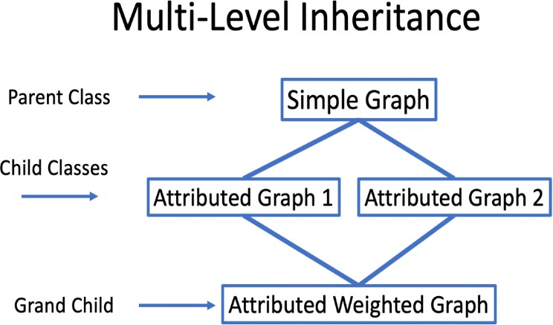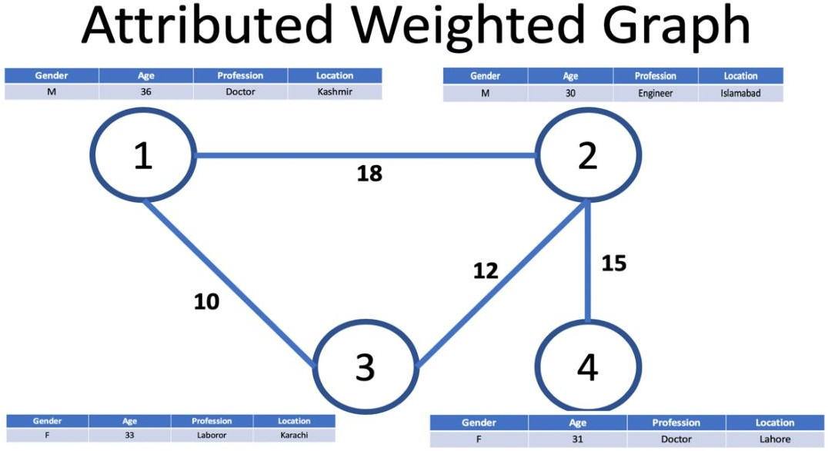

|  |  |
| --- | --- |
|  | **AttributedWeightedGraph.cpp** |
| **Purpose** | Create a class named AttributedWeightedGraph.cpp which extends AttributedGraph1.cpp , AttributeGraph2.cpp |
| **Member Data** | A 2D-array of type **int** to store all the edge weights of **NodeID** |
| **Member Functions** | **Constructor** to initialize the member data. A message should be printed for this action. |

|  |  |
| --- | --- |
|  | **Destructor** to drop the node object. A message should be printed for this action. |
|  | **Name**: appendWeight ()  **Parameter**: nodeId1,nodeId2,Weight  **Return Type**: void  **Purpose**: adds a weight to an edge between given 2 nodes  N1  **5** N2  **2 2**  N3   * **Undirected Graph weight for N1-N2 or N2-N1 will be same** * **No weight will be assign to N2-N3 as there is no edge in-between.** * **Value zero depict there is no edge between the involving Nodes at indexes.** |
|  | **Name**: printNeighbors() **Parameter**: Node id **Return Type**: none  **Purpose**: prints all the neighbors along with weight of an input node and attributes  **Note**: Avoid code repetition by using inheritance |
|  | **Name**: printData() **Parameter**: none **Return Type**: none  **Purpose**: prints all the nodes along with their neighbors, their weights, and attributes  **Note**: Avoid code repetition by using inheritance |

|  |  |  |  |
| --- | --- | --- | --- |
|  | IndexOfN1 | IndexOfN2 | IndexOfN3 |
| IndexOfN1 | 0 | **5** | **2** |
| IndexOfN2 | **5** | 0 | 0 |
| IndexOfN3 | **2** | 0 | 0 |

|  |  |  |  |
| --- | --- | --- | --- |
|  |  |  |  |
|  |  |  |  |
|  |  |  |  |
|  |  |  |  |

## Question No.4:

Implement the above mentioned class and their member functions. Make separate class.h, class.cpp file main.cpp for the question. [* Also ensure to use correct access modifier/access specifier for each class]

1. Create **setter** and **getter** functions of data members.
2. Create an object of type **AttributedWeightedGraph** in main function. Also use this object to add nodes & edges using SimpleGraph’s methods.
3. Call **appendWeight**() function in **main.cpp** to add weight on an edge between two nodes. For this purpose find the indexes of Nodes and fill 2D with the weights. Execute this function multiple times to appendweights on all created edges of graph.
4. Call **printNeighbors**() function in **main.cpp** to print the neighbor of a given id.
5. Call **printGraphData** function in **main.cpp** to print the data of all nodes.

## Self-Learning Tasks:

|  |
| --- |
| **Task 1:** Add a function to find path between any 2 nodes, received as input from the user |
| **Task 2:** Add a function to find path between any 2 nodes, received as input from the user, where sum of weights of all the member edges is higher |
| **Task 3:** You can use any graph visualization tool (like [Cytoscape](https://cytoscape.org/) which is free to download and  easy to play with) to visualize the graphs, paths found, the communities found and so on. |

***********Good Luck *************