Prerequisites

Windows 7+, 64-bit architecture

Install:

* Micro-manager version 1.4.23 for 64-bit architecture
* GenICam .dll file (in C:/Program Files/Micro-Manager 1.4.23/)
* Thorlabs Kinesis Stages 64-bit drivers
* Kinesis .dll file (in C:/Program Files/Micro-Manager 1.4.23/)
* EASYAcq.jar (in C:/Program Files/Micro-Manager 1.4.23/mmplugins/)

Imaging:

1. Turn on Thorlabs stages and wait for boot
2. Start Micro-manager 1.4.23 from the Desktop shortcut or C:/Program Files/Micro-Manager 1.4.23/ImageJ.exe
3. Load Micro-manager default configuration
4. Open Autofocus preferences/parameters and choose OughtaFocus, a good travel range is 30 um
5. Go to the Micro-manager window, choose Plugins->EASY Acquisition
6. Enter a valid save path into the box, otherwise all your data will be saved in a new directory C:/IRIS_Data/ (which will be created unless already present, you’ve been warned)
7. Take a Mirror image
   1. Mount a clean, bare Silicon chip on the microscope
   2. Start Live mode and focus on the chip surface
   3. Run Autofocus
   4. Ensure you are in the rough center of the Si chip and click “Acquire Mirror”
   5. The final mirror image will be saved as *mirror.tif*
      1. NOTE: it will be written over every time you take a mirror
8. Take Data
   1. Mount the sample on the microscope
   2. Enter chip number
   3. Start Live mode and focus on the chip surface
   4. Enter starting x and y positions and scan area into the plugin
      1. REMEMBER: the scan begins at the top right corner of the AOI (see Fig. 1)
   5. Check the “Focus” box if you want the program to interpolate the correct focus for all x and y positions using the Micro-manager Autofocus specs
      1. Again, the recommended algorithm is ‘OughtaFocus’, but you should experiment with this yourself for your given sample
   6. Check that the save path is where the mirror image (*mirror.tif*) is stored
   7. Press “Run” to acquire data
   8. Images will be saved as *chip{chip #}_X{x index}_Y{y index}.tif* (see Fig. 1)

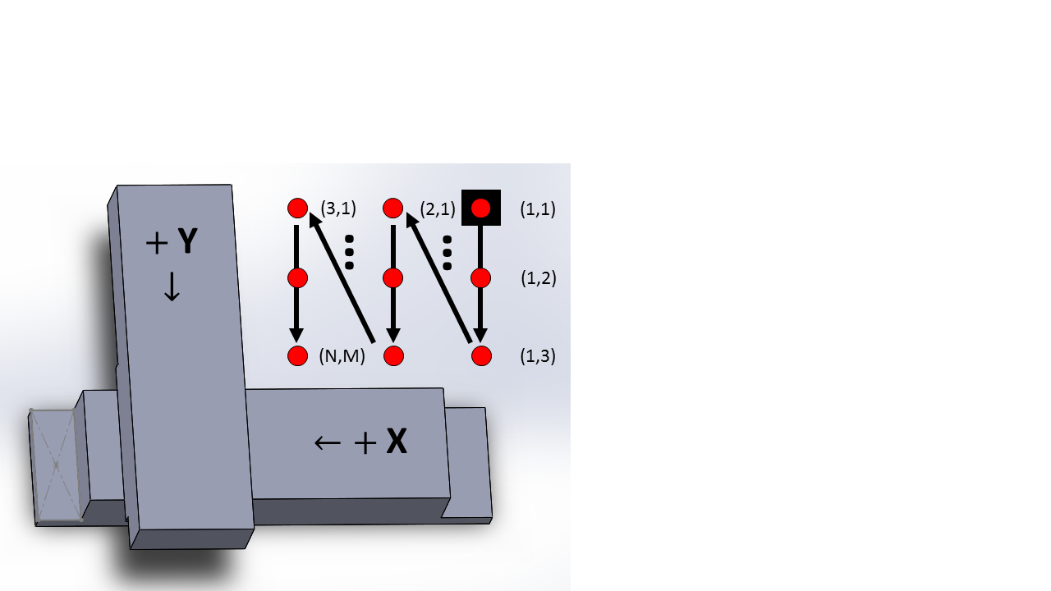

Fig. : The x, y stage configuration and scanning order.