Hybrid Adaptive Operator Selection Hyper Heuristic of Genetic Operators in Multi Objective Evolutionary Neural Architecture Search for Image Classification.

Abstract
Evolutionary Neural Architecture Search (ENAS) has shown its advantages in several areas, such as image recognition, super-resolution tasks, among others. Architectures can be represented in several ways, such as layers, blocks, cells or adjacency matrices. Once a representation has been chosen, a suitable encoding that is able to capture the structure of the architectures must be selected. The search procedure uses genetic operators to look for architectures under certain constraints, such as maximizing accuracy and minimizing FLOPs and number of parameters. Thus, the search procedure becomes a multi-objective minimization problem. Several studies about the performance of genetic operators in NAS have been conducted. In most cases, the performance is measured by the architectures performance themselves as well as performance indicators (PIs) for the Pareto front (PF) individuals, such as the hypervolume (HV), the inverse generational distance (IGD) and recently, the Ries-z Energy (Rez). In this research work, an empirical study about the performance of 15 combinations of genetic operators is made, using several PIs such as successful crossovers, successful mutations, HV and generational distance (GD). Furthermore, an Adaptive Operator Selection (AOS) mechanism (named as Hybrid Adaptive Operator Selection or HAOS) based on Multi-Armed Bandits is incorporated to dynamically adjust operator application probabilities according to their observed contribution during the search. The proposed analysis provides a characterization of operator combinations and their adaptive behavior, identifying which operators are more suitable for exploration and which are more effective for exploitation. The contribution of this work is presenting a characterization of several combinations of genetic operators that makes possible to assess which ones are better for exploration and which ones are better for exploitation, and a new AOS mechanism proposal for the dynamic selection of operators.

INTRODUCTION
ENAS relies on genetic operators, such as crossover and mutation, to balance exploration and exploitation throughout the search process. The effectiveness of these operators is highly problem-dependent and may vary during different stages of evolution. Traditionally, operator application is fixed through the search process. This approach may not effective since different operators may outperform others in exploration of exploitation and selecting the most adequate is not straightforward. For this reason, AOS has emerged as a promising approach to address this challenge. AOS dynamically controls the application of search operators according to their observed contributions to the optimization process. Rather than relying on static operator probabilities, AOS continuously evaluates operator performance and focuses more search effort to operators that are producing beneficial outcomes while reducing the application frequency of less effective ones. Through this adaptive process, ENAS can respond to changing search conditions, promoting exploration when diversity is required and exploitation when promising regions of the search space have been identified.
Most AOS frameworks are composed of two main components: credit assignment, and operator selection. During each iteration, an operator is selected according to a predefined selection mechanism. Once applied, its impact on the search is evaluated using one or more performance criteria, such as fitness improvements, diversity preservation, hypervolume gains, or successful offspring generation. The observed contribution is then transformed into a reward or credit value that reflects the utility of the operator. Finally, the selection mechanism updates its internal model based on the assigned rewards, influencing future operator choices. This process enables the algorithm to continuously adapt its search behavior throughout the evolutionary process.
AOS methods can be broadly classified into stateless and state-based approaches according to how operator performance information is utilized. Stateless approaches select operators exclusively based on their historical performance, without explicitly considering the current state of the search. The underlying assumption is that an operator's future utility can be estimated from its past rewards. To achieve this, these methods maintain statistics such as accumulated rewards, average gains, or selection frequencies for each operator and use them to guide future selections.
Among stateless approaches, Multi-Armed Bandit (MAB) models have received considerable attention due to their ability to formalize the exploration-exploitation trade-off. In this framework, each operator is represented as an arm of a bandit, and the reward obtained after applying the operator is used to estimate its expected utility. The selection strategy seeks to maximize cumulative reward by balancing the exploration of underutilized operators and the exploitation of operators that have demonstrated strong performance. Popular examples include Upper Confidence Bound (UCB), Thompson Sampling, Probability Matching, and Adaptive Pursuit. Because they only require operator-level reward information, stateless methods are generally simple to implement and introduce minimal computational overhead.
However, a limitation of stateless approaches is that they often assume operator performance remains relatively stable over time. In practice, the usefulness of an operator may change significantly as the search progresses. To address this issue, several extensions have been proposed, including sliding-window and reward-discounting mechanisms. These techniques prioritize recent observations over older ones, allowing the adaptation mechanism to react more quickly to changes in operator effectiveness. Representative examples include Sliding Window UCB and Dynamic Multi-Armed Bandits.
In contrast, state-based approaches explicitly incorporate information about the current search state when selecting operators. These methods are motivated by the observation that operator effectiveness often depends on the evolutionary stage. For example, exploratory operators may be more valuable during the early phases of the search, whereas exploitative operators may become more beneficial as the population approaches convergence. For this, operator selection decisions are conditioned on features that describe the current state of the optimization process.
State-based AOS methods typically characterize the search using indicators such as population diversity, convergence measures, fitness improvement rates, hypervolume progression, or Pareto-front characteristics. Based on these indicators, the search process is partitioned into different states, and operator-selection policies are learned separately for each state. As the algorithm transitions between states, different operator preferences can be activated, enabling a more context-aware adaptation mechanism. Several machine learning and reinforcement learning techniques have been proposed to implement state-based AOS. For example, Q-learning models operator selection as a Markov Decision Process in which states represent search conditions and actions correspond to available operators. The algorithm learns a policy that associates each state with the operator expected to maximize long-term reward. More recently, contextual bandit approaches have been explored, where contextual information describing the current search state is incorporated directly into the operator-selection process. Unlike traditional MAB methods, contextual bandits can adapt operator preferences according to the characteristics of the ongoing search.
State-based methods offer greater flexibility and adaptability because they can capture complex relationships between search conditions and operator effectiveness. However, this additional modeling capability comes at the cost of increased computational complexity and the need to define better state features. Furthermore, learning reliable state-dependent policies often requires a larger amount of training data than stateless approaches.
In the context of ENAS, where the search space is extremely large and architecture evaluations are computationally expensive, AOS provides an attractive alternative to static operator schedules. By dynamically adapting the application of crossover and mutation operators according to their observed contributions and the current search conditions, AOS can improve search efficiency, accelerate convergence, and increase the probability of discovering high-quality neural architectures.

Experimental characterization of genetic operators.
Classic AOS methods fix a specific set of operators, chosen during the search process. For our proposal, we first experimentally analyze 15 genetic operators to characterize them accordingly to several performance indicators (PIs), in order to choose only the most outperforming operators. PIs are categorized in Architecture PIs and Search PIs. Architecture PIs consist of mean Pareto Front accuracy, Flops and number of parameters. Mean highest accuracy and mean FLOPs and number of parameters from the architecture with the highest accuracy. Search PIs consist of mean normalized HV, HV differences, Genotypic Distance, successful crossover and successful mutations. A successful crossover is achieved when an architecture strictly dominates at least one of its parents. Similarly, a successful mutation is achieved when an architecture strictly dominates the original architecture.

Experimental settings:
Architectures are real-encoded. Crossover operators consist of: Single-Point Crossover (SPC), Two-Point Crossover (TPC), Uniform Crossover (UC) and SBX. For mutation, non uniform mutation (MNUNF) and polynomial mutation (MPOLY). NONE is used to denote there is no crossover or mutation. There are in total 15 genetic operators.
ENAS was used for classification tasks, using the CIFAR-100 dataset. Objective to be maximized is accuracy, and minimize FLOPs and number of parameters. Accuracy is predicted using a Gradient Boosting regressor, trained with 2000 architectures through 70 epochs, with a RMSE of 0.0142, R² of 0.8740 and Pearson of 0.9350.
Population size is 100 architectures. Search process lasts through 500 generations, repeated through 30 experiments or executions. For each execution, all PIs are measured.

Preliminary Results (more analysis is required here).
Figure A shows convergence plots for the average of different PIs through 30 experiments. Mean PF accuracy, FLOPs and number of parameters are shown in figures a, b and c. Mean best accuracy (that is, mean accuracy from the architectures with the highest accuracy in the final PF), mean FLOPs and mean number of parameters from the best architectures (based on accuracy) are shown in figures d, e and f. Genetic operators are classified according to the mutation operator. Red are operators that use MNUF mutation (called MNUF familiy). Blue lines represent MPOLY familiy and green lines represent NONE familiy.
Figure B shows convergence plots for search PIs.

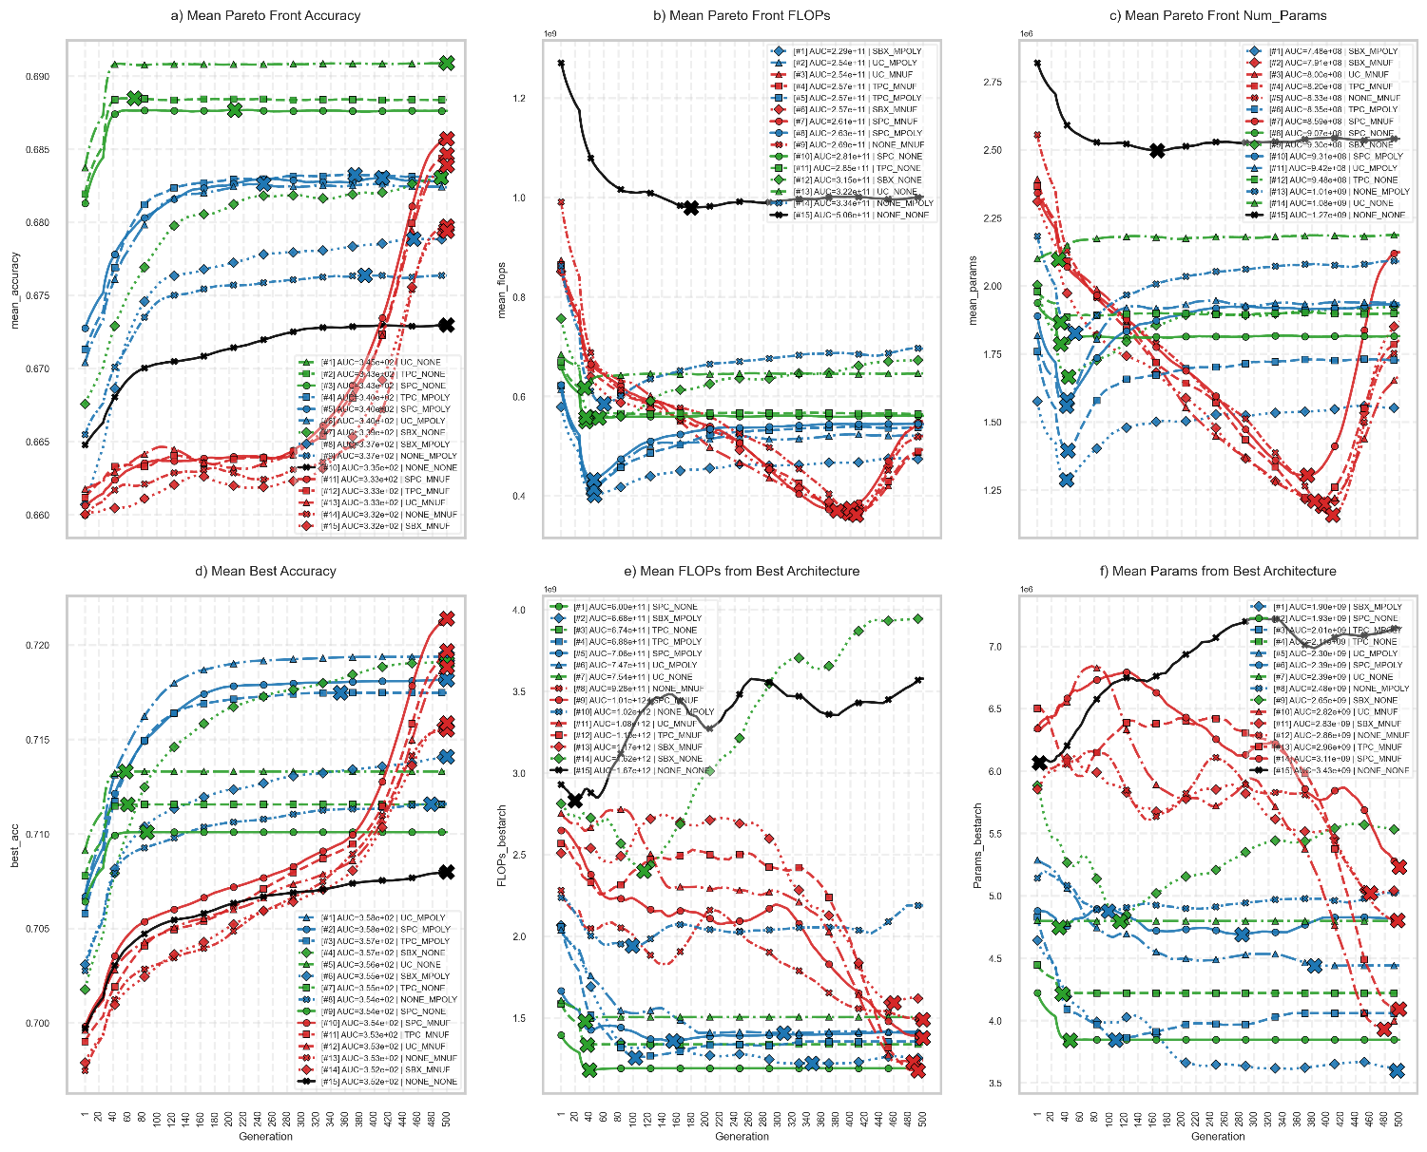
Figure A
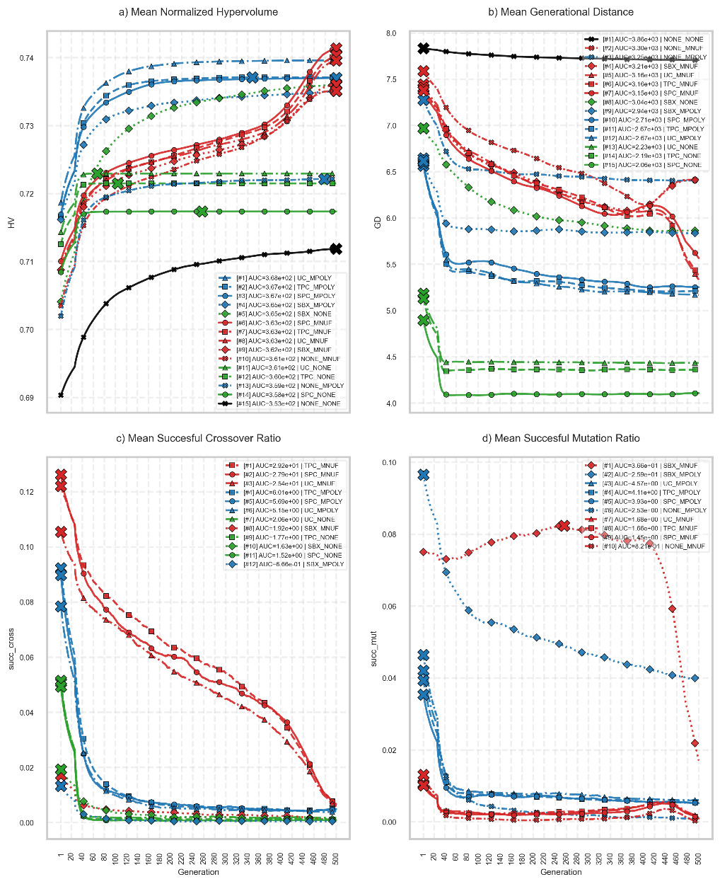
Figure B

Hybrid Adaptive Operator Selection
We propose an hybrid implementation to AOS, namely Hybrid Adaptive Operator Selection (HAOS), that combines both stateless and state-based approaches. First, we divide the search process in three stages: exploration, HV improvement and exploitation. The prior analysis allowed us to determine which operators can be used for these specific stages: for exploration, operators that create successful mutations are used: MUT_SET = {SBX_MNUF, SBX_MPOLY}. For HV improvement, HV_IMP = {SPC_MPOLY, SBX_NONE, TPC_MPOLY} were selected. Finally, for exploitation, CROSS_SET = {SPC_MNUF, TPC_MNUF,UC_MNUF} were selected due to their ability to create successful crossovers.
For the AOS procedure, we used Multi-Armed Bandit (MAB) technique for Credit Assignment (CA) and Upper-Bound Confidence (UPC) method for operator selection. Depending on the search stage, operators will be selected from the previous pools. As a first test, during 500 epochs, 40% of the time interval is dedicated to explore: this means, only operators from MUT_SET will be selected. Next 15% focus on HV improvement, using operators from HV_IMP. Finally, exploitation is performed using operators from CROSS_SET. Also, depending on the search state, the reward function dynamically changes. Genearlly, the reward is a combination as
$$RWD=K1*mean_{acc}+K2*mean_{succCross}+K3*mean_succMutation$$
Where K1, K2 and K3 change reflecting the actual state. For exploration, K1 = 0.30, K2 = 0.10, K3 = 0.60. For HV improvement, 0.80, 0.10, 0.10, respectively, and for exploitation, 0.30, 0.60, 0.10.
Our approach is hybrid because : it depends on the current search stage (state-based approach) and assigns rewards from past performance of each operators (stateless approach). No ML models are needed to be trained.

RESULTS
Figure Z1 shows convergence plots for the average of different performance indicators (PIs) through 30 experiments. Mean PF accuracy, FLOPs and number of parameters are shown in figures a, b and c. Mean best accuracy (that is, mean accuracy from the architectures with the highest accuracy in the final PF), mean FLOPs and mean number of parameters from the best architectures (based on accuracy) are shown in figures d, e and f. Brown and yellow lines, labeled as HHSE_AOS and HHSE_HAOS represent the standard stateless AOS technique with MAB and UCB, whereas HHSE_HAOS represent our proposed technique.
Due to the NFL theorem, no operator outperforms others in all performance indicators (PIs). It can be seen that, for example, SBX_NONE achieves one of the highest mean accuracy from the Pareto Front (PF). However, it also got the highest mean FLOPs and number of parameters, meaning that it finds models with the highest accuracy but with poor efficieny.
It can be seen that AOS and HAOS achieve one of the highest mean accuracy values from the PF, during the whole process (showing a balance between exploration and exploitation). Red lines (operators that use MNUF mutation) achieve the biggest value at the end of the process, meaning that they tend to explore more. For mean FLOPs from the PF, AOS and HAOS converges to quickly at the beginning of the process, whereas MNUF techniques find the most efficient architectures at epoch 400. For number of parameters, a similar situation can be seen. In both cases, at the end, similar results are obtained. For the highest accuracy, both AOS and HAOS achieve one of the highest values at the end, but got middle values for FLOPs and number of parameters from the best architectures.

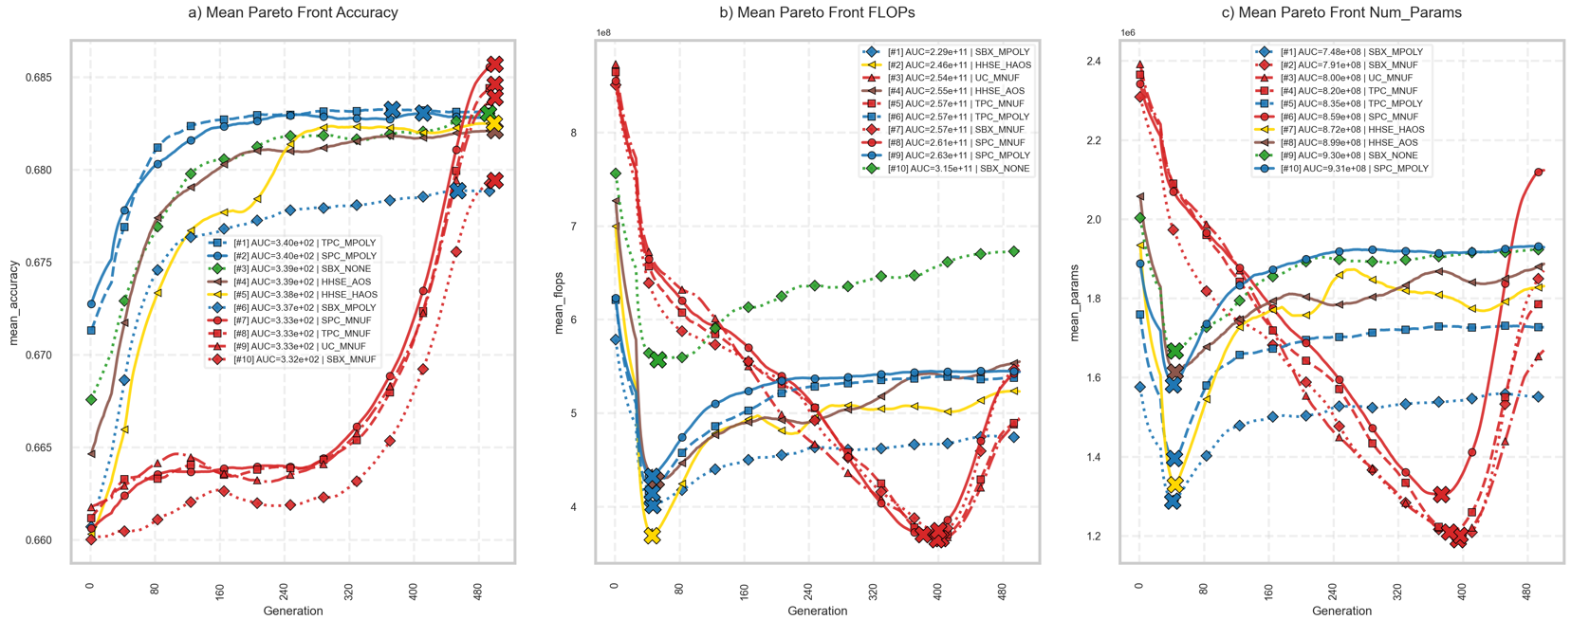
Figure Z1: Architecture PIs

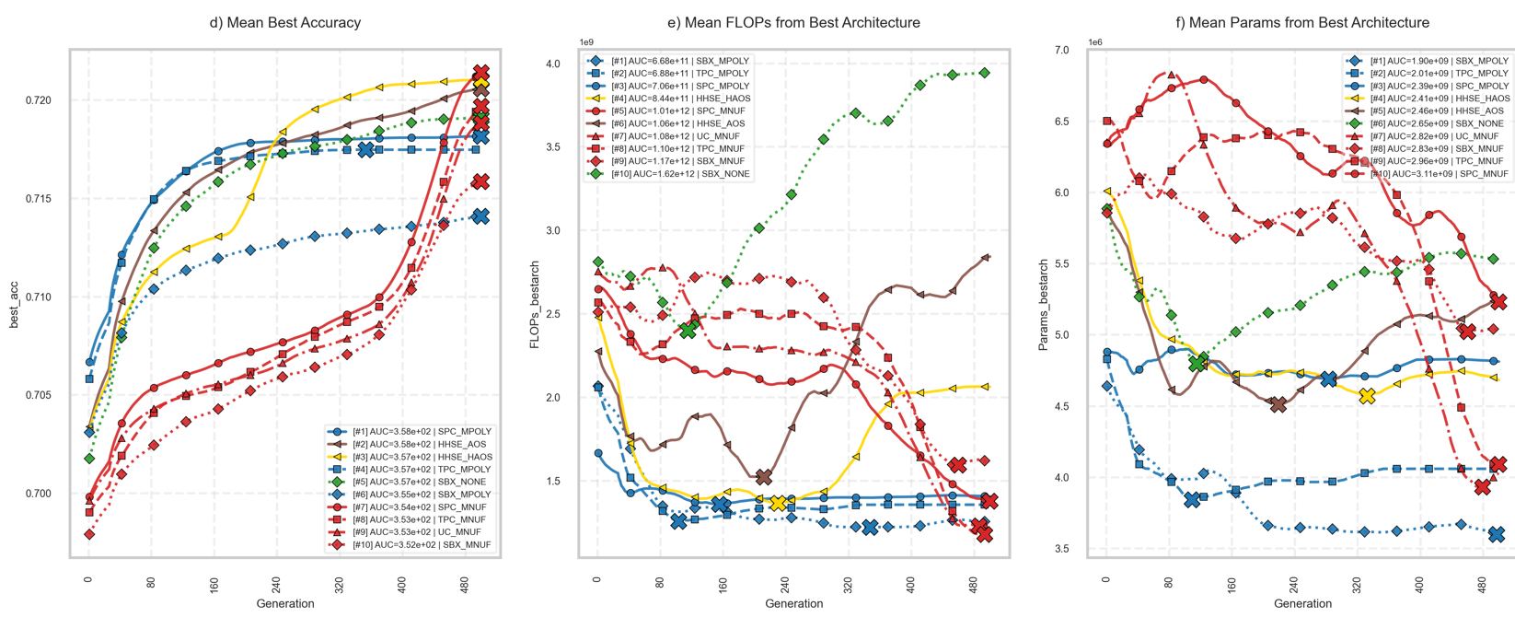
Figure Z1: Architecture PIs

Figure Z2 shows PIs for the search process, namely Mean Normalized HV, Mean Normalized delta HV, mean Genotypic Distance, mean successful crossover and mutation ratios.
Here, it can be seen that AOS and HAOS overall achieve the greatest value for HV during the whole process. For the differences between subsequent HVs (dHV), HAOS obtains the biggest value exactly where the HV improvement stage begins and ends. For genotypic distance, MNUF familiy tends to maintain diversity better through the process, whereas HAOS oscillates between stages. For successful crossovers, SPC, TPC and UC along with MNUF get the highest values from the beginning, where as the rest of the search strategies perform poorly. Finally, for successful mutation ratios, SBX_MNUF maintains the highest mutation ratio values. It can be seen for HAOS in the mutation stage that it gets high mutation ratio values, and then they drop down through the rest of the stages.

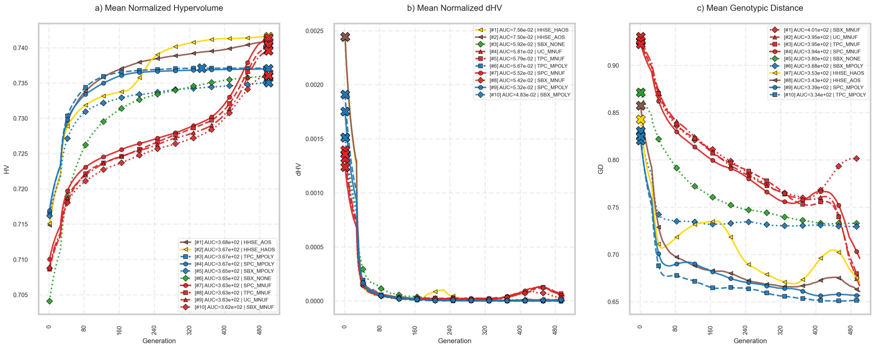
Figure Z2: Search process PIs
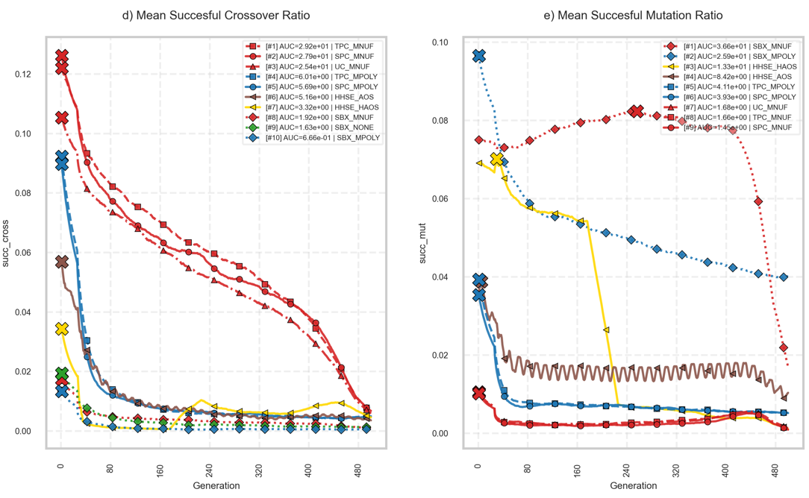
Figure Z2: Search process PIs

CONCLUSION
The use of AOS shows promising results in both architecture and search process PIs. Our first hybrid proposal (HAOS) sets specific time intervals for the three search stages: exploration, HV improvement and exploitation. However, these intervals should be dynamically selected depending on the optimization stage. Exploration, HV improvement and exploitation should not be done sequentially but when they are needed. Exploration should be done when genotypic distance is too high, HV improvement should be done when it stagnates, and exploitation should start when architecture PIs are not improving anymore.
Next tests will consist on implementing other AOS strategies (MAB with Thompson Sampling or Adaptive Pursuit). A deeper benchmark between AOS strategies could reveal which fits better for ENAS for Image Processing Tasks.

