Sanchay: Optimising a Local Retrieval-Augmented Generation System for Heterogeneous Government Documents
Hybrid retrieval, OCR and grounded generation over the Patna Master Plan, Bihar electoral rolls and research papers

[Author name]
[Degree programme]
[University / Department]
Supervisor: [Supervisor]
September 2026

Table of Contents
Right-click and choose Update Field.

Abstract
Retrieval-Augmented Generation (RAG) lets a language model answer questions from a user's own documents and cite the pages it used. This dissertation describes Sanchay, a local RAG system for three heterogeneous document families — the 335-page Patna Master Plan 2031, scanned Hindi electoral rolls, and research papers — and the end-to-end optimisation that made its web interface usable on a CPU-only laptop.
The system combines native-first PDF extraction with OCR fallback, structure-aware parent/child chunking (tables, prose sections and per-voter records), SQLite FTS5 lexical search, multilingual E5 dense retrieval, intent routing, Reciprocal Rank Fusion, cross-encoder reranking and grounded generation with validated citations, served by FastAPI to a Next.js interface.
Tracing a request from browser to model identified nine causes of the interface's missing and delayed answers, among them a 30-second development proxy timeout, stream buffering, uncancellable work on a single pipeline thread, and model loading inside the first request. Fixing them — streamed heartbeats, cancellation, startup warm-up, a dependency-free persistent vector index with fingerprinted reuse, per-page chunking, script-aware reranker selection and engine-aware prompt budgets — was guided by measurements from a reproducible probe that drives the real HTTP API.
On an Intel i5-8265U laptop, re-indexing an unchanged 335-page document fell from 317 s to about 7 s, retrieval with reranking from 2.9–3.7 s to 0.8–1.2 s per question, and the interface now reports progress within a second. With a local 3-billion-parameter model the median time to the first answer token is 31.6 s (38.5 s to a complete answer), bounded by the CPU's prompt-reading speed of about 29 tokens per second; a hosted engine is supported for interactive use. A four-way comparison of prompt configurations showed that cutting evidence saved little time and cost answers, while one explicit instruction was needed to stop a small model from replying with citations alone. Limitations — chiefly OCR on the test machine and an uncalibrated abstention threshold — are reported with the evidence behind them.

1. Introduction

1.1 Background
Public administration in India produces documents that are rich in facts but hard to query. A city's master plan runs to hundreds of pages of tables and maps; an electoral roll lists every voter of a polling station as scanned Devanagari cards; research on urban policy is published as dense academic prose. A citizen, journalist or official who needs one fact from these sources — the proposed share of residential land, the voters registered in a house, a study's main finding — must today read the document by hand.
Retrieval-Augmented Generation (RAG) promises a better interface: a language model answers questions in natural language, but only from passages retrieved from the user's own documents, and cites them. The promise is attractive for government records precisely because the answer must be traceable to a page. It is also demanding, because the documents are heterogeneous (digital text, tables, scans), multilingual (English, Hindi, Urdu), and must often be processed on modest hardware without sending them to a cloud service.

1.2 Problem statement
This project, Sanchay (संचय, "collection"), began as a hybrid RAG pipeline with a command-line interface and a Next.js web interface. The pipeline produced answers on the terminal, but the web interface either showed nothing or answered only after several minutes. The system had to be made to work end to end, from browser to model and back, for three document families at once:
- the Patna Master Plan 2031, a 335-page digital report with many tables;
- the Bihar electoral rolls of assembly constituency 183, 435 scanned
Hindi PDFs of about 28 pages each;
- research papers, digital prose documents.

1.3 Aims and objectives
The aim is a local RAG system that answers questions over any of these corpora quickly, visibly and with verifiable citations. The objectives are:
- Analyse the architecture end to end and identify every cause of missing or
slow answers in the web interface.
- Remove those causes and optimise each pipeline stage — extraction, OCR,
chunking, indexing, retrieval, reranking and generation — for a CPU-only laptop.
- Make retrieval behave correctly for each document type: tables, per-voter
records and prose, including folders that mix them.
- Measure latency per stage with a reproducible script, so that every number
reported here can be regenerated.
- Document the architecture and the engineering decisions.

1.4 Scope and constraints
All work was carried out on an Intel Core i5-8265U laptop (4 cores, 8 threads, 16 GB RAM, no usable GPU) running Windows 11. Several constraints of that environment shaped the design and are reported honestly: Windows Application Control blocked a compiled dependency of the Qdrant client; the installed PaddlePaddle release failed in its accelerated CPU path; and the embedding and language models run on the CPU only. The answer engine is a local Ollama model (qwen2.5:3b); a hosted engine (Groq) is supported but was not configured for the measurements.

1.5 Contributions
- A diagnosis of why a streaming RAG interface fails behind a development
proxy, and a design that streams progress, heartbeats and tokens reliably and cancels abandoned work.
- A dependency-free, persistent dense index that replaces an external vector
database on a single machine, with content-fingerprinted reuse.
- Per-page, structure-aware chunking that keeps tables, prose sections and
voter records intact in a single folder.
- Latency optimisations — model reuse, context sizing, script-aware prompt
budgets, reranker selection by script share — each justified by a measurement.
- A reproducible latency probe that drives the real HTTP API.

1.6 Structure of this report
Chapter 2 reviews the relevant literature. Chapter 3 describes the system architecture. Chapter 4 sets out the methodology: the corpora, questions and measurement protocol. Chapter 5 covers the implementation. Chapter 6 presents the optimisations and the measured results. Chapter 7 discusses limitations and future work, and Chapter 8 concludes.

2. Literature Review

2.1 Retrieval-Augmented Generation
Lewis et al. (2020) introduced Retrieval-Augmented Generation, combining a dense retriever with a sequence-to-sequence generator so that a model's answers are conditioned on retrieved passages rather than on its parameters alone. The approach reduces hallucination on knowledge-intensive tasks and, crucially for this project, makes answers attributable to sources. Later surveys (Gao et al., 2023) describe the now-standard "advanced RAG" pattern: pre-retrieval processing, hybrid retrieval, reranking and post-retrieval prompt construction. Sanchay follows this pattern.

2.2 Lexical and dense retrieval
Lexical retrieval. BM25 (Robertson and Zaragoza, 2009) ranks passages by term frequency and inverse document frequency. It remains a strong baseline, particularly for exact identifiers such as voter EPIC numbers, which dense models represent poorly. SQLite's FTS5 extension provides BM25 ranking over an inverted index inside a single file or in memory.
Dense retrieval. Dense Passage Retrieval (Karpukhin et al., 2020) and Sentence-BERT (Reimers and Gurevych, 2019) embed queries and passages into a shared vector space. The E5 family (Wang et al., 2022) trains such embedders contrastively on large weakly-supervised pair collections; its multilingual variant covers Hindi and Urdu, which matters for the electoral rolls. E5 models expect "query:" and "passage:" prefixes — omitting them measurably reduces recall, a detail the implementation enforces.
Benchmarks. BEIR (Thakur et al., 2021) showed that no single retriever dominates across domains and that BM25 is hard to beat out of domain. FiQA (Maia et al., 2018), a financial question-answering set within BEIR, is used by this project's evaluation harness.

2.3 Fusion and reranking
Reciprocal Rank Fusion (Cormack, Clarke and Buettcher, 2009) merges rankings by summing 1/(k + rank) across lists. Because it uses ranks rather than raw scores, it combines BM25 and cosine similarity, which live on incompatible scales, without calibration.
Cross-encoders score a query and passage jointly. Nogueira and Cho (2019) showed that a BERT reranker over BM25 candidates substantially improves passage ranking on MS MARCO. Distilled models such as MiniLM (Wang et al., 2020) make this affordable on CPUs. mMARCO (Bonifacio et al., 2021) translated MS MARCO into several languages, including Hindi, enabling multilingual cross-encoders. Reranking cost grows with the number of candidates, model depth and sequence length — the three levers tuned in Chapter 6.

2.4 Document understanding and OCR
Government PDFs mix native text with scanned images. Tesseract (Smith, 2007) is a long-standing open-source OCR engine with Devanagari support. PaddleOCR (Du et al., 2020; Cui et al., 2025) provides lightweight detection and recognition networks, including a Devanagari recogniser, designed for CPU deployment. Table structure is a separate problem: PyMuPDF exposes table detection for digital PDFs, and tables spanning pages must be stitched back together before chunking.

2.5 Chunking
How documents are split determines what can be retrieved. Fixed-size windows are simple but cut tables and records apart. Sentence-aware splitting keeps sentences whole. Parent-child ("small-to-big") retrieval indexes small units for precise matching but gives the generator the larger enclosing unit for context. Sanchay applies this idea per structure: table rows under their whole table, prose paragraphs under a bounded section, and voter cards under their household.

2.6 Generation, grounding and abstention
Long prompts are not free: Liu et al. (2023) found that models use information in the middle of long contexts poorly, and on a CPU prompt evaluation dominates latency. Small instruction-tuned models such as Qwen2.5 (Qwen Team, 2024) make local generation feasible. Grounding is enforced by asking for numbered citations and validating them against the supplied evidence.
Selective prediction (Geifman and El-Yaniv, 2017) frames abstention as a trade between coverage and risk. The project's broader research plan applies this to RAG under corpus contamination; this dissertation concentrates on the system and its optimisation, and treats calibrated abstention as future work (Chapter 7).

2.7 Summary
The literature supplies the components: BM25, multilingual dense retrieval, RRF, cross-encoder reranking, OCR, structure-aware chunking and grounded prompting. What it does not supply is the engineering needed to make them work together on heterogeneous documents, on a CPU-only laptop, behind a web interface that users can trust. That integration and optimisation is the subject of the following chapters.

3. System Architecture

3.1 Overview
Sanchay is a single-user system that runs on the user's machine. A browser interface (Next.js) talks to a Python backend (FastAPI), which owns the whole pipeline: extraction, indexing, retrieval and generation. Only the answer engine may be remote.
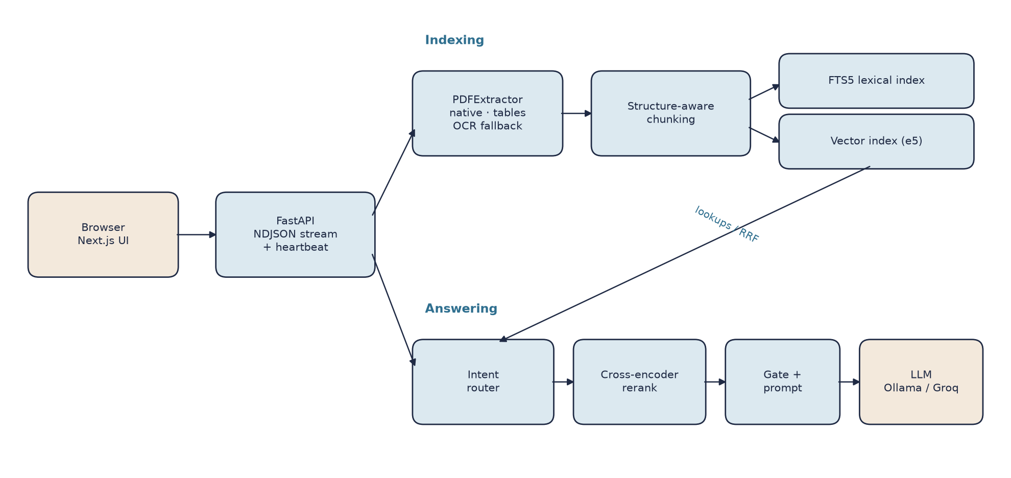
Figure 1. Component architecture of Sanchay
The backend runs all pipeline work on a single dedicated thread. Some stores cannot cross threads (SQLite), and on a four-core laptop concurrent OCR and embedding contend for the CPU rather than parallelise. Serialising work is acceptable for one user, provided the interface is told when a request is waiting — a requirement that became central to the optimisation work.

3.2 Components
Layer | Responsibility
Web interface | Folder picker, engine picker, indexing progress, streamed answers with citations and per-stage timings
API | Streams newline-delimited JSON for indexing and chat; heartbeats; cancellation on disconnect; model warm-up; serves the built interface
Extraction | Native text first; layout-aware table recovery; OCR only for weak pages; a content-addressed per-page cache
Chunking | Parent/child units per structure: table rows, prose sections, voter cards grouped by household
Lexical index | SQLite FTS5 with BM25, slash-safe tokens for IDs, field search, OCR-tolerant ID matching
Dense index | multilingual-e5-small embeddings in a persistent NumPy index (Qdrant when a server is available)
Intent router | Classifies each question and chooses a structured lookup or hybrid retrieval
Reranker | Cross-encoder for semantic questions only
Generation | Threshold gate, prompt packing within a token budget, streaming answer engine, citation and fact checks

3.3 Indexing flow
- The API scans the chosen folder recursively (skipping caches and virtual
environments) and detects the OCR language from file names (Hindi rolls are named …-HIN-…).
- One extractor processes every file, so the OCR model loads once. Each page
is served from the cache when possible; otherwise native text is scored for quality and kept if good, and OCR runs only when it is not. Tables that continue across pages are stitched.
- Pages are chunked by their own structure. The FTS5 index is built in
memory in seconds.
- The chunk texts are fingerprinted. If the stored vectors match, they are
reused; otherwise the chunks are embedded.
- The reranker is chosen from the share of Devanagari and Arabic letters, the
answer engine is resolved, and the local model is loaded into memory.

3.4 Question flow
- The router classifies the question: page lookup, voter ID, serial number,
relation, house, administrative summary, list question, or general semantic question.
- Structured intents use direct index lookups and are never reranked; their
relevance is exact. Semantic questions use Reciprocal Rank Fusion of dense and lexical results followed by cross-encoder reranking.
- The pipeline sizes the evidence to the question: list questions keep up to
30 records; others keep the top few.
- A threshold gate can abstain before any model call.
- The prompt numbers the evidence, labels it with document and page when it
spans documents, and fits it into a token budget chosen for the engine.
- The model's tokens stream to the browser. Citations are validated and
expanded into document/section/page references; numbers are checked against the evidence.

3.5 Streaming protocol
Both long operations stream newline-delimited JSON over a POST body. Event types are progress, status, heartbeat, token, done and error. A heartbeat carrying the current stage and elapsed time is sent every two seconds whenever the pipeline is silent, so that neither the user nor any proxy mistakes a long OCR pass or model load for a dead connection. Closing the stream cancels the request inside the worker.

3.6 Deployment modes
In development the Next.js dev server proxies /api/* to FastAPI. In production the interface is exported as static files and served by FastAPI itself: one process, one port, and no proxy between the browser and the stream.

4. Methodology

4.1 Approach
The work followed an engineering methodology of measure, diagnose, change, re-measure. Each change was motivated by a specific observed failure or measured cost, implemented with a regression test that fails on the previous code, and re-measured on the same hardware. Where a measurement could not be taken — for example the original web interface, which could not run on the test machine at all — this is stated rather than estimated.

4.2 Test environment
Item | Value
CPU | Intel Core i5-8265U, 4 cores / 8 threads, 1.6 GHz base
Memory | 16 GB
GPU | None used (MX130 not suitable)
OS | Windows 11 Pro
Python | 3.11.9; PyTorch 2.10 (CPU)
Embedding model | intfloat/multilingual-e5-small
Rerankers | cross-encoder/ms-marco-MiniLM-L-6-v2; cross-encoder/mmarco-mMiniLMv2-L12-H384-v1
Answer engine | Ollama 0.34 with qwen2.5:3b (Q4_K_M, 1.9 GB)
OCR | PaddleOCR 3.7 with PP-OCRv5 mobile detection and Devanagari recognition

4.3 Corpora
A demonstration corpus was assembled with one representative of each family:
Folder | Document | Pages | Type
data/demo/pmp | Patna Master Plan 2031 report | 335 | Digital, table-heavy
data/demo/rolls | Electoral roll, AC 183, part 1 | 28 | Scanned Hindi
data/demo/paper | Research paper | 18 | Digital prose

4.4 Questions
Five questions per folder (eval/golden_questions.json) were chosen to exercise different retrieval routes: table lookups, page lookups and open-ended questions for the Master Plan; polling-station, count, house and serial lookups for the roll; contribution, method, findings, limitations and future work for the paper.

4.5 Measurement protocol
Latency is measured by eval/latency_probe.py, which drives the running API exactly as the browser does. For indexing it records the total time and the server's progress log. For every question it records, on the client side, the time to the first byte, the first status line, the first answer token and the complete answer; and on the server side the retrieval, reranking and generation times reported in the final event. Each run writes a JSON and CSV file to docs/dissertation/data/; every figure in Chapter 6 is drawn from those files by docs/dissertation/make_figures.py.
Component costs that the API does not expose (embedding throughput, reranker configurations, OCR per page) were measured with small standalone benchmarks, run one at a time to avoid contention.

4.6 Correctness
The automated test suite (289 tests after this work) runs without models or servers, using fakes for the embedder, vector store and answer engine. Every bug fixed during the project has a test that fails against the previous code; this was verified by running the new tests against the unmodified code.

5. Implementation

5.1 Technology stack
The backend is Python 3.11 with FastAPI and Uvicorn. PyMuPDF and pypdf read PDFs; PaddleOCR (or Tesseract) reads scans; sentence-transformers runs the embedding and reranking models; SQLite FTS5 provides lexical search; NumPy holds the dense index. The interface is Next.js 15 with React 19 and Tailwind CSS. Answer engines are reached over HTTP (Ollama's native API, or an OpenAI-compatible API for Groq).

5.2 Extraction
PDFExtractor processes each page in three passes. The first serves pages from a content-addressed cache or accepts native text whose quality score (printable, alphabetic and word-count signals, with Devanagari combining marks counted as letters) passes a threshold; digital pages with tables are re-read through PyMuPDF's table finder and converted to Markdown. The second pass OCRs the remaining pages, in parallel worker processes on Linux. The third stitches tables that continue across page boundaries. OCR failures fall back to native text but are deliberately not cached, so a transient failure is retried on the next run; a missing OCR engine is reported as an error instead of producing blank pages.

5.3 Chunking
StructureAwareParentChildChunker walks each page:
- Tables become children of a few rows each, with the header row and a
linearised "[Record: column: value …]" form prepended; the parent is the whole (possibly stitched) table.
- Prose becomes sentence-aligned children of about 200 words, under
parents capped at 500 words.
- Electoral pages are handed to ElectoralRecordChunker, which re-aligns
the column-interleaved OCR output into one record per voter (serial, EPIC, name with Latin transliteration, relation, house, age, gender) and groups voters by house number as the parent.

5.4 Indexes
FTS5Index stores chunks in an in-memory SQLite FTS5 table whose tokenizer keeps /, -, _ and . inside tokens, so identifiers such as BR/35/207/291052 survive. Every query term is quoted, so words such as NOT or AND cannot be parsed as operators. A field search combines field markers with groups of dual-script synonyms and falls back to substring matching for words OCR has glued together.
LocalDenseIndex stores normalised float16 vectors and JSON payloads on disk, written via write-then-rename and checked for consistency on load. Search is a single matrix-vector product and a partial sort. A fingerprint of the embedded chunk texts decides whether stored vectors can be reused.

5.5 Router and generation
IntentRouter classifies each question with ordered patterns (page, ID, serial, relation, house, administrative, list) and records the intent it used, which the pipeline reads to size evidence for list questions. Relation names are cut at the next clause ("… and live in house 4"), and a page lookup that names a document ("page 66 of the Patna Master Plan", matched through the initials "pmp") reads only that document's page.
RAGPipeline reports each stage to the API, applies the gate, packs the prompt and streams the answer. OllamaBackend sends an explicit context size that only grows, because changing it reloads the model; FallbackBackend puts a local model behind a hosted one.

5.6 API and interface
The API's stream worker runs each request on the pipeline thread, relays its events through a queue, sends heartbeats while the queue is quiet and marks the request cancelled when the response stream is closed. A startup hook loads the embedding and reranking models in the background and reports the state on /api/health.
The interface chooses the engine the server recommends, shows a live stage and elapsed time while waiting, streams tokens, and shows citations and per-stage timings under each answer.

5.7 Testing
Tests cover the fixed defects and the new components: the local vector index (ranking, persistence, page filters, crash consistency), heartbeats and cancellation of the stream worker, context sizing and engine fallback, OCR-language detection, per-page chunking of a mixed folder, fingerprinted reuse, and document-aware page lookups.

6. Optimisation and Results
This chapter follows the pipeline from the browser inwards. Each section states what was observed, what was changed and what the change measured. Raw data for every number is in docs/dissertation/data/.

6.1 Why the web interface showed nothing
The command-line tool printed answers, so the pipeline itself worked; the failures were in how the interface reached it. Tracing one request end to end exposed nine causes:
# | Where | Cause | Effect on the user
1 | Next.js dev proxy | 30-second proxy timeout; gzip compression of the stream | Long requests cut off; progress and tokens held back until the end
2 | API worker | One pipeline thread and no cancellation | An abandoned answer kept generating; later questions queued silently
3 | First request | Library imports, model loads and a ~1 GB model download inside the first "Index" | Minutes of silence on first use
4 | Vector store | Qdrant client blocked by Application Control; embedded Qdrant locked per index | Indexing failed on the laptop; re-indexing failed elsewhere
5 | Answer engine | No context size sent to Ollama; interface picked an arbitrary model | Long prompts silently truncated; slow model by default
6 | API indexing | One OCR worker, English OCR for Hindi scans, top-level files only | Hindi rolls read as noise; nested data ignored
7 | Chunking | One electoral page switched the whole folder to the voter-card chunker | Master Plan tables lost in mixed folders
8 | Page lookups | Page filters ignored the document | "Page 66" mixed pages from every file
9 | Feedback | No events while the pipeline was busy | Slow steps looked like a crash

The fixes (Chapter 5) stream a heartbeat every two seconds with the current stage, cancel work when the browser disconnects, warm the models at startup, and — in production — serve the interface from the API process itself, so no proxy sits between the browser and the stream. Automated tests check the heartbeat and cancellation behaviour, and the production build was verified to be served by FastAPI at the API's own address.

6.2 Indexing
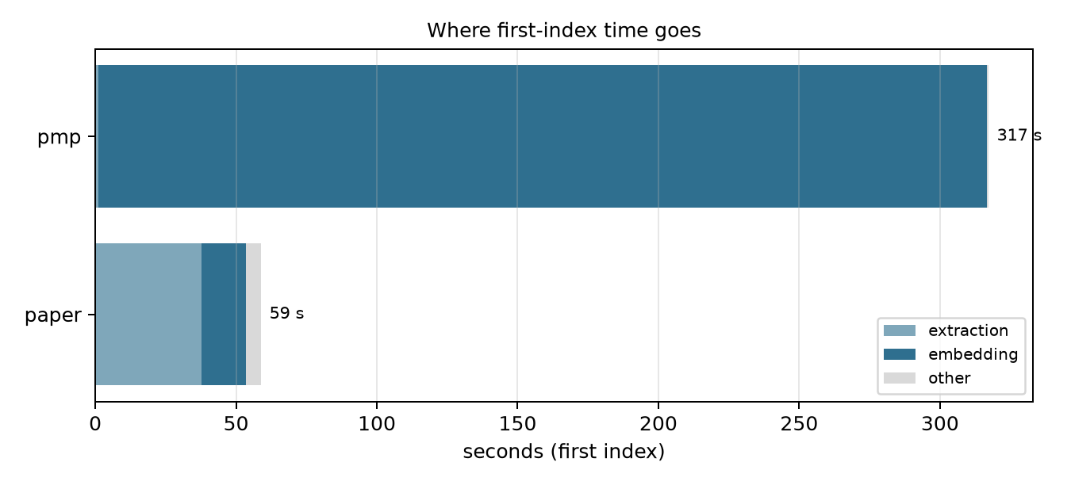
Figure 2. Where first-index time goes
Folder | Pages | Chunks | First index | Of which embedding | Re-index (unchanged)
Research paper | 18 | 83 | 59 s | 16 s | 45–53 s (see note)
Master Plan | 335 | 1,616 | 317 s | 316 s | 6.6–7.0 s

Note: the paper's re-index time is dominated by loading the answer model into memory before the first question, not by indexing itself.
Embedding dominates the first index: the multilingual E5 model embedded 8–10 chunks per second on this CPU in a standalone benchmark, regardless of the thread count. Extraction of the digital Master Plan was already served from the page cache (1–2 s for 335 pages). Fingerprinting the chunk texts lets a re-opened folder skip embedding entirely: the Master Plan re-index fell from 317 s to about 7 s.

6.3 Retrieval and reranking
With a stub engine (no generation), the time from question to evidence was 1.3–1.8 s for the research paper and 2.9–3.7 s for the Master Plan; a page lookup took 0.03 s because it bypasses ranking entirely. The Master Plan was slower because a few quoted Hindi words had selected the 12-layer multilingual reranker.
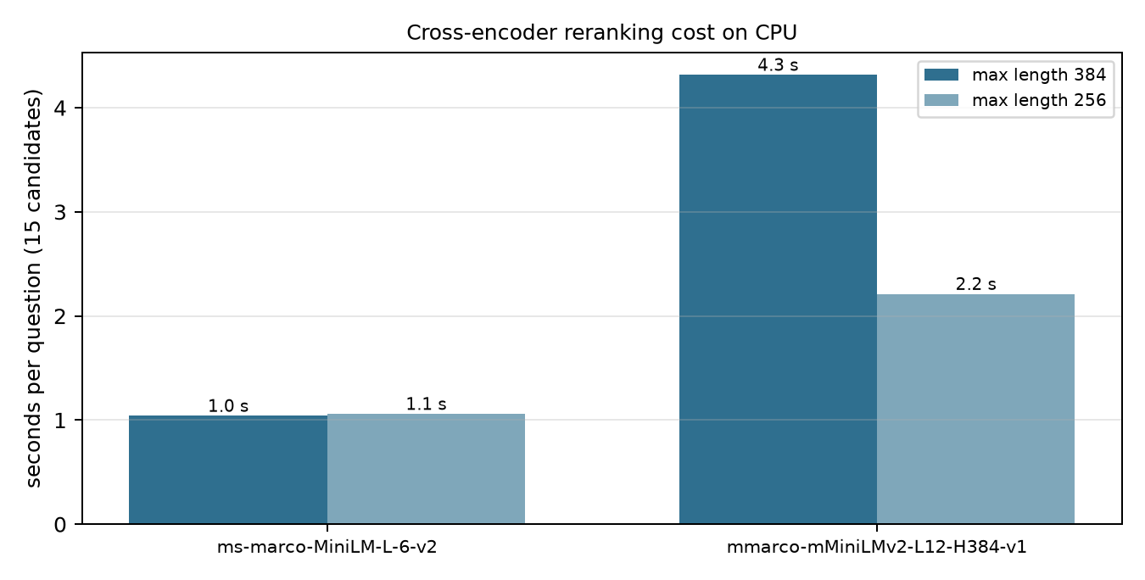
Figure 3. Cross-encoder reranking cost on CPU
Reranker | 384 tokens | 256 tokens
ms-marco-MiniLM-L-6 (English) | 1.04 s | 1.06 s
mmarco-mMiniLMv2-L12 (multilingual) | 4.32 s | 2.21 s

Two changes followed: the multilingual model is chosen only when Devanagari or Arabic letters make up at least 15% of the text, and reranker input is capped at 256 tokens. With the local model, retrieval for Master Plan questions then took 0.8–1.2 s (median about 1.0 s across all questions).

6.4 Generation
Generation was measured directly against Ollama with real Master Plan evidence:
Model | Prompt reading | Output | Repeat of an identical prompt
qwen2.5:3b | 24–30 tokens/s | 6.4–6.7 tokens/s | 0.17 s (prompt cache)
qwen2.5:1.5b | 51 tokens/s | 13–13.5 tokens/s | 0.08 s

On this CPU a 3-billion-parameter model reads about 29 prompt tokens per second, so a 1,000-token prompt waits roughly half a minute for its first token. The smaller model is 1.7× faster but answered the residential land-use question wrongly (40% instead of 55.04%), so it was rejected as the default. Ollama reuses the cached system prompt between questions, which makes the length of the evidence — not of the instructions — the per-question cost.
Four prompt configurations were run through the full API with the ten golden questions:
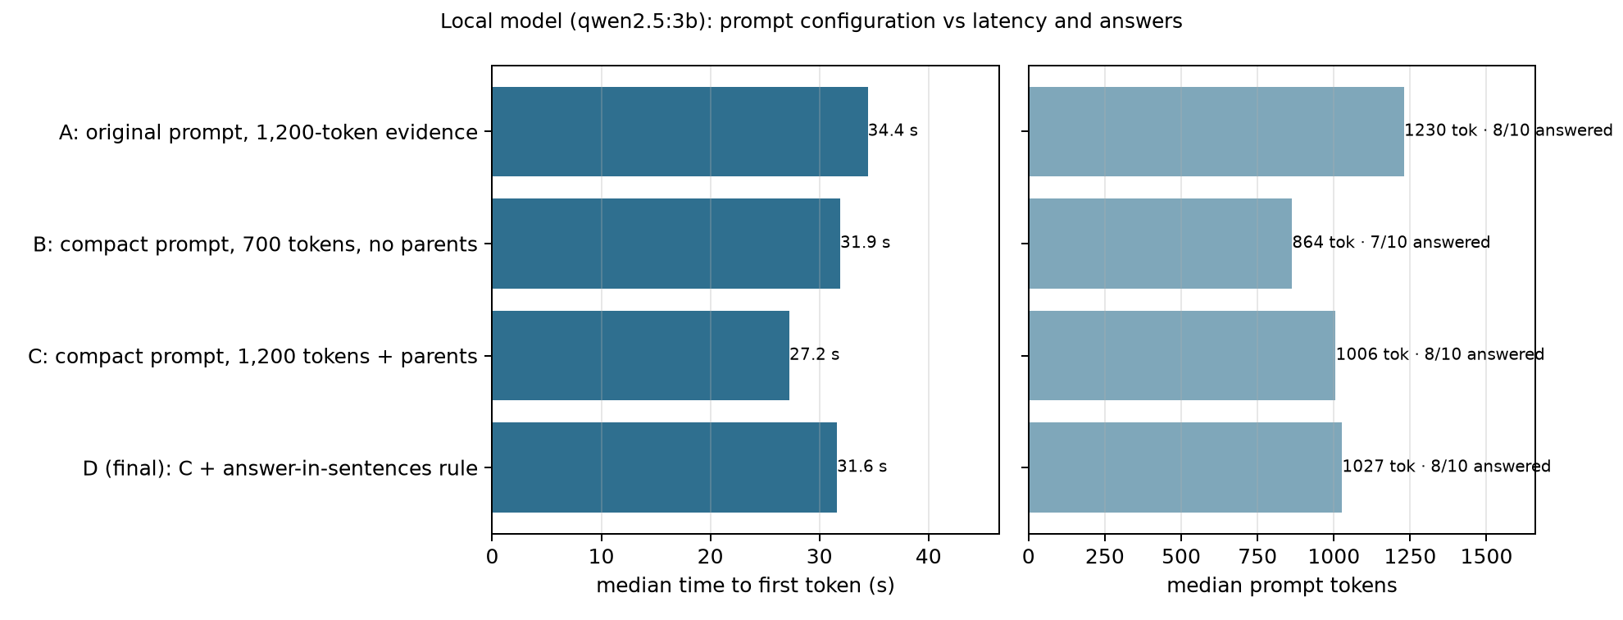
Figure 4. Prompt configuration vs latency and answers
Run | Configuration | Median prompt | Median first token | Median total | Answered | Answers stating the fact
A | Original ten-rule prompt, 1,200-token evidence with parent sections | 1,230 tok | 34.4 s | 40.6 s | 8/10 | 8/8
B | Compact prompt, 700-token evidence, no parent sections | 864 tok | 31.9 s | 37.3 s | 7/10 | 6/7
C | Compact prompt, 1,200-token evidence with parent sections | 1,006 tok | 27.2 s | 31.0 s | 8/10 | 6/8
D | C with an "answer in sentences" rule (final) | 1,027 tok | 31.6 s | 38.5 s | 8/10 | 8/8

Three findings came out of the comparison:
- Cutting evidence was a poor trade. Configuration B shortened prompts by
30% but the first token by only 7%, and a Master Plan question lost its answer. Parent sections carry the facts a small model needs.
- Shorter instructions changed behaviour, not only speed. With the
compact prompt the 3B model twice replied with a bare citation — "[Document pmp-2031-report, Page 80]" for the residential share, "[5]" for the road widths — which the answer counter scores as "answered" but which states no fact. C's lower median also includes one exact repeat of a B prompt served from Ollama's cache (1.0 s).
- One explicit rule fixed it. Asking for sentences that state the fact,
with an example ("Residential use is 55.04% [1]"), restored every factual answer while keeping the shorter prompt. D is the final configuration.
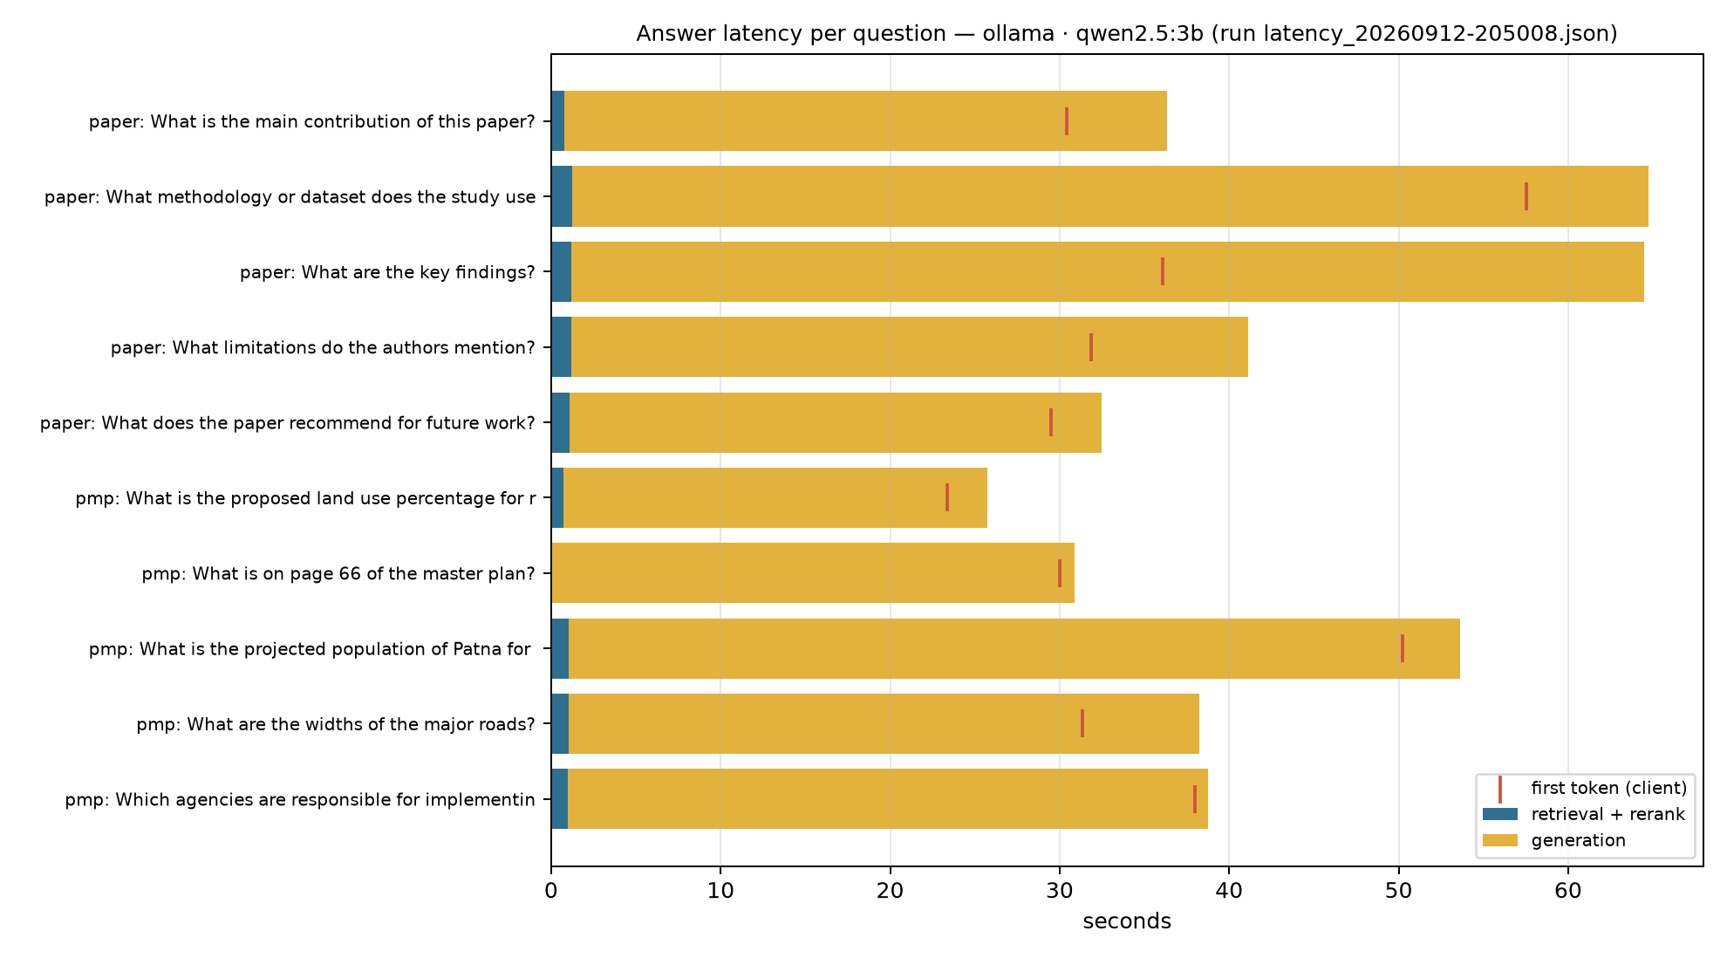
Figure 5. Answer latency per question with the final configuration

6.5 OCR
The scanned electoral rolls could not be measured on the test laptop. The installed PaddlePaddle 3.3.1 fails in its oneDNN path; without oneDNN a roll page took 104–118 s with good recognition (216 lines, 0.93 mean confidence). PaddlePaddle 3.0.0 was tried in isolation and conflicted with PyTorch's runtime. Tesseract, the pipeline's fallback engine, required a machine-wide installation that was not completed. The pipeline now disables a failing Paddle engine after its first error and reports a missing OCR engine as an error instead of producing blank pages — which is exactly how the original interface had been failing silently on the rolls.

6.6 Answer quality
With the final configuration the system answered all five research-paper questions with cited facts (for example, the study's annotated dataset of 1,200 images from several clinics, used to train a YOLOv3 model at 99.33% accuracy) and three of five Master Plan questions: the proposed residential land-use share of 55.04% (page 80), a projected 2031 population of 60.25 lakh for the planning area (page 78), and the widths of the proposed road hierarchy (80 m, 45 m and 30.5 m). The page-66 question and the question about implementing agencies were declined in every run: the evidence was retrieved, but the 3B model judged it insufficient. Declining is the designed behaviour, and the interface presents it as an abstention rather than an error.

6.7 Summary
Stage | Before | After
Interface feedback | none until the request ended (or was cut off at 30 s) | status within 1 s, heartbeat every 2 s
First use | imports, model loads and downloads inside the first request | models warmed at startup; prefetch script
Re-index of an unchanged folder | full re-embedding (317 s for the Master Plan) | ~7 s
Retrieval + rerank (Master Plan) | 2.9–3.7 s | 0.8–1.2 s
Answer, local 3B model (median) | first token 34.4 s, complete 40.6 s | first token 31.6 s, complete 38.5 s, all answers factual

On this laptop the answer model is now the only slow stage, and its cost is set by the CPU's prompt-reading speed of about 29 tokens per second. For interactive use the hosted engine (Groq), which the system selects automatically when a key is configured, removes that bottleneck; the local model remains the offline fallback.

7. Limitations and Future Work

7.1 Limitations
Uncalibrated abstention. The threshold gate is in place, but its default threshold (−2.0) never abstains once any evidence is retrieved: retrieval scores come from three different scales — Reciprocal Rank Fusion scores near 0.03, sigmoid-normalised cross-encoder scores in (0, 1), and a fixed 1.0 for exact structured lookups. A single threshold across these scales is not meaningful, so the system currently relies on the model's own INSUFFICIENT_EVIDENCE reply to decline. The project's research plan — a risk–coverage analysis of abstention under corpus contamination — requires a per-intent gate calibrated on held-out questions, which was out of scope here.
OCR on the test machine. PaddlePaddle 3.3.1's accelerated CPU path (oneDNN) failed on the Windows test laptop with an unimplemented-attribute error; disabling the new executor did not avoid it, and without oneDNN a scanned roll page took 104–118 seconds (about 50 minutes for one 28-page roll). Downgrading to PaddlePaddle 3.0.0 was tried in isolation and rejected: its bundled runtime conflicted with PyTorch's (WinError 127 loading shm.dll). Tesseract, which the pipeline already supports as its fallback engine, needs a machine-wide installation that could not be completed on the test laptop. The electoral rolls were therefore not measured in this work. The roll-specific logic (record re-alignment, household grouping, field and relation search) is covered by the automated tests on OCR text, and the Linux deployment the OCR settings were originally tuned for does not have this problem. The code now reports a missing OCR engine as an error instead of producing blank pages.
CPU-bound embedding. The multilingual embedding model processes about 8–10 chunks per second on the test CPU. The first index of the 335-page Master Plan (1,616 chunks) therefore takes about five minutes. Fingerprinted reuse makes this a one-off cost per document set, but a very large folder (for example all 435 electoral rolls) would take hours to embed on this hardware.
One request at a time. All pipeline work runs on one thread. The interface now reports when a question is waiting behind an index, but a user cannot chat with one folder while another is being indexed.
Measurement scope. Latency was measured with one local model on one laptop. The hosted engine (Groq) is implemented and tested with fakes but was not configured, so no hosted-engine latencies are reported. Answer quality was checked by inspection of the golden-question answers, not by a labelled evaluation.

7.2 Future work
- Calibrated, per-intent abstention, fitted on a held-out split and
reported as risk–coverage curves across contamination levels, as set out in the project plan.
- Faster embedding: an ONNX or 8-bit quantised export of the embedding
model typically gives a two- to three-fold CPU speed-up, which would bring first-index times for the Master Plan down to one or two minutes.
- Streaming indexing into a live session, so questions can be asked about
the first files of a large folder while the rest are still being processed.
- A labelled evaluation set for the three document families, so that
retrieval changes (chunk sizes, reranker choice, evidence budgets) can be compared on recall and answer accuracy rather than latency alone.
- Hosted-engine measurements with Groq, to quantify the latency gap
between local CPU generation and a hosted accelerator.

8. Conclusion
This project set out to make a local RAG system answer questions over three very different kinds of government and academic documents, through a web interface, on an ordinary laptop. The pipeline already produced answers on the command line; the web interface did not. The work therefore began as diagnosis rather than as model tuning.
Tracing a single request from the browser to the model found that the most visible failure — an interface that showed nothing — had nothing to do with retrieval quality. A development proxy cut long requests off after 30 seconds and buffered the stream; the backend could not abandon work its client had given up on; and the first request paid for library imports, model loads and downloads. Streaming heartbeats, cancelling on disconnect, warming models at startup and serving the interface from the API process removed those failures, and made the remaining slow steps visible rather than silent.
The optimisation work that followed was guided by measurement, and several of its results were not the expected ones:
- Embedding, not extraction, dominates the first index on a CPU (316 of
317 seconds for the Master Plan). Fingerprinting chunk texts made repeat indexing about 45 times faster, which matters more to a user than speeding up the first index.
- Reranking cost depended on which model was chosen, not on the question.
Choosing the multilingual reranker by the share of Hindi text, rather than its mere presence, and capping its input cut retrieval from about three seconds to about one.
- Shrinking the prompt was a poor trade. On a CPU the model reads about
29 prompt tokens per second, but cutting evidence by 30% saved only 7% of the wait and cost answers; the enclosing sections carry the facts a small model needs. The instructions, which the model server caches after the first question, were the part worth shortening.
- A smaller model was faster but wrong on a simple numeric question, so
speed was not bought with correctness.
- Short instructions change behaviour, not only speed. A compact prompt
made the 3B model reply to two table questions with a bare citation; one explicit rule ("answer in sentences that state the facts") restored them.
With the final configuration, a local 3-billion-parameter model answers with a median time to the first token of 31.6 seconds and a complete answer in 38.5 seconds, every answer stating its fact with a citation. That remaining cost is set by the hardware; the system already selects a hosted engine when one is configured, and keeps the local model as an offline fallback.
The system now treats the three document families appropriately in one folder — tables stay tables, prose keeps its section, voters stay one record each — and every claim in this report is backed by a logged measurement that can be reproduced with the scripts in the repository. The most important open problem is the one the project's research plan identifies: a calibrated, per-intent abstention gate, so that the system's decision to answer or to decline is as trustworthy as its citations.

References
- Bonifacio, L., Jeronymo, V., Abonizio, H. Q., Campiotti, I., Fadaee, M., Lotufo, R. and Nogueira, R. (2021). mMARCO: A Multilingual Version of the MS MARCO Passage Ranking Dataset. arXiv:2108.13897.
- Cormack, G. V., Clarke, C. L. A. and Buettcher, S. (2009). Reciprocal Rank Fusion Outperforms Condorcet and Individual Rank Learning Methods. Proceedings of SIGIR 2009, 758–759.
- Cui, C. et al. (2025). PaddleOCR 3.0 Technical Report. arXiv:2507.05595.
- Du, Y., Li, C., Guo, R., Yin, X., Liu, W., Zhou, J., Bai, Y., Yu, Z., Yang, Y., Dang, Q. and Wang, H. (2020). PP-OCR: A Practical Ultra Lightweight OCR System. arXiv:2009.09941.
- Gao, Y., Xiong, Y., Gao, X., Jia, K., Pan, J., Bi, Y., Dai, Y., Sun, J., Wang, M. and Wang, H. (2023). Retrieval-Augmented Generation for Large Language Models: A Survey. arXiv:2312.10997.
- Geifman, Y. and El-Yaniv, R. (2017). Selective Classification for Deep Neural Networks. Advances in Neural Information Processing Systems 30.
- Karpukhin, V., Oğuz, B., Min, S., Lewis, P., Wu, L., Edunov, S., Chen, D. and Yih, W. (2020). Dense Passage Retrieval for Open-Domain Question Answering. Proceedings of EMNLP 2020, 6769–6781.
- Lewis, P., Perez, E., Piktus, A., Petroni, F., Karpukhin, V., Goyal, N., Küttler, H., Lewis, M., Yih, W., Rocktäschel, T., Riedel, S. and Kiela, D. (2020). Retrieval-Augmented Generation for Knowledge-Intensive NLP Tasks. Advances in Neural Information Processing Systems 33.
- Liu, N. F., Lin, K., Hewitt, J., Paranjape, A., Bevilacqua, M., Petroni, F. and Liang, P. (2023). Lost in the Middle: How Language Models Use Long Contexts. Transactions of the ACL, 12 (2024), 157–173.
- Maia, M., Handschuh, S., Freitas, A., Davis, B., McDermott, R., Zarrouk, M. and Balahur, A. (2018). WWW'18 Open Challenge: Financial Opinion Mining and Question Answering. Companion Proceedings of The Web Conference 2018, 1941–1942.
- Nogueira, R. and Cho, K. (2019). Passage Re-ranking with BERT. arXiv:1901.04085.
- Qwen Team (2024). Qwen2.5 Technical Report. arXiv:2412.15115.
- Reimers, N. and Gurevych, I. (2019). Sentence-BERT: Sentence Embeddings using Siamese BERT-Networks. Proceedings of EMNLP-IJCNLP 2019, 3982–3992.
- Robertson, S. and Zaragoza, H. (2009). The Probabilistic Relevance Framework: BM25 and Beyond. Foundations and Trends in Information Retrieval, 3(4), 333–389.
- Smith, R. (2007). An Overview of the Tesseract OCR Engine. Proceedings of ICDAR 2007, 629–633.
- Thakur, N., Reimers, N., Rücklé, A., Srivastava, A. and Gurevych, I. (2021). BEIR: A Heterogeneous Benchmark for Zero-shot Evaluation of Information Retrieval Models. NeurIPS 2021 Datasets and Benchmarks Track.
- Wang, L., Yang, N., Huang, X., Jiao, B., Yang, L., Jiang, D., Majumder, R. and Wei, F. (2022). Text Embeddings by Weakly-Supervised Contrastive Pre-training. arXiv:2212.03533.
- Wang, L., Yang, N., Huang, X., Yang, L., Majumder, R. and Wei, F. (2024). Multilingual E5 Text Embeddings: A Technical Report. arXiv:2402.05672.
- Wang, W., Wei, F., Dong, L., Bao, H., Yang, N. and Zhou, M. (2020). MiniLM: Deep Self-Attention Distillation for Task-Agnostic Compression of Pre-Trained Transformers. Advances in Neural Information Processing Systems 33.

