A Multi-Agent Power Distribution Systems Management Via Inverter PV Control for Smart-Grid Applications

Ahmad R. Malekpour, Student Member, IEEE, Denise M. Case, Member, IEEE, Anil Pahwa, *Fellow*, IEEE, and Scott A. DeLoach, Member, IEEE

*Abstract*— **The move to a smart-grid is a shift from a passive centralized network to one that is more customer-interactive in an automated fashion favoring the efficiency, reliability, and sustainability of supply. In this context, worldwide interest in deployment of rooftop solar PV systems has increased. However, high penetration of house level PV may result in incremental power losses or voltage regulation issues for utility companies. In addition, smart grid calls for faster algorithms to deal with the scalability issues associated with integration of large number of rooftop PVs. In this paper, a holonic multi-agent system (HMAS) is proposed to address these issues through PV reactive power management using a hierarchical optimization algorithm. Agents introduced are blah, blah, and blah. The simulation of the HMAS by using OBAA++ verifies the performance of the proposed method.**

*Index Terms*— Cyber-physical systems, multi-agent system, optimization, holonic mas, power distribution system, smart grid, solar power, distributed optimal power flow.

# INTRODUCTION

Rooftop solar generation is expected to reach significant market share due to downward trend of solar module prices and state or federal subsidy programs to use renewables [1]. According to International Energy Agency (IEA) solar PV roadmap [2], PV could reach 11% of global electricity production and contribute in 2.3 gigatonnes (Gt) CO2 emissions reduction per year by 2050. However, power quality is the major concern that can degrade the very benefits expected from the large scale proliferation of renewables. Massive integration of rooftop solar PV in existing distribution systems may impose several issues such as incremental power losses, voltage violation, voltage fluctuation and other power quality issues [3-6]. Under current utility practice, IEEE 1547 standard [7], inverter-based PVs are designed to sense the grid and inject active power in phase with the voltage. However, new smart inverters are able to contribute in reactive power generation and guarantee the availability of reactive power with 0.9 PF for the whole year [8]. Hence, the reactive power injection capability of smart inverters for loss reduction and voltage control in distribution system with large penetration of PV generation is becoming an emerging research area. Using the potential capability of these inverters in systems with large scale distributed PV integration is promising for mitigating the negative effects mentioned above and establishing future standards towards active power distribution systems.

Control schemes based on reactive power capability of inverter-based PV units are categorized into centralized and distributed approaches. Majority of optimization studies in distribution system are based on centralized approach [9]-[11] using a balanced network model. In [9], voltage control and loss reduction is formulated as an OPF problem subject to PV inverter reactive power and voltage constraints. In [10], an OPF is used to systematically find the optimal active and reactive power set points of PV inverters in residential area. Optimal management of the reactive power by controlling the inverters of PV units was proposed in [11] using the reduced network model from the point of common coupling. Recently, an OPF is implemented to improve the performance of unbalanced distribution system based on the reactive power capability and real power curtailment of PV inverters [12]. In contrast, [13]-[16] proposed distributed control methods for management of the inverter-based PV units. In [13], [14] local solar inverter reactive power control method based on sensitivity analysis is proposed for Volt/Var control and overvoltage prevention in low-voltage grids, respectively. Reactive power injection of PV inverters to mitigate voltage fluctuations is studied in [15], [16].

Distribution systems are highly distributed and unbalanced in nature and using simple balanced model may lead to incorrect results and conclusions. With a paradigm shift towards massive deployment of rooftop PV and smart measuring devices, future distribution system will be complex and scalability becomes the major concern in handling the optimization problems. Decentralized control methods seem to overcome the aforementioned issues but they are inherently locally optimal due to the lack of full system information. This calls for a new flexible framework that provides precise solution of centralized approaches while representing the independent property of decentralized approaches with limited exchange of information.

Recently, multi-agent systems (MASs) have been applied to solve power engineering problems including system monitoring and fault diagnostics [11], [12], system restoration [13], [14], system simulation [15], [16], and system control [17], [18] (more description by Ahmad). In this paper, a holonic multiagent systems (HMAS) is proposed to facilitate the large-scale integration of rooftop solar PV in residential level, minimize the power losses and deal with scalability issues in distribution system.

An HMAS is a type of MAS where the system can be decomposed hierarchically into a system of nested agents called *holons*. Each holon may manage and represent an entire lower-level organization while acting as a participant in an organization higher up the control hierarchy. Holonic design enables the reuse of control logic at each level and provides a means for propagating multiple distributed local optimizations up the hierarchy (called a *holarchy* in an HMAS) to support increasingly centralized control objectives. (Denise)

A holon is a semi-autonomous sub-system within a holarchy (i.e. hierarchy of holons) aiming to manage its resources and make decision autonomously through bidirectional power exchange with its environment in a recursive manner [17]. Based on the concept of holarchy, power distribution system is partitioned into substation, feeder, and neighborhood levels. The goal is to find the optimal reactive power generation of PV inverters by hierarchically decomposing the power loss minimization problem into sub-problems (holons) of smaller size that can be solved independently in a decentralized fashion.

Holons are connected throughout the holarchy that will have influence on other parts of distribution system. Hence, design and shared variables for the entire distribution system as well as for each holon are first identified. Then, target values are assigned at the substation level, based on loss minimization criteria. These targets are propagated to the feeder and neighborhood levels, and appropriate PV inverter reactive powers are determined using a three-phase optimal power flow (OPF) based on [18]. In this formulation, OPF is executed for each holon, and interaction with the super/sub-holons is revisited through an iterative process to minimize the discrepancy between shared variables that should become zero at the optimum.

The contributions of this paper are 1) blah blah 2) blah blah 3) blah blah

# Proposed Holonic Architecture

## Hierarchical decomposition of DISTRIBUTION SYSTEM

As shown in Fig. 1, power distribution system can be decomposed into a three-level hierarchical ordered system based on its natural physical topology, i.e. substation, feeder, and neighborhood level. The neighborhood holon represents a single phase transformer serving a group of residences or end-user consumers/producers (prosumers), and neighborhood level encompasses all the neighborhood holons. The feeder holon is referred to a single phase lateral nesting a group of neighborhood holons while feeder level includes all feeder holons. Finally, feeder holons are nested in the substation holon, which is the three-phase primary distribution lines and laterals connected to the distribution substation. In this view, there is only one substation holon in substation level.

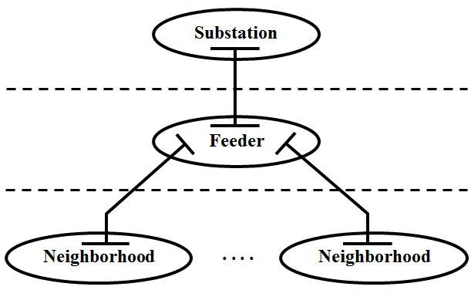

Figure 1. Architecting DISTRIBUTION SYSTEM as three-level holarchy

The provided holonic partitioning scheme requires no physical change in system configuration or customer connection. Moreover, the proposed architecture relieves loading on communication and information processing while reducing the control, and energy management computational burden by enabling substation holon targets to be cascaded down to lower level holons of the holarchy.

* 1. *Introducing target and response variables*

In the proposed holonic framework, problem partitioning also includes identifying common links between sub-problems. The vertical relationships between decomposed levels are embodied by target and response variables. Fig. 2 shows the information flow up and down the hierarchy for a three-level problem with one substation, three feeder, and two neighborhood level holons.

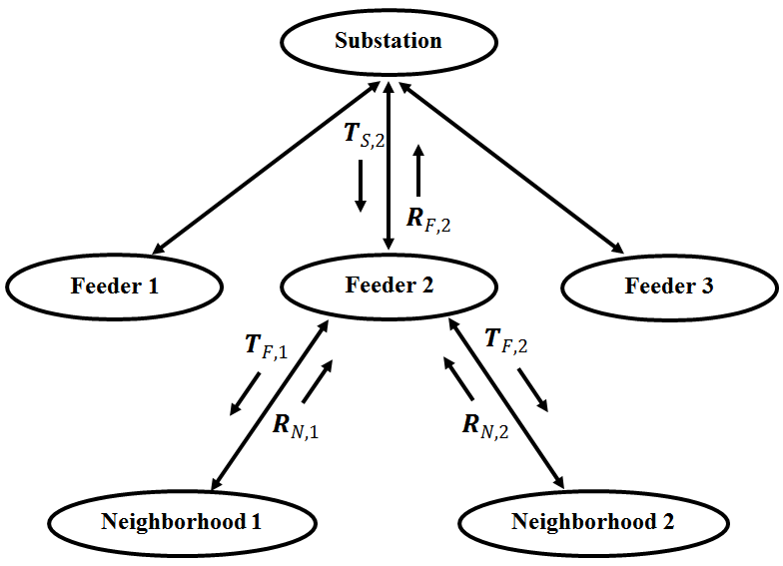

Figure 2. Information flow up and down the holarchy

As an example, at an iteration *k* in the loss minimization process, the feeder holon 2 receives its target values $T_{S,2}^{}$ from the substation holon and response variables $R_{N,1}^{}$ and $R_{N,2}^{}$ from the neighborhood holons 1 and 2 as inputs. Holon 2 is solved for determining values of its local decision variables $X_{F,2}^{}$, value of response to the substation level holon $R_{F,2}^{}$, and values of targets to the neighborhood level holons 1 and 2 i.e. $T_{F,1}^{}$ and $T_{F,2}^{}$ such that deviations from information received from upper and lower levels are minimized. This includes minimizing deviations between $T_{S,2}^{}$ and $R_{F,2}^{}$, $T_{F,1}^{}$ and $R_{N,1}^{}$, and $T_{F,2}^{}$ and $R_{N,2}^{}$.

## Defining target and response variables

As can be seen from Fig. 1, adjacent nodes in decomposed layers are coupled via a line exchanging power between super-holon and sub-holon networks. The power exchanged through the line connecting super/sub-holon networks is modeled as pseudo load/generator, respectively. Fig. 3 shows the illustration of target and response variables as pseudo load/generator For example, the exchanged power between substation holon and feeder holon *m* is modeled as pseudo generation $P_{S,m}^{y}$ and pseudo load $P_{F,m}^{y}$ from substation/feeder holon point of view, respectively. Modeling the power exchanged between the feeder holon *m* and its *n* neighborhood sub-holons is similar as stated in Eq. (1).

$$T_{S,m}^{y}=P_{S,m}^{y}$$

$$R_{F,m}^{y}=P_{F,m}^{y}$$

$$T_{F,n}^{y}=P_{F,n}^{y}$$

$$R_{N,n}^{y}=P_{N,n}^{y} (1)$$

At each holon, an optimization problem is formulated using the known targets from the super-holon and responses from sub-holons. The optimization problem is solved using an OPF developed based on [18]. After solving the OPF problem, the optimization output is provided as input parameter to super/sub-holons.

.

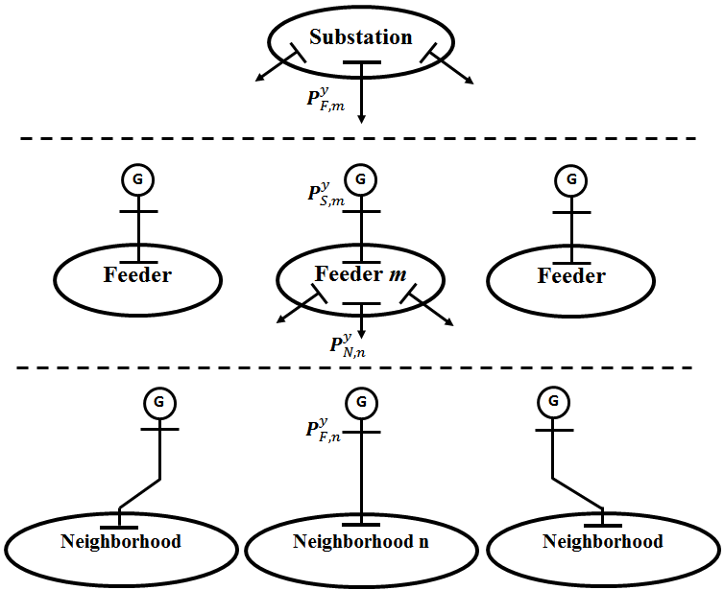

Figure 3. Illustrating target and response variables as pseudo load/generator

# Mathematical Formulation

In this section, the mathematical formulation of the modeling hierarchy is given for a distribution system composed of substation, feeder, and neighborhood levels.

## General description of loss minimization problem

The original loss minimization problem is formally stated as follows:

min $f(X)$

s. t. $g\left(X\right)=0$

$h\left(X\right)≤0 (2)$

where the objective function $f(X)$ is defined as the power losses in distribution system or equivalently power injected to the network from distribution transformer. $g\left(X\right)$ and $h\left(X\right)$ are inequality and equality constraint vectors, and the variable $X$ is defined within its lower and upper bounds. The goal is to determine the reactive power injection of PV inverters while satisfying the system operational and security constraints.

In theory, given models for the substation, feeder, and neighborhood levels, formulating and solving the above problem as a single optimization problem is possible using classical optimization techniques. However, this single problem approach is often impractical and even computationally impossible. An alternative is to decompose the problem and use a multilevel formulation to solve the problem. The loss minimization problem can be stated then as follows: given models for all substation, feeder, and neighborhood levels, determine reactive power injection of PV inverters by hierarchically partitioning the overall problem into sub-problems (holons) of smaller size, while satisfying feasibility of constraints and achieving power loss minimization objective. Alternatively, determine the values of substation, feeder, and neighborhood levels design variables that minimize the discrepancy between target variables from the top-level and response variable from the bottom-level.

## Loss minimization at the substation level

At the substation level (top level of the holarchy) the problem is stated as follows: minimize power injected to the network from substation transformer and deviation tolerance constraints that coordinate substation holon target variables and sub-holons response variables. Formally,

$$\min_{X_{S}}{P_{S}^{y}\left({\tilde{X}}_{S}^{y}\right)}+ε_{SF}$$

Subject to:

$$\sum_{m∈H_{S}}{{\left\|T_{S,m}^{y}-R_{F,m}^{y}\right\|}_{2}^{2}}≤ε_{SF}$$

$$g_{S}({\tilde{X}}_{S}^{y})=0$$

$$h_{S}\left({\tilde{X}}_{S}^{y}\right)≤0 (3)$$

where ${\tilde{X}}_{S}^{y}=[X_{S}^{y},T_{S,m}^{y},∀m∈H_{S}]$, $H_{S}$ is the set of children of substation holon, and ${\left\|·\right\|}_{2}^{2}$ represents the square of the $l_{2}$ norm. $g_{S}$, $h_{S}$ are equality and inequality constraints at the substation level, subsets of the original constraints $g$ and $h$ and $y$ denotes the ABC phases. $ε_{SF}$ is the deviation tolerance and becomes zero at convergence.

## Loss minimization at the feeder level

Since the feeder level is located in the middle of the overall hierarchy, its formulation is the most comprehensive, capturing all interactions, through response variables from the neighborhood level, and target variables from the substation level. In feeder holon *m*, the problem is stated as in Eq. (4): minimize the power injected from the substation holon and minimize the deviations for substation and feeder holon target and response variables, subject to feeder holon constraints and deviation constraints that coordinate feeder holon target variables and neighborhood holon responses.

$$\min_{X_{F,m}}{P_{F,m}^{y}\left({\tilde{X}}_{F,m}^{y}\right)}+ε_{SF}+ε_{FN}$$

Subject to:

$${\left\|T_{S,m}^{y}-R_{F,m}^{y}\right\|}_{2}^{2}≤ε_{SF}$$

$$\sum_{n∈H_{Fm}}{{\left\|T_{F,n}^{y}-R_{N,n}^{y}\right\|}_{2}^{2}}≤ε_{FN}$$

$$g_{F,m}({\tilde{X}}_{F,m}^{y})=0$$

$$h_{F,m}\left({\tilde{X}}_{F,m}^{y}\right)≤0 (4)$$

where ${\tilde{X}}_{F,m}^{y}=[X_{F,m}^{y},R_{S,m}^{y},T_{F,n}^{y},∀n∈H_{F,m}]$, $H_{F,m}$ is the set of children of feeder holon *m* and $y$ denotes either of A, B or C phases.

## Loss minimization at the neighborhood level

The neighborhood level problem for holon *n* connected to the parent feeder holon *m* is stated in Eq. (5): minimize the power injected from the feeder holon *m*, minimize the deviations between feeder target variables and neighborhood response variables subject to neighborhood level local constraints. Formally,

$$\min_{X_{N,n}}{P_{N,n}^{y}\left({\tilde{X}}_{N,n}^{y}\right)}+ε_{FN}$$

Subject to:

$${\left\|T_{F,n}^{y}-R_{N,n}^{y}\right\|}_{2}^{2}≤ε_{FN}$$

$$g_{N,n}({\tilde{X}}_{N,n}^{y})=0$$

$$h_{N,n}\left({\tilde{X}}_{N,n}^{y}\right)≤0 (5)$$

## Hierarchical coordination

Once the loss minimization problem is set up for all holons in the holarchy, a top-down coordination strategy is applied to iterate through the holarchy. Each level is solved and the solution is dispatched to lower levels sequentially. The iterative process is repeated until specified termination criteria are met i.e. deviation between target and response variables are less than $ε$. The flowchart of the coordination strategy based on the proposed holonic architecture is shown in Fig. 4.

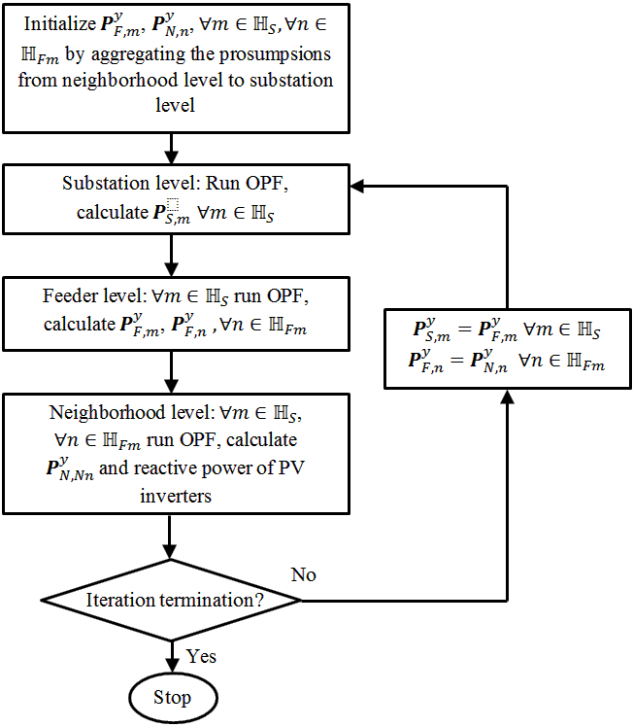

Figure 4. Flowchart of the coordination strategy for solving loss minimization problem based on holonic architecture.

# Holonic Agents

Denise Case, PhD student at Kansas State University said “….” ☺

# Simulation Results

## Network description

The modified IEEE 37 node test feeder [21] is employed to demonstrate the performance of proposed holonic architecture for loss minimization based on residential PV inverter capability. The original system is a 3-phase feeder with multiple single phase, two and three phase loads. The extended system is modeled by pole to pole lines branching out of primary feeder 32 i.e. from node 39 to 42. It is assumed that each pole mounted transformer distributes power to a neighborhood consisting of 4 homes. The transformer, overhead and drop cables characteristic are described in detail in [3]. The modified system consists of 560 nodes and 144, 144, 160 homes in phase A, B, C, respectively, with %50 rooftop PV penetration in each phase. PV enabled homes are selected randomly in each phase. In particular, the PV enabled homes in the extended feeder in phase A are located at nodes 44, 46, 52, 55, 56, 57, 59, 60, 61 and 62. For simplicity and without the loss of generality, the load and generation are aggregated to the substation level except for node 32 and its children as shown in a holonic fashion Fig. 5. The home load data are extracted from eGauge website [23]. The load reactive power is defined proportional to the real load connected at the same bus with a power factor of 0.9 lagging. The PV generation is obtained from the NREL data measured from a station near Hawaii’s Honolulu International Airport on the island of Oahu [24]. Both load and generation are represented as negative constant power.

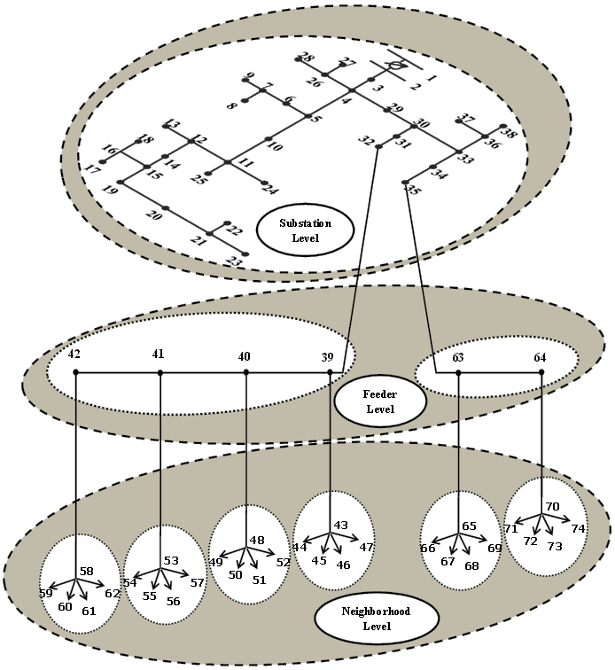

Figure 5. Modified IEEE 37 node test feeder

The studies have been implemented in MATLAB using a Intel(R) Core(TM) i7, 3.4 GHz personal computer with 8 GB of RAM. The accepted voltage range is set to 0.95 and 1.05 p.u.

## Results

Loss minimization problem is studied using three case studies.

# Conclusions

Denise and Ahmad proposed blah blah blah...

# Acknowledgment

The authors would like to thank the National Science Foundation for providing support for this research under Award ECCS-0926020. The views expressed in this paper are those of the authors.

# References

1. *The Smart Grid: An Introduction*, US DOE Publication, 2008.
2. *IEEE Power & Energy Magazine*, Special Issue on Smart Grid, March/April 2009.
3. E.C. Kern, E. M. Gulachenski, and G. A. Kern. “Cloud Effects on Distributed Photovoltaic Generation: Slow Transients at the Gardner” Massachusetts Photovoltaic Experiment. Volume 4, no. 2, June 1989, pages 184-190.
4. A. R. Malekpour, A. Pahwa, S. Das, “Inverter-based var Control in Low Voltage Distribution Systems with Rooftop Solar PV,” *45th North American Power Symposium*, Manhattan, Kansas, Sept. 2013.
5. S. Russell and P. Norvig*, Artificial Intelligence: A Modern Approach*, 3rd ed., Prentice Hall Press, Upper Saddle River, NJ, USA, 2009.
6. S. Ionita, “Multi Agent Holonic Based Architecture for Communication and Learning about Power Demand in Residential Areas,” Fourth International Conference on Machine Learning and Applications, 2009, pages 644-649.
7. Z. Jiang, “Agent-based power sharing scheme for active hybrid power sources,” *Journal of Power Sources*, Volume 177, Issue 1, 15 February 2008, Pages 231-238.
8. H. Asano, “Holonic Energy Systems: Coevolution of Distributed Energy Resources and Existing Network Energy,” International Symposium on Distributed Energy Systems and Micro Grids, The University of Tokyo, December 7-8, 2005.
9. S.S. Venkata, S. Roy, A. Pahwa, G. L. Clark and E. C. Boardman.,“Smart Distribution Grid: Status, Goals, Vision and Pathway for Success,” 2010 NSF/ECEDHA Energy and Power Educational Programs Development Workshop, Washington, DC, November 1, 2010.
10. D. Case , S.A. DeLoach, X. Ou. OBAA++: An Agent Architecture for Participating in Multiple Groups. Proceedings of the 13th International Conference on Autonomous Agents and Multiagent Systems. International Foundation for Autonomous Agents and Multiagent Systems, Richland, SC. 2014.
11. [Online].Available:http://ewh.ieee.org/soc/pes/dsacom/testfeeders/
12. F. C. Lu and Y. Y. Hsu, “Fuzzy dynamic programming approach to reactive power/voltage control in a distribution substation,” IEEE Trans. Power Systems, vol. 12, no. 2, pp. 681-688, May 1997.
13. A.R. Malekpour, T. Niknam, A. Pahwa, and A. Kavousi Fard, “Multi-Objective Stochastic Distribution Feeder Reconfiguration in Systems With Wind Power Generators and Fuel Cells Using the Point Estimate Method”, IEEE Trans. on Power Systems, vol. 28 (2), pp. 1483–1492, May 2013
14. M. B. Liu, C. A. Canizares, and W. Huang, “Reactive Power and Voltage Control in Distribution Systems with Limited Switching Operations, ”IEEE Trans. Power Systems, vol. 24, No. 2, pp. 889-899, May 2009.
15. M. Liu, S. K. Tso, and Y. Cheng, “An extended nonlinear primal dual interior-point algorithm for reactive-power optimization of large scale power systems with discrete control variables,” IEEE Trans. Power Systems, vol. 17, no. 4, pp. 982-991, Nov. 2002
16. Malekpour AR, Niknam T. A probabilistic multi-objective daily volt/var control at distribution networks including renewable energy sources. Energy 2011;36:3477–88.
17. S. Alam, B. Natarajan, and A. Pahwa, “Impact of correlated distributed

generation on information aggregation in smart grid,” in *Green Technologies Conference, 2013 IEEE*, April 2013, pp. 160–166.

1. S. Alam, B. Natarajan, and A. Pahwa, “Distribution grid state estimation from compressed measurements,” *Smart Grid, IEEE Transactions on (In Press)*, 2014.
2. Y.-F. Huang, S. Werner, J. Huang, N. Kashyap, and V. Gupta, “State

estimation in electric power grids: Meeting new challenges presented by

the requirements of the future grid,” *Signal Processing Magazine, IEEE*, vol. 29, no. 5, pp. 33–43, 2012.

1. A. Gómez-Expósito, A. Abur, A. de la Villa Jaén, and C. Gómez-Quiles,“A multilevel state estimation paradigm for smart grids,” *Proceedings of the IEEE*, vol. 99, no. 6, pp. 952–976, 2011.
2. L. Xie, D.-H. Choi, S. Kar, and H. Poor, “Fully distributed state estimation for wide-area monitoring systems,” *Smart Grid, IEEE Transactions on*, vol. 3, no. 3, pp. 1154–1169, 2012.
3. V. Kekatos and G. Giannakis, “Distributed robust power system state

estimation,” *Power Systems, IEEE Transactions on*, vol. 28, no. 2, pp.

1617–1626, 2013.

1. H. Zhu and G. Giannakis, “Multi-area state estimation using distributed

sdp for nonlinear power systems,” in *Smart Grid Communications*

*(SmartGridComm), 2012 IEEE Third International Conference on*, 2012, pp. 623–628.

1. W. H. Kersting, Distribution System Modeling and Analysis. CRC Press

LLC, 2002.

1. H. Wang and N. Schulz, “A revised branch current-based distribution

system state estimation algorithm and meter placement impact,” *Power*

*Systems, IEEE Transactions on*, vol. 19, no. 1, pp. 207 – 213, Feb. 2004.

1. A. Abur and A. G. Expósito, Power System State Estimation: Theory

*and Implementation*. New York, USA: Marcel Dekker, Inc., 2004.

1. S. Alam, B. Natarajan, and A. Pahwa, “Agent based state estimation in

smart distribution grid,” in *Communications (LATINCOM), 2013 IEEE*

*Latin-America Conference on*, Nov 2013, pp. 1–6.

# Biographies

**Ahmad Reza Malekpour** (S’06–GS’12) received the B.S. and M.S. degrees in electrical engineering from Shiraz University, Shiraz, Iran, in 2003 and 2006, respectively. Currently, he is pursuing the Ph.D. degree at Kansas State University, Manhattan. From 2003 to 2009, he has served as a lecturer at several academic institutions in Fars, Iran. From 2009 to 2011, he was an engineer at Fars Regional Electric Company (FREC), Shiraz, where he managed various distribution and transmission planning studies as well as distributed generation interconnection and integration analysis. His research interests include renewable energy, smart grids, stochastic electric power system planning, power system reliability, and energy market. He is a member of Eta Kappa Nu (HKN), Tau Beta Pi and Sigma Xi.

**Denise M. Case**received her B.S. degree in chemical engineering (honors scholar) from the University of Missouri at Columbia in 1985 and her Masters of Software Engineering from Kansas State University in 2013. She has been a consulting engineer for 20+ years, focusing on information management and analytics in critical infrastructure industries. Her research interests include distributed artificial intelligence, smart infrastructure, and adaptive systems. She is a member of ACM, IEEE, Alpha Chi Sigma, Omicron Delta Kappa, and Tau Beta Pi.

**Anil Pahwa** (F’03**)** received the B.E. (honors) degree in electrical engineering from BITS-Pilani, India, in 1975, the M.S. degree in electrical engineering from University of Maine, Orono, in 1979, and the Ph.D. degree in electrical engineering from Texas A&M University, College Station, in 1983. Since 1983, he has been with Kansas State University, Manhattan, where presently he is Logan-Fetterhoof Chair Professor in the ECE Department. His research interests include distribution automation, and intelligent computational methods for distribution system applications.

**Scott A. DeLoach** received the B.S. degree in computer engineering from Iowa State University in 1982 and an M.S. and Ph.D. degree in computer engineering from the Air Force Institute of Technology in 1987 and 1996. Following 20 years in the U.S. Air Force, Dr. DeLoach joined the Department of Computing & Information Sciences at Kansas State University, Manhattan. His research interests include distributed adaptive systems, where agents cooperate as part of a team to achieve an overarching goal.