

ALIGARH MUSLIM UNIVERSITY

COMPUTER LAB FILE
Subject code: CABSMJ-2P02
Semester II
Submitted by:
Mohd Fahad Khan
Roll no.: 25CABSA573
Enrol.no: GR0028
Submitted to:
Dr. Mohammad Luqman

Department of Computer Science
Aligarh Muslim University
Session 2025-2026

GitHub


Link- https://github.com/m-fahadk/B.Sc_Lab-2nd-Sem.git

SCAN


Week- 1
Q1- Write a C program to remove all vowels from a string.
#include <stdio.h>
int main()
{
char str1[81], str2[81];
printf("Enter a string(max 80 character)\n");
fgets(str1, 81, stdin);
int i = 0;
int j = 0;
char letter = str1[0];
while (letter != '\0')
{
if (!(letter == 'A' || letter == 'E' || letter == 'I' || letter == 'O' || letter == 'U' || letter == 'a' || letter == 'e' || letter == 'i' || letter == 'o' || letter == 'u'))
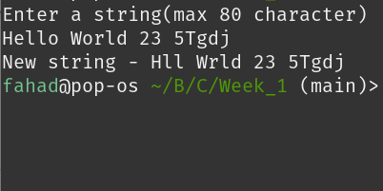
{
str2[j] = str1[i];
i++;
j++;
}
else
i++;
letter = str1[i];
}
str2[j] = '\0';
printf("New string - ");
printf("%s", str2);
}
Q2- Write a C program to remove a given word from a string.
#include <stdio.h>
#include <string.h>

int main()
{
char str1[81], str2[81], given_word[21], word2[21];
str2[0] = '\0';

printf("Enter a string(max 80 character)\n");
fgets(str1, 81, stdin);

printf("Enter a word to remove(max 20 character)\n");
fgets(given_word, 21, stdin);
given_word[strcspn(given_word, "\n")] = '\0';
int i = 0;
int j = 0;

while (str1[i] != '\0' && str1[i] != '\n')
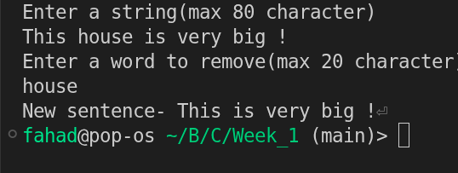
{
word2[j] = str1[i];
i++, j++;

if (str1[i] == ' ')
{
word2[j] = '\0';
if (!(strcmp(given_word, word2) == 0))
{
strcat(str2, word2);
strcat(str2, " ");
}
j = 0;
i++;
}
}
word2[j] = '\0';
if (!(strcmp(given_word, word2) == 0))
{
strcat(str2, word2);
}
printf("New sentence- %s", str2);
}

Q3- Write a C program to find the number of vowels, consonants, digits, and white space character

#include <stdio.h>
#include <string.h>

int main()
{
char str[81];
int vowel_count = 0, consonant_count = 0, digit_count = 0, white_space_count = 0, i = 0, others = 0;

printf("Enter a string(max len 80)\n");
fgets(str, 81, stdin);

str[strcspn(str, "\n")] = '\0';
while (str[i] != '\0')
{
if ((str[i] >= 'A' && str[i] <= 'Z') || (str[i] >= 'a' && str[i] <= 'z'))
{
if (str[i] == 'A' || str[i] == 'E' || str[i] == 'I' || str[i] == 'O' || str[i] == 'U' || str[i] == 'a' || str[i] == 'e' || str[i] == 'i' || str[i] == 'o' || str[i] == 'u')
vowel_count++;
else
consonant_count++;
}
else if (str[i] >= '0' && str[i] <= '9')
digit_count++;

else if (str[i] == ' ' || str[i] == '\t')
white_space_count++;

else
others++;

i++;
}
printf("\nVowels = %d\n", vowel_count);
printf("Consonats = %d\n", consonant_count);
printf("Digits = %d\n", digit_count);
printf("White Spaces = %d\n", white_space_count);
printf("Others = %d", others);
}
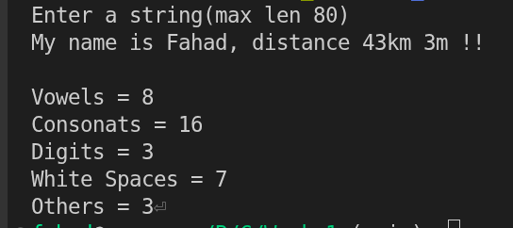

Q4- Write a C program to perform the following operation in a matrix
a. Addition b. Subtraction
c. Multiplication d. Transpose

#include <stdio.h>
#include <string.h>
void input_matix(int m, int n, int arr[][n]){
printf("Enter the elements row wise :\n");
for (int i = 0; i < m; i++) {
for (int j = 0; j < n; j++){
scanf("%d", *(arr + (i)) + j);
} } }
void print_matrix(int m, int n, int (*arr)[n]){
printf("\nMatrix\n");
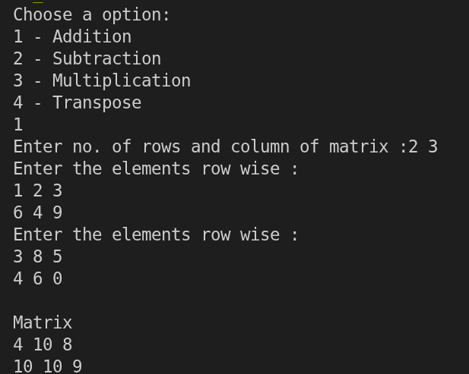
for (int i = 0; i < m; i++){
for (int j = 0; j < n; j++){
printf("%d ", *(*(arr + i) + j));
}
printf("\n");
} }
int main(){
printf("Choose a option: \n");
printf("1 - Addition \n");
printf("2 - Subtraction \n");
printf("3 - Multiplication \n");
printf("4 - Transpose \n");
int choice, m, n, p;
scanf("%d", &choice);
switch (choice) {
case 1:
{
printf("Enter no. of rows and column of matrix :");
scanf("%d%d", &m, &n);
int arr1[m][n], arr2[m][n], res_arr[m][n];
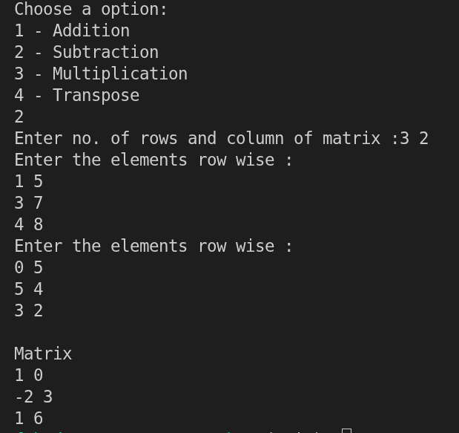
input_matix(m, n, arr1);
input_matix(m, n, arr2);

for (int i = 0; i < m; i++)
{
for (int j = 0; j < n; j++)
{
res_arr[i][j] = arr1[i][j] + arr2[i][j];
}
}
print_matrix(m, n, res_arr);
break;
}

case 2:
{
printf("Enter no. of rows and column of matrix :");
scanf("%d%d", &m, &n);
int arr1[m][n], arr2[m][n], res_arr[m][n];
input_matix(m, n, arr1);
input_matix(m, n, arr2);

for (int i = 0; i < m; i++)
{
for (int j = 0; j < n; j++)
{
res_arr[i][j] = arr1[i][j] - arr2[i][j];
}
}
print_matrix(m, n, res_arr);
break;
}

case 3:
{
printf("Enter no. of rows and column of ( 1st ) matrix :");
scanf("%d%d", &m, &n);
printf("2nd matix will have (%d) rows \n Enter the no. columns: ", n);
scanf("%d", &p);
int arr1[m][n], arr2[n][p], res_arr[m][p];
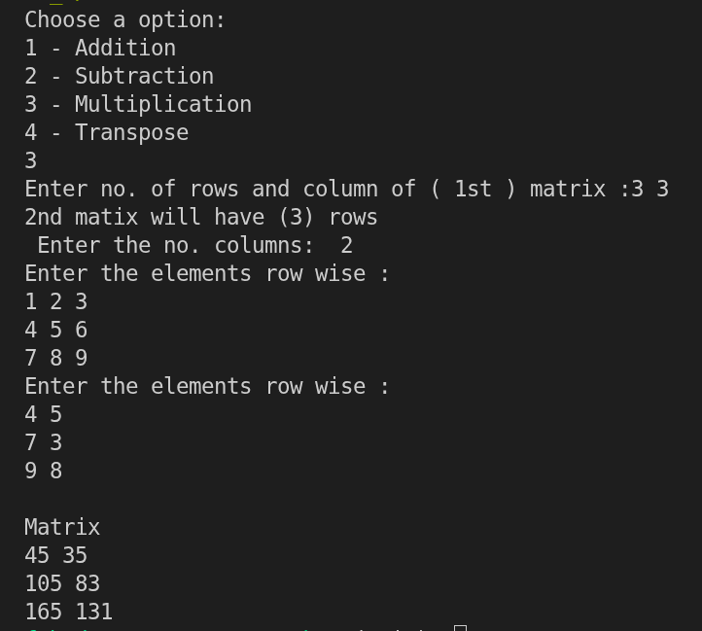
memset(res_arr, 0, sizeof(res_arr));

input_matix(m, n, arr1);
input_matix(n, p, arr2);

for (int i = 0; i < m; i++)
{
for (int j = 0; j < p; j++)
{
for (int k = 0; k < n; k++)
{
res_arr[i][j] += arr1[i][k] * arr2[k][j];
}
}
}
print_matrix(m, p, res_arr);
break;
}

case 4:
{
printf("Enter no. of rows and column of matrix :");
scanf("%d%d", &m, &n);
int arr1[m][n], res_arr[n][m];
input_matix(m, n, arr1);
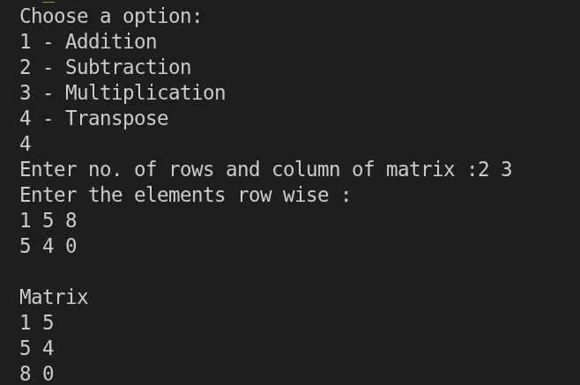
for (int i = 0; i < n; i++)
{
for (int j = 0; j < m; j++)
{
res_arr[i][j] = arr1[j][i];
}
}
print_matrix(n, m, res_arr);
break;
}
default:
printf("\nInvalid input");
}
}
Q5- Write a C program to perform the following operation on strings using string functions.
a. Addition b. Copying
c. Reverse d. Length of String.

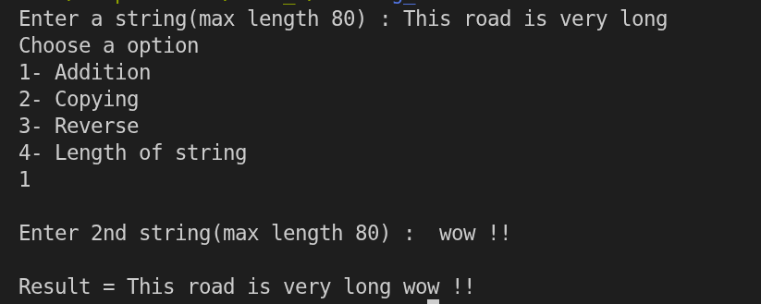
#include <stdio.h>
#include <string.h>
void strrev(char str[81]){
char strcopy[81];
strcpy(strcopy, str);
int len = strlen(str);
for (int i = 0; i < len; i++) {
str[i] = strcopy[len - i - 1];
}
}
int main(){
char str1[81], str2[200];
int choice;
printf("Enter a string(max length 80) : ");
fgets(str1, 81, stdin);
char *postion = strchr(str1, '\n');
if (postion != NULL)
{
*postion = '\0';
}
printf("Choose a option\n1- Addition\n2- Copying\n3- Reverse\n4- Length of string\n");
scanf("%d", &choice);

if (choice == 1)
{
getchar();
printf("\nEnter 2nd string(max length 80) : ");
fgets(str2, 200, stdin);
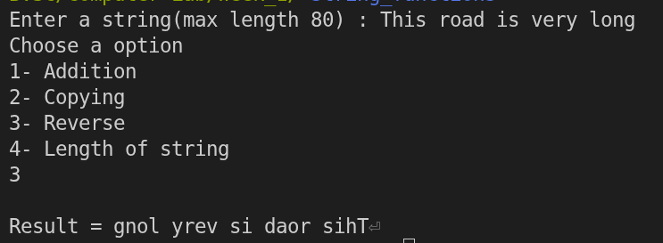
strcat(str1, str2);
printf("\nResult = %s", str1);
}
else if (choice == 2)
{
strcpy(str2, str1);
printf("\nResult = %s", str2);
}
else if (choice == 3)
{
strrev(str1);
printf("\nResult = %s", str1);
}

else if (choice == 4)
{
int l = strlen(str1);
printf("Length of string = %ld", strlen(str1));
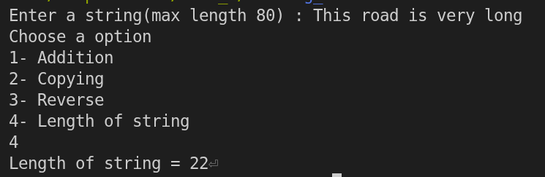
}

else
printf("Invalid choice");
}
Week- 2
Q1- Write a C program to store students' information on using a structure.

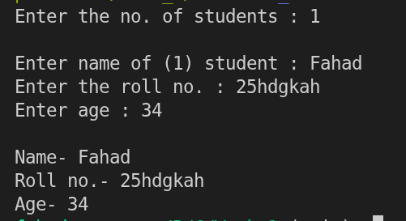
#include <stdio.h>

struct student_info
{
char name[81];
char roll_no[21];
int age;
};
typedef struct student_info stud;

int main()
{
int n,i;

printf("Enter the no. of students : ");
scanf("%d",&n);
stud s[n];

for(i=0;i<n;i++)
{

getchar();
printf("\nEnter name of (%d) student : ",i+1);
fgets(s[i].name, 81, stdin);

printf("Enter the roll no. : ");
fgets(s[i].roll_no, 21, stdin);

printf("Enter age : ");
scanf("%d", &s[i].age);

printf("\nName- %sRoll no.- %sAge- %d\n", s[i].name, s[i].roll_no, s[i].age);
}
}

Q2- Write a C program to add two distances (in inch-feet) system using structure.

#include <stdio.h>
struct distances
{
int feet;
int inches;
};

int main()
{
struct distances d1, d2, d3;

printf("Enter the distance in (feet and inches) : ");
scanf("%d%d", &d1.feet, &d1.inches);
printf("Enter the 2nd distance in (feet and inches): ");
scanf("%d%d", &d2.feet, &d2.inches);
d3.feet = d1.feet + d2.feet;
d3.inches = d1.inches + d2.inches;
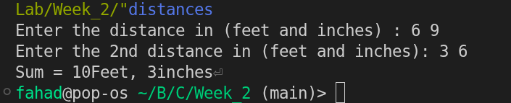
if (d3.inches >= 12)
{
d3.feet += d3.inches / 12;
d3.inches = d3.inches % 12;
}

printf("Sum = %dFeet, %dinches", d3.feet, d3.inches);
}
Q3- Write a C program to add two complex numbers by passing structure to a function.

#include <stdio.h>
struct complex{
float imaginary;
float real;
};
typedef struct complex complex;

complex complex_sum(complex s1, complex s2){
complex temp;
temp.imaginary = s1.imaginary + s2.imaginary;
temp.real = s1.real + s2.real;
return temp;
}
int main(){
complex s1, s2, result;
printf("Enter the real and imaginary part : ");
scanf("%f%f", &s1.real, &s1.imaginary);

printf("Enter the real and imaginary part : ");
scanf("%f%f", &s2.real, &s2.imaginary);
result = complex_sum(s1, s2);
printf("Result = %.2f + %.2fi", result.real, result.imaginary);
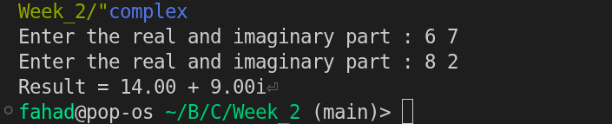
}

Q4- Write a C program to calculate the difference between the two time periods (HH: MM: SS).
#include <stdio.h>

struct time
{
int hour;
int min;
int sec;
};
typedef struct time time;

time time_diff(time t1, time t2)
{
time temp;
t1.sec = t1.hour * 3600 + t1.min * 60 + t1.sec;
t2.sec = t2.hour * 3600 + t2.min * 60 + t2.sec;
if (t1.sec > t2.sec)
{
temp.sec = t1.sec - t2.sec;
}

else
{
temp.sec = t2.sec - t1.sec;
}

temp.hour = temp.sec / 3600;
temp.sec = temp.sec % 3600;

temp.min = temp.sec / 60;
temp.sec = temp.sec % 60;

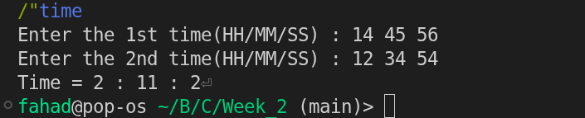
return temp;
}

int main()
{
time t1, t2, t3;

printf("Enter the 1st time(HH/MM/SS) : ");
scanf("%d%d%d", &t1.hour, &t1.min, &t1.sec);
printf("Enter the 2nd time(HH/MM/SS) : ");
scanf("%d%d%d", &t2.hour, &t2.min, &t2.sec);

t3 = time_diff(t1, t2);
printf("Time = %d : %d : %d", t3.hour, t3.min, t3.sec);
}

Q5- Write a C program to store information using structures and pointers with dynamic memory allocation.

#include <stdio.h>
#include <stdlib.h>

struct commodity_data
{
char name[81];
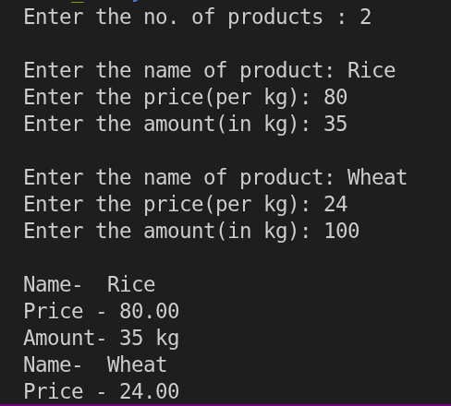
int amount;
float price;
};
typedef struct commodity_data co_data;

int main()
{
int n;
printf("Enter the no. of products : ");
scanf("%d", &n);

co_data *p = (co_data *)malloc(n * sizeof(co_data));

for (int i = 0; i < n; i++)
{
getchar();
printf("\nEnter the name of product: ");
fgets((p + i)->name, sizeof((p + i)->name), stdin);

printf("Enter the price(per kg): ");
scanf("%f", &(p + i)->price);

printf("Enter the amount(in kg): ");
scanf("%d", &(p + i)->amount);
}

for (int i = 0; i < n; i++)
{
printf("\nName- %s", (*(p + i)).name);

printf("Price - %.2f", (*(p + i)).price);

printf("\nAmount- %d kg", (*(p + i)).amount);
}
}

Week- 3
Q1- Write a C program that uses functions to perform the following operations on an array
a. Create an array of size 25 and insert the element of your choice
b. Delete the element at the beginning, middle, and end and adjust the Array.
c. Insert the element at the particular locations in the Array.
d. Display all the elements

#include <stdio.h>
void insertion(int a[], int n, int *m, int item, int k){
int i;
if (*m == (n - 1))
printf("Array full (insertion not possible)\n");
else if (k < 0 || k > (*m + 1))
printf("Invalid value of index for insertion\n");
else{
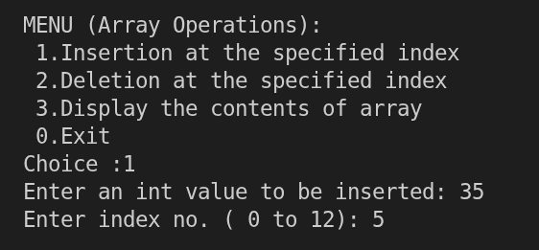
for (i = *m; i >= k; i--)
a[i + 1] = a[i];
a[k] = item;
*m = *m + 1;
}}
void deletion(int a[], int *m, int k){
int i;
if (*m == -1)
printf("Array empty (deletion not possible)\n");
else if (k < 0 || k > (*m))
printf("Invalid value of array index for deletion\n");
else{
for (i = k + 1; i <= (*m); i++)
a[i - 1] = a[i];
*m = *m - 1;
}
}
void traversal(int a[], int n, int m){
int i = 0;
if (m == -1){
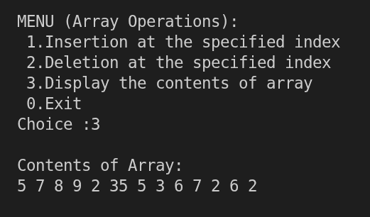
printf("\nArray empty\n");
return;
}
printf("\nContents of Array:\n");
for (i = 0; i <= m; i++)
printf("%d ", a[i]);
printf("\n");
}
int main(){
const int n = 25;
int choice, item, mid, index;
int arr[25] = {5, 7, 8, 9, 2, 5, 3, 6, 7, 2, 6, 2};
int m = 11;

do
{
printf("\nMENU (Array Operations):");
printf("\n 1.Insertion at the specified index");
printf("\n 2.Deletion at the specified index");
printf("\n 3.Display the contents of array");
printf("\n 0.Exit");
printf("\nChoice :");
scanf("%d", &choice);

switch (choice)
{
case 1:
printf("Enter an int value to be inserted: ");
scanf("%d", &item);
printf("Enter index no. ( 0 to %d): ", m + 1);
scanf("%d", &index);
insertion(arr, n, &m, item, index);
break;

case 2:
printf("Enter index no.: ( <= %d): ", m);
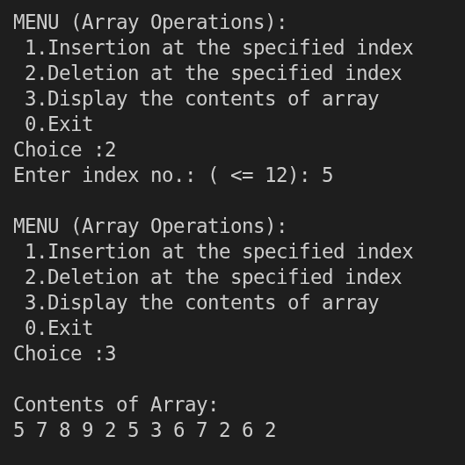
scanf("%d", &index);
deletion(arr, &m, index);
break;

case 3:
traversal(arr, n, m);
break;
}
} while (choice != 0);
}

Q2- Write a C Program to merge two sorted arrays into one sorted array.
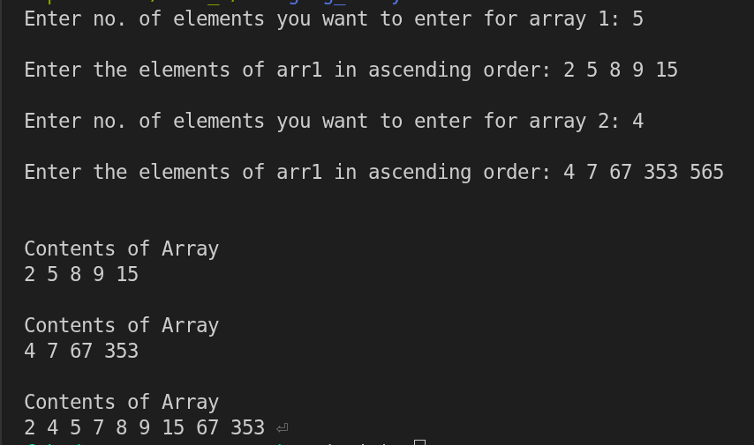
#include <stdio.h>
void array_print(int arr[], int n){
int i;
printf("\n\nContents of Array\n");
for (i = 0; i < n; i++){
printf("%d ", arr[i]);
}
}
int main(){
int i, j, l, n1, n2;
printf("Enter no. of elements you want to enter for array 1: ");
scanf("%d", &n1);
int arr1[n1];
printf("\nEnter the elements of arr1 in ascending order: ");
for (i = 0; i < n1; i++){
scanf("%d", &arr1[i]);
}
printf("\nEnter no. of elements you want to enter for array 2: ");
scanf("%d", &n2);
int arr2[n2];
printf("\nEnter the elements of arr1 in ascending order: ");
for (i = 0; i < n2; i++){
scanf("%d", &arr2[i]);
}
int arr3[n1 + n2];
i = 0, j = 0, l = 0;
while (i < n1 && j < n2){
if (arr1[i] < arr2[j])
{
arr3[l] = arr1[i];
i++;
}
else
{
arr3[l] = arr2[j];
j++;
}
l++;
}
while (i < n1)
{
arr3[l] = arr1[i];
i++, l++;
}
while (j < n2)
{
arr3[l] = arr2[j];
j++;
l++;
}

array_print(arr1, n1);
array_print(arr2, n2);
array_print(arr3, (n1 + n2));
}
Q3- Write a C Program to traverse the array using pointers.

#include <stdio.h>

int main()
{
int n, i;
printf("Enter the size of array: ");
scanf("%d", &n);
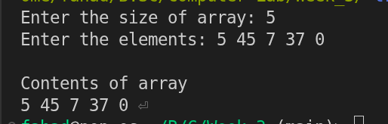
int arr[n];
int *ptr = arr;

printf("Enter the elements: ");
for (i = 0; i < n; i++)
{
scanf("%d", ptr + i);
}

printf("\nContents of array\n");
for (i = 0; i < n; i++)
{
printf("%d ", *(ptr + i));
}
}
Q4- Write a C Program that takes an index as input and prints the element of the array at that index using pointer arithmetic.
#include <stdio.h>
int main(){
int n;
printf("Enter size of array: ");
scanf("%d", &n);
int arr[n];
int *ptr = arr;
printf("Enter elements of the array:\n");
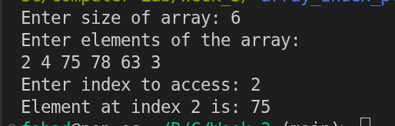
for (int i = 0; i < n; i++)
scanf("%d", &arr[i]);

int index;
printf("Enter index to access: ");
scanf("%d", &index);

if (index >= 0 && index < n)
{
printf("Element at index %d is: %d\n", index, *(ptr + index));
}
else
{
printf("Invalid index!\n");
}

return 0;
}
Week- 4
Q1- Write a C program that uses functions to perform the following operations on a singly linked list
1# Creation
2# Insertion
- At beginning
- At middle
- At end
3# Deletion
- At beginning
- At middle
- At end
4# Traversal.
#include <stdio.h>
#include <stdlib.h>

struct node {
int data;
struct node *next;
};

struct node *head = NULL;

void insert_begin() {
struct node *newnode;
int value;
newnode = (struct node *)malloc(sizeof(struct node));
printf("Enter value: ");
scanf("%d", &value);
newnode->data = value;
newnode->next = head;
head = newnode;
printf("Inserted at beginning.\n");
}

void insert_end() {
struct node *newnode, *temp;
int value;
newnode = (struct node *)malloc(sizeof(struct node));
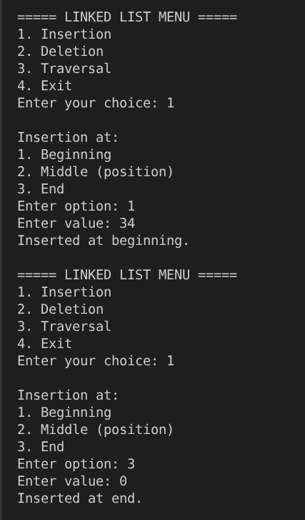
printf("Enter value: ");
scanf("%d", &value);
newnode->data = value;
newnode->next = NULL;
if (head == NULL) {
head = newnode;
return;
}
temp = head;
while (temp->next != NULL)
temp = temp->next;
temp->next = newnode;
printf("Inserted at end.\n");
}

void insert_middle() {
struct node *newnode, *temp;
int value, pos, i;
printf("Enter position: ");
scanf("%d", &pos);
if (pos == 1) {
insert_begin();
return;
}
newnode = (struct node *)malloc(sizeof(struct node));
printf("Enter value: ");
scanf("%d", &value);
newnode->data = value;
temp = head;
for (i = 1; i < pos - 1 && temp != NULL; i++)
temp = temp->next;
if (temp == NULL) {
printf("Invalid position\n");
free(newnode);
return;
}
newnode->next = temp->next;
temp->next = newnode;
printf("Inserted at position %d.\n", pos);
}

void delete_begin() {
struct node *temp;
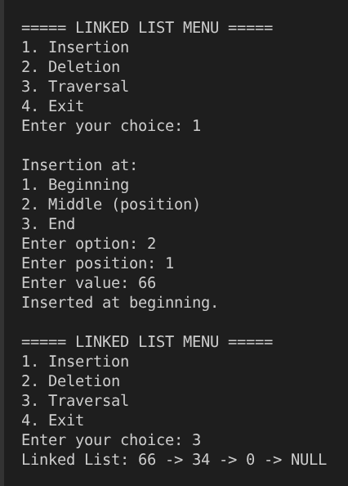
if (head == NULL) {
printf("List empty.\n");
return;
}
temp = head;
head = head->next;
free(temp);
printf("Deleted first node.\n");
}

void delete_end() {
struct node *temp, *prev;
if (head == NULL) {
printf("List empty.\n");
return;
}
if (head->next == NULL) {
free(head);
head = NULL;
return;
}
temp = head;
while (temp->next != NULL) {
prev = temp;
temp = temp->next;
}
prev->next = NULL;
free(temp);
printf("Deleted last node.\n");
}

void delete_middle() {
struct node *temp, *prev;
int pos, i;
printf("Enter position: ");
scanf("%d", &pos);
if (pos == 1) {
delete_begin();
return;
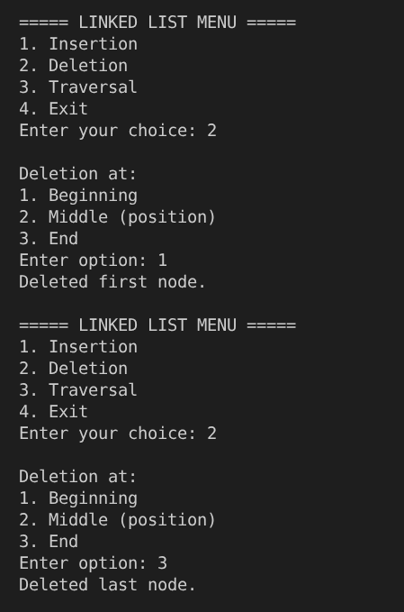
}
temp = head;
for (i = 1; i < pos && temp != NULL; i++) {
prev = temp;
temp = temp->next;
}
if (temp == NULL) {
printf("Invalid position\n");
return;
}
prev->next = temp->next;
free(temp);
printf("Deleted node at position %d.\n", pos);
}

void traversal() {
struct node *temp = head;
if (head == NULL) {
printf("List empty.\n");
return;
}
printf("Linked List: ");
while (temp != NULL) {
printf("%d -> ", temp->data);
temp = temp->next;
}
printf("NULL\n");
}

int main() {
int choice, subchoice;
do {
printf("\n===== LINKED LIST MENU =====\n");
printf("1. Insertion\n");
printf("2. Deletion\n");
printf("3. Traversal\n");
printf("4. Exit\n");
printf("Enter your choice: ");
scanf("%d", &choice);

switch (choice) {
case 1:
printf("\nInsertion at:\n");
printf("1. Beginning\n");
printf("2. Middle (position)\n");
printf("3. End\n");
printf("Enter option: ");
scanf("%d", &subchoice);
if (subchoice == 1)
insert_begin();
else if (subchoice == 2)
insert_middle();
else if (subchoice == 3)
insert_end();
else
printf("Invalid insertion option.\n");
break;

case 2:
printf("\nDeletion at:\n");
printf("1. Beginning\n");
printf("2. Middle (position)\n");
printf("3. End\n");
printf("Enter option: ");
scanf("%d", &subchoice);
if (subchoice == 1)
delete_begin();
else if (subchoice == 2)
delete_middle();
else if (subchoice == 3)
delete_end();
else
printf("Invalid deletion option.\n");
break;

case 3:
traversal();
break;

case 4:
printf("Exiting program...\n");
break;

default:
printf("Invalid choice. Try again.\n");
}
} while (choice != 4);
return 0;
}

Week- 5
Q1- 1. Write a C program that uses functions to perform the following operations on a doubly linked list
1# Creation
2# Insertion
- At beginning
- At middle
- At end
3# Deletion
- At beginning
- At middle
- At end
4# Traversal.
#include <stdio.h>
#include <stdlib.h>

struct node {
int data;
struct node *prev;
struct node *next;
};

struct node *head = NULL;

void insert_begin() {
struct node *newnode;
int value;
newnode = (struct node *)malloc(sizeof(struct node));
printf("Enter value: ");
scanf("%d", &value);
newnode->data = value;
newnode->prev = NULL;
newnode->next = head;
if (head != NULL) head->prev = newnode;
head = newnode;
printf("Inserted at beginning.\n");
}

void insert_end() {
struct node *newnode, *temp;
int value;
newnode = (struct node *)malloc(sizeof(struct node));
printf("Enter value: ");
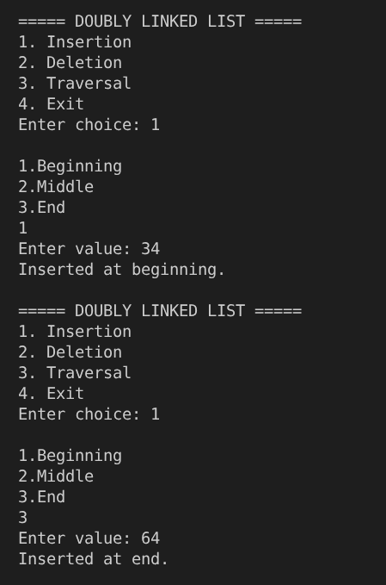
scanf("%d", &value);
newnode->data = value;
newnode->next = NULL;
if (head == NULL) {
newnode->prev = NULL;
head = newnode;
return;
}
temp = head;
while (temp->next != NULL) temp = temp->next;
temp->next = newnode;
newnode->prev = temp;
printf("Inserted at end.\n");
}

void insert_middle() {
struct node *newnode, *temp;
int pos, i, value;
printf("Enter position: ");
scanf("%d", &pos);
if (pos == 1) {
insert_begin();
return;
}
newnode = (struct node *)malloc(sizeof(struct node));
printf("Enter value: ");
scanf("%d", &value);
newnode->data = value;
temp = head;
for (i = 1; i < pos - 1 && temp != NULL; i++) temp = temp->next;
if (temp == NULL) {
printf("Invalid position\n");
free(newnode);
return;
}
newnode->next = temp->next;
newnode->prev = temp;
if (temp->next != NULL) temp->next->prev = newnode;
temp->next = newnode;
printf("Inserted at position %d\n", pos);
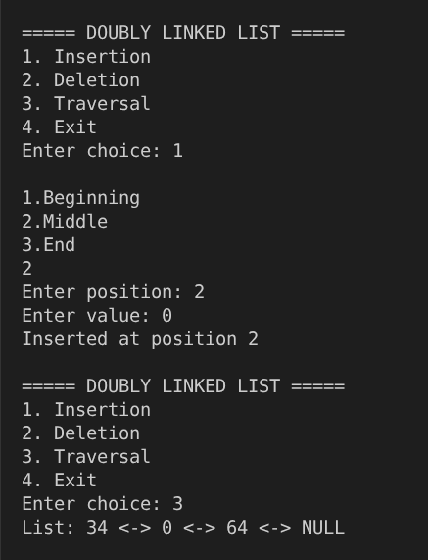
}

void delete_begin() {
struct node *temp;
if (head == NULL) {
printf("List empty.\n");
return;
}
temp = head;
head = head->next;
if (head != NULL) head->prev = NULL;
free(temp);
printf("First node deleted.\n");
}

void delete_end() {
struct node *temp;
if (head == NULL) {
printf("List empty.\n");
return;
}
temp = head;
while (temp->next != NULL) temp = temp->next;
if (temp->prev != NULL) temp->prev->next = NULL;
else head = NULL;
free(temp);
printf("Last node deleted.\n");
}

void delete_middle() {
struct node *temp;
int pos, i;
printf("Enter position: ");
scanf("%d", &pos);
if (pos == 1) {
delete_begin();
return;
}
temp = head;
for (i = 1; i < pos && temp != NULL; i++) temp = temp->next;
if (temp == NULL) {
printf("Invalid position\n");
return;
}
if (temp->prev != NULL) temp->prev->next = temp->next;
if (temp->next != NULL) temp->next->prev = temp->prev;
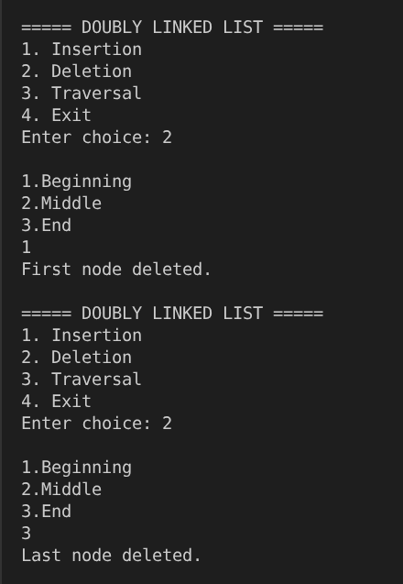
free(temp);
printf("Node deleted at position %d\n", pos);
}

void traversal() {
struct node *temp = head;
if (head == NULL) {
printf("List empty.\n");
return;
}
printf("List: ");
while (temp != NULL) {
printf("%d <-> ", temp->data);
temp = temp->next;
}
printf("NULL\n");
}

int main() {
int choice, subchoice;
do {
printf("\n===== DOUBLY LINKED LIST =====\n");
printf("1. Insertion\n2. Deletion\n3. Traversal\n4. Exit\nEnter choice: ");
scanf("%d", &choice);

switch (choice) {
case 1:
printf("\n1.Beginning\n2.Middle\n3.End\n");
scanf("%d", &subchoice);
if (subchoice == 1) insert_begin();
else if (subchoice == 2) insert_middle();
else if (subchoice == 3) insert_end();
else printf("Invalid option\n");
break;

case 2:
printf("\n1.Beginning\n2.Middle\n3.End\n");
scanf("%d", &subchoice);
if (subchoice == 1) delete_begin();
else if (subchoice == 2) delete_middle();
else if (subchoice == 3) delete_end();
else printf("Invalid option\n");
break;
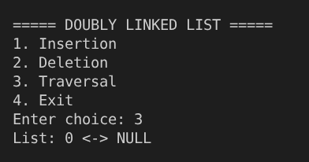
case 3:
traversal();
break;

case 4:
printf("Program ended.\n");
break;

default:
printf("Invalid choice\n");
}
} while (choice != 4);
return 0;
}

