Note: PocMemoryManagement has been renamed to MemoryManagement

The Purpose of the Change
We want to support hierarchical-P picture (HPP) coding with temporal scalability for low-delay applications. For example, we want to support the type of coding structure shown in Figure 1 where frames do not predict from higher temporal layer frames. In the below figure frames are vertically placed according to their temporal layer value: Frames 0, 4, 8, … are in temporal layer 0 (TL0), Frames 2, 6, 10, … are in TL1, and Frames 1, 3, 5, … are in TL2. The frames are also horizontally placed and numbered according to their captured/display time. The letters below each frame represent the encoding order. Note that due to the constraint where frames do not predict from higher temporal layer frames, we can achieve temporal scalability. Assuming the frames are encoded at 30 FPS, we can achieve 15 FPS by discarding TL2 frames (Frames 1, 3, 5, …) without disrupting decodability of TL0 and TL1 frames. We can further reduce the frame rate to 7.5 FPS by also discarding TL1 frames.
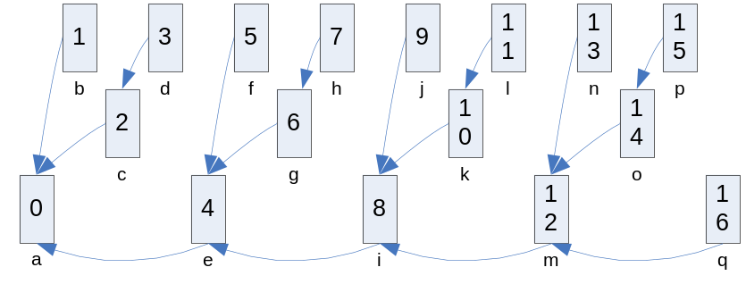
Figure 1: An example of HPP coding structure with temporal scalability.

Current State of JM (v. 16.1)
We can achieve similar HPP coding structure as shown in Figure 1 by using the following configuration:
PReplaceBSlice = 1
NumberBFrames = 3
HierarchicalCoding = 3
ExplicitHierarchyFormat = "p0e4p1r3p2e4"

This will produce the structure as shown in Figure 2.
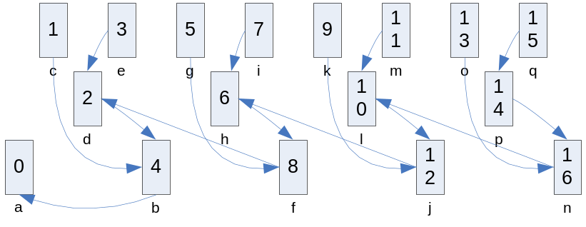
Figure 2: An example of HPP coding structure using JM.

In addition to the above configuration, we can set ReferenceReorder = 1, and get the structure as shown in Figure 3.
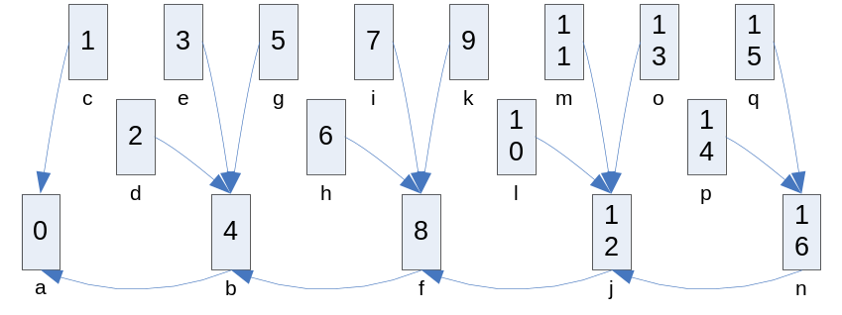
Figure 3: An example of HPP coding structure using JM with ReferenReorder = 1.

Note that for Figures 2 and 3, Frame 4 is encoded prior to Frames 1, 2, and 3, causing delay.

Modifications to JM
- Low delay support for HPP coding

A new parameter LowDelay is added in the config file.

In addition to the configuration used to generate the structure shown in Figure 3, setting LowDelay = 1 generates the following structure.
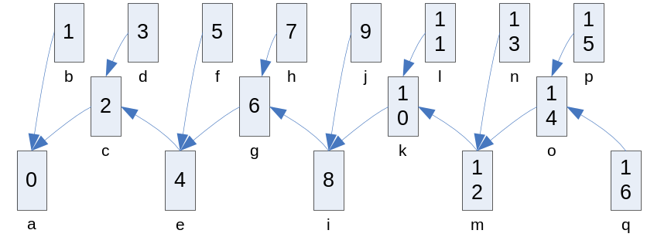
Figure 4: An example of HPP coding structure using JM with ReferenReorder = 1 and LowDelay = 1.

Note that there is no encoding delay as frames are encoded in the captured/display order.

- General temporal scalability support

- Added an optional notation to ExplicitHierarchyFormat as a way to indicate temporal layer of B/P frames. For the temporal structure shown in Figure 1, we can set ExplicitHierarchyFormat = "p0e4t2p1r3t1p2e4t2”. “t#” is optional and, when specified, it assigns a temporal layer # to each frame. When the optional notation is not used, all frames are marked as TL0 frames.
- Added another option to ReferenceReorder (ReferenceReorder = 2). If ReferenceReorder = 2, then reorder references according to POC and then use only the frames that has valid temporal layer values to ensures that frames do not predict from higher temporal layer frames.

Using the following configuration, we get the structure as shown in Figure 1.
LowDelay = 1
PReplaceBSlice = 1
NumberBFrames = 3
HierarchicalCoding = 3
ExplicitHierarchyFormat = "p0e4t2p1r3t1p2e4t2"
ReferenReorder = 2

Now assume that NumberReferenceFrames = 4 is used with the above configuration. Then the frames used as reference frames for encoding Frames 13, 14, 15, and 16 are shown in the below figure. The frames in red are reference frames.
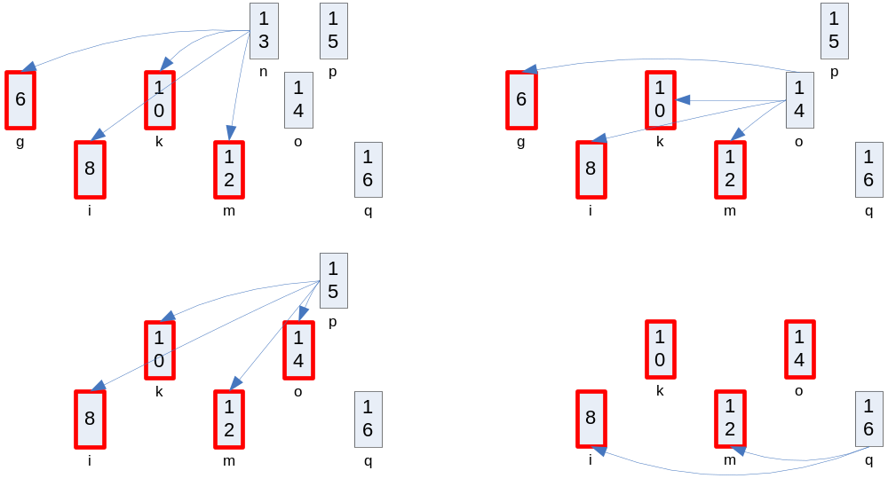
Figure 5: The reference frames that are used to encode Frames 13, 14, 15, and 16 of the coding structure shown in Figure 1 with ReferenReorder = 2, LowDelay = 1 and NumberReferenceFrames = 4.

Note that even though NumberReferenceFrames is set to 4, TL0 frames get to use at most 2 reference frames.

- Added another option to MemoryManagement (MemoryManagement = 2). If MemoryManagement = 2, then after encoding a reference frame with temporal layer T, create a list of MMCO commands to delete higher temporal layer frames.

Using MemoryManagement = 2 with the configuration used for Figure 5, we get the following reference frames use for encoding Frames 13, 14, 15, and 16.
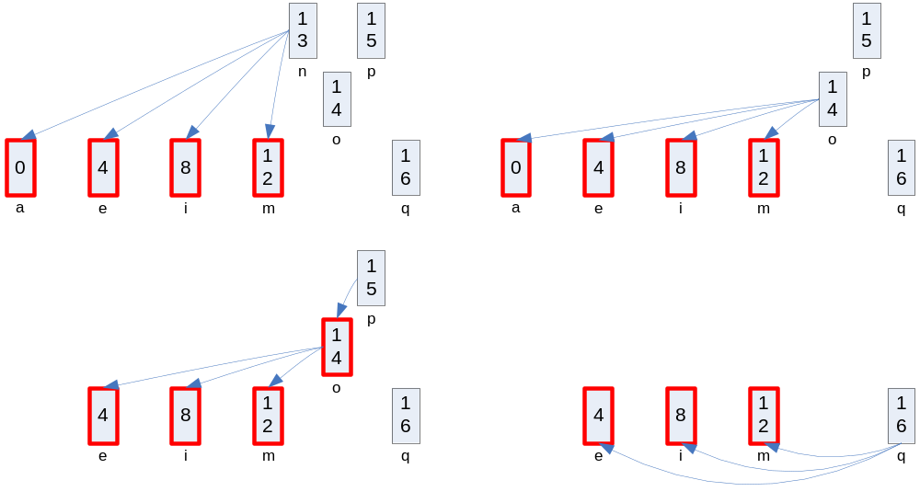
Figure 6: The reference frames that are used to encode Frames 13, 14, 15, and 16 of the coding structure shown in Figure 1 with ReferenReorder = 2, LowDelay = 1, NumberReferenceFrames = 4 and MemoryManagement = 2.

Note that even with this change, when NumberReferenceFrames is set to 4, TL0 frames get to use at most 3 reference frames.

- List of files that are changed for the modifications described above

The following are modified for the config file related modifications:
- params.h in lcommon
- configfile.h and configfile.c in lencode

The following is modified to support LowDelay = 1
- pred_struct.c in lencode
  - modified init_pred_struct() only for the case where ExplicitHierarchyFormat is used; for all other cases, the LowDelay parameter has no effect

The following are modified so that each frame is marked with a temporal value:
- global.h in lencode: added a variable temporal_layer in the GOP_DATA structure
- mbuffer.h in lencode: added a variable temporal_layer in the StorablePicture structure
- pred_struct_types.h in lencode: added a variable temporal_layer in the PredStructFrm structure and also in the FrameUnitStruct structure

The following are modified to support the optional notation added to ExplicitHierarchyFormat:
- explicit_gop.c in lencode
  - modified interpret_gop_structure()
- pred_struct.c in lencode
  - modified init_gop_struct() and init_pred_struct()

The following are modified to support the ReferenceReorder = 2:
- list_reorder.h and list_reorder.c in lencode
  - modified init_ref_pic_list_reordering() and reorder_lists()
  - added tlyr_ref_pic_reorder_frame_default()

The following are modified to support the MemoryManagement = 2:
- mmco.h and mmco.c in lencode
  - added tlyr_based_ref_management_frame_pic()

The following is modified for the above related changes:
- slice.c in lencode

