SE ENABLEMENT PLATFORM · NEW-HIRE ONBOARDING
New-Hire Onboarding Workflow
The full workflow across hiring manager, mentor and new hire

Version: 1.1, October 27, 2026. Updated after a second end-to-end walkthrough.
For: Enablement leads and anyone who wants the end-to-end picture.
Walkthroughs: recorded on the live platform twice: first with Bill Smith (hiring manager), Matt Giblin (mentor) and Kevin Jones (new hire), then with Kathy Jones (hiring manager), Matt Giblin (mentor) and two new hires, Steve Smith and Susan Left. Text visible in the screens, such as briefs, notes and pitches, is example content from those walkthroughs; the Fill in boxes describe what you enter.
Companion guides: this is one of three role guides (hiring manager, mentor, new hire). A combined workflow guide covers all three.

Contents
Contents
Overview
Who does what
The workflow at a glance
Rules that shape the workflow
Section 1 — Hiring manager: set up the new hire
Section 2 — Mentor: meet the new hire and set the schedule
Section 3 — New hire: work through the ramp
Section 4 — Review and progress
Mentor: review a submitted step
Hiring manager: check progress
Section 5 — New hire: practise beyond the ramp
Section 6 — Extra work the manager assigns
Hiring manager: assign and review
New hire: work it
Appendix A — Notifications
Appendix B — Quality notes from the walkthroughs

Overview
Onboarding a new Solutions Engineer involves three people. The hiring manager sets the new hire up and owns the stage gates. The mentor meets the new hire, agrees the due dates with them and reviews their everyday work. The new hire works through the ramp plan one step at a time.
Beyond the plan, the new hire practises on their own, and the manager can assign extra work, such as a playbook chapter ahead of a deal, that has no mentor and scores itself.
This guide follows that order. Each section starts again at step 1, and every step explains why it matters. Screens are shown as they appear in the platform; text visible in them is example content from the walkthroughs. The Fill in boxes describe what you enter.

Who does what
Role | In this walkthrough | Responsibilities
Hiring manager | Kathy Jones (Bill Smith in earlier screens) | Writes the hiring brief, assigns the onboarding program and the mentor, schedules 1:1s, signs off every stage gate, assigns extra work and watches progress.
Mentor | Matt Giblin | Reads the brief, holds the first 1:1, sets the due dates with the new hire, approves or sends back everyday steps and logs check-ins.
New hire | Steve Smith and Susan Left (Kevin Jones in earlier screens) | Works through the ramp plan, submits each step with evidence, acts on feedback, practises beyond the plan and completes extra work the manager assigns.

The workflow at a glance
Phase | Who | Outcome
1 | Hiring manager | The new hire has a hiring brief, a mentor and a four-stage onboarding program (Days 1–30 to Days 91–120).
2 | Mentor | The first 1:1 has happened and the due dates are agreed. The new hire and manager are told.
3 | New hire | Steps are completed and submitted with evidence.
4 | Mentor and manager | The mentor approves or sends back everyday steps. The manager signs off stage gates and tracks progress.
5 | New hire | Practises beyond the plan: pitches, knowledge checks and simulations, private unless shared.
6 | Manager and new hire | The manager assigns extra work; it scores itself, and the manager is told when it's finished and can read what was said.

Rules that shape the workflow
- The mentor sets the due dates. The template's dates are only a starting point. The mentor agrees the real dates with the new hire at their first meeting, and the platform tells the new hire and the manager straight away. No approval is needed.
- The mentor approves everyday steps. Reading, pitches, knowledge checks, challenges and simulations go to the mentor.
- The manager signs off stage gates. Test-outs and the end-of-stage sign-off unlock the next stage, so they stay with the hiring manager.
- Mentoring appears only for mentors. The Mentoring area shows in the sidebar only for people assigned as someone's mentor.
- Details open in a workbench. Clicking a person, step or item opens a full popup workbench over the page. Press Esc or the close button to return.
- Extra work belongs to whoever assigned it. Work assigned outside the plan has no mentor review; it scores itself and reports to the manager.

Section 1 — Hiring manager: set up the new hire
Signed in as the hiring manager. Before you start, the new hire must have an account and report to you.

1. Find the new hire on Today
- Open Today from the sidebar.
- Find the new hire under Your team, most urgent first. A new starter shows New to the team, no ramp plan yet.

Why it matters: Today lists everyone who needs you, most urgent first. A new starter is flagged for onboarding, not as at risk, so you can see straight away what to do.
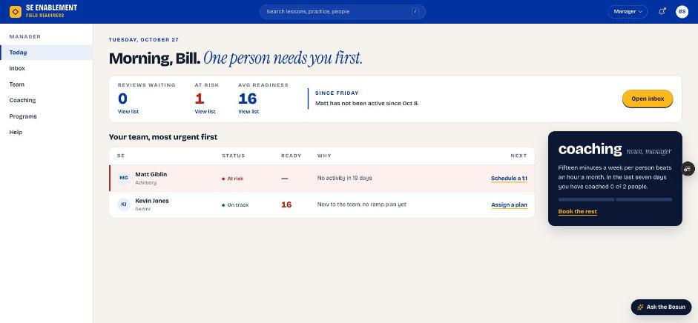
Figure 1.1 — Manager Today page with the new hire waiting for a plan

2. Open the new hire's profile workbench
- Click the new hire's name. Their profile opens as a workbench.
- The left side shows the overview, counters, Suggested next and assigned work. The right side holds Mentor and notes.
- If you've typed something and press Esc or close, you're asked first, so unsaved text isn't lost.

Why it matters: Everything you need for onboarding is in one place: the brief, the mentor, the plan and the 1:1 scheduler. You don't need to move between pages.
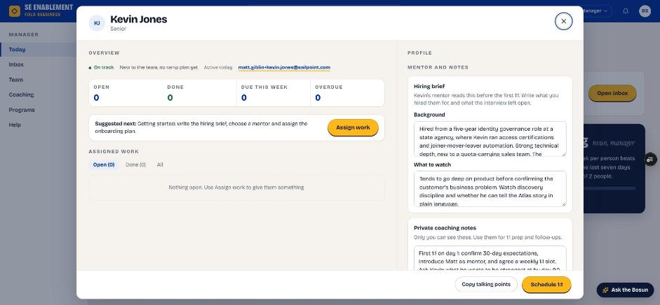
Figure 1.2 — The profile workbench

3. Write the hiring brief
- In Hiring brief, complete both fields.
- Click Save hiring brief. The confirmation says it's saved; the mentor sees it once you choose one in step 6.

Fill in: Background: what you hired this person for: their experience, strengths and the role they're stepping into. What to watch: what the interviews left open and what the mentor should keep an eye on in the first weeks.

Why it matters: The mentor reads the brief before the first 1:1. It gives them the context to coach from day one instead of starting cold.
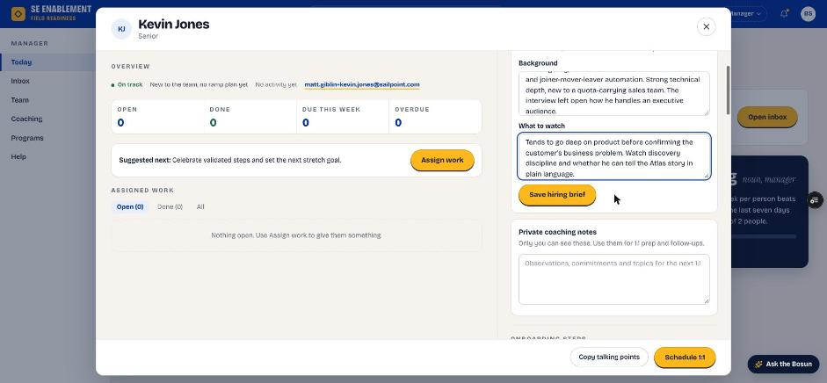
Figure 1.3 — Hiring brief fields
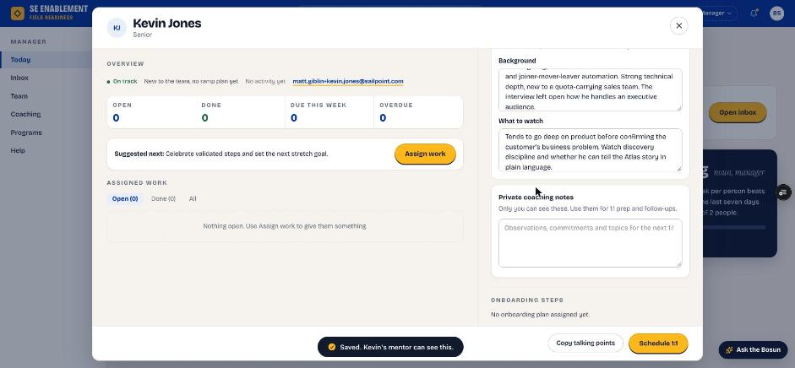
Figure 1.4 — Brief saved and shared with the mentor

4. Add private coaching notes
- In Private coaching notes, add your own notes.
- Click Save notes.

Fill in: Your goals for the first 1:1, anything to follow up on, and what you want the new hire to be strongest at by the end of the program. Only you can see these notes.

Why it matters: These notes are your preparation for 1:1s and follow-ups. They stay private, so you can be candid.
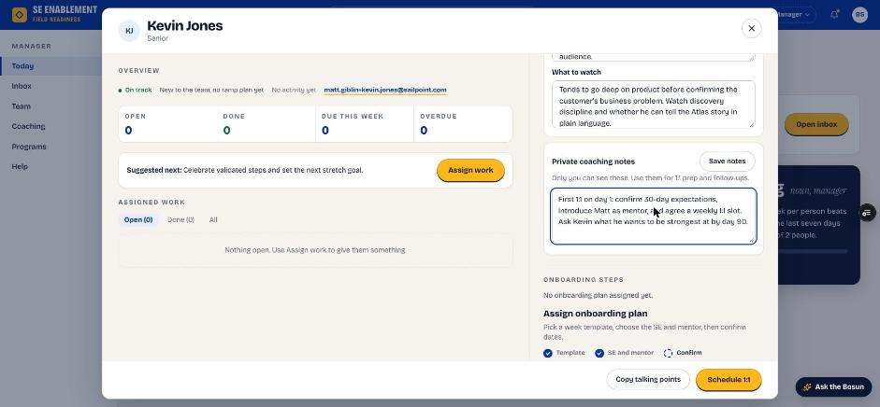
Figure 1.5 — Private coaching notes
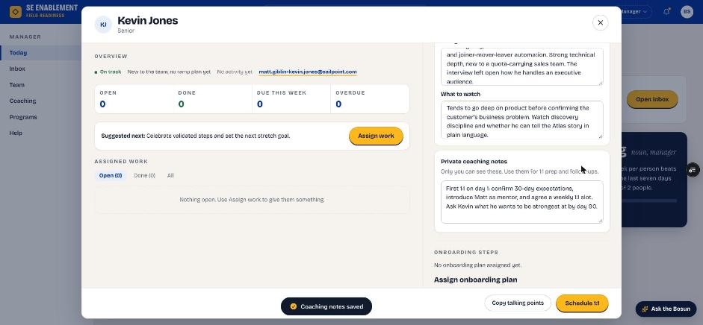
Figure 1.6 — Notes saved

5. Choose the onboarding template
- Click Assign a plan, on Today, under Suggested next or in the profile. The plan form opens in its own workbench.
- Under Step 1, Template, choose the first stage of the new-hire program (Days 1–30 — Foundation). Check the stage length and step count.

Why it matters: The program has four 30-day stages. Assigning the first stage starts the program, and later stages unlock as each stage gate is signed off. Start experienced hires here too: they can take a stage's test-outs straight away, and when you sign off the gates the rest of the stage closes as tested out.
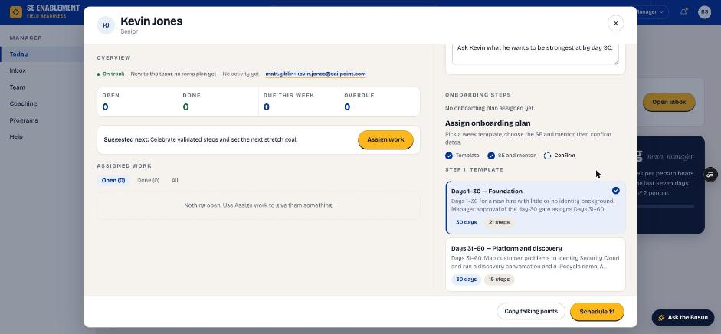
Figure 1.7 — Choosing the Days 1–30 template

6. Choose the person, mentor and start date
- Assign to: the new hire.
- Mentor: an experienced SE who will coach them. Only experienced people are offered; new hires aren't.
- If you leave No mentor, you're asked to confirm. The new hire is then told you'll set up their first 1:1, and you can add a mentor later from Assigned mentor, which notifies everyone involved.
- Start date: the new hire's first day.
- Target completion fills in from the template.

Fill in: Assign to, Mentor and Start date. Leave Target completion as suggested; the mentor will confirm the final dates.

Why it matters: The mentor you choose is who the new hire works with every week and who reviews their everyday steps. Target completion is a starting point because the mentor agrees the real dates with the new hire.
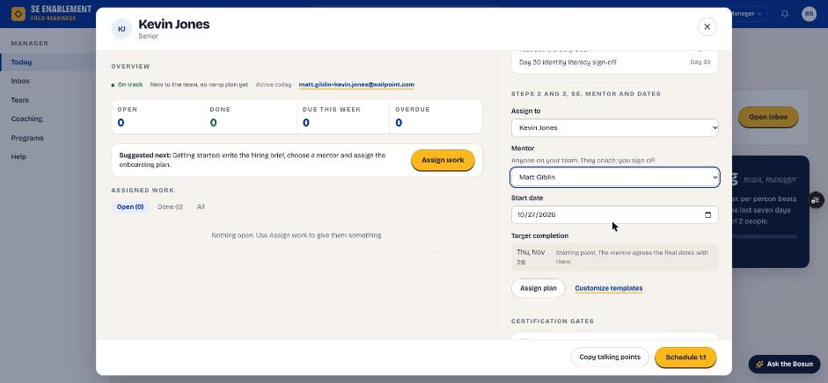
Figure 1.8 — Assign to, mentor, start date and target completion

7. Assign the plan
- Click Assign plan.
- The profile stays open, the steps appear with their starting dates, and a confirmation appears.

Why it matters: Assigning notifies both people. The new hire is told who their mentor is and that dates are agreed at the first 1:1. The mentor is told they've been chosen and what to do next.
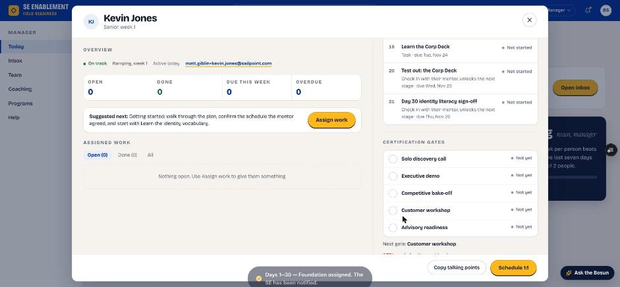
Figure 1.9 — Plan assigned; the new hire has been notified
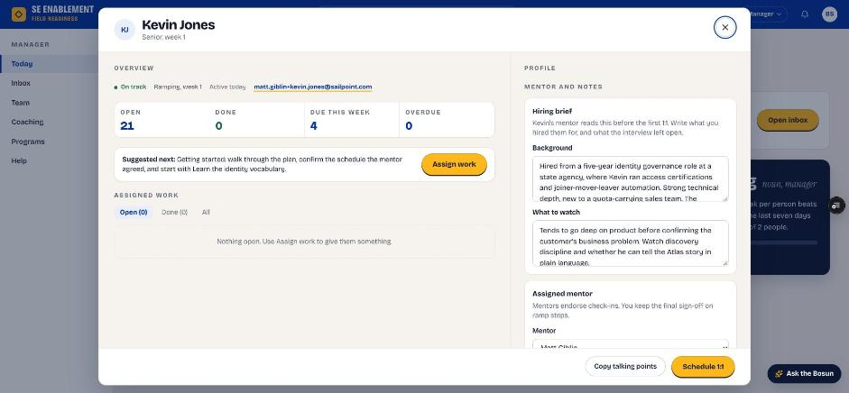
Figure 1.10 — Profile after assignment: counters, brief and mentor

8. Schedule a 1:1 with the new hire
- In the profile footer, click Schedule 1:1.
- Pick the date, time and length, and choose whether the mentor joins. Times that have passed can't be picked.
- Click Schedule and download invite, then open the downloaded invite to send it from your calendar.

Fill in: Date, time and length of the meeting. Tick the mentor box if they should join.

Why it matters: The 1:1 is saved in the platform. The new hire sees it under Coming up on their Today page, they (and the mentor, if invited) get a notification, and the profile shows Next 1:1. Today then shows 1:1 booked instead of suggesting one.
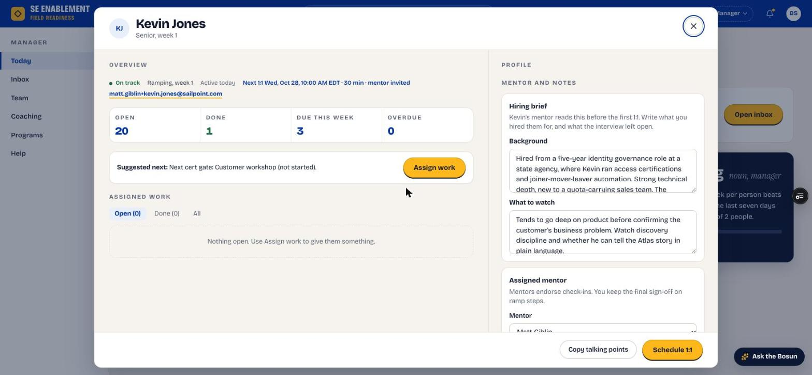
Figure 1.11 — The profile shows the next 1:1 and whether the mentor is invited

Section 2 — Mentor: meet the new hire and set the schedule
Signed in as the mentor. The Mentoring area appears in your sidebar once you're assigned as someone's mentor.

1. See your new mentee on Today
- Open Today. The You're mentoring card names the new hire and the next move: read the hiring brief, meet them, then set the schedule together.
- If the hiring manager has booked a 1:1 and invited you, the card shows 1:1 booked with the date and time.
- Click Read the brief to go straight to the new hire's workbench. Once the schedule is set, the button reads Open workbench.
- If you're also a manager or admin, the same card appears on your Manager Today, so you don't need to switch workspace.

Why it matters: Your first job is clear from the moment you sign in, without having to find it in notifications.
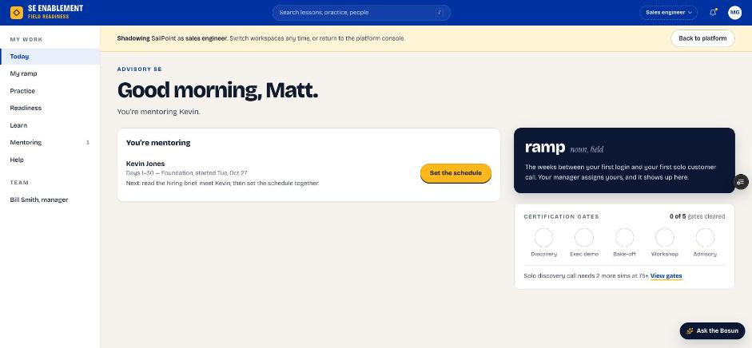
Figure 2.1 — Mentor Today page with the You're mentoring card

2. Open Mentoring
- Click Mentoring in the sidebar.
- Each mentee has a row showing their program, progress, any 1:1 booked, your Last 1:1, and anything waiting on you.

Why it matters: Mentoring is your home for every mentee. It shows who needs a meeting, a schedule or a review.
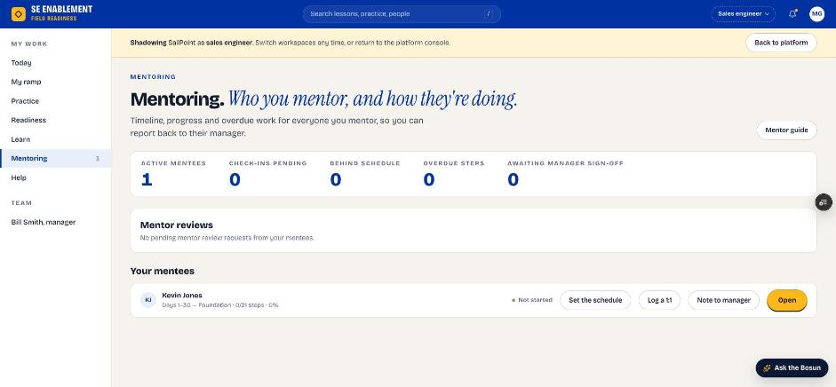
Figure 2.2 — Mentoring page

3. Open the mentee workbench and read the hiring brief
- Click the mentee's name or Open (or Read the brief on Today).
- The workbench shows the program, dates and steps on the left, and the hiring brief and your coaching notes on the right.
- Read the brief before you meet.

Why it matters: The brief tells you what the manager hired for and what to watch. Reading it first makes the first 1:1 focused.
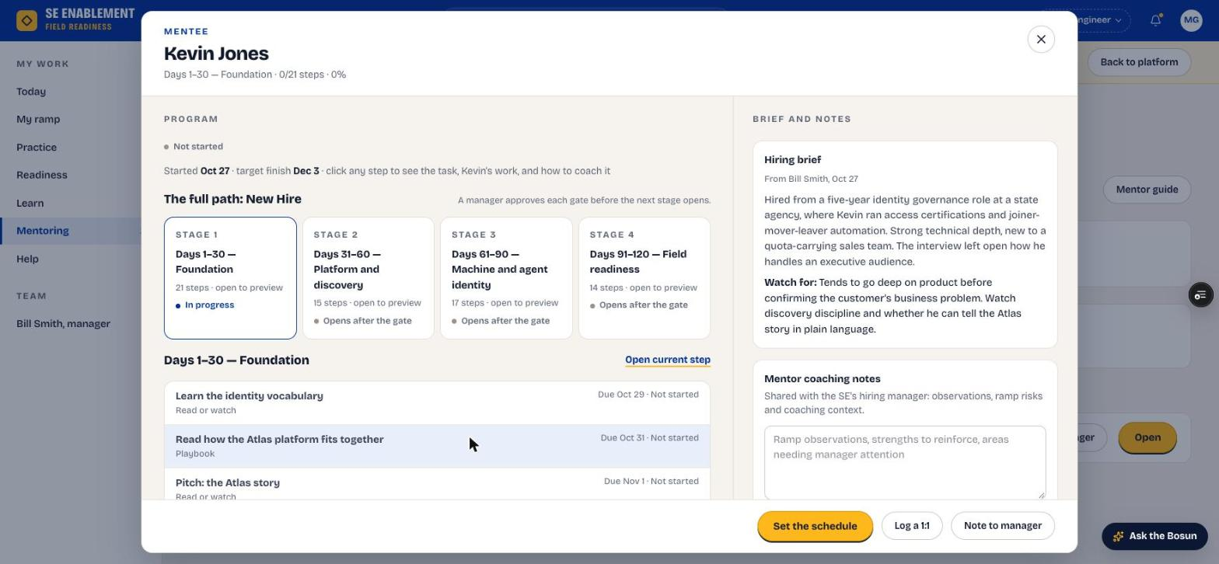
Figure 2.3 — Mentee workbench with the hiring brief

4. Preview the stages
- Click a stage card to open its steps in a step workbench.

Why it matters: Knowing what's coming lets you agree realistic dates and point the new hire at the right preparation.
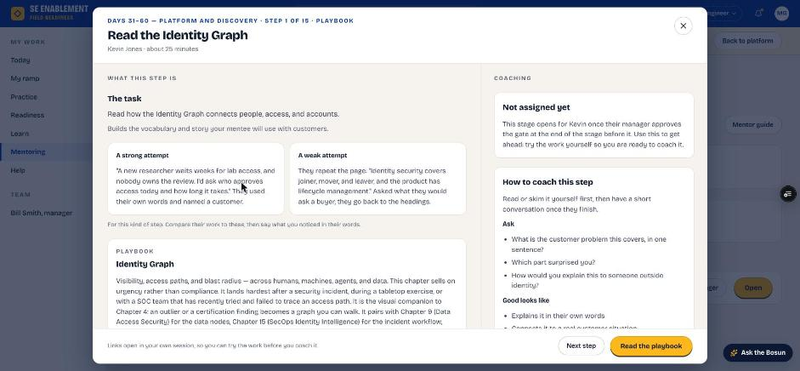
Figure 2.4 — Previewing a later stage

5. Hold the first 1:1 and log it
- Meet the new hire. Log the 1:1 after it has happened; a date in the future isn't accepted.
- In the workbench footer, click Log a 1:1.
- Tick the agenda items you covered. The first-meeting agenda is filled in for you, including what the hiring brief asks you to watch.
- Check the date, add notes and next actions, then click Save check-in.

Fill in: Date of the 1:1: when you met. Notes: what you talked about and noticed. Next actions: what they will do before you next meet.

Why it matters: The new hire receives the next actions as a notification, and the mentee's row and workbench show Last 1:1, so the manager can see the relationship is working.
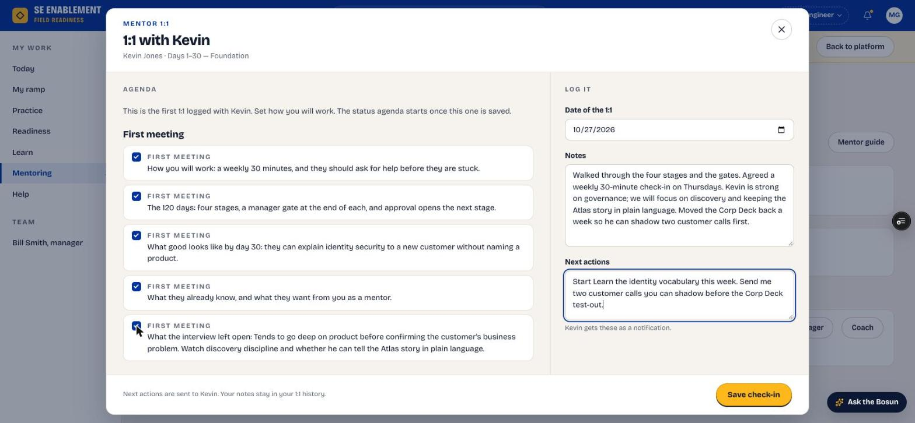
Figure 2.5 — Logging the first 1:1
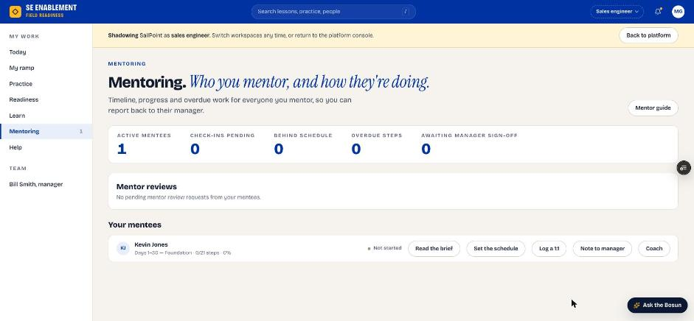
Figure 2.6 — Mentoring page after the 1:1

6. Set the schedule together
- In the workbench footer, click Set the schedule. If you haven't logged a 1:1 yet, a reminder suggests meeting first; you can still set dates and change them later.
- Adjust the due dates you agreed with the new hire. The stage end date moves with them. Default dates fall on workdays, avoiding weekends and US holidays; a note tells you if a date you pick lands on a weekend or holiday.
- If a date can't be saved (a day that has passed, or a step due before the one it builds on), the panel says which and why.
- Add a note explaining any changes, then click Set to save. Afterwards the button reads Change dates.

Fill in: The due dates you agreed, and a short note on why any date moved.

Why it matters: The mentor owns the dates because they agreed them face to face. They apply immediately, without approval, and the new hire and manager are both told.
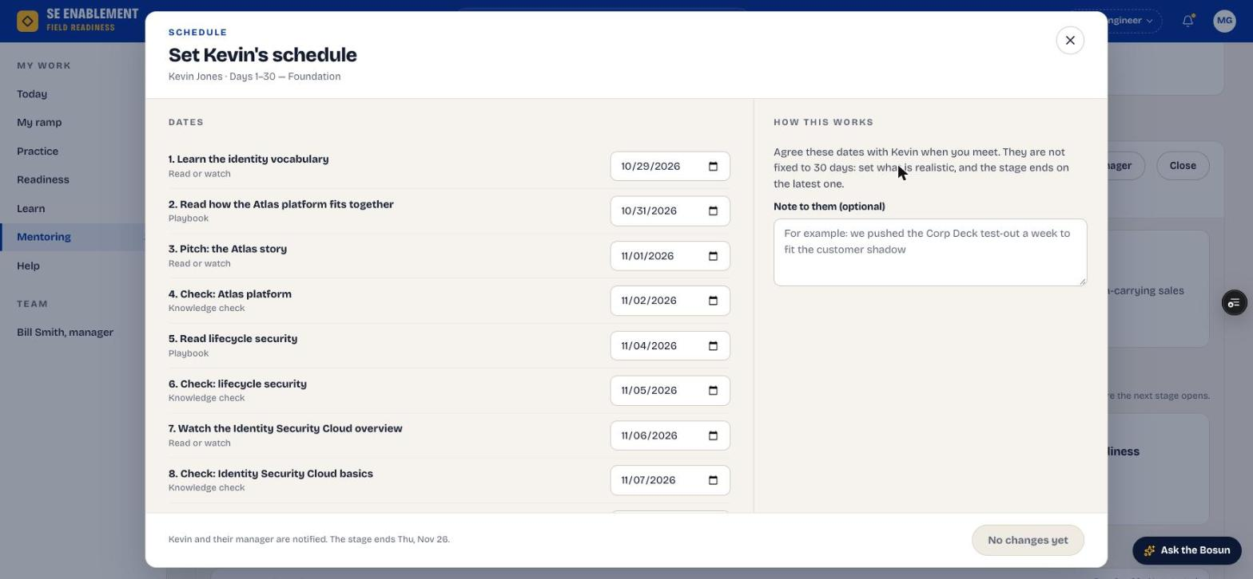
Figure 2.7 — Set the schedule
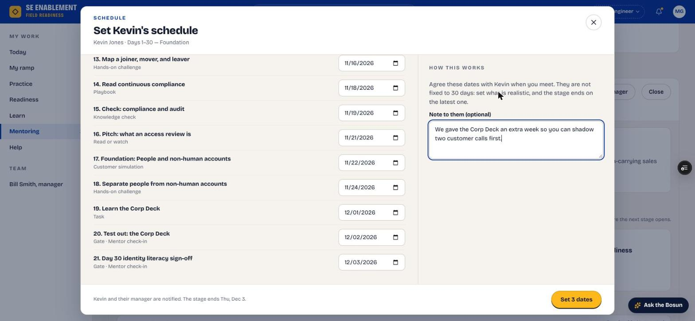
Figure 2.8 — Dates changed; the stage end moves

7. Confirm everyone was told
- A confirmation shows that the new hire and their manager were notified.

Why it matters: Everyone works from the same dates. The manager's Inbox also lists the change under Schedule changes by mentors, for information.
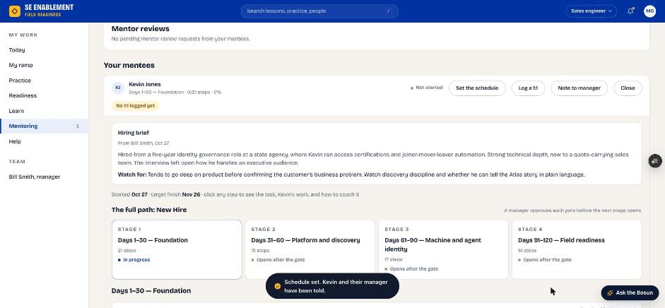
Figure 2.9 — Schedule saved and shared

Section 3 — New hire: work through the ramp
Signed in as the new hire.

1. Start on Today
- Today shows your next step, its due date and who reviews it, what's coming up, and the Your mentor card.
- Any 1:1 your manager has scheduled appears under Coming up, and every row there opens its step.
- While a step is with your reviewer, Today says who has it and its main button starts your next step, so you can keep going.

Why it matters: Today always answers "what do I do next?", so you never have to work out where you are in the program.
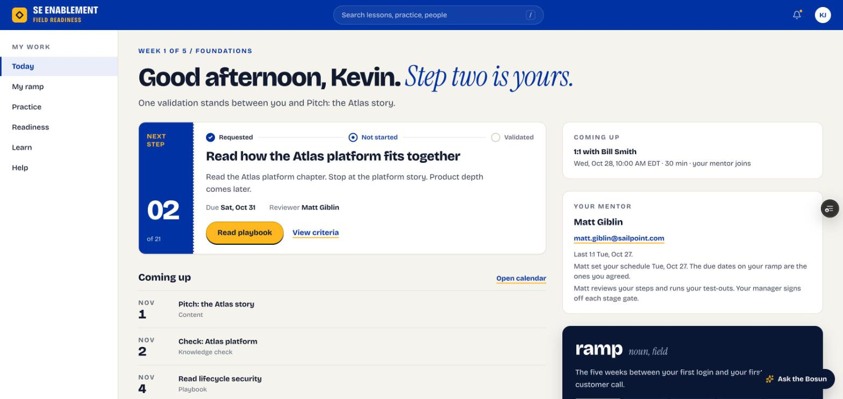
Figure 3.1 — New hire Today page
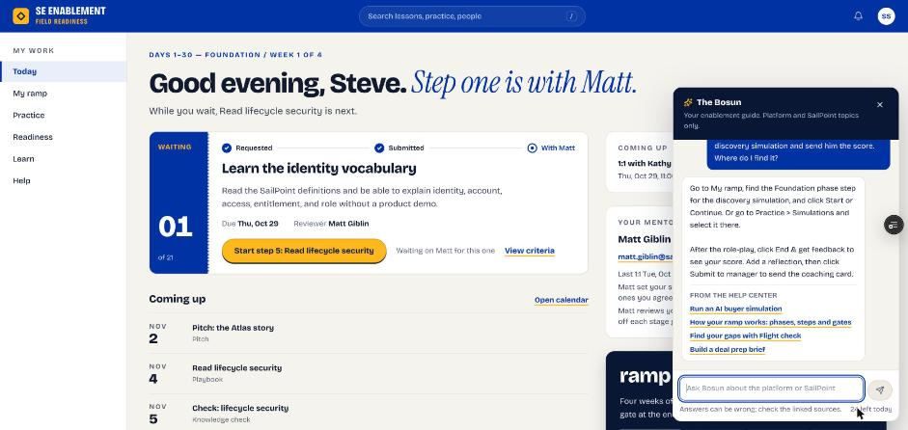
Figure 3.2 — Step 1 is with the mentor; Today offers the next step. The Bosun is open on the right

2. Check your notifications
- Click the bell. Your notifications open in a workbench: the plan assignment, the schedule your mentor set (with their note), the next actions from your 1:1, reviews of your steps and any 1:1 your manager scheduled.
- Click a notification to go to it, or Mark all read.

Why it matters: Notifications confirm who your mentor is, the dates you agreed and what you promised to do next.
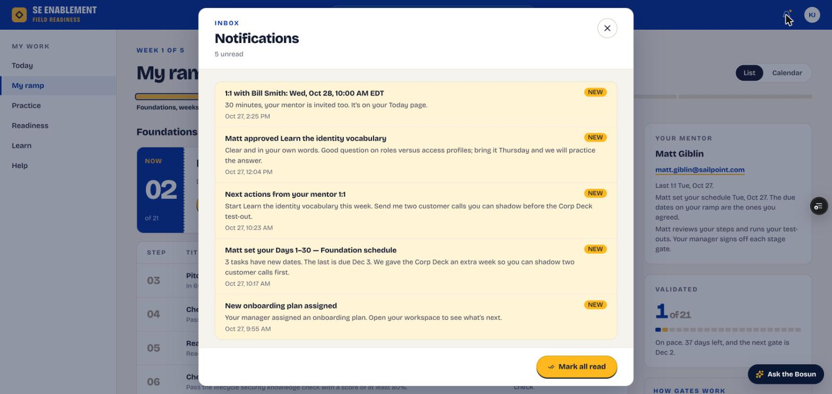
Figure 3.3 — Notifications

3. Open My ramp
- Click My ramp. You see the current step, every step with its agreed due date, your progress and your mentor. Finished steps are listed under Done.
- Switch to Calendar for a week or month view of the same dates. Steps with your reviewer show In review. Click any step to open it.

Why it matters: The full plan with real dates helps you pace the 30 days and spot anything that needs to move early.
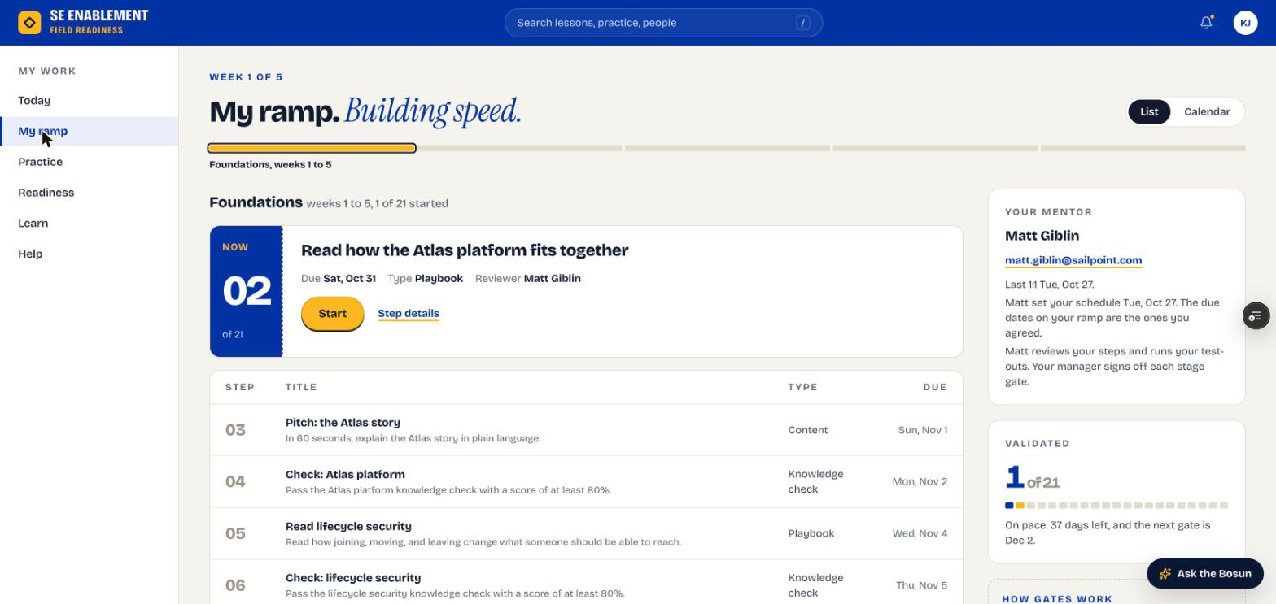
Figure 3.4 — My ramp
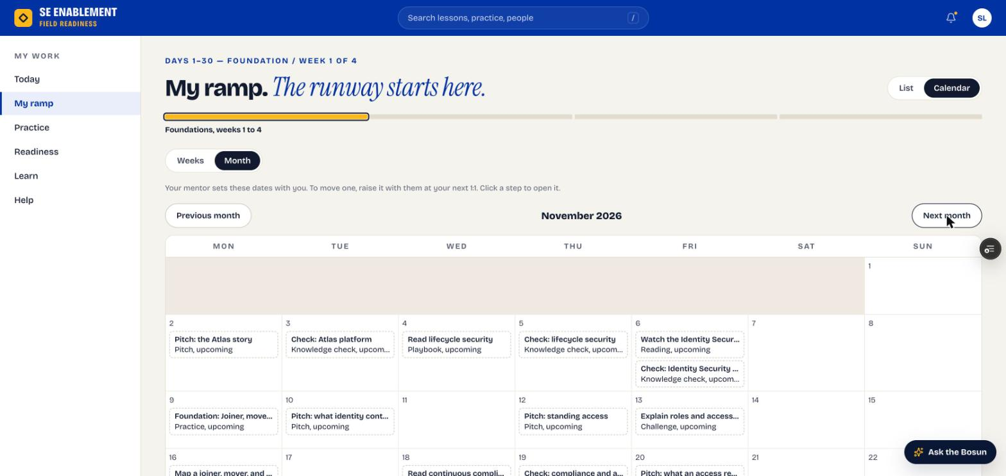
Figure 3.5 — My ramp as a month calendar

4. Complete and submit a step
- Click a step. It opens as a workbench over My ramp.
- Read the brief and the Done when criteria, and open the linked resource.
- Tick each criterion as you meet it, write your evidence and click Submit for review. The note under the evidence box says who reviews it, and the button says what's missing if it isn't ready.
- Pitch steps have an Open Pitch Studio button. Record or type the pitch there and score it, then submit it from the Studio: the pitch, its AI score and the coaching note attach to the step for your mentor.
- Playbook steps complete themselves when you read the chapter to the end and mark it read; knowledge checks complete when you pass.

Fill in: What did you learn? Your evidence in your own words: the key takeaways, set against the Done when criteria, and any questions for your next 1:1.

Why it matters: Your evidence is what your reviewer judges. Clear evidence gets a quick approval instead of a send-back.
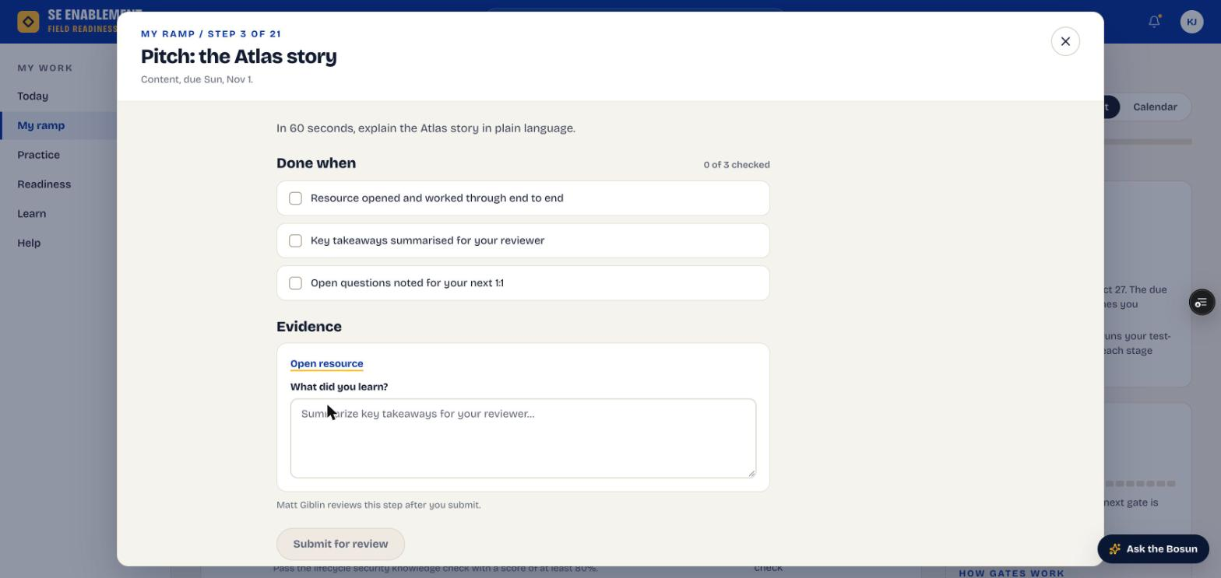
Figure 3.6 — Step workbench: Done when criteria, evidence and reviewer
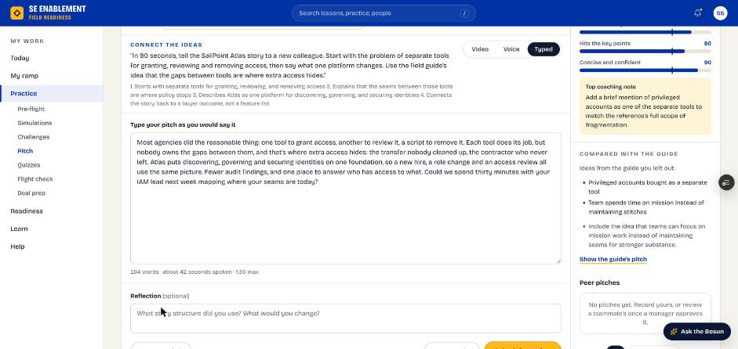
Figure 3.7 — Pitch Studio opened from a pitch step, scored and ready to submit
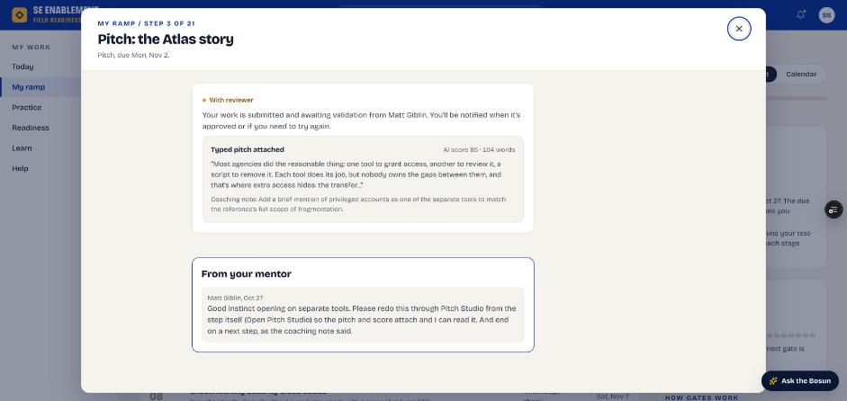
Figure 3.8 — The scored pitch attached to the step, with the mentor's earlier note

5. Know what happens next
- The step shows In review on My ramp.
- Today says who has it (for example, "Step one is with Matt") and shows the next step so you can keep going.
- When your mentor approves or sends it back, you get a notification with their note (see your notifications).

Why it matters: You don't have to wait idle. Your reviewer is notified, and you can move on to the next step.

Section 4 — Review and progress
The mentor reviews everyday steps. The hiring manager signs off stage gates and keeps an eye on progress.

Mentor: review a submitted step

1. See that work is waiting
- On Today, the You're mentoring card says how many steps are waiting on your review. Click Review: the first waiting step opens straight away, on top of the mentee's workbench.
- The submitted work notification opens the exact step too.

Why it matters: Reviews are what keep the new hire moving. Surfacing them on Today means they don't sit unnoticed.
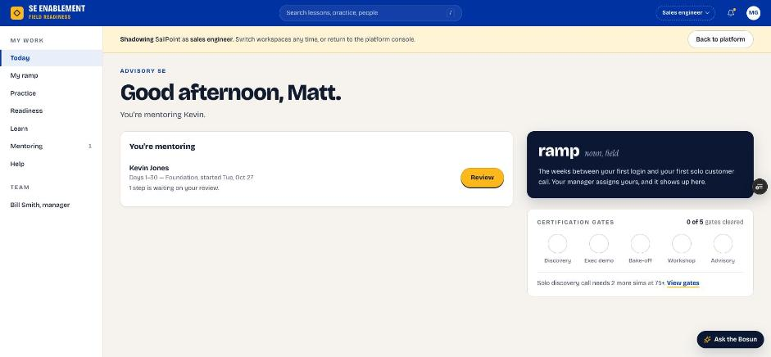
Figure 4.1 — A step waiting on the mentor's review

2. Find it on Mentoring
- The Waiting on your review counter and the mentee's row both show the submitted step.

Why it matters: With several mentees, this is where you see everything waiting on you at once.
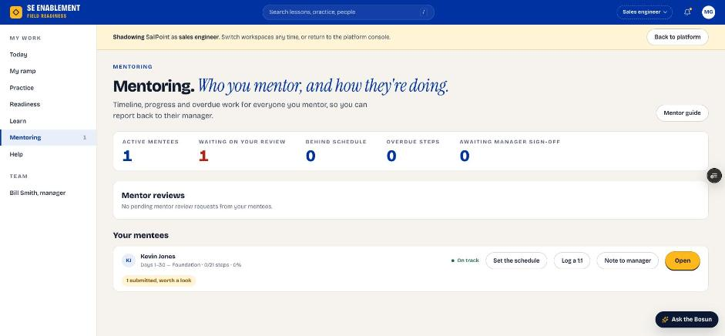
Figure 4.2 — Waiting on your review

3. Approve or send back
- Open the step. What this step is shows the task with a strong and a weak example; What they did shows their work, and Your review sits on the right.
- For a pitch step you see Pitch from Pitch Studio: how it was recorded, the AI score with its rubric, and the full pitch.
- Add a note, then click Approve, or Send back if it needs more work. Send back stays disabled until you've written a note, because the note is what the new hire acts on.

Fill in: A short review note: what was good, and what to change if you're sending it back.

Why it matters: The new hire's answer is kept as submitted, and your note reaches them as feedback. Approving counts the step toward their progress. Stage gates don't show these buttons because the manager signs them off; see step 4.
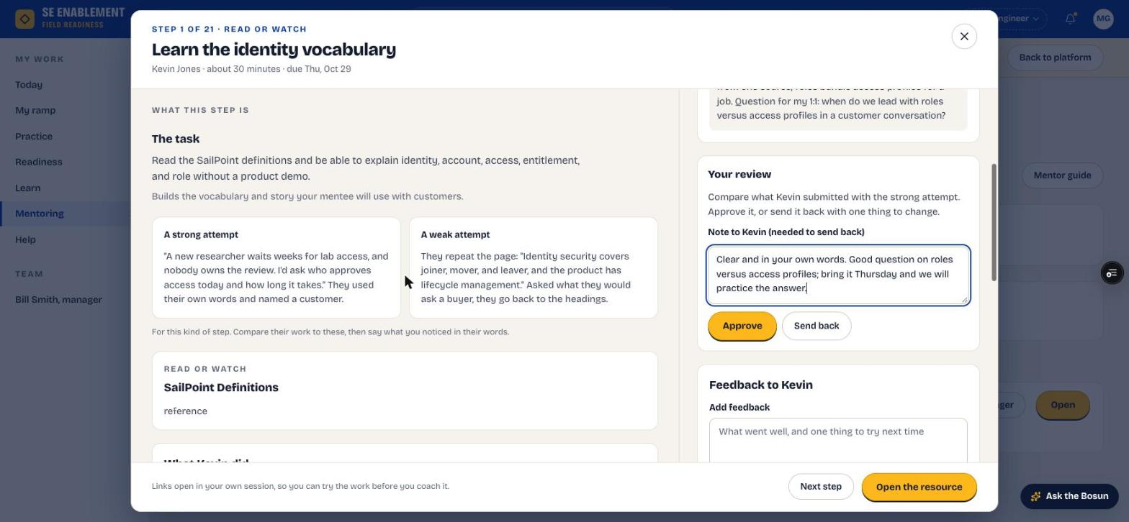
Figure 4.3 — Reviewing the new hire's step
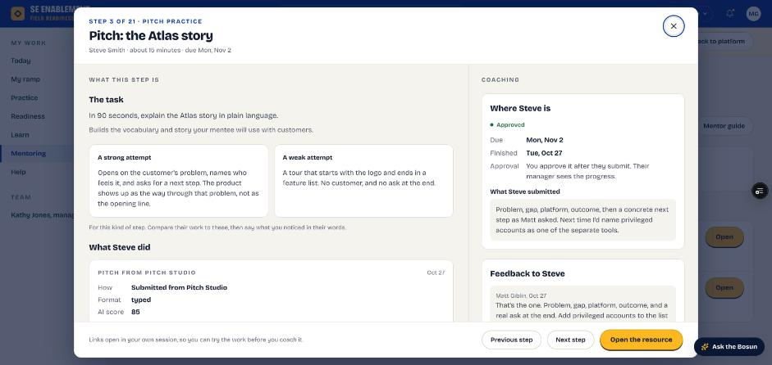
Figure 4.4 — A pitch step opened from Review: the task, examples and the pitch from Pitch Studio

4. Recommend on a stage gate
- When the new hire submits a test-out or sign-off, Review opens the gate step. Instead of Approve, it has Your recommendation.
- Choose Ready for sign-off or Not ready yet, write why, and click Send to the manager.
- The gate then leaves your waiting count and shows as Manager sign-off pending; the manager decides.

Fill in: Why: what you saw that shows they meet the gate's criteria, or what they still need.

Why it matters: The manager signs off each gate, and your recommendation is the evidence they decide on. New hires can take gates early, so this may come well before day 30.

5. Confirm the result
- The step's status changes to Approved, your note shows under Feedback to the new hire, and a confirmation says they have been told. Nothing is left waiting.
- The new hire is told the step was approved or sent back, with your note; the notification opens the step.

Why it matters: Both sides see the same status, so there's no doubt about where the step stands.
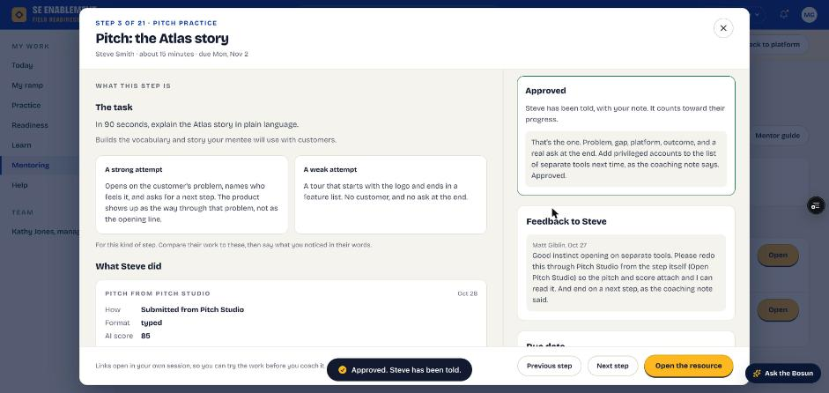
Figure 4.5 — After Approve: the decision and the note sent to the new hire
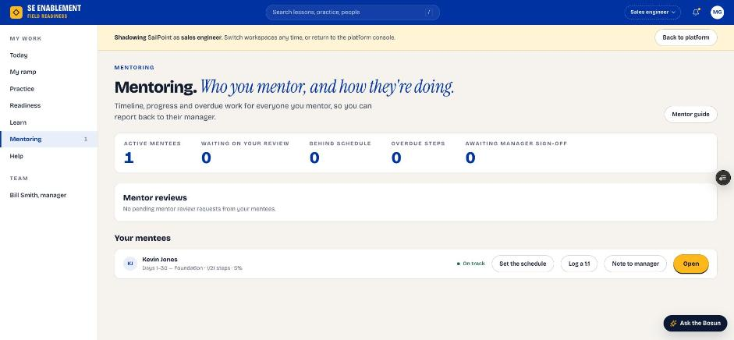
Figure 4.6 — Mentoring after approval

6. Keep checking in
- After each 1:1, open the mentee workbench and click Log a 1:1.
- If a date needs to move, agree it with the new hire and click Change dates.

Fill in: Agenda, notes and next actions for each meeting; any changed dates with a short reason.

Why it matters: Regular logged check-ins keep the new hire on pace, send them their next actions, and show the manager the mentoring is happening.

7. Prepare them for stage gates
- Each stage ends with a test-out and a sign-off step. Run the test-out practice with the new hire before they submit.
- Gate steps don't show Approve or Send back for you; they go to the hiring manager.
- An experienced hire can take the gates early. Once the manager signs them off, the stage's remaining steps close as tested out.

Why it matters: The manager decides whether the new hire moves to the next stage. Your preparation is what gets them through first time.

8. Pitches and simulations your mentee shares
- A new hire can Share with my mentor from free practice in Pitch Studio or a simulation. You're notified with the score and summary, and the notification opens it.
- Everything shared is listed under Shared with you in the mentee's workbench. A simulation opens with its coaching card, their reflection and the conversation; a pitch with its rubric and the words they used.
- Work the manager assigns directly, such as a playbook chapter, isn't yours to review; it checks itself and goes back to the manager.

Why it matters: Shared practice shows you what your mentee is working on between 1:1s, without adding to your review queue.

Hiring manager: check progress

1. Read Today
- Since Friday summarises what the team did, such as "Kevin finished a ramp step".
- Each person's status, readiness and suggested next action are listed. A new hire in their first 30 days shows Ramping, week N, and their readiness isn't marked red while they ramp.
- A mentor's reviews, schedules and 1:1s count as them being active.
- Reviews waiting counts only what needs you. Steps the mentor reviews reach you only after the mentor has approved them.

Why it matters: You can see progress at a glance without approving every step yourself. Your attention goes to the people who need it.
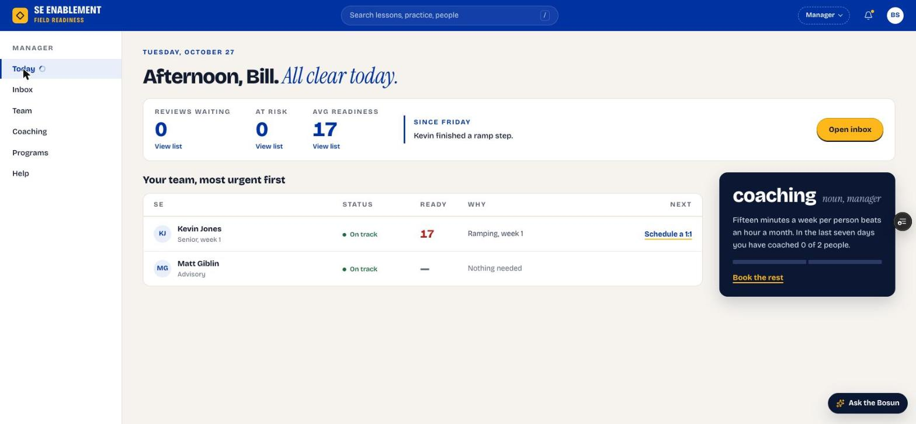
Figure 4.7 — Manager Today page after the first step

2. Open the new hire's profile
- Click the name. The counters show open, done, due this week and overdue steps.
- Onboarding steps lists every step with its agreed date. Stage gates read Stage gate, you sign off.
- Recent activity shows who approved what, the mentor's 1:1s and the schedule.
- Next 1:1 shows the next scheduled meeting.

Why it matters: The profile is the full picture for your next 1:1: progress, the mentor's involvement and what's coming up.
Figure 4.8 — Profile with progress and the next 1:1

3. Check the Inbox
- Open Inbox. Items that need your sign-off, such as stage gates, are listed oldest first.
- Schedule changes by mentors shows the dates mentors set, for information.

Why it matters: The Inbox holds only what needs your decision, so you can clear it quickly. Everyday steps go to the mentor and don't appear here.
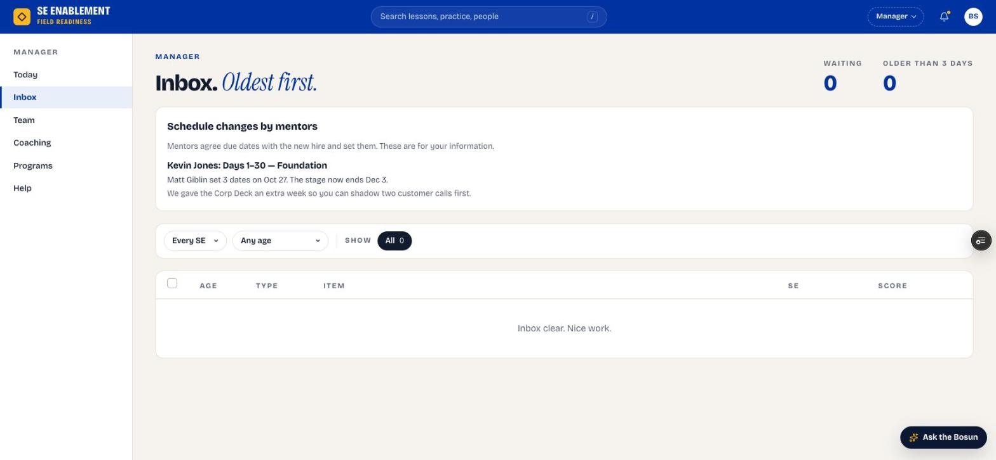
Figure 4.9 — Manager Inbox

4. Read your notifications
- Click the bell. Notifications open in a workbench; click one to go to it, or Mark all read.

Why it matters: Notifications tell you when a mentor sets or changes the schedule, so you're never surprised by a new date.
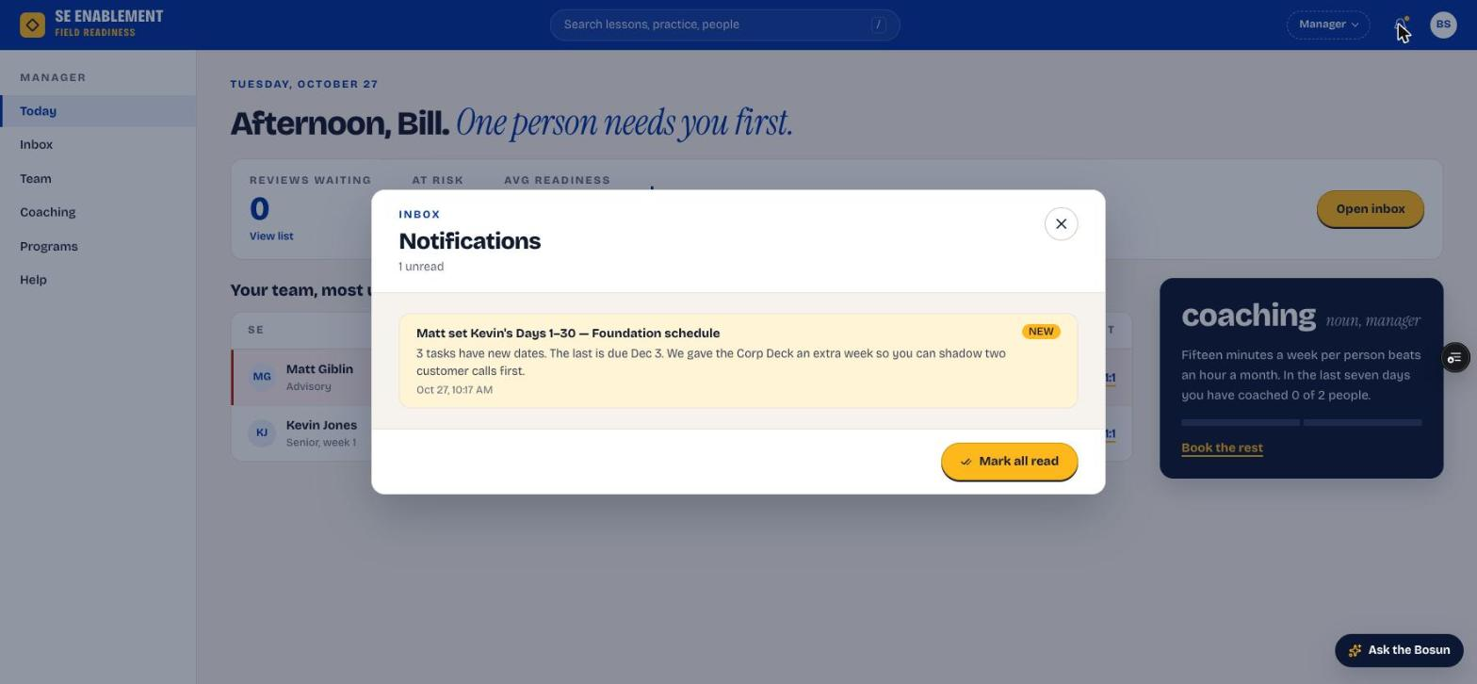
Figure 4.10 — Notifications workbench

5. Sign off stage gates
- When the new hire submits a test-out or the end-of-stage sign-off, it appears in your Inbox and on their profile.
- Open it. The mentor's recommendation is shown on the left. Your sign-off may come pre-filled by an AI coaching brief; rewrite anything that isn't what you saw.
- Fill in Strength observed, Gap to address, Concrete next action and Readiness confidence. Gates also need Live coaching attestation: tick it only if you saw them do it yourself (in a 1:1, call shadow or live review) and say what you observed. Then click Approve, or Request changes.
- Signing off a stage's last gate closes any steps still open as tested out, so an experienced hire who tests out early finishes the stage. The new hire is told how many closed.

Why it matters: Signing off the gate unlocks the next 30-day stage. This is the manager's decision because it confirms the new hire is ready to move on.

Section 5 — New hire: practise beyond the ramp
Practice is open to the new hire at any time, whether or not it's on the plan.

1. Start from the Practice hub
- Open Practice. Pre-flight builds a short plan before a real call; Keep skills sharp links to Simulations, Challenges and Pitch.
- Assigned to you on the right lists practice from your ramp with its due date.

Why it matters: Practice is how the reading turns into something you can say to a customer. Nothing here counts against you unless you choose to submit or share it.
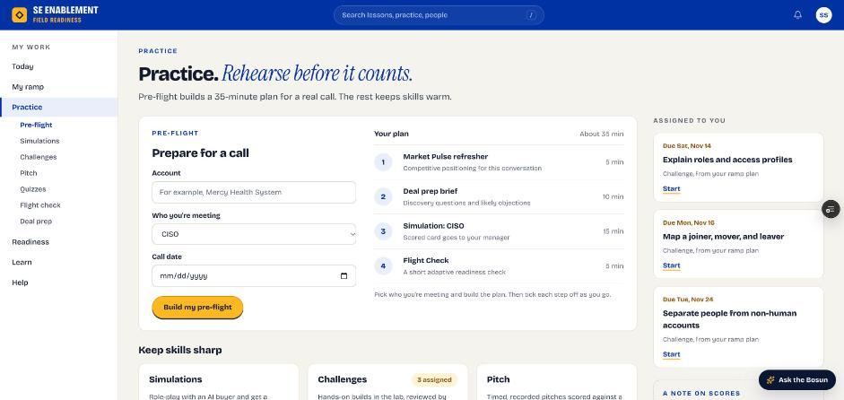
Figure 5.1 — The Practice hub

2. Practise straight from a playbook chapter
- Open any chapter under Learn › Playbooks. Practise this at the top offers the chapter's pitches (numbered to match the chapter's Test yourself), the cold open, the knowledge check and Practise these objections.
- Each opens with the chapter already chosen, so you can practise right after you read.

Why it matters: Practising while the chapter is fresh is the quickest way to make it stick.
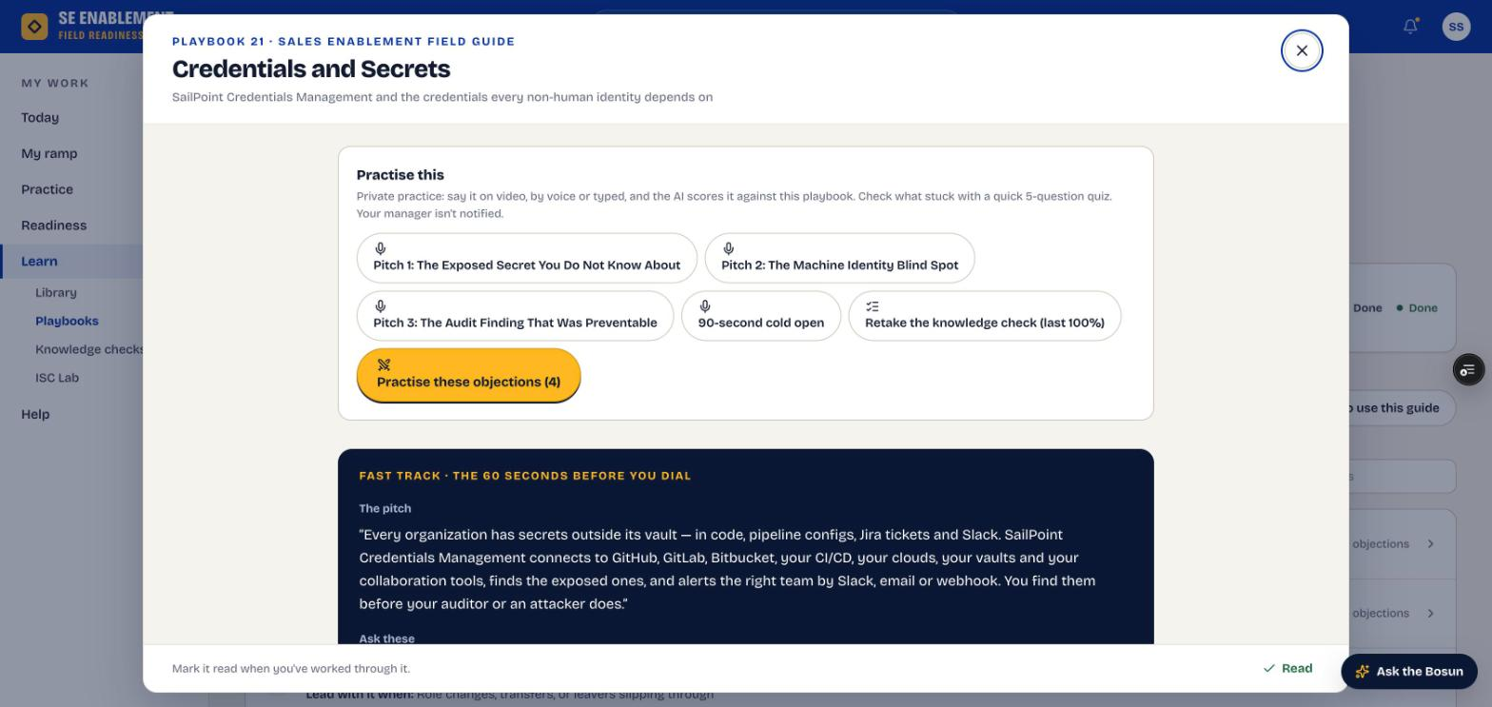
Figure 5.2 — Practise this, at the top of a chapter

3. Pitch in Pitch Studio
- Choose Free practice, then pick a scenario under From playbooks (the page may open on a practice scenario, which is video only). Answer by Video, Voice or Typed within the time limit.
- Click Score my pitch. Scoring takes up to 30 seconds and returns a rubric score, a coaching note and Compared with the guide, which lists the ideas you left out. Show the guide's pitch lets you compare word for word.
- Save it if you want to keep it, or Share with my mentor to send it with its score.

Fill in: Your pitch, in the words you'd use with a customer, and an optional reflection on what you'd change.

Why it matters: The rubric scores the three things customers notice: leading with their problem, hitting the key points, and keeping it short and confident.
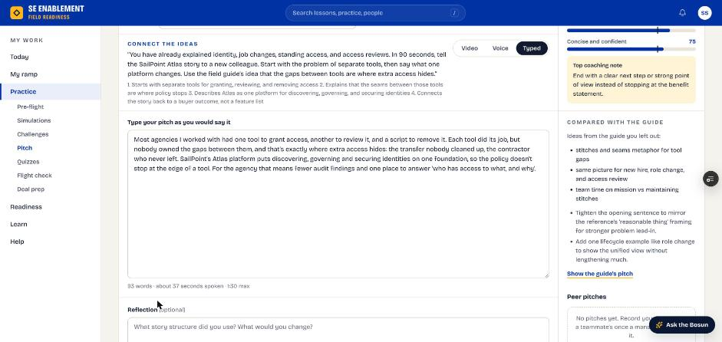
Figure 5.3 — A scored typed pitch, compared with the guide

4. Check what stuck with a knowledge check
- Take a chapter's check from the chapter or from Learn › Knowledge checks. Each sitting draws 5 questions from the chapter's set.
- After you submit, every question shows Right or Not quite with the explanation. Click New questions to try again.

Why it matters: The explanations are where the learning is, especially on the ones you got wrong.
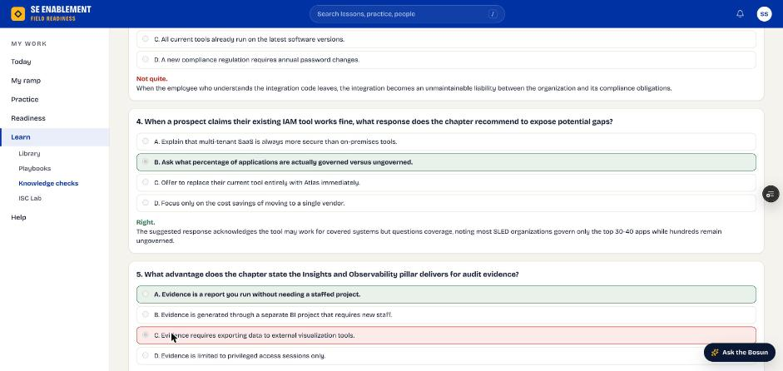
Figure 5.4 — Knowledge check results with explanations

5. Rehearse with an AI buyer
- Open Practice › Simulations. From your ramp comes first; Browse scenarios lists the rest by level, starting with Foundational.
- In a simulation, the left shows the buyer and your objective, the middle is the conversation and Live coaching on the right gives a Next move after each reply. Type HINT: for a tip mid-call.
- Click End & get feedback for the coaching card: a score out of 100, a strength, what to improve and what to practise next.

Why it matters: A simulation is the closest thing to a real discovery call without the risk. Practice rounds aren't scored toward Readiness; only what you submit or share is seen by others.
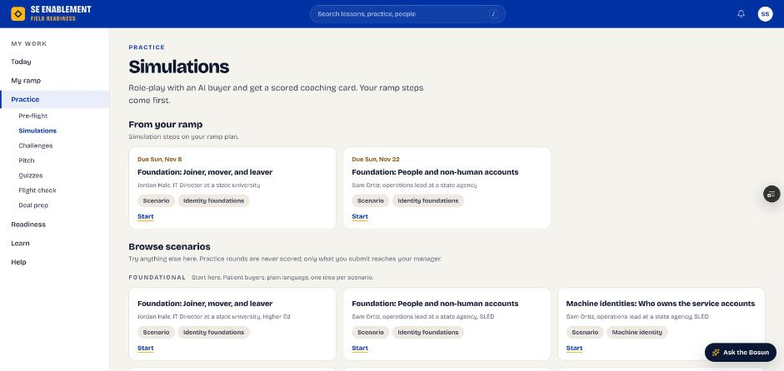
Figure 5.5 — The simulation catalogue
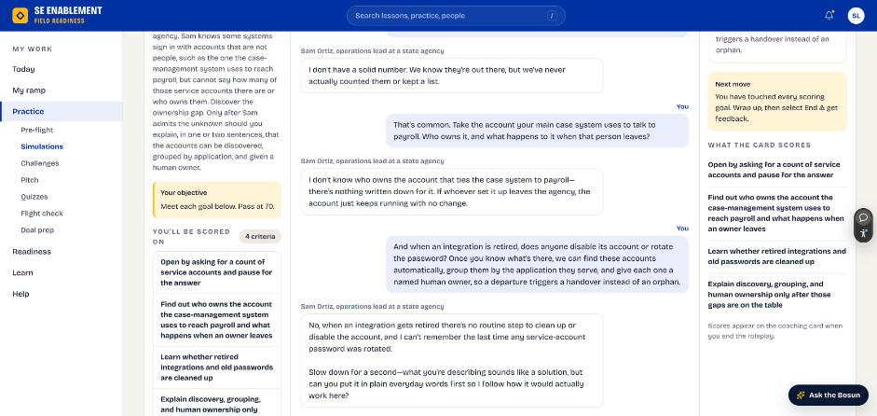
Figure 5.6 — A simulation with live coaching
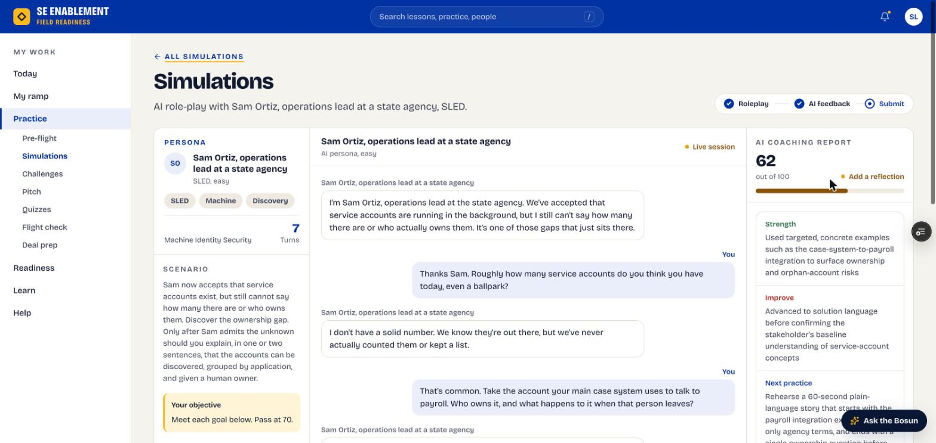
Figure 5.7 — The coaching card after ending the simulation

6. Find anything with search and the Bosun
- The search bar at the top finds ramp steps, playbook chapters, knowledge checks, simulations, pitches and people, including your mentor.
- Ask the Bosun (bottom right) answers questions about the platform and SailPoint, with links to where things are.

Why it matters: You shouldn't have to remember where something lives. Search and the Bosun get you there from any page.
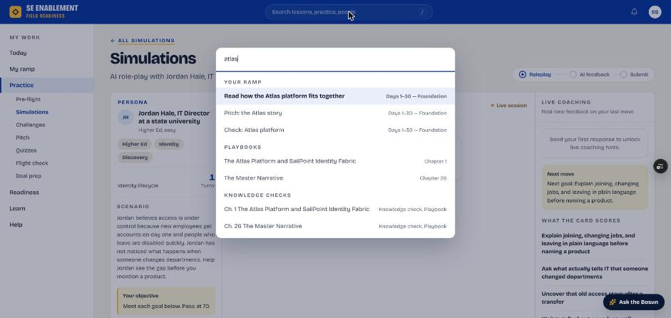
Figure 5.8 — Search results grouped by type
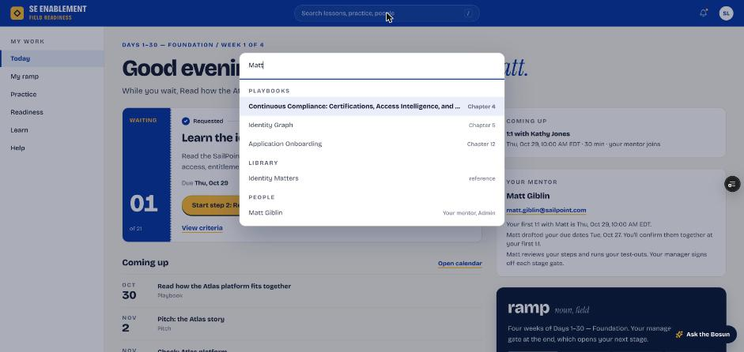
Figure 5.9 — Searching for your mentor by name

Section 6 — Extra work the manager assigns
Work outside the onboarding plan, such as a playbook chapter ahead of a deal. There's no mentor for it: each part scores itself and the manager sees the result.

Hiring manager: assign and review

1. Open Assign work
- Open the person's profile and click Assign work (next to Suggested next).
- Choose what kind of work: a Playbook chapter, a Simulation, a Pitch, a Knowledge check, a Library item or a Ramp task.

Why it matters: Real work doesn't wait for the onboarding plan to finish. Assign work puts a deal-driven or team-driven task in front of someone without touching their ramp.
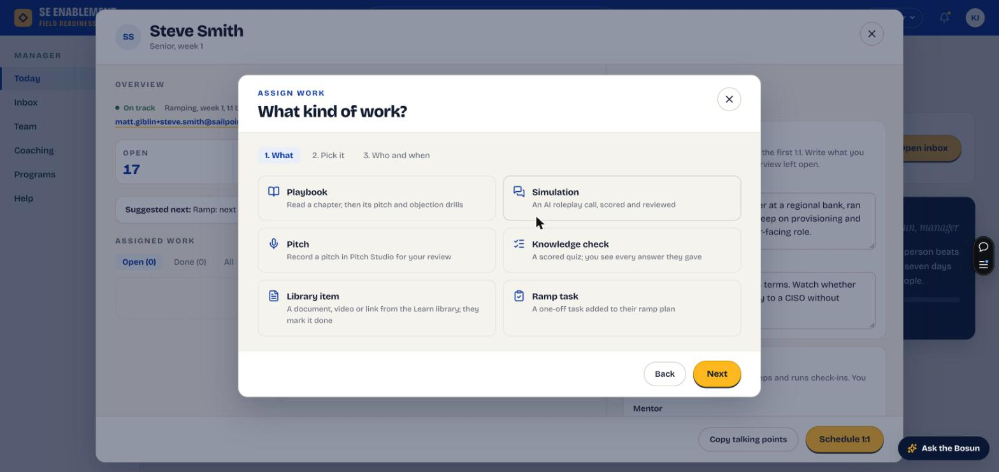
Figure 6.1 — Assign work, step 1: what kind of work

2. Pick it
- Search by title or product name. A search for a product name finds the chapter that covers it, and each result shows its subtitle.
- Tick one or more items. Try it yourself opens the item in a new tab, so you know what you're asking for.

Why it matters: Searching by product means you don't need to know how the field guide names its chapters.
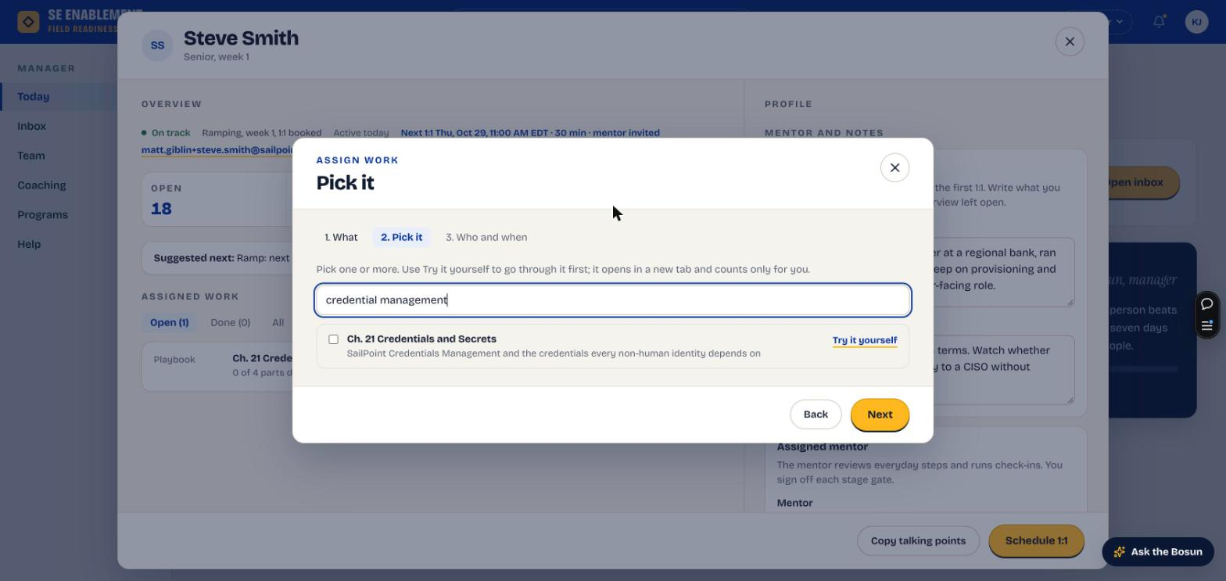
Figure 6.2 — Pick it: a product-name search finds the chapter

3. Choose who and when
- Tick one or more people. Each shows their role.
- Set the due date. If that week is clearly heavier than someone's usual ramp week, a Busy week note says so and offers a lighter week; click Use to take its Friday.
- Add a note saying why it matters now. The summary at the bottom shows what, for whom and when.

Fill in: Due date: when it must be finished. Note: the reason for the assignment and what you expect them to be able to do afterwards.

Why it matters: The note is the context the SE reads first, on their profile card and with the assignment. A due date in an already heavy ramp week doubles the load; the Busy week note only appears when that's the case.
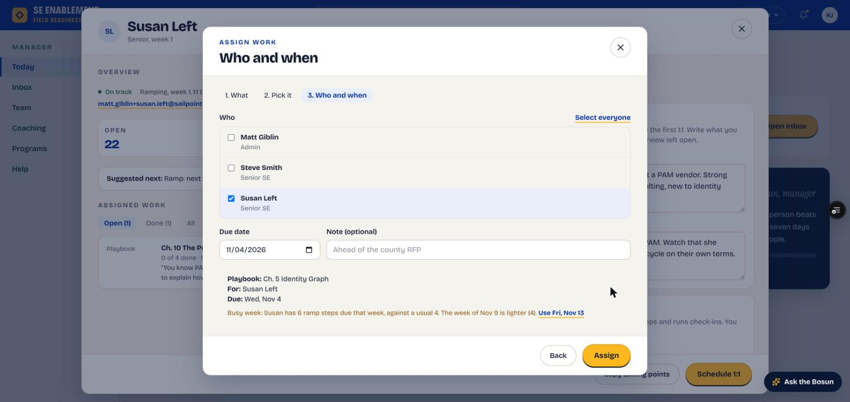
Figure 6.3 — Who and when: roles, the summary, and a Busy week note offering a lighter week

4. Assign and check it landed
- Click Assign. A confirmation says how many people it went to.
- The person's profile lists it under Assigned work › Open with its parts, due date and your note.
- Each person is notified with your name, the item and the due date; the notification opens the item.

Why it matters: Assigned work has no mentor. The parts check themselves: reading marked done, pitch drills scored by the AI, the objection drill scored at the end, and the knowledge check scored automatically.
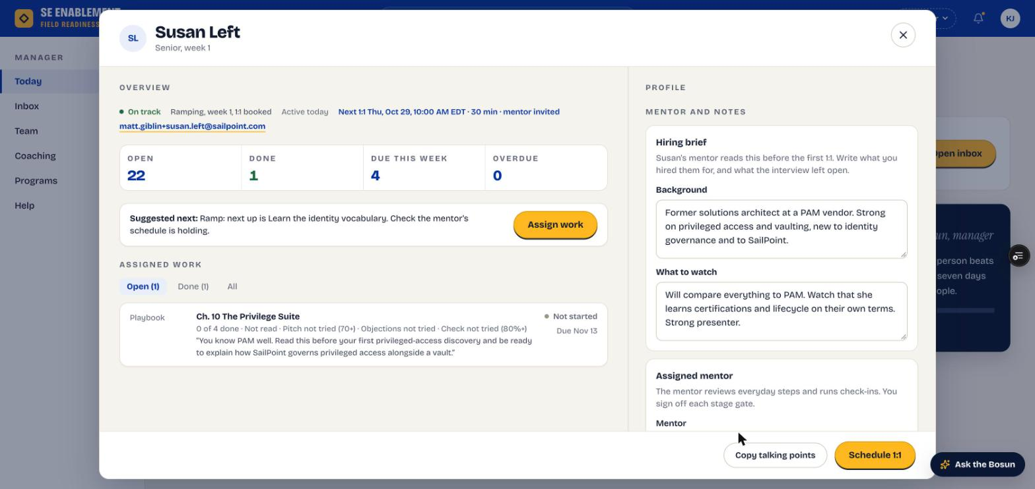
Figure 6.4 — The assignment on the profile: each part's status and pass mark, with the note on its own line

5. Get told when it's finished
- When the last part is done, you're notified straight away, for example "Susan Left finished Credentials and Secrets 7 days early: read, pitch 78, objections 83%, check 80%."

Why it matters: You don't need to check back. The notification gives you the result at a glance and how early or late it was.
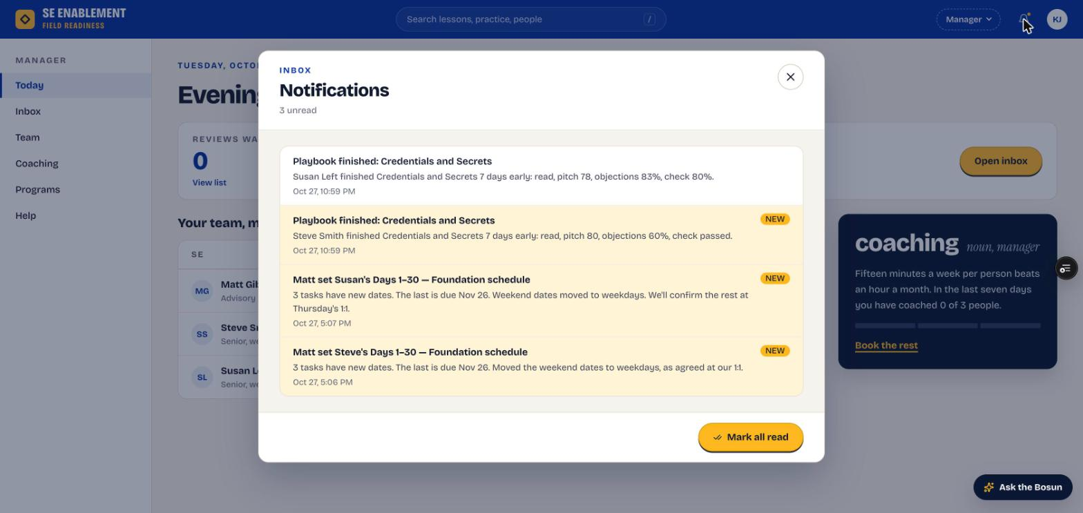
Figure 6.5 — Finished-assignment notifications

6. Review what they did
- Click the notification. The person's profile opens with the assignment's workbench on top.
- The header gives each part's result against its pass mark, for example Pitch 78 (70+).
- Knowledge check shows every question with the answer picked; Objection drill shows the debrief, each answer and the coach's score; Pitch drills show the rubric, what was said and what was left out.
- Only attempts made while the assignment was open are shown. Practice afterwards is private, and the SE is told so.

Why it matters: A score on its own doesn't tell you whether someone is ready for the customer conversation you assigned it for. Reading what they actually said does.
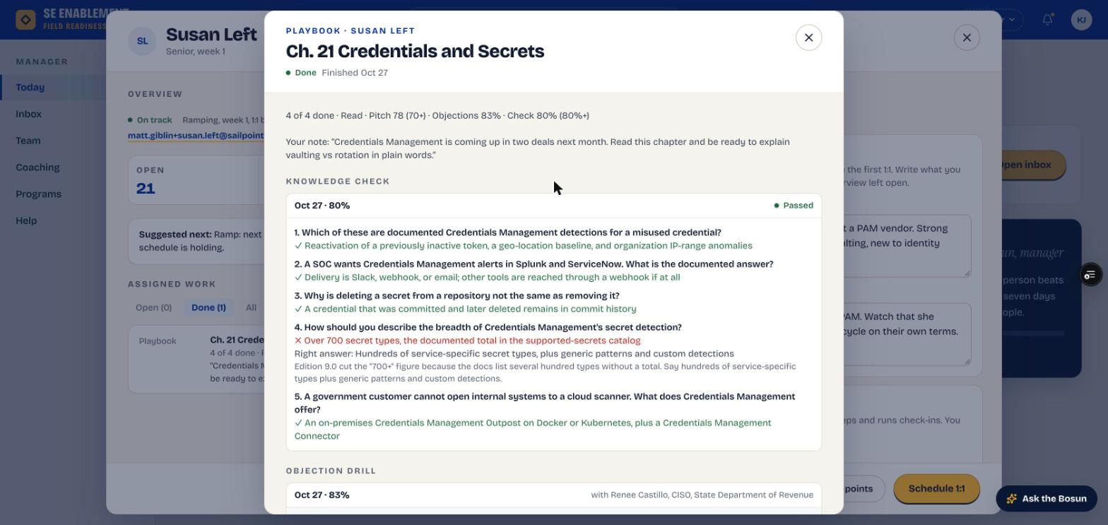
Figure 6.6 — The assignment workbench: results, your note and the knowledge check
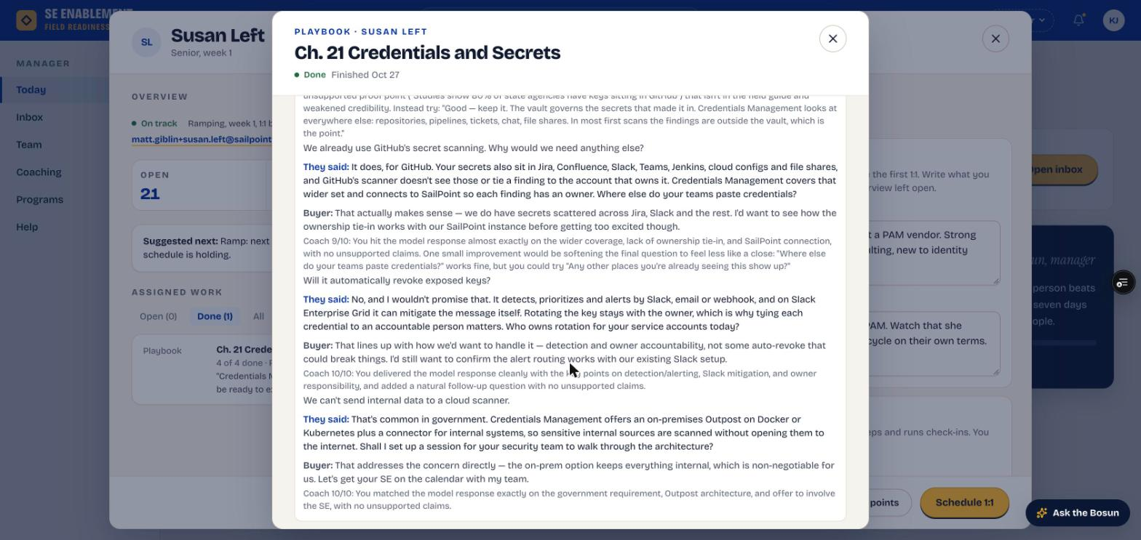
Figure 6.7 — The objection drill: each answer with the coach's score and note
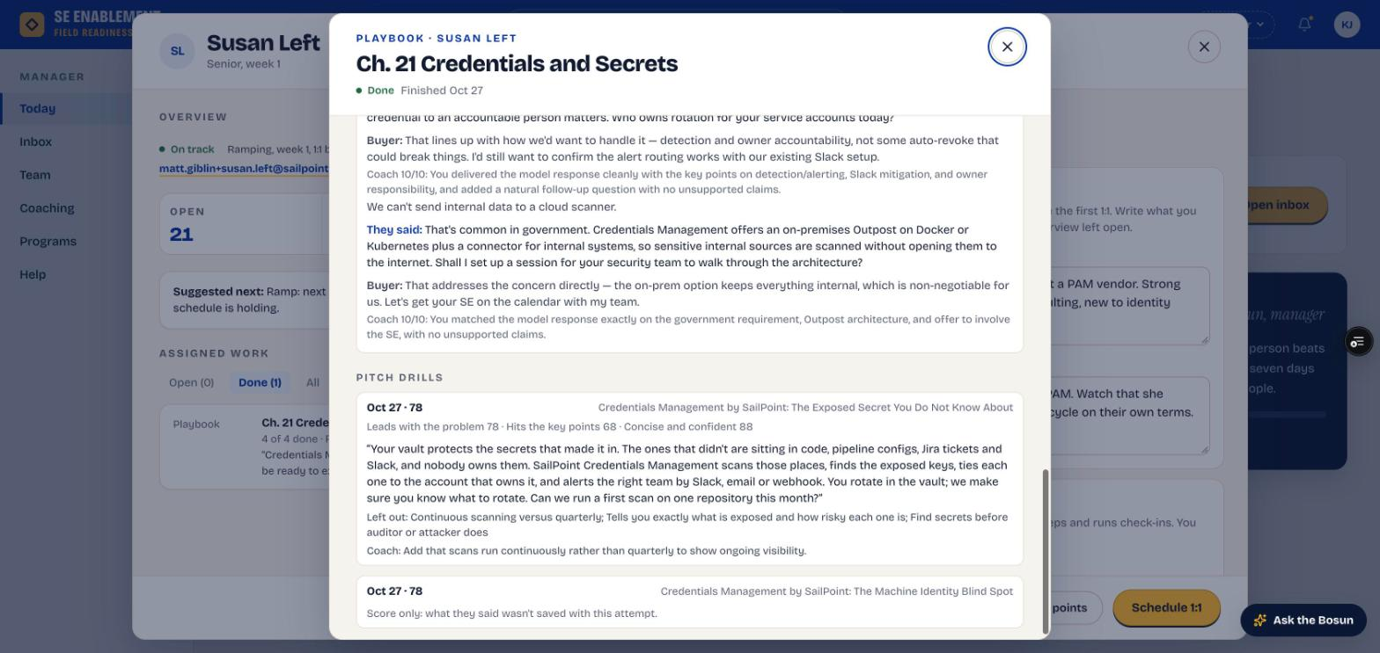
Figure 6.8 — A pitch drill: rubric, the pitch as delivered, and what was left out

New hire: work it

1. See it on Today
- Work your manager assigns appears under Playbooks due (or Your training) on Today, with who assigned it, how many parts are left and the due date.
- You're also notified with your manager's note; the notification opens the item.

Why it matters: Assigned work sits alongside your ramp, not inside it. Today keeps both in view so neither slips.
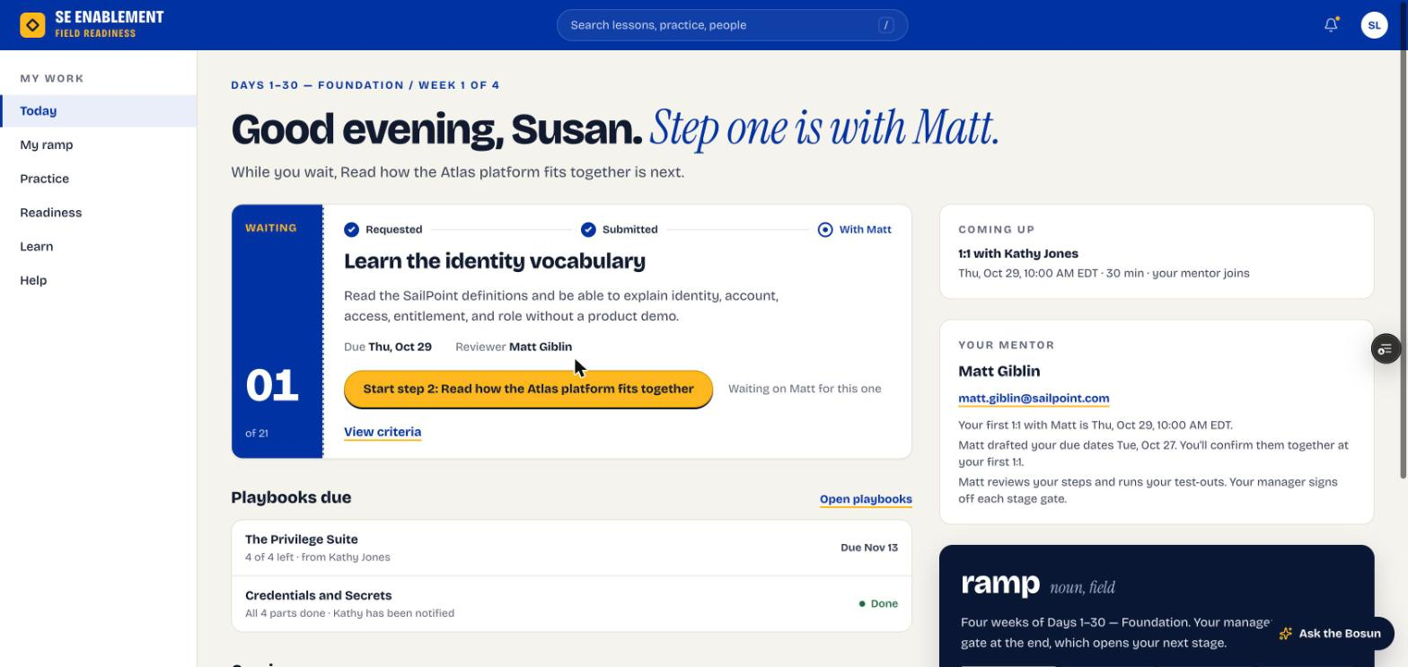
Figure 6.9 — Today: an open assignment with parts left, and a finished one marked Done

2. Read what counts
- Open the chapter. Practise this says your manager assigned it, that every scored attempt counts, and exactly what finishes it, for example: read to the end and mark it read, score 70+ on any pitch, finish the objection drill, and get 80% or more on the knowledge check.
- There's no mentor review: each part checks itself.

Why it matters: Knowing the pass marks up front means you practise toward a clear target.
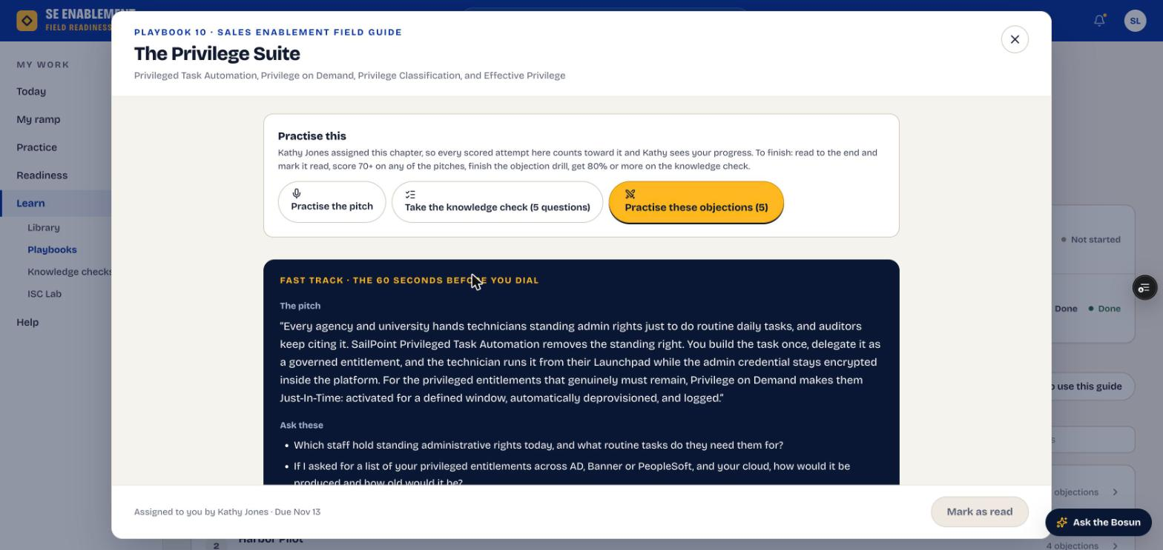
Figure 6.10 — An assigned chapter: who assigned it, what counts and what finishes it

3. Do each part
- Read: scroll to the end of the chapter, then Mark as read.
- Pitch: open a pitch from Practise this. Pitch Studio shows Counts toward … score 70+ to pass.
- Knowledge check: the header shows the pass mark, and the result says whether you passed it.
- Objection drill: the AI buyer raises each objection in turn and the coach scores each answer out of 10. Only use proof points that are in the chapter: invented statistics or customer names are flagged as unsupported and cost points.

Why it matters: Every scored attempt counts while the assignment is open, so your best score is the one that's kept.
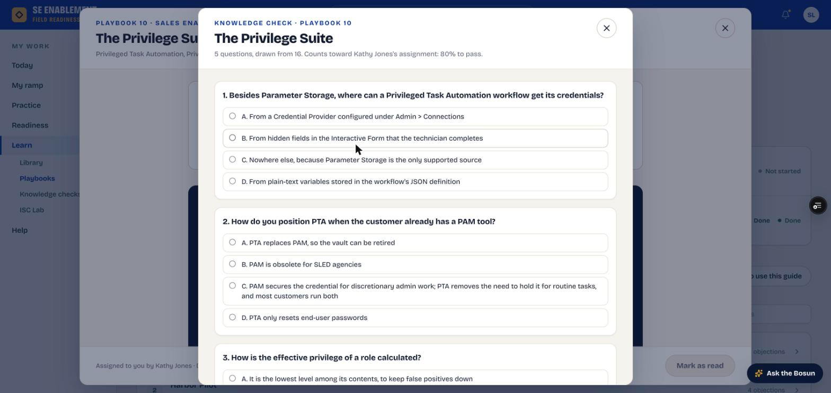
Figure 6.11 — The knowledge check names the assignment and its pass mark
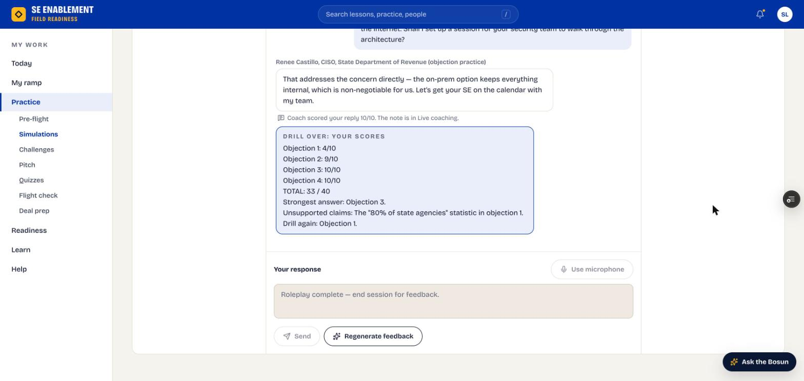
Figure 6.12 — End of the objection drill: scores per objection, total and anything unsupported

4. Finish it
- When the last part is done, Assignment complete appears where you did it and your manager is notified.
- Today keeps it for three days as Done, with "All 4 parts done" and that your manager has been notified (see the Today screen above). From then on, practice on the chapter is private again, and the chapter says so.

Why it matters: You and your manager see the same result at the same moment, with nothing to submit or chase.

Appendix A — Notifications
Who is told what, and when.
Event | Who is told | What they see
Plan assigned | New hire | Who assigned which program, who the mentor is, and that dates are agreed at the first 1:1.
Plan assigned | Mentor | That they're mentoring the new hire, with next steps: read the brief, meet, set the schedule.
Mentor sets the schedule | New hire and manager | How many dates changed, the new stage end and the mentor's note.
Mentor logs a 1:1 | New hire | The next actions from the meeting.
Manager schedules a 1:1 | New hire, and mentor if invited | Date, time, length and who's joining. It also appears under Coming up on the new hire's Today page.
New hire submits a step | Reviewer (mentor or manager) | That work is waiting. The mentor's Today and Mentoring pages count it.
Mentor approves or sends back | New hire | The decision, the step and the mentor's note.
New hire shares practice | Mentor | The pitch or simulation, its score and summary.
Manager assigns work | Each person assigned | Who assigned what, the due date and the note. It opens the item.
Assigned work is finished | Manager who assigned it | Who finished what, how early or late, and each part's result. It opens the assignment's workbench.

Appendix B — Quality notes from the walkthroughs
This guide was produced by running the workflow end to end on the live platform, twice. Problems found along the way were logged and fixed before moving on, so the steps above describe the corrected behaviour. A separate Run 2 report lists every finding.
- Walkthrough 1: 65 items logged; almost all fixed during the walkthrough. Mentors approve everyday steps, set dates without approval, and everyone is told about schedule changes and 1:1s.
- Walkthrough 2: 114 items logged with a second manager, the same mentor and two new hires; 108 fixed and released during the walkthrough.
- Biggest changes from walkthrough 2: pitch steps run through Pitch Studio and reach the mentor with the score; the mentor's review opens the exact step; new hires get a simulation catalogue, working search and calendar; extra work the manager assigns completes itself, notifies the manager and shows what was said.
- Still open: the plan form is long to scroll on the profile; there is no faster path for experienced hires; holidays aren't avoided in default due dates; a mentor can't yet open a shared simulation card from the workbench.

