SE ENABLEMENT PLATFORM · NEW-HIRE ONBOARDING
Hiring Manager Guide
Set up a new hire, choose their mentor, and track their ramp to each stage gate

Version: 1.1, October 27, 2026. Updated after a second end-to-end walkthrough.
For: SE managers who hire and onboard Solutions Engineers.
Walkthroughs: recorded on the live platform twice: first with Bill Smith (hiring manager), Matt Giblin (mentor) and Kevin Jones (new hire), then with Kathy Jones (hiring manager), Matt Giblin (mentor) and two new hires, Steve Smith and Susan Left. Text visible in the screens, such as briefs, notes and pitches, is example content from those walkthroughs; the Fill in boxes describe what you enter.
Companion guides: this is one of three role guides (hiring manager, mentor, new hire). A combined workflow guide covers all three.

Contents
Contents
Your role
Who's involved
Rules that shape your work
Part 1 — Set up the new hire
Part 2 — Track progress and sign off stage gates
Part 3 — Assign extra work and review the results
Appendix — Notifications
What you'll receive
What your actions send

Your role
As the hiring manager you start onboarding and you finish each stage. You set the new hire up with a hiring brief, a mentor and the onboarding program, then step back: the mentor agrees the dates and reviews the everyday work, while you watch progress and sign off the stage gates that unlock each 30-day stage.

Who's involved
Role | In this walkthrough | Responsibilities
Hiring manager | Kathy Jones (Bill Smith in earlier screens) | Writes the hiring brief, assigns the onboarding program and the mentor, schedules 1:1s, signs off every stage gate, assigns extra work and watches progress.
Mentor | Matt Giblin | Reads the brief, holds the first 1:1, sets the due dates with the new hire, approves or sends back everyday steps and logs check-ins.
New hire | Steve Smith and Susan Left (Kevin Jones in earlier screens) | Works through the ramp plan, submits each step with evidence, acts on feedback, practises beyond the plan and completes extra work the manager assigns.

Rules that shape your work
- You own the stage gates. Test-outs and the end-of-stage sign-off come to you; signing them off unlocks the next stage.
- The mentor owns the dates. The template's dates are a starting point. The mentor agrees the real dates with the new hire and you're told when they change. No approval is needed.
- The mentor approves everyday steps. Reading, pitches, knowledge checks, challenges and simulations don't come to your Inbox.
- Details open in a workbench. Clicking a person or item opens a full popup over the page. Press Esc or the close button to return; if you've typed something unsaved, you're asked first.
- Extra work you assign is yours. Chapters, pitches and checks you assign outside the plan have no mentor review. They score themselves and report back to you.

Part 1 — Set up the new hire
Signed in as the hiring manager. Before you start, the new hire must have an account and report to you.

1. Find the new hire on Today
- Open Today from the sidebar.
- Find the new hire under Your team, most urgent first. A new starter shows New to the team, no ramp plan yet.

Why it matters: Today lists everyone who needs you, most urgent first. A new starter is flagged for onboarding, not as at risk, so you can see straight away what to do.
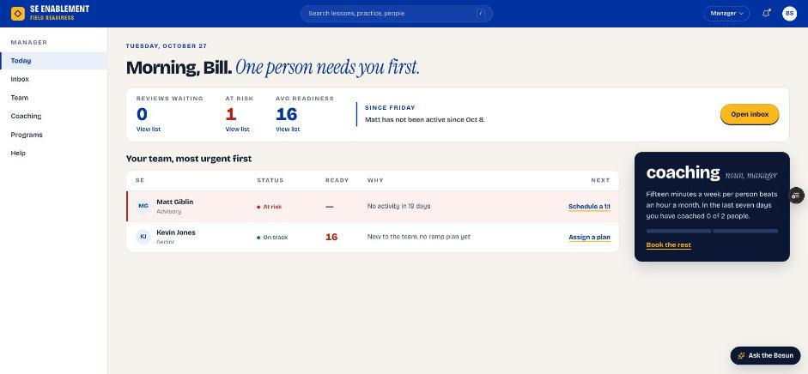
Figure 1.1 — Manager Today page with the new hire waiting for a plan

2. Open the new hire's profile workbench
- Click the new hire's name. Their profile opens as a workbench.
- The left side shows the overview, counters, Suggested next and assigned work. The right side holds Mentor and notes.
- If you've typed something and press Esc or close, you're asked first, so unsaved text isn't lost.

Why it matters: Everything you need for onboarding is in one place: the brief, the mentor, the plan and the 1:1 scheduler. You don't need to move between pages.
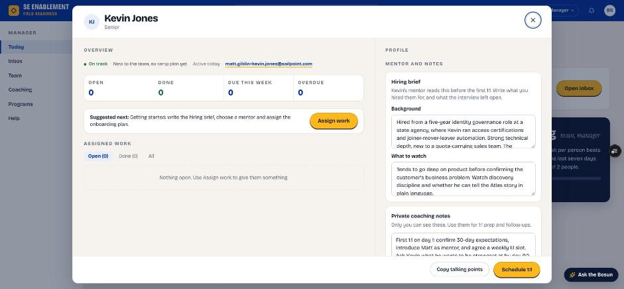
Figure 1.2 — The profile workbench

3. Write the hiring brief
- In Hiring brief, complete both fields.
- Click Save hiring brief. The confirmation says it's saved; the mentor sees it once you choose one in step 6.

Fill in: Background: what you hired this person for: their experience, strengths and the role they're stepping into. What to watch: what the interviews left open and what the mentor should keep an eye on in the first weeks.

Why it matters: The mentor reads the brief before the first 1:1. It gives them the context to coach from day one instead of starting cold.
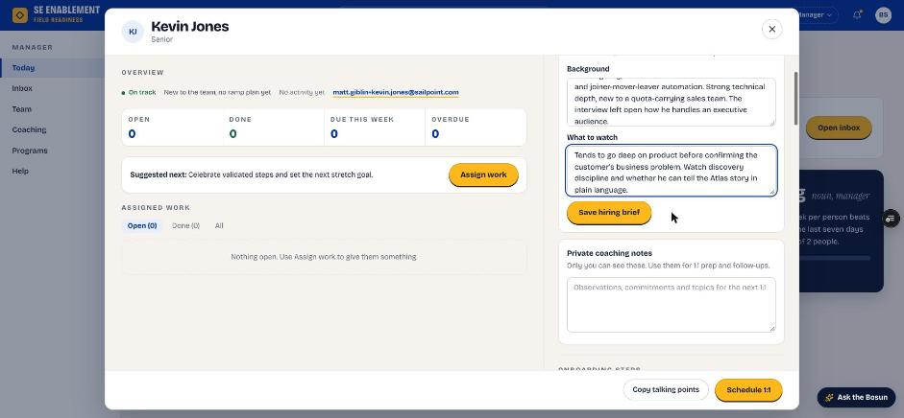
Figure 1.3 — Hiring brief fields
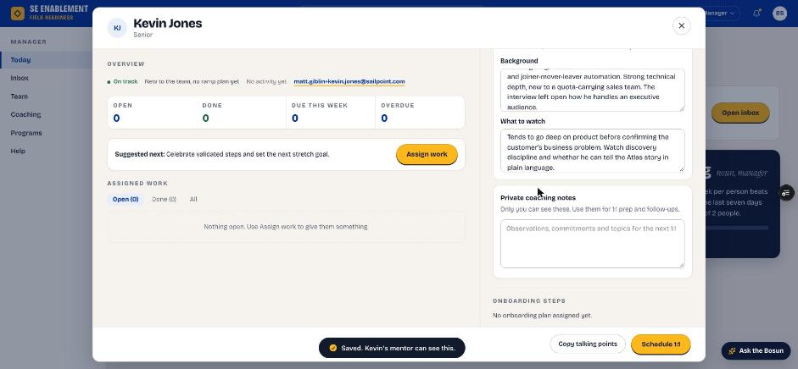
Figure 1.4 — Brief saved and shared with the mentor

4. Add private coaching notes
- In Private coaching notes, add your own notes.
- Click Save notes.

Fill in: Your goals for the first 1:1, anything to follow up on, and what you want the new hire to be strongest at by the end of the program. Only you can see these notes.

Why it matters: These notes are your preparation for 1:1s and follow-ups. They stay private, so you can be candid.
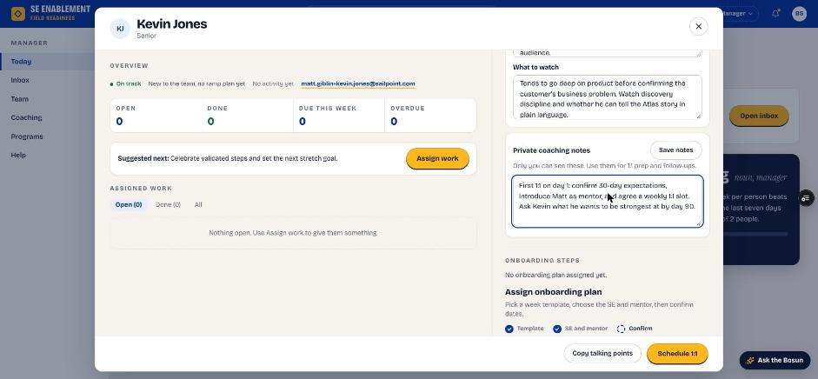
Figure 1.5 — Private coaching notes
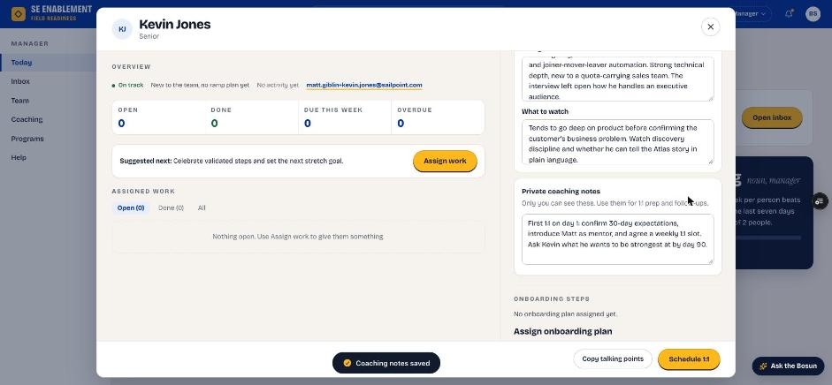
Figure 1.6 — Notes saved

5. Choose the onboarding template
- Click Assign a plan, on Today, under Suggested next or in the profile. The plan form opens in its own workbench.
- Under Step 1, Template, choose the first stage of the new-hire program (Days 1–30 — Foundation). Check the stage length and step count.

Why it matters: The program has four 30-day stages. Assigning the first stage starts the program, and later stages unlock as each stage gate is signed off. Start experienced hires here too: they can take a stage's test-outs straight away, and when you sign off the gates the rest of the stage closes as tested out.
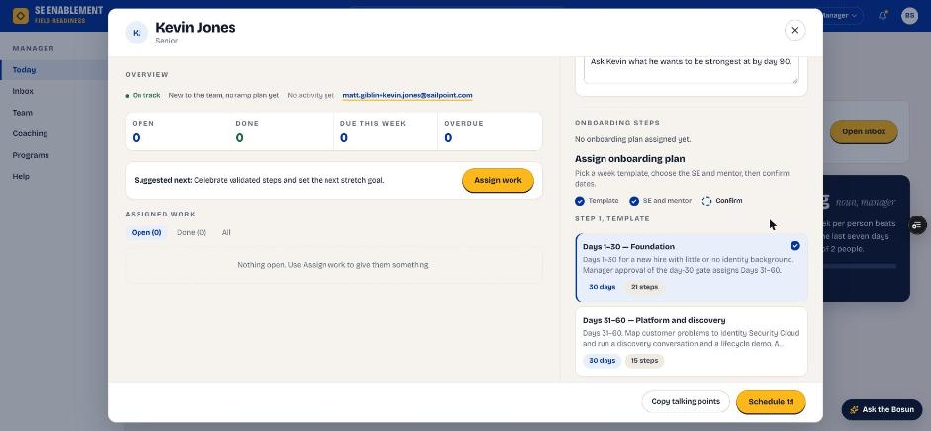
Figure 1.7 — Choosing the Days 1–30 template

6. Choose the person, mentor and start date
- Assign to: the new hire.
- Mentor: an experienced SE who will coach them. Only experienced people are offered; new hires aren't.
- If you leave No mentor, you're asked to confirm. The new hire is then told you'll set up their first 1:1, and you can add a mentor later from Assigned mentor, which notifies everyone involved.
- Start date: the new hire's first day.
- Target completion fills in from the template.

Fill in: Assign to, Mentor and Start date. Leave Target completion as suggested; the mentor will confirm the final dates.

Why it matters: The mentor you choose is who the new hire works with every week and who reviews their everyday steps. Target completion is a starting point because the mentor agrees the real dates with the new hire.
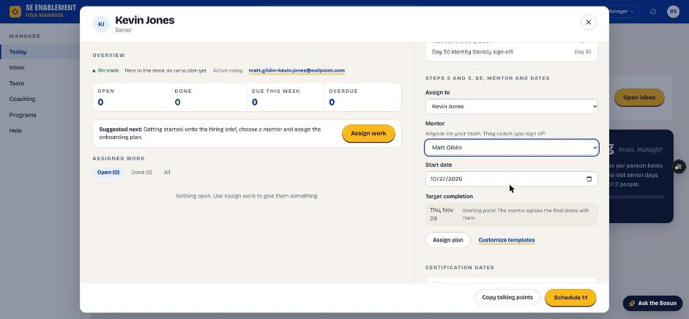
Figure 1.8 — Assign to, mentor, start date and target completion

7. Assign the plan
- Click Assign plan.
- The profile stays open, the steps appear with their starting dates, and a confirmation appears.

Why it matters: Assigning notifies both people. The new hire is told who their mentor is and that dates are agreed at the first 1:1. The mentor is told they've been chosen and what to do next.
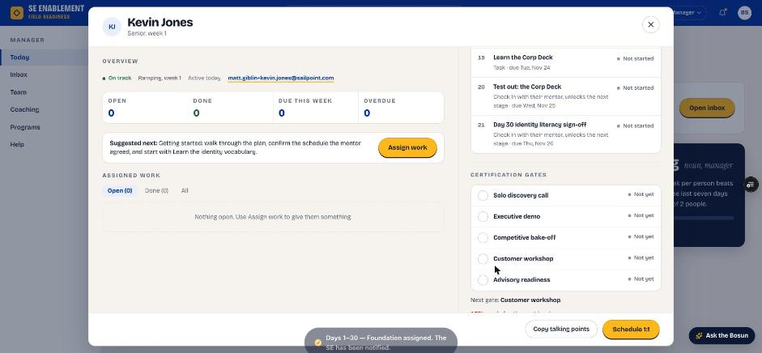
Figure 1.9 — Plan assigned; the new hire has been notified
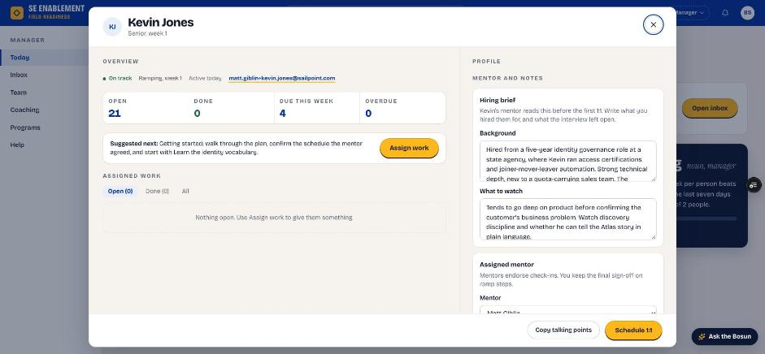
Figure 1.10 — Profile after assignment: counters, brief and mentor

8. Schedule a 1:1 with the new hire
- In the profile footer, click Schedule 1:1.
- Pick the date, time and length, and choose whether the mentor joins. Times that have passed can't be picked.
- Click Schedule and download invite, then open the downloaded invite to send it from your calendar.

Fill in: Date, time and length of the meeting. Tick the mentor box if they should join.

Why it matters: The 1:1 is saved in the platform. The new hire sees it under Coming up on their Today page, they (and the mentor, if invited) get a notification, and the profile shows Next 1:1. Today then shows 1:1 booked instead of suggesting one.
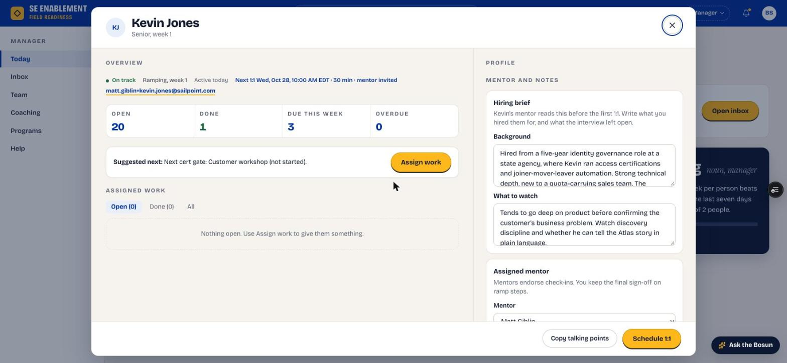
Figure 1.11 — The profile shows the next 1:1 and whether the mentor is invited

Part 2 — Track progress and sign off stage gates
Once the plan is running, the mentor handles the day-to-day. Your job is to keep an eye on progress, meet the new hire, and sign off each stage gate.

1. Read Today
- Since Friday summarises what the team did, such as "Kevin finished a ramp step".
- Each person's status, readiness and suggested next action are listed. A new hire in their first 30 days shows Ramping, week N, and their readiness isn't marked red while they ramp.
- A mentor's reviews, schedules and 1:1s count as them being active.
- Reviews waiting counts only what needs you. Steps the mentor reviews reach you only after the mentor has approved them.

Why it matters: You can see progress at a glance without approving every step yourself. Your attention goes to the people who need it.
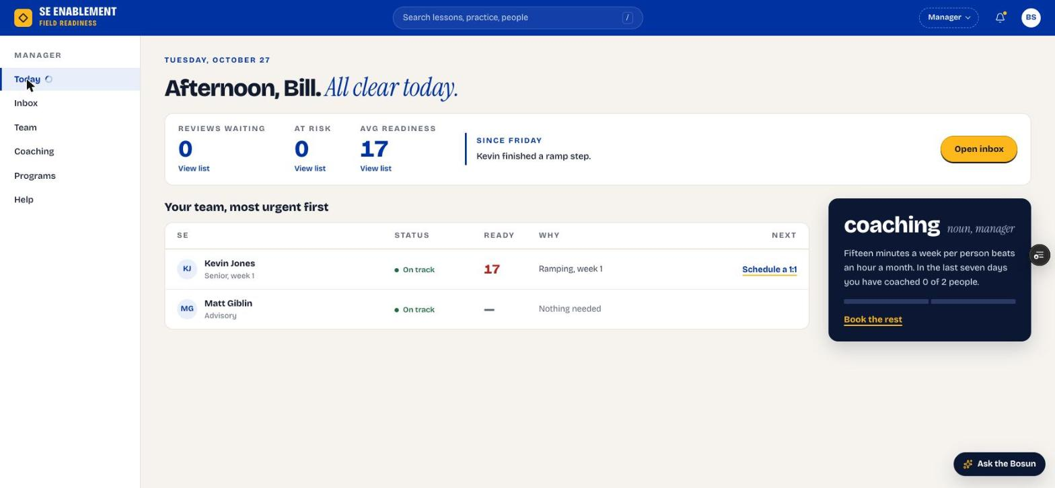
Figure 2.1 — Manager Today page after the first step

2. Open the new hire's profile
- Click the name. The counters show open, done, due this week and overdue steps.
- Onboarding steps lists every step with its agreed date. Stage gates read Stage gate, you sign off.
- Recent activity shows who approved what, the mentor's 1:1s and the schedule.
- Next 1:1 shows the next scheduled meeting.

Why it matters: The profile is the full picture for your next 1:1: progress, the mentor's involvement and what's coming up.
Figure 2.2 — Profile with progress and the next 1:1

3. Check the Inbox
- Open Inbox. Items that need your sign-off, such as stage gates, are listed oldest first.
- Schedule changes by mentors shows the dates mentors set, for information.

Why it matters: The Inbox holds only what needs your decision, so you can clear it quickly. Everyday steps go to the mentor and don't appear here.
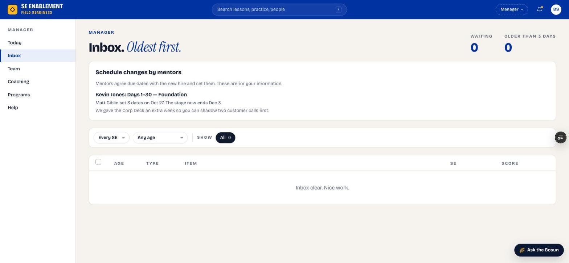
Figure 2.3 — Manager Inbox

4. Read your notifications
- Click the bell. Notifications open in a workbench; click one to go to it, or Mark all read.

Why it matters: Notifications tell you when a mentor sets or changes the schedule, so you're never surprised by a new date.
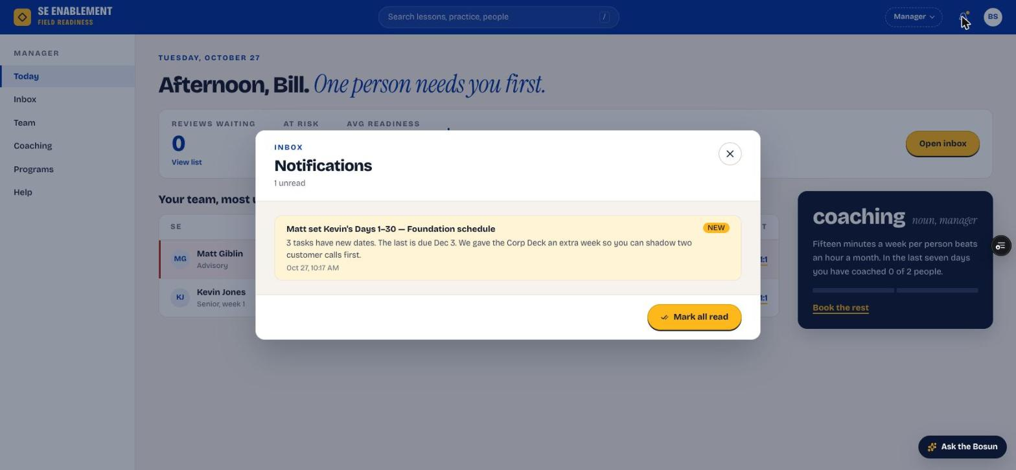
Figure 2.4 — Notifications workbench

5. Sign off stage gates
- When the new hire submits a test-out or the end-of-stage sign-off, it appears in your Inbox and on their profile.
- Open it. The mentor's recommendation is shown on the left. Your sign-off may come pre-filled by an AI coaching brief; rewrite anything that isn't what you saw.
- Fill in Strength observed, Gap to address, Concrete next action and Readiness confidence. Gates also need Live coaching attestation: tick it only if you saw them do it yourself (in a 1:1, call shadow or live review) and say what you observed. Then click Approve, or Request changes.
- Signing off a stage's last gate closes any steps still open as tested out, so an experienced hire who tests out early finishes the stage. The new hire is told how many closed.

Why it matters: Signing off the gate unlocks the next 30-day stage. This is the manager's decision because it confirms the new hire is ready to move on.

Part 3 — Assign extra work and review the results
The onboarding plan isn't the only work. When a deal or the team needs a skill now, assign it directly. In the walkthrough, the manager assigned the Credentials and Secrets chapter to both new hires, due the following week.

1. Open Assign work
- Open the person's profile and click Assign work (next to Suggested next).
- Choose what kind of work: a Playbook chapter, a Simulation, a Pitch, a Knowledge check, a Library item or a Ramp task.

Why it matters: Real work doesn't wait for the onboarding plan to finish. Assign work puts a deal-driven or team-driven task in front of someone without touching their ramp.
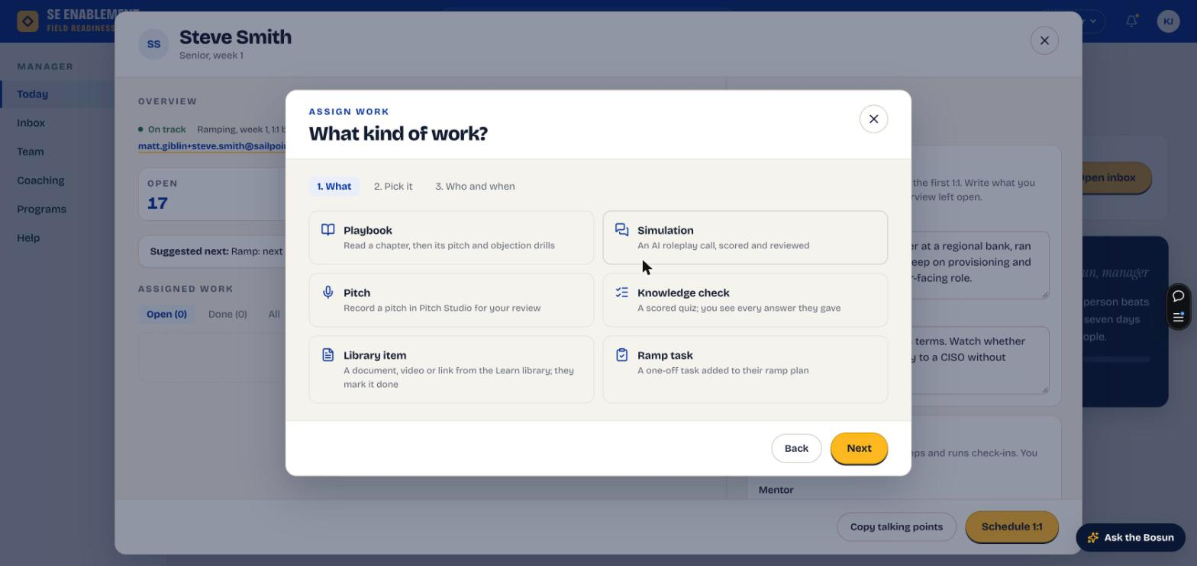
Figure 3.1 — Assign work, step 1: what kind of work

2. Pick it
- Search by title or product name. A search for a product name finds the chapter that covers it, and each result shows its subtitle.
- Tick one or more items. Try it yourself opens the item in a new tab, so you know what you're asking for.

Why it matters: Searching by product means you don't need to know how the field guide names its chapters.
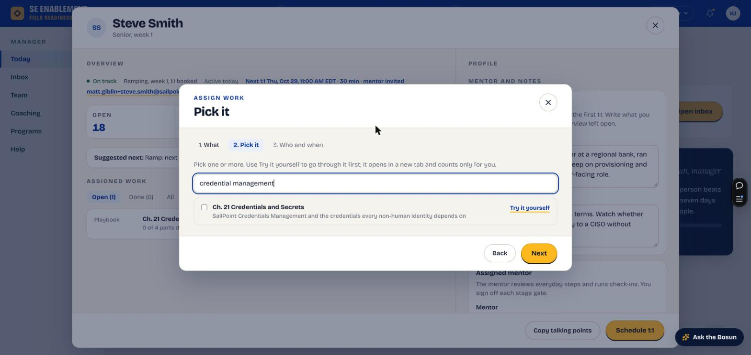
Figure 3.2 — Pick it: a product-name search finds the chapter

3. Choose who and when
- Tick one or more people. Each shows their role.
- Set the due date. If that week is clearly heavier than someone's usual ramp week, a Busy week note says so and offers a lighter week; click Use to take its Friday.
- Add a note saying why it matters now. The summary at the bottom shows what, for whom and when.

Fill in: Due date: when it must be finished. Note: the reason for the assignment and what you expect them to be able to do afterwards.

Why it matters: The note is the context the SE reads first, on their profile card and with the assignment. A due date in an already heavy ramp week doubles the load; the Busy week note only appears when that's the case.
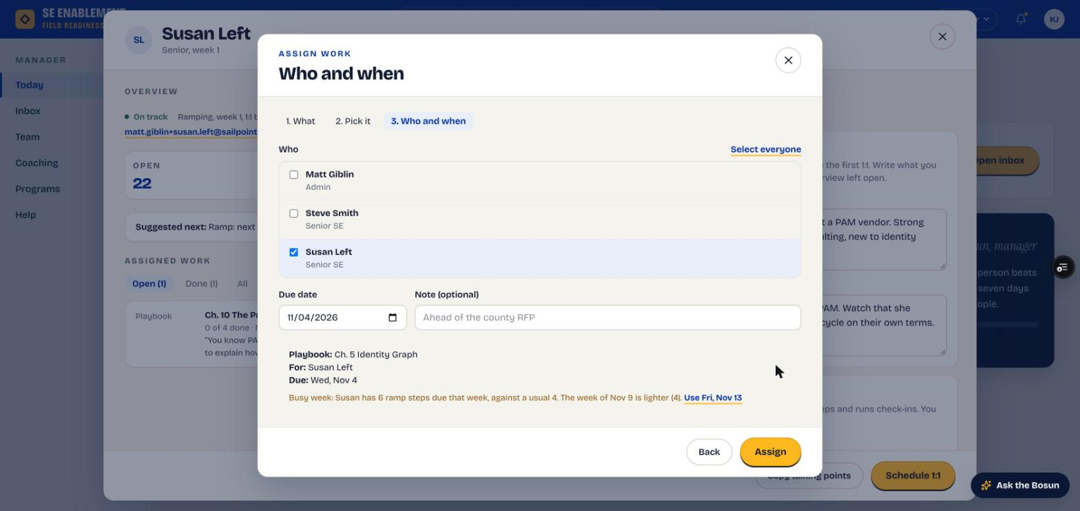
Figure 3.3 — Who and when: roles, the summary, and a Busy week note offering a lighter week

4. Assign and check it landed
- Click Assign. A confirmation says how many people it went to.
- The person's profile lists it under Assigned work › Open with its parts, due date and your note.
- Each person is notified with your name, the item and the due date; the notification opens the item.

Why it matters: Assigned work has no mentor. The parts check themselves: reading marked done, pitch drills scored by the AI, the objection drill scored at the end, and the knowledge check scored automatically.
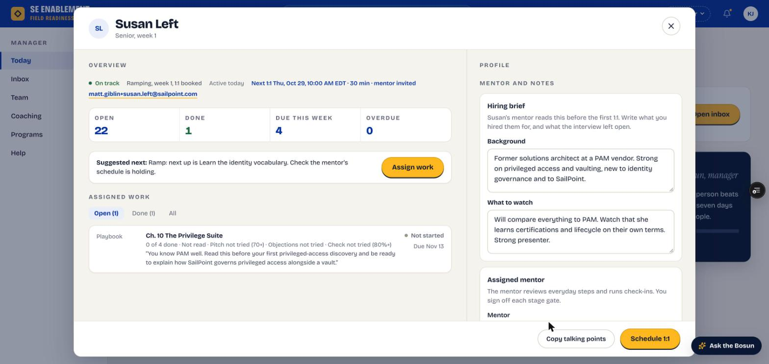
Figure 3.4 — The assignment on the profile: each part's status and pass mark, with the note on its own line

5. Get told when it's finished
- When the last part is done, you're notified straight away, for example "Susan Left finished Credentials and Secrets 7 days early: read, pitch 78, objections 83%, check 80%."

Why it matters: You don't need to check back. The notification gives you the result at a glance and how early or late it was.
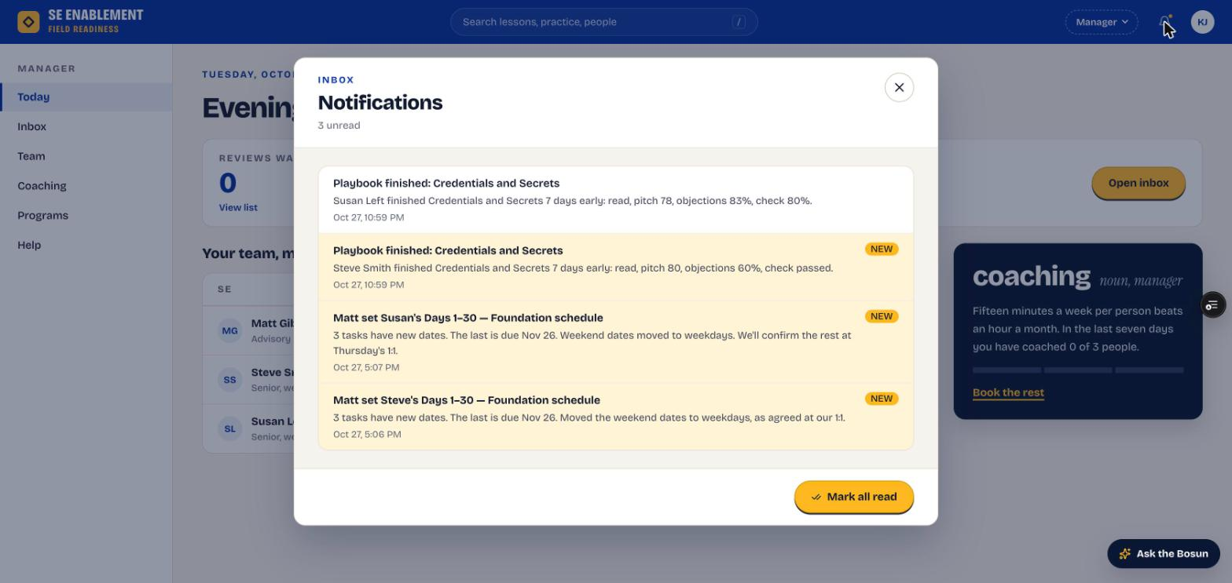
Figure 3.5 — Finished-assignment notifications

6. Review what they did
- Click the notification. The person's profile opens with the assignment's workbench on top.
- The header gives each part's result against its pass mark, for example Pitch 78 (70+).
- Knowledge check shows every question with the answer picked; Objection drill shows the debrief, each answer and the coach's score; Pitch drills show the rubric, what was said and what was left out.
- Only attempts made while the assignment was open are shown. Practice afterwards is private, and the SE is told so.

Why it matters: A score on its own doesn't tell you whether someone is ready for the customer conversation you assigned it for. Reading what they actually said does.
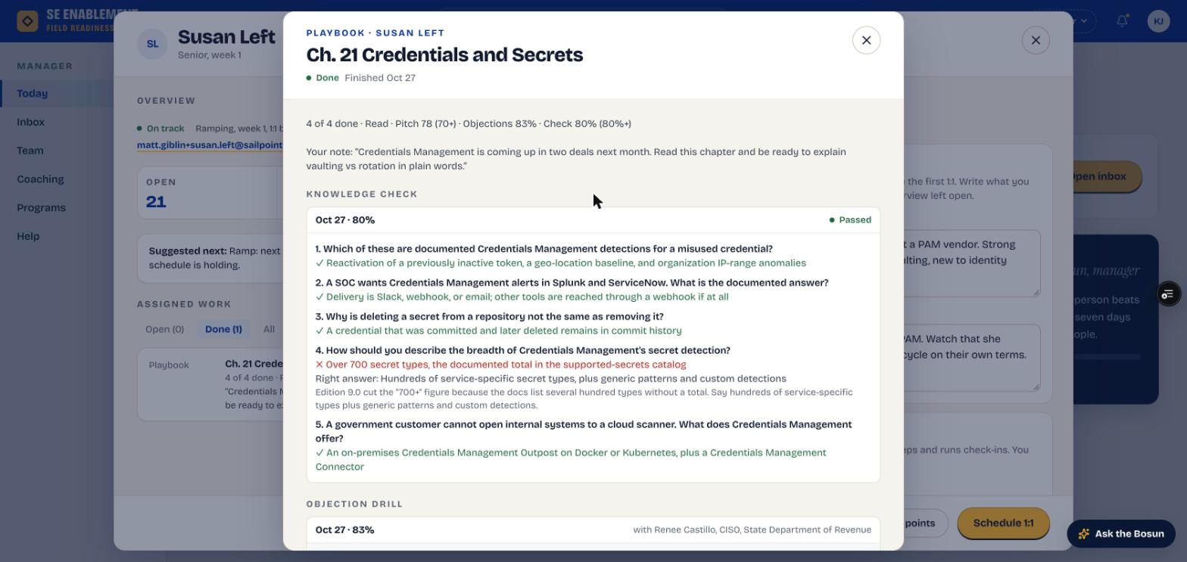
Figure 3.6 — The assignment workbench: results, your note and the knowledge check
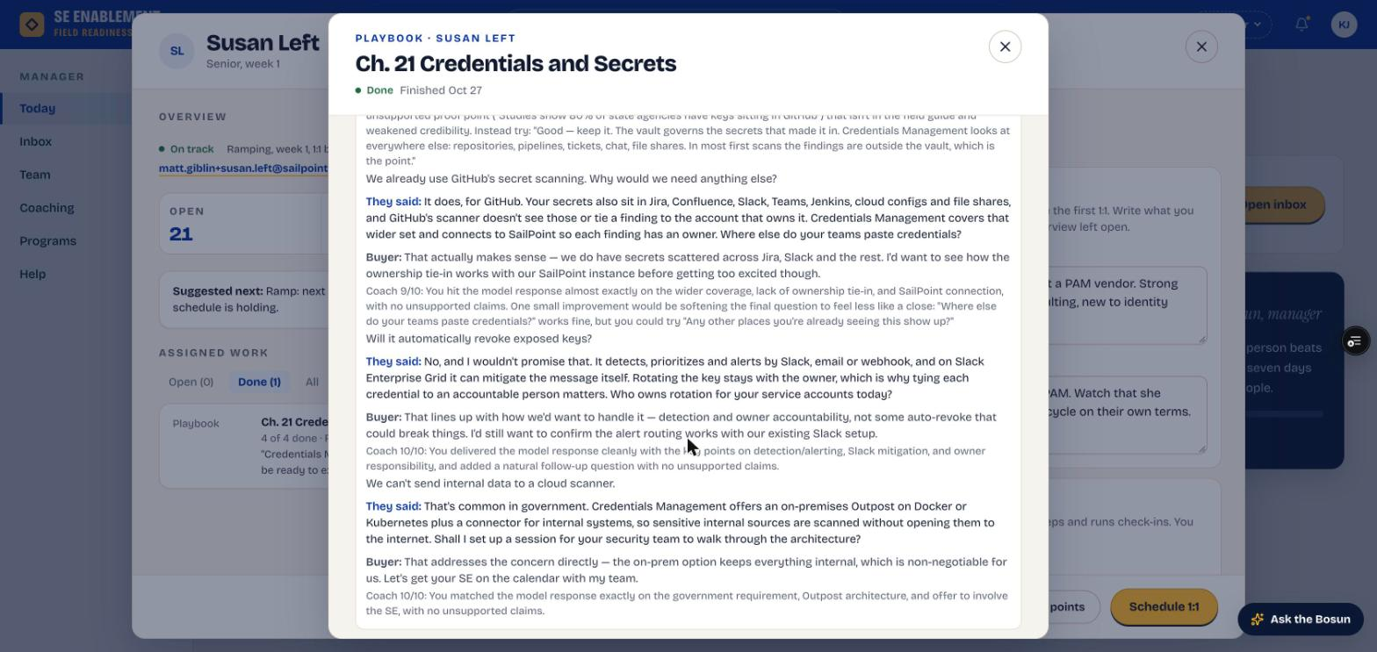
Figure 3.7 — The objection drill: each answer with the coach's score and note
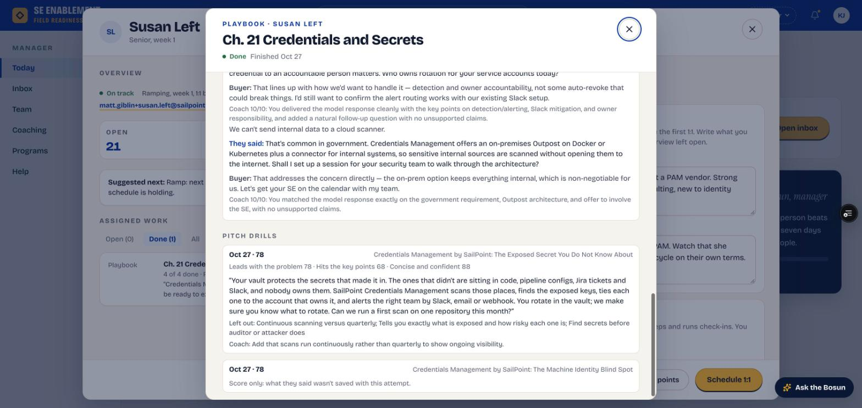
Figure 3.8 — A pitch drill: rubric, the pitch as delivered, and what was left out

Appendix — Notifications

What you'll receive
When | What you see
Mentor sets or changes the schedule | How many dates changed, the new stage end and the mentor's note. Also listed in your Inbox under Schedule changes by mentors.
New hire submits a stage gate | The gate appears in your Inbox and on their profile for sign-off.
Someone finishes work you assigned | Who finished what, how early or late, and each part's result. It opens the assignment's workbench.

What your actions send
When you… | Who is told, and what
You assign the plan | New hire: who assigned which program, who the mentor is, and that dates are agreed at the first 1:1. Mentor: that they're mentoring the new hire, with next steps.
You schedule a 1:1 | New hire (and the mentor, if invited): date, time, length and who's joining. It appears under Coming up on the new hire's Today page.
You assign work | Each person: who assigned what, the due date and your note. It opens the item.

