SE ENABLEMENT PLATFORM · NEW-HIRE ONBOARDING
New Hire Guide
Find your way around, work through your ramp, and move through each stage

Version: 1.1, October 27, 2026. Updated after a second end-to-end walkthrough.
For: Solutions Engineers starting the onboarding program.
Walkthroughs: recorded on the live platform twice: first with Bill Smith (hiring manager), Matt Giblin (mentor) and Kevin Jones (new hire), then with Kathy Jones (hiring manager), Matt Giblin (mentor) and two new hires, Steve Smith and Susan Left. Text visible in the screens, such as briefs, notes and pitches, is example content from those walkthroughs; the Fill in boxes describe what you enter.
Companion guides: this is one of three role guides (hiring manager, mentor, new hire). A combined workflow guide covers all three.

Contents
Contents
Your role
Who's involved
Rules that shape your work
Part 1 — Get started
Part 2 — Complete and submit steps
Part 3 — Reviews, 1:1s and stage gates
Part 4 — Practise beyond your ramp
Part 5 — Work your manager assigns
Appendix — Notifications
What you'll receive
What your actions send

Your role
Your onboarding program has four 30-day stages. Each stage is a list of steps: reading, pitches, knowledge checks, challenges and simulations, ending in a stage gate. Your mentor agrees your due dates with you and reviews your everyday steps. Your hiring manager signs off each stage gate, which unlocks the next stage.

Who's involved
Role | In this walkthrough | Responsibilities
Hiring manager | Kathy Jones (Bill Smith in earlier screens) | Writes the hiring brief, assigns the onboarding program and the mentor, schedules 1:1s, signs off every stage gate, assigns extra work and watches progress.
Mentor | Matt Giblin | Reads the brief, holds the first 1:1, sets the due dates with the new hire, approves or sends back everyday steps and logs check-ins.
New hire | Steve Smith and Susan Left (Kevin Jones in earlier screens) | Works through the ramp plan, submits each step with evidence, acts on feedback, practises beyond the plan and completes extra work the manager assigns.

Rules that shape your work
- Your mentor sets your dates with you. The dates on your ramp are the ones you agreed at your first 1:1.
- Your mentor reviews everyday steps. Each step shows who reviews it.
- Your manager signs off stage gates. Test-outs and the end-of-stage sign-off go to your manager.
- Details open in a workbench. Clicking a step or notification opens a full popup. Press Esc or the close button to return.
- Practice is private unless you share it. Free practice isn't seen by anyone unless you submit or share it, except attempts on a chapter your manager has assigned, which count toward that assignment.

Part 1 — Get started
Signed in as the new hire, after your manager has assigned your plan.

1. Start on Today
- Today shows your next step, its due date and who reviews it, what's coming up, and the Your mentor card.
- Any 1:1 your manager has scheduled appears under Coming up, and every row there opens its step.
- While a step is with your reviewer, Today says who has it and its main button starts your next step, so you can keep going.

Why it matters: Today always answers "what do I do next?", so you never have to work out where you are in the program.
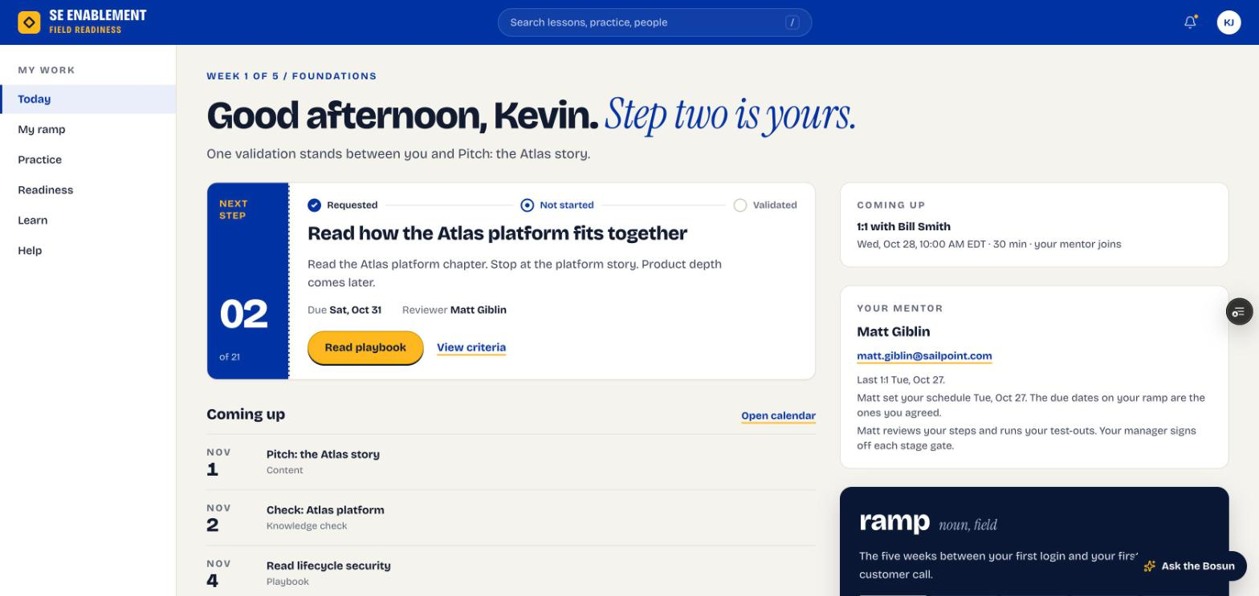
Figure 1.1 — New hire Today page
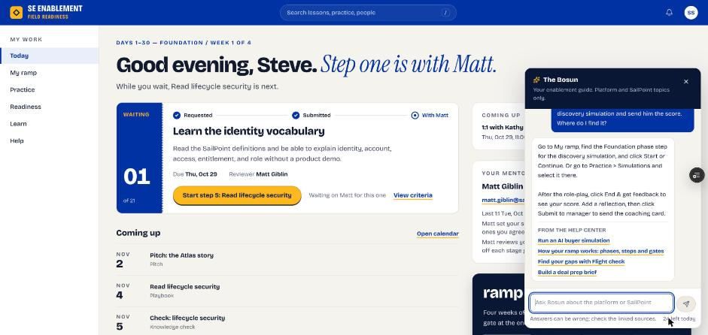
Figure 1.2 — Step 1 is with the mentor; Today offers the next step. The Bosun is open on the right

2. Check your notifications
- Click the bell. Your notifications open in a workbench: the plan assignment, the schedule your mentor set (with their note), the next actions from your 1:1, reviews of your steps and any 1:1 your manager scheduled.
- Click a notification to go to it, or Mark all read.

Why it matters: Notifications confirm who your mentor is, the dates you agreed and what you promised to do next.
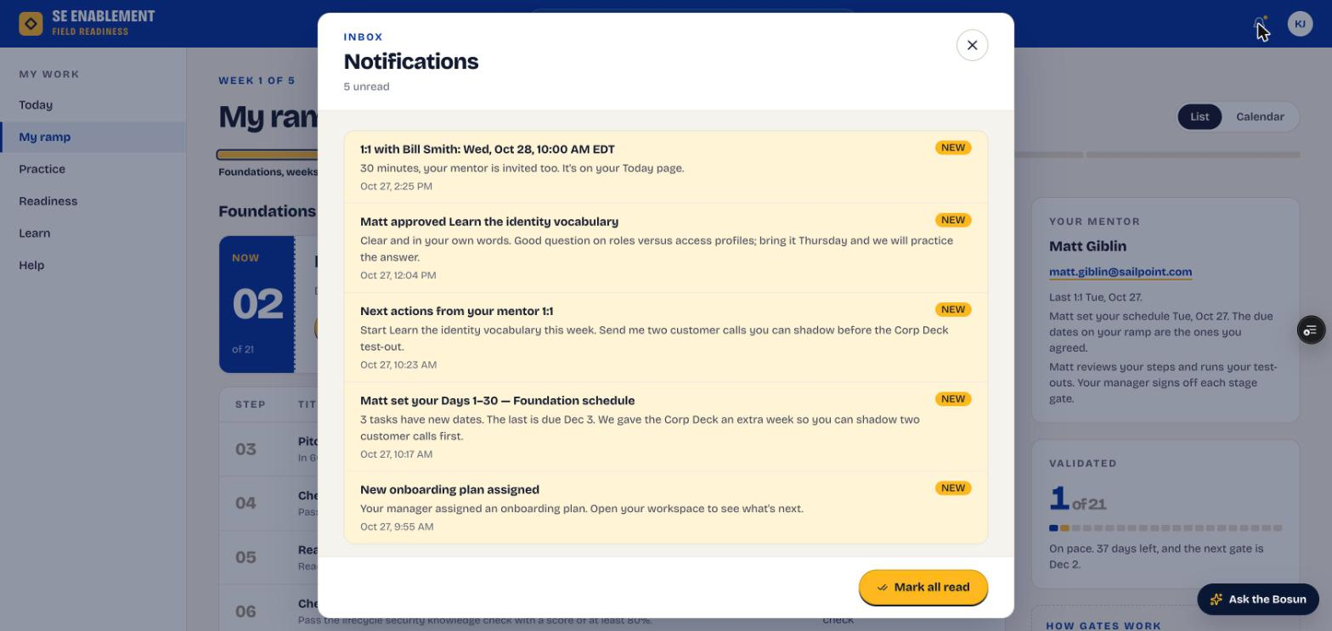
Figure 1.3 — Notifications

3. Open My ramp
- Click My ramp. You see the current step, every step with its agreed due date, your progress and your mentor. Finished steps are listed under Done.
- Switch to Calendar for a week or month view of the same dates. Steps with your reviewer show In review. Click any step to open it.

Why it matters: The full plan with real dates helps you pace the 30 days and spot anything that needs to move early.
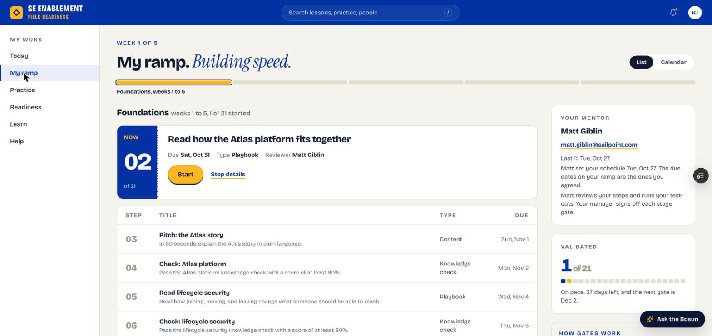
Figure 1.4 — My ramp
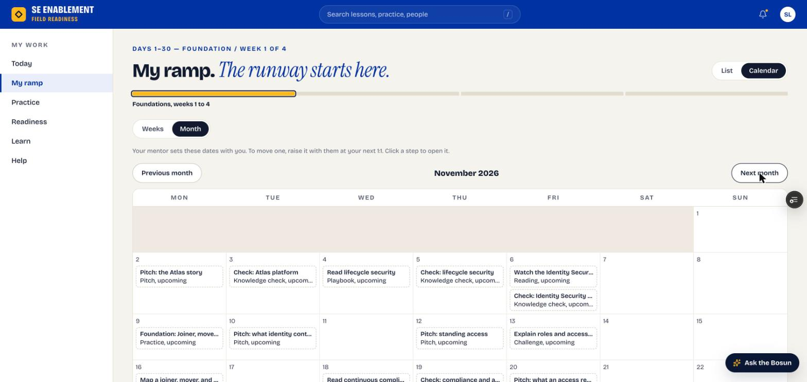
Figure 1.5 — My ramp as a month calendar

Part 2 — Complete and submit steps
Work through your ramp one step at a time.

1. Complete and submit a step
- Click a step. It opens as a workbench over My ramp.
- Read the brief and the Done when criteria, and open the linked resource.
- Tick each criterion as you meet it, write your evidence and click Submit for review. The note under the evidence box says who reviews it, and the button says what's missing if it isn't ready.
- Pitch steps have an Open Pitch Studio button. Record or type the pitch there and score it, then submit it from the Studio: the pitch, its AI score and the coaching note attach to the step for your mentor.
- Playbook steps complete themselves when you read the chapter to the end and mark it read; knowledge checks complete when you pass.

Fill in: What did you learn? Your evidence in your own words: the key takeaways, set against the Done when criteria, and any questions for your next 1:1.

Why it matters: Your evidence is what your reviewer judges. Clear evidence gets a quick approval instead of a send-back.
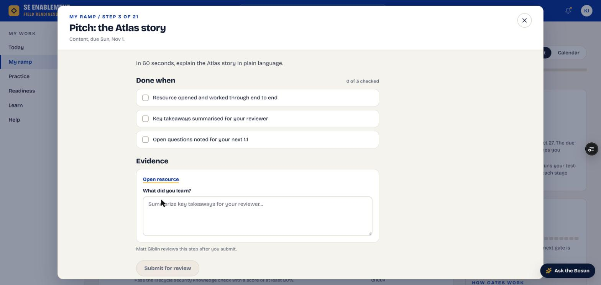
Figure 2.1 — Step workbench: Done when criteria, evidence and reviewer
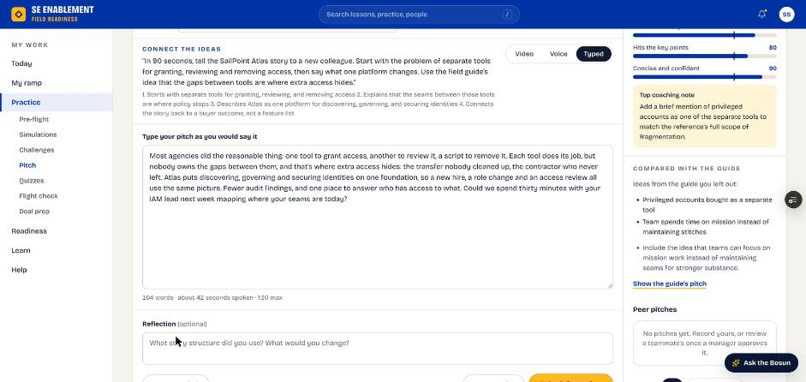
Figure 2.2 — Pitch Studio opened from a pitch step, scored and ready to submit
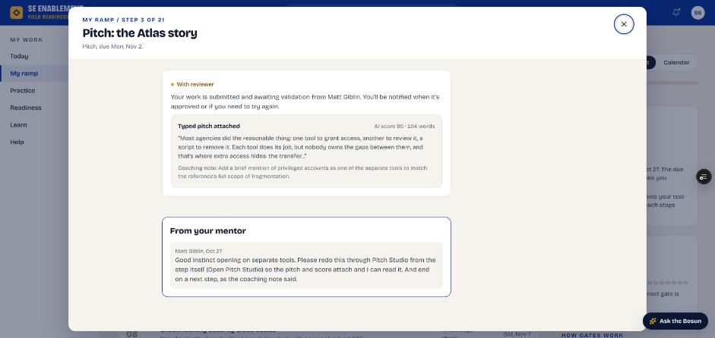
Figure 2.3 — The scored pitch attached to the step, with the mentor's earlier note

2. Know what happens next
- The step shows In review on My ramp.
- Today says who has it (for example, "Step one is with Matt") and shows the next step so you can keep going.
- When your mentor approves or sends it back, you get a notification with their note (see your notifications).

Why it matters: You don't have to wait idle. Your reviewer is notified, and you can move on to the next step.

Part 3 — Reviews, 1:1s and stage gates
What happens after you submit, and how you move to the next stage.

1. Read your reviewer's feedback
- When a step is approved or sent back, you get a notification with the decision and your reviewer's note. It opens the step.
- Approved steps count toward your progress on My ramp and Today.
- Readiness › Feedback lists every review in one place, including steps still awaiting your mentor.

Why it matters: The note tells you what landed and what to sharpen. Bring anything you want to discuss to your next 1:1.
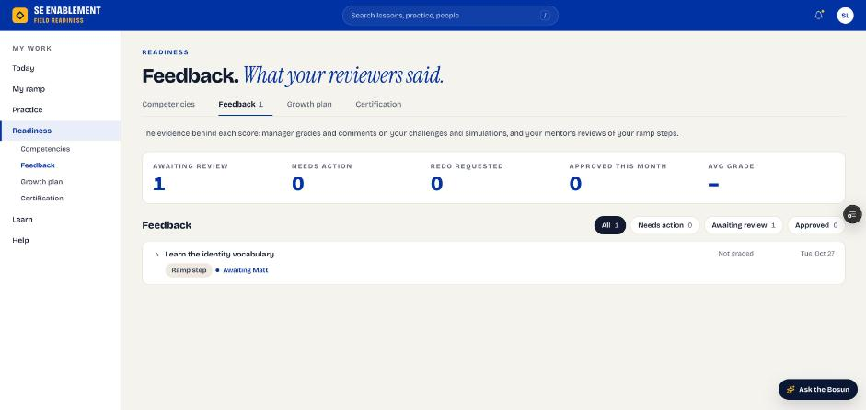
Figure 3.1 — Readiness › Feedback with a step awaiting the mentor

2. Rework a step that was sent back
- Open the step from the notification or My ramp. What your mentor asked sits above the form, and your earlier answer is kept.
- Update your evidence to address the note and submit it again. For a pitch step, redo it in Pitch Studio from the step.

Fill in: Your revised evidence, answering the points in the reviewer's note.

Why it matters: A send-back is coaching, not a failure. Responding to the note directly is the fastest way to get the step approved.

3. Prepare for your 1:1s
- Meetings your manager schedules appear under Coming up on Today, with the time, length and whether your mentor joins.
- Your mentor's card shows when you last met.

Fill in: Questions and blockers to raise, collected from your step notes.

Why it matters: 1:1s are where dates move, gaps get worked on and stage gates get planned. Arriving with questions makes them count.

4. Pass each stage gate
- Each stage ends with a test-out and a sign-off step, marked as a stage gate.
- Practise the test-out with your mentor, then open the gate step and click Submit for sign-off. Your mentor adds a recommendation, then your manager signs it off.
- Signing off the last gate assigns the next 30-day stage; it appears on My ramp and you get a Next program assigned notice.
- Already know the material? You can take a stage's gates as soon as you're ready, even in a part of the stage that is still locked: My ramp lists them under that part. When your manager signs them off, any steps still open close as tested out and the next stage opens.

Why it matters: Gates confirm you're ready for the next stage, so your manager makes that call. Your mentor's job is to get you ready.

Part 4 — Practise beyond your ramp
Your ramp tells you what's due. Practice is how you get good at it. Everything here is open to you at any time, whether or not it's on your plan.

1. Start from the Practice hub
- Open Practice. Pre-flight builds a short plan before a real call; Keep skills sharp links to Simulations, Challenges and Pitch.
- Assigned to you on the right lists practice from your ramp with its due date.

Why it matters: Practice is how the reading turns into something you can say to a customer. Nothing here counts against you unless you choose to submit or share it.
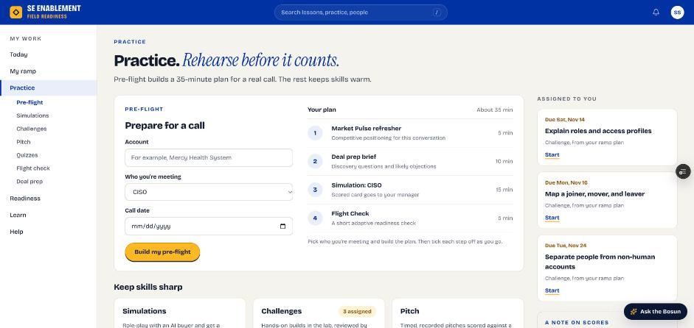
Figure 4.1 — The Practice hub

2. Practise straight from a playbook chapter
- Open any chapter under Learn › Playbooks. Practise this at the top offers the chapter's pitches (numbered to match the chapter's Test yourself), the cold open, the knowledge check and Practise these objections.
- Each opens with the chapter already chosen, so you can practise right after you read.

Why it matters: Practising while the chapter is fresh is the quickest way to make it stick.
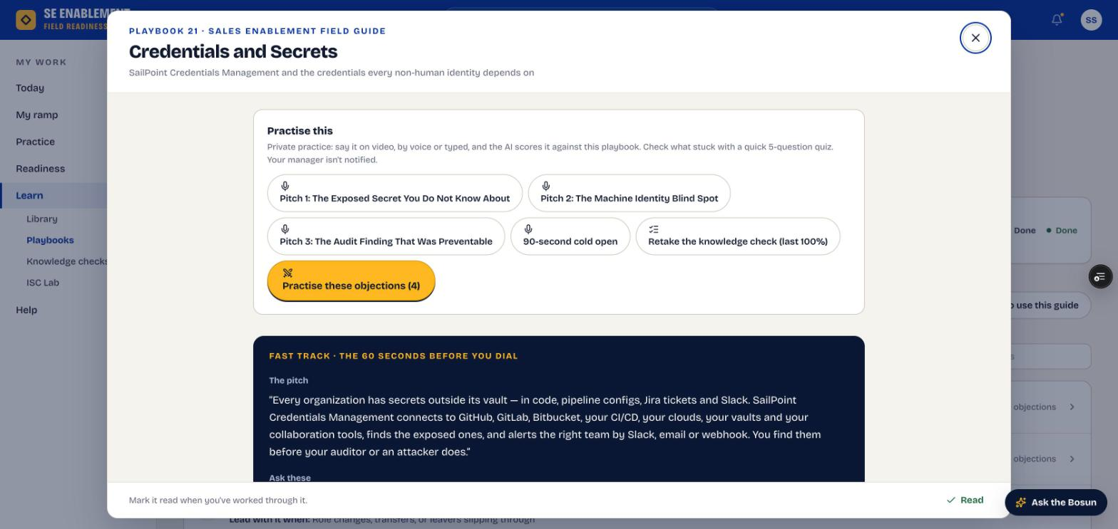
Figure 4.2 — Practise this, at the top of a chapter

3. Pitch in Pitch Studio
- Choose Free practice, then pick a scenario under From playbooks (the page may open on a practice scenario, which is video only). Answer by Video, Voice or Typed within the time limit.
- Click Score my pitch. Scoring takes up to 30 seconds and returns a rubric score, a coaching note and Compared with the guide, which lists the ideas you left out. Show the guide's pitch lets you compare word for word.
- Save it if you want to keep it, or Share with my mentor to send it with its score.

Fill in: Your pitch, in the words you'd use with a customer, and an optional reflection on what you'd change.

Why it matters: The rubric scores the three things customers notice: leading with their problem, hitting the key points, and keeping it short and confident.
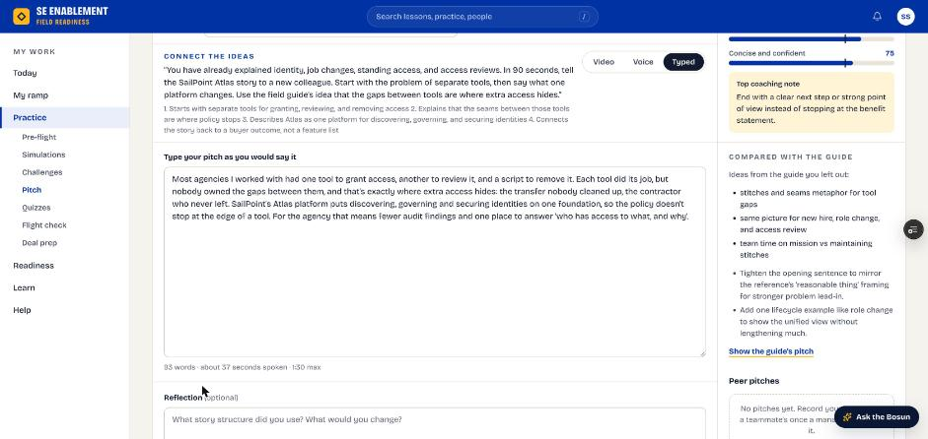
Figure 4.3 — A scored typed pitch, compared with the guide

4. Check what stuck with a knowledge check
- Take a chapter's check from the chapter or from Learn › Knowledge checks. Each sitting draws 5 questions from the chapter's set.
- After you submit, every question shows Right or Not quite with the explanation. Click New questions to try again.

Why it matters: The explanations are where the learning is, especially on the ones you got wrong.
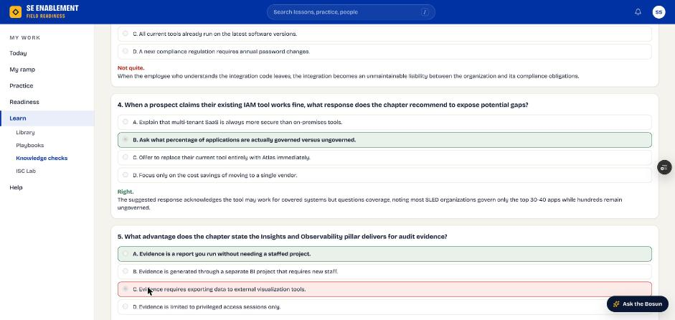
Figure 4.4 — Knowledge check results with explanations

5. Rehearse with an AI buyer
- Open Practice › Simulations. From your ramp comes first; Browse scenarios lists the rest by level, starting with Foundational.
- In a simulation, the left shows the buyer and your objective, the middle is the conversation and Live coaching on the right gives a Next move after each reply. Type HINT: for a tip mid-call.
- Click End & get feedback for the coaching card: a score out of 100, a strength, what to improve and what to practise next.

Why it matters: A simulation is the closest thing to a real discovery call without the risk. Practice rounds aren't scored toward Readiness; only what you submit or share is seen by others.
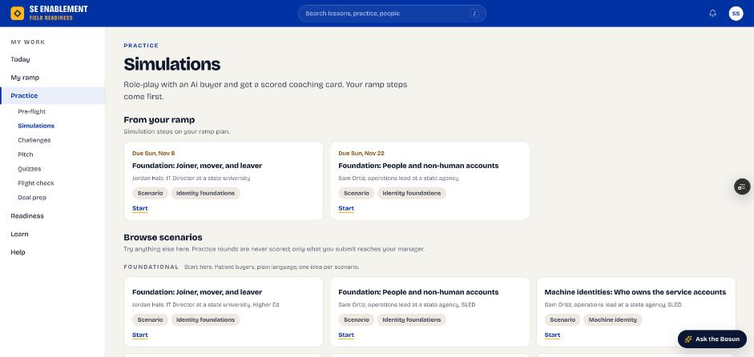
Figure 4.5 — The simulation catalogue
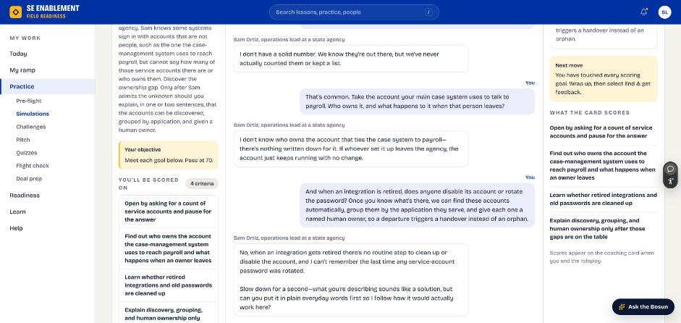
Figure 4.6 — A simulation with live coaching
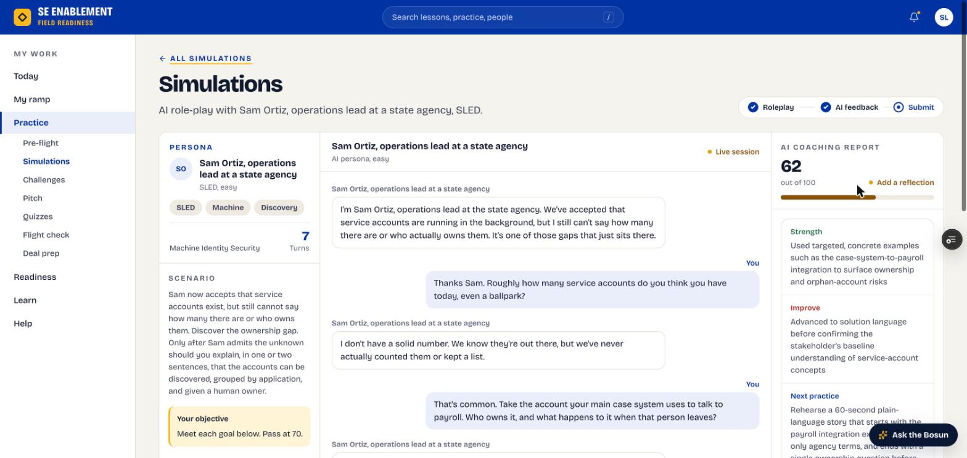
Figure 4.7 — The coaching card after ending the simulation

6. Find anything with search and the Bosun
- The search bar at the top finds ramp steps, playbook chapters, knowledge checks, simulations, pitches and people, including your mentor.
- Ask the Bosun (bottom right) answers questions about the platform and SailPoint, with links to where things are.

Why it matters: You shouldn't have to remember where something lives. Search and the Bosun get you there from any page.
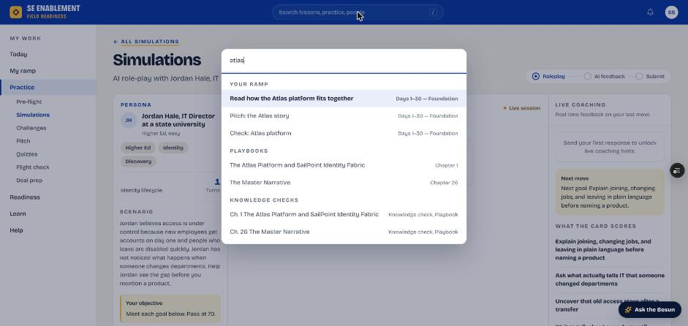
Figure 4.8 — Search results grouped by type
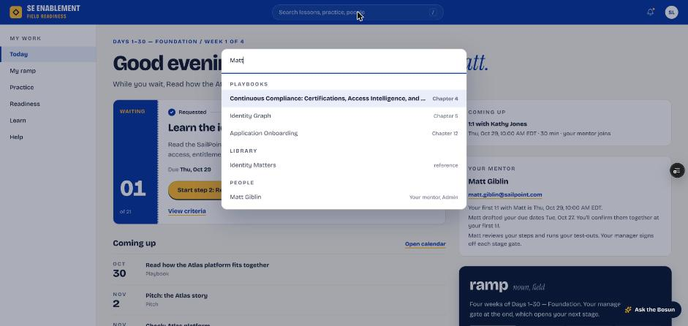
Figure 4.9 — Searching for your mentor by name

Part 5 — Work your manager assigns
Your manager can assign extra work outside the ramp, such as a playbook chapter ahead of a deal. There's no mentor for it: each part scores itself and your manager sees the result.

1. See it on Today
- Work your manager assigns appears under Playbooks due (or Your training) on Today, with who assigned it, how many parts are left and the due date.
- You're also notified with your manager's note; the notification opens the item.

Why it matters: Assigned work sits alongside your ramp, not inside it. Today keeps both in view so neither slips.
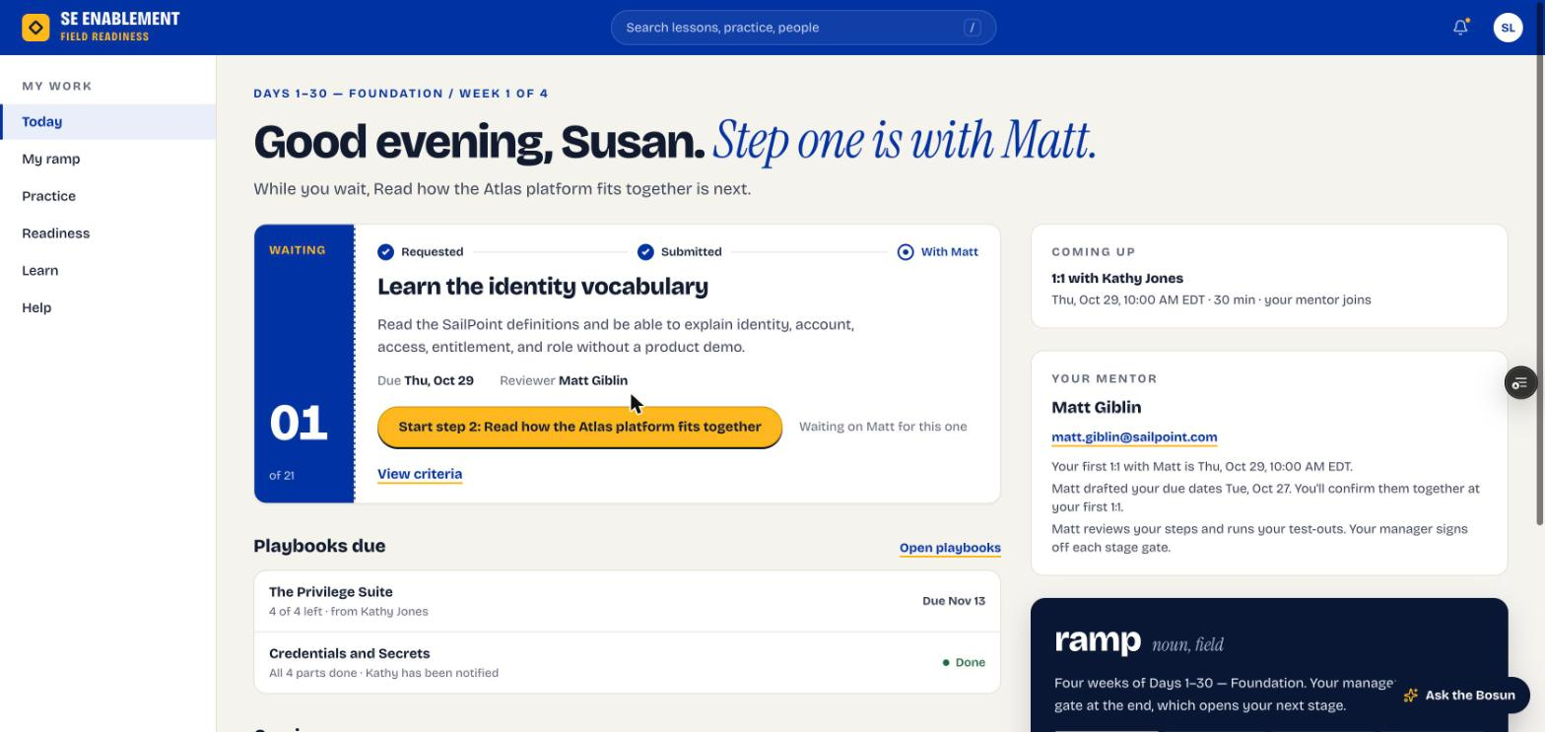
Figure 5.1 — Today: an open assignment with parts left, and a finished one marked Done

2. Read what counts
- Open the chapter. Practise this says your manager assigned it, that every scored attempt counts, and exactly what finishes it, for example: read to the end and mark it read, score 70+ on any pitch, finish the objection drill, and get 80% or more on the knowledge check.
- There's no mentor review: each part checks itself.

Why it matters: Knowing the pass marks up front means you practise toward a clear target.
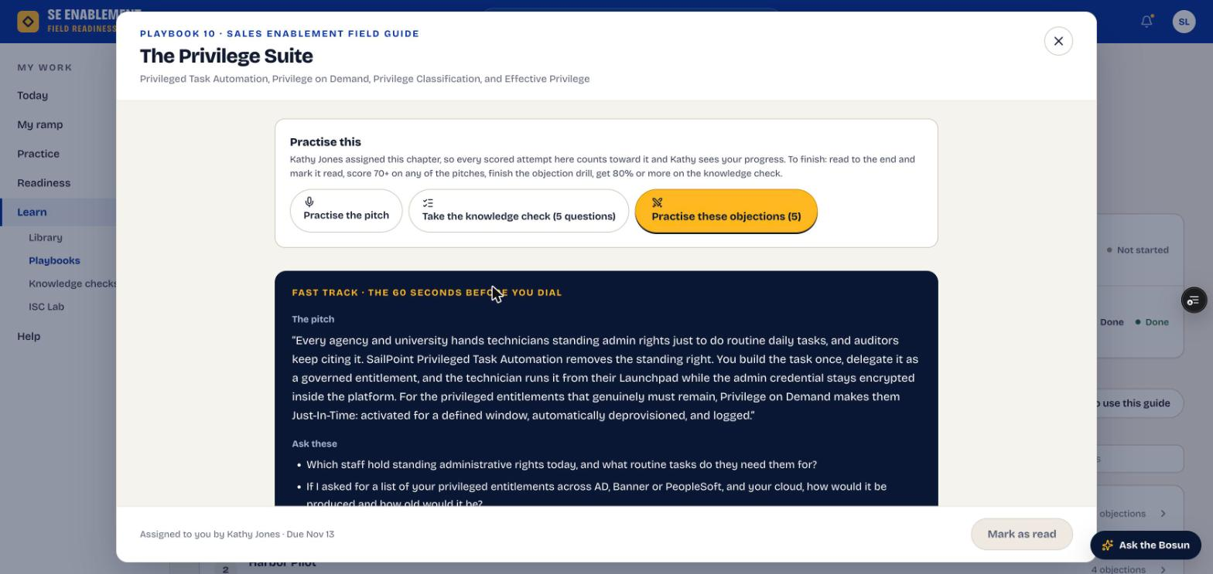
Figure 5.2 — An assigned chapter: who assigned it, what counts and what finishes it

3. Do each part
- Read: scroll to the end of the chapter, then Mark as read.
- Pitch: open a pitch from Practise this. Pitch Studio shows Counts toward … score 70+ to pass.
- Knowledge check: the header shows the pass mark, and the result says whether you passed it.
- Objection drill: the AI buyer raises each objection in turn and the coach scores each answer out of 10. Only use proof points that are in the chapter: invented statistics or customer names are flagged as unsupported and cost points.

Why it matters: Every scored attempt counts while the assignment is open, so your best score is the one that's kept.
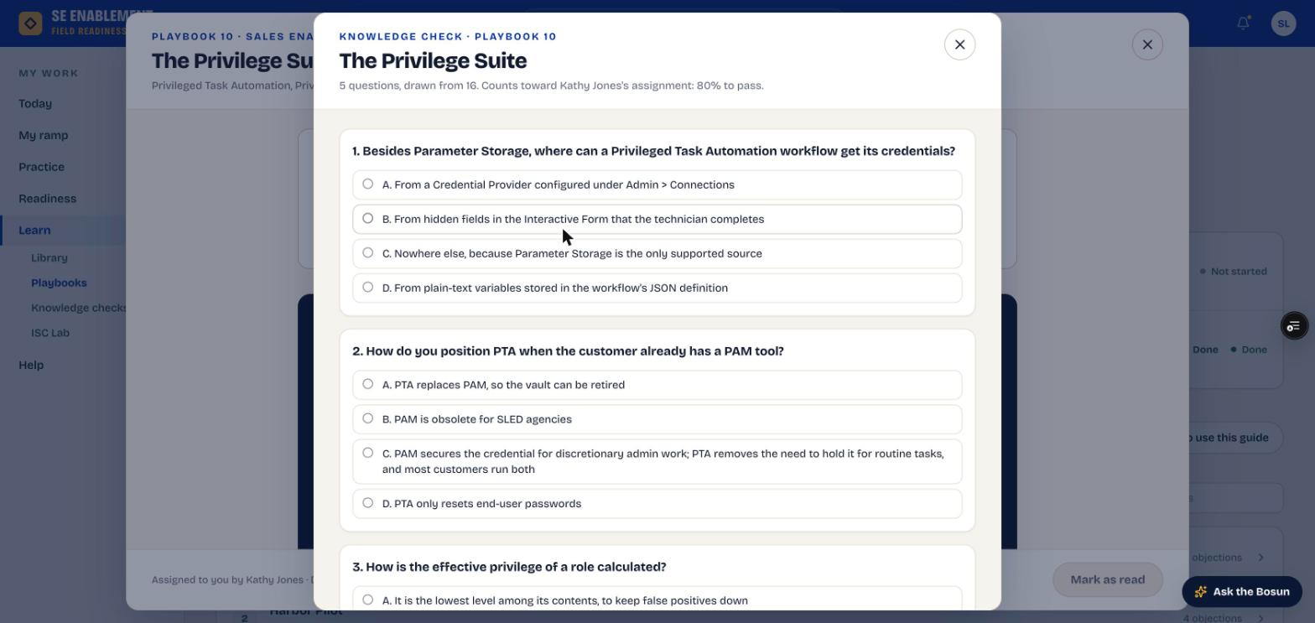
Figure 5.3 — The knowledge check names the assignment and its pass mark
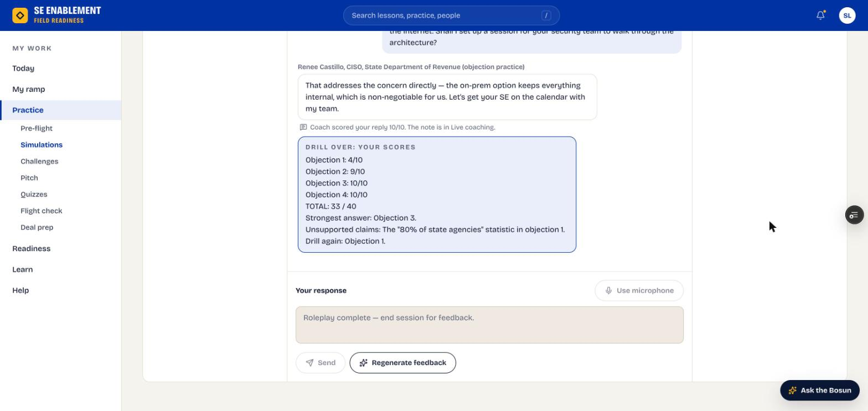
Figure 5.4 — End of the objection drill: scores per objection, total and anything unsupported

4. Finish it
- When the last part is done, Assignment complete appears where you did it and your manager is notified.
- Today keeps it for three days as Done, with "All 4 parts done" and that your manager has been notified (see the Today screen above). From then on, practice on the chapter is private again, and the chapter says so.

Why it matters: You and your manager see the same result at the same moment, with nothing to submit or chase.

Appendix — Notifications

What you'll receive
When | What you see
Your plan is assigned | Who assigned which program, who your mentor is, and that dates are agreed at the first 1:1.
Your mentor sets the schedule | How many dates changed, the new stage end and your mentor's note.
Your mentor logs a 1:1 | The next actions from the meeting.
Your manager schedules a 1:1 | Date, time, length and who's joining. It also appears under Coming up on Today.
A step is approved or sent back | The decision, the step and your reviewer's note.
Your manager assigns work | Who assigned what, the due date and their note. It opens the item.

What your actions send
When you… | Who is told, and what
You submit a step | Your reviewer (mentor for everyday steps, manager for stage gates): that work is waiting.
You share practice with your mentor | Your mentor: the pitch or simulation, its score and summary.
You finish assigned work | Your manager: what you finished and each part's result.

