SE ENABLEMENT PLATFORM · NEW-HIRE ONBOARDING
Mentor Guide
Meet your new hire, agree their schedule, and review their everyday work

Version: 1.1, October 27, 2026. Updated after a second end-to-end walkthrough.
For: Experienced Solutions Engineers chosen to mentor a new hire.
Walkthroughs: recorded on the live platform twice: first with Bill Smith (hiring manager), Matt Giblin (mentor) and Kevin Jones (new hire), then with Kathy Jones (hiring manager), Matt Giblin (mentor) and two new hires, Steve Smith and Susan Left. Text visible in the screens, such as briefs, notes and pitches, is example content from those walkthroughs; the Fill in boxes describe what you enter.
Companion guides: this is one of three role guides (hiring manager, mentor, new hire). A combined workflow guide covers all three.

Contents
Contents
Your role
Who's involved
Rules that shape your work
Part 1 — Meet the new hire and set the schedule
Part 2 — Review the new hire's work
Appendix — Notifications
What you'll receive
What your actions send

Your role
As the mentor you are the new hire's closest guide. You read the hiring brief, hold the first 1:1, agree the due dates with them, and review the everyday steps they submit. The hiring manager signs off the stage gates; you prepare the new hire for them.

Who's involved
Role | In this walkthrough | Responsibilities
Hiring manager | Kathy Jones (Bill Smith in earlier screens) | Writes the hiring brief, assigns the onboarding program and the mentor, schedules 1:1s, signs off every stage gate, assigns extra work and watches progress.
Mentor | Matt Giblin | Reads the brief, holds the first 1:1, sets the due dates with the new hire, approves or sends back everyday steps and logs check-ins.
New hire | Steve Smith and Susan Left (Kevin Jones in earlier screens) | Works through the ramp plan, submits each step with evidence, acts on feedback, practises beyond the plan and completes extra work the manager assigns.

Rules that shape your work
- You set the due dates. Agree them with the new hire at your first 1:1. They apply immediately, and the new hire and manager are told.
- You approve everyday steps. Approve or send back reading, pitches, knowledge checks, challenges and simulations, with a note.
- The manager signs off stage gates. Run the test-out practice with the new hire; the manager makes the sign-off decision.
- Mentoring appears once you're chosen. The Mentoring area shows in your sidebar only while you're mentoring someone.
- Managers and admins can mentor too. The You're mentoring card shows on Today in both the Sales engineer and Manager workspaces, and Mentoring is in both sidebars.

Part 1 — Meet the new hire and set the schedule
Signed in as the mentor, after the hiring manager has assigned the plan and chosen you.

1. See your new mentee on Today
- Open Today. The You're mentoring card names the new hire and the next move: read the hiring brief, meet them, then set the schedule together.
- If the hiring manager has booked a 1:1 and invited you, the card shows 1:1 booked with the date and time.
- Click Read the brief to go straight to the new hire's workbench. Once the schedule is set, the button reads Open workbench.
- If you're also a manager or admin, the same card appears on your Manager Today, so you don't need to switch workspace.

Why it matters: Your first job is clear from the moment you sign in, without having to find it in notifications.
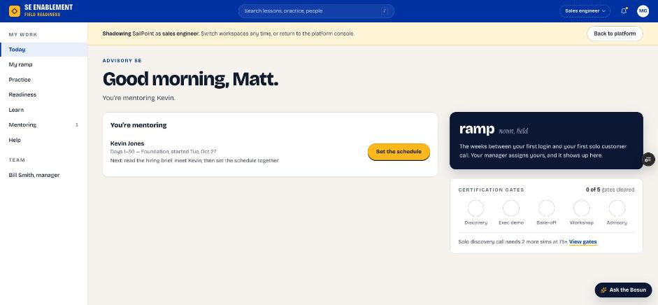
Figure 1.1 — Mentor Today page with the You're mentoring card

2. Open Mentoring
- Click Mentoring in the sidebar.
- Each mentee has a row showing their program, progress, any 1:1 booked, your Last 1:1, and anything waiting on you.

Why it matters: Mentoring is your home for every mentee. It shows who needs a meeting, a schedule or a review.
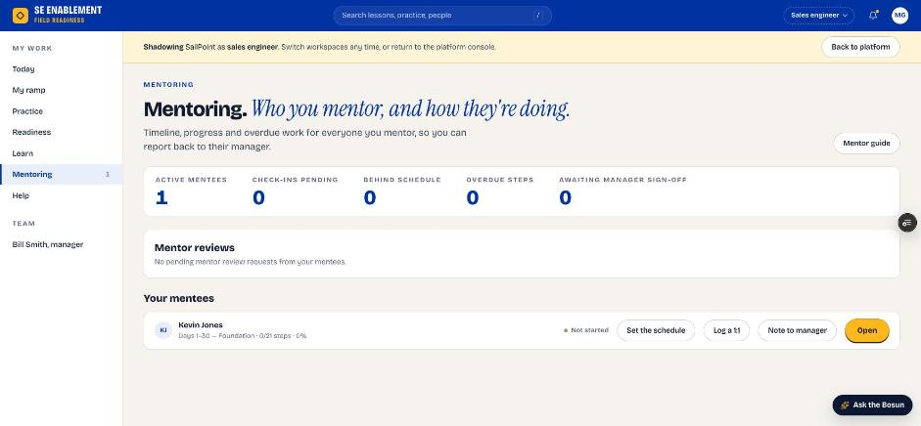
Figure 1.2 — Mentoring page

3. Open the mentee workbench and read the hiring brief
- Click the mentee's name or Open (or Read the brief on Today).
- The workbench shows the program, dates and steps on the left, and the hiring brief and your coaching notes on the right.
- Read the brief before you meet.

Why it matters: The brief tells you what the manager hired for and what to watch. Reading it first makes the first 1:1 focused.
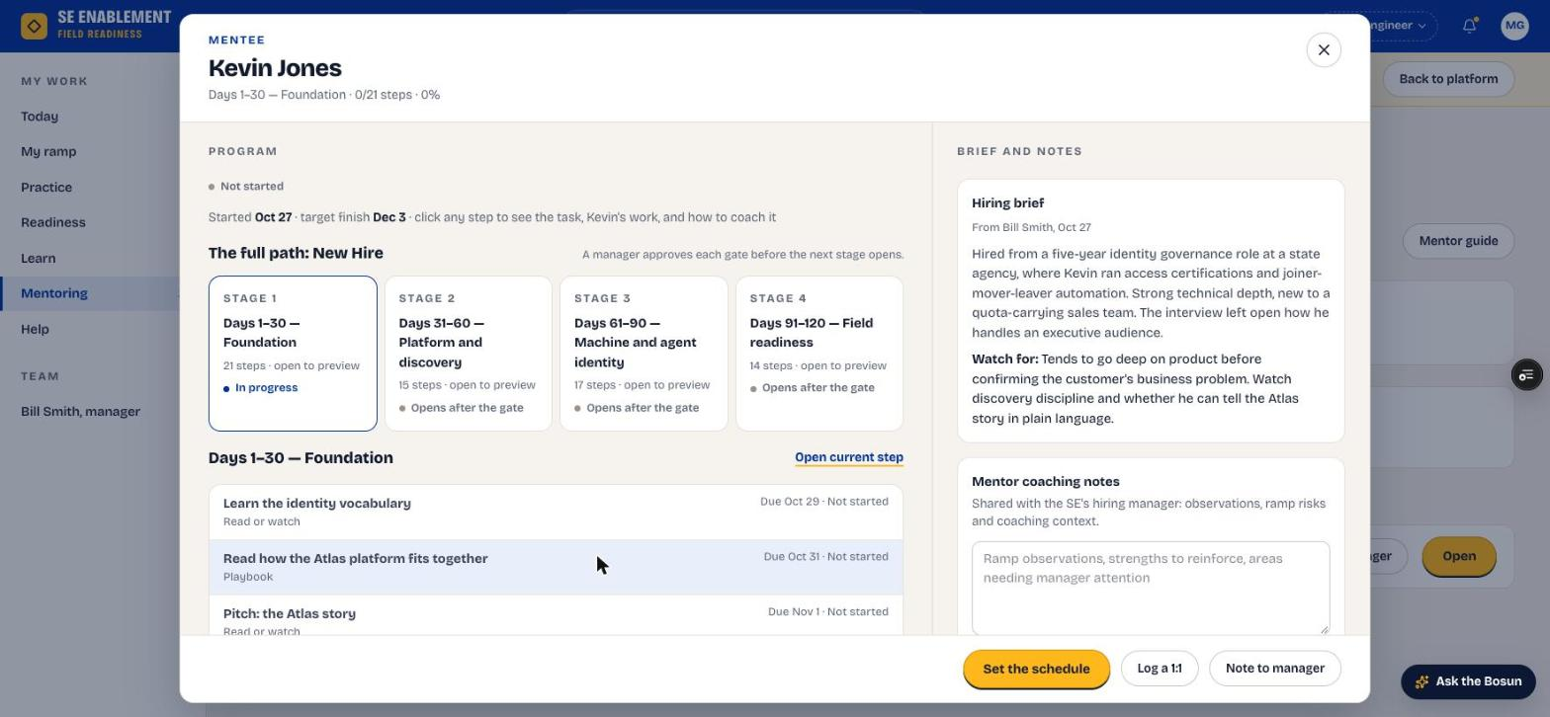
Figure 1.3 — Mentee workbench with the hiring brief

4. Preview the stages
- Click a stage card to open its steps in a step workbench.

Why it matters: Knowing what's coming lets you agree realistic dates and point the new hire at the right preparation.
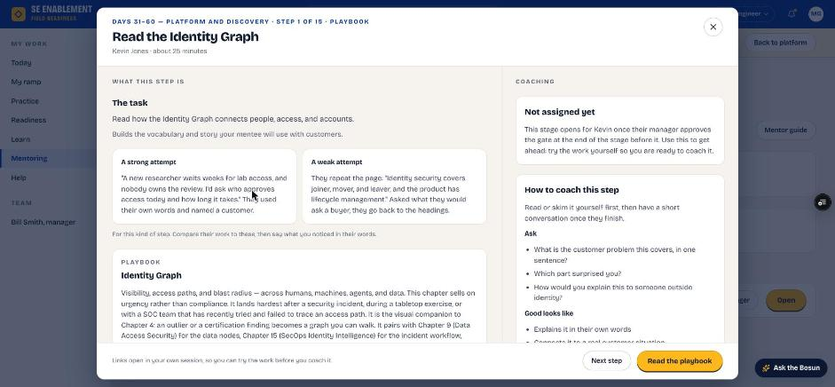
Figure 1.4 — Previewing a later stage

5. Hold the first 1:1 and log it
- Meet the new hire. Log the 1:1 after it has happened; a date in the future isn't accepted.
- In the workbench footer, click Log a 1:1.
- Tick the agenda items you covered. The first-meeting agenda is filled in for you, including what the hiring brief asks you to watch.
- Check the date, add notes and next actions, then click Save check-in.

Fill in: Date of the 1:1: when you met. Notes: what you talked about and noticed. Next actions: what they will do before you next meet.

Why it matters: The new hire receives the next actions as a notification, and the mentee's row and workbench show Last 1:1, so the manager can see the relationship is working.
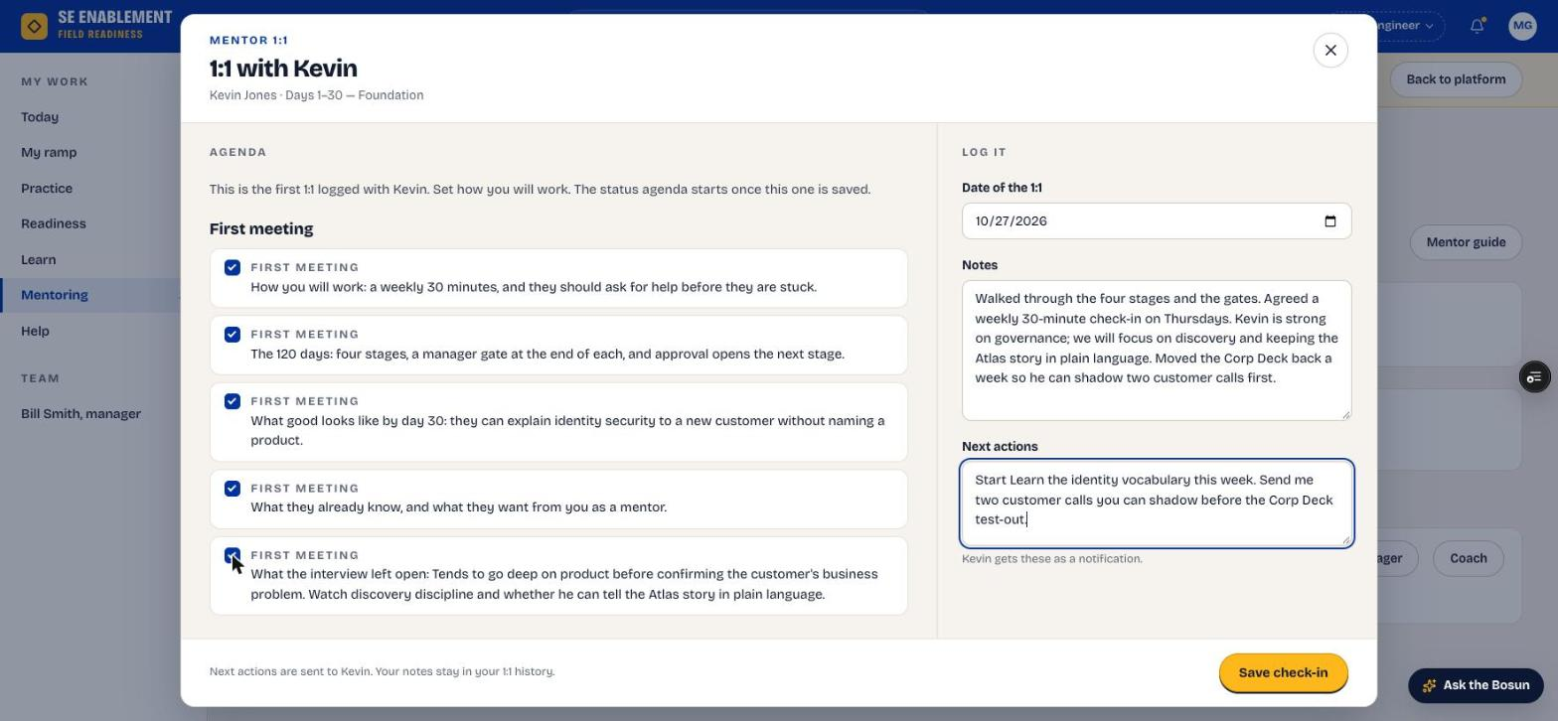
Figure 1.5 — Logging the first 1:1
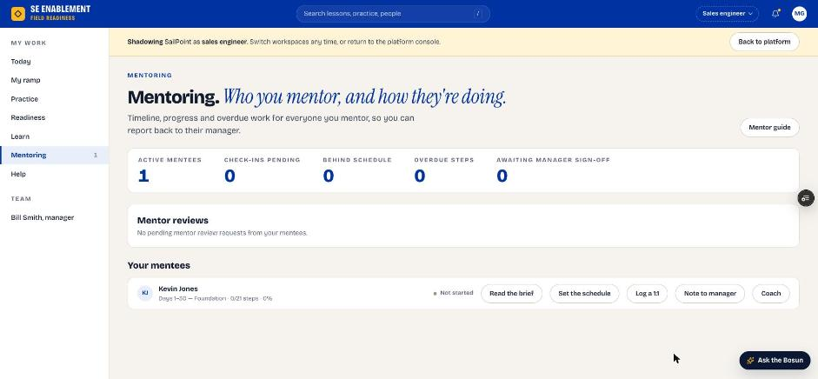
Figure 1.6 — Mentoring page after the 1:1

6. Set the schedule together
- In the workbench footer, click Set the schedule. If you haven't logged a 1:1 yet, a reminder suggests meeting first; you can still set dates and change them later.
- Adjust the due dates you agreed with the new hire. The stage end date moves with them. Default dates fall on workdays, avoiding weekends and US holidays; a note tells you if a date you pick lands on a weekend or holiday.
- If a date can't be saved (a day that has passed, or a step due before the one it builds on), the panel says which and why.
- Add a note explaining any changes, then click Set to save. Afterwards the button reads Change dates.

Fill in: The due dates you agreed, and a short note on why any date moved.

Why it matters: The mentor owns the dates because they agreed them face to face. They apply immediately, without approval, and the new hire and manager are both told.
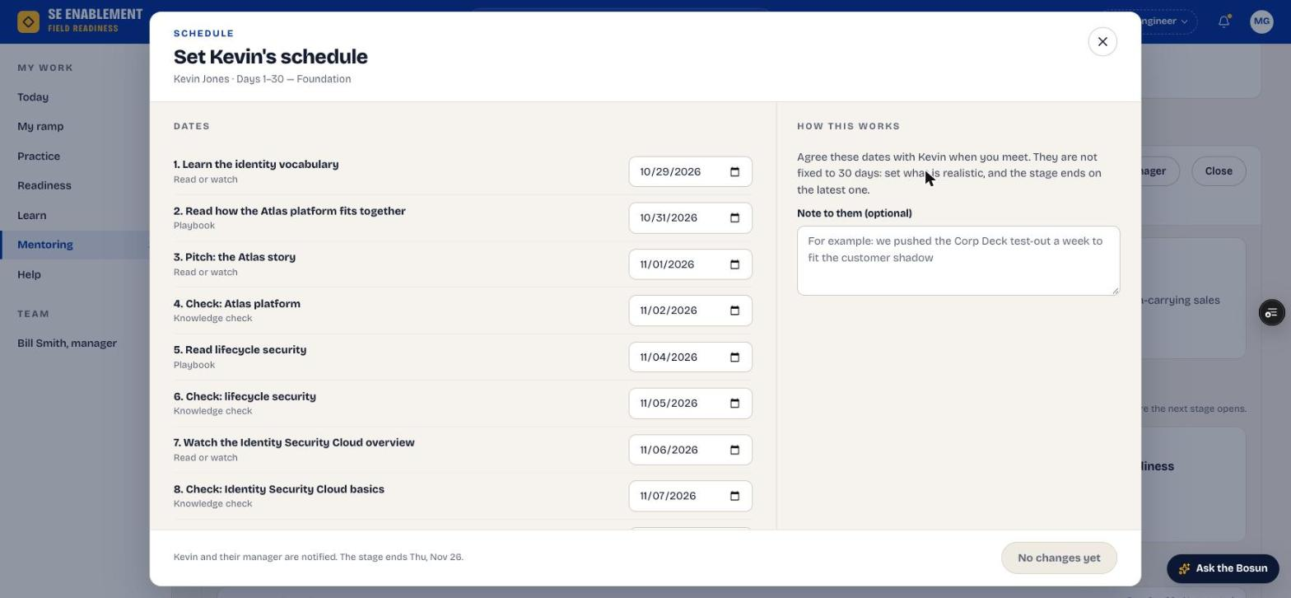
Figure 1.7 — Set the schedule
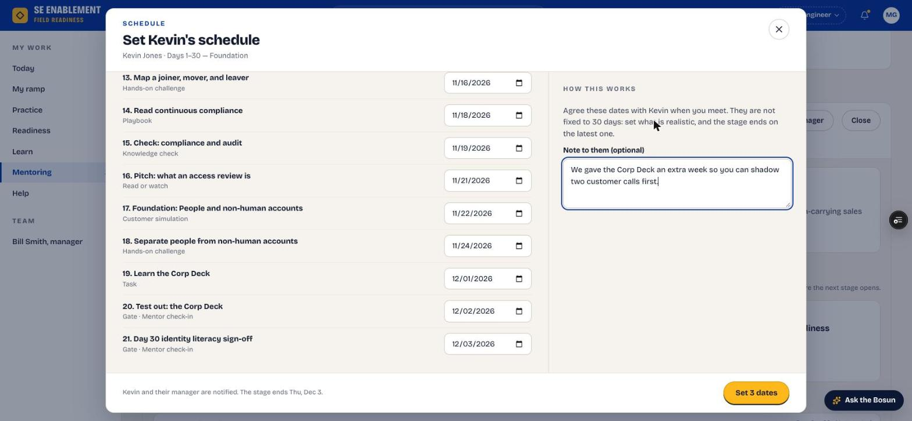
Figure 1.8 — Dates changed; the stage end moves

7. Confirm everyone was told
- A confirmation shows that the new hire and their manager were notified.

Why it matters: Everyone works from the same dates. The manager's Inbox also lists the change under Schedule changes by mentors, for information.
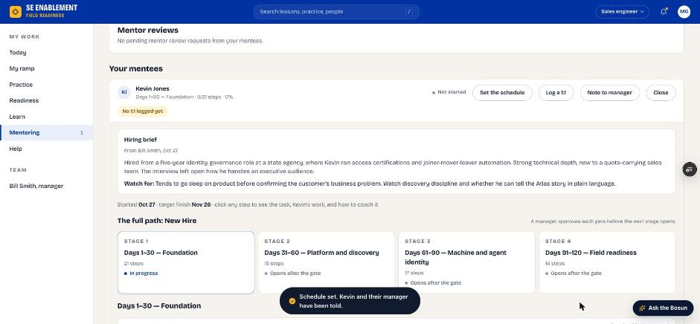
Figure 1.9 — Schedule saved and shared

Part 2 — Review the new hire's work
Each time the new hire submits an everyday step, it comes to you for review.

1. See that work is waiting
- On Today, the You're mentoring card says how many steps are waiting on your review. Click Review: the first waiting step opens straight away, on top of the mentee's workbench.
- The submitted work notification opens the exact step too.

Why it matters: Reviews are what keep the new hire moving. Surfacing them on Today means they don't sit unnoticed.
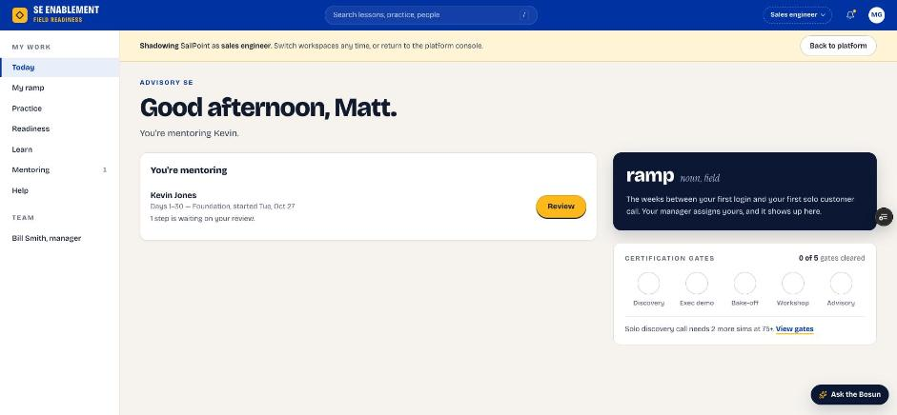
Figure 2.1 — A step waiting on the mentor's review

2. Find it on Mentoring
- The Waiting on your review counter and the mentee's row both show the submitted step.

Why it matters: With several mentees, this is where you see everything waiting on you at once.
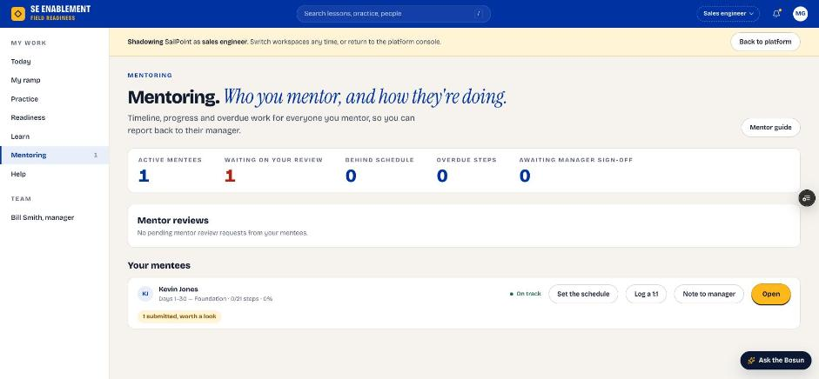
Figure 2.2 — Waiting on your review

3. Approve or send back
- Open the step. What this step is shows the task with a strong and a weak example; What they did shows their work, and Your review sits on the right.
- For a pitch step you see Pitch from Pitch Studio: how it was recorded, the AI score with its rubric, and the full pitch.
- Add a note, then click Approve, or Send back if it needs more work. Send back stays disabled until you've written a note, because the note is what the new hire acts on.

Fill in: A short review note: what was good, and what to change if you're sending it back.

Why it matters: The new hire's answer is kept as submitted, and your note reaches them as feedback. Approving counts the step toward their progress. Stage gates don't show these buttons because the manager signs them off.
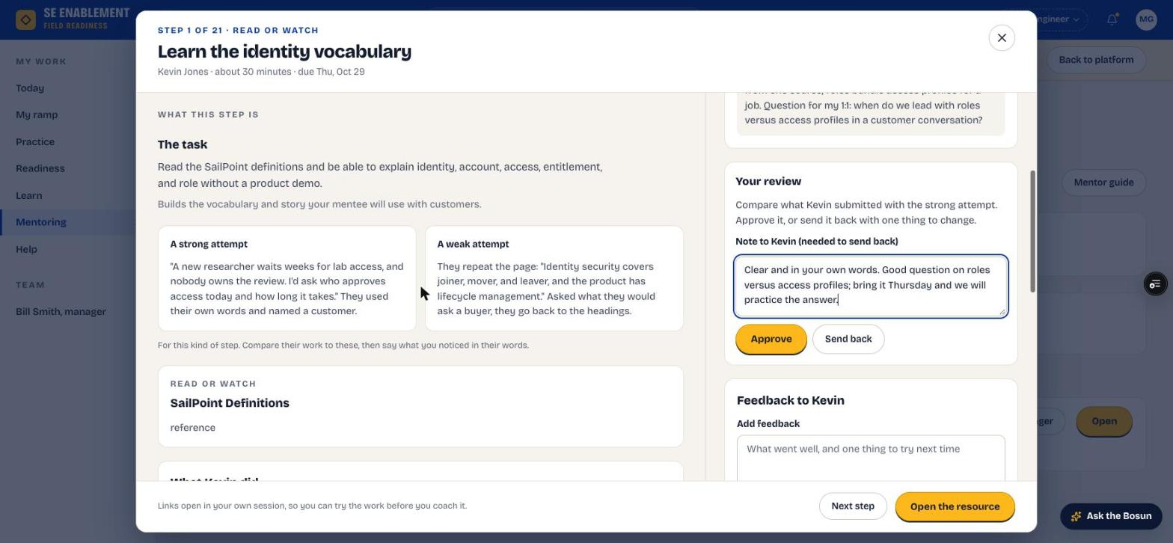
Figure 2.3 — Reviewing the new hire's step
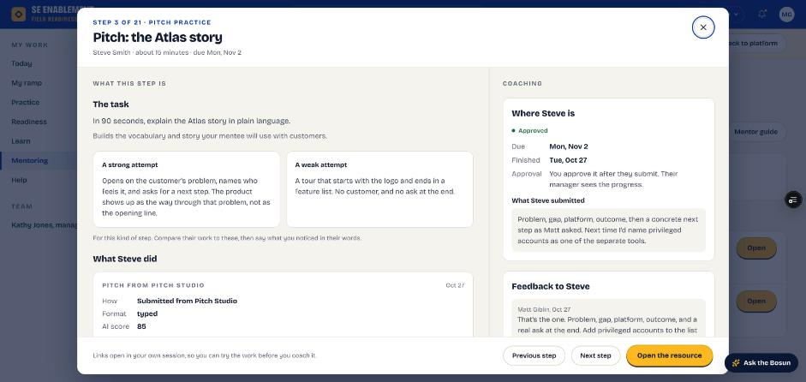
Figure 2.4 — A pitch step opened from Review: the task, examples and the pitch from Pitch Studio

4. Confirm the result
- The panel shows the decision and your note, for example Approved. Steve has been told, with your note. Nothing is left waiting.
- The new hire is told the step was approved or sent back, with your note; the notification opens the step.

Why it matters: Both sides see the same status, so there's no doubt about where the step stands.
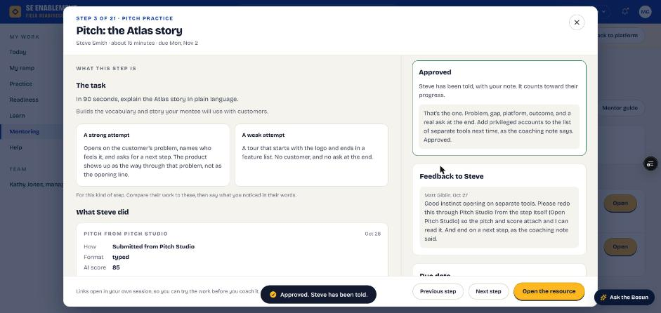
Figure 2.5 — After Approve: the decision and the note sent to the new hire
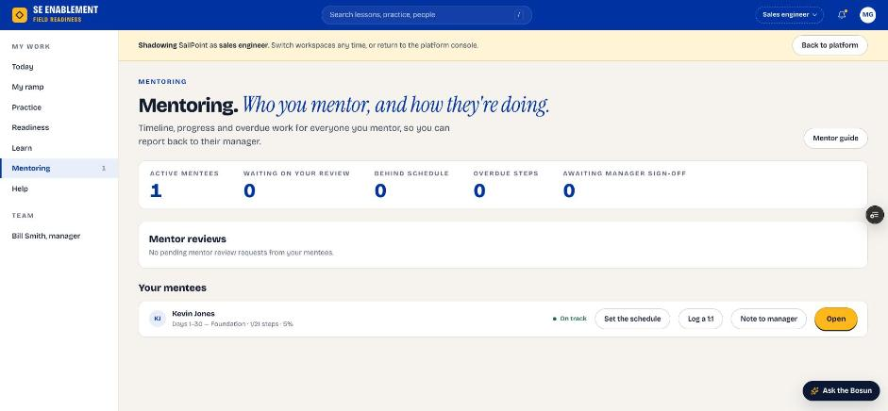
Figure 2.6 — Mentoring after approval

5. Keep checking in
- After each 1:1, open the mentee workbench and click Log a 1:1.
- If a date needs to move, agree it with the new hire and click Change dates.

Fill in: Agenda, notes and next actions for each meeting; any changed dates with a short reason.

Why it matters: Regular logged check-ins keep the new hire on pace, send them their next actions, and show the manager the mentoring is happening.

6. Prepare them for stage gates
- Each stage ends with a test-out and a sign-off step. Run the test-out practice with the new hire before they submit.
- Gate steps don't show Approve or Send back for you; they go to the hiring manager.
- An experienced hire can take the gates early. Once the manager signs them off, the stage's remaining steps close as tested out.

Why it matters: The manager decides whether the new hire moves to the next stage. Your preparation is what gets them through first time.

7. Pitches and simulations your mentee shares
- A new hire can Share with my mentor from free practice in Pitch Studio or a simulation. You're notified with the score and summary, and the notification opens it.
- Everything shared is listed under Shared with you in the mentee's workbench. A simulation opens with its coaching card, their reflection and the conversation; a pitch with its rubric and the words they used.
- Work the manager assigns directly, such as a playbook chapter, isn't yours to review; it checks itself and goes back to the manager.

Why it matters: Shared practice shows you what your mentee is working on between 1:1s, without adding to your review queue.

Appendix — Notifications

What you'll receive
When | What you see
You're chosen as mentor | That you're mentoring the new hire, with next steps: read the brief, meet, set the schedule.
New hire submits a step | That work is waiting. Your Today and Mentoring pages count it.
Manager schedules a 1:1 and invites you | Date, time, length and who's joining.
Your mentee shares practice | The pitch or simulation, its score and summary.

What your actions send
When you… | Who is told, and what
You set the schedule | New hire and manager: how many dates changed, the new stage end and your note.
You log a 1:1 | New hire: the next actions from the meeting.
You approve or send back a step | New hire: the decision, the step and your note.

