SE ENABLEMENT PLATFORM · NEW-HIRE ONBOARDING
Onboarding Walkthrough 2: Report
Testing the onboarding guides end to end, with a second team, extra assigned work and free practice

Date: October 27, 2026
People: Kathy Jones (hiring manager), Matt Giblin (mentor), Steve Smith and Susan Left (new hires, both starting the same day).
Goal: follow the version 1.0 guides click by click, look for bugs and bad workflow, let the new hires explore and practise beyond their assigned work, and add work outside the onboarding plan that has no mentor.
Companion documents: the four onboarding guides, updated to version 1.1 from this walkthrough.

Contents
Contents
Summary
What held up
What didn't, at the start
Findings that mattered most
1. An objection drill result was lost (#90, #91)
2. The manager couldn't see what was said (#110)
3. A new hire hit a dead end after submitting (#33)
4. The simulation leaked its hidden brief (#41)
5. The ramp calendar was a day off (#67)
Workflow and design lessons
How the new hires practised
Tips worth passing on
Performance
Still open
Notes on how the walkthrough ran
Appendix — All findings

Summary
The walkthrough logged 115 findings. 111 were fixed and released to production, in 25 commits, and nearly all were re-checked live as the person affected. The other four were notes or questions that needed no change (#21, #36, #87, and #89, a "slow" close that was the browser's own discard-changes box waiting for a click). The two design items left open at the end of the walkthrough (#6, #10) were fixed the following day; see Still open.
Area | Findings | Bugs | Workflow / design | Content / wording | Fixed
Manager setup and team view | 24 | 4 | 14 | 4 | 22
Mentoring and reviews | 22 | 8 | 9 | 2 | 22
New hire ramp and steps | 23 | 2 | 10 | 10 | 22
Practice, search and help | 16 | 5 | 5 | 6 | 16
Extra work the manager assigns | 30 | 3 | 13 | 12 | 29
Total | 115 | 22 | 51 | 34 | 111

What held up
- The guides' core path works as written. The manager set up both hires, the mentor met them and set schedules, the new hires submitted steps, and the mentor approved and sent back work. Every notification in the guides arrived.
- The review loop works end to end. A pitch sent back by the mentor was redone in Pitch Studio, scored 85, attached to the step and approved, with each side told at every turn.
- Extra work with no mentor works. Kathy assigned the Credentials and Secrets chapter to both new hires. Both finished it (Steve 4 of 4; Susan read, pitch 78, objections 83%, check 80%). Kathy was told and could read what each of them said.

What didn't, at the start
- Practice was cut off from progress. A pitch step didn't take a pitch, free practice couldn't reach the mentor, and the manager couldn't see what was said in assigned drills.
- Ownership was often wrong on screen. The mentor reviews everyday steps, but many screens still said "your manager". The manager was even shown a mentor's review as her own.
- Things finished or failed silently. An objection drill result was lost, a finished assignment told nobody, and disabled buttons gave no reason.
- New hires couldn't find things. Search only matched page names, Simulations had no catalogue, and the Bosun refused a basic navigation question.

Findings that mattered most
Each pair shows what the walkthrough found and the same screen after the fix. Text in the screens is example content from the walkthrough.

1. An objection drill result was lost (#90, #91)
Steve finished the assigned objection drill, but the AI ended it with a slightly different marker than the code expected. The score was never saved, so his assignment stuck at 3 of 4 with no way to finish it, and the debrief showed up as if it were the next objection. The end marker is now matched loosely, Steve's result was backfilled, and the debrief has its own box.
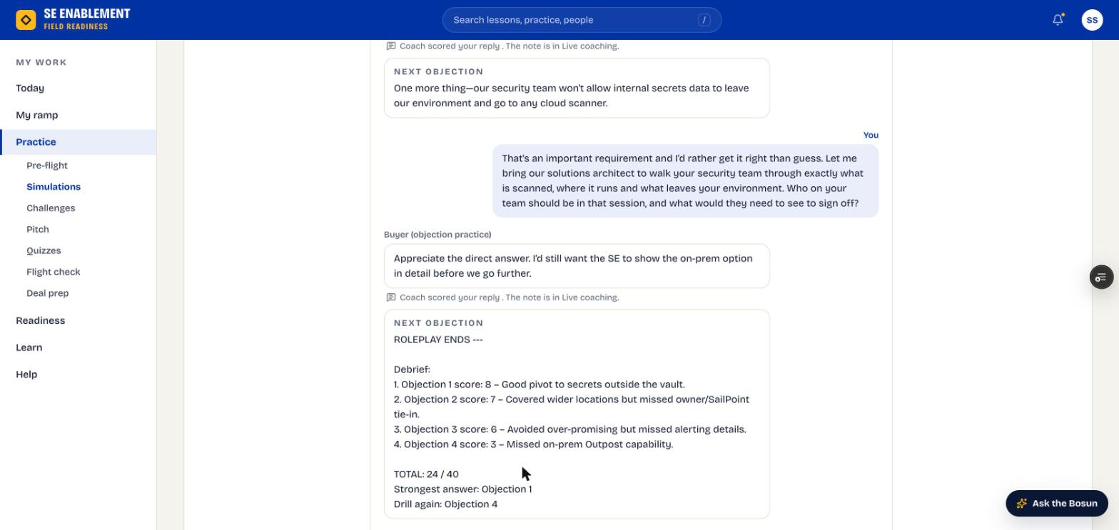
Figure 1.1 — Before: the end-of-drill debrief shown as the next objection
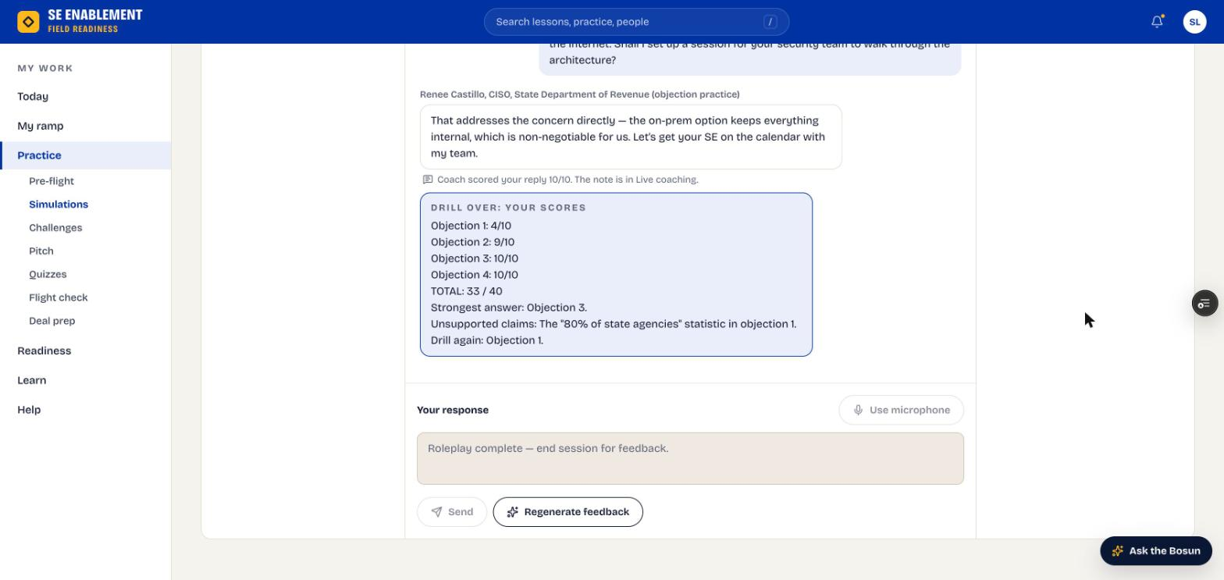
Figure 1.2 — After: Drill over, with each score, the total and an unsupported claim flagged

2. The manager couldn't see what was said (#110)
When the assignment finished, Kathy's workbench showed only the knowledge check answers, not the pitch or the objection drill. Her note asked Susan to explain vaulting versus rotation in plain words, and the drill was the only evidence of that. The workbench now shows each objection answer with the coach's score and each pitch as delivered.
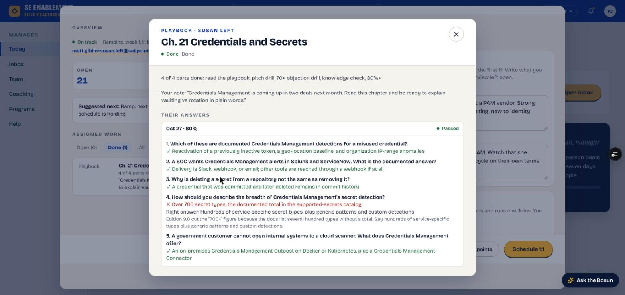
Figure 1.3 — Before: only the knowledge check
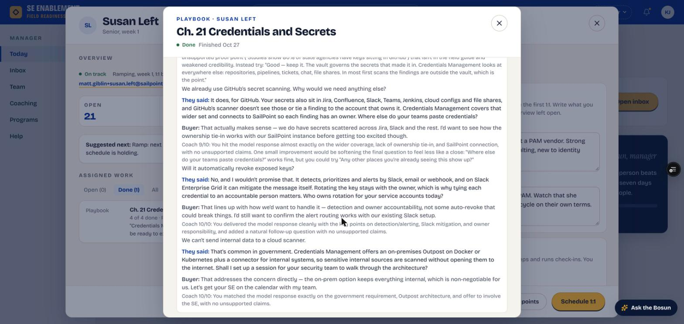
Figure 1.4 — After: the objection drill, answer by answer

3. A new hire hit a dead end after submitting (#33)
After submitting step 1, Steve's Today page led with a greyed "Waiting on Matt" button. The next step was named but had no button, and Coming up rows weren't links. Today now starts the next step and every row opens its step.
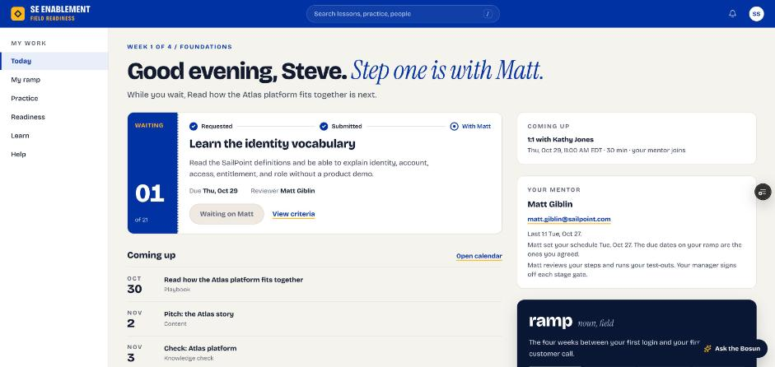
Figure 1.5 — Before: waiting, with nothing to click
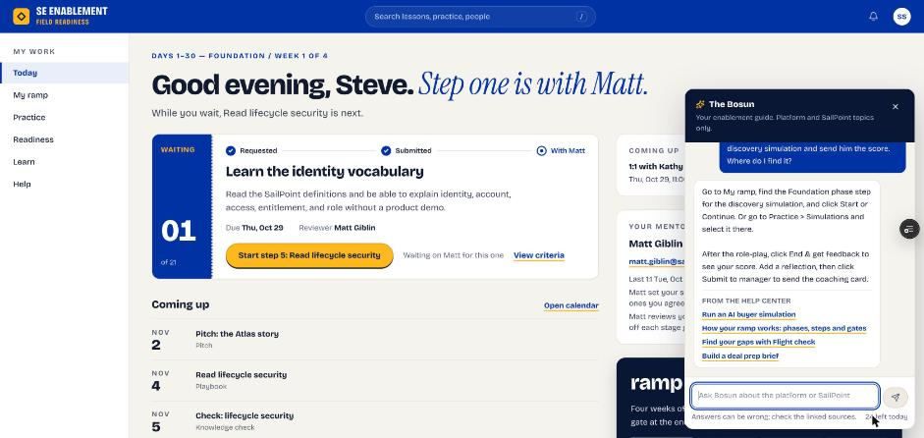
Figure 1.6 — After: Start step 5, while step 1 is with Matt

4. The simulation leaked its hidden brief (#41)
The simulation transcript showed the buyer's full persona card, including the hidden "Secret Fear", which gave away the answer. The buyer now opens with only their first line.
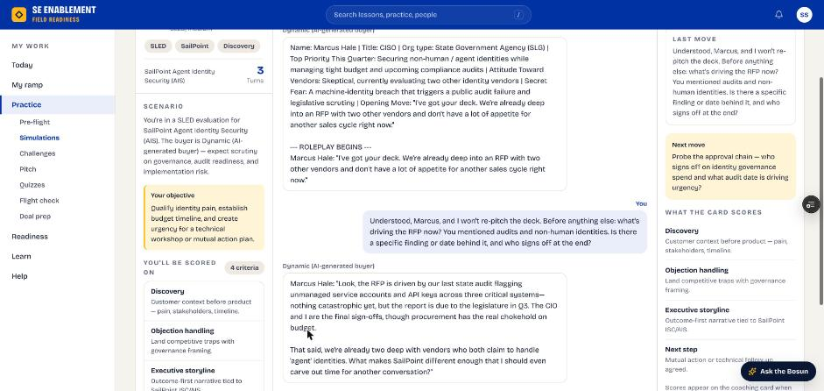
Figure 1.7 — Before: the hidden persona in the transcript
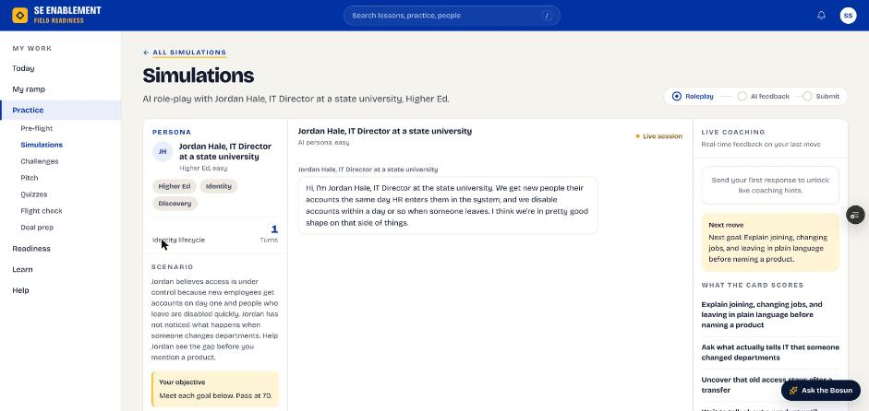
Figure 1.8 — After: only the buyer's opening line

5. The ramp calendar was a day off (#67)
The month view put every step a day early and matched by day number only, so October steps also appeared in November. Steps now sit on their own dates and the calendar pages between months.
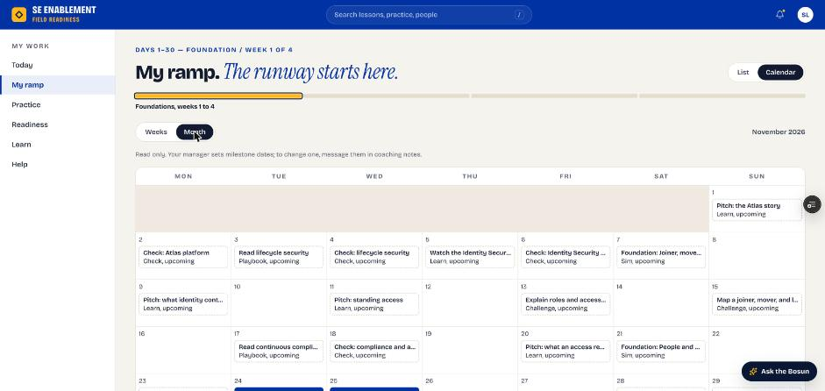
Figure 1.9 — Before: steps a day early, on weekends
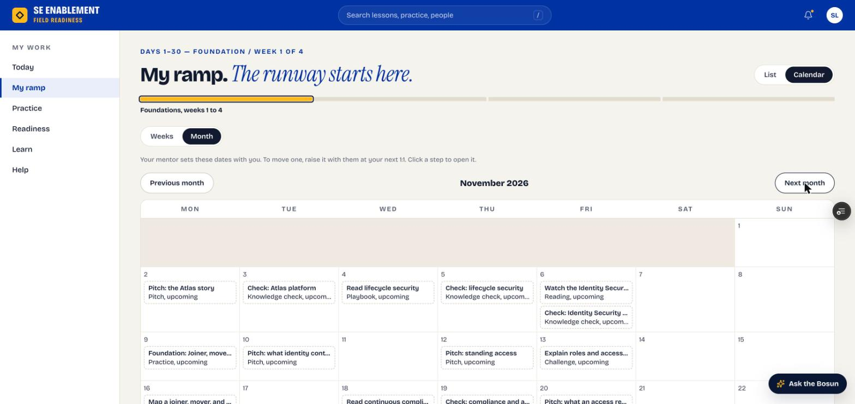
Figure 1.10 — After: weekdays, the right dates

Workflow and design lessons
Patterns behind the individual findings, for future work on the platform.
- Say who owns it, in context. The mentor reviews everyday steps, the manager signs off gates and owns extra work, and free practice belongs to the SE. Screens written for one owner ("your manager") were wrong for the others (#15, #47, #72, #75, #81, #82, #93, #99, #113). Wording now follows who actually owns the item.
- Every link should land on the thing. Notifications and buttons that opened a list instead of the item cost a click and a search each time (#25, #61, #65, #84, #109). They now open the exact step or assignment.
- Never fail silently. Disabled buttons without a reason (#27, #43, #60), a switch that quietly returned 403 (#54), a drill score that never saved (#90) and an assignment that finished with no word to anyone (#104, #105) all looked like the user's fault. Each now explains itself.
- Practice should feed evidence. A pitch step that couldn't take a pitch (#34), practice that couldn't be shared (#42), and drills the manager couldn't read (#110) all disconnected practice from progress. Practice now attaches to steps, can be shared, and counts toward assignments while they're open.
- Dates are local and on weekdays. UTC dates showed the next day in the evening (#59, #64), defaults landed on weekends (#28, #68) and the calendar was a day off (#67). Holidays are still not avoided.
- Renames leave debris. The Entro to Credentials Management rename and renumbered chapters left "an Credentials", stale chapter numbers and a mismatched search (#83, #94, #96). Generated content now avoids storing things that change, like chapter numbers.
- Coaching must check facts. The objection coach praised an invented statistic as a good customer example (#98). The coach now credits only proof points from the guide and flags the rest; Susan's invented "80% of state agencies" was caught.

How the new hires practised
Both new hires were asked to explore beyond their assigned work. What they used, and what works well, is now Part 4 of the New Hire Guide.
Practice | What happened
Knowledge checks | Steve failed the Atlas check at 40%, read the explanations, and passed at 100% with New questions. Susan scored 80% on Credentials and Secrets, exactly the pass mark.
Pitch Studio | Typed pitches scored 75 to 85, with a rubric and the ideas left out compared with the guide. Scoring took up to 30 seconds at first, about 15 seconds later in the evening; a still-scoring message now shows after 6 seconds.
Simulations | Susan ran a free simulation outside her ramp (Machine identities: who owns the service accounts) and scored 62, with a strength, improvement and next practice. The Next move hint now advances as goals are met.
Objection drills | Four objections from the chapter, each scored out of 10. Susan scored 33 of 40; the coach flagged her one invented statistic and named the objection to drill again.
Search and the Bosun | After the fixes, search finds steps, chapters, checks, simulations, pitches and people. The Bosun answers where-is-it questions with links.

Tips worth passing on
- Read the explanation on every question you miss, then take New questions.
- After scoring a pitch, open Show the guide's pitch and compare it word for word with Compared with the guide.
- In a simulation, type HINT: when stuck; the coach answers out of character and returns you to the conversation.
- Use only proof points from the chapter. Invented numbers or customers are flagged and cost points.

Performance
Measured in the browser during the walkthrough. The earlier baseline was 0.6 to 3.2 seconds per page.
Page or action | Time
New hire Today | 0.81 s (Susan), 1.64 s (Steve)
Manager Today | 1.41 s
Learn | 1.04 s
Readiness | 0.72 s
Submit a step | 0.84 s
Pitch AI scoring | About 30 s early, 15 s later
Simulation buyer's first line | About 7 s

Page loads are within the baseline. The AI steps are the slow ones; they now say they're working.

Still open
Nothing from the walkthrough is still open. The items left at the end were done the following day:
- #6, plan form buried: Assign a plan now opens the plan form in its own workbench, from Today, Suggested next or the profile.
- #10, experienced hires: a new hire can take a stage's test-outs as soon as they're ready. When the manager signs off the gates, the stage's remaining steps close as tested out and the next stage opens. The gate step, the plan form and the guides say so.
- #89, slow close: the 9.3 s was the browser's discard-changes box waiting for a click, not slow code. No change needed.
- Smaller leftovers, also done: default dates skip US holidays as well as weekends; the calendar shows submitted steps as In review; mentors can open shared simulations and pitches from the workbench; new hires read "Senior new hire, week 1" on the team list.
- One date left as agreed: Steve's and Susan's Day 30 sign-off is due on Thanksgiving, Nov 26, a date the mentor set. It wasn't moved automatically; the schedule editor now flags it.

Notes on how the walkthrough ran
- Data corrections made along the way: Steve's lost drill score was restored; weekend due dates on both plans were moved to weekdays; a test 1:1 logged in the future was redated; Kathy's completion notifications were sent and later rewritten in the shorter form; drill personas, chapter numbers and pitch prompts were rewritten in stored content.
- A comment posted by mistake: a click hit the Vercel toolbar's comment widget and posted a test question as a comment on the Learn page. It was found and removed. Later clicks avoided the toolbar.
- One deploy needed a nudge: Vercel built only previews for one commit; an empty commit triggered the production deploy.
- One database change ran by hand: two columns to keep pitch text with drill results were added in the Supabase SQL editor, because the connector has no permission on this project.

Appendix — All findings
Numbered as logged. Summaries are shortened; status is as of the end of the walkthrough.
# | Type | Finding | Status
1 | Workflow / design | Today flags Matt (experienced Advisory SE, about to mentor two people) "At risk · No activity in 19 days", the top "needs you first" item. | Fixed
2 | Workflow / design | New hires show readiness 16 in red next to a green "On track". | Fixed
3 | Workflow / design | "Assign a plan" on Today opens the profile at the top; the plan form is ~3 screens down the right column. | Fixed
4 | Workflow / design | Hiring brief placeholders ("Came from a university IAM team...") are dark enough to read as a brief someone already wrote. | Fixed
5 | Bug | Saving the brief before a plan existed said "Steve's mentor can see this", but Steve had no mentor yet. | Fixed
6 | Workflow / design | Assigning the plan needed about 25 scroll-wheel ticks down the narrow right column of the profile. | Fixed
7 | Workflow / design | Mentor dropdown offers Susan Left (a day-zero new hire with no plan) and Kathy herself as mentors for Steve. | Fixed
8 | Content / wording | Mentor hint "Anyone on your team. They coach; you sign off." predates the rule that the mentor approves everyday steps. | Fixed
9 | Workflow / design | "Assign plan" (the primary action of the whole setup) is styled as a secondary/outline button; Assign work and Schedule 1:1 are the yellow primaries. | Fixed
10 | Workflow / design | Only the "little or no identity background" Days 1–30 template is offered first, even for Steve (5 years IAM, ran an IIQ upgrade). | Fixed
11 | Workflow / design | "13% ready for the next level" in red on a week-1 hire's profile (open #65). | Fixed
12 | Content / wording | Team roster hint "Click anyone to open their plan, scores and coaching notes in a side panel." It's a workbench now, not a side panel. | Fixed
13 | Workflow / design | Team › Roster shows Susan (no plan) under On track with no "Assign a plan" prompt; only Today shows it. | Fixed
14 | Bug | Typed the hiring brief and private notes for Susan, pressed Esc: the workbench closed with no warning and everything typed was gone on reopen. | Fixed
15 | Workflow / design | Assign plan accepts "No mentor" with no warning. | Fixed
16 | Bug | Setting a mentor after the plan was assigned notified nobody: neither the mentor nor the new hire. | Fixed
17 | Workflow / design | Assigned mentor dropdown on Susan's profile offers Steve Smith (another day-zero new hire) as her mentor. | Fixed
18 | Content / wording | Brief panel still says "Susan's mentor reads this before the first 1:1" while she has no mentor. | Fixed
19 | Workflow / design | Schedule 1:1 date picker allows past dates (no min); the server refuses with "Pick a time that hasn't passed" only after clicking. | Fixed
20 | Workflow / design | With both 1:1s booked, Today still suggested scheduling one, and the coaching card counted the mentor as someone to coach. | Fixed
21 | Other | Schedule 1:1 final click downloads an .ics; saved through the same API instead to avoid a download on the tester's machine. | Note / answered
22 | Workflow / design | Matt is an admin, so he lands in the Manager workspace. | Fixed
23 | Bug | "Your training" lists Matt's own practice sessions as "Assigned to you by your manager". | Fixed
24 | Workflow / design | The 1:1 Kathy booked for Thu Oct 29, with Matt invited, appears nowhere for Matt: not on the Today card, the Mentoring row or the workbench. | Fixed
25 | Workflow / design | "Set the schedule" on Today only goes to the Mentoring list. | Fixed
26 | Bug | Log a 1:1 accepted a future date (Oct 29) and said "Saved". | Fixed
27 | Bug | A past due date silently disables the Set button with no reason given. | Fixed
28 | Bug | The default dates fall on weekends, 7 of Steve's 21 (Oct 31, Nov 1, 7, 8, 14, 21, 22). | Fixed
29 | Workflow / design | The Mentoring row keeps "Set the schedule" after the schedule is set, and shows no last or next 1:1. | Fixed
30 | Workflow / design | The schedule can be set before any 1:1 (Susan) with no nudge. | Fixed
31 | Content / wording | Mentor Guide step 1 should say that a manager or admin who mentors must switch to the Sales engineer workspace. | Fixed
32 | Other | "Pitch: the Atlas story" is labelled "Read or watch" rather than as a pitch. | Fixed
33 | Workflow / design | After submitting, Today's main card is the greyed "Waiting on Matt" button. | Fixed
34 | Bug | Pitch steps were treated as reading: the step asked "What did you learn?", Pitch Studio opened in private free practice, and the pitch never reached the step. | Fixed
35 | Content / wording | The step says 60 seconds, the scenario says 90. | Fixed
36 | Content / wording | A knowledge check warns against quoting FedRAMP status from memory, while an old drill response stated it; current content is consistent. | Note / answered
37 | Workflow / design | Practice › Simulations had no catalogue and opened an advanced default simulation for everyone, including a week-1 hire. | Fixed
38 | Bug | The top search ("Search lessons, practice, people") only matches page names. | Fixed
39 | Bug | Learn library search for "atlas" returns 0. | Fixed
40 | Bug | The Bosun refused "Where do I find the Foundation discovery simulation my mentor asked for?" with "I can only help with SE Enablement and SailPoint topics". | Fixed
41 | Bug | The simulation transcript shows the raw persona card, including "Secret Fear" and the hidden context. | Fixed
42 | Workflow / design | There's no way to "send the score" to the mentor, as Matt's next actions asked. | Fixed
43 | Workflow / design | "Done when" criteria aren't enforced (step 3 submitted with 2 of 3 ticked). | Fixed
44 | Content / wording | Today and My ramp say "Week 1 of 4", "Foundations, weeks 1 to 4" and "The four weeks between your first login and your first solo customer call". | Fixed
45 | Content / wording | On Today and My ramp, pitch steps still show "Content". | Fixed
46 | Workflow / design | A day-1 new hire sees a "Senior to Advisory, 0 of 5 gates" career card and "Solo discovery call needs 2 more sims at 75+" on Today. | Fixed
47 | Content / wording | The submit toast says "Submitted for review by your manager or mentor" when the step names Matt. | Fixed
48 | Workflow / design | Completed steps vanish from the My ramp list, with no "done" section, so Steve can't look back at what he submitted. | Fixed
49 | Workflow / design | Steve's Readiness shows "No scored evidence yet", but Kathy and Matt see a readiness score of 16 for him. | Fixed
50 | Content / wording | The Learn rail says "Continue where you left off: Generative AI module" for something Steve never started. | Fixed
51 | Workflow / design | "Mark as read" on the playbook works without reaching the end, so "Chapter read through to the end" isn't checked. | Fixed
52 | Content / wording | The plan-assigned notification said the mentor would set up the first 1:1, but the manager had booked it. | Fixed
53 | Other | The pitch's AI score panel disappears after Save practice. | Fixed
54 | Bug | A super admin who mentors was bounced out of Mentoring, and switching workspace failed silently with a 403. | Fixed
55 | Workflow / design | The Mentoring row reads "2/21 steps · 0%" for Steve, who has 2 validated. | Fixed
56 | Workflow / design | A "Mentor reviews: No pending mentor review requests" panel sits right under "Waiting on your review: 2". | Fixed
57 | Bug | The review screen said "What Steve did: Nothing yet" next to what Steve had submitted. | Fixed
58 | Workflow / design | After Approve, the panel still shows an empty review form with Approve and Send back; it only says "Reviewed" in the list. | Fixed
59 | Bug | The feedback is dated "Oct 28" on Oct 27 evening Eastern, so it's shown in UTC. | Fixed
60 | Other | Send back is enabled before a note is typed, although its label says a note is "needed to send back". | Fixed
61 | Other | The approval notification links to /dashboard rather than the step. | Fixed
62 | Workflow / design | A sent-back step opens with a generic "Your reviewer asked you to try this pitch again". | Fixed
63 | Workflow / design | In ramp mode, Pitch Studio briefly showed a placeholder scenario, and the dropdown let the SE switch away from the step's scenario. | Fixed
64 | Bug | Evidence and Finished dates showed the next day for work done in the evening, because timestamps were cut to the UTC day. | Fixed
65 | Workflow / design | On Today, Review opens Steve's workbench, not the step waiting on review. | Fixed
66 | Content / wording | A playbook step Steve finished himself shows "work to review · Completed" in Matt's list. | Fixed
67 | Bug | The ramp calendar's month view shows every step one day early. | Fixed
68 | Content / wording | Susan's plan had 5 weekend due dates, generated before the weekday rule. | Fixed
69 | Content / wording | The calendar said the manager sets dates; the mentor does. It also showed November in the Weeks view during October. | Fixed
70 | Content / wording | The same step has three type names. Step 1 is "Content" (My ramp), "Learn" (calendar) and nothing on Today. | Fixed
71 | Workflow / design | Calendar rows and month cells aren't clickable. | Fixed
72 | Content / wording | The mentor card says "Matt will set up your first 1:1." Kathy already booked it, with Matt invited, and it shows right above. | Fixed
73 | Bug | The simulation's Next move hint never advanced as goals were met. | Fixed
74 | Content / wording | A state-agency simulation scored the SE on a school's student-information account, and opened as if continuing another scenario. | Fixed
75 | Workflow / design | A free practice simulation offers "Submit to manager", with "Manager recommends 1 practice round". | Fixed
76 | Workflow / design | Readiness says "Scored simulations: None yet" right after a 62/100 coaching card. | Fixed
77 | Workflow / design | The Readiness › Feedback tab only knows manager grades ("Awaiting manager 0"). | Fixed
78 | Workflow / design | Search placeholder says "Search lessons, practice, people", but "Matt" (her mentor) finds nothing. | Fixed
79 | Content / wording | Learn's "Start here" for a week-1 Foundation hire is "Generative AI (GenAI)", not her ramp's step or Chapter 1. | Fixed
80 | Content / wording | "From the Help Center" links are unrelated to the question ("View your account and change your password", "Build a deal prep brief"). | Fixed
81 | Content / wording | The Simulations page says "only what you submit reaches your manager", and Pre-flight says "Scored card goes to your manager". | Fixed
82 | Bug | Kathy's Today shows Susan "Waiting on you · Review step" for "Learn the identity vocabulary submitted", and "Reviews waiting 1". | Fixed
83 | Workflow / design | In Pick it, "credential management" finds nothing. | Fixed
84 | Workflow / design | The assignment notification links to /learn/playbooks (the list), not Chapter 21. | Fixed
85 | Content / wording | Who lists roles as raw codes, "super admin" and "senior se". | Fixed
86 | Workflow / design | Kathy's note shows in the notification only. | Fixed
87 | Other | The assignment isn't in content_assignments (still empty). | Note / answered
88 | Content / wording | Learn's Start here eyebrow wraps "PLAYBOOK" as "PLAYBO / OK" in the narrow ticket stub. | Fixed
89 | Performance | The Vercel toolbar flagged "INP Issue: event handlers blocked UI updates for 9,273.9 ms" when closing the Assign work wizard with a chapter ticked. | Note / answered
90 | Bug | The objection drill result was never saved, because the end-of-drill marker was matched too strictly; the assignment stuck at 3 of 4. | Fixed
91 | Bug | Because the end wasn't detected, the drill's debrief showed as the next objection. | Fixed
92 | Bug | After each objection reply the line read "Coach scored your reply ." with the score missing. | Fixed
93 | Content / wording | The chapter's "Practise this" says "Private practice… Your manager isn't notified", and the check says "Private: your manager isn't notified". | Fixed
94 | Content / wording | Pitch Studio's prompt says "From the Sales Enablement Field Guide playbook, chapter 17". | Fixed
95 | Content / wording | The check says "9 questions" in its header and on the chapter button, but shows 5 (a sample of 9). | Fixed
96 | Content / wording | "an Credentials Management Connector" in quiz option 2C, a leftover from the Entro → Credentials Management rename. | Fixed
97 | Content / wording | The objection drill persona is named "Buyer (objection practice)", with avatar initials "B(". | Fixed
98 | Content / wording | Steve made up a statistic ("one customer found over two hundred live keys"). | Fixed
99 | Workflow / design | For an assigned chapter's drill, the card offers "Share with my mentor" and "Summary for your mentor". | Fixed
100 | Workflow / design | Today showed the same assignment twice, once under Playbooks due and once under Your training. | Fixed
101 | Workflow / design | Ramp step 5 (Read lifecycle security) and the Credentials assignment are both due Wed Nov 4. | Fixed
102 | Workflow / design | Pitch Studio opened from an assigned chapter is in "Free practice" mode with "Private unless you share it with your mentor". | Fixed
103 | Performance | Pitch AI scoring took about 30s with no progress message after the spinner. | Fixed
104 | Workflow / design | Kathy got no notification when Steve completed the chapter she assigned. | Fixed
105 | Workflow / design | When the last part finishes, nothing tells Susan she's done. | Fixed
106 | Content / wording | The quiz result shows 4/5 = 80% but doesn't say whether that meets Kathy's 80% pass mark. | Fixed
107 | Content / wording | Pitch prompts pasted the chapter's problem heading into the sentence ("The problem to lead with: Secrets Escape Vaults."). | Fixed
108 | Workflow / design | Assignments complete lazily, only when someone next loads a page that reads them (loadAssignments), not when the last part is recorded. | Fixed
109 | Workflow / design | The finished-assignment notification landed on the profile's empty Open tab, not the assignment. | Fixed
110 | Workflow / design | The assignment workbench shows only the knowledge check answers under "Their answers". | Fixed
111 | Content / wording | The row and the workbench header both say "Done Done" (status pill plus a status label). | Fixed
112 | Content / wording | The notification body is one dense run-on ("Read the playbook: Read; Pitch drill, 70+: Best 78; …"). | Fixed
113 | Content / wording | After an assignment finished, the chapter said practice was private, yet the manager still saw every new attempt. | Fixed
114 | Content / wording | All three pitches told the SE to open with the chapter's problem heading instead of each pitch's own angle. | Fixed
115 | Workflow / design | The same-week note on Assign work shows for almost any date during a ramp, because nearly every week has ramp steps. | Fixed

