ITAI Midterm Project: Creating Images with Diffusion Models

Overview
This repository contains the completed work for the ITAI Midterm Assignment: Creating Images with Diffusion Models.
The objective of this project was to implement, train, evaluate, and analyze a diffusion-based image generation model using a U-Net architecture. The project explores the fundamental concepts behind modern generative AI systems such as Stable Diffusion, DALL-E, and Midjourney.
The model learns to generate images by gradually adding noise to training images and then learning how to reverse that process through denoising.

Learning Objectives
This project demonstrates:
- Understanding of diffusion model theory and mathematics
- Implementation of a U-Net architecture for image generation
- Forward and reverse diffusion processes
- Training and evaluation of generative models
- Visualization of image generation through progressive denoising
- Analysis of generated image quality
- Optional evaluation using CLIP scoring

Dataset
Dataset Used: MNIST
Available options provided by the assignment:
- MNIST (Handwritten Digits)
- Fashion-MNIST (Clothing Items)
- CIFAR-
- 10 (Real-World Objects)

Dataset Characteristics
Feature | Value
Image Size | Insert Size
Channels | 1 (Grayscale)
Number of Classes | 10
Training Samples | 60,000
Test Samples | 10,000
Total Samples | 70,000

Project Components

1. Dataset Preparation
The dataset pipeline includes:
- Dataset loading
- Image preprocessing
- Normalization
- Train-validation splitting
- DataLoader creation

2. U-Net Architecture
The diffusion model utilizes a U-Net neural network containing:
- Encoder blocks
- Decoder blocks
- Skip connections
- GELU activation functions
- Time conditioning
- Class conditioning
Skip connections preserve high-resolution spatial information and improve reconstruction quality throughout the denoising process.

3. Forward Diffusion Process
The forward diffusion process gradually corrupts images by adding Gaussian noise over a sequence of timesteps.
Training samples are generated by:
- Selecting a clean image
- Selecting a random timestep
- Applying the corresponding noise level
- Recording the actual noise added
- Training the U-Net to predict that noise

4. Reverse Diffusion Process
During generation:
- Start with pure random noise
- Predict the noise present at each timestep
- Remove a portion of the predicted noise
- Repeat iteratively until a clean image emerges
This process enables the creation of completely new images from noise.

Training Configuration
Parameter | Value
Epochs | 30
Batch Size | 64
Learning Rate | 0.001 (1e-3) at the start; a ReduceLROnPlateau scheduler lowers it when validation loss stops improving for 5 epochs
Optimizer | Adam
Device | GPU (Google Colab)
Framework | PyTorch

Results

Training Performance
- Successful completion of model training
- Convergence observed through decreasing loss values
- Generation of recognizable images from pure noise

Generated Samples
Example outputs generated during training and evaluation:
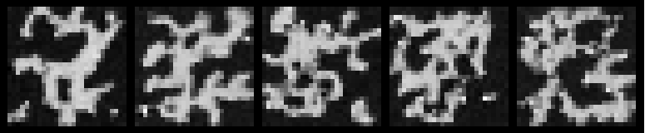
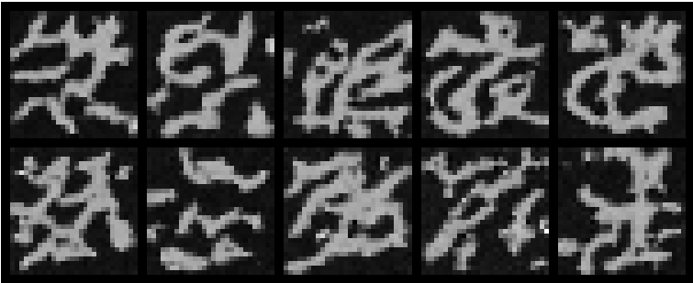

Denoising Visualization
The generation process was visualized by capturing intermediate timesteps, demonstrating the gradual transition from random noise to recognizable images.

CLIP Evaluation (Bonus)
If implemented, CLIP was used to evaluate image quality and alignment between generated images and class labels.
Evaluation goals:
- Measure semantic consistency
- Compare generated classes
- Analyze generation quality

Repository Structure
.
├── README.md
├── MD_Notebook_Your_Name_ITAI.ipynb
├── MD_Notebook_Your_Name_ITAI.pdf
├── MD_Report_Your_Name_ITAI.pdf
├── Contribution_Journal.pdf
├── Reflection_Journal.pdf
├── generated_images/
├── checkpoints/
└── outputs/

Deliverables
This repository contains the following required deliverables:

Completed Notebook
- Fully executed notebook
- All code sections completed
- Visible outputs and visualizations

Analysis Report
The report includes:
- Assessment question responses
- Technical analysis
- Experimental observations
- Generated image evaluations

Contribution Journal
Documentation of each team member's contributions, including:
- Design decisions
- Coding tasks
- Testing
- Debugging
- Model tuning

Reflection Journal
Individual reflections covering:
- Lessons learned
- Challenges encountered
- Solutions implemented
- Understanding gained from diffusion modeling

Team Contributions
Team Member |  | Contribution
Cesar Antonio Noreiga Martinez | Completed a full diffusion model implementation, debugging, training, evaluation, generated sample analysis, and assessment question responses. Participated in comparison and review of team notebooks.
Luiz Paludo | Completed a full diffusion model implementation, debugging, training, evaluation, generated sample analysis, and assessment question responses. Participated in comparison and review of team notebooks.
Mary Ann Mastri | Completed a full diffusion model implementation, debugging, training, evaluation, generated sample analysis, and assessment question responses. Participated in comparison and review of team notebooks.
Nichelle Graf | Completed a full diffusion model implementation, debugging, training, evaluation, generated sample analysis, and assessment question responses. Participated in comparison and review of team notebooks.

Assessment Topics Covered

Understanding Diffusion
- Forward diffusion process
- Noise scheduling
- Image emergence during denoising

Model Architecture
- U-Net design
- Skip connections
- Class conditioning
- Time embeddings

Training Analysis
- Loss interpretation
- Training progression
- Image quality evaluation

Practical Applications
Potential uses include:
- AI image generation
- Medical imaging
- Image restoration
- Data augmentation
- Creative content generation

Challenges Encountered
Examples of challenges addressed during development:
- GPU memory limitations
- Training instability
- Hyperparameter tuning
- Dataset preprocessing
- Implementation debugging
Solutions included:
- Batch size optimization
- Memory-efficient training
- Progressive testing
- Checkpoint saving
- Visualization-assisted debugging

Technologies Used
- Python
- PyTorch
- Torchvision
- NumPy
- Matplotlib
- Google Colab
- CLIP (Optional)

Academic Integrity
This midterm was completed as a team effort. Contributions from all team members are documented in the Contribution Journal. Each member was responsible for specific implementation, testing, analysis, and reporting tasks.

Acknowledgements
This project was completed for the ITAI-2376 course as part of the Midterm Assignment: Creating Images with Diffusion Models.
Special thanks to the course instructor for providing the diffusion model framework, implementation guidance, and evaluation criteria.

