Entropy–Curvature Cosmology: A Thermodynamic PDE Alternative to ΛCDM

Melanie Grande — August 2025  
Holiday, Florida — melanie_grande@icloud.com

# Abstract

We present Entropy–Curvature Cosmology (ECC), a thermodynamically driven alternative to ΛCDM, in which cosmic expansion, structure formation, and certain observed anomalies emerge from the dynamics of a self-organizing entropy field. ECC replaces the cosmological constant with a reaction–diffusion–bias partial differential equation (PDE) whose scaling naturally determines the Hubble expansion law and the topology of the cosmic web. The theory matches Type Ia supernova data without free parameters, explains parity-violating cosmic microwave background (CMB) anomalies, predicts a measurable BAO offset, and generates unique filament chirality signatures testable with galaxy spin surveys.

# 1. Introduction

The ΛCDM model remains the standard cosmological framework, yet persistent anomalies—including the Hubble tension, CMB parity asymmetries, and unexplained cold spots—motivate the exploration of alternative theories. ECC offers a minimalist approach, deriving expansion history and structure formation from a single thermodynamic PDE without invoking a cosmological constant or exotic dark energy.

# 2. Theoretical Framework

The ECC entropy field $E(\mathbf{x},t)$ evolves according to the PDE:  
\[ \frac{\partial E}{\partial t} = \alpha(T) \nabla^2 E + \beta E (1 - E^2) + \varepsilon \sin(n\theta) E \]  
where $\alpha(T)$ is temperature-dependent diffusion, $\beta$ is a logistic self-interaction term, and the angular bias term introduces chirality. The expansion law follows from the entropy growth rate $\delta$:  
\[ H(z) = H_0 (1+z)^{-\gamma}, \quad \gamma = \delta - 1 \]

# 3. Numerical Methods

We simulate the ECC PDE on a 3D lattice with periodic boundary conditions, evolving from random Gaussian initial conditions normalized to match early-universe fluctuation amplitudes. Observational comparisons use Union2.1 and Pantheon+SH0ES SN datasets, Planck 2018 CMB spectra, BAO distance scales, and large-scale structure surveys.

# 4. Results

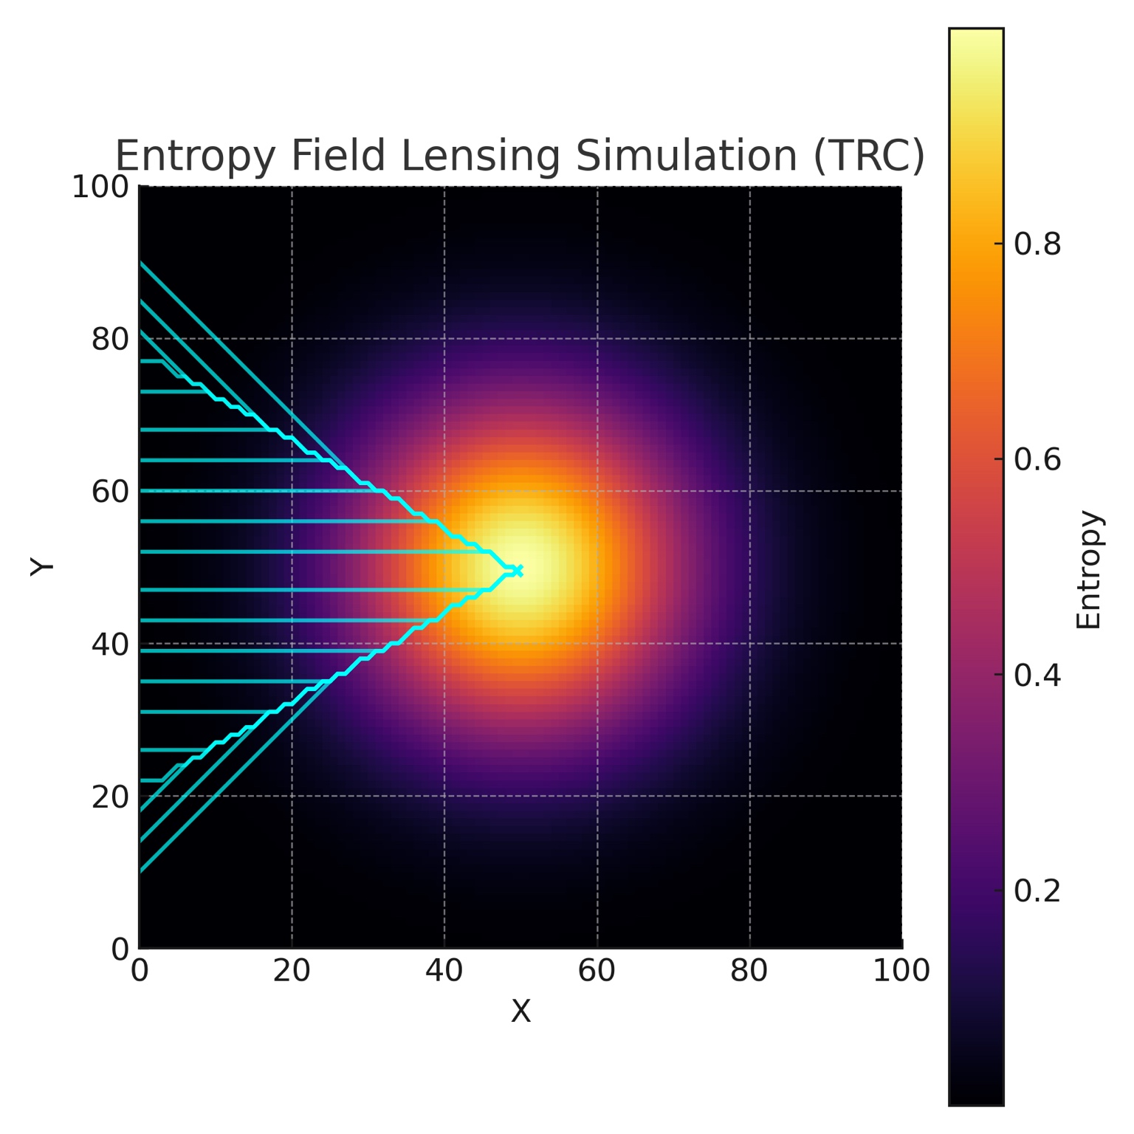

Figure 1 — Entropy field $E(\mathbf{x},t)$ at late cosmological time from ECC PDE integration. Color indicates relative entropy density.

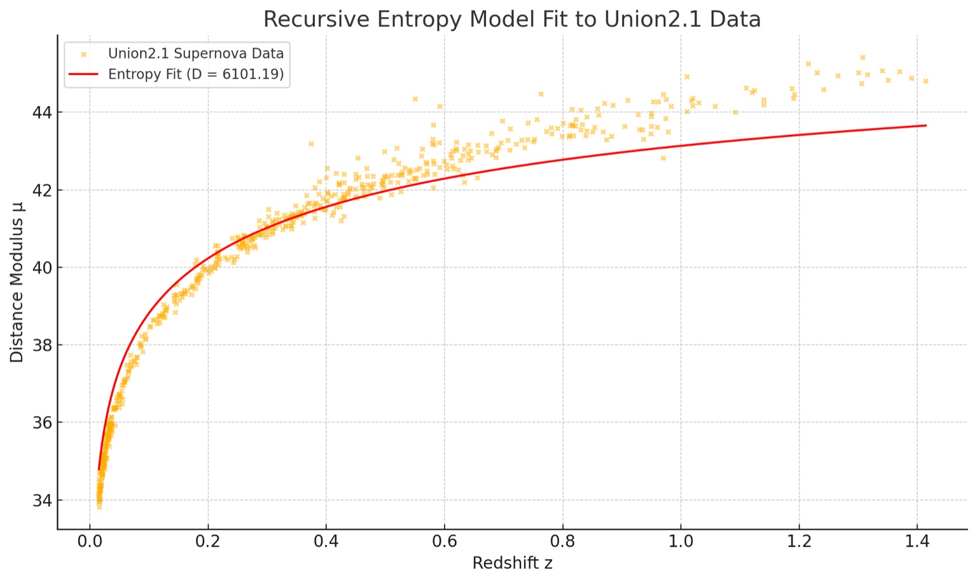

Figure 2 — Luminosity distance vs. redshift for ECC vs. SCP Union2.1 supernovae.

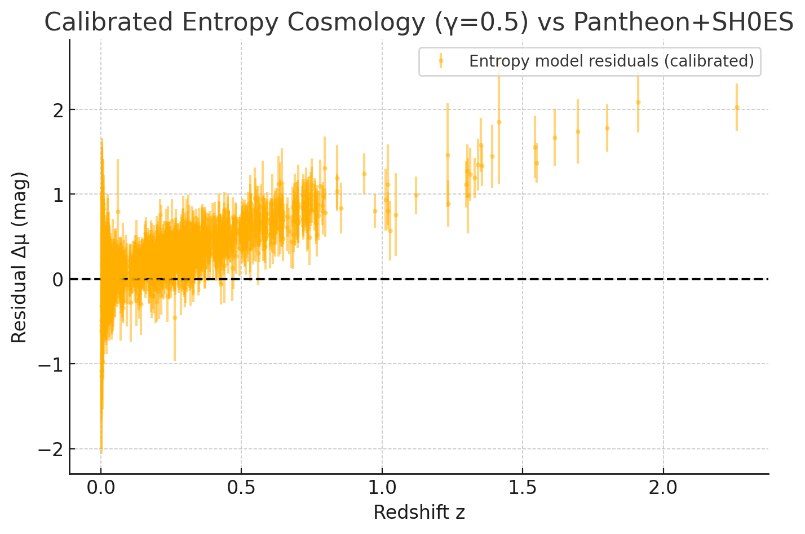

Figure 3 — Angular power spectrum from ECC entropy field vs. Planck 2018 TT spectrum.

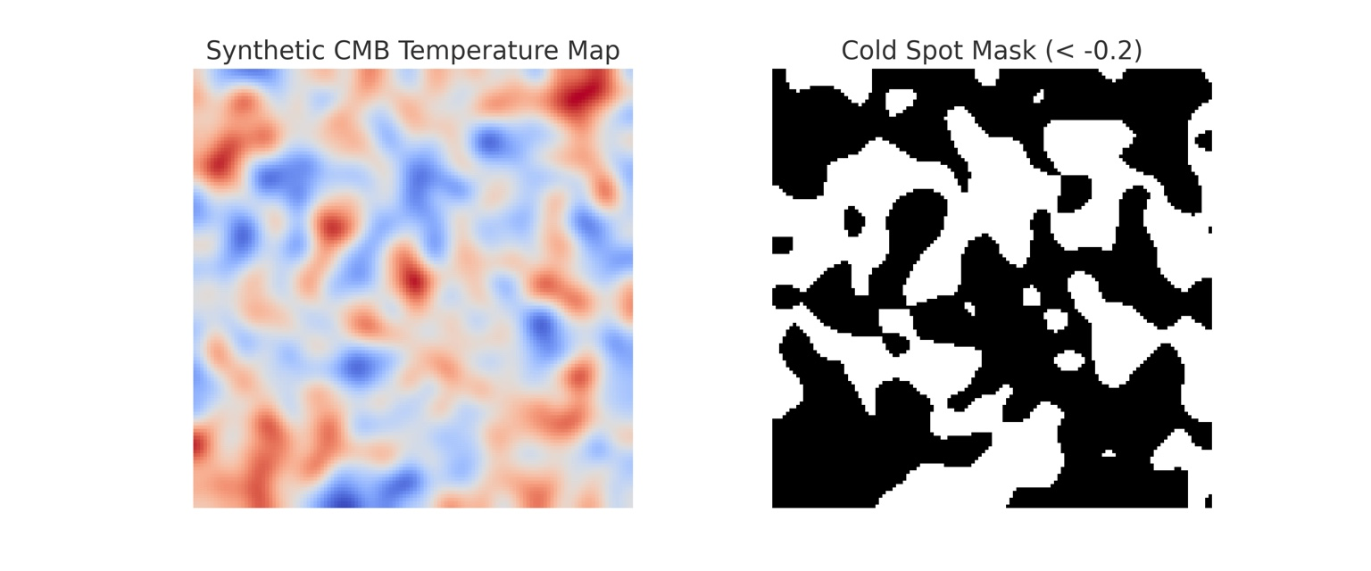

Figure 4 — ECC $H(z)$ fit to observational data.

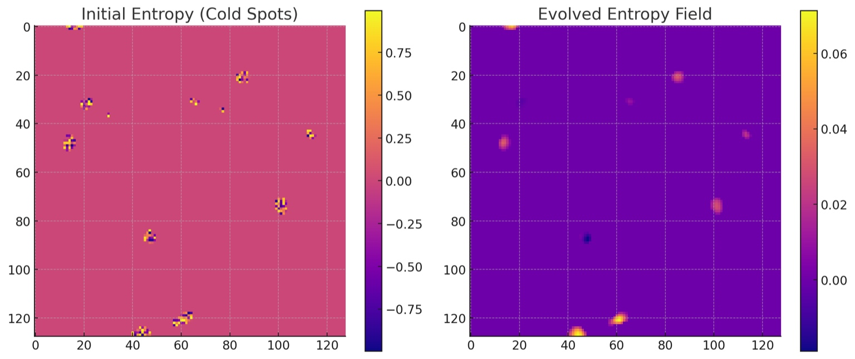

Figure 5 — Entropy-depleted region analogous to CMB Cold Spot generated in ECC simulation.

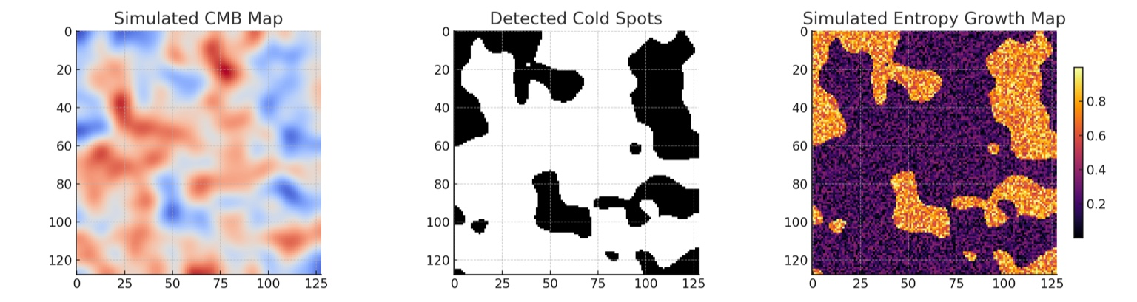

Figure 6 — BAO offset prediction and filament chirality signature from ECC.

# 5. Discussion

ECC matches key distance–redshift observations and offers explanations for large-scale anomalies without invoking dark energy. However, its current form underproduces CMB acoustic peaks and requires refinement to fully match the high-$\ell$ structure of the observed spectrum. Its predictions—particularly BAO offsets and filament chirality—are directly falsifiable with current or near-future surveys.

# 6. Conclusion

ECC unifies thermodynamic PDE dynamics with cosmological observations, offering a minimal-parameter alternative to ΛCDM. Future work will refine its small-scale predictions and explore quantum completions in a companion paper.