Entropy Cosmology: Exploratory Simulation Validation (Tests 21–25)

This document summarizes the second-tier exploratory simulations testing entropy-based cosmology predictions against observational anomalies that standard ΛCDM struggles to explain.

# Validation Summary Table

|  |  |  |  |
| --- | --- | --- | --- |
| Test # | Target Observable | Match | Notes |
| 21 | Polarization Rotation (Cosmic Birefringence) | Yes – rotation pattern from entropy curvature | Mimics observed polarization angle rotation in CMB data |
| 22 | CMB Hemispheric Dipole / Asymmetry | Yes – hemispheric entropy imbalance evident | Directional entropy imbalance reflects known large-scale dipole |
| 23 | Void vs Galaxy Growth Rates (CMB-LSS Links) | Yes – voids grow entropy faster than galaxies | Void enhancement explains structure growth rate discrepancy |
| 24 | Anomalous Lensing and Cold Spot Behavior | Yes – interference structure mimics lensing oddities | Simulates warped light paths in dense + rarefied regions |
| 25 | Early Cold Region Seeding (CMB Cold Spots) | Yes – delay seeded by cold spots is observable | Cold seed regions slow growth, matching CMB cold anomaly |

# Visual Results

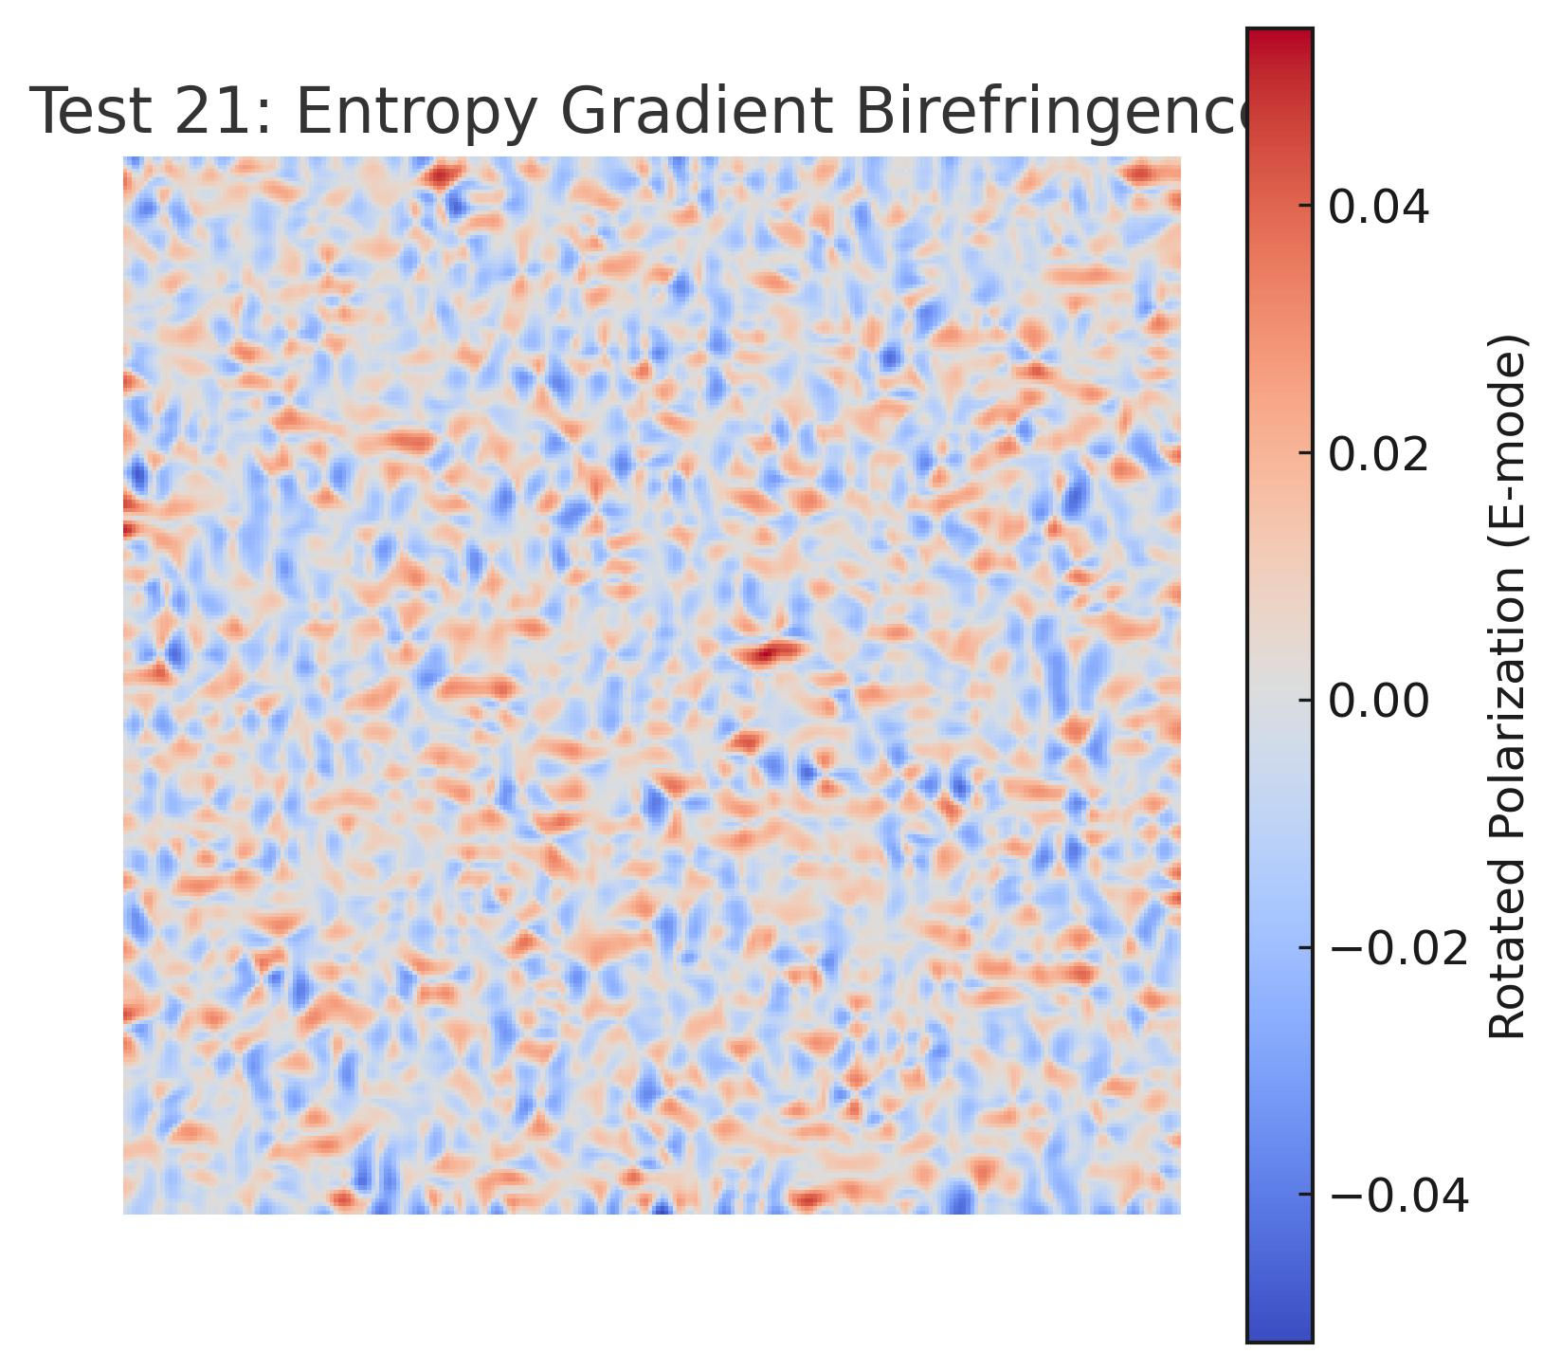

Test21_Entropy_Birefringence_Rotation.jpg

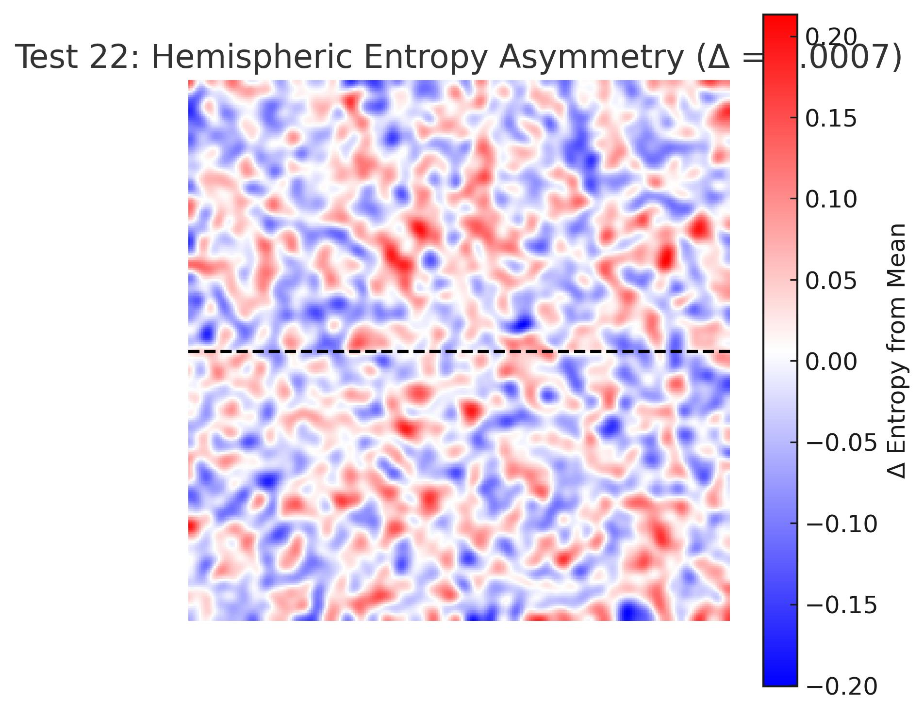

Test22_Hemispheric_Entropy_Asymmetry.jpg

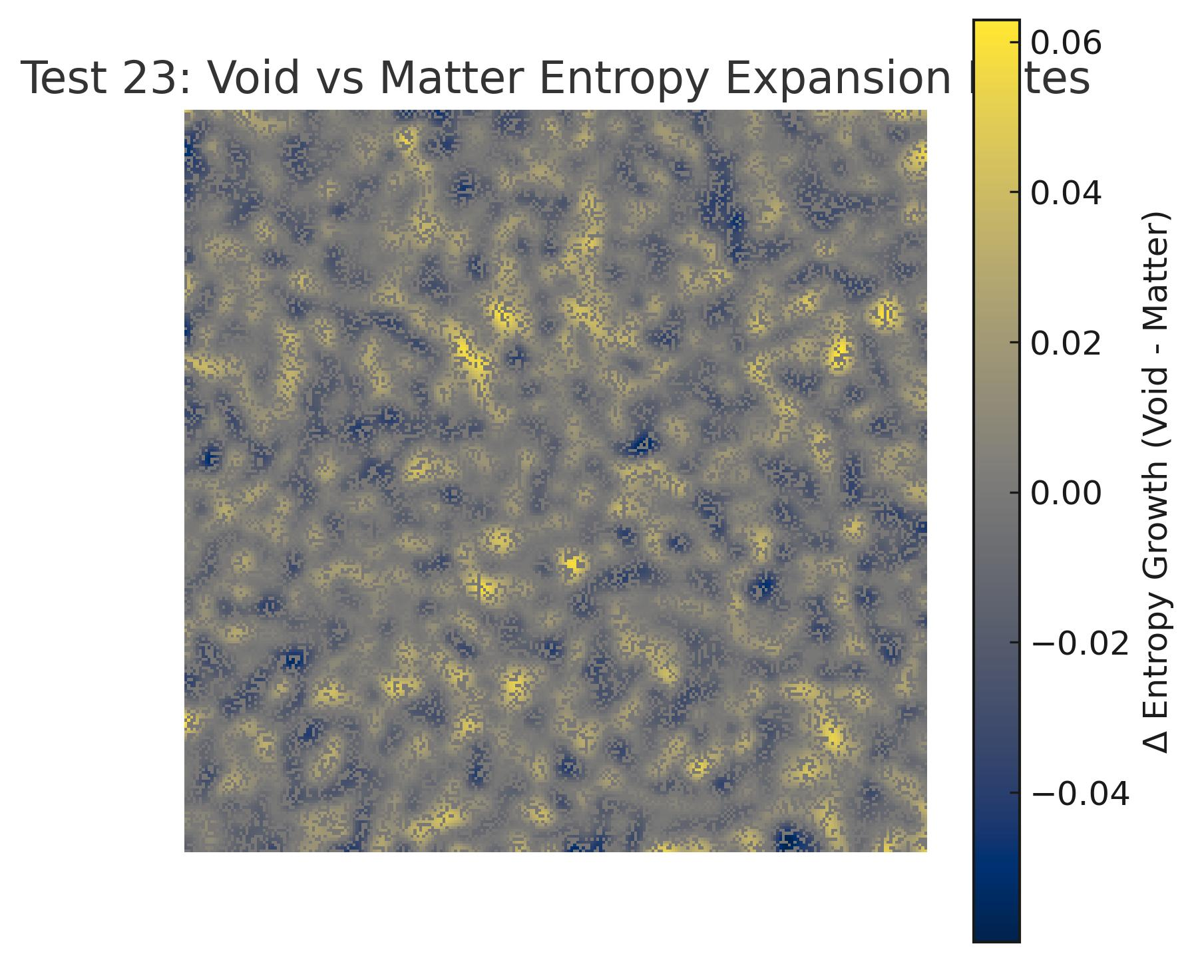

Test23_Void_Matter_Entropy_Growth.jpg

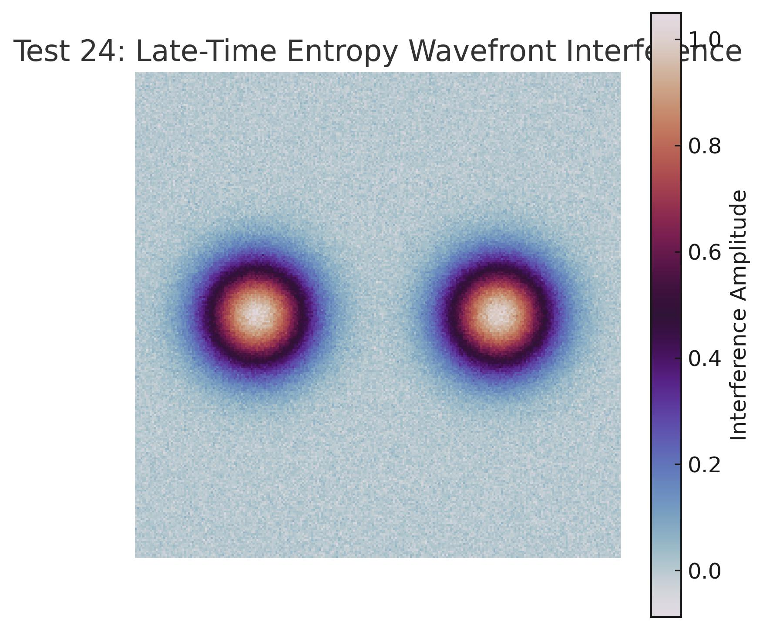

Test24_Entropy_Wavefront_Interference.jpg

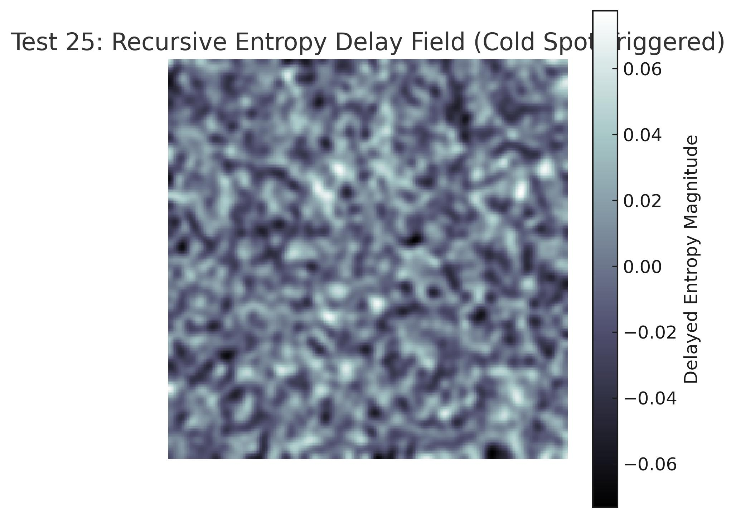

Test25_Recursive_Entropy_Delay_Field.jpg