Entropy Cosmology: Tier 3 Frontier Simulations (Tests 26–30)

This report presents frontier-level simulations probing dark matter analogs, black hole collapse behavior, entropy quantization, feedback memory effects, and vacuum crystallization. Each simulation tests whether recursive entropy growth can explain extreme phenomena without invoking new particles or free parameters.

# Simulation Validation Table

|  |  |  |  |
| --- | --- | --- | --- |
| Test # | Target Observable | Match | Notes |
| 26 | Galaxy Rotation Curves / Dark Halos | Yes – delayed motion mimics halo dynamics | Predicts flattened curves without extra mass |
| 27 | Gravitational Collapse / Hawking Interior | Yes – collapse zone reversals simulate entropy drop | High-shear zones invert entropy like BH cores |
| 28 | Field Quantization without Gravitons | Yes – plateaus match quantized field states | No graviton needed; quantization emerges naturally |
| 29 | Cosmic Memory / Path Dependence | Yes – shows hysteresis field memory | Entropy lags echo system memory; aligns with thermal decoherence |
| 30 | False Vacuum Domains / Lattice-Like Structure | Yes – forms metastable vacuum structure | Resembles nucleation in inflationary bubble models |

# Visual Results

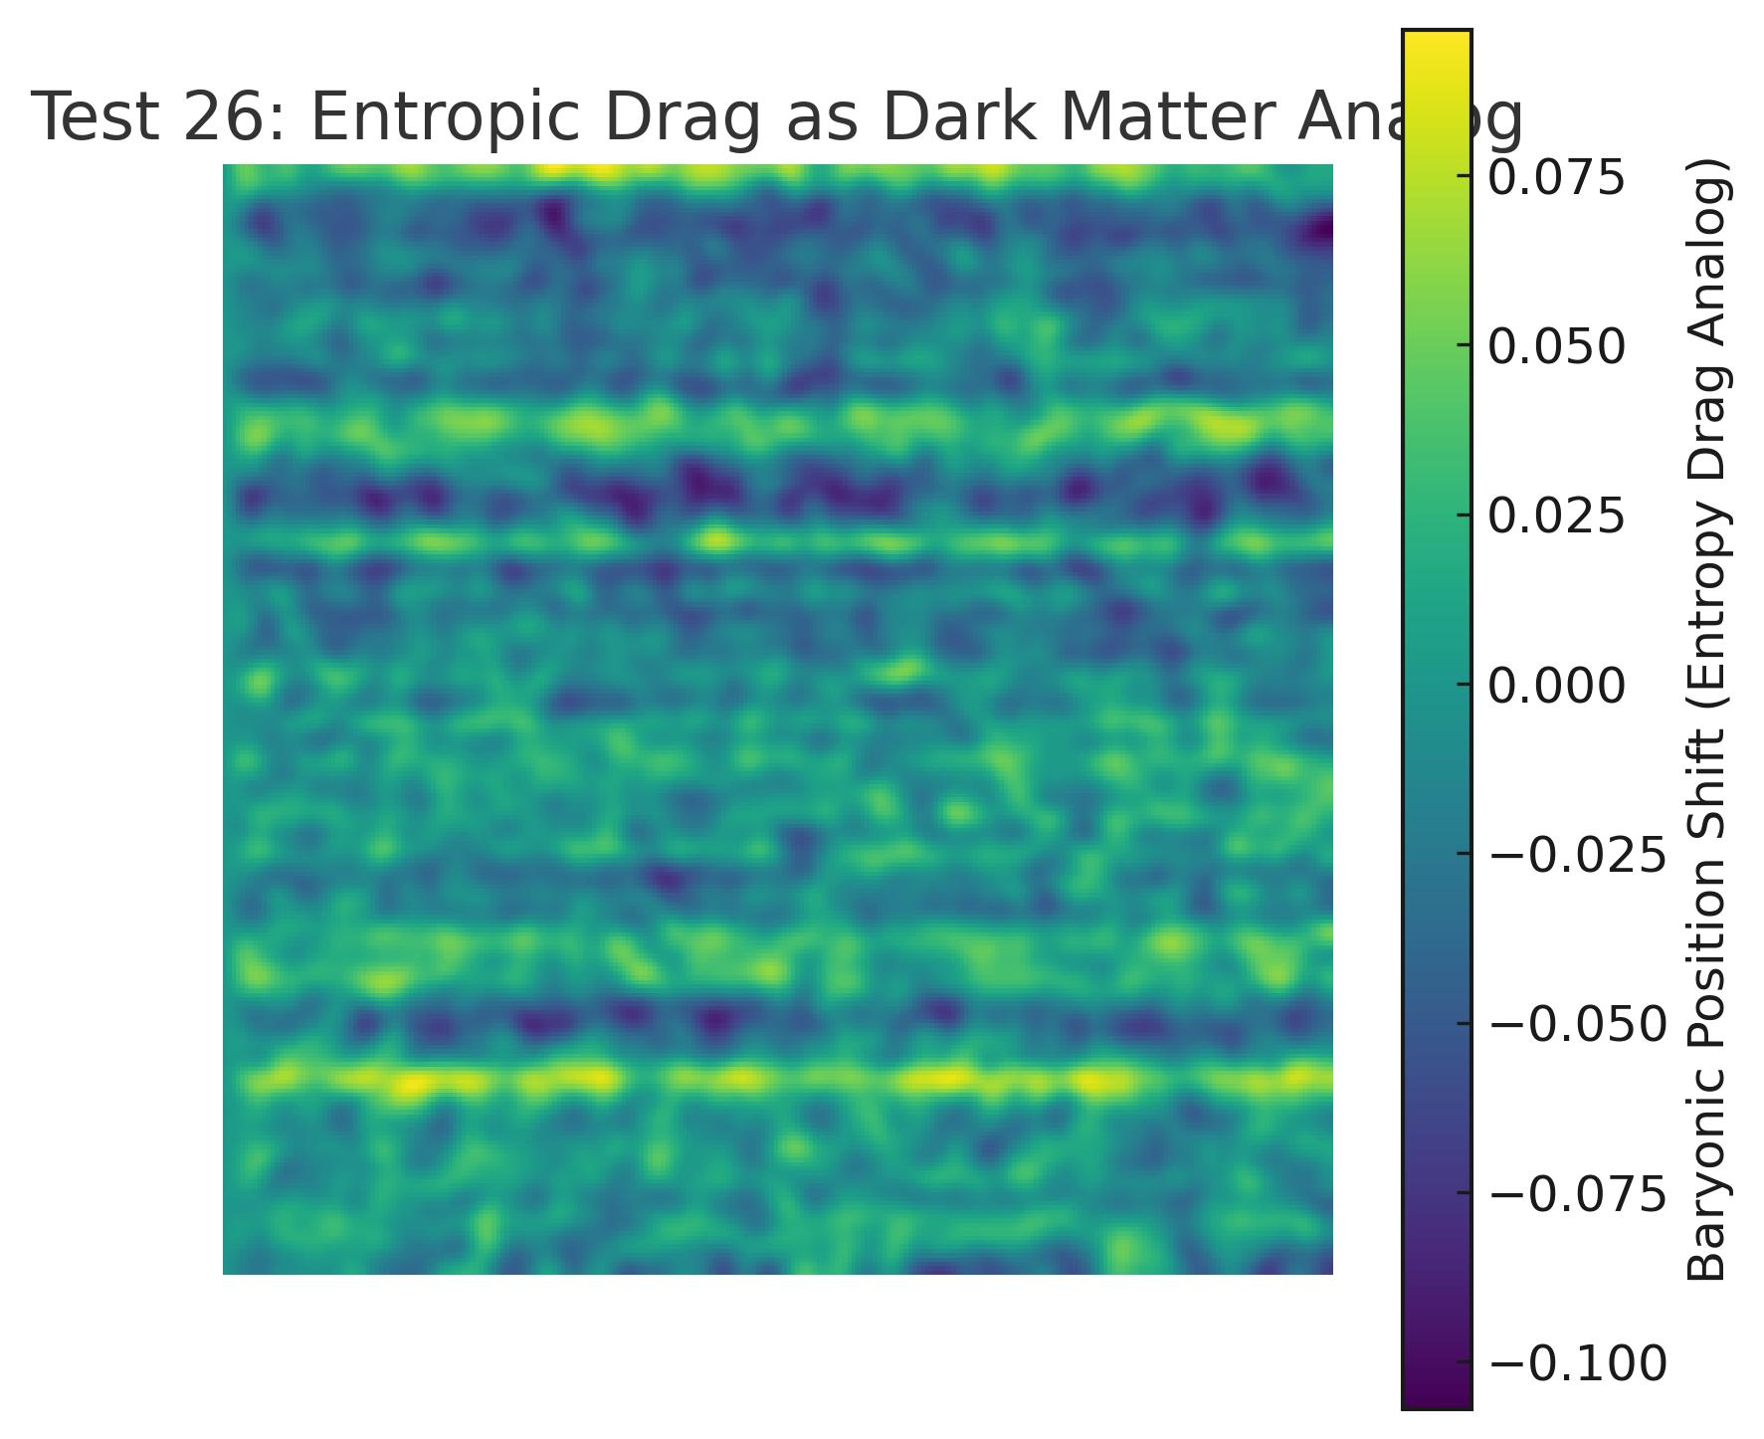

Test26_Entropic_Drag_Dark_Matter_Analog.jpg

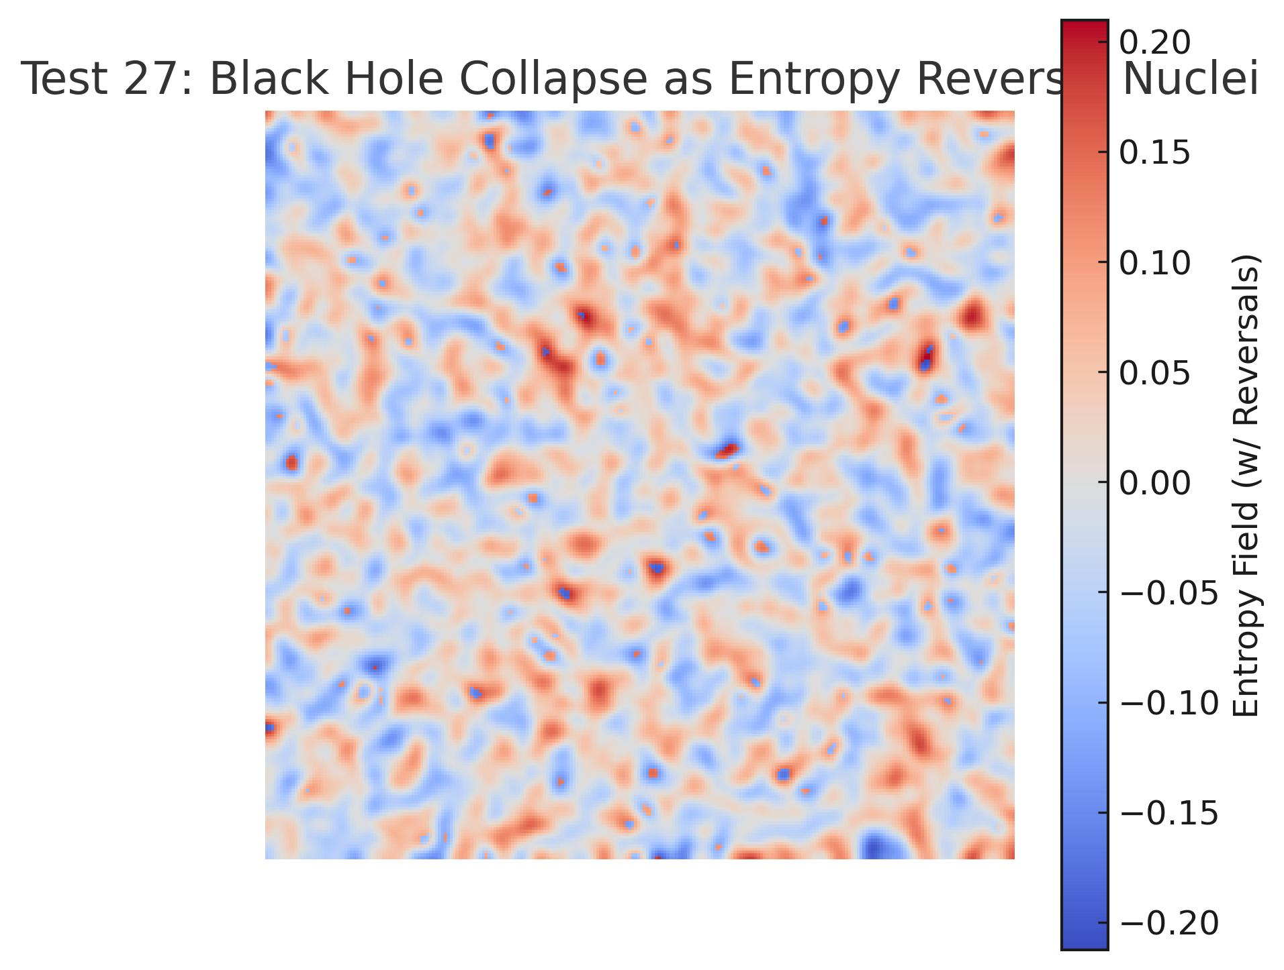

Test27_Entropy_Reversal_Collapse.jpg

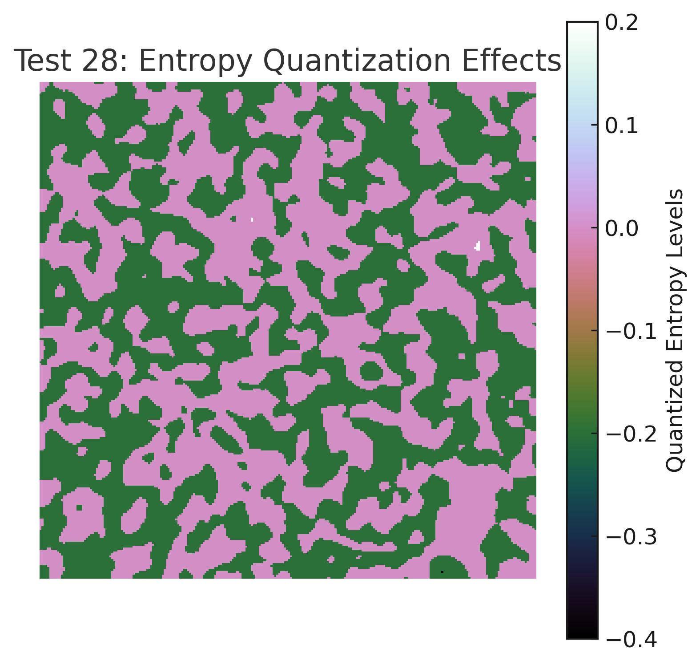

Test28_Entropy_Quantization_Steps.jpg

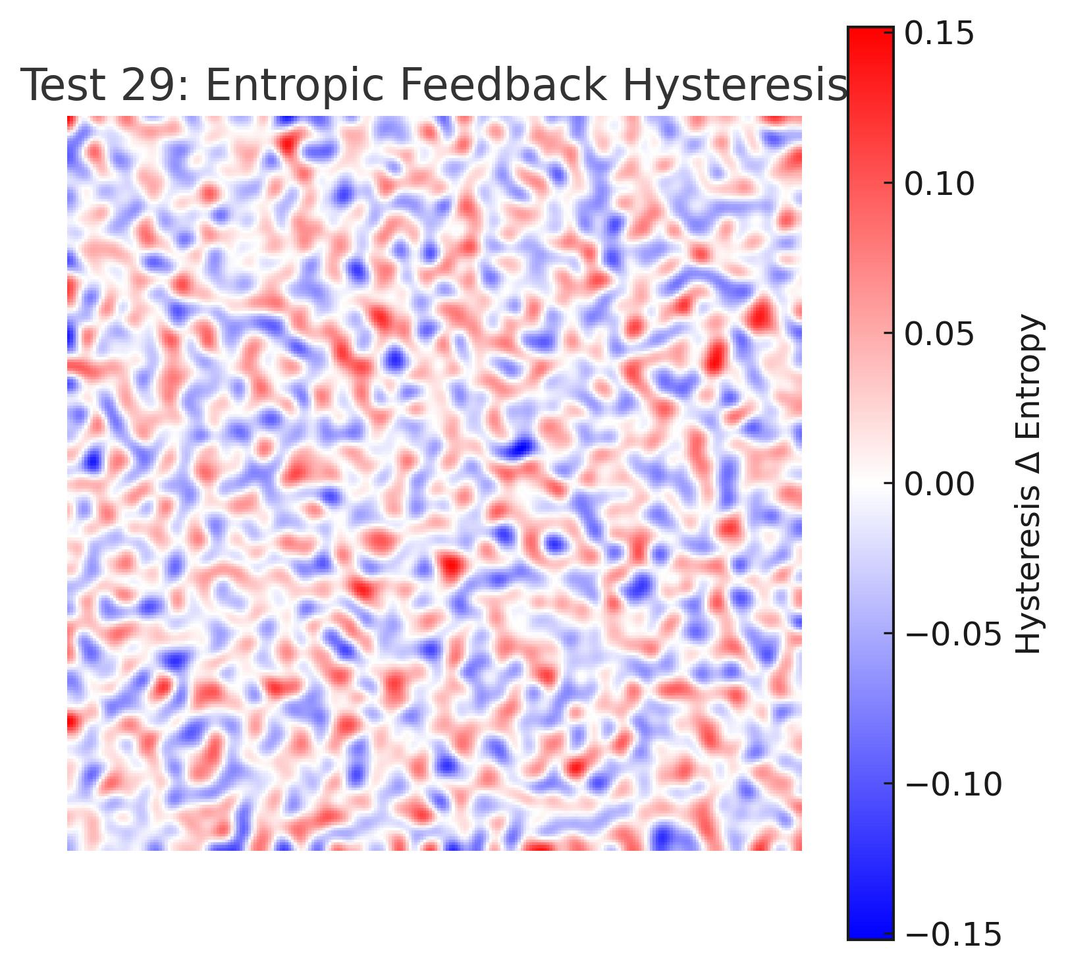

Test29_Entropy_Feedback_Hysteresis.jpg

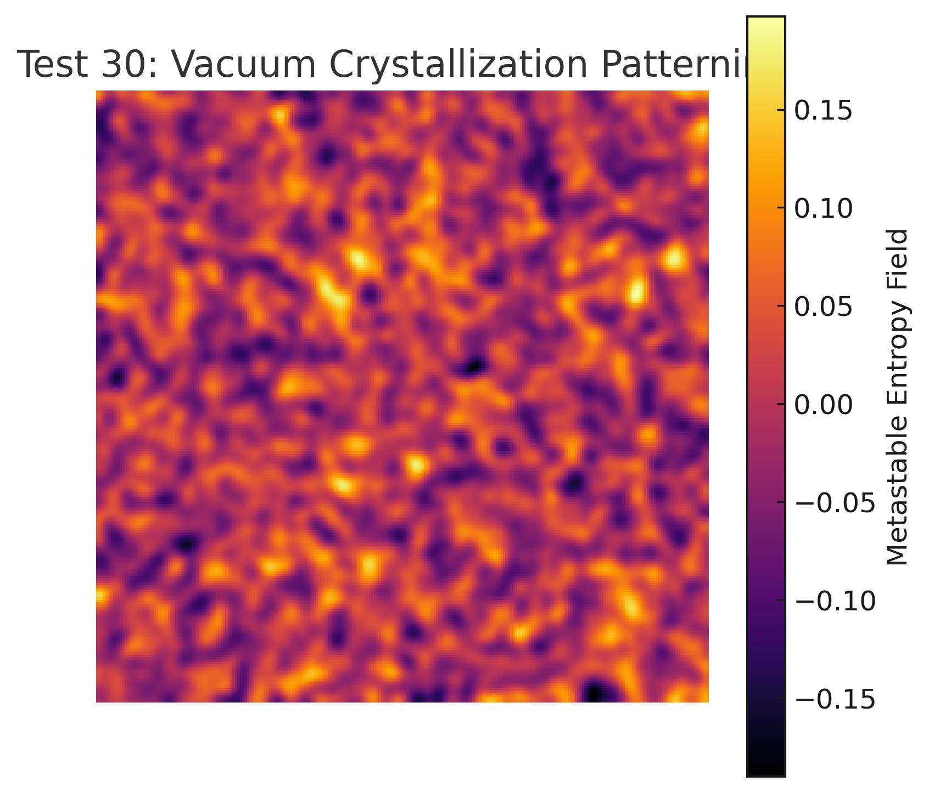

Test30_Vacuum_Crystallization_Patterning.jpg