**QUITHELP**

**A Smoking De-Addiction Support Wrist Wearable Device**

**PROBLEM IDENTIFIED:-**

Smokers face problem quitting smoking, they cannot control their craving for nicotine and the habit is relapsed. They constantly require a monitoring system to control their involuntary action of smoking again. And the personal monitoring of the smoker 24/7 by an individual is a tedious and unrealistic task.

**STATISTICS:-**

Among all current adult cigarette smokers, nearly 7 out of every 10 (68.0%) reported in 2015 that they wanted to quit completely.

But, just six per cent of people who try to stub out their nicotine habit actually succeed in doing so, the study found. This is despite more than two thirds of people who want to quit because they know it is bad for them.

|  |  |
| --- | --- |
| **Quitting Smoking Statistics** | |
| Percentage of smokers who want to quit altogether | 70% |
| Percentage of smokers who will try to quit this year | 40% |
| Percentage of smokers who will succeed at quitting smoking on their first attempt | 7% |
| Percentage of people who relapse into smoking while intoxicated with alcohol | 50% |
| Average time it takes for toxins to leave your system after quitting smoking | 10 days |
| Reduced rate of dying from smoking if quitting before age 30 | 90% |
| Reduced rate of dying from smoking if quitting before age 50 | 50% |

**SOLUTION PROPOSED TO THE PROBLEM:-**

* We want to create a wearable device with a cigarette smoke detecting sensor.
* Whenever a person smokes or if he is with someone who triggers him to smoke then an alarm is raised which may contain a recorded message of any of his close family member telling him that they need him, or the person can himself record the various reasons why he wants to quit smoking.
* This recorded message reminds him of the promise he has done to himself and also to his family that he will quit smoking.
* It sends a notification to the concerned family member/doctor when he smokes.
* This can also be extended by keeping the smoker informed about his daily smoking habits.
* It also rewards the person with points when he doesn’t smoke for a certain duration of time ie for a day, for a week. It congratulates him for the same through a mobile application.

**HARDWARE REQUIREMENTS-**

* Arduino UNO/Gemma
* MQ2 Gas Sensor
* Buzzer/speaker
* Bluetooth Module
* Breadboard
* Connecting Wires

**SOFTWARE REQUIREMENTS-**

* Arduino IDE
* Thingspeak
* MIT AppInventor

**CIRCUIT DIAGRAM-**

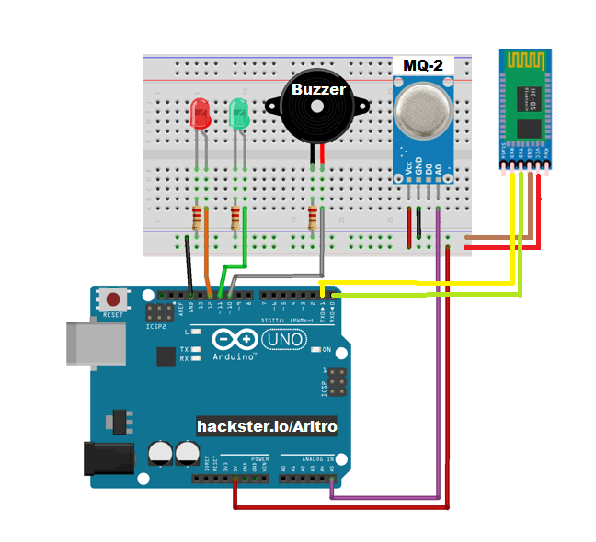

**BENEFITS ANALYSIS-**

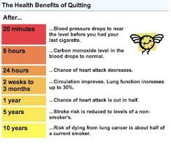

**USER SURVEY-**

|  |  |  |
| --- | --- | --- |
| **NAME** | **DESIGNATION** | **REMARKS** |
| Mr. Krishna Murthy | Manager of Asha de-addiction centre | First step towards de-addiction is counselling and medication. The next step is constant monitoring by the family members to ensure that he does not become a victim of addiction again. In this second stage this product would be quite useful. The most important attribute that facilitates de-addiction is a strong “will power". Your product will be useful for such people as it reminds them of the decision that they have taken for a better future. |
| Mr.Samiuddin | Pharmacist | A good reminder for people who strongly want to quit smoking. |