Blood Donation System - Playwright Test Documentation
JavaScript Playwright E2E Framework
This document summarizes the automation framework design, the test plan, and the implemented test cases for the Blood Donation web application.

1. Project Overview
- Application under test: Flask-based Blood Donation System
- Framework: Playwright with JavaScript
- Reporting: Allure via allure-playwright
- Pattern: Page Object Model with reusable fixtures and utilities
- Data-driven testing: JSON test data files

2. Architecture Diagram
The diagram below shows how test execution flows through suites, cases, page objects, utilities, and reporting.
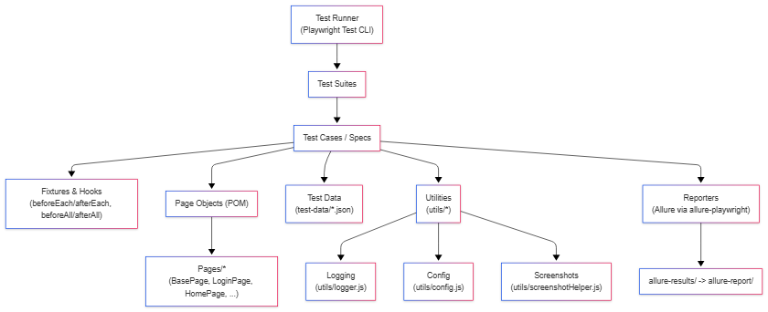

3. Framework Structure
- Test suites and cases: tests/positive and tests/negative
- Page objects: pages/
- Fixtures and hooks: fixtures/test-fixtures.js and tests/hooks/global-hooks.js
- Utilities: utils/dataLoader.js, utils/screenshotHelper.js, utils/stepHelper.js, utils/config.js, utils/logger.js
- Test data: test-data/*.json
- Reports: allure-results and allure-report

4. Test Environment and Execution
- Prerequisite 1: MySQL database 'bd' imported from sql/bd (1).sql
- Prerequisite 2: Flask application running locally on http://127.0.0.1:5000
- Prerequisite 3: Node.js 18+ and Playwright browser binaries installed
- Install dependencies: npm install
- Install browsers: npm run install:browsers
- Run all tests: npm test
- Generate Allure report: npm run report:generate and npm run report

5. Test Plan
ID | Area | Type | Objective | Expected Result
TP-01 | Navigation | Positive | Verify core public pages load correctly | Pages load and headings are visible
TP-02 | Registration | Positive | Verify donor and hospital registration | Account creation redirects to login
TP-03 | Search | Positive | Verify search by blood type and location | Matching results are displayed
TP-04 | Authentication | Positive | Verify valid login flows | Users reach their respective dashboards
TP-05 | Donor Features | Positive | Verify donor profile and history views | Relevant profile sections are displayed
TP-06 | Hospital Features | Positive | Verify hospital dashboard actions | Blood request form and profile are accessible
TP-07 | Admin Features | Positive | Verify admin dashboard views | Active users and blood requests are displayed
TP-08 | Login Validation | Negative | Verify invalid login scenarios | Validation message or stay-on-page behavior
TP-09 | Registration Validation | Negative | Verify invalid registration inputs | Validation prevents submission
TP-10 | Authorization | Negative | Verify protected route access without login | Users are redirected or blocked

6. Positive Test Cases
ID | Module | Test Case | Expected Outcome
POS-NAV-001 | Navigation | Home page loads with main heading | Main heading is visible
POS-NAV-002 | Navigation | About page loads successfully | About content is visible
POS-NAV-003 | Navigation | Login page displays Welcome Back heading | Login page heading is visible
POS-NAV-004 | Navigation | Register page displays Create Account heading | Register page heading is visible
POS-REG-001 | Registration | Register new donor with valid unique data | Redirects to login page
POS-REG-002 | Registration | Register new hospital with valid unique data | Redirects to login page
POS-SEARCH-001 | Search | Search donors by blood type A+ returns results | Result rows are displayed
POS-SEARCH-002 | Search | Search donors by location Karachi returns results | Result rows are displayed
POS-SEARCH-003 | Search | Search donors by blood type O+ returns results | Result rows are displayed
POS-AUTH-001 | Authentication | Admin login with valid credentials redirects to admin dashboard | Admin dashboard is visible
POS-AUTH-002 | Authentication | New donor registration and login redirects to donor profile | Donor profile page is visible
POS-AUTH-003 | Authentication | New hospital registration and login redirects to hospital dashboard | Hospital dashboard is visible
POS-DONOR-001 | Donor | Donor dashboard shows welcome header and blood requests section | Both sections are visible
POS-DONOR-002 | Donor | Donor can view profile details page | Profile details are visible
POS-DONOR-003 | Donor | Donor can open appointment history page | Appointment history is visible
POS-HOSP-001 | Hospital | Hospital dashboard shows blood request form | Blood request form is visible
POS-HOSP-002 | Hospital | Hospital can view profile page | Hospital profile is visible
POS-HOSP-003 | Hospital | Hospital can submit a new blood request | Request appears in existing requests
POS-ADMIN-001 | Admin | Admin dashboard displays active users view | Active users table is visible
POS-ADMIN-002 | Admin | Admin dashboard displays blood requests view | Blood requests table is visible

7. Negative Test Cases
ID | Module | Test Case | Expected Outcome
NEG-LOGIN-001 | Login | Login fails with invalid password for existing username | Stay on login page with error message
NEG-LOGIN-002 | Login | Login fails with non-existent username | Stay on login page with error message
NEG-LOGIN-003 | Login | Login fails with empty username | HTML5 validation prevents submission
NEG-LOGIN-004 | Login | Login fails with empty password | HTML5 validation prevents submission
NEG-REG-001 | Registration | Registration blocked with invalid email format | Validation prevents submission
NEG-REG-002 | Registration | Registration blocked with password shorter than 6 characters | Validation prevents submission
NEG-REG-003 | Registration | Registration blocked with invalid 10-digit phone number | Validation prevents submission
NEG-REG-004 | Registration | Registration blocked with invalid 6-digit zip code | Validation prevents submission
NEG-REG-005 | Registration | Registration blocked with invalid username pattern | Validation prevents submission
NEG-REG-006 | Registration | Registration blocked with invalid name containing numbers | Validation prevents submission
NEG-REG-007 | Registration | Registration fails with duplicate username | Duplicate username message appears
NEG-AUTH-001 | Authorization | Unauthenticated access to donor profile redirects to login | User is redirected to login
NEG-AUTH-002 | Authorization | Unauthenticated access to hospital dashboard redirects to home | User is redirected to home
NEG-AUTH-003 | Authorization | Unauthenticated access to admin dashboard redirects to home | User is redirected to home
NEG-ADMIN-001 | Admin | Admin login fails with wrong username | Stay on admin login with error
NEG-ADMIN-002 | Admin | Admin login fails with wrong password | Stay on admin login with error
NEG-ADMIN-003 | Admin | Admin login fails with empty credentials | HTML5 validation prevents submission
NEG-SEARCH-001 | Search | Search with empty term blocked by HTML5 validation | Validation prevents submission
NEG-SEARCH-002 | Search | Search with non-existent blood type ZZ shows no results | No results are returned
NEG-SEARCH-003 | Search | Search with non-existent city shows no results | No results are returned

8. Reporting
- Allure captures execution summary, pass/fail status, screenshots, and timing information.
- Screenshots are attached on failures and optionally on success when SCREENSHOT_ALL=true.
- Artifacts are written to allure-results and rendered in allure-report.

9. Notes
- The framework uses JSON test data and reusable page objects to keep tests maintainable.
- The document reflects the JavaScript version of the framework files.
- Refer to the repository README for the latest setup and execution commands.

