Q1

from queue import PriorityQueue

class Node:

def __init__(self, position, parent=None):

self.position = position

self.parent = parent

self.g = 0

self.h = 0

self.f = 0

def __lt__(self, other):

return self.f < other.f

def heuristic(pos, goals):

return min(abs(pos[0] - g[0]) + abs(pos[1] - g[1]) for g in goals)

def best_first_search_multiple_goals(maze, start, goals):

rows, cols = len(maze), len(maze[0])

path = []

for goal in goals:

start_node = Node(start)

frontier = PriorityQueue()

frontier.put(start_node)

visited = set()

while not frontier.empty():

current_node = frontier.get()

current_pos = current_node.position

if current_pos == goal:

temp_path = []

while current_node:

temp_path.append(current_node.position)

current_node = current_node.parent

path.extend(temp_path[::-1])

start = goal

break

visited.add(current_pos)

for dx, dy in [(1, 0), (-1, 0), (0, 1), (0, -1)]:

new_pos = (current_pos[0] + dx, current_pos[1] + dy)

if 0 <= new_pos[0] < rows and 0 <= new_pos[1] < cols and maze[new_pos[0]][new_pos[1]] == 0 and new_pos not in visited:

new_node = Node(new_pos, current_node)

new_node.g = current_node.g + 1

new_node.h = heuristic(new_pos, goals)

new_node.f = new_node.h

frontier.put(new_node)

return path

# Example run for Task #1

maze = [

[0, 0, 1, 0],

[0, 1, 0, 0],

[0, 0, 0, 1],

[1, 0, 0, 0]

]

start = (0, 0)

goals = [(2, 2), (3, 3)]

path = best_first_search_multiple_goals(maze, start, goals)

print("Task #1 Path through multiple goals:", path)

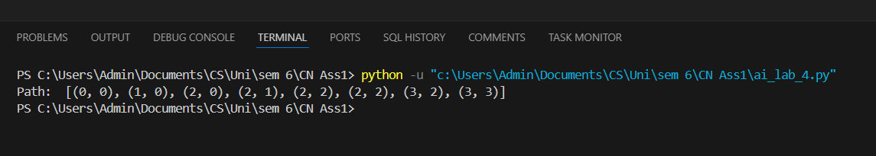

Q2

# TASK #2: Dynamic A* Search with Changing Edge Costs

import random

def a_star_dynamic(graph, start, goal, heuristic):

frontier = [(start, 0 + heuristic[start])]

visited = set()

g_costs = {start: 0}

came_from = {start: None}

while frontier:

frontier.sort(key=lambda x: x[1])

current_node, _ = frontier.pop(0)

if current_node == goal:

path = []

while current_node is not None:

path.append(current_node)

current_node = came_from[current_node]

return path[::-1]

visited.add(current_node)

for neighbor in graph[current_node]:

cost = graph[current_node][neighbor] + random.randint(-2, 2)

new_g_cost = g_costs[current_node] + cost

f_cost = new_g_cost + heuristic[neighbor]

if neighbor not in g_costs or new_g_cost < g_costs[neighbor]:

g_costs[neighbor] = new_g_cost

came_from[neighbor] = current_node

frontier.append((neighbor, f_cost))

return None

# Example run for Task #2

graph = {

'A': {'B': 2, 'C': 3},

'B': {'D': 4},

'C': {'D': 2},

'D': {}

}

heuristic = {'A': 6, 'B': 4, 'C': 3, 'D': 0}

path = a_star_dynamic(graph, 'A', 'D', heuristic)

print("Task #2 Path with dynamic costs:", path)

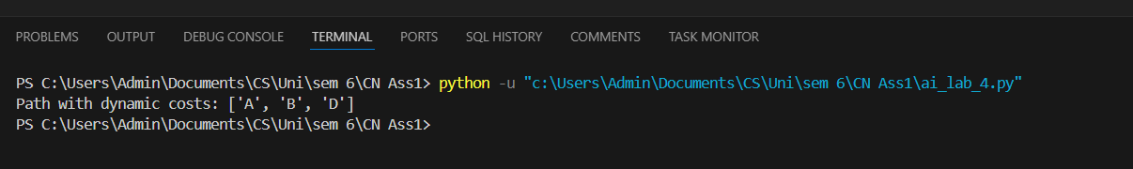

Q3

def greedy_bfs_with_time(graph, start, goal, heuristic, time_windows):

frontier = [(start, heuristic[start])]

visited = set()

came_from = {start: None}

while frontier:

frontier.sort(key=lambda x: x[1])

current_node, _ = frontier.pop(0)

if current_node in visited:

continue

print(f"Visiting {current_node} within time window {time_windows.get(current_node, 'N/A')}")

visited.add(current_node)

if current_node == goal:

path = []

while current_node is not None:

path.append(current_node)

current_node = came_from[current_node]

return path[::-1]

for neighbor in graph[current_node]:

if neighbor not in visited:

came_from[neighbor] = current_node

frontier.append((neighbor, heuristic[neighbor]))

return None

graph = {

'A': {'B': 2, 'C': 3},

'B': {'D': 4},

'C': {'D': 2},

'D': {}

}

heuristic = {'A': 6, 'B': 4, 'C': 3, 'D': 0}

time_windows = {'A': (8, 10), 'B': (9, 11), 'C': (10, 12)}

path = greedy_bfs_with_time(graph, 'A', 'D', heuristic, time_windows)

print("Task #3 Delivery Route Path:", path)



Q4

def a_star_with_traffic(graph, start, goal, heuristic, traffic_updates):

frontier = [(start, 0 + heuristic[start])]

visited = set()

g_costs = {start: 0}

came_from = {start: None}

while frontier:

frontier.sort(key=lambda x: x[1])

current_node, _ = frontier.pop(0)

if current_node == goal:

path = []

while current_node is not None:

path.append(current_node)

current_node = came_from[current_node]

return path[::-1]

visited.add(current_node)

for neighbor in graph[current_node]:

traffic_cost = graph[current_node][neighbor] + traffic_updates.get((current_node, neighbor), 0)

new_g_cost = g_costs[current_node] + traffic_cost

f_cost = new_g_cost + heuristic[neighbor]

if neighbor not in g_costs or new_g_cost < g_costs[neighbor]:

g_costs[neighbor] = new_g_cost

came_from[neighbor] = current_node

frontier.append((neighbor, f_cost))

return None

graph = {

'A': {'B': 2, 'C': 3},

'B': {'D': 4},

'C': {'D': 2},

'D': {}

}

heuristic = {'A': 6, 'B': 4, 'C': 3, 'D': 0}

# Example run for Task #4

traffic_updates = {('A', 'B'): 3, ('B', 'D'): -1}

path = a_star_with_traffic(graph, 'A', 'D', heuristic, traffic_updates)



print("Task #4 Path with traffic updates:", path)