Question1
#include <stdio.h>
int main()
{
int totmarks=100 ;
int marks;
double percentage,income;
printf("enter obtained marks\n");
scanf("%d",&marks);
printf(" enter your family income\n");
scanf("%lf",&income);
percentage=(marks/totmarks)*100;
if((percentage>=80)||(income<50000.00))
{
printf("you are eligible for a scholarship");
}else
{
printf("sorry you are not eligible for scholarship");

}
return 0;

}

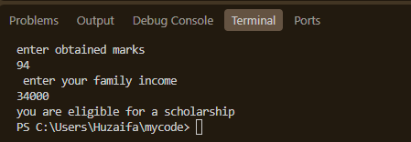

Question2
#include <stdio.h>
int main()
{
int Dayslate;

printf("enter the number of days late");
scanf("%d",&Dayslate);
if(Dayslate==0){
printf("no fine");
}else if((Dayslate>=1) && (Dayslate<=5)){
printf(" pay fine of 50.Rs");
}else if((Dayslate>=6) && (Dayslate<=10)){
printf(" pay fine of 100.Rs");
}else if(Dayslate>10){
printf(" pay fine of 200.Rs");
}
return 0;

}

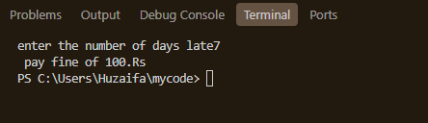

Question3
#include <stdio.h>

int main()
{
char name[100];
printf("enter student full name including spaces\n");
fgets(name,sizeof(name),stdin);
printf("the name of student is: ");
puts(name);

return 0;

}

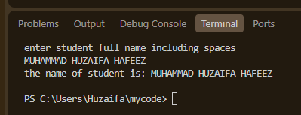

Question4
#include <stdio.h>
int main()
{
int perimeter,area,length,width;
printf("enter lentgh");
scanf("%d",&length);
printf("\nenter width");
scanf("%d",&width);
area=length*width;
perimeter=((2*length)+(2*width));
printf( "the area of the rectangle is %d and the perimeter is %d",area,perimeter);
return 0;

}

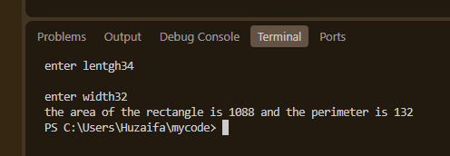

Question5
#include <stdio.h>
int main()
{
int Num,Square,Cube;
printf("enter a number");
scanf("%d",&Num);
Square=Num*Num;
Cube=Num*Num*Num;
printf(" the square of number %d is %d and its cube is %d",Num,Square,Cube);
return 0;

}

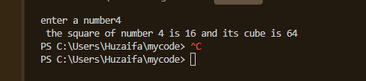

Question6
#include <stdio.h>
int main()
{
int Marks;
printf(" enter your marks\n");
scanf("%d",&Marks);
if(Marks>=50){
printf("pass");
}else{
printf("fail");
}
return 0;

}

