Logistic Regression in Octave

Building a logistic regression model to predict whether a student gets admitted into a university.

Suppose that the administrator of a university department wants to determine each applicant’s chance of admission based on their results on two exams. He/She has historical data from previous applicants that he/she can use as a training set for logistic regression. For each training example, he/she has the applicant’s scores on two exams and the admissions decision. His/Her task is to build a classification model that estimates an applicant’s probability of admission based the scores from those two exams.

Recall that the logistic regression hypothesis is defined as:



where function g is the sigmoid function. The sigmoid function is defined as:



Recall that the cost function in logistic regression is



and the gradient of the cost is a vector of the same length as θ where the jth  
element (for j = 0; 1; : : : ; n) is defined as follows:

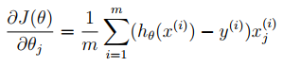

Recall that the regularized cost function in logistic regression is

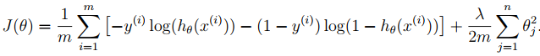

The gradient of the cost function is a vector where the jth element is defined as follows:

