Punjab Industries Survey App
Database Schema and ERD, Section by Section (A to K)
Built from 'Database Design for Survey APP'. 3 roles, 1 survey form, 11 sections (A to K). Every field is marked as dropdown, text, number, Yes/No or tick-box table.
What is included | Count
Database tables | 64
Dropdown lists | 57
Dropdown choices loaded | 315
Rows of tick-box tables loaded | 79
Dashboard views | 4
Survey form / sections | 1 form, 11 sections (A to K)
Roles | Admin, Supervisor, Surveyor

How to read the diagrams
Every field in a section diagram has a coloured tag that tells you how the surveyor fills it in:
Tag | Meaning | Example from your document
DROP | Pick one choice from a dropdown list | Current operation status (B-ii)
SEARCH | Type a word, then pick from the filtered results | HS code (C-vii), PSIC activity (A-xii)
MULTI | Pick one or more choices | Air pollutants (H-iii)
TEXT | Type words | Name of establishment (A-i)
NUM | Type a number | Quantity of machines (G-i)
% | Pick items, then type a percentage for each | Types of buyers (F-i)
Y/N | Yes or No | Parent company (A-xi)
AUTO / GPS | Filled by the app, not typed | Coordinates (A-iii), total employees (D-i)
TABLE | Tick-box table (rows to tick or score 1-5) | Barriers and bottlenecks (K)

Colour of boxes: coloured table = a database table; purple rounded box = a dropdown list; light-blue box = reference data (districts, PSIC, HS codes); pink/blue/red rounded boxes = questions saved in shared answer tables; orange box = the survey visit (survey_responses).
Lines: solid line = 'belongs to' (many rows to one parent, crow's foot on the many side); dashed line = 'pick one from this list'; dotted line = 'filters the next dropdown'.

1. Review of your document
I read the whole file, including all 13 table pictures. These are the things I found. 'Resolved' means you already confirmed the point and the schema follows it. 'Fix' means something looks wrong or missing in the document. 'Confirm' means I made an assumption you should check. 'Info' is a note.
Type | Where | What I found | What I did / what you should do
Confirm | Roles (top of document) | The role lines at the top looked swapped. | Confirmed by you: ADMIN has complete access (manages roles and rights, assigns designations, adds new surveyors). SURVEYOR and SUPERVISOR can both fill forms. A surveyor's form is first confirmed by the supervisor and only then goes into the database. Built exactly like this (see section 2).
Confirm | Top of document | 'Total survey forms: 7' while sections A to K are 11. | Confirmed by you: there are 11 survey sections and each section has its own multiple questions. Built as 1 survey form with 11 sections (A to K).
Fix | Last section heading | Two sections are called 'J'. The list at the top calls the last one 'K'. | Treated as Section K (Future Collaborations & Barriers). Please correct the heading in the document.
Confirm | A-viii, A-ix, A-x | Zone type (6 zones), Ownership (4 types) and Legal structure (7 types) are 'hard coded in DB' but their names are not written anywhere. | Lists are created and 'Other' is added. The actual names must be supplied before go-live.
Fix | Section C | There is no field for the product name, only output, capacity, share and HS code. | Added products.product_name.
Fix | C-iii | Installed capacity only shows 'per day / per month'. There is no field for the capacity number. | Added installed_capacity (number) plus its period.
Confirm | C-i, C-ii, C-iv | Three unit fields (daily output unit, annual unit, and 'Unit of measurement'). | Each quantity keeps its own unit. C-iv is stored as the unit for capacity. Confirm this is the intent.
Confirm | B-iii | Weekly and monthly hours are 'auto-calculated' but no formula is given. '8 hrs' and '8 hrs - single shift' look like the same option. | Assumed 6 working days a week and 52/12 weeks a month (editable). The two 8-hour options are merged.
Fix | Section F | Copy-paste problems: 'Direct buyer feedback' appears twice. 'Mode of scale by payment' appears twice (first one is really mode of sale, second is payment terms). 'Demand gaps' repeats the supply-disruption wording and says 6 options but lists 5. Acceptance-rate label says 'mostly on time'. | Corrected in the drop-down lists: Mode of sale and Payment terms are separate; 5 demand-gap reasons; acceptance label fixed.
Fix | J-v | Option 'Enter export markets for the' is cut off and overlaps with 'Expand into export markets'. | Both kept; the first is marked 'wording incomplete in source - confirm'.
Confirm | Many questions | 'Select from drop down' does not say single or multiple choice (hiring channel, reasons, air pollutants, water source, advisory support, upscaling plans, government support, demand assessment). | Treated as multi-select and stored in response_choices. Change any that should allow only one answer.
Confirm | E-i, E-ii, F-i, F-ii, G-v, H-i | Percentage questions are not said to total 100%. | Stored as shares. View v_percentage_checks flags any set that does not add up to 100.
Fix | G-iii | Capacity utilization starts at 40-59%. There is no option for below 40%. | Add 'Below 40%' to the list. Not added by me because it changes the form.
Fix | E-vii, E-viii, F-vi | Some bands share boundaries (70-90% and 50-70%). | Consider 70-89% / 50-69% so every answer fits one band only.
Confirm | I-i | 'Check the status' for permits, but status options are not listed. | Assumed the same options as certifications: Held / In Progress / N/A.
Confirm | K barriers, J-vii | Rating 1-5 is explained for readiness (1 = not at all ready) but not for barriers. | Stored as 1-5. Print the meaning on the form (for example 1 = minor, 5 = severe).
Confirm | Pictures in the document | Digital presence says 6 channels but 5 are visible. The barriers table may be cut off after 'Law & order'. | Loaded exactly what is visible. Please send the full lists.
Fix | I-iii | 'Number of workers with safety training' says 'enter text'. | Stored as a whole number.
Confirm | A-v | Location has an empty bullet (possibly province or division). | All four levels are stored on the establishment and filled automatically from the tehsil.
Confirm | Highlighted text | Yellow-highlighted lines (HS code under E-ix, weights and measures G-xii) look like unconfirmed items. | Included. Confirm they are final.
Info | 'v2 database design' | The document says other details are 'already mentioned in v2 database design'. That file was not shared. | I built on the earlier tech description (users and roles, geography, estates and clusters, sync, audit, dashboard). The old 'sectors' table is replaced by PSIC.

2. Roles and the confirm-then-submit workflow
Three roles are built into the database. The Admin controls who can do what, so rights can change later without changing the app.
Role | What this role is | Rights (stored in role_permissions)
Admin | Full access. Adds surveyors and supervisors, assigns designations and supervisors, manages roles and their rights, manages reference data, sees and edits everything. | Add a new surveyor or supervisor; Remove (deactivate) a user; Assign designation, role and supervisor to a user; Create and edit roles; Give or take away rights of a role; Manage drop-down lists, geography, PSIC and HS codes; Start and fill a survey form; Edit own surveys before they are confirmed; Submit a survey for confirmation; View surveys of the surveyors assigned to me; Edit surveys of the surveyors assigned to me; Confirm, return or reject a surveyor's form; View every survey; Edit every survey; Sync data with the central database; View dashboard and maps; View audit and backup logs
Supervisor | Fills survey forms like a surveyor. Reviews the forms of the surveyors assigned to them and confirms, returns or rejects them. Own forms need no second confirmation. | Start and fill a survey form; Edit own surveys before they are confirmed; Submit a survey for confirmation; View surveys of the surveyors assigned to me; Edit surveys of the surveyors assigned to me; Confirm, return or reject a surveyor's form; Sync data with the central database; View dashboard and maps
Surveyor | Fills survey forms (offline allowed) and submits them for confirmation. A form reaches the database as confirmed data only after the assigned supervisor confirms it. | Start and fill a survey form; Edit own surveys before they are confirmed; Submit a survey for confirmation; Sync data with the central database

How a survey reaches the database
A surveyor's form is not final when it is typed. It waits in PENDING_CONFIRMATION until the assigned supervisor confirms it. Only then does it count as data on the dashboard.
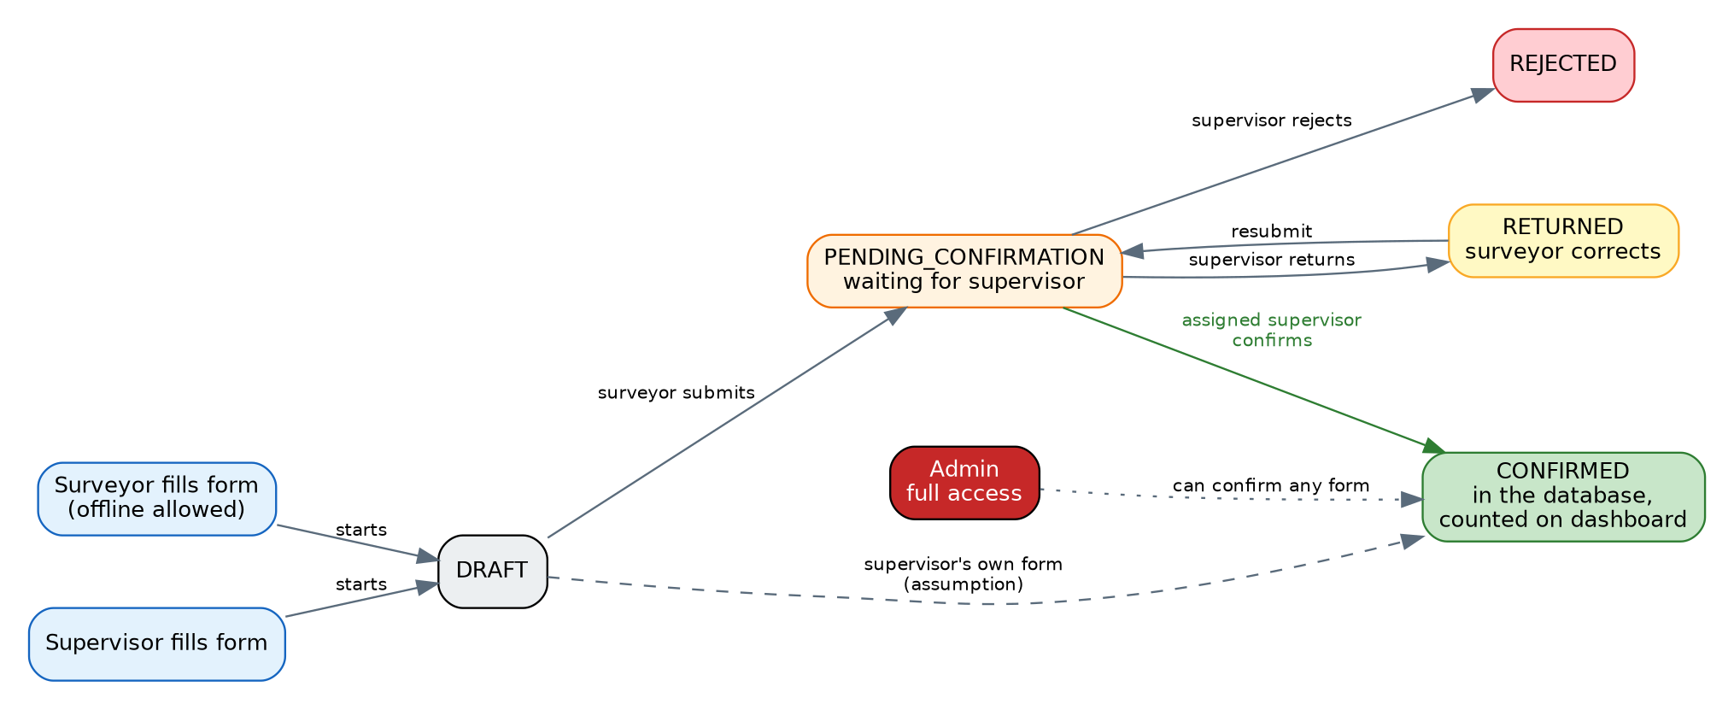
Fig. 1 Life of a survey form (status column in survey_responses)
The database enforces this: it refuses a confirmation made by a surveyor, by a supervisor who is not assigned to that surveyor, or with no confirmer recorded. Every submit, confirm, return and reject is written to unit_approval_log with who did it and when.

3. Which sections use dropdowns and which use text
This table counts the fields in each section by how they are filled in. Dropdown-heavy sections (for example G and E) need many reference lists. Text-heavy sections (for example A) need careful validation, such as phone and email format.
Section | DROP | SEARCH | MULTI | % | TABLE | Y/N | NUM | TEXT | AUTO | GPS | Total
A. Establishment Identity | 11 | 1 | - | - | - | 1 | 2 | 15 | 2 | 1 | 33
B. Operational Details | 2 | - | 1 | - | - | - | 2 | 1 | 2 | - | 8
C. Core & Secondary Activities | 4 | 1 | - | - | - | - | 4 | 3 | - | - | 12
D. Workforce | 1 | - | 1 | - | - | - | 4 | 2 | 1 | - | 9
E. Backward Linkages | 7 | 1 | 1 | 2 | - | 1 | 1 | 1 | - | - | 14
F. Forward Linkages | 6 | - | 2 | 2 | 2 | 1 | - | - | - | - | 13
G. Technology and Production Processes | 10 | - | 1 | 1 | 1 | - | 4 | 7 | - | - | 24
H. Energy and Waste Management | 5 | - | 3 | - | 2 | 1 | 6 | 3 | - | - | 20
I. Certifications and Compliances | - | - | - | - | 2 | - | 1 | - | - | - | 3
J. Strategic Business Plan | 3 | - | 2 | - | 2 | - | - | 1 | - | - | 8
K. Future Collaborations & Barriers | 2 | - | 1 | - | 1 | 1 | - | 1 | - | - | 6

Counting rule: each column of a section table counts as one field, and each multi-select, percentage or tick-box question counts as one field. Technical columns (IDs, timestamps) are not counted.

4. The big picture
The database has 13 groups of tables. Section tables (B to K) all attach to survey_responses, which is one survey visit to one establishment. Dropdown choices come from the questionnaire group.
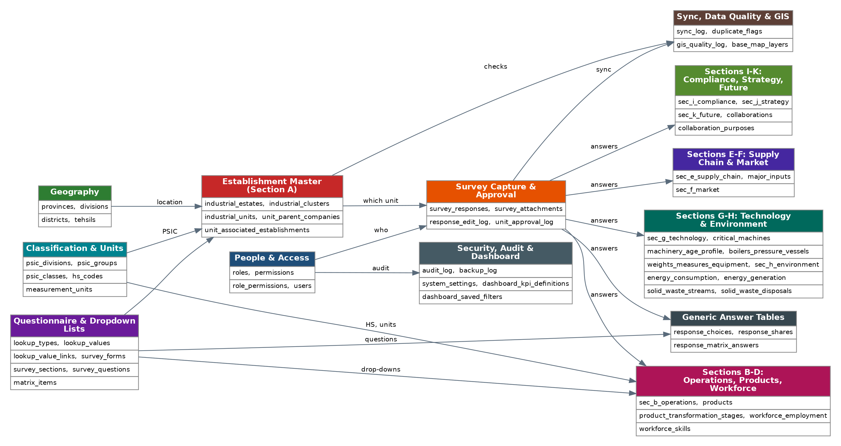
Fig. 2 Groups of tables and how they connect

5. Section-by-section ERD (A to K)
One diagram per section of your form. Each diagram shows the tables of that section, the tag for every field, the dropdown lists the field uses, and the shared tables that save multi-select, percentage and tick-box answers. The page after each diagram lists where every question is stored.

Section A: Establishment Identity
Fields: 15 TEXT | 2 NUM | 1 GPS | 2 AUTO | 11 DROP | 1 Y/N | 1 SEARCH
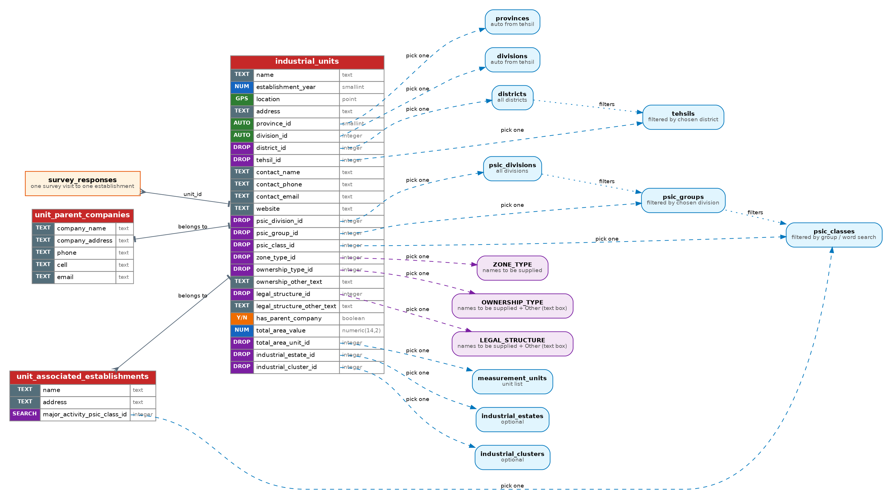

Section A: where each question is stored
No. | Question | Stored in
i | Name of establishment | industrial_units.name
ii | Year of establishment | industrial_units.establishment_year
iii | Coordinates (auto from device) | industrial_units.location, gps_accuracy_m
iv | Address | industrial_units.address
v | Location (district, tehsil) | industrial_units.district_id, tehsil_id (province and division filled automatically)
vi | Contact person, phone, email, website | industrial_units.contact_name, contact_phone, contact_email, website
vii | PSIC division / group / class | industrial_units.psic_division_id, psic_group_id, psic_class_id
viii | Zone type | industrial_units.zone_type_id (list ZONE_TYPE)
ix | Ownership of establishment | industrial_units.ownership_type_id, ownership_other_text
x | Legal structure of ownership | industrial_units.legal_structure_id, legal_structure_other_text
xi | Parent company details | industrial_units.has_parent_company + unit_parent_companies
xii | Establishments of the parent company | unit_associated_establishments (many rows)
xiii | Total establishment area | industrial_units.total_area_value, total_area_unit_id

Section B: Operational Details
Fields: 1 MULTI | 2 DROP | 1 TEXT | 2 NUM | 2 AUTO
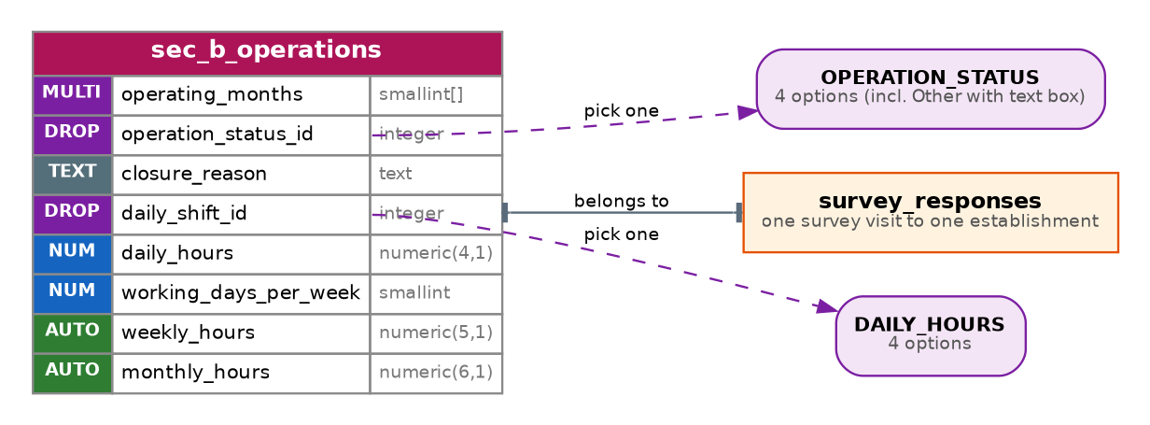

Section B: where each question is stored
No. | Question | Stored in
i | Operation months | sec_b_operations.operating_months
ii | Current operation status | sec_b_operations.operation_status_id, closure_reason
iii | Operational hours (daily, weekly, monthly) | sec_b_operations.daily_shift_id, daily_hours; weekly_hours and monthly_hours are calculated

Section C: Core & Secondary Activities
Fields: 3 TEXT | 4 NUM | 4 DROP | 1 SEARCH
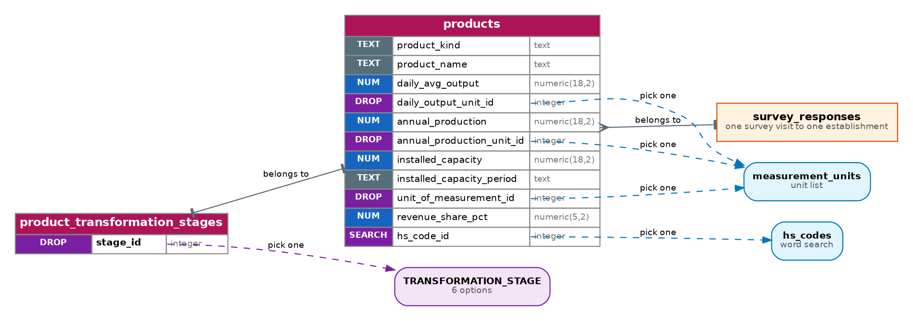

Section C: where each question is stored
No. | Question | Stored in
- | Main and secondary products (many) | products (product_kind = MAIN or SECONDARY, product_name)
i | Daily average output | products.daily_avg_output, daily_output_unit_id
ii | Annual total production | products.annual_production, annual_production_unit_id
iii | Installed capacity | products.installed_capacity, installed_capacity_period
iv | Unit of measurement | products.unit_of_measurement_id
v | Transformation stage on arrival (main only) | product_transformation_stages (one or more per product)
vi | % share in total revenue (main only) | products.revenue_share_pct
vii | HS code (main only) | products.hs_code_id

Section D: Workforce
Fields: 2 TEXT | 4 NUM | 1 AUTO | 1 DROP | 1 MULTI
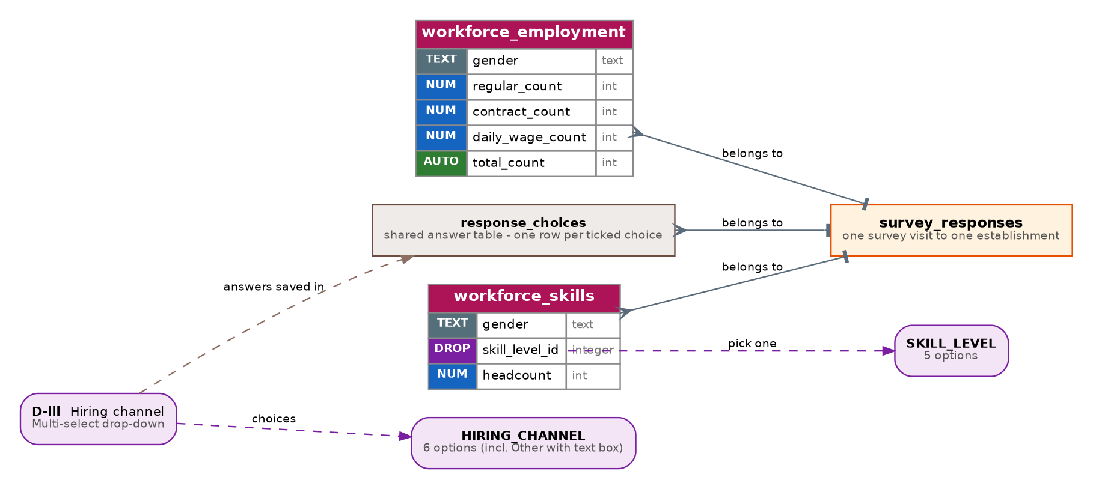

Section D: where each question is stored
No. | Question | Stored in
i | Employment details, last financial year | workforce_employment (one row per gender)
ii | Employment skill levels | workforce_skills (gender x skill level)
iii | Hiring channel | response_choices (question D_HIRING_CHANNEL)

Section E: Backward Linkages
Fields: 7 DROP | 1 Y/N | 1 TEXT | 1 NUM | 1 SEARCH | 1 MULTI | 2 %
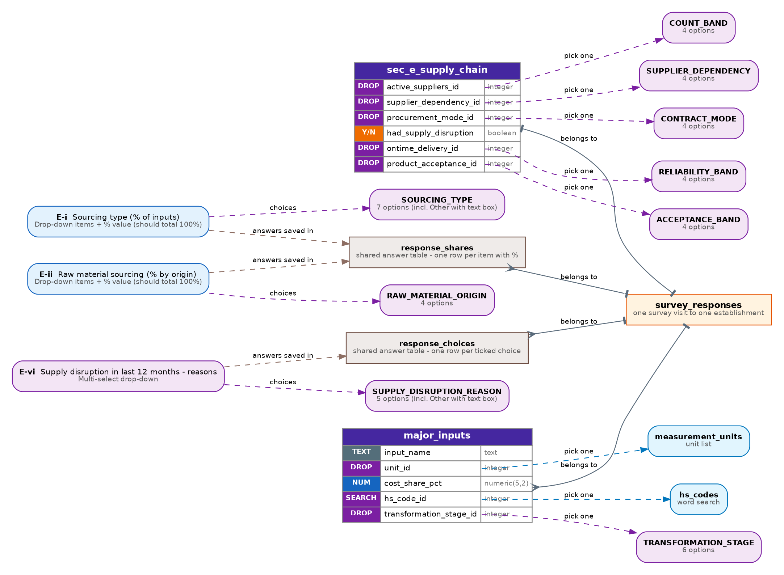

Section E: where each question is stored
No. | Question | Stored in
i | Sourcing type (%) | response_shares (E_SOURCING_TYPE)
ii | Raw material sourcing (%) | response_shares (E_RAW_MATERIAL_ORIGIN)
iii | Active suppliers | sec_e_supply_chain.active_suppliers_id
iv | Supplier dependency | sec_e_supply_chain.supplier_dependency_id
v | Mode of procurement | sec_e_supply_chain.procurement_mode_id
vi | Supply disruption (Yes/No + reasons) | sec_e_supply_chain.had_supply_disruption + response_choices (E_SUPPLY_DISRUPTION_REASON)
vii | On-time delivery reliability | sec_e_supply_chain.ontime_delivery_id
viii | Product acceptance rate | sec_e_supply_chain.product_acceptance_id
ix | Major inputs (many) | major_inputs

Section F: Forward Linkages
Fields: 6 DROP | 1 Y/N | 2 MULTI | 2 % | 2 TABLE
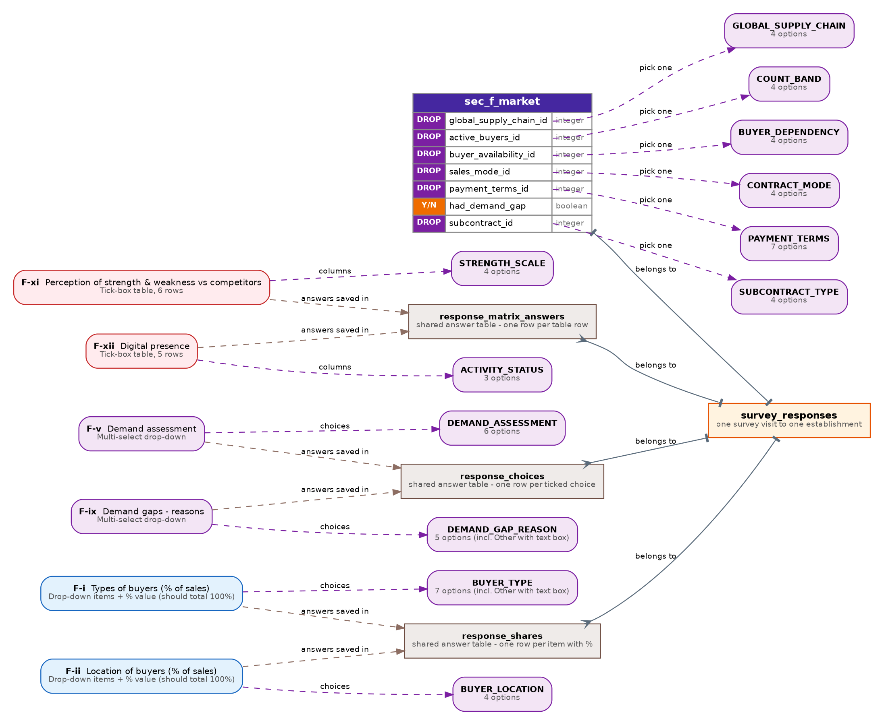

Section F: where each question is stored
No. | Question | Stored in
i | Types of buyers (%) | response_shares (F_BUYER_TYPE)
ii | Location of buyers (%) | response_shares (F_BUYER_LOCATION)
iii | Part of global supply chain | sec_f_market.global_supply_chain_id
iv | Active buyers | sec_f_market.active_buyers_id
v | Demand assessment | response_choices (F_DEMAND_ASSESSMENT)
vi | Buyer availability | sec_f_market.buyer_availability_id
vii | Mode of sale | sec_f_market.sales_mode_id
viii | Payment terms | sec_f_market.payment_terms_id
ix | Demand gaps (Yes/No + reasons) | sec_f_market.had_demand_gap + response_choices (F_DEMAND_GAP_REASON)
x | Subcontract opportunities | sec_f_market.subcontract_id
xi | Strength and weakness vs competitors | response_matrix_answers (F_STRENGTH_VS_COMPETITORS)
xii | Digital presence | response_matrix_answers (F_DIGITAL_PRESENCE)

Section G: Technology and Production Processes
Fields: 7 TEXT | 10 DROP | 4 NUM | 1 MULTI | 1 % | 1 TABLE
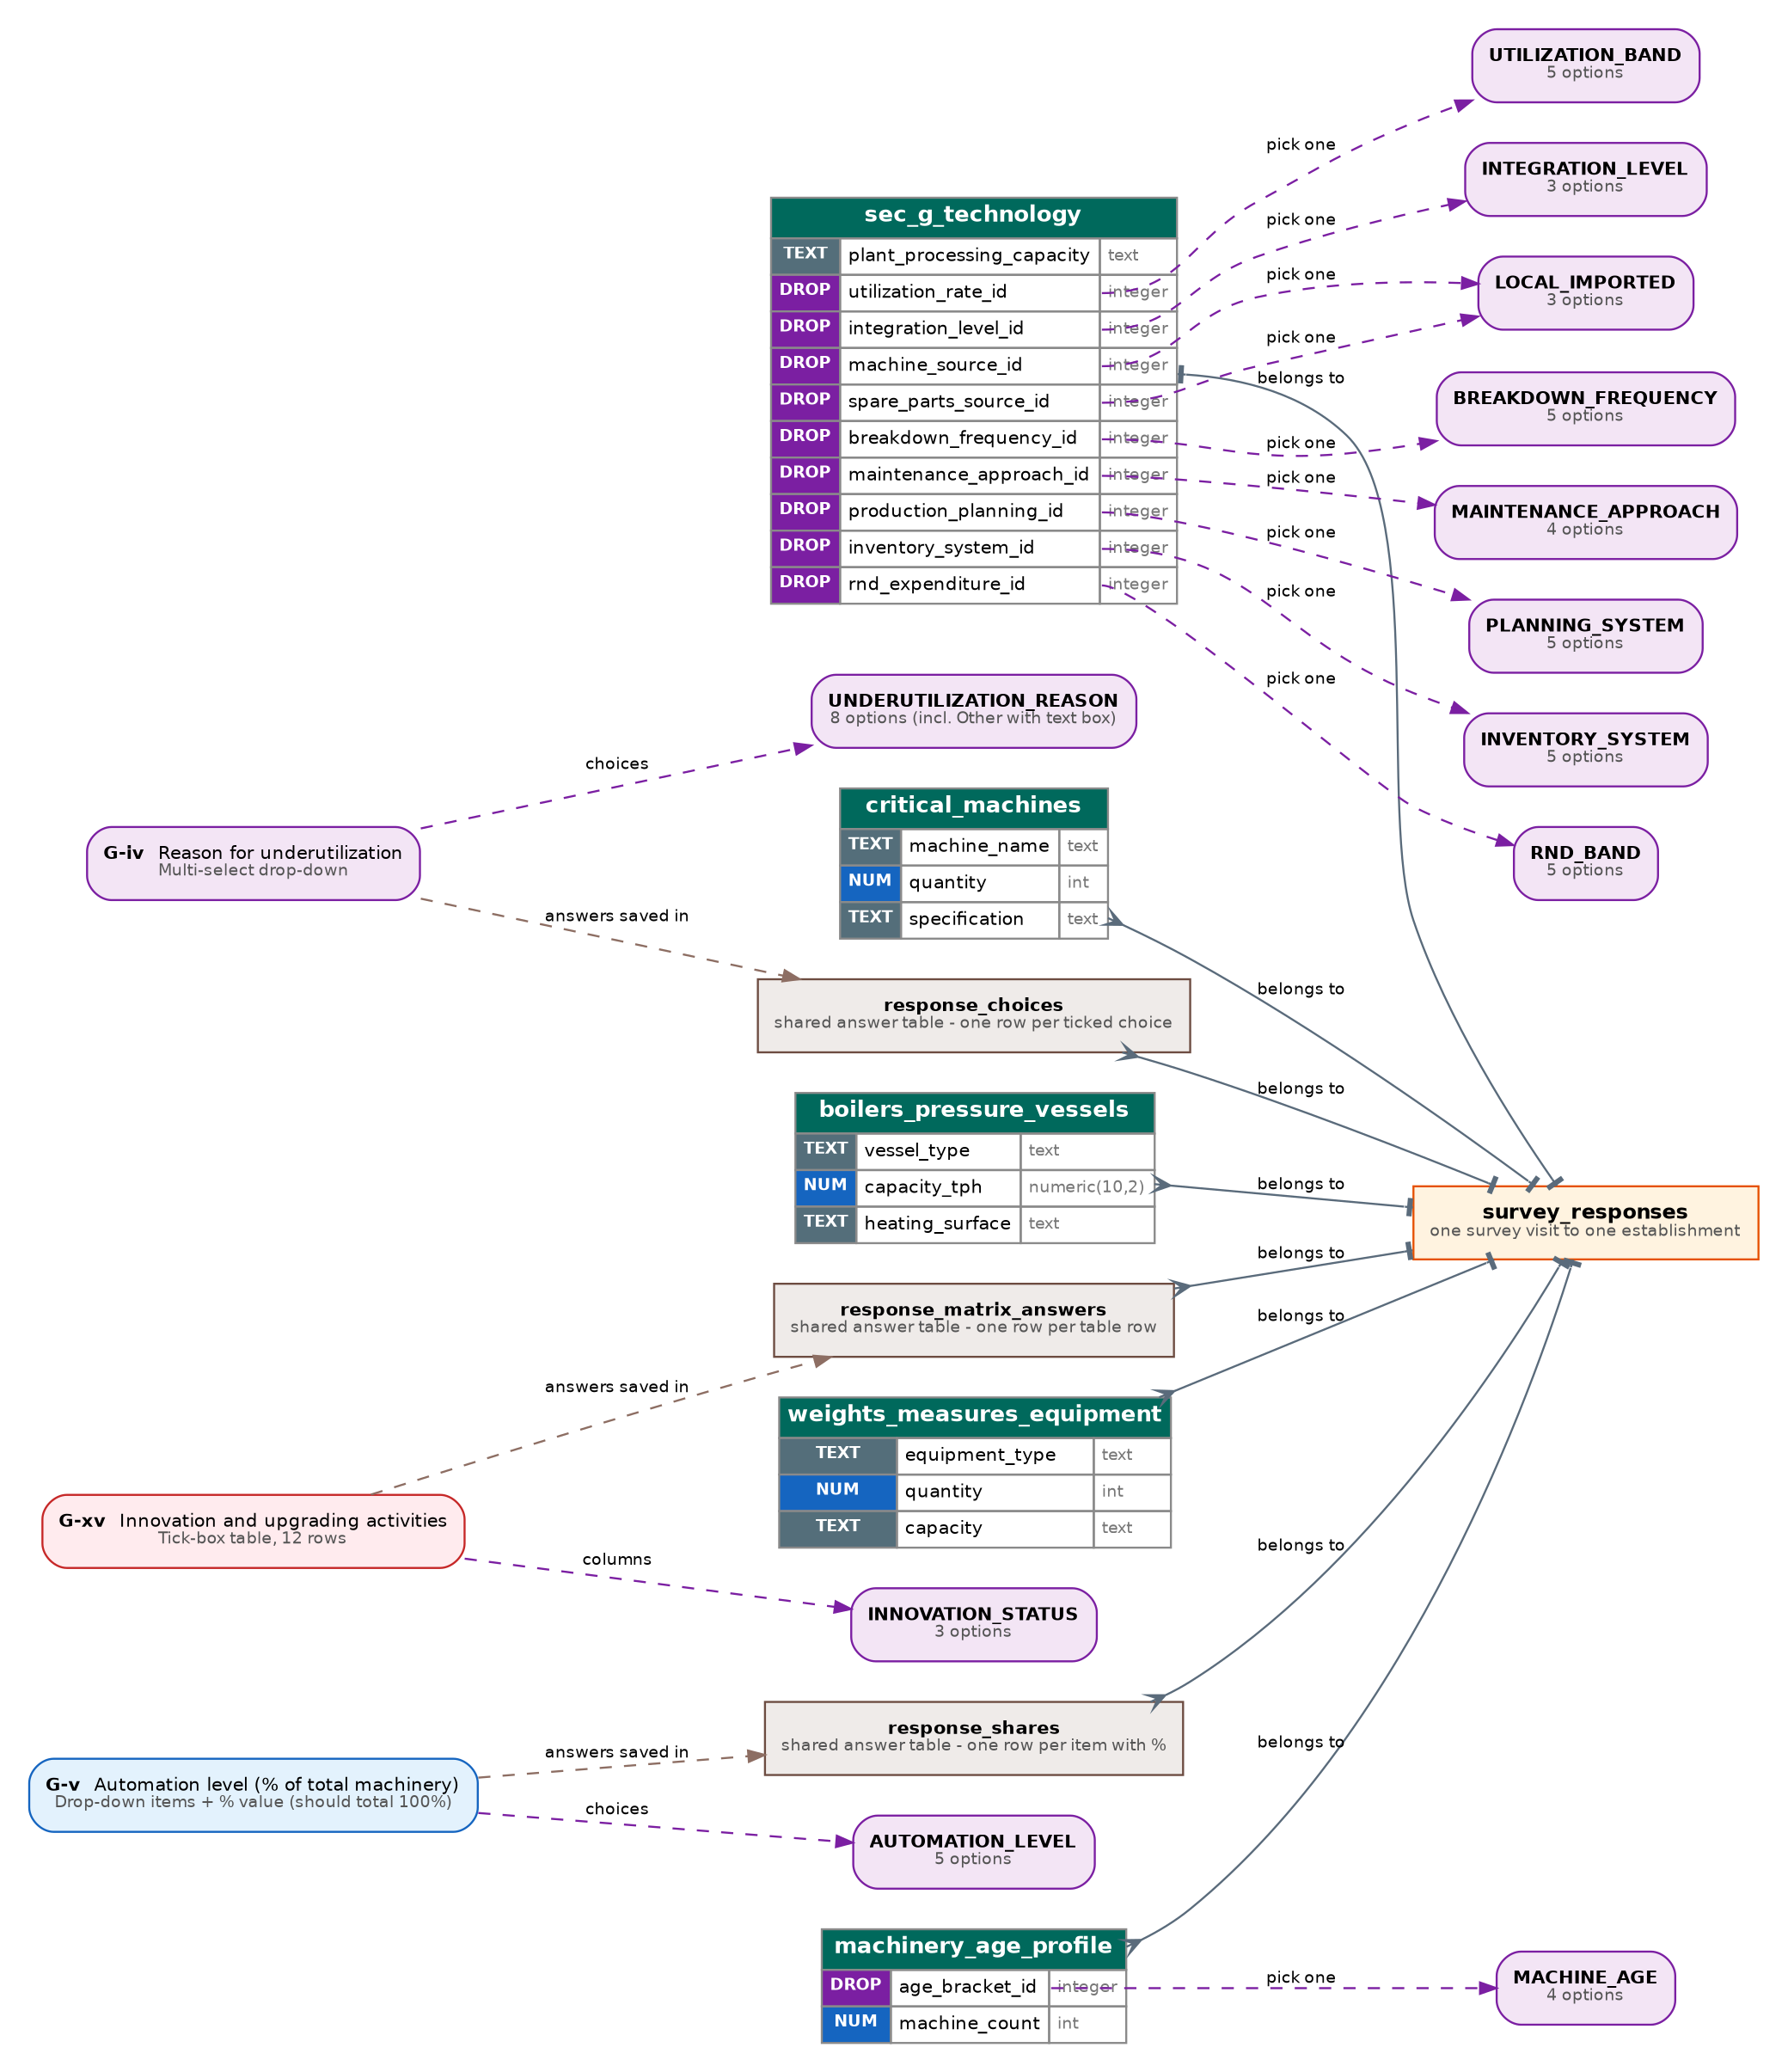

Section G: where each question is stored
No. | Question | Stored in
i | Capacity of plant: critical machines (many) | critical_machines
ii | Plant processing capacity | sec_g_technology.plant_processing_capacity
iii | Capacity utilization rate | sec_g_technology.utilization_rate_id
iv | Reason for underutilization | response_choices (G_UNDERUTILIZATION_REASON)
v | Automation level (% of machinery) | response_shares (G_AUTOMATION_LEVEL)
vi | Level of integration between machines | sec_g_technology.integration_level_id
vii | Machine and spare-parts source | sec_g_technology.machine_source_id, spare_parts_source_id
viii | Machinery age profile | machinery_age_profile
ix | Frequency of machinery breakdown | sec_g_technology.breakdown_frequency_id
x | Maintenance approach | sec_g_technology.maintenance_approach_id
xi | Boilers and pressure vessels (many) | boilers_pressure_vessels
xii | Weights and measures equipment (many) | weights_measures_equipment
xiii | Production planning system | sec_g_technology.production_planning_id
xiv | Inventory management | sec_g_technology.inventory_system_id
xv | Innovation and upgrading activities | response_matrix_answers (G_INNOVATION)
xvi | R&D expenditure | sec_g_technology.rnd_expenditure_id

Section H: Energy and Waste Management
Fields: 6 NUM | 5 DROP | 3 TEXT | 1 Y/N | 3 MULTI | 2 TABLE
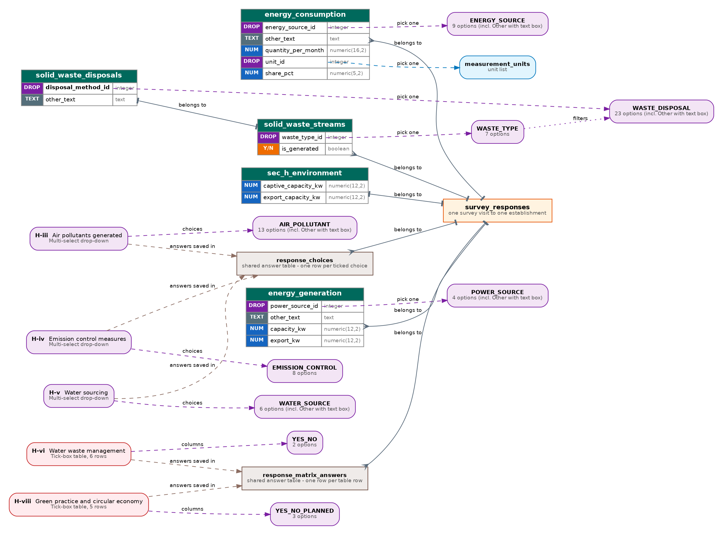

Section H: where each question is stored
No. | Question | Stored in
i | Energy consumption | energy_consumption (one row per source)
ii | Energy generation | energy_generation + sec_h_environment (captive and export capacity)
iii | Air pollutants generated | response_choices (H_AIR_POLLUTANT)
iv | Emission control measures | response_choices (H_EMISSION_CONTROL)
v | Water sourcing | response_choices (H_WATER_SOURCE)
vi | Water waste management (Yes/No) | response_matrix_answers (H_WATER_WASTE_DISPOSAL)
vii | Solid waste and by-products | solid_waste_streams + solid_waste_disposals
viii | Green practice and circular economy | response_matrix_answers (H_GREEN_PRACTICES)

Section I: Certifications and Compliances
Fields: 1 NUM | 2 TABLE
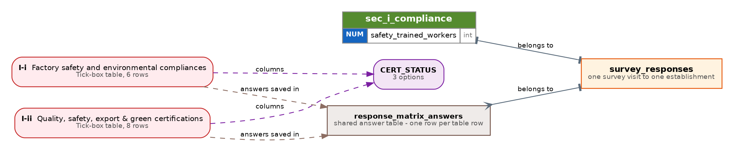

Section I: where each question is stored
No. | Question | Stored in
i | Factory safety and environmental compliances | response_matrix_answers (I_COMPLIANCE_PERMITS)
ii | Quality, safety, export and green certifications | response_matrix_answers (I_CERTIFICATIONS)
iii | Worker safety training | sec_i_compliance.safety_trained_workers

Section J: Strategic Business Plan
Fields: 3 DROP | 1 TEXT | 2 MULTI | 2 TABLE
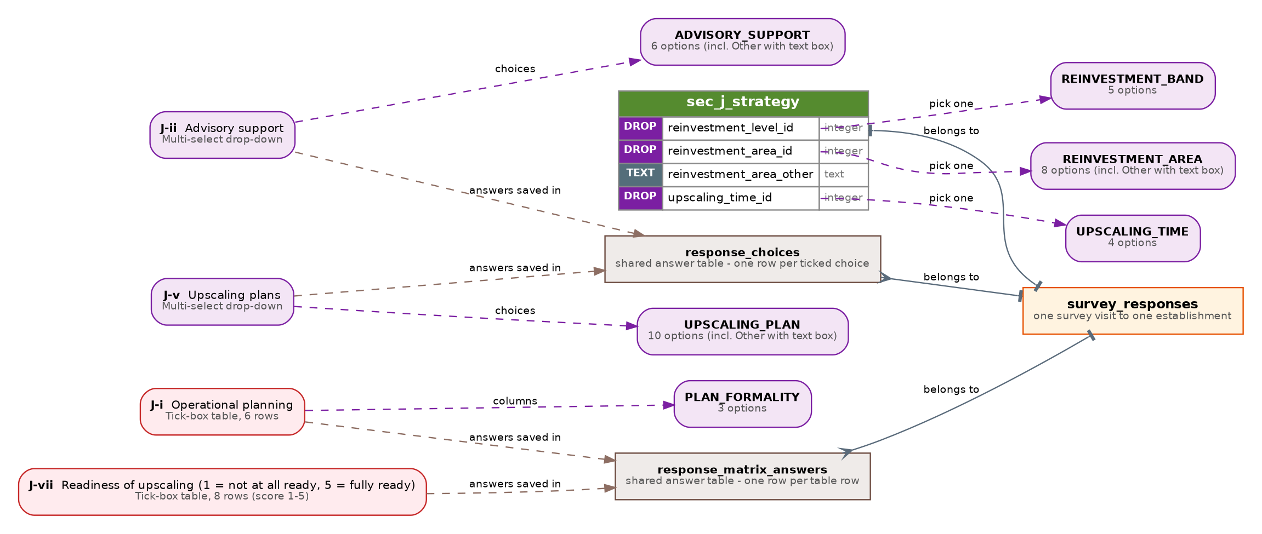

Section J: where each question is stored
No. | Question | Stored in
i | Operational planning | response_matrix_answers (J_PLANNING_AREAS)
ii | Advisory support | response_choices (J_ADVISORY_SUPPORT)
iii | Reinvestment strategy | sec_j_strategy.reinvestment_level_id
iv | Primary area of reinvestment | sec_j_strategy.reinvestment_area_id, reinvestment_area_other
v | Upscaling plans | response_choices (J_UPSCALING_PLAN)
vi | Upscaling time | sec_j_strategy.upscaling_time_id
vii | Readiness of upscaling (1 to 5) | response_matrix_answers (J_UPSCALING_READINESS)

Section K: Future Collaborations & Barriers
Fields: 1 Y/N | 1 TEXT | 2 DROP | 1 MULTI | 1 TABLE
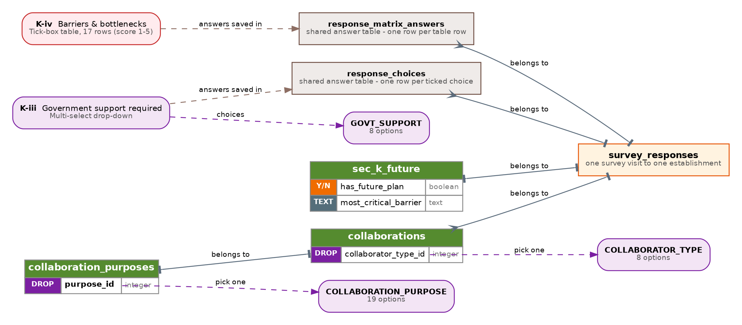

Section K: where each question is stored
No. | Question | Stored in
i | Do they have a future plan? (Yes/No) | sec_k_future.has_future_plan
ii | Future opportunities: collaborator and purpose | collaborations + collaboration_purposes
iii | Government support required | response_choices (K_GOVT_SUPPORT)
iv | Barriers and bottlenecks (1 to 5) | response_matrix_answers (K_BARRIERS)
v | Single most critical barrier | sec_k_future.most_critical_barrier

6. Supporting diagrams

Reference data
Area hierarchy and PSIC classification. These fill the cascading dropdowns in Section A.
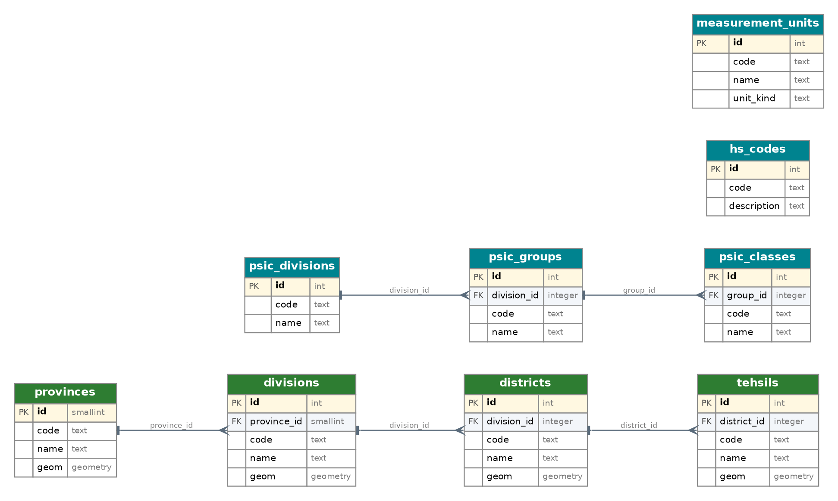

Questionnaire engine and dropdown lists
How dropdown lists, questions and the three shared answer tables fit together.
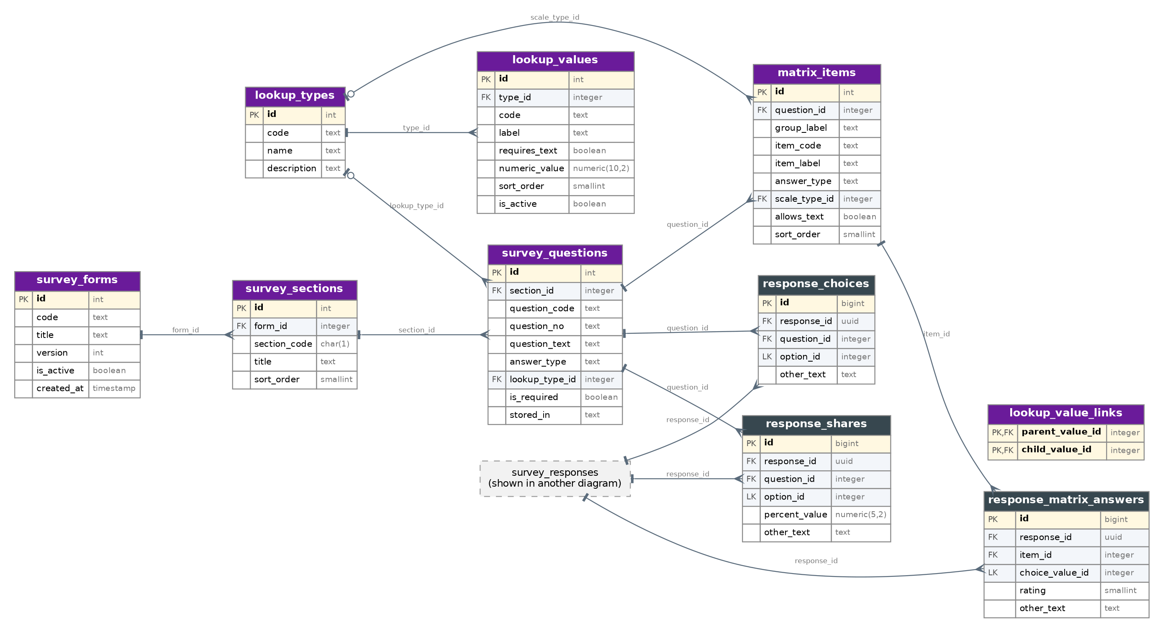

Survey capture and approval
One row per survey visit, edit history and the approval workflow.
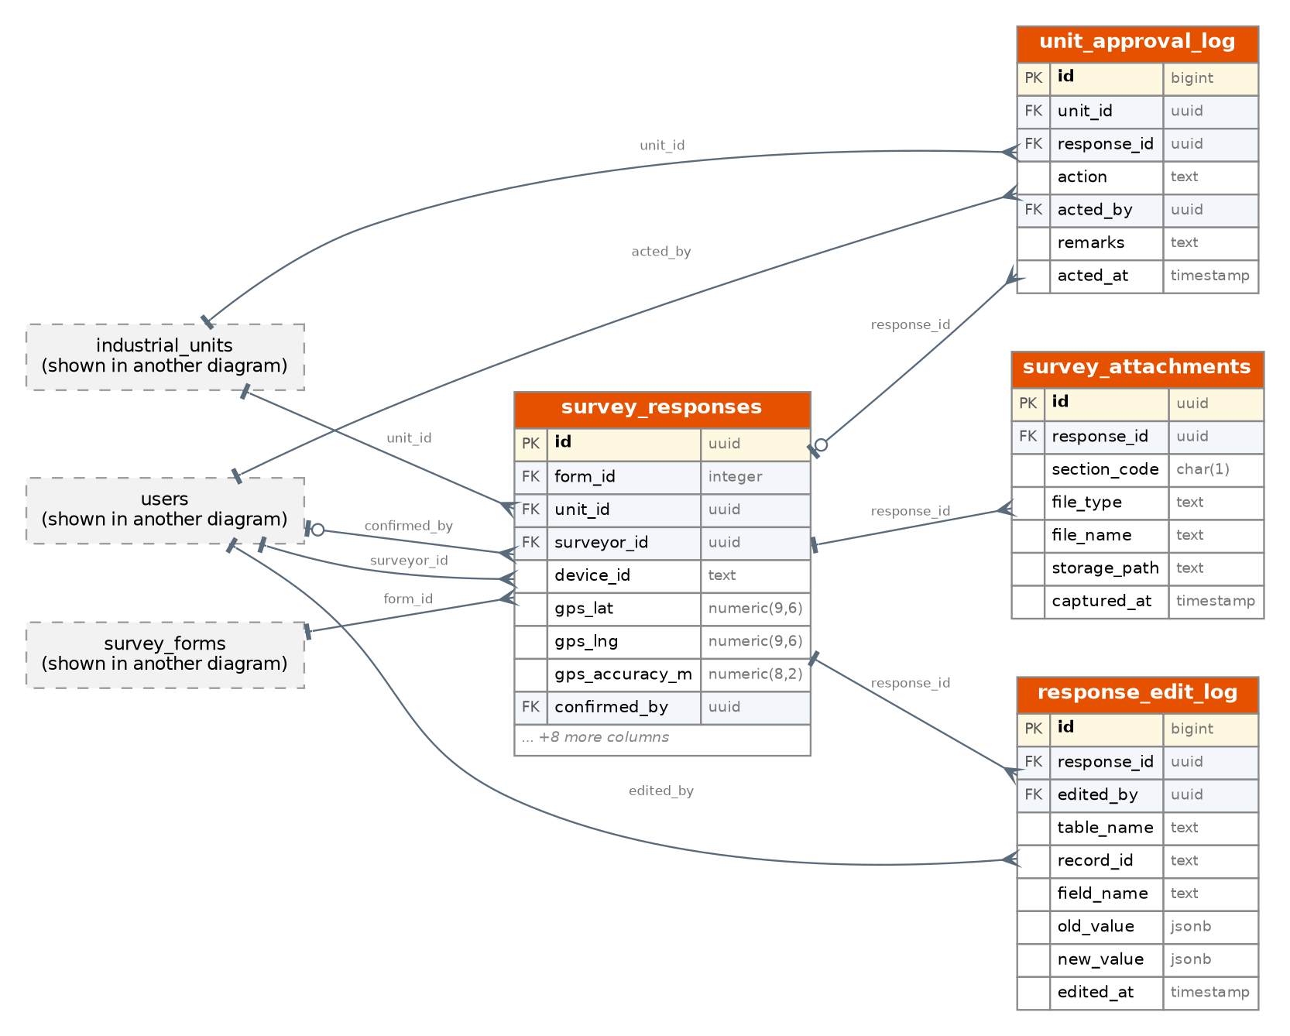

People, security and dashboard
Three roles, permissions, audit and dashboard tables.
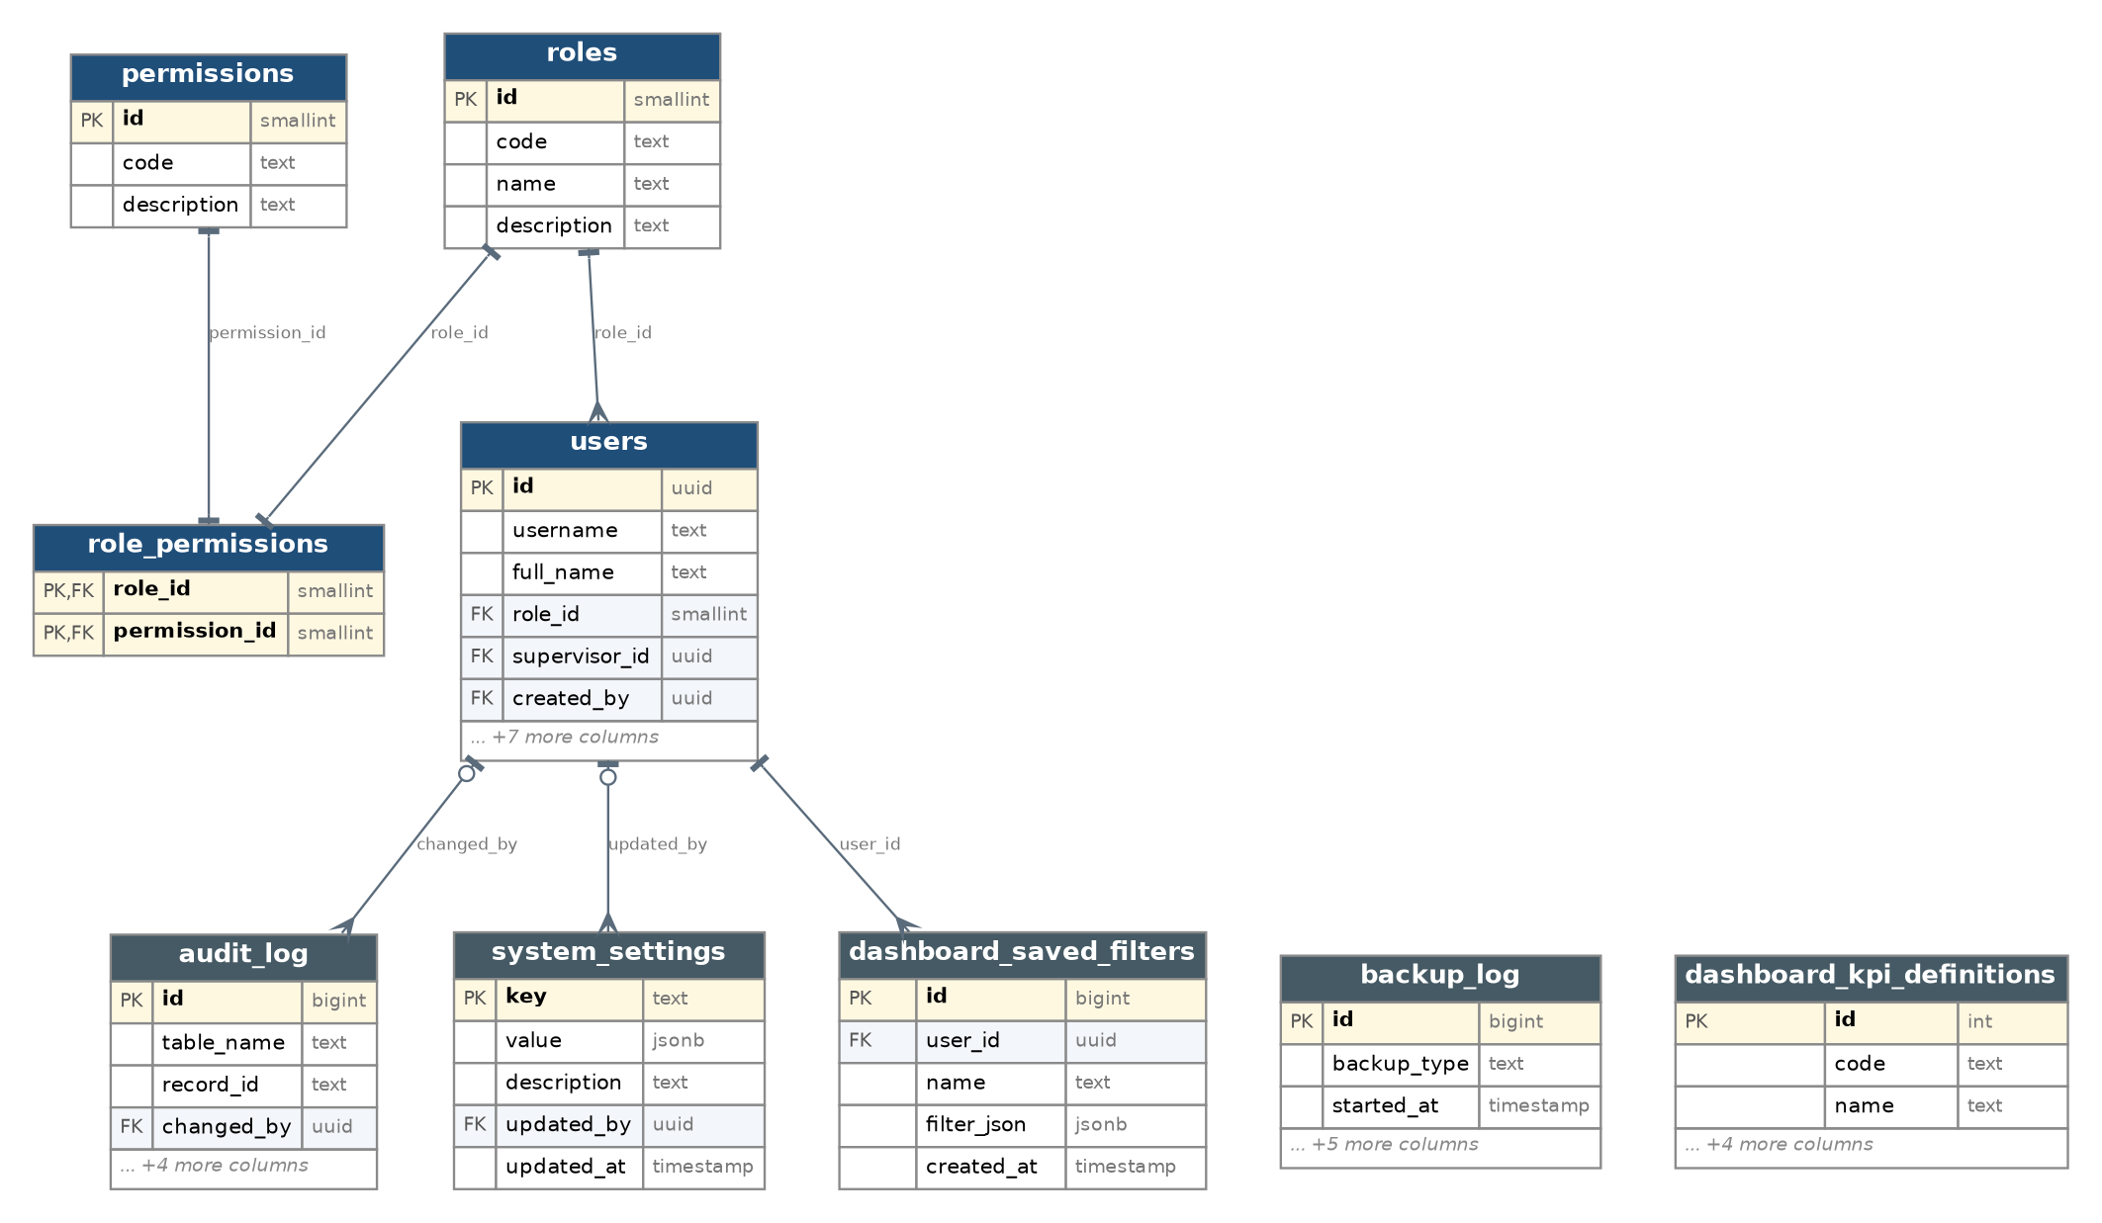

Offline sync and data quality
Sync sessions, suspected duplicates and map checks.
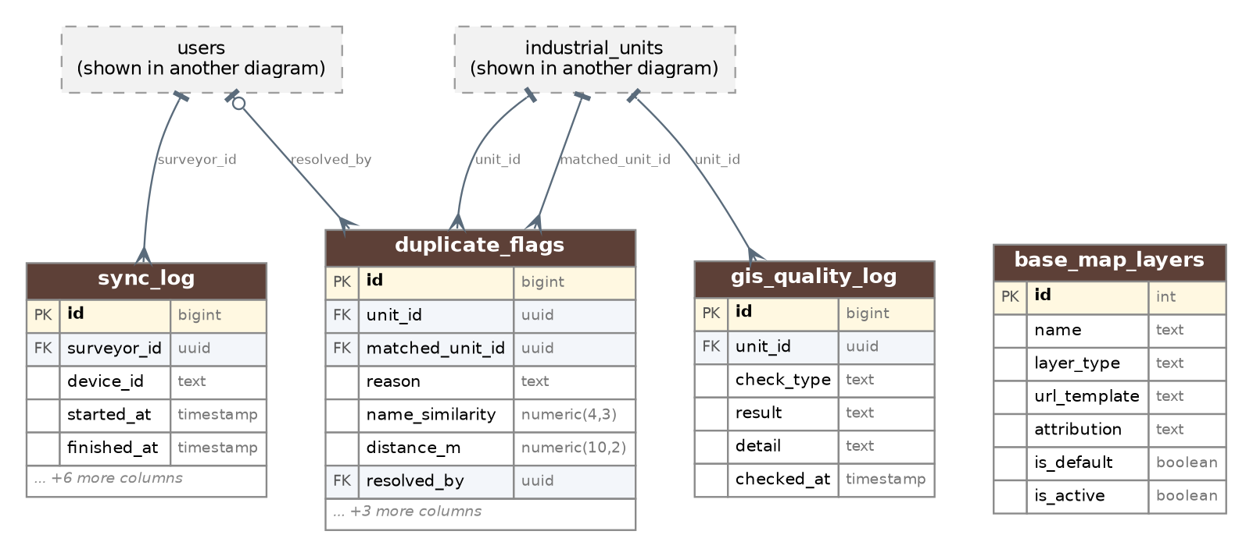

7. Database schema: every table and field
Tag = how the field is filled in (see the key on the first page). 'Rules' lists primary keys, links to other tables, required fields, defaults and allowed values.

M1. People & Access

roles
The three app roles: ADMIN, SUPERVISOR, SURVEYOR.
Tag | Field | Type | Rules | Note
TEXT | id | smallint (auto) | Primary key | Auto number
TEXT | code | varchar(30) | Required; Unique | ADMIN / SUPERVISOR / SURVEYOR
TEXT | name | varchar(60) | Required | Display name
TEXT | description | text |  | What this role may do

permissions
Small, separate rights (e.g. USER_CREATE, SURVEY_APPROVE).
Tag | Field | Type | Rules | Note
TEXT | id | smallint (auto) | Primary key
TEXT | code | varchar(60) | Required; Unique | Right code
TEXT | description | text

role_permissions
Which role holds which right (many-to-many link).
Tag | Field | Type | Rules | Note
DROP | role_id | smallint | Primary key; Links to roles
DROP | permission_id | smallint | Primary key; Links to permissions

users
Every person who can log in: admins, supervisors and surveyors.
Tag | Field | Type | Rules | Note
TEXT | id | uuid | Primary key; Default: gen_random_uuid()
TEXT | username | varchar(50) | Required; Unique | Login name
TEXT | full_name | varchar(120) | Required
TEXT | designation | varchar(80) |  | Job title, assigned by the Admin
TEXT | email | varchar(120) | Unique
TEXT | phone | varchar(20)
TEXT | password_hash | text | Required | Never store the real password
DROP | role_id | smallint | Links to roles; Required
DROP | supervisor_id | uuid | Links to users | For a surveyor: the supervisor who confirms their forms (assigned by Admin)
Y/N | is_active | boolean | Required; Default: true | Admin 'removes' a user by setting this to false (history is kept)
DROP | created_by | uuid | Links to users | Admin who added this user
TEXT | created_at | timestamptz | Required; Default: now()
TEXT | deactivated_at | timestamptz

M2. Geography

provinces
Top level of the area hierarchy.
Tag | Field | Type | Rules | Note
TEXT | id | smallint (auto) | Primary key
TEXT | code | varchar(10) | Required; Unique
TEXT | name | varchar(80) | Required
GPS | geom | geometry(MultiPolygon,4326) |  | Province boundary

divisions
Second level (e.g. Lahore Division).
Tag | Field | Type | Rules | Note
TEXT | id | integer (auto) | Primary key
DROP | province_id | smallint | Links to provinces; Required
TEXT | code | varchar(10) | Required; Unique
TEXT | name | varchar(80) | Required
GPS | geom | geometry(MultiPolygon,4326)

districts
Third level. Drop-down in Section A-v.
Tag | Field | Type | Rules | Note
TEXT | id | integer (auto) | Primary key
DROP | division_id | integer | Links to divisions; Required
TEXT | code | varchar(10) | Required; Unique
TEXT | name | varchar(80) | Required
GPS | geom | geometry(MultiPolygon,4326)

tehsils
Fourth level. Filtered by the chosen district.
Tag | Field | Type | Rules | Note
TEXT | id | integer (auto) | Primary key
DROP | district_id | integer | Links to districts; Required
TEXT | code | varchar(10) | Required; Unique
TEXT | name | varchar(80) | Required
GPS | geom | geometry(MultiPolygon,4326)
Rule: Each combination of district_id + name can appear only once.

M3. Classification & Units

psic_divisions
PSIC level 1: Division (Section A-vii).
Tag | Field | Type | Rules | Note
TEXT | id | integer (auto) | Primary key
TEXT | code | varchar(10) | Required; Unique
TEXT | name | text | Required

psic_groups
PSIC level 2: Group. Filtered by division.
Tag | Field | Type | Rules | Note
TEXT | id | integer (auto) | Primary key
DROP | division_id | integer | Links to psic_divisions; Required
TEXT | code | varchar(10) | Required; Unique
TEXT | name | text | Required

psic_classes
PSIC level 3: Class. Filtered by group. Also searched by word in A-xii.
Tag | Field | Type | Rules | Note
TEXT | id | integer (auto) | Primary key
DROP | group_id | integer | Links to psic_groups; Required
TEXT | code | varchar(10) | Required; Unique
TEXT | name | text | Required | Word search is supported

hs_codes
Harmonized System product codes (Sections C-vii and E-ix).
Tag | Field | Type | Rules | Note
TEXT | id | integer (auto) | Primary key
TEXT | code | varchar(12) | Required; Unique
TEXT | description | text | Required | Word search is supported

measurement_units
All units used in the survey (area, quantity, energy, power).
Tag | Field | Type | Rules | Note
TEXT | id | integer (auto) | Primary key
TEXT | code | varchar(20) | Required; Unique | e.g. SQM, HECTARE, KW
TEXT | name | varchar(60) | Required
TEXT | unit_kind | varchar(20) | Required; Allowed: AREA, QUANTITY, ENERGY, POWER, OTHER

M4. Questionnaire & Dropdown Lists

lookup_types
One row per drop-down list (e.g. OWNERSHIP_TYPE).
Tag | Field | Type | Rules | Note
TEXT | id | integer (auto) | Primary key
TEXT | code | varchar(50) | Required; Unique
TEXT | name | varchar(100) | Required
TEXT | description | text

lookup_values
The choices inside each drop-down list.
Tag | Field | Type | Rules | Note
TEXT | id | integer (auto) | Primary key
DROP | type_id | integer | Links to lookup_types; Required | Which list this choice belongs to
TEXT | code | varchar(60) | Required | Stable code used by the app
TEXT | label | text | Required | Text the surveyor sees
Y/N | requires_text | boolean | Required; Default: false | True for 'Other - specify' style choices
NUM | numeric_value | numeric(10,2) |  | Optional number behind a choice (e.g. 16 hours)
NUM | sort_order | smallint | Required; Default: 0
Y/N | is_active | boolean | Required; Default: true
Rule: Each combination of type_id + code can appear only once.

lookup_value_links
Allowed-choice filters: which child choices appear after a parent choice (waste type -> disposal methods, collaborator -> purposes).
Tag | Field | Type | Rules | Note
DROP | parent_value_id | integer | Primary key; Links to lookup_values
DROP | child_value_id | integer | Primary key; Links to lookup_values

survey_forms
A versioned survey form. A new round = new row, no app redeploy.
Tag | Field | Type | Rules | Note
TEXT | id | integer (auto) | Primary key
TEXT | code | varchar(40) | Required
TEXT | title | text | Required
NUM | version | int | Required; Default: 1
Y/N | is_active | boolean | Required; Default: true
TEXT | created_at | timestamptz | Required; Default: now()
Rule: Each combination of code + version can appear only once.

survey_sections
Sections A to K of a form.
Tag | Field | Type | Rules | Note
TEXT | id | integer (auto) | Primary key
DROP | form_id | integer | Links to survey_forms; Required
TEXT | section_code | char(1) | Required | A to K
TEXT | title | text | Required
NUM | sort_order | smallint | Required; Default: 0
Rule: Each combination of form_id + section_code can appear only once.

survey_questions
Question register. Every question stored in a generic table (choices, shares, matrix) must be listed here.
Tag | Field | Type | Rules | Note
TEXT | id | integer (auto) | Primary key
DROP | section_id | integer | Links to survey_sections; Required
TEXT | question_code | varchar(60) | Required; Unique | e.g. H_AIR_POLLUTANT
TEXT | question_no | varchar(10) |  | i, ii, iii ... as printed on the form
TEXT | question_text | text | Required
TEXT | answer_type | varchar(20) | Required; Allowed: TEXT, NUMBER, YES_NO, SINGLE_CHOICE, MULTI_CHOICE, SHARE_PERCENT, MATRIX, REPEATING_GROUP
DROP | lookup_type_id | integer | Links to lookup_types | Which drop-down list this question uses
Y/N | is_required | boolean | Required; Default: false
TEXT | stored_in | varchar(80) |  | Table.column where the answer lands (documentation)

matrix_items
Rows of tick-box tables (e.g. each innovation activity, each barrier).
Tag | Field | Type | Rules | Note
TEXT | id | integer (auto) | Primary key
DROP | question_id | integer | Links to survey_questions; Required | The matrix question this row belongs to
TEXT | group_label | varchar(100) |  | Heading above the row (e.g. 'Market & Demand')
TEXT | item_code | varchar(60) | Required
TEXT | item_label | text | Required | Row text shown to the surveyor
TEXT | answer_type | varchar(15) | Required; Allowed: CHOICE, RATING_1_5 | Tick one choice, or score 1 to 5
DROP | scale_type_id | integer | Links to lookup_types | Choice list used when answer_type = CHOICE
Y/N | allows_text | boolean | Required; Default: false | Row has a 'specify' box
NUM | sort_order | smallint | Required; Default: 0
Rule: Each combination of question_id + item_code can appear only once.

M5. Establishment Master (Section A)

industrial_estates
Industrial estates / special zones (optional link from a unit).
Tag | Field | Type | Rules | Note
TEXT | id | integer (auto) | Primary key
TEXT | name | text | Required
DROP | district_id | integer | Links to districts
GPS | geom | geometry(MultiPolygon,4326) |  | Estate boundary

industrial_clusters
Clusters of similar factories (used for cluster-wise dashboard).
Tag | Field | Type | Rules | Note
TEXT | id | integer (auto) | Primary key
TEXT | name | text | Required
DROP | district_id | integer | Links to districts
GPS | geom | geometry(MultiPolygon,4326) |  | Cluster boundary

industrial_units
Master list of establishments. All of Section A lives here.
Tag | Field | Type | Rules | Note
TEXT | id | uuid | Primary key; Default: gen_random_uuid() | Created on the phone when offline
TEXT | unit_code | varchar(30) | Unique | Readable code, e.g. PK-PB-LHR-00001 (given by server after sync)
TEXT | name | text | Required | A-i Name of establishment
NUM | establishment_year | smallint | Range 1800 to 2100 | A-ii Year of establishment
GPS | location | geometry(Point,4326) |  | A-iii Coordinates (auto from device)
NUM | gps_accuracy_m | numeric(8,2) |  | GPS accuracy in metres
TEXT | address | text |  | A-iv
AUTO | province_id | smallint | Links to provinces; Required | A-v Location (filled from district)
AUTO | division_id | integer | Links to divisions; Required
DROP | district_id | integer | Links to districts; Required | A-v District
DROP | tehsil_id | integer | Links to tehsils; Required | A-v Tehsil
TEXT | contact_name | varchar(120) |  | A-vi Contact person
TEXT | contact_phone | varchar(20)
TEXT | contact_email | varchar(120)
TEXT | website | varchar(200)
DROP | psic_division_id | integer | Links to psic_divisions | A-vii PSIC Division
DROP | psic_group_id | integer | Links to psic_groups | A-vii PSIC Group
DROP | psic_class_id | integer | Links to psic_classes | A-vii PSIC Class
DROP | zone_type_id | integer | Links to lookup_values | A-viii List: ZONE_TYPE (6 zones)
DROP | ownership_type_id | integer | Links to lookup_values | A-ix List: OWNERSHIP_TYPE
TEXT | ownership_other_text | text |  | Filled only when 'Other' is chosen
DROP | legal_structure_id | integer | Links to lookup_values | A-x List: LEGAL_STRUCTURE
TEXT | legal_structure_other_text | text |  | Filled only when 'Other' is chosen
Y/N | has_parent_company | boolean |  | A-xi Yes / No
NUM | total_area_value | numeric(14,2) |  | A-xiii Total area
DROP | total_area_unit_id | integer | Links to measurement_units | A-xiii Unit (square metre / hectare)
DROP | industrial_estate_id | integer | Links to industrial_estates | Optional
DROP | industrial_cluster_id | integer | Links to industrial_clusters | Optional
TEXT | approval_status | varchar(20) | Required; Default: PENDING; Allowed: PENDING, CONFIRMED, RETURNED, REJECTED | PENDING until a supervisor confirms; only CONFIRMED units count on the dashboard
DROP | created_by | uuid | Links to users
TEXT | created_at | timestamptz | Required; Default: now()
TEXT | updated_at | timestamptz | Required; Default: now()

unit_parent_companies
Parent company details (A-xi) - only when has_parent_company = Yes.
Tag | Field | Type | Rules | Note
DROP | unit_id | uuid | Primary key; Links to industrial_units | One parent company per unit
TEXT | company_name | text | Required
TEXT | company_address | text
TEXT | phone | varchar(20)
TEXT | cell | varchar(20)
TEXT | email | varchar(120)

unit_associated_establishments
Other establishments of the same parent company (A-xii). Repeating rows.
Tag | Field | Type | Rules | Note
TEXT | id | bigint (auto) | Primary key
DROP | unit_id | uuid | Links to industrial_units; Required
TEXT | name | text | Required
TEXT | address | text
SEARCH | major_activity_psic_class_id | integer | Links to psic_classes | Chosen by word search; PSIC code comes from the class

M6. Survey Capture & Approval

survey_responses
One survey visit to one establishment. Hub table: every section hangs off this.
Tag | Field | Type | Rules | Note
TEXT | id | uuid | Primary key | Made on the phone the moment a survey starts (no clashes when offline)
DROP | form_id | integer | Links to survey_forms; Required
DROP | unit_id | uuid | Links to industrial_units; Required
DROP | surveyor_id | uuid | Links to users; Required | Who collected the data
TEXT | device_id | varchar(100)
NUM | gps_lat | numeric(9,6)
NUM | gps_lng | numeric(9,6)
NUM | gps_accuracy_m | numeric(8,2)
TEXT | status | varchar(25) | Required; Default: DRAFT; Allowed: DRAFT, PENDING_CONFIRMATION, CONFIRMED, RETURNED, REJECTED | DRAFT > PENDING_CONFIRMATION > CONFIRMED (in the database). Supervisor may also RETURN or REJECT.
TEXT | sync_status | varchar(20) | Required; Default: PENDING; Allowed: PENDING, SYNCED, REJECTED, DUPLICATE | Result of the last sync attempt
TEXT | started_at | timestamptz | Required
TEXT | completed_at | timestamptz
TEXT | submitted_at | timestamptz |  | Sent to supervisor for confirmation
DROP | confirmed_by | uuid | Links to users | Supervisor (or Admin) who confirmed it
TEXT | confirmed_at | timestamptz
TEXT | synced_at | timestamptz
TEXT | app_version | varchar(20)

survey_attachments
Photos or files taken during a survey.
Tag | Field | Type | Rules | Note
TEXT | id | uuid | Primary key; Default: gen_random_uuid()
DROP | response_id | uuid | Links to survey_responses; Required
TEXT | section_code | char(1) |  | Which section it belongs to
TEXT | file_type | varchar(20)
TEXT | file_name | text
TEXT | storage_path | text | Required
TEXT | captured_at | timestamptz

response_edit_log
Before/after record of every correction to a survey.
Tag | Field | Type | Rules | Note
TEXT | id | bigint (auto) | Primary key
DROP | response_id | uuid | Links to survey_responses; Required
DROP | edited_by | uuid | Links to users; Required
TEXT | table_name | varchar(60) | Required
TEXT | record_id | text
TEXT | field_name | varchar(80)
TEXT | old_value | jsonb
TEXT | new_value | jsonb
TEXT | edited_at | timestamptz | Required; Default: now()

unit_approval_log
Submit / confirm / return / reject history (supervisor workflow).
Tag | Field | Type | Rules | Note
TEXT | id | bigint (auto) | Primary key
DROP | unit_id | uuid | Links to industrial_units; Required
DROP | response_id | uuid | Links to survey_responses
TEXT | action | varchar(25) | Required; Allowed: SUBMITTED, CONFIRMED, RETURNED, REJECTED
DROP | acted_by | uuid | Links to users; Required
TEXT | remarks | text
TEXT | acted_at | timestamptz | Required; Default: now()

M7. Sections B-D: Operations, Products, Workforce

sec_b_operations
Section B: operating months, status and working hours. One row per survey.
Tag | Field | Type | Rules | Note
DROP | response_id | uuid | Primary key; Links to survey_responses
MULTI | operating_months | smallint[] |  | B-i Months of operation, 1 to 12
DROP | operation_status_id | integer | Links to lookup_values | B-ii List: OPERATION_STATUS
TEXT | closure_reason | text |  | Needed when permanently closed
DROP | daily_shift_id | integer | Links to lookup_values | B-iii List: DAILY_HOURS
NUM | daily_hours | numeric(4,1) |  | Hours per day (empty if flexible)
NUM | working_days_per_week | smallint | Default: 6; Range 1 to 7 | Assumption - please confirm
AUTO | weekly_hours | numeric(5,1) | Calculated | Auto-calculated
AUTO | monthly_hours | numeric(6,1) | Calculated | Auto-calculated from weekly

products
Section C: main and secondary products (repeating rows).
Tag | Field | Type | Rules | Note
TEXT | id | bigint (auto) | Primary key
DROP | response_id | uuid | Links to survey_responses; Required
TEXT | product_kind | varchar(10) | Required; Allowed: MAIN, SECONDARY
TEXT | product_name | text | Required | Missing in the source form - added
NUM | daily_avg_output | numeric(18,2) |  | C-i
DROP | daily_output_unit_id | integer | Links to measurement_units
NUM | annual_production | numeric(18,2) |  | C-ii
DROP | annual_production_unit_id | integer | Links to measurement_units
NUM | installed_capacity | numeric(18,2) |  | C-iii
TEXT | installed_capacity_period | varchar(10) | Allowed: PER_DAY, PER_MONTH
DROP | unit_of_measurement_id | integer | Links to measurement_units | C-iv
NUM | revenue_share_pct | numeric(5,2) | Range 0 to 100 | C-vi - main products only
SEARCH | hs_code_id | integer | Links to hs_codes | C-vii - main products only
NUM | sort_order | smallint | Default: 0
Rule: A SECONDARY product cannot have a revenue share or HS code (only MAIN products can).

product_transformation_stages
C-v: one or more stages (T1-T6) per main product.
Tag | Field | Type | Rules | Note
DROP | product_id | bigint | Primary key; Links to products
DROP | stage_id | integer | Primary key; Links to lookup_values | List: TRANSFORMATION_STAGE

workforce_employment
D-i: employees by type and gender.
Tag | Field | Type | Rules | Note
TEXT | id | bigint (auto) | Primary key
DROP | response_id | uuid | Links to survey_responses; Required
TEXT | gender | varchar(10) | Required; Allowed: MALE, FEMALE
NUM | regular_count | int | Required; Default: 0; 0 or more
NUM | contract_count | int | Required; Default: 0; 0 or more
NUM | daily_wage_count | int | Required; Default: 0; 0 or more
AUTO | total_count | int | Calculated | Auto-calculated
Rule: Each combination of response_id + gender can appear only once.

workforce_skills
D-ii: employees by skill level and gender.
Tag | Field | Type | Rules | Note
TEXT | id | bigint (auto) | Primary key
DROP | response_id | uuid | Links to survey_responses; Required
TEXT | gender | varchar(10) | Required; Allowed: MALE, FEMALE
DROP | skill_level_id | integer | Links to lookup_values; Required | List: SKILL_LEVEL
NUM | headcount | int | Required; Default: 0; 0 or more
Rule: Each combination of response_id + gender + skill_level_id can appear only once.

M8. Sections E-F: Supply Chain & Market

sec_e_supply_chain
Section E single-answer questions (backward linkages).
Tag | Field | Type | Rules | Note
DROP | response_id | uuid | Primary key; Links to survey_responses
DROP | active_suppliers_id | integer | Links to lookup_values | E-iii List: COUNT_BAND
DROP | supplier_dependency_id | integer | Links to lookup_values | E-iv List: SUPPLIER_DEPENDENCY
DROP | procurement_mode_id | integer | Links to lookup_values | E-v List: CONTRACT_MODE
Y/N | had_supply_disruption | boolean |  | E-vi Yes / No (reasons are in response_choices)
DROP | ontime_delivery_id | integer | Links to lookup_values | E-vii List: RELIABILITY_BAND
DROP | product_acceptance_id | integer | Links to lookup_values | E-viii List: ACCEPTANCE_BAND

major_inputs
E-ix: major raw materials / inputs (repeating rows).
Tag | Field | Type | Rules | Note
TEXT | id | bigint (auto) | Primary key
DROP | response_id | uuid | Links to survey_responses; Required
TEXT | input_name | text | Required
DROP | unit_id | integer | Links to measurement_units
NUM | cost_share_pct | numeric(5,2) | Range 0 to 100 | Share in production cost
SEARCH | hs_code_id | integer | Links to hs_codes
DROP | transformation_stage_id | integer | Links to lookup_values | List: TRANSFORMATION_STAGE (T1-T6)

sec_f_market
Section F single-answer questions (forward linkages).
Tag | Field | Type | Rules | Note
DROP | response_id | uuid | Primary key; Links to survey_responses
DROP | global_supply_chain_id | integer | Links to lookup_values | F-iii List: GLOBAL_SUPPLY_CHAIN
DROP | active_buyers_id | integer | Links to lookup_values | F-iv List: COUNT_BAND
DROP | buyer_availability_id | integer | Links to lookup_values | F-vi List: BUYER_DEPENDENCY
DROP | sales_mode_id | integer | Links to lookup_values | F-vii List: CONTRACT_MODE
DROP | payment_terms_id | integer | Links to lookup_values | F-viii List: PAYMENT_TERMS
Y/N | had_demand_gap | boolean |  | F-ix Yes / No (reasons are in response_choices)
DROP | subcontract_id | integer | Links to lookup_values | F-x List: SUBCONTRACT_TYPE

M9. Sections G-H: Technology & Environment

sec_g_technology
Section G single-answer questions (technology and production).
Tag | Field | Type | Rules | Note
DROP | response_id | uuid | Primary key; Links to survey_responses
TEXT | plant_processing_capacity | text |  | G-ii
DROP | utilization_rate_id | integer | Links to lookup_values | G-iii List: UTILIZATION_BAND
DROP | integration_level_id | integer | Links to lookup_values | G-vi List: INTEGRATION_LEVEL
DROP | machine_source_id | integer | Links to lookup_values | G-vii List: LOCAL_IMPORTED
DROP | spare_parts_source_id | integer | Links to lookup_values | G-vii List: LOCAL_IMPORTED
DROP | breakdown_frequency_id | integer | Links to lookup_values | G-ix List: BREAKDOWN_FREQUENCY
DROP | maintenance_approach_id | integer | Links to lookup_values | G-x List: MAINTENANCE_APPROACH
DROP | production_planning_id | integer | Links to lookup_values | G-xiii List: PLANNING_SYSTEM
DROP | inventory_system_id | integer | Links to lookup_values | G-xiv List: INVENTORY_SYSTEM
DROP | rnd_expenditure_id | integer | Links to lookup_values | G-xvi List: RND_BAND

critical_machines
G-i: critical machines (repeating rows).
Tag | Field | Type | Rules | Note
TEXT | id | bigint (auto) | Primary key
DROP | response_id | uuid | Links to survey_responses; Required
TEXT | machine_name | text | Required
NUM | quantity | int | 0 or more
TEXT | specification | text |  | Salient specification

machinery_age_profile
G-viii: number of machines in each age bracket.
Tag | Field | Type | Rules | Note
TEXT | id | bigint (auto) | Primary key
DROP | response_id | uuid | Links to survey_responses; Required
DROP | age_bracket_id | integer | Links to lookup_values; Required | List: MACHINE_AGE
NUM | machine_count | int | Required; Default: 0; 0 or more
Rule: Each combination of response_id + age_bracket_id can appear only once.

boilers_pressure_vessels
G-xi: boilers and pressure vessels (repeating rows).
Tag | Field | Type | Rules | Note
TEXT | id | bigint (auto) | Primary key
DROP | response_id | uuid | Links to survey_responses; Required
TEXT | vessel_type | text | Required
NUM | capacity_tph | numeric(10,2) |  | Steam per hour (TPH)
TEXT | heating_surface | text

weights_measures_equipment
G-xii: weights and measures equipment (repeating rows).
Tag | Field | Type | Rules | Note
TEXT | id | bigint (auto) | Primary key
DROP | response_id | uuid | Links to survey_responses; Required
TEXT | equipment_type | text | Required
NUM | quantity | int | 0 or more
TEXT | capacity | text

sec_h_environment
Section H totals for energy generation.
Tag | Field | Type | Rules | Note
DROP | response_id | uuid | Primary key; Links to survey_responses
NUM | captive_capacity_kw | numeric(12,2) |  | Own-use generation capacity (KW)
NUM | export_capacity_kw | numeric(12,2) |  | Export capacity under NEPRA licence (KW)

energy_consumption
H-i: monthly use and share of each fuel/energy source.
Tag | Field | Type | Rules | Note
TEXT | id | bigint (auto) | Primary key
DROP | response_id | uuid | Links to survey_responses; Required
DROP | energy_source_id | integer | Links to lookup_values; Required | List: ENERGY_SOURCE
TEXT | other_text | text
NUM | quantity_per_month | numeric(16,2)
DROP | unit_id | integer | Links to measurement_units | e.g. kWh, litre, kg
NUM | share_pct | numeric(5,2) | Range 0 to 100
Rule: Each combination of response_id + energy_source_id can appear only once.

energy_generation
H-ii: own power generation by source.
Tag | Field | Type | Rules | Note
TEXT | id | bigint (auto) | Primary key
DROP | response_id | uuid | Links to survey_responses; Required
DROP | power_source_id | integer | Links to lookup_values; Required | List: POWER_SOURCE
TEXT | other_text | text
NUM | capacity_kw | numeric(12,2)
NUM | export_kw | numeric(12,2)
Rule: Each combination of response_id + power_source_id can appear only once.

solid_waste_streams
H-vii: each waste type and whether it is generated.
Tag | Field | Type | Rules | Note
TEXT | id | bigint (auto) | Primary key
DROP | response_id | uuid | Links to survey_responses; Required
DROP | waste_type_id | integer | Links to lookup_values; Required | List: WASTE_TYPE
Y/N | is_generated | boolean | Required; Default: false
Rule: Each combination of response_id + waste_type_id can appear only once.

solid_waste_disposals
Disposal methods ticked for a waste type (tick all that apply).
Tag | Field | Type | Rules | Note
DROP | stream_id | bigint | Primary key; Links to solid_waste_streams
DROP | disposal_method_id | integer | Primary key; Links to lookup_values | List: WASTE_DISPOSAL (filtered by waste type)
TEXT | other_text | text

M10. Sections I-K: Compliance, Strategy, Future

sec_i_compliance
Section I single answer: safety training.
Tag | Field | Type | Rules | Note
DROP | response_id | uuid | Primary key; Links to survey_responses
NUM | safety_trained_workers | int | 0 or more | I-iii Workers with formal safety training (OSHA 10/30 or similar)

sec_j_strategy
Section J single-answer questions.
Tag | Field | Type | Rules | Note
DROP | response_id | uuid | Primary key; Links to survey_responses
DROP | reinvestment_level_id | integer | Links to lookup_values | J-iii List: REINVESTMENT_BAND
DROP | reinvestment_area_id | integer | Links to lookup_values | J-iv List: REINVESTMENT_AREA
TEXT | reinvestment_area_other | text
DROP | upscaling_time_id | integer | Links to lookup_values | J-vi List: UPSCALING_TIME

sec_k_future
Section K single-answer questions.
Tag | Field | Type | Rules | Note
DROP | response_id | uuid | Primary key; Links to survey_responses
Y/N | has_future_plan | boolean |  | K-i Yes continues to the next questions
TEXT | most_critical_barrier | text |  | Single most critical barrier (free text)

collaborations
K-ii: each potential collaborator type (repeating rows).
Tag | Field | Type | Rules | Note
TEXT | id | bigint (auto) | Primary key
DROP | response_id | uuid | Links to survey_responses; Required
DROP | collaborator_type_id | integer | Links to lookup_values; Required | List: COLLABORATOR_TYPE
Rule: Each combination of response_id + collaborator_type_id can appear only once.

collaboration_purposes
Purposes chosen for each collaborator.
Tag | Field | Type | Rules | Note
DROP | collaboration_id | bigint | Primary key; Links to collaborations
DROP | purpose_id | integer | Primary key; Links to lookup_values | List: COLLABORATION_PURPOSE

M11. Generic Answer Tables

response_choices
Multi-select drop-downs: one row per ticked choice.
Tag | Field | Type | Rules | Note
TEXT | id | bigint (auto) | Primary key
DROP | response_id | uuid | Links to survey_responses; Required
DROP | question_id | integer | Links to survey_questions; Required
DROP | option_id | integer | Links to lookup_values; Required
TEXT | other_text | text |  | For 'Other - specify'
Rule: Each combination of response_id + question_id + option_id can appear only once.

response_shares
'Share of total' answers that should add up to 100%.
Tag | Field | Type | Rules | Note
TEXT | id | bigint (auto) | Primary key
DROP | response_id | uuid | Links to survey_responses; Required
DROP | question_id | integer | Links to survey_questions; Required
DROP | option_id | integer | Links to lookup_values; Required
NUM | percent_value | numeric(5,2) | Required; Range 0 to 100
TEXT | other_text | text
Rule: Each combination of response_id + question_id + option_id can appear only once.

response_matrix_answers
Tick-box tables: one row per row of the table.
Tag | Field | Type | Rules | Note
TEXT | id | bigint (auto) | Primary key
DROP | response_id | uuid | Links to survey_responses; Required
DROP | item_id | integer | Links to matrix_items; Required
DROP | choice_value_id | integer | Links to lookup_values | The ticked column (e.g. Held / Ongoing / Yes)
NUM | rating | smallint | Range 1 to 5 | Score when the table uses 1-5
TEXT | other_text | text
Rule: Each combination of response_id + item_id can appear only once.
Rule: A tick-box row holds either a choice or a 1-5 rating, never both.

M12. Sync, Data Quality & GIS

sync_log
One row per sync session of a device.
Tag | Field | Type | Rules | Note
TEXT | id | bigint (auto) | Primary key
DROP | surveyor_id | uuid | Links to users; Required
TEXT | device_id | varchar(100)
TEXT | started_at | timestamptz | Required
TEXT | finished_at | timestamptz
NUM | records_sent | int | Default: 0
NUM | records_synced | int | Default: 0
NUM | records_rejected | int | Default: 0
NUM | records_duplicate | int | Default: 0
TEXT | status | varchar(20) |  | SUCCESS / PARTIAL / FAILED
TEXT | error_message | text

duplicate_flags
Suspected duplicate establishments waiting for a supervisor decision.
Tag | Field | Type | Rules | Note
TEXT | id | bigint (auto) | Primary key
DROP | unit_id | uuid | Links to industrial_units; Required | The newer record
DROP | matched_unit_id | uuid | Links to industrial_units; Required | The record it looks like
TEXT | reason | varchar(30) | Required; Allowed: NAME_SIMILARITY, GPS_PROXIMITY, BOTH
NUM | name_similarity | numeric(4,3) |  | 0 to 1
NUM | distance_m | numeric(10,2) |  | Metres apart
TEXT | resolution | varchar(25) | Required; Default: OPEN; Allowed: OPEN, CONFIRMED_DUPLICATE, NOT_DUPLICATE, MERGED
DROP | resolved_by | uuid | Links to users
TEXT | resolved_at | timestamptz
TEXT | created_at | timestamptz | Required; Default: now()

gis_quality_log
Map quality checks (e.g. point outside its district).
Tag | Field | Type | Rules | Note
TEXT | id | bigint (auto) | Primary key
DROP | unit_id | uuid | Links to industrial_units; Required
TEXT | check_type | varchar(40) | Required | OUTSIDE_DISTRICT / LOW_ACCURACY / MISSING_COORDINATES
TEXT | result | varchar(10) | Required; Allowed: PASS, FAIL
TEXT | detail | text
TEXT | checked_at | timestamptz | Required; Default: now()

base_map_layers
Background maps (satellite, street, licensed) used by app and dashboard.
Tag | Field | Type | Rules | Note
TEXT | id | integer (auto) | Primary key
TEXT | name | varchar(80) | Required
TEXT | layer_type | varchar(15) | Required; Allowed: SATELLITE, STREET, LICENSED
TEXT | url_template | text | Required
TEXT | attribution | text
Y/N | is_default | boolean | Required; Default: false
Y/N | is_active | boolean | Required; Default: true

M13. Security, Audit & Dashboard

audit_log
Generic before/after change log for sensitive tables.
Tag | Field | Type | Rules | Note
TEXT | id | bigint (auto) | Primary key
TEXT | table_name | varchar(60) | Required
TEXT | record_id | text
TEXT | action | varchar(10) | Required; Allowed: INSERT, UPDATE, DELETE
TEXT | old_data | jsonb
TEXT | new_data | jsonb
DROP | changed_by | uuid | Links to users
TEXT | changed_at | timestamptz | Required; Default: now()

backup_log
Proof that each backup job really ran.
Tag | Field | Type | Rules | Note
TEXT | id | bigint (auto) | Primary key
TEXT | backup_type | varchar(15) | Required; Allowed: FULL, INCREMENTAL
TEXT | started_at | timestamptz | Required
TEXT | finished_at | timestamptz
TEXT | status | varchar(10) | Required; Allowed: SUCCESS, FAILED
NUM | size_mb | numeric(12,2)
TEXT | storage_location | text
Y/N | verified | boolean | Required; Default: false

system_settings
App-wide settings.
Tag | Field | Type | Rules | Note
TEXT | key | varchar(80) | Primary key
TEXT | value | jsonb | Required
TEXT | description | text
DROP | updated_by | uuid | Links to users
TEXT | updated_at | timestamptz | Required; Default: now()

dashboard_kpi_definitions
KPIs stored as data: name + the view that calculates it.
Tag | Field | Type | Rules | Note
TEXT | id | integer (auto) | Primary key
TEXT | code | varchar(50) | Required; Unique
TEXT | name | text | Required
TEXT | description | text
TEXT | sql_view_name | varchar(80) | Required
TEXT | unit_label | varchar(30)
Y/N | is_active | boolean | Required; Default: true

dashboard_saved_filters
Filters a user saved on the dashboard.
Tag | Field | Type | Rules | Note
TEXT | id | bigint (auto) | Primary key
DROP | user_id | uuid | Links to users; Required
TEXT | name | varchar(100) | Required
TEXT | filter_json | jsonb | Required
TEXT | created_at | timestamptz | Required; Default: now()

8. Dropdown lists and their choices
These lists are already loaded in the SQL file 02_seed_reference_data.sql. A choice marked [+text box] opens a text box where the surveyor types the 'Other' answer.
List code | Used for | Choices
ZONE_TYPE | Zone type (6 zones - names NOT in source document) | (names not given in the document - to be supplied)
OWNERSHIP_TYPE | Ownership of establishment (3 names NOT in source document + Other) | Other (please specify) [+text box]
LEGAL_STRUCTURE | Legal structure of ownership (6 names NOT in source document + Other) | Other (please specify) [+text box]
OPERATION_STATUS | Current operation status | Running | Not running, because it is the off season | Temporarily Close | Permanently Close [+text box]
DAILY_HOURS | Daily operating hours | 8 hrs - single shift | 16 hrs - double shift | 24 hrs - triple shift | Flexible hrs
TRANSFORMATION_STAGE | Transformation stage on arrival | T1 - Natural/Unprocessed | T2 - Primary processed | T3 - Generic intermediate | T4 - Specified intermediate | T5 - Fabricated component | T6 - Consumable/packaging
SKILL_LEVEL | Employment skill levels | Managers | Skilled/Technical workers | Semi-skilled workers | Unskilled worker (low level staff) | Administrative/Supporting Staff
HIRING_CHANNEL | Hiring channel | Universities and degree colleges | Technical and vocational training centers (TVETs) | Online job portal and recruitment staff agencies | Employee referrals | Internal upskilling of existing staff | Other (please specify) [+text box]
SOURCING_TYPE | Sourcing type | Direct from primary producers | Traders/Brokers | Wholesalers/Local Dealers | Importers/Foreign Suppliers | Own production/In-house | Spot/Open market purchases | Other (please specify) [+text box]
RAW_MATERIAL_ORIGIN | Raw material sourcing (origin) | Local (same district) | Regional (same province) | National (other province) | Imported
COUNT_BAND | Number of active suppliers / buyers | 1-2 | 3-5 | 6-10 | More than 10
SUPPLIER_DEPENDENCY | Supplier dependency | Low - replaceable within 1 week | Moderate - replaceable in 1-4 weeks | High - replaceable takes 1-6 months | Critical - sole source or locked in
CONTRACT_MODE | Mode of procurement / mode of sale | Long term contract (1 year or more) | Short term contract (less than 1 year) | Spot/market purchases | Combination of contract and spot
SUPPLY_DISRUPTION_REASON | Reason for supply disruption | Supplier failure | Price spike | Import restriction | Transport breakdown | Other (please specify) [+text box]
RELIABILITY_BAND | On-time delivery reliability | Above 90% (very reliable) | 70-90% (mostly on time, occasional delays) | 50-70% (frequent delays) | Below 50% (serious delivery problem)
ACCEPTANCE_BAND | Product acceptance rate | Above 90% (very low rejection rate) | 70-90% (mostly accepted) | 50-70% (frequent rejections/reworks) | Below 50% (serious quality problems)
BUYER_TYPE | Types of buyers | Wholesalers/traders | Retailers | Other manufacturers | Government/public sector | Direct consumers | Export/foreign buyers | Other (please specify) [+text box]
BUYER_LOCATION | Location of buyers | Regional (same province) | Local (same district) | National (other provinces) | Exported
GLOBAL_SUPPLY_CHAIN | Part of global supply chain | Yes, as a direct exporter | Yes, as a supplier to an exporter | No, but planning to | No
DEMAND_ASSESSMENT | Demand assessment method | Direct buyer feedback | Trade fairs & exhibitions | Informal networks | Hired market research firm | No formal market research | Online research
BUYER_DEPENDENCY | Buyer availability | Low - easily replaceable (under 2 weeks) | Moderate - replaceable with effort (2-8 weeks) | High - difficult to replace (2-6 months) | Critical - single buyer or contractually locked
PAYMENT_TERMS | Mode of sale by payment | Cash / advance payment (before or on delivery) | Credit sales - short term (up to 30 days) | Credit sales - medium term (31-90 days) | Credit sales - long term (90+ days) | Letter of Credit / LC (primarily for export) | Consignment basis (payment after buyer sells) | Mixed - varies by buyer
DEMAND_GAP_REASON | Reason for demand gap | Buyer insolvency/exit | Price collapse | Export restriction | Demand contraction | Other (please specify) [+text box]
SUBCONTRACT_TYPE | Subcontract opportunities | Receives subcontracted work from larger firms | Subcontracts work out to smaller firms or home workers | Both - gives and receives subcontracted work | No subcontracting arrangements
STRENGTH_SCALE | Strength vs competitors scale | Stronger | Same | Weaker | Don't Know / NA
ACTIVITY_STATUS | Digital presence status | Active | Inactive | NA
UTILIZATION_BAND | Capacity utilization rate | 40-59% | 60-74% | 75-84% | 85-95% | Above 95%
UNDERUTILIZATION_REASON | Reason for underutilization | Energy shortage/load shedding | Raw material unavailability | Insufficient market demand / orders | Machinery breakdown | Labor shortage | Financing constraints | Seasonal nature of production | Other (please specify) [+text box]
AUTOMATION_LEVEL | Automation level | Fully manual / hand-operated | Mechanical / power-driven (non-programmable) | Semi-automatic | CNC / computer-controlled | Fully automated / robotic
INTEGRATION_LEVEL | Level of integration between machines | No integration | Partial integration | Full integration
LOCAL_IMPORTED | Machine / spare parts source | Local | Imported | Both
MACHINE_AGE | Machinery age bracket | Less than 5 years | 5-10 years | 11-20 years | More than 20 years
BREAKDOWN_FREQUENCY | Frequency of machinery breakdown | Almost never (less than once a year) | Rarely (a few times a year, 1 to 5 times) | Occasionally (once a month on average) | Frequently (multiple times per month) | Very frequently (weekly or more)
MAINTENANCE_APPROACH | Maintenance approach | In-house maintenance team | External contractor | Combination | No formal maintenance system
PLANNING_SYSTEM | Production planning system | Manual / paper-based | Spreadsheet (Excel) | Standalone scheduling software | ERP system (SAP, Oracle, Odoo etc.) | Custom-developed system
INVENTORY_SYSTEM | Inventory management | No formal system | Manual registers | Spreadsheet-based | Integrated with ERP | Dedicated inventory software
RND_BAND | R&D expenditure | No R&D expenditure | Less than 1% | 1-3% | 3-5% | More than 5%
INNOVATION_STATUS | Innovation activity status | Completed | Ongoing | Planned
ENERGY_SOURCE | Fuel / energy source | Grid electricity (WAPDA/DISCO) | Diesel | Gas | Natural gas (for process) | Coal | Furnace oil | Solar | Biomass | Other (please specify) [+text box]
POWER_SOURCE | Type of power source | Gensets | Solar | Powerhouse | Other (please specify) [+text box]
AIR_POLLUTANT | Air pollutants generated | Particulate Matter - PM10 / PM2.5 / Black carbon | Sulfur Dioxide - SO2 | Nitrogen Oxides - NOx | Carbon Monoxide - CO | Carbon Dioxide - CO2 | Methane - CH4 | Ammonia - NH3 | Volatile Organic Compounds - VOCs | Hydrogen Sulfide - H2S | Chlorine / HCl | Heavy Metals (Lead, Mercury, Cadmium) | Dye/color-bearing fumes | Other (please specify) [+text box]
EMISSION_CONTROL | Emission control measures | Chimney / stack with minimum height compliance | Bag filter / fabric filter installed | Wet scrubber installed | Electrostatic precipitator (ESP) | Cyclone separator | Ventilation and extraction system indoors | No control measures in place | Not applicable - no significant air emissions
WATER_SOURCE | Water sourcing | Municipal supply | Own borehole/tube well | Canal/surface Water | Purchased tanker | Recycled/treated water | Other (please specify) [+text box]
YES_NO | Yes / No | Yes | No
YES_NO_PLANNED | Yes / No / Planned | Yes | No | Planned
WASTE_TYPE | Solid waste / by-product type | Production scrap / off cuts | Packaging waste | Hazardous / chemical waste | E-waste / electrical scrap (wiring, circuit boards, batteries, old equipment) | Organic / biodegradable waste | Industrial sludge / effluent residue | Ash, slag and furnace or boiler residue
WASTE_DISPOSAL | Waste disposal method | Sold to another industry | Recycled on-site | Waste-to-energy | Co-processing (cement/brick kiln) | Incineration | Open burning | Licensed contractor | Engineered landfill | Open dumping | On-site secure storage | Licensed e-waste recycler | Sold to scrap dealer | Returned to manufacturer | On-site storage | Composted on-site | Biogas generation | Co-processing (cement kiln) | Sold to cement, brick or block makers, other industry or a dealer | Given free or used for road base, land filling or farms | Collected by a licensed contractor or the municipality | Kept in a secured or lined site, or an engineered landfill | Discharged to a drain, canal or water body | Other (please specify) [+text box]
CERT_STATUS | Certification / permit status | Held | In Progress | N/A
PLAN_FORMALITY | Planning formality | Formal Written Plan | Informal / Ad hoc | No Plan
ADVISORY_SUPPORT | Advisory support | Business consultant | Industry or trade association | Government advisory body | Academic/research institution | No external advisory support | Other (please specify) [+text box]
REINVESTMENT_BAND | Reinvestment strategy | None - profits fully withdrawn | Less than 25% | 25-50% | 51-75% | More than 75%
REINVESTMENT_AREA | Primary area of reinvestment | Machinery upgrade | Capacity expansion | Working capital | Debt repayment | R&D / new product development | Workforce training | Environmental compliance | Other (please specify) [+text box]
UPSCALING_PLAN | Upscaling plans | Increase production volume | Improved/new product lines | Enter new domestic markets | Enter export markets (wording incomplete in source - confirm) | Expand into export markets | Invest in new technology | Expand physical facility | New production unit | No expansion plans currently | Other (please specify) [+text box]
UPSCALING_TIME | Upscaling time | Within 1 year | 1-2 years | 2-3 years | Beyond 3 years
COLLABORATOR_TYPE | Potential collaborator | Manufacturers in same sector | Manufacturers in different sector | Foreign manufacturer / firm | Supplier / raw material producer | Buyer / distributor | University / R&D institution | Industry association / cluster | Not interested in any collaboration
COLLABORATION_PURPOSE | Purpose of collaboration | Bulk procurement | Shared production | Technology sharing | By-product / waste utilization | New product development | Technology transfer | Joint venture | Export partnership | Long-term supply agreement | Quality improvement | Input development | Long-term offtake agreement | Product co-development | Product development | Process improvement | Testing & certification | Collective bargaining | Shared services | Market access
GOVT_SUPPORT | Government support required | Direct financial subsidy | Subsidized loan through bank | Tax exemption or rebate | Technical assistance / advisory | Infrastructure provision | Regulatory reform | Training programs | Market linkage facilitation

Tick-box table rows
Rows of the tick-box tables you supplied as pictures. They are loaded in the table matrix_items.
Question | Group heading | Row | Answer type
F_STRENGTH_VS_COMPETITORS |  | Product quality | Choice: STRENGTH_SCALE
F_STRENGTH_VS_COMPETITORS |  | Price competitiveness | Choice: STRENGTH_SCALE
F_STRENGTH_VS_COMPETITORS |  | Delivery reliability | Choice: STRENGTH_SCALE
F_STRENGTH_VS_COMPETITORS |  | Product variety / range | Choice: STRENGTH_SCALE
F_STRENGTH_VS_COMPETITORS |  | After-sales service | Choice: STRENGTH_SCALE
F_STRENGTH_VS_COMPETITORS |  | Technological capability | Choice: STRENGTH_SCALE
F_DIGITAL_PRESENCE |  | Company website | Choice: ACTIVITY_STATUS
F_DIGITAL_PRESENCE |  | Social media (Facebook, Instagram, LinkedIn) | Choice: ACTIVITY_STATUS
F_DIGITAL_PRESENCE |  | B2B platform (Alibaba, etc.) | Choice: ACTIVITY_STATUS
F_DIGITAL_PRESENCE |  | Own e-commerce / online store | Choice: ACTIVITY_STATUS
F_DIGITAL_PRESENCE |  | Digital marketing / paid advertising | Choice: ACTIVITY_STATUS
G_INNOVATION | PRODUCT | 1. Introduced a new or significantly improved product, or moved to higher quality or value-added products | Choice: INNOVATION_STATUS
G_INNOVATION | PRODUCT | 2. Obtained a new quality certification (e.g. ISO, halal, organic) | Choice: INNOVATION_STATUS
G_INNOVATION | PRODUCTION PROCESS | 3. Invested in new machinery or equipment | Choice: INNOVATION_STATUS
G_INNOVATION | PRODUCTION PROCESS | 4. Improved production methods, efficiency or reduced waste and rejection | Choice: INNOVATION_STATUS
G_INNOVATION | QUALITY, TECHNOLOGY & R&D | 5. Introduced new quality control or testing methods (including bringing testing in-house) | Choice: INNOVATION_STATUS
G_INNOVATION | QUALITY, TECHNOLOGY & R&D | 6. Conducted R&D or acquired/licensed new technology (own, partner, domestic or foreign) | Choice: INNOVATION_STATUS
G_INNOVATION | BUSINESS FUNCTIONS & VALUE CHAIN | 7. Started own packaging, labelling, branding or product design | Choice: INNOVATION_STATUS
G_INNOVATION | BUSINESS FUNCTIONS & VALUE CHAIN | 8. Added own logistics, warehousing or delivery capability | Choice: INNOVATION_STATUS
G_INNOVATION | MARKET & SALES | 9. Adopted new sales channels or markets (e.g. online, modern retail, direct export, higher-tier buyers) | Choice: INNOVATION_STATUS
G_INNOVATION | ORGANISATIONAL | 10. Restructured workflows, management practices or supply chain operations | Choice: INNOVATION_STATUS
G_INNOVATION | DIVERSIFICATION | 11. Added a product line in a new or different sector (specify) | Choice: INNOVATION_STATUS
G_INNOVATION | DIVERSIFICATION | 12. None of the above (tick only, no status) | Choice: INNOVATION_STATUS
H_WATER_WASTE_DISPOSAL |  | Treated on-site before discharge | Choice: YES_NO
H_WATER_WASTE_DISPOSAL |  | Discharged to municipal drain untreated | Choice: YES_NO
H_WATER_WASTE_DISPOSAL |  | Discharged to open lands/agricultural lands/others untreated | Choice: YES_NO
H_WATER_WASTE_DISPOSAL |  | Discharged to common effluent treatment plant (CETP) | Choice: YES_NO
H_WATER_WASTE_DISPOSAL |  | Recycled within the production process | Choice: YES_NO
H_WATER_WASTE_DISPOSAL |  | Disposed via licensed contractor | Choice: YES_NO
H_GREEN_PRACTICES |  | 1. Replaced hazardous materials, or redesigned the product or process to use fewer or more sustainable materials | Choice: YES_NO_PLANNED
H_GREEN_PRACTICES |  | 2. Reduced material, water or energy use per unit of output | Choice: YES_NO_PLANNED
H_GREEN_PRACTICES |  | 3. Repaired, refurbished or took parts from old equipment or products instead of buying new | Choice: YES_NO_PLANNED
H_GREEN_PRACTICES |  | 4. Used recycled material as a production input | Choice: YES_NO_PLANNED
H_GREEN_PRACTICES |  | 5. Reused components, containers or returnable packaging | Choice: YES_NO_PLANNED
I_COMPLIANCE_PERMITS |  | Fire safety NOC (Rescue 1122 or district administration) | Choice: CERT_STATUS
I_COMPLIANCE_PERMITS |  | Boiler inspection certificate (only if the unit has a boiler) | Choice: CERT_STATUS
I_COMPLIANCE_PERMITS |  | Environmental approval from the provincial EPA (NOC, IEE or EIA, whichever applies) | Choice: CERT_STATUS
I_COMPLIANCE_PERMITS | Optional | Electrical installation inspection | Choice: CERT_STATUS
I_COMPLIANCE_PERMITS | Optional | Hazardous waste or water permit | Choice: CERT_STATUS
I_COMPLIANCE_PERMITS | Optional | Other (specify) | Choice: CERT_STATUS
I_CERTIFICATIONS |  | 1. Quality management (ISO 9001) | Choice: CERT_STATUS
I_CERTIFICATIONS |  | 2. Environment or energy management (ISO 14001, ISO 50001) | Choice: CERT_STATUS
I_CERTIFICATIONS |  | 3. Occupational health and safety (ISO 45001) | Choice: CERT_STATUS
I_CERTIFICATIONS |  | 4. Social compliance audit or certification (SA8000, amfori BSCI, SMETA or SEDEX, WRAP) | Choice: CERT_STATUS
I_CERTIFICATIONS |  | 5. Product standard or mark (PSQCA, CE marking) | Choice: CERT_STATUS
I_CERTIFICATIONS |  | 6. Food safety or sector-specific standard (HACCP, ISO 22000, halal, organic, GOTS, OEKO-TEX) | Choice: CERT_STATUS
I_CERTIFICATIONS |  | 7. Export market registration (GSP+ or REX, other) | Choice: CERT_STATUS
I_CERTIFICATIONS |  | 8. Other (specify) | Choice: CERT_STATUS
J_PLANNING_AREAS |  | Production planning & scheduling | Choice: PLAN_FORMALITY
J_PLANNING_AREAS |  | Human resource planning | Choice: PLAN_FORMALITY
J_PLANNING_AREAS |  | Financial / budgetary planning | Choice: PLAN_FORMALITY
J_PLANNING_AREAS |  | Sales & marketing plan | Choice: PLAN_FORMALITY
J_PLANNING_AREAS |  | Environmental / sustainability plan | Choice: PLAN_FORMALITY
J_PLANNING_AREAS |  | Export Strategy | Choice: PLAN_FORMALITY
J_UPSCALING_READINESS |  | Funds / capital available for investment | Rating 1-5
J_UPSCALING_READINESS |  | Physical space to accommodate expansion | Rating 1-5
J_UPSCALING_READINESS |  | Machinery capacity to increase output | Rating 1-5
J_UPSCALING_READINESS |  | Skilled workers available or trainable | Rating 1-5
J_UPSCALING_READINESS |  | Buyers / demand exists for expanded output | Rating 1-5
J_UPSCALING_READINESS |  | Reliable energy to support higher production | Rating 1-5
J_UPSCALING_READINESS |  | Raw material supplies sufficient for scale-up | Rating 1-5
J_UPSCALING_READINESS |  | Licenses / approvals in place or obtainable | Rating 1-5
K_BARRIERS | Production & Operations | Electricity shortage / load shedding | Rating 1-5
K_BARRIERS | Production & Operations | Gas supply interruption | Rating 1-5
K_BARRIERS | Production & Operations | Raw material unavailability or price volatility | Rating 1-5
K_BARRIERS | Production & Operations | Machinery breakdown / obsolete equipment | Rating 1-5
K_BARRIERS | Production & Operations | Skilled labor shortage | Rating 1-5
K_BARRIERS | Market & Demand | Weak domestic demand | Rating 1-5
K_BARRIERS | Market & Demand | Competition from cheaper imports | Rating 1-5
K_BARRIERS | Market & Demand | Competition from informal / unregistered producers | Rating 1-5
K_BARRIERS | Market & Demand | Inability to meet buyer quality standards | Rating 1-5
K_BARRIERS | Market & Demand | Lack of access to export markets | Rating 1-5
K_BARRIERS | Finance & Investment | Access to credit / finance | Rating 1-5
K_BARRIERS | Finance & Investment | High cost of machinery / technology | Rating 1-5
K_BARRIERS | Finance & Investment | High taxation or tax compliance burden | Rating 1-5
K_BARRIERS | Regulatory & Infrastructure | Regulatory complexity / licensing delays | Rating 1-5
K_BARRIERS | Regulatory & Infrastructure | Inadequate road / transport infrastructure | Rating 1-5
K_BARRIERS | Regulatory & Infrastructure | Unavailability of industrial land / space | Rating 1-5
K_BARRIERS | Regulatory & Infrastructure | Law & order / security concerns | Rating 1-5

9. Rules built into the database

Who can do what (roles)
ADMIN: full access. Adds surveyors and supervisors, assigns designation and supervisor, creates roles and gives or removes their rights, manages reference lists, sees and edits every survey. SUPERVISOR: fills forms like a surveyor and also reviews the forms of the surveyors assigned to them (confirm, return or reject). SURVEYOR: fills forms and submits them for confirmation. Rights are small separate items in the permissions table, so the Admin can change a role later without touching the app.

Confirm before it reaches the database
A surveyor's form moves DRAFT > PENDING_CONFIRMATION > CONFIRMED. Only CONFIRMED surveys and units count on the dashboard. The supervisor can also RETURN a form (surveyor corrects and sends it again) or REJECT it. The database itself refuses a confirmation made by a surveyor, by a supervisor who is not assigned to that surveyor, or without a confirmer (trigger fn_check_confirmation). An Admin can confirm any form. A supervisor's own forms can be confirmed by that supervisor, so they need no second step (assumption - please confirm).

Drop-downs that depend on another drop-down
Tehsil depends on district. PSIC group depends on division, and class on group. Waste disposal methods depend on waste type (table lookup_value_links, already loaded). Collaboration purposes depend on collaborator type, but the source document does not say which purposes belong to which collaborator, so that mapping still has to be supplied.

Questions that only appear after an answer
Parent company details only if 'Yes'. Closure reason only if 'Permanently Close'. A text box appears when a choice has requires_text = true ('Other - specify'). Supply-disruption and demand-gap reasons only if 'Yes'. Secondary products skip transformation stage, revenue share and HS code (the database blocks revenue share and HS code on secondary products). If 'no future plan' is chosen, the rest of Section K is skipped.

Numbers the database calculates itself
Weekly and monthly hours (Section B) and the employment total (Section D-i). Skill-level totals (D-ii) are added up by a query.

Percentages that must add up
Sourcing type, raw material origin, buyer types, buyer location, automation level and energy consumption should total 100%. Main-product revenue shares should not exceed 100%. View v_percentage_checks lists any survey that fails, so the app can warn before submission.

Wrong-list protection
A trigger refuses a choice that does not belong to the drop-down list of its question, and refuses a rating on a row that takes a choice (and the other way round). This keeps bad data out even if the app has a bug.

Offline safety
survey_responses.id and industrial_units.id are UUIDs created on the phone. Two phones can never create the same ID, so records created offline never clash when they sync.

Duplicate detection
On sync, the server compares the new establishment's name (pg_trgm similarity, index included) and GPS point (PostGIS distance, for example within 50 metres) with existing units. Suspects go to duplicate_flags for a supervisor to resolve.

History and removal
Users are never deleted, only deactivated, so old surveys keep their surveyor. Corrections go to response_edit_log. Submit, confirm, return and reject steps go to unit_approval_log. Other sensitive changes can be recorded in audit_log.

Dashboard speed
Three materialized views (district, PSIC division, cluster) hold ready-made counts of confirmed units. Refresh them on a schedule (for example every 15 minutes) instead of recalculating on every page load.

10. What I still need from you
- Names for ZONE_TYPE (6), OWNERSHIP_TYPE (3 + Other) and LEGAL_STRUCTURE (6 + Other).
- The measurement units list (kg, tonne, litre, m3, pieces and so on) and which units apply to which question.
- PSIC data (divisions, groups, classes) and HS code data to load into the classification tables.
- Confirm that a supervisor's own forms need no second confirmation, and whether a supervisor may confirm forms of surveyors who are not assigned to them (currently only the assigned supervisor or an Admin can).
- Formula assumptions for weekly and monthly hours, and the meaning of the 1-5 barrier scale.
- Which collaboration purposes belong to which collaborator type.
- The complete digital-presence and barriers lists (the pictures look cut off).

Files delivered with this document
- 01_schema.sql: Creates all 64 tables, indexes, rules and dashboard views (PostgreSQL 16 + PostGIS).
- 02_seed_reference_data.sql: Loads roles, permissions, dropdown lists, form sections, question register and tick-box rows.
- ERD_Images (folder): All diagrams as PNG pictures.
Both SQL files were run on a real PostgreSQL 16 database with PostGIS. They load without errors, and test data confirmed the calculated fields, the percentage check and the wrong-dropdown protection work.

