Computer Vision – Module 1 Question Bank with answers
Image Formation Models

Part A – 5 Mark Questions with Answers

1. Define Computer Vision and explain its importance.
Computer Vision is a field of Artificial Intelligence that enables computers to interpret and understand visual information from digital images and videos.
Importance:
• Medical imaging – disease detection using MRI/CT
• Security – face recognition and surveillance
• Autonomous vehicles – object detection and lane detection
• Industrial automation – quality inspection
• Optical Character Recognition (OCR) – converting scanned documents to text

2. Explain Monocular and Binocular Vision.
Monocular Vision:
• Uses a single camera or eye
• Large field of view
• Limited depth perception

Binocular Vision:
• Uses two cameras/eyes
• Provides stereo vision
• Accurate depth estimation

Comparison:
Monocular → single camera, poor depth estimation
Binocular → two cameras, good depth estimation

3. What are Homogeneous Coordinates?
Homogeneous coordinates represent a 2D point (x, y) as (x, y, w).
Advantages:
• Represents points at infinity
• Enables perspective projection
• Allows geometric transformations using matrix multiplication
Example:
Point (3,4) → Homogeneous representation (3,4,1)
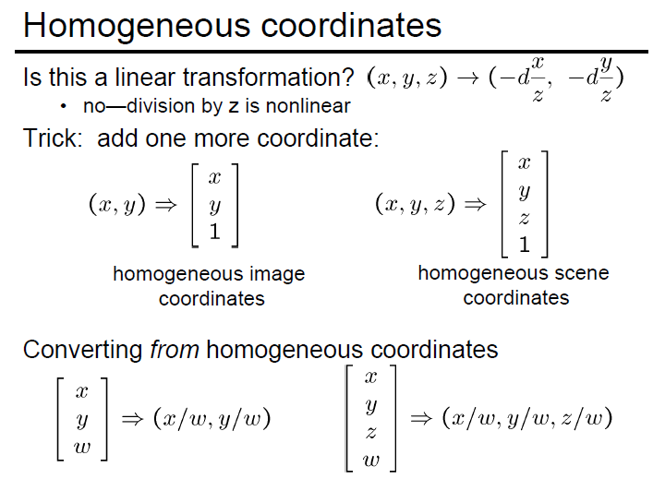
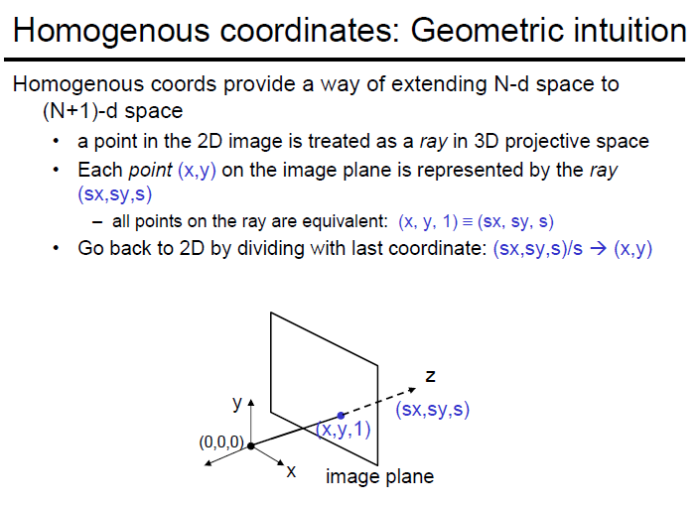

4. Explain Perspective Projection and orthographic Projection
Perspective projection maps a 3D point (X,Y,Z) onto a 2D image plane
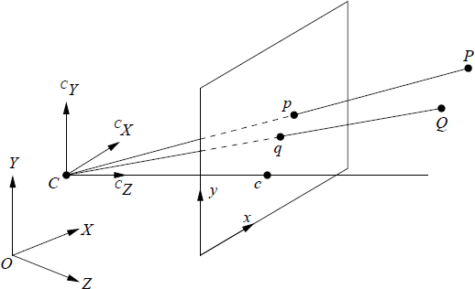
Equations:
x = fX/Z
y = fY/Z
Where:
f – focal length
Z – depth of object
Properties:
• Objects appear smaller with distance
• Parallel lines converge at vanishing points
Orthographic projection
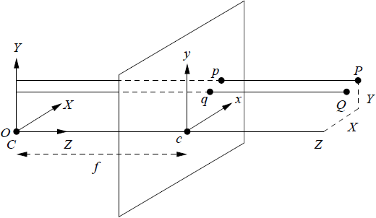

5. Explain Histogram Equalization.
Histogram equalization improves image contrast by redistributing intensity values.
**-Steps:
1. Compute histogram
2. Compute cumulative distribution function (CDF)
3. Map intensities using CDF

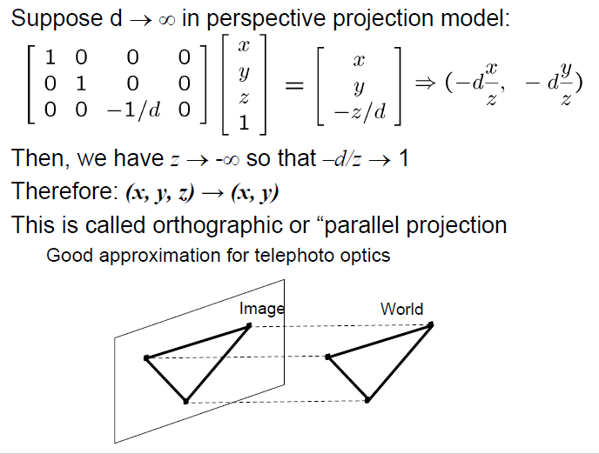
Advantages:
• Enhances visibility
• Uses full intensity range
• Improves details in dark images

Part B – 10 Mark Questions with Answers

1. Explain the Image Formation Process with Components.
Image formation explains how 3D scenes are converted into 2D images.
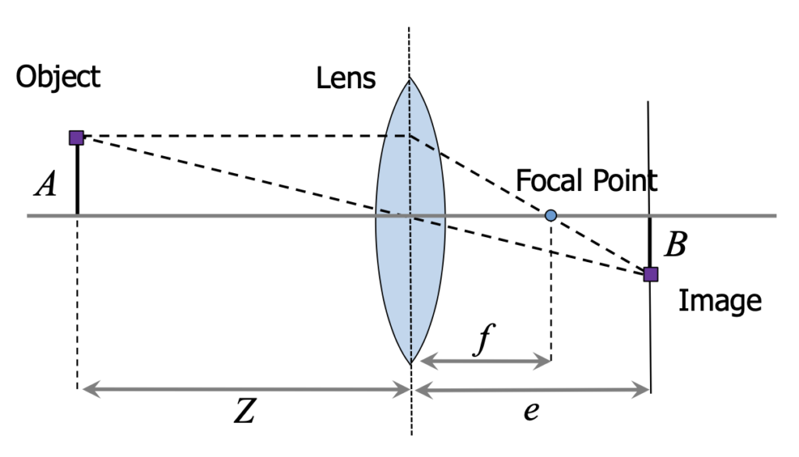
Components:
1. Scene Geometry – objects represented by points, lines, planes
2. Light Interaction – reflection and absorption determine brightness
3. Lens Optics – focuses light onto the sensor
4. Sensor Sampling – converts light into digital signals
- Perspective projection-Perspective projection is a realistic 3D-to-2D mapping technique that mimics human vision, making distant objects appear smaller and closer objects larger, with parallel lines converging at vanishing points, unlike parallel projection where lines stay parallel and sizes are preserved
- Light interaction with surfaces
- Lens optics
- Sensor sampling (Bayer pattern)
- Brief explanation:
An image is the result of geometry + physics + sensor design.

2. Explain 3D to 2D Projection Models.
Projection models map 3D world points to 2D image coordinates
Orthographic Projection:
x = X
y = Y
• Parallel projection rays
• No depth distortion
Perspective Projection:
x = fX/Z
y = fY/Z
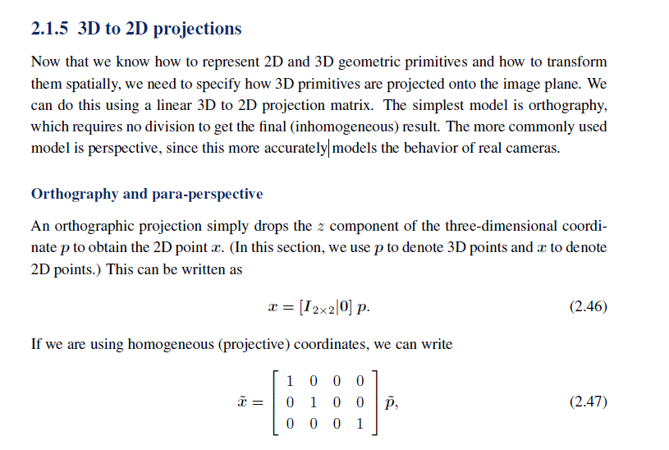
Characteristics:
• Objects shrink with distance
• Parallel lines converge
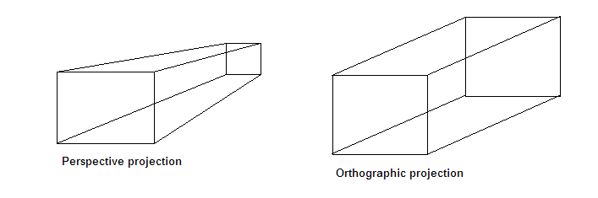

3. Explain Intrinsic and Extrinsic Camera Parameters.
Extrinsic Parameters:
Describe camera position and orientation.

Transformation:
Pc = R Pw + T
Where:
R – rotation matrix
T – translation vector
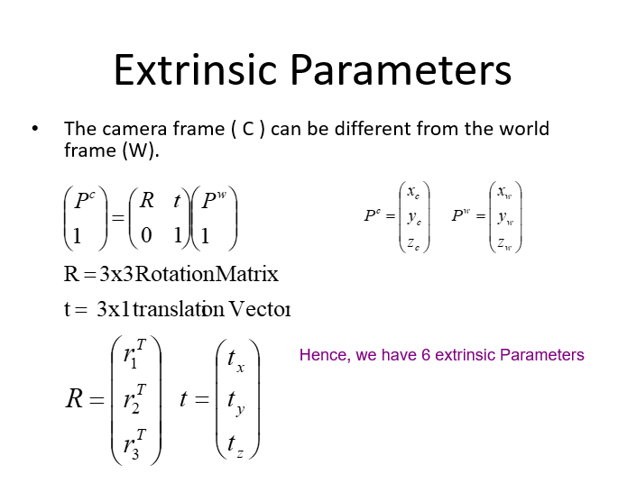
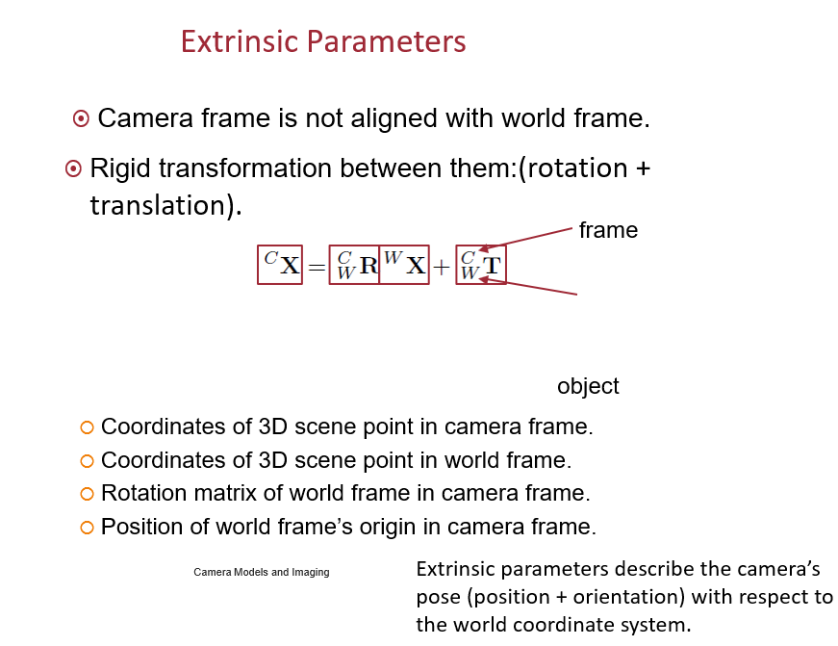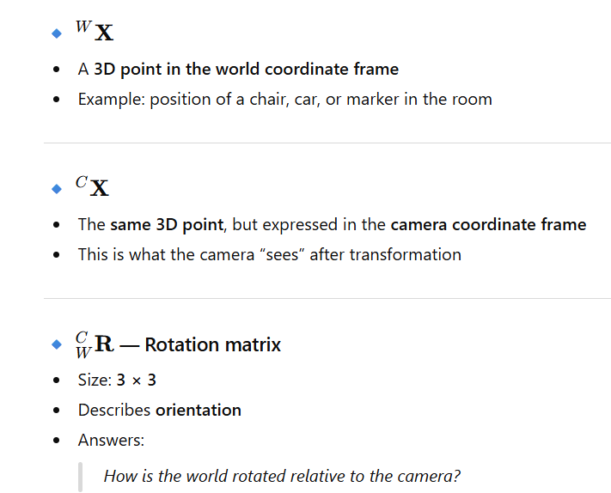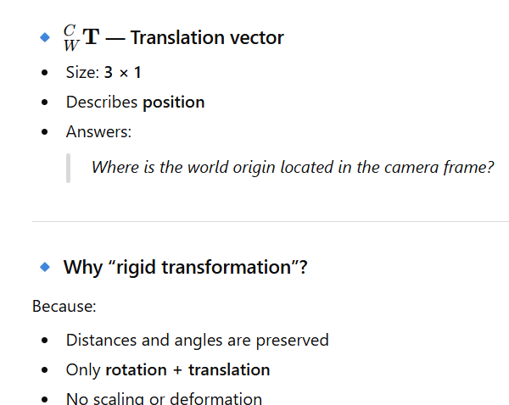
Intrinsic Parameters:
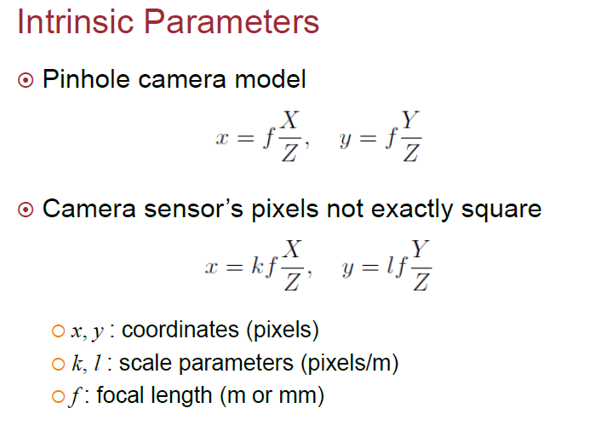
Used in camera calibration and 3D reconstruction.

4. Explain Linear Filtering.
Linear filtering computes each output pixel using a weighted sum of neighboring pixels.
Convolution Equation:
g(x,y) = Σ Σ f(x+i,y+j) h(i,j)
Where:
f(x,y) – input image
h(i,j) – kernel
g(x,y) – output image
- Linear filtering is a fundamental image processing technique used to modify images using a neighbourhood operation.
What is a Neighbourhood Operator?
- Instead of processing one pixel alone:
- We take a small window (kernel/mask) around it.
- Compute a new value based on its neighbours.
- Replace the centre pixel with this new value.
- Common kernel sizes:
- 3×3
- 5×5
- 7×7
- Output Pixel = Weighted Sum of Neighbours
- Each neighbouring pixel is multiplied by a weight (from the kernel), and all are summed.
- This is called convolution.

Applications:
• Noise reduction
• Edge detection
• Image smoothing

5. Explain Image Matting and Alpha Compositing.
Image matting separates foreground objects from the background.

Alpha Compositing Equation:
C = αF + (1−α)B
Where:
C – composite image
F – foreground
B – background
α – transparency value
The intermediate representation used for the foreground object between these two stages is called an alpha-matted colour image
- Matting: extracting foreground object
- Compositing: placing foreground onto new background
- Uses alpha channel (α):
- α = 1 → opaque
α = 0 → transparent
The alpha channel controls transparency.
Each pixel has:
$$α∈\left[0 , 1\right]$$
Where:
- α = 1 → Fully opaque (visible)
- α = 0 → Fully transparent (invisible)
- 0 < α < 1 → Semi-transparent
It acts like a soft mask.

Applications:
• Movie visual effects
• Background replacement
• Image editing
6. Explain pinhole camera model?
