* 1. Use case Diagram

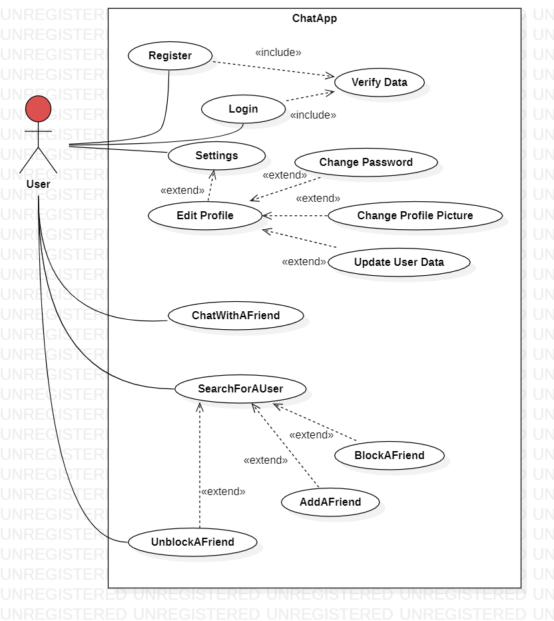

* 1. Use case Scenario
     1. Registration

|  |  |
| --- | --- |
| **Registration Page** | **Name** |
| Unregistered user | **Actor** |
| Create an account | **Description** |
| None | **Pre-condition** |
| 1. User will click the "Sign-up" button to be redirected to the sign-up page. 2. User will fill in the required fields:  * Name * E-mail address * Password * Age * Bio  1. After filling in, he will click the "Create Account" button | **Successful scenario** |
| User will become a registered user and redirected to home page. | **Post-condition** |

* + 1. Login

|  |  |
| --- | --- |
| **Login Page** | **Name** |
| Registered user | **Actor** |
| Log in to the system | **Description** |
| User has an account | **Pre-condition** |
| 1. User will sign in by filling in:    * E-mail address / User Name    * Password 2. After filling in, he will click the "Sign in" button. | **Successful scenario** |
| User will become logged in and redirected to home page. | **Post-condition** |

* + 1. Settings

|  |  |
| --- | --- |
| **Settings to Profile** | **Name** |
| Logged in user | **Actor** |
| Settings to user’s profile | **Description** |
| User logged in | **Pre-condition** |
| 1. User clicks on the drop-down list 2. Then he clicks on sittings list item 3. Then he will be able to view or edit his Personal Data 4. User will see the following details about his/her profile and update them:    * User name    * Profile Picture    * Change Password Link    * Bio 5. After editing what he wants will click save and his/her information will be updated | **Successful scenario** |
| User Information Updated. | **Post-condition** |

* + 1. Set Profile Picture

|  |  |
| --- | --- |
| **Set Profile Picture** | **Name** |
| Logged in user | **Actor** |
|  | **Diagram** |
| When a user wants to set profile Picture. | **Description** |
| User logged in | **Pre-condition** |
| * User clicks on profile picture from settings list * Select Picture * Upload Picture * Click Set Picture set profile picture. | **Successful scenario** |
| User Profile Picture added or updated. | **Post-condition** |

* + 1. Change Password

|  |  |
| --- | --- |
| **Change Password** | **Name** |
| Logged in user | **Actor** |
| When a user wants to change his password | **Description** |
| User logged in | **Pre-condition** |
| 1. User opened the profile page. 2. User clicks on **Change Password Link**. 3. The system opens change password form. 4. Form will have three inputs: current password, new password, and confirm new password, with two buttons (**submit** and **cancel**). 5. *Current password* must match their current password and the *new password* should match its confirmation. 6. If successful, bring them to a new page saying that their password has been changed with a continue button (leads to the home page). 7. If failed, then the system shall refresh the change password form page and give them an error message. 8. The cancel button cancels the process and closes the form | **Successful scenario** |
| User Password is updated. | **Post-condition** |

* + 1. Search for a user

|  |  |
| --- | --- |
| **Search for a user** | **Name** |
| Logged in user | **Actor** |
| When a user wants to search for a user in the app | **Description** |
| User logged in | **Pre-condition** |
| 1. User opened the Home page 2. User clicks on **search bar** 3. User starts to type his search 4. User clicks ok button (**Key Action 13**) or search button to submit his search query 5. List of users with the letters in the search query in their user names is displayed 6. He /She can then click on the one they wanted to chat with 7. Or they click on settings to (Add-Block -Remove) them as a friend 8. They can send a friend request if they are not friends yet 9. He can Chat or Block the user if they are already friends 10. If he is blocked from or blocked another user then that user won’t be able to be displayed to the user at the filtered search list | **Successful scenario** |
| List of filtered users is displayed | **Post-condition** |

* + 1. Add a friend

|  |  |
| --- | --- |
| **Add a friend** | **Name** |
| Logged in user | **Actor** |
| When a user wants to add another user as a friend to chat with each other | **Description** |
| * User logged in * User is not a friend with or blocked from the other user | **Pre-conditions** |
| 1. User clicks on the Add a friend Button 2. User is prompt that the request was sent successfully 3. The other user is notified immediately that a user wants to be his friend and cancel or accept the request 4. If the request was accepted, then they can chat with each other and the sender is notified that his request was accepted, in addition to being in each other’s friend list 5. If the request was canceled then the request can no more exist without telling the first user | **Successful scenario** |
| A friend request is sent | **Post-condition** |

* + 1. Block a friend

|  |  |
| --- | --- |
| **Block a friend** | **Name** |
| Logged in user | **Actor** |
| When a user wants to Block a friend | **Description** |
| * User logged in * The one that he wants to block must be a friend of his | **Pre-condition** |
| * + 1. Clicks on Block Button     2. A Dialog will be opened to confirm Blocking     3. If User Clicked “Yes” then the connection between both of the would be suspended until the block is canceled     4. The blocked user will be added to blocked list and so he will be prevented from messaging, searching for the user | **Successful scenario** |
| A friend request is sent and notified | **Post-condition** |

* + 1. Unblock a friend

|  |  |
| --- | --- |
| **Unblock a friend** | **Name** |
| Logged in user with blocked friend/s | **Actor** |
| When a user wants to unblock from a friend | **Description** |
| * User logged in * The one that he wants to unblock must be a friend of his | **Pre-condition** |
| 1. User opens blocked friend list 2. Clicks on Unblock Button 3. A Dialog will be opened to confirm unblocking 4. If User Clicked “Yes” then the connection between both of the would be back 5. The unblocked user will be removed from blocked list and so he will be able to message and search for the user | **Successful scenario** |
| A friend is removed from blocked friends list | **Post-condition** |

* + 1. Chat with a friend

|  |  |
| --- | --- |
| **Chat with a friend** | **Name** |
| Logged in user with friend/s | **Actor** |
| Start chat messaging session with one of the user’s friends Using texting | **Description** |
| * User logged in * The one that he wants to chat with must be a friend of his | **Pre-condition** |
| * + 1. User chooses a specific friend from his friends list     2. User starts typing at the typing bar     3. when he finishes, he then can send it using send button or “Enter” button at his keyboard     4. the messaging service, must be instant, Real-time service     5. the friend is notified when a new message is received | **Successful scenario** |
| * Messaging session started and running | **Post-condition** |

* 1. Sequence Diagram
     1. Registration

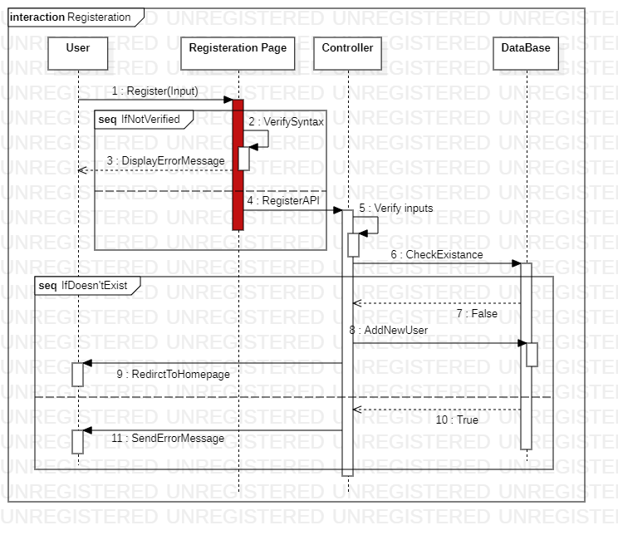

* + 1. Login

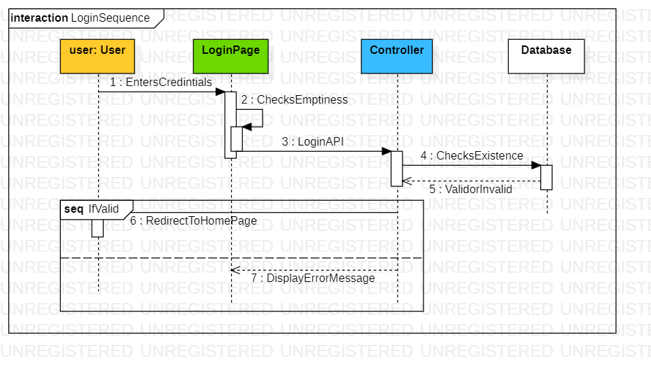

* + 1. Edit Profile

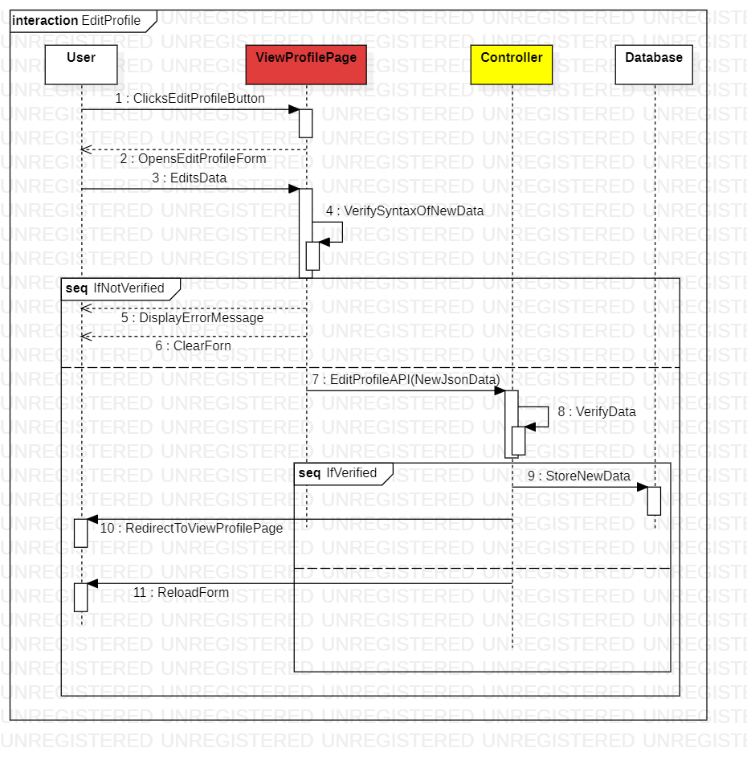

* + 1. Set Profile Picture

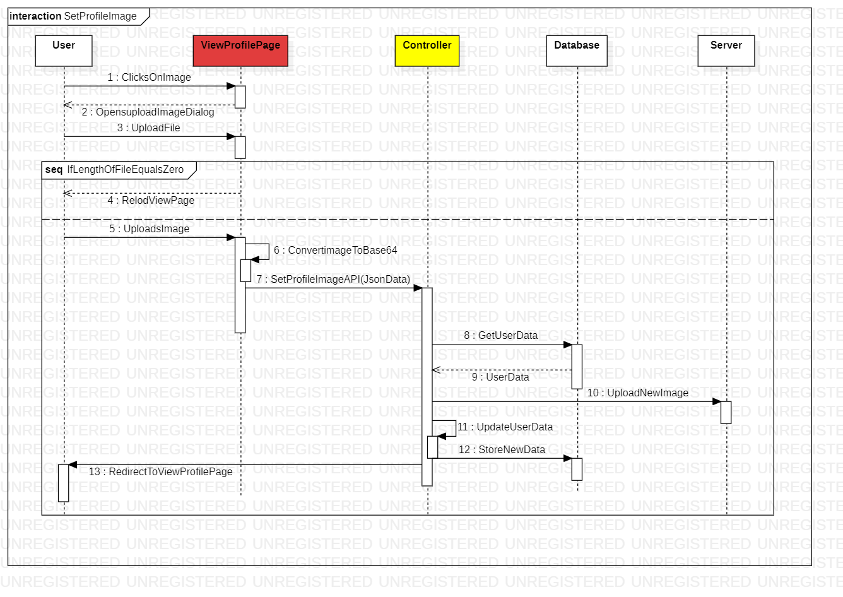

* + 1. Change Password

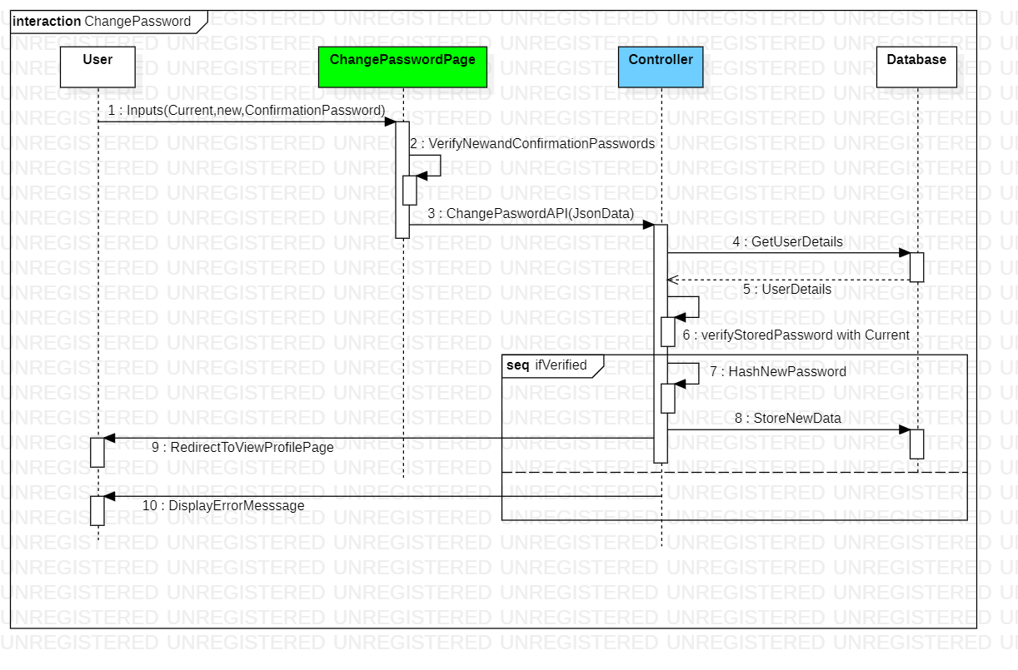

* + 1. Search for a user

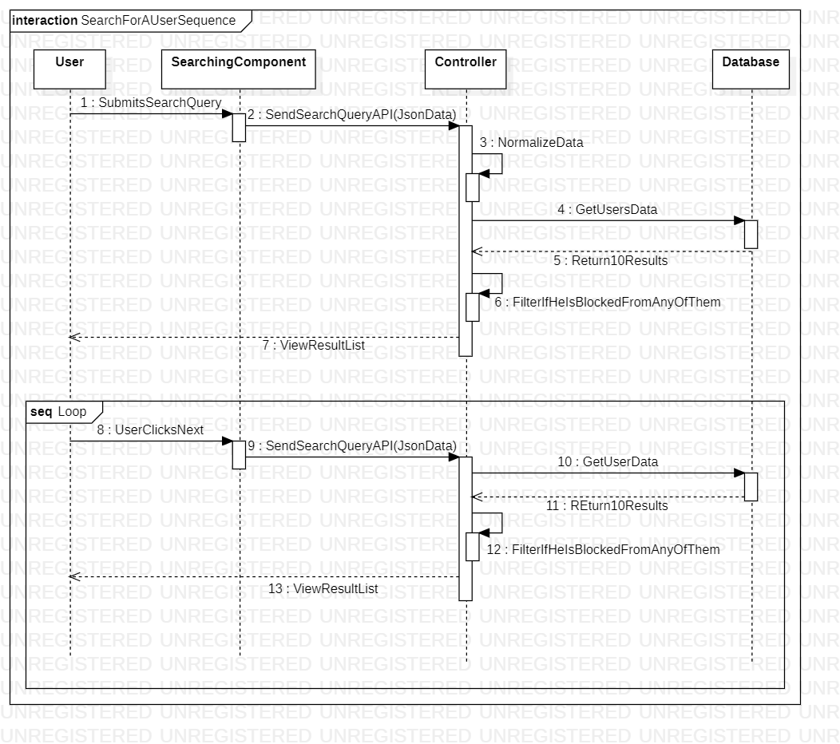

* + 1. Add a friend

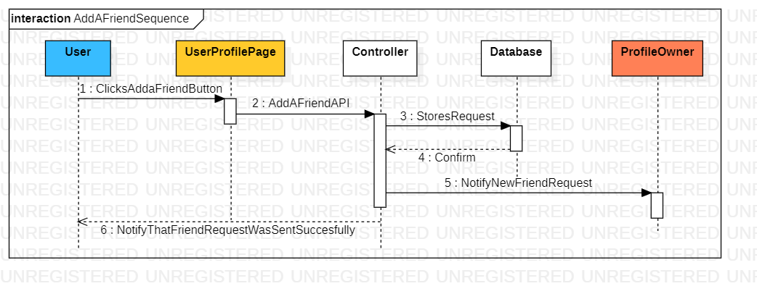

* + 1. Block a friend

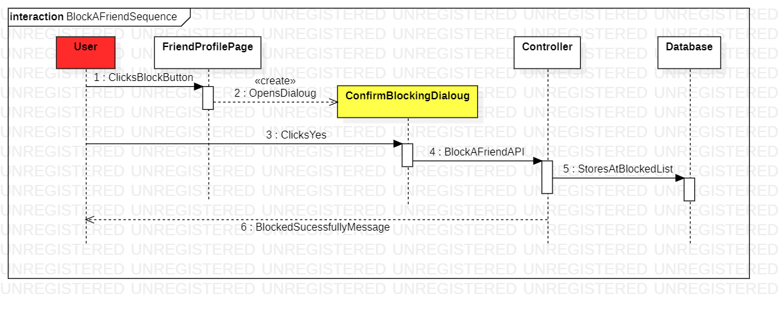

* + 1. Unblock a friend

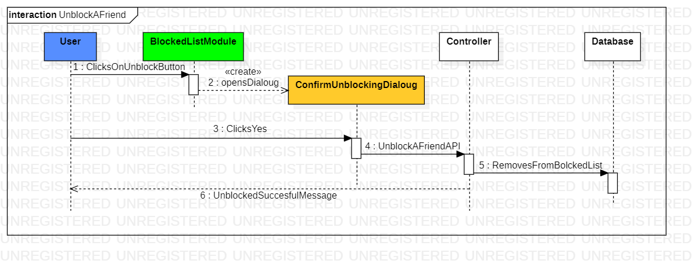

* + 1. Chat with a friend

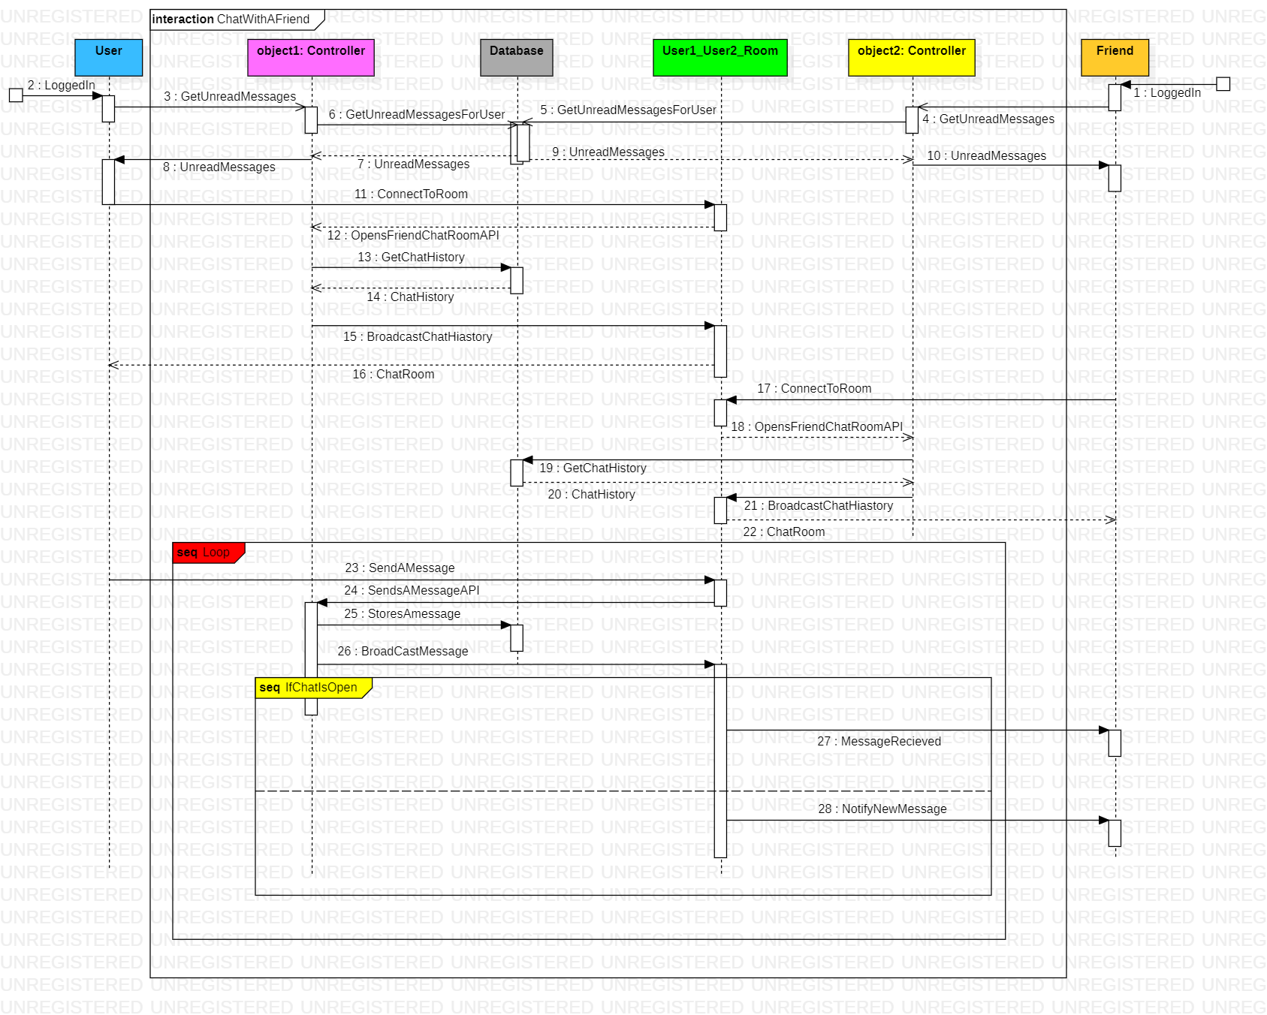

* 1. ER Diagram

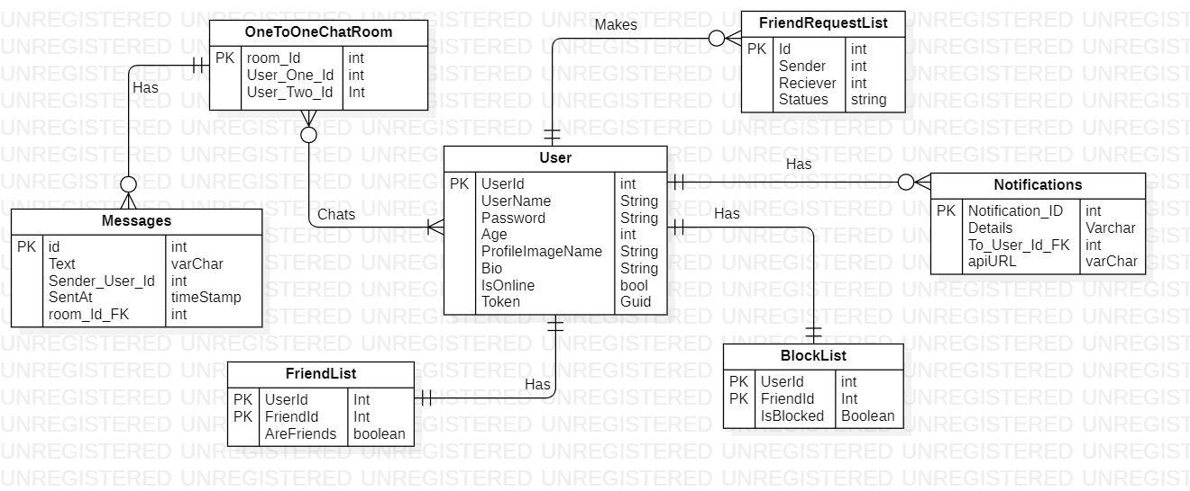

* 1. Class Diagram

