Login

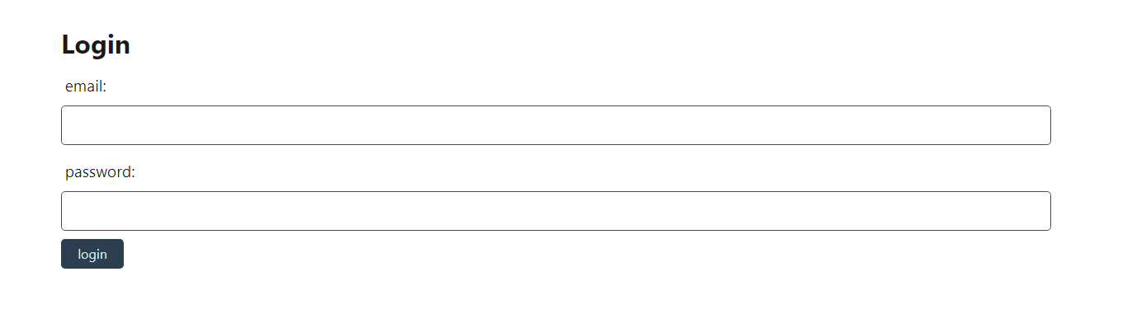

or

Create New User

User Name

email

Password

Save