## Training Stages

**Stage 0**: all ports lights on; reward always available (with bias correction on); 50 trials

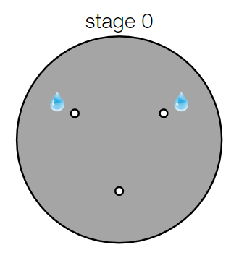

**Stage 1**: dot projected (north and centre locations); port lights on after dot offset

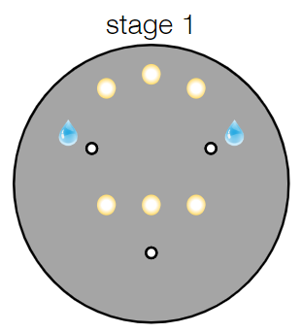

* **Stage 1.0**: reward available for 30s after dot offset; dot trigger time 50ms; 40 trials
* **Stage 1.1**: reward available both ports 0 and 1 on every trial for 15s after dot offset; 40 trials
* **Stage 1.2**: port lights off; 40 trials
* **Stage 1.3**: dot trigger time 100ms; reward available for 10s after dot offset; 40 trials
* **Stage 1.4**: dot trigger time 200-300ms; 40 trials

**Stage 2**: sound on after dot offset; no switching allowed

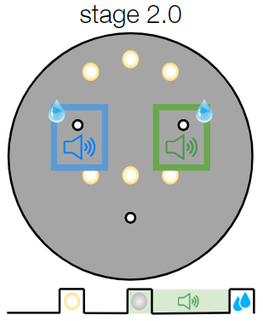

**Stage 3**

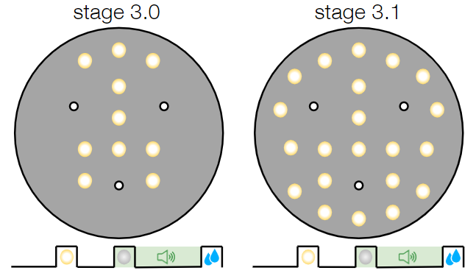

* **Stage 3**.**0:** Add additional dot locations
* **Stage 3.1**: All dot locations

**Stage 4**: Audio cue is triggered as the mouse enters a ROI or diameter from dot location

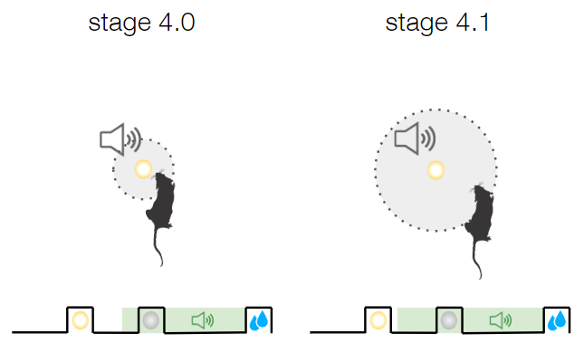

* **Stage 4**.**0:** small sound ROI around dot
* **Stage 4.1**: larger sound ROI around dot; reward available for 5s after dot offset

**Stage 5.0** (final): sound starts playing at t=∆t before dot projection

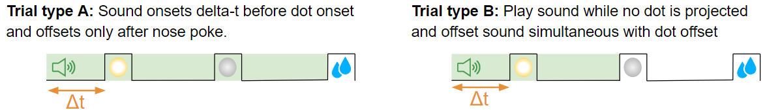

* **Essential features:**
  + Introduce sound at fixed time Δt before presentation of dot, (where Δt is parameterised).
  + Two timeout conditions should be applied: 1) timeout between dot projection and offset, 2) timeout between dot offset and nose poke. Cause of timeout should be logged in .csv file.
  + Option to parameterise % trials of type A and % trials of type B, either in an external csv or from bonsai (either way this should be logged).
* **Nice to have:** 
  + Option to alternate between blocks of trial type A and trial type B, where blocks of length n trials (where n is parameterizable).
  + Option to offset sound at fixed time t after dot offset. (This could be an added feature of trial type B, so if t is set to 0 we have the original type B).

**Stage 7.0** (single location test): only port 0 or port 1 dispense a reward. We can adjust the size of the trial block and what context plays

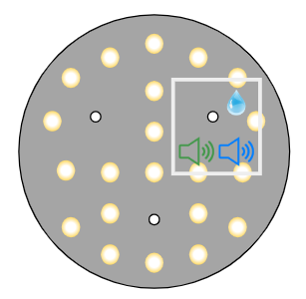 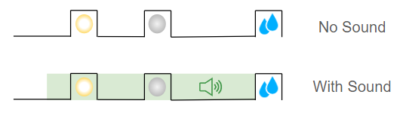

* **Essential features:**
  + Present rewards only on port 0 or only on port 1 regardless of audio cue
  + Option to specify % trials sound A, % trials sound B, % trials no sound where the reward port identity alternates between blocks (between port 0 and port 1)
* Nice to have
  + Alternating blocks of length n trials, where

## Callibration workflow(s)

**Valve calibration**

**Flush valves**

**Calibrate dot locations**

## Global features

**Workflow should be working across all boxes**

* Refactored workflow should be the same between boxes, differing only in parameters such as calibration (which must vary between boxes to keep a consistent coordinate frame).
* Option to set / save box-specific parameters locally without issues with github. E.g. box-specific parameters could be set in a .csv file which is on the repo for all boxes?
* *All* conditions should be the same between all boxes, e.g. audio cue pitch / volume, dot brightness, location of dots relative to ports, so that we can smoothly transition animals to the ephys box

**Global task logic features**

* Beep on top offset: Pure tone of duration ~200ms
* Antibias algorithm: Implement Antibias algorithm over a sliding window of length w based on choice and reward history (exact algorithm TBD), ideally such that the kernel of the sliding window is weighted towards more recent trials.
* Exclude dot projection within radius r1 from mouse:Dot should never be projected on top of the mouse so he doesn’t accidentally trigger it
* Option to automatically progress through the stages after n correct trials (set True/False)
* Dot offset should be triggered by nose poke to dot (rather than distance from centroid)

**Wall rotation control**

* Wall rotation = true → no feedback after each trial (no reward or timeout after touching the port). All task parameters, e.g. choice of port should be recorded as normal.
* Walls rotated = true → log whether or not walls were rotated as one of the session parameters. (No change to task logic).

**User-specified parameters**

* **Dot variables**
  + Dot onset radius
  + Dot brightness
  + Dot diameter
* **Audio variables**
  + Audio attenuation for each audio cue
  + Mapping from audio cue identity to correct port
* Data output folder
* Path to relevant .csv files for bonsai workflow parameters

**Nice to have**:

* Option to project dot within maximum distance r2 :
* 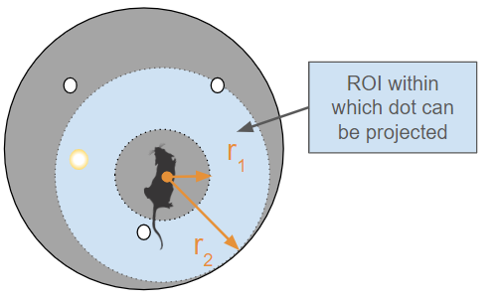

## Data logging

* All user-specified parameters (global and stage-specific) should be automatically logged and saved for each session, including:
  + mapping from audio cue identity to port location

## Interface

**User-specified parameters set in GUI**

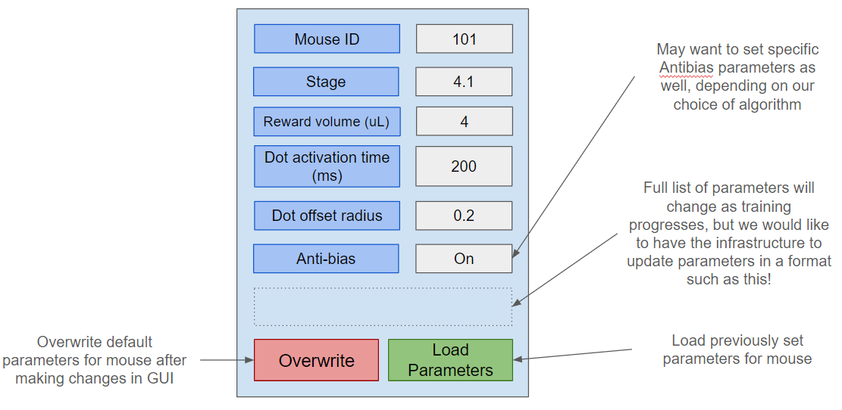

**Visualiser:**

|  |  |
| --- | --- |
| **Mouse ID** | 101 |
| **Stage** | 4.1 |
| **Time since experiment started (min)** | mm.ss |
| **Reward size (uL)** | 2 |
| **Trial number** | 300 |
| **Correct Count** | 250 |
| **Total volume of reward (uL)** | 500 |
| **Rolling accuracy** |  |
| **Rolling bias** |  |

