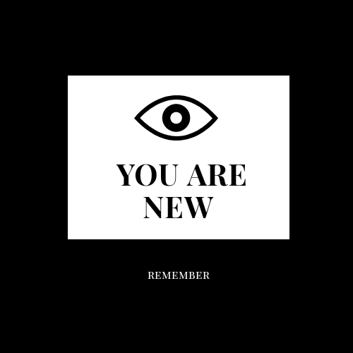

Notes for Time Here

# 2020

A plain paragraph having some **bold** and some *italic.*

# 2019

A plain paragraph having some **bold** and some *italic.*

# 2018

A plain paragraph having some **bold** and some *italic.*

# 2017

A plain paragraph having some **bold** and some *italic.*

# 2016

A plain paragraph having some **bold** and some *italic.*

# 2015

A plain paragraph having some **bold** and some *italic.*

# 2014

A plain paragraph having some **bold** and some *italic.*

# 2013

A plain paragraph having some **bold** and some *italic.*

# 2012

A plain paragraph having some **bold** and some *italic.*

# 2011

A plain paragraph having some **bold** and some *italic.*

# 2010

A plain paragraph having some **bold** and some *italic.*

# 2009

A plain paragraph having some **bold** and some *italic.*

# 2008

A plain paragraph having some **bold** and some *italic.*

# 2007

A plain paragraph having some **bold** and some *italic.*

# 2006

A plain paragraph having some **bold** and some *italic.*

# 2005

A plain paragraph having some **bold** and some *italic.*

# 2004

A plain paragraph having some **bold** and some *italic.*

# 2003

A plain paragraph having some **bold** and some *italic.*

# 2002

A plain paragraph having some **bold** and some *italic.*

# 2001

A plain paragraph having some **bold** and some *italic.*

# 2000

A plain paragraph having some **bold** and some *italic.*

# 1999

A plain paragraph having some **bold** and some *italic.*

# 1998

A plain paragraph having some **bold** and some *italic.*

# 1997

A plain paragraph having some **bold** and some *italic.*

# 1996

A plain paragraph having some **bold** and some *italic.*

# 1995

A plain paragraph having some **bold** and some *italic.*

# 1994

A plain paragraph having some **bold** and some *italic.*

# 1993

A plain paragraph having some **bold** and some *italic.*

# 1992

A plain paragraph having some **bold** and some *italic.*

# 1991

A plain paragraph having some **bold** and some *italic.*

# 1990

A plain paragraph having some **bold** and some *italic.*

# 1989

A plain paragraph having some **bold** and some *italic.*

# 1988

A plain paragraph having some **bold** and some *italic.*

# 1987

A plain paragraph having some **bold** and some *italic.*

# 1986

A plain paragraph having some **bold** and some *italic.*

# 1985

A plain paragraph having some **bold** and some *italic.*

# 1984

A plain paragraph having some **bold** and some *italic.*

# 1983

A plain paragraph having some **bold** and some *italic.*

# 1982

A plain paragraph having some **bold** and some *italic.*

# 1981

A plain paragraph having some **bold** and some *italic.*

# 1980

A plain paragraph having some **bold** and some *italic.*

# 1979

A plain paragraph having some **bold** and some *italic.*

# 1978

A plain paragraph having some **bold** and some *italic.*

# 1977

A plain paragraph having some **bold** and some *italic.*

# 1976

A plain paragraph having some **bold** and some *italic.*

# 1975

A plain paragraph having some **bold** and some *italic.*

# 1974

A plain paragraph having some **bold** and some *italic.*

# 1973

A plain paragraph having some **bold** and some *italic.*

# 1972

A plain paragraph having some **bold** and some *italic.*

# 1971

A plain paragraph having some **bold** and some *italic.*

# 1970

A plain paragraph having some **bold** and some *italic.*

# 1969

A plain paragraph having some **bold** and some *italic.*

# 1968

A plain paragraph having some **bold** and some *italic.*

# 1967

A plain paragraph having some **bold** and some *italic.*

# 1966

A plain paragraph having some **bold** and some *italic.*

# 1965

A plain paragraph having some **bold** and some *italic.*

# 1964

A plain paragraph having some **bold** and some *italic.*

# 1963

A plain paragraph having some **bold** and some *italic.*

# 1962

A plain paragraph having some **bold** and some *italic.*

# 1961

A plain paragraph having some **bold** and some *italic.*

# 1960

A plain paragraph having some **bold** and some *italic.*

# 1959

A plain paragraph having some **bold** and some *italic.*