# Home page

## Welcome to the Microbial Chemoresistance Knowledgebase (MiCK)

Cancer remains one of the most formidable health challenges globally, with millions of new cases and deaths reported annually. Chemoresistance significantly impacts the efficacy of cancer treatment, often leading to treatment failure and disease progression. MiCK is dedicated to addressing the challenge of chemoresistance in cancer by serving as a resource for microbial gene sequences associated with treatment efficacy. Our goal is to facilitate researchers and healthcare professionals in further understanding and mitigation of chemoresistance across various cancer types.

## Key Statistics

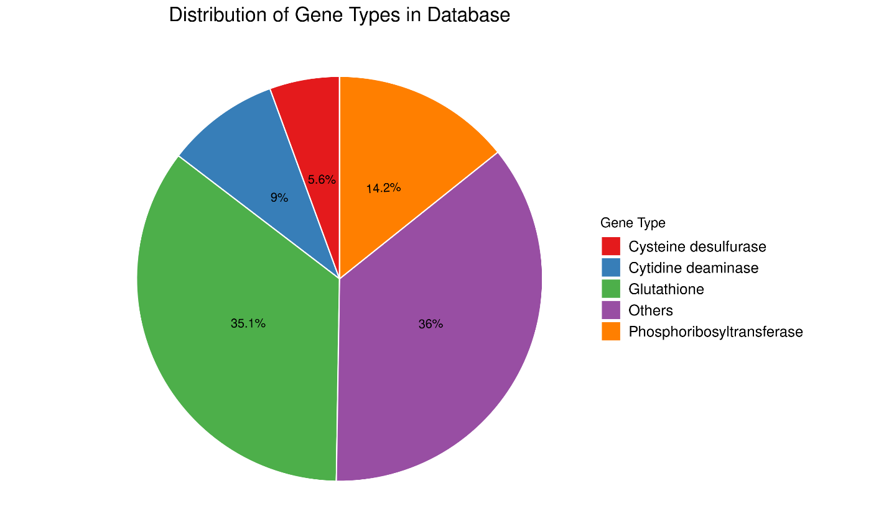

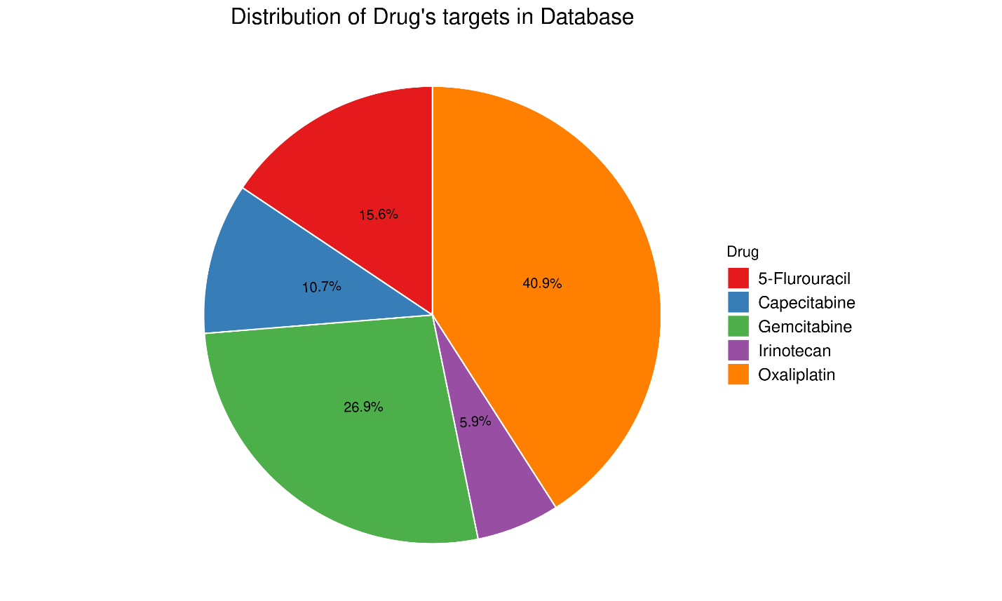

### In MiCK, users can:

* Perform gene search using gene name
* Use drug name to find all the target gene sequences and their effects
* Search the effect to find out which gene will cause such effects
* In FAQ’s users can view some of the most frequently asked questions
* In download interface, users have access to download different datasets

# Search page

### MiCK Search page

Search page allows a keyword search against the sequences of MiCK database.

**Search**

Type keyword like 5-FU, irinotecan, Capecitabine, Gemcitabine and oxaliplatin.

Drug

# Download page

MiCK-80

Download database clustered at 80% identity

MiCK-75

Download database clustered at 75% identity

MiCK-50

Download database clustered at 50% identity

Datatables

Download Database data table

Metadata

Download table that have information of genes, drugs and effects

MiCK-90

Download database clustered at 90% identity

# About Page

MiCK is a comprehensive knowledge base that houses ~1.6 million microbial gene sequences associated with chemoresistance in multiple cancers. These sequences encompass 29 different gene types linked to chemoresistance and drug metabolism, meticulously curated from recent literature and databases.

## FAQ’s

1. What is the Microbial Chemoresistance Knowledgebase (MiCK)?

MiCK is a comprehensive database cataloging microbial gene sequences associated with chemoresistance in cancer, providing researchers with valuable data for improving treatment strategies.

1. How does the gut microbiome affect cancer treatment?

The gut microbiome can modulate the efficacy of chemotherapeutic drugs, potentially leading to chemoresistance. MiCK helps researchers understand these interactions to improve treatment outcomes.

1. How can I access and use data from MiCK?

Researchers can access MiCK through a user-friendly web interface, search for specific gene sequences, and download datasets for further analysis.

## Team

 

Muhammad Shahzaib Dr. Masood Ur Rehman Kayani

(Author) (Principal Investigator)

Contact us

Dr,Masood Ur Rehman Kayani (m.kayani at sines.nust.edu.pk)

Muhammad Shahzaib (kshahzaib9937 at gmail.com)