NATURAL LANGUAGE PROCESSING FUNDAMENTALS
From Text Preprocessing to Word Embeddings, with Python
Draft manuscript — Part III: Preparing Text
Chapters 6–9 · Cleaning, Tokenization, Stop Words, Stemming and Lemmatization
[Author name — to be supplied]
Contents
Part III Preparing Text 3
Chapter 6 Text Cleaning and Normalization 4
6.1 Why Clean Text? 4
6.2 Whitespace and Repeated Punctuation 5
6.3 Case Normalisation 5
6.4 HTML, URLs and E-mail Addresses 6
6.5 Unicode Normalisation 7
6.6 Punctuation, Numbers, Emoji and Spelling 8
6.7 A Reusable Cleaning Function 8
6.8 Common Mistakes 9
6.9 Chapter Summary 9
6.10 Review Questions and Exercises 10
Chapter 7 Tokenization and Sentence Segmentation 11
7.1 What Is Tokenization? 11
7.2 Creating Tokens with spaCy 12
7.3 Important spaCy Objects 13
7.4 Token Attributes 14
7.5 Extracting Specific Information 15
7.6 Multilingual Tokenization 16
7.7 Customising Tokenization 16
7.8 Sentence Segmentation 17
7.9 Common Mistakes 18
7.10 Chapter Summary 18
7.11 Review Questions and Exercises 18
Chapter 8 Stop Words 20
8.1 What Are Stop Words? 20
8.2 Why Remove Stop Words? 21
8.3 When Not to Remove Stop Words 21
8.4 Stop-Word Removal with spaCy 22
8.5 Removing Stop Words with a List Comprehension 23
8.6 A Reusable Cleaning Function 24
8.7 Applying Stop-Word Removal to a pandas DataFrame 24
8.8 Preserving Important Words Such as “not” 25
8.9 Stop Words, Stemming and Lemmatization 26
8.10 Common Mistakes 26
8.11 Chapter Summary 26
8.12 Review Questions and Exercises 26
Chapter 9 Stemming and Lemmatization 28
9.1 Introduction 28
9.2 Stemming 28
9.3 Lemmatization 31
9.4 Customising Lemmatization in spaCy 34
9.5 Stemming versus Lemmatization 35
9.6 Applications 36
9.7 Common Mistakes 36
9.8 Chapter Summary 36
9.9 Review Questions and Exercises 37

Part III Preparing Text
Raw text is messy. It contains markup, stray symbols, inconsistent capitalisation, unusual characters and words in many different forms. Part III teaches the preparation steps that come before any numerical representation: cleaning and normalising text (Chapter 6), splitting it into sentences and tokens (Chapter 7), deciding which common words to drop (Chapter 8), and reducing words to base forms (Chapter 9). The goal throughout is the same: reduce irrelevant variation without destroying information the task needs.

Chapter 6 Text Cleaning and Normalization
Learning objectives
After studying this chapter you will be able to:
• identify common kinds of noise in raw text and the cleaning step that addresses each;
• convert text to a consistent case, and explain when lower-casing hurts;
• remove or mask HTML, URLs and e-mail addresses;
• normalise Unicode so that visually identical strings compare as equal;
• assemble a reusable, configurable cleaning function and apply it consistently.

6.1 Why Clean Text?
In Chapter 4 we cleaned a support ticket by combining its fields and tidying spaces and punctuation (Figure 4.3). That was one instance of a general need. Text collected from websites, e-mails, chat messages and databases is rarely ready for analysis. Without cleaning, a model sees “Great”, “GREAT” and “great!!!” as three unrelated strings, treats &amp; as a word, and learns from advertisements and tracking links.
Text cleaning removes or repairs noise. Text normalisation maps different surface forms of the same thing to one canonical form. In practice the two overlap, and this chapter treats them together.
Problem | Example | Typical remedy | Risk if overdone
Extra whitespace and line breaks | “My payment failed” | Collapse whitespace | Loses paragraph structure
Repeated punctuation | “failed!!!” | Collapse repeats | Loses emphasis, which can signal sentiment
Inconsistent case | “GREAT” vs “great” | Lower-case or case-fold | Erases useful capitals (names, acronyms)
HTML markup and entities | <p>, &amp; | Decode entities, strip tags | Can remove meaningful content if done crudely
URLs and e-mail addresses | “https://…” | Delete or replace with a placeholder | Loses the information that a link was present
Unicode variants | “é” as one character or two | Unicode normalisation | Stripping accents can merge different words
Numbers | “450” | Replace with a placeholder | Loses the value, which may matter
Table 6.1 Common noise in raw text, with the usual remedy and its risk.
The last column is the most important. Every cleaning step discards some information, so the right amount of cleaning depends on the task and on the model that follows. A bag-of-words classifier usually benefits from aggressive cleaning; a modern transformer model, trained on raw text, often performs better with little.

6.2 Whitespace and Repeated Punctuation
Extra spaces, tabs and line breaks are the simplest noise to remove, and they matter more than they appear. spaCy, for example, turns a run of two spaces into a separate whitespace token:
import spacy

nlp = spacy.blank("en")
print([(t.text, t.is_space) for t in nlp("hello world")])

Output
[('hello', False), (' ', True), ('world', False)]

Collapsing all whitespace runs to a single space with a regular expression (Chapter 5) prevents such surprises:
import re

text = "My payment failed!!! \n Please help."
text = re.sub(r"([!?.])\1+", r"\1", text) # "!!!" -> "!"
text = re.sub(r"\s+", " ", text).strip() # collapse whitespace
print(text)

Output
My payment failed! Please help.

The first substitution uses a back-reference: \1 refers to whatever the first group matched, so ([!?.])\1+ means “a punctuation mark followed by one or more copies of itself”.

6.3 Case Normalisation
Converting text to lower case is the most common normalisation. It lets “Great”, “GREAT” and “great” count as the same word and shrinks the vocabulary of count-based representations (Chapter 16).
print("Great GREAT great".lower())
print("Stra\u00dfe".lower(), "Stra\u00dfe".casefold())
print("STRASSE".lower() == "Stra\u00dfe".lower())
print("STRASSE".casefold() == "Stra\u00dfe".casefold())

Output
great great great
straße strasse
False
True

str.lower() is adequate for English. str.casefold() is a more aggressive form designed for caseless comparison across languages: the German letter ß folds to “ss”, so “STRASSE” and “Straße” compare as equal only after case-folding.
When not to lower-case
Capital letters carry information. A named entity recogniser (Chapter 13) uses capitalisation as one of its strongest clues. Compare what a pre-trained spaCy pipeline finds in the same sentence with and without capitals:
nlp = spacy.load("en_core_web_sm")
print([(e.text, e.label_) for e in nlp("Apple is hiring in US").ents])
print([(e.text, e.label_) for e in nlp("apple is hiring in us").ents])

Output
[('Apple', 'ORG'), ('US', 'GPE')]
[('apple', 'ORG')]

With the original capitals, the model finds both the company and the country. After lower-casing it finds only the company: “us” has become the ordinary pronoun. Lower-casing is therefore a good default for classification with bag-of-words features, and a poor choice before entity recognition or when acronyms matter.

6.4 HTML, URLs and E-mail Addresses
Text scraped from the web or copied from e-mails often contains markup. Python’s standard library can decode HTML entities such as &amp;, and a regular expression can remove simple tags:
import html, re

raw = "<p>Caf\u00e9 &amp; Bar: GREAT food!!! Visit https://example.com or mail us@cafe.com</p>"

s = html.unescape(raw) # &amp; -> &
s = re.sub(r"<[^>]+>", " ", s) # remove tags
s = re.sub(r"https?://\S+", "<URL>", s)
s = re.sub(r"[\w.+-]+@[\w-]+(?:\.[\w-]+)+", "<EMAIL>", s)
print(s)

Output
Café & Bar: GREAT food!!! Visit <URL> or mail <EMAIL>

Two design choices appear here. First, the order matters: entities are decoded before tags are stripped, and URLs are replaced before the e-mail pattern runs. Second, we replace URLs and addresses with placeholders such as <URL> instead of deleting them. A placeholder keeps the signal that “there was a link here” (useful for spam detection) while discarding the unique, unhelpful string.
A caution about stripping HTML with regex
The pattern <[^>]+> is fine for simple fragments. Real HTML pages contain scripts, styles, comments and malformed tags; for those, use a dedicated HTML parser such as the one in the BeautifulSoup library rather than regular expressions.

6.5 Unicode Normalisation
Computers store text as Unicode code points, and the same visible character can be encoded in more than one way. The letter “é” can be a single code point or an “e” followed by a combining accent mark:
import unicodedata

a = "e\u0301" # 'e' + combining acute accent
b = "\u00e9" # precomposed 'é'
print(a == b, len(a), len(b))
print(unicodedata.normalize("NFC", a) == b)

Output
False 2 1
True

To a reader, a and b look identical, but Python considers them different strings. Unicode defines normalisation forms that resolve this:
Form | Name | What it does
NFC | Canonical composition | Combines base letters and accents into single characters where possible
NFD | Canonical decomposition | Splits characters into base letter plus combining marks
NFKC | Compatibility composition | NFC plus folding of “compatibility” characters such as ligatures and full-width letters
NFKD | Compatibility decomposition | NFD plus the same folding
Table 6.2 The four Unicode normalisation forms.
print(unicodedata.normalize("NFKC", "\ufb01nance \u2460 \uff28\uff45\uff4c\uff4c\uff4f"))

Output
finance 1 Hello

The input contains the ligature “ﬁ”, the circled digit “①” and full-width letters; NFKC converts them to ordinary “fi”, “1” and “Hello”. For most NLP work, NFC or NFKC is a sensible first step.
Removing accents
Sometimes you want “café” and “cafe” to match, for example in search over user-typed queries. Decomposing with NFD and dropping the combining marks does this:
def strip_accents(text):
decomposed = unicodedata.normalize("NFD", text)
return "".join(c for c in decomposed if unicodedata.category(c) != "Mn")

print(strip_accents("Caf\u00e9 na\u00efve r\u00e9sum\u00e9"))

Output
Cafe naive resume

Use this with care. In some languages accents distinguish different words, and removing them creates ambiguity. “Mn” is the Unicode category for combining (non-spacing) marks.

6.6 Punctuation, Numbers, Emoji and Spelling
Several further operations are common but need more thought.
- Removing punctuation. A blunt rule such as removing every non-word character is risky. Applied to “Hello, World! It’s 5 o’clock.” with the pattern [^\w\s], it produces “Hello World Its 5 oclock” — the contractions have been damaged. Tokenisation (Chapter 7) usually handles punctuation better than deleting it.
- Numbers. re.sub(r"\d+", "<NUM>", text) replaces every number with a placeholder, which is useful when the exact value is unimportant. If the value matters (prices, quantities), keep it.
- Emoji and emoticons. These often carry sentiment. Removing them can discard exactly the signal a sentiment classifier needs; consider keeping them or mapping them to descriptive words.
- Spelling correction. Customer messages contain typos, and correcting them can help a count-based model. Automatic correctors, however, can change names, product codes and slang into dictionary words. Apply correction selectively, and evaluate whether it improves results.
- Contractions and slang. Expanding “can’t” to “cannot”, or mapping “bro” to “brother”, is domain-dependent. Chapter 9 shows how spaCy lets you add such mappings as rules.

6.7 A Reusable Cleaning Function
The steps above combine naturally into one function. Making optional steps into parameters lets you choose the right amount of cleaning for each task:
import html, re, unicodedata

def clean_text(text, lower=True):
text = html.unescape(text)
text = re.sub(r"<[^>]+>", " ", text)
text = re.sub(r"https?://\S+", "<URL>", text)
text = re.sub(r"[\w.+-]+@[\w-]+(?:\.[\w-]+)+", "<EMAIL>", text)
text = unicodedata.normalize("NFKC", text)
text = re.sub(r"([!?.])\1+", r"\1", text)
text = re.sub(r"\s+", " ", text).strip()
return text.lower() if lower else text

raw = (" <p>Caf\u00e9 &amp; Bar: GREAT food!!! "
"Visit https://example.com or mail us@cafe.com</p>\n")
print(clean_text(raw))
print(clean_text(raw, lower=False))
print(clean_text("Title: Payment Failed\nDescription: My payment failed!!!"))

Output
café & bar: great food! visit <url> or mail <email>
Café & Bar: GREAT food! Visit <URL> or mail <EMAIL>
title: payment failed description: my payment failed!

Notice that lower-casing also lower-cases the placeholders (<url>). That is harmless as long as you treat them consistently; if you prefer capitalised placeholders, insert them after lower-casing.
The third call echoes the ticket example from Chapter 4: whitespace is collapsed, repeated punctuation reduced and capitals normalised. Together with the combining step of Chapter 4’s clean_ticket() function, this completes the cleanup shown in Figure 4.3.
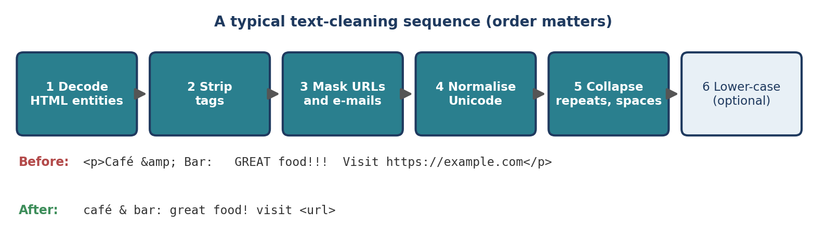
Figure 6.1 A typical text-cleaning sequence. The order matters: decode entities before stripping tags, and mask URLs before e-mails.

6.8 Common Mistakes
- Cleaning differently in training and in production. Use one function for both (Section 4.4).
- Over-cleaning. Removing punctuation, numbers, emoji and capitals “just in case” often removes the most informative features.
- Lower-casing before entity recognition (Section 6.3).
- Cleaning for a transformer as you would for bag of words. Pre-trained transformer models were trained on raw text; heavy cleaning can move your input away from what they expect.
- Regex for complex HTML. Use a parser (Section 6.4).
- Not looking at the data. Print a sample of text before and after each step. Surprises (such as “oclock”) are easy to spot and hard to predict.

6.9 Chapter Summary
- Cleaning removes noise; normalisation maps variants of the same thing to one form. Each step trades information for consistency.
- Regular expressions handle whitespace, repeated punctuation, simple HTML tags, URLs and e-mail addresses; html.unescape decodes entities.
- Lower-casing shrinks the vocabulary but removes capitalisation clues that entity recognisers rely on.
- Unicode normalisation (NFC or NFKC) makes visually identical strings equal; accent stripping is optional and language-dependent.
- Wrap your steps in one configurable function, and use it identically for training and deployment.

6.10 Review Questions and Exercises
- Why might a spam detector replace URLs with <URL> instead of deleting them?
- Explain why "STRASSE".lower() == "Stra\u00dfe".lower() is False but the case-folded comparison is True.
- Give one task where lower-casing helps and one where it hurts. Justify each.
- What does unicodedata.normalize("NFC", "e\u0301") return, and why does it matter for string comparison?
- Exercise. Extend clean_text() with an optional strip_accents argument that uses the function in Section 6.5, and an optional mask_numbers argument that replaces digits with <NUM>. Test all four combinations on a message of your choice.
- Exercise. Collect ten short texts from a source you use (reviews, messages, headlines). Apply each cleaning step in turn and list the cases where a step damaged the meaning.
- Exercise. Run clean_text() on a string containing the HTML comment <!-- ad --> followed by text. Does the output look right? Explain what would go wrong with a <script> block.

Editorial note — remove before publication
From your notes: the “Text Extraction and Cleanup” section of the End-to-End NLP Pipeline and the preprocessing list in the Common NLP Workflow (removing noise, lower-casing, removing extra spaces, handling missing and duplicate values, spelling).
Mostly new: your notes covered cleaning only as a pipeline step, so most of this chapter is added material — whitespace and punctuation handling, case-folding, HTML/URL/e-mail handling, Unicode normalisation, accent stripping, the reusable clean_text() function, pitfalls and exercises. Missing and duplicate values are data-handling steps that belong with the pandas material in Chapter 8 and in Part VII. All code in this chapter was run and every output shown is real.

Chapter 7 Tokenization and Sentence Segmentation
Learning objectives
After studying this chapter you will be able to:
• define tokens and explain why splitting on spaces is not enough;
• tokenise text into words and punctuation with spaCy and NLTK;
• work with the Doc, Token and Span objects;
• use token attributes such as is_alpha, like_num and is_currency to extract information;
• tokenise other languages, add custom tokenisation rules, and split text into sentences.

7.1 What Is Tokenization?
Tokenization is one of the first steps in NLP. It divides text into smaller units called tokens: words, punctuation marks, numbers and symbols. A computer cannot analyse a sentence until it knows where the words are.
Sentence tokenization
Sentence tokenization (also called sentence segmentation) divides a paragraph into individual sentences.
Input: Dr. Kumar works at a college. He teaches NLP.

Output: 1. Dr. Kumar works at a college.
2. He teaches NLP.

Word tokenization
Word tokenization divides a sentence into words and symbols.
Input: I am learning NLP.
Output: ["I", "am", "learning", "NLP", "."]

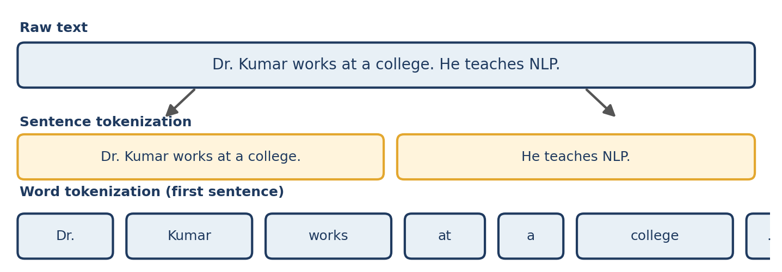
Figure 7.1 Two levels of tokenization applied to the same text.
Why not simply split on spaces?
Python’s str.split() separates text at whitespace. It is quick, but it leaves punctuation glued to words and cannot split contractions. Compare three tools on one sentence:
import spacy, nltk

s = "I'm learning NLP, e.g. Dr. Rao's class costs $5.50."

print(s.split())
print([t.text for t in spacy.blank("en")(s)])
print(nltk.word_tokenize(s))

Output
["I'm", 'learning', 'NLP,', 'e.g.', 'Dr.', "Rao's", 'class', 'costs', '$5.50.']
['I', "'m", 'learning', 'NLP', ',', 'e.g.', 'Dr.', 'Rao', "'s", 'class', 'costs', '$', '5.50', '.']
['I', "'m", 'learning', 'NLP', ',', 'e.g', '.', 'Dr.', 'Rao', "'s", 'class', 'costs', '$', '5.50', '.']

The differences are instructive:
- split() leaves “NLP,” and “$5.50.” as single tokens, with the comma and full stop attached. A vocabulary built from such tokens would treat “NLP,” and “NLP” as different words.
- spaCy separates the contractions (“I’m” into “I” and “’m”, “Rao’s” into “Rao” and “’s”) and the currency symbol and keeps the number “5.50” together. It keeps abbreviations such as “e.g.” and “Dr.” whole.
- NLTK makes the same decisions about contractions and currency but splits “e.g.” into “e.g” and a separate full stop.
Neither tokenizer is “wrong”; they apply different conventions. What matters is that the convention suits your task and that you use the same tokenizer for training and deployment. spaCy uses language-specific rules to handle punctuation, abbreviations such as Dr., e-mail addresses, currency symbols, numbers and special characters.
Subword tokens
Modern transformer models usually do not split text into whole words. They use subword tokenizers, which break rare words into smaller pieces so that any word can be represented from a fixed vocabulary. Chapter 21 explains this; the word-level tokenization taught here remains the foundation for classical methods such as Bag of Words and TF-IDF.

7.2 Creating Tokens with spaCy
Install spaCy with pip install spacy. For basic English tokenization you only need a blank pipeline, which contains a tokenizer but no trained components such as a part-of-speech tagger or named entity recogniser:
import spacy

nlp = spacy.blank("en")

text = "I am learning Natural Language Processing."
doc = nlp(text)

for token in doc:
print(token.text)

Output
I
am
learning
Natural
Language
Processing
.

- nlp(text) processes the input text.
- doc is a spaCy Doc object.
- Each item in the Doc is a token.
- token.text returns the original text of the token.
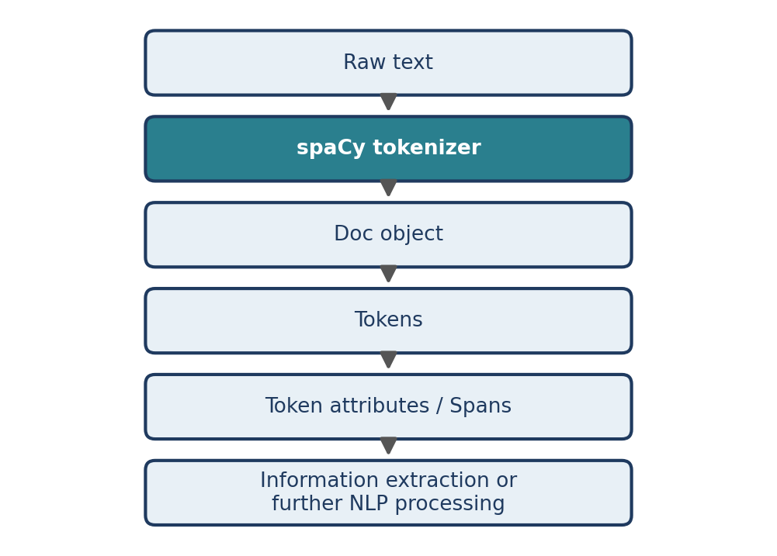
Figure 7.2 The tokenization workflow in spaCy.

7.3 Important spaCy Objects
Three objects appear in almost every spaCy program (Figure 7.3).
Doc
A Doc represents the complete processed text. It contains all tokens, their positions, sentence information, linguistic features and, when available, named entities.
Token
A Token is one individual unit of text, such as “Hello”, “,”, “123” or “$”.
Span
A Span is a continuous slice of a Doc, selected with ordinary Python slicing:
doc = nlp("I am learning Natural Language Processing.")
span = doc[3:5]
print(span.text)
print(len(doc), doc[0], type(span).__name__)

Output
Natural Language
7 I Span

The slice doc[3:5] selects tokens 3 and 4, following Python’s usual rule that the end index is excluded. A span is a convenient way to represent a phrase or part of a sentence, and spans are how spaCy represents named entities (Chapter 13).
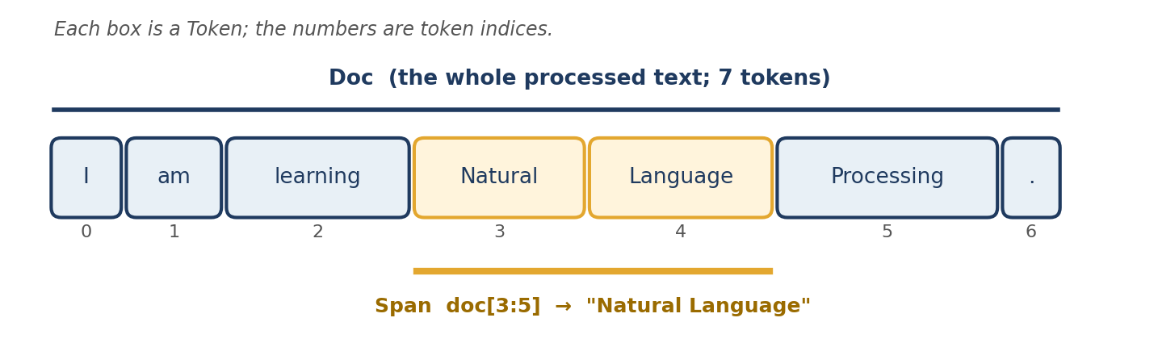
Figure 7.3 A Doc is a sequence of Tokens; a Span is a slice of it.

7.4 Token Attributes
Each token carries attributes that describe its type and properties. They let you find useful information without writing complicated regular expressions.
doc = nlp("The price is ₹500, and 20% off!")
for t in doc:
print(t.i, t.text, t.is_alpha, t.is_digit, t.is_punct, t.like_num, t.is_currency)

Output
0 The True False False False False
1 price True False False False False
2 is True False False False False
3 ₹ False False False False True
4 500 False True False True False
5 , False False True False False
6 and True False False False False
7 20 False True False True False
8 % False False True False False
9 off True False False False False
10 ! False False True False False

Attribute | True when the token is…
is_alpha | made only of letters
is_digit | made only of digits
is_punct | punctuation
like_num | a number or looks like one (including words such as “ten”)
is_currency | a currency symbol
is_stop | a stop word (Chapter 8)
is_space | whitespace
i | index of the token in the Doc (an integer)
Table 7.1 Frequently used token attributes.
Notice three things. The currency symbol “₹” is the only token with is_currency; the numbers “500” and “20” are both is_digit and like_num; and spaCy treats “%” as punctuation. Token attributes are descriptive rules, not understanding: they tell you what a token looks like, not what it means.

7.5 Extracting Specific Information
Attributes can extract numbers, currencies and similar details from unstructured text:
doc = nlp("The product costs ₹500 and weighs 2 kg.")
for token in doc:
if token.like_num or token.is_currency:
print(token.text)

Output
₹
500
2

This can help identify financial figures, quantities, dates, numerical values and currency symbols. Note that the output consists of separate tokens, not “₹500” as a unit. Because the symbol and the number are neighbours, a slice recovers the unit: doc[3:5].text is ₹500. More advanced extraction may require additional rules or NLP components.
Tokens remember their whitespace
spaCy does not discard the original spacing. Each token stores the whitespace that followed it, so the original text can be reconstructed exactly:
doc = nlp("Hello, world!")
print([(t.text, t.whitespace_) for t in doc])
print("".join(t.text_with_ws for t in doc) == doc.text)

Output
[('Hello', ''), (',', ' '), ('world', ''), ('!', '')]
True

7.6 Multilingual Tokenization
spaCy supports tokenization for many languages. A blank Hindi pipeline is created with the language code hi:
nlp_hi = spacy.blank("hi")
doc = nlp_hi("मुझे प्राकृतिक भाषा प्रसंस्करण सीखना है।")
for token in doc:
print(token.text)

Output
मुझे
प्राकृतिक
भाषा
प्रसंस्करण
सीखना
है
।

The Hindi sentence ends with the danda (“।”), which spaCy separates as its own token. Language-specific rules let spaCy handle each language’s punctuation and structure, which a one-size-fits-all splitter cannot.

7.7 Customising Tokenization
Sometimes the default tokenizer does not treat a word the way your application needs. You can add a special case, a rule that says how a particular string must be split. Suppose a corpus of chat messages contains the informal “lemme”, which you want to treat as two tokens, “lem” and “me”:
from spacy.symbols import ORTH

nlp = spacy.blank("en")
print([t.text for t in nlp("lemme see")]) # default behaviour

special_case = [{ORTH: "lem"}, {ORTH: "me"}]
nlp.tokenizer.add_special_case("lemme", special_case)
print([t.text for t in nlp("lemme see")]) # with the rule

Output
['lemme', 'see']
['lem', 'me', 'see']

The rule must be made of tokens whose texts, joined together, reproduce the original string exactly (“lem” + “me” = “lemme”). Custom rules are useful for domain-specific terms, slang, abbreviations, product names and technical words.
A note on the original example
The notes used add_special_case("NLP", [{ORTH: "NLP"}]). That rule tells the tokenizer to keep “NLP” as one token, which it already does by default, so the output does not change. The example above shows a rule that makes a real difference.

7.8 Sentence Segmentation
A blank spaCy pipeline provides tokenization but does not split text into sentences. Asking for doc.sents raises an error until sentence boundaries are set. The simplest remedy is the rule-based sentencizer component:
nlp = spacy.blank("en")
nlp.add_pipe("sentencizer")

text = "I am learning NLP. spaCy makes tokenization easy."
doc = nlp(text)

for sentence in doc.sents:
print(sentence.text)

Output
I am learning NLP.
spaCy makes tokenization easy.

The sentencizer starts a new sentence after sentence-ending punctuation such as a full stop, question mark or exclamation mark. Each sentence is a Span, so sentence.start and sentence.end give token positions.
What about abbreviations? The opening example contained “Dr. Kumar”, whose full stop must not end a sentence. It works here because spaCy’s tokenizer keeps “Dr.” as a single token, so the sentencizer never sees a stand-alone full stop:
for text in ["Dr. Kumar works at a college. He teaches NLP.",
"Is it 3.5 or 4? I think 4!"]:
print([s.text for s in nlp(text).sents])

Output
['Dr. Kumar works at a college.', 'He teaches NLP.']
['Is it 3.5 or 4?', 'I think 4!']

Pre-trained pipelines such as en_core_web_sm determine sentence boundaries with their dependency parser, which uses the grammar of the sentence and is generally more robust than punctuation rules on messy text (Chapter 12). NLTK provides nltk.sent_tokenize() for the same job; it uses a pre-trained model for abbreviations and produced the same sentence splits for the examples above.
Rule-based boundaries are heuristics
A punctuation-based rule can still be fooled, for example by an unusual abbreviation or by text with no punctuation at all (social-media posts, speech transcripts). Always inspect a sample of your own data.

7.9 Common Mistakes
- Using `split()` for real text. It leaves punctuation attached and cannot separate contractions (Section 7.1).
- Mixing tokenizers between training and deployment.
- Expecting sentences from a blank pipeline. Add sentencizer, or use a pre-trained pipeline (Section 7.8).
- Forgetting that whitespace can be a token. Double spaces produce space tokens (Section 6.2); clean first.
- Reading too much into attributes. like_num is True for “2” in “2 kg” as well as for “500” in “₹500”; check the context.
- Custom rules that do not reproduce the original string. The pieces of a special case must concatenate to the original text.

7.10 Chapter Summary
- Tokenization splits text into tokens (words, punctuation, numbers, symbols); sentence segmentation splits it into sentences.
- split() is not a real tokenizer. spaCy and NLTK apply language-specific rules but follow different conventions.
- In spaCy, nlp(text) returns a Doc of Token objects; a Span is a slice of a Doc.
- Token attributes such as is_alpha, like_num and is_currency support simple information extraction.
- spacy.blank("hi") and other language codes give language-specific tokenizers; add_special_case adds custom rules.
- A blank pipeline needs a sentencizer for sentence segmentation; pre-trained pipelines use the parser.

7.11 Review Questions and Exercises
- List three kinds of text that str.split() handles badly, and show what spaCy does with each.
- What is the difference between a Doc, a Token and a Span? Which one is doc[3:5]?
- Why does the sentencizer not split “Dr. Kumar” into two sentences?
- Why must the pieces of a special-case rule concatenate to the original string?
- Exercise. Tokenise “The U.K. costs $5.50, i.e. 3.5kg of state-of-the-art C++ code!” with spaCy and NLTK. Compare the outputs and describe each difference.
- Exercise. Write a function that takes a text and returns all tokens for which like_num is true, together with their index. Test it on a paragraph containing prices, quantities and a spelled-out number such as “ten”.
- Exercise. Add a special-case rule that splits “gimme” into “gim” and “me”, then test it. Then write one rule that you think would not work, and explain why.

Editorial note — remove before publication
From your notes: all 9 sections of “Tokenization in spaCy” (sentence and word tokenization, blank pipeline, creating tokens, Doc/Token/Span, token attributes, extracting information, multilingual tokenization, custom rules, sentence segmentation) and the tokenization workflow diagram; the sentence-segmentation and word-tokenization examples from the End-to-End Pipeline.
Correction for review: the notes’ special-case example (add_special_case("NLP", [{ORTH: "NLP"}])) changes nothing, because spaCy already keeps “NLP” as one token (verified). It is replaced by a “lemme” example that visibly changes the output; a note in Section 7.7 explains why.
Added: why split() is insufficient (three-way comparison), subword-token preview, whitespace storage, the attribute table, NLTK comparisons, behaviour of the sentencizer on abbreviations, common mistakes and exercises. Figure 7.1 to 7.3 are new. All code was run (spaCy 3.8.16, NLTK 3.x) and every output shown is real.

Chapter 8 Stop Words
Learning objectives
After studying this chapter you will be able to:
• define stop words and explain why they are sometimes removed;
• decide when stop-word removal helps and when it damages meaning;
• identify and remove stop words with spaCy, and apply the process to a pandas DataFrame;
• preserve important words such as “not” and customise a stop-word list;
• distinguish stop-word removal from stemming and lemmatization.

8.1 What Are Stop Words?
Stop words are very common words in a language that may contribute relatively little useful information to certain NLP tasks. Typical examples are:
- articles: a, an, the;
- prepositions: in, on, at;
- auxiliary verbs: is, are, was;
- conjunctions: and, but, or.
Consider the sentence “The student is learning machine learning in the classroom.” After removing selected stop words it becomes “student learning machine learning classroom”, which concentrates on the main content words (Figure 8.1).
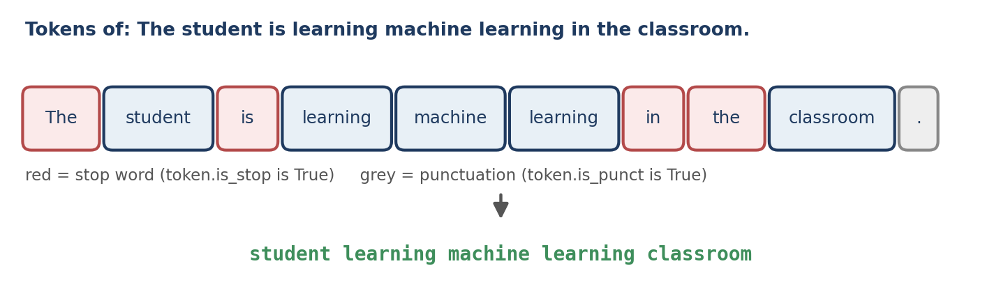
Figure 8.1 Stop-word removal: stop words (red) and punctuation (grey) are dropped, leaving the content words.
Important
Stop words are not always meaningless. Whether a word should be removed depends on the task and the context. A stop-word list is a convenience, not a law of language.

8.2 Why Remove Stop Words?
Reduce vocabulary size
Common words appear in nearly every document. Removing them reduces the number of features in count-based representations such as Bag of Words (Chapter 16).
Improve computational efficiency
A smaller vocabulary can reduce memory use and computation, particularly in traditional machine-learning workflows.
Focus on informative terms
For tasks such as basic document classification or keyword extraction, dropping some very frequent words helps the model concentrate on the more informative ones.
Technical correction
Removing stop words does not automatically make a Bag-of-Words matrix less sparse. It reduces the number of vocabulary features, but the percentage of zero entries (the sparsity) may rise or fall depending on the dataset.

TF-IDF (Chapter 18) offers a different way to deal with common words: instead of deleting them, it assigns them low weights. For many modern classifiers this makes explicit stop-word removal unnecessary.

8.3 When Not to Remove Stop Words
Stop-word removal is not appropriate for every application.
Sentiment analysis
Consider “The product is good.” and “The product is not good.” If every stop word is removed, spaCy’s stop list reduces both to the same text:
import spacy

nlp = spacy.load("en_core_web_sm")

def remove_stopwords(text):
return " ".join(t.text for t in nlp(text)
if not t.is_stop and not t.is_punct)

print(remove_stopwords("The product is good."))
print(remove_stopwords("The product is not good."))

Output
product good
product good

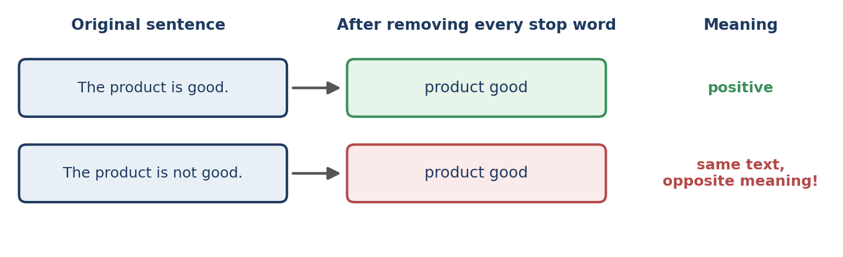
Figure 8.2 Removing “not” erases the difference between a positive and a negative review.
Two sentences with opposite sentiment have become identical. For sentiment analysis, negation words must be kept.
Machine translation
Small words carry grammatical information such as tense and relationships between words. Removing them damages the grammar and meaning of the translated sentence.
Chatbots and question answering
“Who is the president?” and “Who was the president?” ask different questions. With stop words removed, both become “president”:
print(remove_stopwords("Who is the president?"))
print(remove_stopwords("Who was the president?"))

Output
president
president

Other cases
Stop-word removal can also be inappropriate for text summarisation, speech-recognition transcripts, language modelling, grammar analysis, and search queries in which every term matters (for example, a query for the exact phrase “to be or not to be”).
Rule of thumb
Remove stop words only when doing so benefits your specific task, and verify the benefit by comparing results with and without removal.

8.4 Stop-Word Removal with spaCy
spaCy provides a built-in token property, token.is_stop, which is True when the token is a stop word according to the language’s stop list. Install spaCy and the English pipeline first (Section 3.3).
import spacy

nlp = spacy.load("en_core_web_sm")

text = "The student is learning machine learning in the classroom."
doc = nlp(text)

for token in doc:
print(token.text, token.is_stop)

Output
The True
student False
is True
learning False
machine False
learning False
in True
the True
classroom False
. False

- spacy.load("en_core_web_sm") loads the English pipeline.
- nlp(text) processes the text and creates a Doc.
- token.is_stop is True if the token is in spaCy’s stop list.
Note that “The” is flagged even though it is capitalised: the check is case-insensitive.
Stop lists differ between tools
There is no single official list of stop words. spaCy’s English list contains 326 words and NLTK’s contains 198; the two share 123 of them. Both include “not”. A word removed by one tool may be kept by another, so a pipeline’s results depend on the list it uses.
import nltk
nltk.download("stopwords") # one-time download
from nltk.corpus import stopwords

nltk_list = set(stopwords.words("english"))
spacy_list = nlp.Defaults.stop_words

print(len(spacy_list), len(nltk_list), len(nltk_list & spacy_list))

Output
326 198 123

These counts come from spaCy 3.8 and a recent NLTK release; they can change between versions.

8.5 Removing Stop Words with a List Comprehension
filtered_tokens = [
token.text
for token in doc
if not token.is_stop and not token.is_punct
]
print(filtered_tokens)

Output
['student', 'learning', 'machine', 'learning', 'classroom']

- not token.is_stop keeps tokens that are not stop words.
- not token.is_punct removes punctuation marks.
- token.text preserves the original spelling and capitalisation of the tokens that remain.
This example removes both stop words and punctuation. To remove only stop words, drop the second condition:
filtered_tokens = [token.text for token in doc if not token.is_stop]

8.6 A Reusable Cleaning Function
When processing many documents, define a function instead of repeating the logic.
def remove_stopwords(text):
doc = nlp(text)
return " ".join(
token.text
for token in doc
if not token.is_stop and not token.is_punct
)

print(remove_stopwords("The student is learning NLP in the classroom."))

Output
student learning NLP classroom

The function accepts text, processes it with spaCy, filters out stop words and punctuation, and joins the remaining tokens into a cleaned string.

8.7 Applying Stop-Word Removal to a pandas DataFrame
Real datasets contain many documents. In a pandas DataFrame, the .apply() method runs a function on every value in a column:
import pandas as pd

df = pd.DataFrame({
"text": [
"The movie was very good.",
"This product is not useful.",
"The student is learning NLP.",
]
})

df["cleaned_text"] = df["text"].apply(remove_stopwords)
print(df)

Output
text cleaned_text
0 The movie was very good. movie good
1 This product is not useful. product useful
2 The student is learning NLP. student learning NLP

Caution
Row 1 lost its “not”: “This product is not useful.” became “product useful”, which now reads as a compliment. If sentiment matters, preserve negation words (next section).

8.8 Preserving Important Words Such as “not”
You can keep selected words even when spaCy marks them as stop words:
def clean_text(text):
preserve = {"not", "no", "never"}
return " ".join(
token.text
for token in nlp(text)
if not token.is_punct
and (not token.is_stop or token.lower_ in preserve)
)

print([clean_text(t) for t in df["text"]])

Output
['movie good', 'product not useful', 'student learning NLP']

token.lower_ is the lower-case form of the token text, so “Not” and “NOT” are preserved as well. This is a simple example of task-specific preprocessing; your application may need to keep other words, such as question words in a chatbot.
Changing the stop list itself
spaCy stores the flag on the vocabulary entry, so you can change it for a word directly:
nlp.vocab["btw"].is_stop = True # add a custom stop word
nlp.vocab["not"].is_stop = False # stop treating "not" as a stop word

print([(t.text, t.is_stop) for t in nlp("btw this product is not useful")])

Output
[('btw', True), ('this', True), ('product', False), ('is', True), ('not', False), ('useful', False)]

This is often cleaner than filtering on a preserve set, because the change then applies everywhere is_stop is used.

8.9 Stop Words, Stemming and Lemmatization
Stop-word removal is sometimes confused with stemming and lemmatization (Chapter 9). They are different techniques with different purposes. They can be combined in a pipeline, but they are not interchangeable.
Technique | Purpose | Example
Stop-word removal | Removes selected common words | the student is running → student running
Stemming | Reduces a word to a stem, which may not be a valid word | studies → studi (with some stemmers)
Lemmatization | Converts a word to its dictionary base form | running → run (in an appropriate context)
Table 8.1 Three different preprocessing techniques.

8.10 Common Mistakes
- Removing stop words by default. Treat it as an experiment, not a ritual (Section 8.3).
- Losing negation. Check what your list does to “not”, “no”, “never” and similar words.
- Assuming all lists are alike. Lists differ between libraries and versions (Section 8.4); record which one you used.
- Using an English list for another language. Each language needs its own stop list.
- Expecting a smaller matrix to be less sparse (Section 8.2).
- Applying removal to the input of a transformer model, which was trained on complete sentences.

8.11 Chapter Summary
- Stop words are very common words that may add little information for some tasks. They are removed to shrink the vocabulary and focus on content words.
- Removal harms sentiment analysis, translation, question answering, summarisation and language modelling.
- In spaCy, token.is_stop flags stop words and token.is_punct flags punctuation; list comprehensions and DataFrame.apply() make filtering easy to scale.
- Keep negation words, or edit the stop list through nlp.vocab[word].is_stop.
- Stop lists vary between tools, and stop-word removal is distinct from stemming and lemmatization.

8.12 Review Questions and Exercises
- Give three examples of stop words and explain why removing them can reduce the vocabulary.
- Why can stop-word removal reverse the meaning of a review? Use an example from this chapter.
- What does not token.is_punct do in the list comprehension of Section 8.5?
- Explain why the NLTK and spaCy stop lists give different results on the same text.
- Exercise. Apply remove_stopwords() to ten sentences from a source you read and list every sentence whose meaning changed.
- Exercise. Write a version of clean_text() that also preserves question words (who, what, when, where, why, how) and test it on “Who is the president?” and “Who was the president?”. Are the outputs now different?
- Exercise. Using the DataFrame in Section 8.7, compare how many tokens remain in each document with and without stop-word removal. Compute the average reduction.

Editorial note — remove before publication
From your notes: all 10 sections of “Stop Words in NLP” — definition, reasons for removal, when to avoid, spaCy is_stop, list comprehension, reusable function, pandas DataFrame, preserving “not”, comparison with stemming and lemmatization — including your “technical correction” about sparsity.
Moved: stop words appeared after Bag of Words and Bag of N-grams in your notes; because they are a preprocessing step, they now precede the representation chapters.
Added: Figures 8.1 and 8.2, demonstrations of the negation and question-answering problems with real output, the spaCy-versus-NLTK stop-list comparison (counts verified), editing the stop list through nlp.vocab, the TF-IDF cross-reference, common mistakes and exercises. “Possible output” lines from the notes were replaced with real outputs (spaCy 3.8.16, en_core_web_sm 3.8.0, pandas).

Chapter 9 Stemming and Lemmatization
Learning objectives
After studying this chapter you will be able to:
• explain what stemming and lemmatization do and why NLP systems use them;
• apply the Porter, Snowball and Lancaster stemmers with NLTK and compare their output;
• lemmatize text with NLTK’s WordNet lemmatizer and with spaCy, and explain the role of part-of-speech information;
• customise lemmatization in spaCy with the attribute ruler;
• choose between stemming, lemmatization and neither for a given task.

9.1 Introduction
Text contains many forms of the same underlying word. Consider playing, plays, played and player. A system that needs to recognise the relationship between them must normalise the word forms. Two techniques do this: stemming and lemmatization. Both reduce words to a simpler base form, but they work very differently.
Normalising word forms helps tasks such as sentiment analysis, text classification, search engines, information retrieval, text summarisation and chatbots, because it reduces the number of distinct word forms the system has to learn.

9.2 Stemming
Definition
Stemming is a text preprocessing technique that removes prefixes or suffixes from words using predefined rules to obtain a stem. The stem does not have to be a valid word.
How stemming works
A stemming algorithm applies rule-based operations to strip word endings, and sometimes beginnings. Take “playing”: the algorithm recognises the suffix ing, removes it, and returns “play”. Figure 9.1 contrasts this with lemmatization, introduced below.
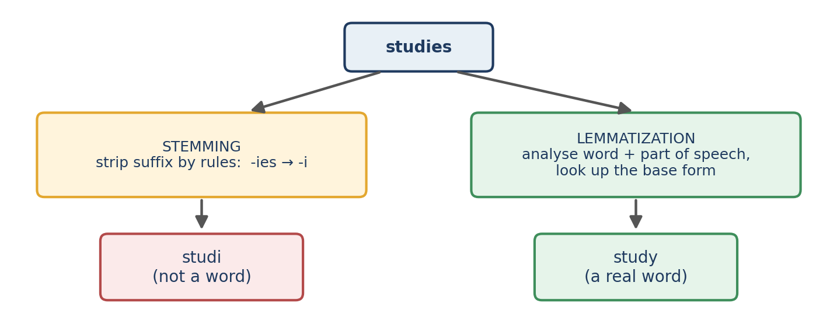
Figure 9.1 Stemming strips endings by rule and can produce non-words; lemmatization uses vocabulary and grammar to find the real base form.
Original word | Stem (Porter)
playing | play
played | play
studies | studi
connected | connect
happiness | happi
running | run
Table 9.1 Porter stems. The output depends on the algorithm and its rules.
Types of stemming algorithms
Stemmer | Characteristics
Porter | One of the most widely used algorithms. Applies a sequence of suffix-removal rules. Common for English text. Available in NLTK.
Snowball | An improved, multilingual stemming framework that supports several languages (Arabic, Danish, Dutch, English, Finnish and French among them). Available in NLTK.
Lancaster | Uses relatively aggressive rules and produces shorter stems. Can remove too much of a word.
Table 9.2 Three common stemmers.
Python implementation with NLTK
from nltk.stem import PorterStemmer

stemmer = PorterStemmer()
words = ["playing", "played", "studies", "connected", "happiness"]

for word in words:
print(word, "->", stemmer.stem(word))

Output
playing -> play
played -> play
studies -> studi
connected -> connect
happiness -> happi

PorterStemmer() creates a stemmer object that applies Porter’s predefined rules, and stem() returns the stem of one word. Stemmers work on one word at a time, so you must tokenise first (Chapter 7).
Comparing the three stemmers
from nltk.stem import PorterStemmer, SnowballStemmer, LancasterStemmer

porter, snowball, lancaster = (PorterStemmer(),
SnowballStemmer("english"),
LancasterStemmer())

for w in ["playing", "studies", "happiness", "university",
"better", "ate", "mice", "generously"]:
print(f"{w:12}{porter.stem(w):12}{snowball.stem(w):12}{lancaster.stem(w)}")

Output
playing play play play
studies studi studi study
happiness happi happi happy
university univers univers univers
better better better bet
ate ate ate at
mice mice mice mic
generously gener generous gen

Reading the table: Porter and Snowball agree on most of these words, although Snowball keeps “generous” where Porter cuts to “gener”. Lancaster is more aggressive: it turns “better” into “bet” and “mice” into “mic”, which are different words altogether, but it happens to give the real words “study” and “happy” for “studies” and “happiness”. No stemmer is right for all purposes, so test on your own task.
Over-stemming and under-stemming
- Over-stemming merges words that should stay apart. Porter maps both “universe” and “university” to “univers”, and Lancaster’s “bet” for “better” is an extreme case.
- Under-stemming leaves related forms separate. Porter leaves “ate” unchanged, so it is not linked with “eat” or “eating”, which both become “eat”.
Advantages and disadvantages
Advantages | Disadvantages
Fast and computationally efficient | May produce words that are not in the dictionary
Simple to implement | Can remove too many or too few characters
Reduces variation among word forms | Does not understand meaning or context
Useful for large-scale information retrieval | May merge words with different meanings
Table 9.3 Stemming: advantages and disadvantages.

9.3 Lemmatization
Definition
Lemmatization converts a word into its linguistically valid base form, called a lemma. Unlike stemming, it uses linguistic information: vocabulary, morphology and, in some systems, grammatical context.
How lemmatization works
A lemmatizer analyses a word form and identifies its dictionary base form. It can handle irregular forms that no suffix rule can: “ate” becomes “eat” and “mice” becomes “mouse”, rather than the word simply losing characters.
Original word | Lemma
playing | play
played | play
studies | study
better | good*
am | be
ate | eat
mice | mouse
cars | car
Table 9.4 Typical lemmas. *The lemma of “better” depends on the grammatical context and on the tool (see below).
The importance of part-of-speech information
The part of speech (POS) identifies a word’s grammatical role: noun, verb, adjective, adverb and so on (Chapter 11). Many words have different lemmas in different roles, so POS information improves lemmatization. NLTK’s WordNet lemmatizer treats every word as a noun unless told otherwise:
import nltk
nltk.download("wordnet") # one-time download
from nltk.stem import WordNetLemmatizer

lemmatizer = WordNetLemmatizer()

print(lemmatizer.lemmatize("ate"), lemmatizer.lemmatize("better"))
print(lemmatizer.lemmatize("ate", pos="v"))
print(lemmatizer.lemmatize("better", pos="a"), lemmatizer.lemmatize("better", pos="v"))
print(lemmatizer.lemmatize("playing", pos="v"), lemmatizer.lemmatize("am", pos="v"))

Output
ate better
eat
good better
play be

Without POS information, “ate” and “better” are unchanged. With the verb tag, “ate” becomes “eat”. “better” becomes “good” as an adjective (pos="a") but stays “better” as a verb, which is the behaviour the original notes described. POS tags in NLTK’s lemmatizer are n (noun), v (verb), a (adjective) and r (adverb).
Lemmatization with spaCy
spaCy’s pre-trained pipelines determine part of speech automatically and use it to select lemmas, so you do not have to supply tags yourself. Install spaCy and download the English model first (Section 3.3):
import spacy

nlp = spacy.load("en_core_web_sm")

text = "The children were playing and ate apples."
doc = nlp(text)

for token in doc:
print(token.text, "->", token.lemma_)

Output
The -> the
children -> child
were -> be
playing -> play
and -> and
ate -> eat
apples -> apple
. -> .

- spacy.load() loads the pre-trained English pipeline.
- nlp(text) processes the text, including POS tagging.
- token.text is the original token and token.lemma_ is its lemma (the trailing underscore returns the string; token.lemma is a numeric hash).
The spaCy lemmatizer in this pipeline is rule-based: it applies rules and exception tables using the part of speech assigned earlier in the pipeline. A blank pipeline has neither a tagger nor a lemmatizer, so lemmas are empty:
print([t.lemma_ for t in spacy.blank("en")("running shoes")])

Output
['', '']

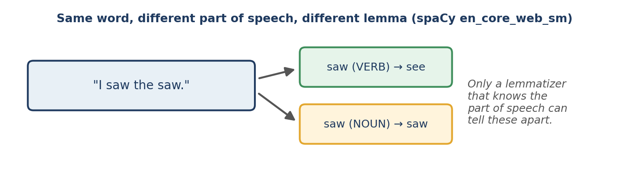
Figure 9.2 The same word form receives different lemmas depending on its part of speech.
The next example shows why context matters. In “I saw the saw”, the first “saw” is a verb (past tense of “see”) and the second is a noun:
for t in nlp("I saw the saw"):
print(t.text, t.pos_, t.lemma_)

Output
I PRON I
saw VERB see
the DET the
saw NOUN saw

A stemmer would treat both occurrences identically, because it never looks at the sentence. Part-of-speech tagging itself is the subject of Chapter 11.
The lemma of “better” depends on the tool
The original notes list “better → good”. That is what NLTK’s WordNet lemmatizer returns for an adjective. spaCy’s en_core_web_sm pipeline, in our test on “The better player is running happily.”, tagged “better” as an adjective and returned “well”. Both are defensible lemmatizations; the lesson is to inspect the output of the tool you use instead of assuming a textbook answer.

Advantages and disadvantages
Advantages | Disadvantages
Produces valid base forms in many cases | Usually requires more computation than stemming
Preserves word meaning more reliably | Needs a dictionary, language model or other linguistic resource
Can use grammatical information | Slower than stemming
Valuable when accurate normalisation matters | Accuracy depends on the language, model and context available
Table 9.5 Lemmatization: advantages and disadvantages.

9.4 Customising Lemmatization in spaCy
Pre-trained models do not always handle slang, abbreviations, informal expressions or specialised terminology. A model may not know that “bro” should map to “brother”, or that a domain-specific abbreviation should map to its full form. We can add rules.
The spaCy pipeline
A spaCy pipeline is a sequence of components that process text in order. The pipeline we have used contains these components (Chapter 10 treats them in detail):
- tok2vec produces vector representations that later components share;
- tagger assigns grammatical tags;
- parser analyses grammatical structure;
- attribute_ruler applies rules to token attributes, including grammatical ones;
- lemmatizer determines the base form of a token;
- ner recognises named entities.
Custom lemmas with the AttributeRuler
nlp = spacy.load("en_core_web_sm")

print([(t.text, t.lemma_) for t in nlp("My bro is helpful.")])

ruler = nlp.get_pipe("attribute_ruler")
ruler.add(
patterns=[[{"LOWER": "bro"}]],
attrs={"LEMMA": "brother"}
)

print([(t.text, t.lemma_) for t in nlp("My bro is helpful.")])
print([(t.text, t.lemma_) for t in nlp("Bro, my BRO and bros.")])

Output
[('My', 'my'), ('bro', 'bro'), ('is', 'be'), ('helpful', 'helpful'), ('.', '.')]
[('My', 'my'), ('bro', 'brother'), ('is', 'be'), ('helpful', 'helpful'), ('.', '.')]
[('Bro', 'brother'), (',', ','), ('my', 'my'), ('BRO', 'brother'), ('and', 'and'), ('bros', 'bros'), ('.', '.')]

- The pre-trained pipeline is loaded and its attribute_ruler component is retrieved.
- The pattern {"LOWER": "bro"} matches any token whose lower-case form is “bro”.
- The rule assigns the lemma “brother”.
The third line shows both the strength and the limit of the rule: “Bro” and “BRO” are handled, but “bros” is not, because the pattern matches the exact lower-case form “bro”. Add a rule for each form you need, and test custom rules on varied text so they do not fire in unintended contexts.

9.5 Stemming versus Lemmatization
Feature | Stemming | Lemmatization
Method | Removes word affixes using rules | Finds a linguistically valid base form
Output | A stem | A lemma
Dictionary knowledge | Usually not required | Commonly uses linguistic resources
Context awareness | Generally absent | May use part of speech and grammatical context
Accuracy | Less linguistically precise | Generally more precise
Speed | Usually faster | Usually slower
Output validity | May be a non-word | Typically a valid word
Complexity | Simple | More complex
Best suited for | Fast normalisation | Meaning-sensitive processing
Table 9.6 Stemming versus lemmatization.
Word | Stemming (Porter) | Lemmatization
studies | studi | study
happiness | happi | happiness (WordNet)
ate | ate | eat
mice | mice | mouse
running | run | run (as a verb)
Table 9.7 Typical outputs of Porter stemming and English lemmatization. Results vary with the algorithm, model and part-of-speech information.
Stemming and lemmatization in a search example
Which is better for search? It depends. Compare how a query and a document are normalised:
query, document = "running shoes", "She runs in new shoe"

print([porter.stem(w) for w in query.split()])
print([porter.stem(w) for w in document.lower().split()])
print([t.lemma_ for t in nlp(query)])
print([t.lemma_ for t in nlp(document)])

Output
['run', 'shoe']
['she', 'run', 'in', 'new', 'shoe']
['running', 'shoe']
['she', 'run', 'in', 'new', 'shoe']

The stemmer maps “running” and “runs” to the same stem “run”, so the query matches the document. The lemmatizer gives “run” for “runs” in the document but keeps “running” in the query, where it is used as a modifier of “shoes”, so the two lemmas differ. Here the cruder stemmer matches more reliably. This is why search systems still use stemming widely, and a reminder that “more linguistically precise” does not always mean “better for the task”.

9.6 Applications
Application | How normalisation helps
Sentiment analysis | Normalises word variations when identifying positive or negative opinions.
Search engines | Improves matching between a query and documents containing different forms of a word.
Text classification | Normalises the text features used to classify e-mails, reviews, news articles and other documents.
Information retrieval | Reduces vocabulary variation and improves document matching.
Chatbots | Helps process different forms of the words in user messages.
Text analytics | Supports counting the frequent terms across large collections.
Table 9.8 Where stemming and lemmatization are used.
Neither technique is always necessary. Modern transformer-based models, which use subword representations learned from very large text collections, can process word variations without explicit stemming or lemmatization, and applying them before such a model usually does not help.

9.7 Common Mistakes
- Treating stems as words. Stems like “studi” and “happi” are for matching, not for display to users.
- Lemmatizing without part of speech. NLTK’s WordNet lemmatizer defaults to nouns and leaves “ate” unchanged.
- Using an English stemmer on another language. Use the Snowball stemmer for the right language, or a language-specific tool.
- Ignoring over-stemming. Always inspect which different words collapse into the same stem.
- Expecting lemmas from a blank spaCy pipeline (Section 9.3).
- Applying both blindly. Stemming a lemmatized text is usually pointless; choose one.
- Assuming textbook outputs. Verify the behaviour of your own tool and version.

9.8 Chapter Summary
- Stemming removes affixes using rules to produce stems that need not be words; it is fast but crude.
- NLTK offers the Porter, Snowball and Lancaster stemmers; Lancaster is the most aggressive.
- Lemmatization returns the dictionary base form using vocabulary, morphology and, often, part-of-speech information.
- spaCy lemmatizes using the part of speech assigned by its tagger; NLTK’s WordNet lemmatizer needs the POS supplied.
- The attribute ruler lets you add custom lemma rules for slang and domain terms.
- Choose by task: stemming for fast matching (search), lemmatization for meaning-sensitive work, and neither for modern transformer models.

9.9 Review Questions and Exercises
- Define stem and lemma, and give an example in which they differ.
- Why does Porter leave “ate” unchanged while a lemmatizer produces “eat”?
- What does over-stemming mean? Give an example from Section 9.2.
- Explain, using “I saw the saw”, why part-of-speech information matters for lemmatization.
- Exercise. Run the three NLTK stemmers on 20 words from a text of your choice. Which words does each stemmer treat differently? Which stemmer would you pick for a search engine?
- Exercise. Write a function normalize(text, method) that tokenises with spaCy and returns either the stems (Porter) or the lemmas, depending on method. Compare the vocabulary sizes produced by the two methods on a paragraph.
- Exercise. Add attribute-ruler rules that map “gonna” to “going” and “u” to “you”. Test them on several sentences, including one where the rule should not apply, and describe what you find.

Editorial note — remove before publication
From your notes: all 7 sections of “Stemming and Lemmatization in NLP” — introduction, stemming (definition, mechanics, Porter, Snowball, Lancaster, pros and cons, NLTK code), lemmatization (definition, POS, pros and cons, spaCy code), customising with AttributeRuler, comparison tables, applications, and the note that transformers may not need either technique.
Corrections for review: (1) the comparison table in your notes lists “Python library: NLTK / spaCy”. That row is misleading, because NLTK also provides a lemmatizer (WordNetLemmatizer) and spaCy has no stemmer, so it was replaced by the tool comparisons shown in this chapter. (2) “better → good” holds for NLTK’s WordNet lemmatizer with an adjective tag; spaCy’s en_core_web_sm returned “well” in our test (see the box in Section 9.3).
Replaced “Possible output” in the notes with real output from running the code (NLTK 3.x, spaCy 3.8.16, en_core_web_sm 3.8.0). Added: the three-stemmer comparison, over- and under-stemming, WordNet POS demonstration, the “saw” example, the blank-pipeline note, the search-matching example, Figures 9.1 and 9.2, common mistakes and exercises.

