NATURAL LANGUAGE PROCESSING FUNDAMENTALS
From Text Preprocessing to Word Embeddings, with Python
Draft manuscript — Part II: Rule-Based Text Processing
Chapter 5 · Regular Expressions for Text Extraction
[Author name — to be supplied]
Contents
Part II Rule-Based Text Processing 3
Chapter 5 Regular Expressions for Text Extraction 4
5.1 Introduction 4
5.2 What Is a Regular Expression? 4
5.3 Regex Symbols 6
5.4 Application: Customer-Service Chatbots 7
5.5 Handling Different Phone-Number Formats 8
5.6 Information Extraction from Unstructured Text 10
5.7 Capturing Groups 11
5.8 Escape Characters 12
5.9 Reusable Extraction Functions 13
5.10 Best Practices 14
5.11 Limitations of Regex 14
5.12 Common Mistakes 15
5.13 Chapter Summary 15
5.14 Review Questions and Exercises 15

Part II Rule-Based Text Processing
Before machine learning, the most direct way to make a computer find information in text was to describe what that information looks like. Part II teaches the most important tool for that approach, regular expressions. Even in an age of neural networks, regular expressions remain valuable: they are fast, transparent and free, and they often serve as the first step of a larger pipeline.

Chapter 5 Regular Expressions for Text Extraction
Learning objectives
After studying this chapter you will be able to:
• explain what a regular expression is and where it fits among NLP techniques;
• read and write patterns using character classes, quantifiers, anchors, groups and escapes;
• use Python’s re module to search, extract and replace text;
• extract order numbers, e-mail addresses, phone numbers and structured fields from messages;
• recognise the limits of rule-based extraction and know when to move to other methods.

5.1 Introduction
Regular expressions, commonly called regex, are a technique for finding and extracting specific patterns from text. They are the best-known example of the first approach introduced in Section 1.4: rules and heuristics.
Text data is usually unstructured. A customer message may contain an order number, a phone number and an e-mail address mixed in with ordinary sentences. Regex lets a program locate the information it needs by applying predefined rules.
Consider this message:
Hello, my name is Mani. My order number is ORD12345. Please contact me at 9876543210.

A regex-based program can extract the following:
Information | Extracted value
Name | Mani
Order number | ORD12345
Phone number | 9876543210
Table 5.1 Information a regex program can extract from the message above.
The program does not need to understand the meaning of the whole message. It only needs to recognise the patterns that match its rules. This is both the great strength of regex (simplicity and speed) and its great weakness (no understanding), as Section 5.11 explains.

5.2 What Is a Regular Expression?
A regular expression is a sequence of characters that defines a search pattern. In Python, regular expressions are provided by the built-in re module.
import re

text = "My order number is 12345"
pattern = r"\d+"

result = re.search(pattern, text)
print(result.group())

Output
12345

Code explanation
- import re imports Python’s regular-expression module.
- r"\d+" defines the pattern. The r before the quotation mark makes it a raw string (Section 5.8).
- \d matches one digit from 0 to 9.
- + means “one or more of the preceding item”, so \d+ matches a run of digits.
- re.search() scans the text and returns a match object for the first place the pattern matches, or None if there is no match.
- group() returns the matched text.
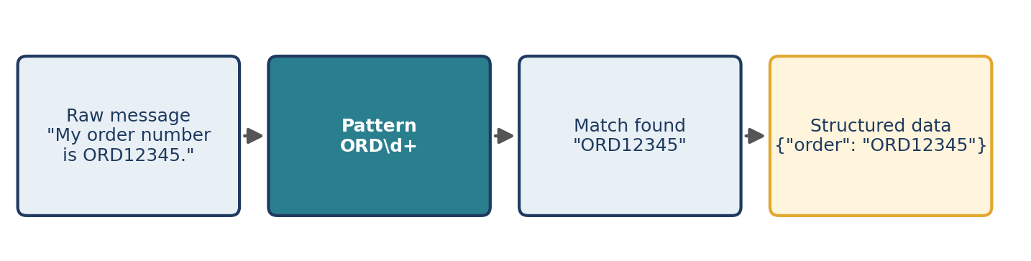
Figure 5.1 A regex program turns an unstructured message into structured data through a pattern.
The main functions of the re module
Function | What it does | Returns
re.search(p, text) | Finds the first match anywhere in the text | A match object or None
re.match(p, text) | Matches only at the start of the text | A match object or None
re.findall(p, text) | Finds all non-overlapping matches | A list of strings (or tuples when the pattern has groups)
re.finditer(p, text) | Like findall, but yields match objects (with positions) | An iterator of match objects
re.sub(p, repl, text) | Replaces every match with repl | A new string
re.compile(p) | Pre-compiles a pattern for reuse | A pattern object
Table 5.2 Core functions of Python’s re module.
print(re.search(r"\d+", "abc123").group()) # search looks anywhere
print(re.match(r"\d+", "abc123")) # match needs the start
print(re.sub(r"\d+", "<NUM>", "Order 12 costs 450 rupees"))
print([m.span() for m in re.finditer(r"ORD\d+", "ORD1 and ORD22")])

Output
123
None
Order <NUM> costs <NUM> rupees
[(0, 4), (9, 14)]

The second line prints None because re.match() requires the pattern to match at position 0, and the text begins with “abc”. Section 5.12 returns to this common source of confusion.

5.3 Regex Symbols
A pattern is built from ordinary characters, which match themselves, and special symbols, which match classes of characters or control repetition and position. Table 5.3 lists the essential symbols with examples.
Symbol | Name | Meaning | Pattern | Matches in the sample text
\d | Digit | Any digit 0–9 | \d+ | 12, 450 in “Pay 450 by 12 Oct”
\w | Word character | Letter, digit or underscore | \w+ | Hi, NLP_2, rocks in “Hi, NLP_2 rocks!”
\s | Whitespace | Space, tab, newline | \s | the spaces and tab in “a b⇥c”
\b | Word boundary | Edge between a word character and a non-word character | \bbank\b | bank, bank in “The bank by the river bank”
. | Wildcard | Any character except a newline | c.t | cat, cut, c9t
* | Zero or more | Previous item 0 or more times | a* | “”, a, aa, aaa…
+ | One or more | Previous item 1 or more times | a+ | a, aa, aaa
? | Optional | Previous item 0 or 1 time | colou?r | color, colour
{n} | Exact count | Previous item exactly n times | \d{4} | 1931
[ ] | Character class | Any one character from the set | [aeiou] | a, e, i, o, u
[^ ] | Negated class | Any one character not in the set | [^0-9] | any non-digit
^ | Start anchor | Match must be at the start | ^Hello | Hello world
$ | End anchor | Match must be at the end | world$ | Hello world
| | Alternation (OR) | Either the left or the right expression | cat|dog | cat, dog
( ) | Capturing group | Groups items and captures the match | (Mr|Ms) | Mr, Ms
\. | Escaped dot | A literal period | \. | .
Table 5.3 Essential regex symbols. The ⇥ sign stands for a tab character.
print(re.findall(r"\d+", "Pay 450 by 12 Oct"))
print(re.findall(r"c.t", "cat cut c9t"))
print(re.findall(r"colou?r", "color colour"))
print(re.findall(r"[^0-9]", "a1b2"))
print(re.findall(r"cat|dog", "cat dog cow"))
print(re.findall(r"(Mr|Ms)\. (\w+)", "Mr. Rao and Ms. Devi"))

Output
['450', '12']
['cat', 'cut', 'c9t']
['color', 'colour']
['a', 'b']
['cat', 'dog']
[('Mr', 'Rao'), ('Ms', 'Devi')]

Greedy versus lazy matching
Quantifiers such as * and + are greedy by default: they match as much text as possible. Adding ? after them makes them lazy, matching as little as possible.
print(re.findall(r"<.+>", "<b>bold</b>")) # greedy
print(re.findall(r"<.+?>", "<b>bold</b>")) # lazy

Output
['<b>bold</b>']
['<b>', '</b>']

The greedy pattern swallows everything between the first < and the last >. The lazy pattern stops at the first > it can. Whenever a pattern captures more than you expected, suspect greediness.
A complete pattern combines several symbols. The pattern ORD\d+, for example, means “the letters ORD followed by one or more digits”.

5.4 Application: Customer-Service Chatbots
One important use of regex is extracting information from customer messages. Suppose a customer writes:
I want to track my order. My order number is ORD12345.

A chatbot can use regex to extract ORD12345 and pass that order number to the order-tracking system. Typical items extracted from messages are order numbers (from tracking requests), phone numbers (in different formats) and e-mail addresses.
Extracting an order number
import re

message = "Please track order ORD12345"
pattern = r"ORD\d+"

match = re.search(pattern, message)
if match:
print(match.group())

Output
ORD12345

The pattern means the text must contain the letters ORD followed by one or more digits. The if match: test matters: when nothing matches, re.search() returns None, and calling .group() on None raises an AttributeError.
Word boundaries
Without further care, ORD\d+ would also match inside a longer token such as “xORD34”. Adding \b at both ends requires the order number to stand alone:
print(re.findall(r"\bORD\d+\b", "ORD12 xORD34 ORD56x"))

Output
['ORD12']

Extracting an e-mail address
message = "Hello, my order number is ORD12345. Contact me at mani@example.com"
print(re.findall(r"[\w.+-]+@[\w-]+(?:\.[\w-]+)+", message))

Output
['mani@example.com']

The pattern reads: one or more letters, digits, dots, plus signs or hyphens; an @; a domain label; and then one or more .label parts. It is a practical extractor, not a full implementation of the e-mail standard.

5.5 Handling Different Phone-Number Formats
Customers write the same phone number in many ways:
- 9876543210
- 987-654-3210
- 987 654 3210
- +91 9876543210
A flexible pattern allows an optional country code and optional spaces or hyphens between the digit groups.
import re

text = "Contact me at +91 987-654-3210"
pattern = r"(?:\+91[\s-]?)?\d{3}[\s-]?\d{3}[\s-]?\d{4}"

match = re.search(pattern, text)
if match:
print(match.group())

Output
+91 987-654-3210

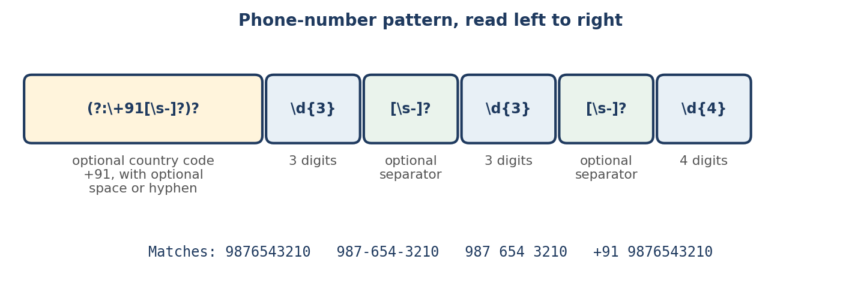
Figure 5.2 Anatomy of the phone-number pattern.
How the pattern works
- (?: ... ) groups part of the pattern without capturing it.
- \+91 matches the literal country code +91 (the plus sign must be escaped).
- The ? after the group makes the whole country-code part optional.
- [\s-]? allows one optional whitespace character or hyphen.
- \d{3} matches exactly three digits.
- The final \d{4} matches the last four digits.
This pattern is illustrative, not a validator
It matches the four formats above, but it does not match a number written with a 5 + 5 grouping such as “+91 98765 43210”. It will also match the first ten digits of a longer digit string. Production systems must validate country codes, allowed lengths and other business rules.

The second weakness can be reduced with lookarounds. (?<!\d) means “not preceded by a digit” and (?!\d) means “not followed by a digit”:
strict = r"(?<!\d)(?:\+91[\s-]?)?\d{3}[\s-]?\d{3}[\s-]?\d{4}(?!\d)"

print(re.search(strict, "id 12345678901234"))
print(re.search(strict, "call +91 987-654-3210 now").group())

Output
None
+91 987-654-3210

5.6 Information Extraction from Unstructured Text
Information extraction is the process of retrieving specific, useful information from raw text and converting it into a structured format. Take this input:
A. P. J. Abdul Kalam was born on 15 October 1931 in Rameswaram, Tamil Nadu. He was an Indian aerospace scientist and served as the 11th President of India.

The goal is to produce a table of fields and values:
Field | Value
Name | A. P. J. Abdul Kalam
Birth date | 15 October 1931
Birthplace | Rameswaram, Tamil Nadu
Profession | Aerospace scientist
Table 5.4 The structured result we want from the biography.
The same idea applies to Wikipedia articles, news articles, résumés and many other documents. Figure 5.3 shows the workflow.
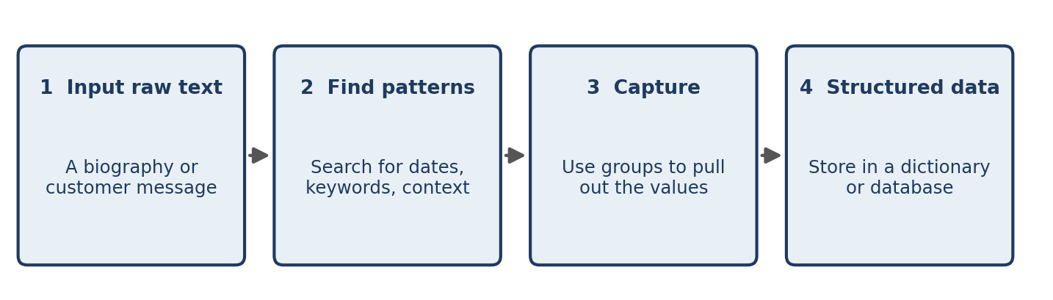
Figure 5.3 The information-extraction workflow.
Here is one way to implement it. The pattern uses named groups ((?P<name>...)), which let us retrieve values by name instead of by position:
bio = ("A. P. J. Abdul Kalam was born on 15 October 1931 in Rameswaram, "
"Tamil Nadu. He was an Indian aerospace scientist and served as "
"the 11th President of India.")

pattern = (r"^(?P<name>.+?) was born on "
r"(?P<birth_date>\d{1,2} [A-Z][a-z]+ \d{4}) in "
r"(?P<birthplace>[^.]+)\.\s+"
r"He was an? (?:\w+ )?(?P<profession>.+?) and served")

match = re.search(pattern, bio)
print(match.groupdict())

Output
{'name': 'A. P. J. Abdul Kalam', 'birth_date': '15 October 1931', 'birthplace': 'Rameswaram, Tamil Nadu', 'profession': 'aerospace scientist'}

The pattern encodes the exact sentence structure of this one biography: “… was born on DATE in PLACE. He was an ADJECTIVE PROFESSION and served …”. It works for this text and for others written in the same style, and it fails for any other phrasing. That limitation is the central lesson of rule-based extraction, and the reason Chapter 13 introduces named entity recognition.

5.7 Capturing Groups
Parentheses ( ) capture the part of the text that matches the enclosed sub-pattern. This is especially useful when you want to extract separate fields from one sentence.
import re

text = "Name: Mani, Age: 21"
pattern = r"Name:\s*(\w+),\s*Age:\s*(\d+)"

match = re.search(pattern, text)
if match:
print("Name:", match.group(1))
print("Age:", match.group(2))

Output
Name: Mani
Age: 21

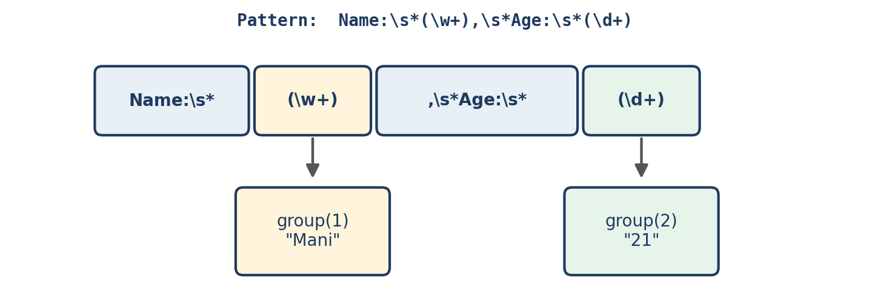
Figure 5.4 Each pair of parentheses defines a numbered group that captures part of the match.
Groups are numbered from left to right by their opening parenthesis. match.group(0) returns the whole match ('Name: Mani, Age: 21'), group(1) the first group, and match.groups() all groups as a tuple: ('Mani', '21').
A common trap: findall with groups
When a pattern contains capturing groups, re.findall() returns the groups, not the whole match:
print(re.findall(r"(\w+)@(\w+)\.com", "a@x.com b@y.com"))

Output
[('a', 'x'), ('b', 'y')]

If you want the whole match but need grouping for structure, use non-capturing groups (?: ... ), as in the e-mail and phone patterns above.

5.8 Escape Characters
Some characters have special meanings in regex: ., +, *, ?, (, ), [, ], {, }, |, ^, $ and the backslash itself. To match one of them literally, put a backslash in front of it.
text = "Hello. Welcome to NLP."
print(re.findall(r"\.", text))

Output
['.', '.']

Without the backslash, . would match every character. Table 5.5 lists the common escape sequences.
Regex | Meaning
\d | A digit
\w | A word character (letter, digit, underscore)
\s | Whitespace
\. | A literal period
\+ | A literal plus sign
\( | A literal opening parenthesis
\) | A literal closing parenthesis
Table 5.5 Common escape sequences.
Why raw strings?
In Python, a backslash inside an ordinary string is already an escape character ("\n" is a newline). Writing the pattern as a raw string, r"\d+", preserves backslashes so they reach the regex engine unchanged. Always write patterns as raw strings.
print(len("\n"), len(r"\n"))

Output
1 2

The ordinary string "\n" has length 1, a single newline character. The raw string r"\n" has length 2: a backslash and the letter n.

5.9 Reusable Extraction Functions
Rather than writing a new pattern for every message, wrap your logic in functions that accept any text and return structured results.
import re

def extract_info(text):
pattern = r"Name:\s*(\w+),\s*Age:\s*(\d+)"
match = re.search(pattern, text)
if match:
return {
"name": match.group(1),
"age": int(match.group(2))
}
return None

print(extract_info("Name: Mani, Age: 21"))
print(extract_info("no data here"))

Output
{'name': 'Mani', 'age': 21}
None

The function returns a dictionary on success and None on failure, and it converts the age to an integer. It can be reused for any message that follows the same format.
A larger example combines the patterns of this chapter. Compiling the patterns once with re.compile() avoids rebuilding them on every call:
ORDER_RE = re.compile(r"\bORD\d+\b")
EMAIL_RE = re.compile(r"[\w.+-]+@[\w-]+(?:\.[\w-]+)+")
PHONE_RE = re.compile(
r"(?<!\d)(?:\+91[\s-]?)?\d{3}[\s-]?\d{3}[\s-]?\d{4}(?!\d)")

def extract_contact_info(message):
return {
"orders": ORDER_RE.findall(message),
"emails": EMAIL_RE.findall(message),
"phones": PHONE_RE.findall(message),
}

msg = ("Hello, my order number is ORD12345. "
"Contact me at mani@example.com or +91 987-654-3210.")
print(extract_contact_info(msg))

Output
{'orders': ['ORD12345'], 'emails': ['mani@example.com'], 'phones': ['+91 987-654-3210']}

5.10 Best Practices
- Test patterns before using them. Tools such as Regex101 (regex101.com) show matches and explain how a pattern works, which makes patterns far easier to create and debug.
- Escape special characters when you want them literally, for example \. for a period.
- Write raw strings and compile patterns you use repeatedly.
- Build reusable functions that take text and return structured data.
- Validate extracted data. A match only means that the text fits the pattern. It does not guarantee that the information is correct or exists in the real world: ORD99999999 may match, yet no such order may exist.
- Document complex patterns. Python’s re.VERBOSE flag lets you spread a pattern over several lines with comments:
phone = re.compile(r"""
(?:\+91[\s-]?)? # optional country code
\d{3}[\s-]? # first three digits
\d{3}[\s-]? # next three digits
\d{4} # last four digits
""", re.VERBOSE)

print(phone.search("call 987-654-3210").group())

Output
987-654-3210

5.11 Limitations of Regex
Regex is useful for rule-based extraction, but it is not a replacement for machine learning or language understanding.
- It works best when information follows predictable patterns.
- It fails when people use unexpected wording or spelling.
- It does not understand the meaning of a sentence.
- Complex tasks such as detecting sarcasm or answering open questions need machine learning or deep learning.
Example of meaning. Regex can find the word “bank” in a sentence, but it cannot reliably tell whether the sentence is about a financial institution or a riverbank without additional context.
Example of variation. The pattern ORD\d+ finds “ORD12345” but misses a customer who types “ord 12345”:
msg = "my order is ord 12345"
print(re.search(r"ORD\d+", msg))
print(re.search(r"\bORD\s*\d+\b", msg, re.IGNORECASE).group())

Output
None
ord 12345

The second pattern tolerates optional spaces and any capitalisation. Each such repair adds complexity, and a rule set that must anticipate every variation quickly becomes difficult to maintain. At that point the statistical and neural methods of later chapters become more attractive. Many real systems use both: regex for rigidly formatted items such as IDs, and learned models for everything else.

5.12 Common Mistakes
- Forgetting the raw string. "\d+" often works by accident, but "\b" is a backspace character in an ordinary string. Use r"...".
- Using `match` when you meant `search`. re.match() only matches at the start of the text.
- Not checking for `None`. Calling .group() on the result of a failed search raises AttributeError.
- Unescaped special characters. "3.5" as a pattern also matches “3x5”; write 3\.5.
- Greedy surprises. .+ often captures far more than intended; use .+? or a negated class such as [^.]+.
- Surprising `findall` results when the pattern contains groups (Section 5.7).
- Trusting a match. Always validate extracted values (Section 5.10).

5.13 Chapter Summary
- A regular expression is a pattern that describes text to be found; Python provides regex through the re module.
- Core building blocks: character classes (\d, \w, \s, [ ]), quantifiers (*, +, ?, {n}), anchors (^, $, \b), alternation (|) and groups (( )).
- Capturing groups extract individual fields; named groups make the results easier to read.
- Special characters must be escaped with a backslash to be matched literally, and patterns should be written as raw strings.
- Wrap patterns in reusable functions, test them, and validate the data they extract.
- Regex handles fixed formats well but cannot cope with free variation or meaning; later chapters introduce methods that can.

5.14 Review Questions and Exercises
- What is the difference between re.search(), re.match() and re.findall()?
- Explain the pattern \bORD\d+\b piece by piece. What would change if you removed the two \b?
- Why must the + in the country code be written \+?
- What does re.findall(r"(\d+)-(\d+)", "10-20 30-40") return? Run it to check your answer.
- Give one reason regex is a poor choice for deciding whether a sentence is sarcastic.
- Exercise. Write a pattern that extracts dates written like “15 October 1931” from text containing several dates. Then extend it to accept “15 Oct 1931” as well.
- Exercise (replaces the interactive extractor in the original notes). Write a function extract_order(message) that returns the order number from messages such as “Please track ORD12345”, “my order ord 12345 has not arrived” and “where is order ORD-12345?”. Normalise every result to the form ORD12345. Test it on at least five invented messages, including one with no order number.
- Exercise. Take a paragraph from a news article and write regex rules that extract all years (four-digit numbers between 1900 and 2099) and all amounts of money written with the rupee symbol or the letters “Rs”. What false positives do you find?

Editorial note — remove before publication
From your notes: all 12 regex sections — introduction, what is regex, common symbols, customer-service chatbots, phone-number formats, information extraction (Kalam example), capturing groups, escape characters, best practices, reusable function, limitations.
Corrected: the symbol table row labelled “[^]*” in your notes is now the negated character class [^ ]. The “(Mr│Ms)” example uses the ordinary pipe character.
Replaced: the notes’ “Regex pattern explorer” and “Regex extractor” interactive widgets cannot exist in a book; they became Table 5.3 with verified sample matches and Exercise 7.
Added: re function table, greedy vs lazy matching, word boundaries, e-mail pattern, lookarounds, working code for the Kalam extraction (your notes gave only the goal table), named groups, the findall-with-groups trap, compiled patterns, re.VERBOSE, a common-mistakes list, and review questions. All code in this chapter was run, and every output shown is real.

