NATURAL LANGUAGE PROCESSING
FUNDAMENTALS
From Text Preprocessing to Word Embeddings, with Python
Manikandan M
Working title and subtitle; both are placeholders.

Copyright and Publication Information
Copyright © [year] [copyright holder — to be supplied]. All rights reserved.
[Publisher name and address — to be supplied]
First edition: [month year — to be supplied]
ISBN: [to be supplied]
Cover design: [to be supplied]
Python, spaCy, NLTK, scikit-learn, Gensim, TensorFlow, PyTorch, Hugging Face and other product names are trademarks or registered trademarks of their respective owners. They are used here for identification only.
The code in this book is provided for learning purposes. [Licence terms for code and figures — to be supplied.]

Preface
Natural language processing has moved, in little more than a decade, from a specialist research topic to a tool that millions of people use every day without noticing: when they search, translate a sentence, filter spam or ask a voice assistant for the weather.
This book teaches the fundamentals behind those systems. It begins with the question of what NLP is and builds step by step: rule-based text extraction with regular expressions; preparing text through tokenisation, stop-word handling, stemming and lemmatisation; linguistic analysis with spaCy; and representing text as numbers using Bag of Words, TF-IDF and word embeddings. It closes by joining these pieces into evaluated, deployable text classifiers.
Each chapter follows one principle: explain the idea, show it working, and then show where it breaks. Techniques are presented with the reasoning behind them, so that you can choose among them, not only run them.
[Acknowledgements — to be supplied.]

Who Should Read This Book
- Students in computer science, data science, linguistics or related fields who are meeting NLP for the first time.
- Software developers who want to add text-processing features to applications.
- Analysts and self-learners who want a clear, practical foundation before moving to advanced and generative models.
The book is written to be accessible to beginners while remaining rigorous enough for university-level study.

Prerequisites
- Python. You should be comfortable with variables, lists, dictionaries, loops, functions and importing libraries.
- Mathematics. School-level algebra is enough. Where a chapter needs logarithms or vectors, it explains them, and Appendix D provides a refresher.
- Machine learning. Prior knowledge is helpful but not required. Concepts such as training, testing and classification are introduced as they are needed.

How to Use This Book
Structure. The book has seven parts that build on one another. Chapters in Parts I to III can be read in order without a computer; from Part IV onward you will gain most by running the code.
Chapter anatomy. Most chapters open with learning objectives and close with a summary, review questions and exercises. Shaded boxes highlight common mistakes, version notes and key definitions.
Code. Code appears in shaded blocks; output appears in a green block beneath it. Outputs shown were produced by running the code unless the text says otherwise. Examples were run with spaCy 3.8, the en_core_web_sm 3.8.0 pipeline and a recent NLTK 3 release; Appendix A gives setup instructions and notes where version differences matter.
Figures and tables. These are numbered by chapter (Figure 4.2 is the second figure in Chapter 4) and are discussed in the surrounding text.
Consistent examples. Where possible, the same sample sentences and datasets recur across chapters so that you can compare techniques on identical input.
Draft notice — remove before publication
This manuscript is being delivered in batches. This file contains the front matter and Part I (Chapters 1 to 4). Each chapter ends with an editorial note that records which parts come from the original study notes and which were added, plus any corrections for your review. The table of contents lists page numbers as of this draft and will be regenerated for the final manuscript.
Contents
Preface 3
Who Should Read This Book 4
Prerequisites 5
How to Use This Book 6
Part I Foundations 8
Chapter 1 What Is Natural Language Processing? 9
1.1 Introduction 9
1.2 What Can NLP Do? 9
1.3 Real-Life Applications of NLP 10
1.4 Three Approaches to Building NLP Systems 11
1.5 Ten Fundamental NLP Tasks 12
1.6 Key Terminology 14
1.7 Common Misconceptions 14
1.8 Chapter Summary 14
1.9 Review Questions and Exercises 15
Chapter 2 Why NLP Is Everywhere Now 16
2.1 From Research Field to Industry Standard 16
2.2 Five Factors Driving NLP Adoption 16
2.3 Pre-Trained Models 16
2.4 A Robust Open-Source Ecosystem 17
2.5 Affordable Computing Power 18
2.6 Accessible Learning Resources 18
2.7 Big-Tech Investment and the Adoption Cycle 18
2.8 What Easy Adoption Does Not Mean 19
2.9 Chapter Summary 19
2.10 Review Questions and Exercises 19
Chapter 3 The NLP Toolkit 21
3.1 Choosing Tools by Problem 21
3.2 spaCy and NLTK Compared 21
3.3 Setting Up Your Environment 23
3.4 Common Mistakes 24
3.5 Chapter Summary 24
3.6 Review Questions and Exercises 24
Chapter 4 The NLP Pipeline: An Overview 26
4.1 The Common NLP Workflow 26
4.2 An End-to-End Example: Support-Ticket Classification 27
4.3 A Map of the Book 31
4.4 Common Mistakes 31
4.5 Chapter Summary 31
4.6 Review Questions and Exercises 32

Part I Foundations
Part I answers four questions. What is natural language processing, and what can it do? Why has it become an everyday technology? Which tools do practitioners use? How do the pieces fit together into a working system? Later parts of the book study each piece in detail; this part gives you the map.

Chapter 1 What Is Natural Language Processing?
Learning objectives
After studying this chapter you will be able to:
• define natural language processing (NLP) and explain why human language is hard for computers;
• distinguish the three ways of building NLP systems: rules, statistical machine learning and deep learning;
• name and describe ten fundamental NLP tasks, with a real-world example of each;
• recognise NLP in everyday products such as search engines, spam filters and voice assistants.

1.1 Introduction
Natural Language Processing (NLP) is a branch of Artificial Intelligence (AI) and Computer Science that enables computers to understand, process and generate human language.
People communicate in languages such as English, Tamil and Hindi. Computers, however, work with numbers and precisely defined instructions. NLP acts as a bridge between the two: it converts human language into forms that a computer can analyse, and it converts the results back into language that people can read.
Example. When you ask a voice assistant, “What is the weather today?”, NLP helps the computer interpret your question, work out what you want, and produce a meaningful reply.
Why is language hard for computers?
A spreadsheet cell either contains the number 42 or it does not. Language is rarely so exact. Three properties make it difficult to process:
- Ambiguity. The same word can have different meanings. The word “bank” may refer to a financial institution or to the side of a river, and only the surrounding words reveal which one is intended.
- Variation. The same idea can be expressed in many ways: “My payment failed”, “The transaction did not go through” and “I couldn’t pay” describe the same problem.
- Context. Meaning often depends on what was said earlier, on who is speaking, and on shared knowledge that is never written down.
Every technique in this book is, in one way or another, a strategy for coping with these three difficulties.

1.2 What Can NLP Do?
NLP systems perform three broad kinds of work:
Capability | Meaning | Example
Understand language | Identify the meaning and intent of human sentences. | Recognising that “Book me a taxi” is a request, not a question.
Process language | Analyse, translate, classify and extract information from text. | Labelling an email as spam; pulling a date out of a message.
Generate language | Produce replies, summaries, translations and other useful text. | A chatbot composing an answer to a customer.

The distinction between understanding and generating language is sometimes expressed with two acronyms. Natural Language Understanding (NLU) covers tasks in which the system reads text and extracts meaning, such as intent detection. Natural Language Generation (NLG) covers tasks in which the system writes text. Many real products combine both.
How NLP works in simple terms
At the simplest level, an NLP system receives human language as input, analyses it, and returns a useful result. Figure 1.1 shows this with a movie-review example.
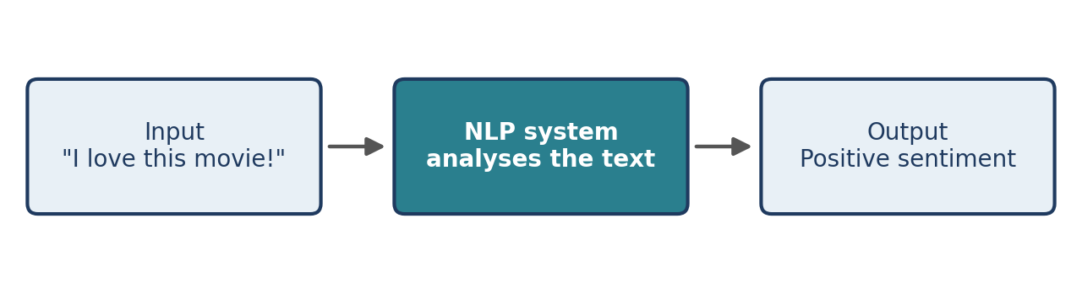
Figure 1.1 The simplest view of an NLP system: language in, analysis, useful output.
The system identifies the words and the sentiment expressed by them. It concludes that the sentiment is positive, which means the user likes the movie. Inside the box labelled “NLP system” there is, in practice, a sequence of steps that the rest of this book explains.

1.3 Real-Life Applications of NLP
NLP is already part of many everyday applications. Table 1.1 summarises seven of them.
Application | Example | What NLP does
Email auto-complete | Gmail | Models predict the next word or phrase while you type, helping you complete sentences faster.
Spam filtering | Email services | Classifies messages as spam or legitimate by analysing text patterns, suspicious phrases and other features.
Language translation | Google Translate | Converts text from one language to another while trying to preserve the original meaning.
Customer service chatbots | Automated support | Analyses a customer’s question, identifies the intent, and either answers or routes the request to a human agent.
Voice assistants | Alexa, Google Assistant | Combines speech recognition with NLP to understand spoken requests, answer questions and perform tasks such as setting reminders.
Search engines | Google Search | Helps the engine understand the meaning behind a query and return relevant results. BERT is one of the language models used in search technology.
Automated news generation | Financial news platforms | Analyses financial data and generates reports or news stories from structured information.
Table 1.1 Seven everyday NLP applications.

1.4 Three Approaches to Building NLP Systems
NLP problems are solved with three main approaches. They differ in how they process text and in how they acquire knowledge about language. Figure 1.2 contrasts them, and the following subsections describe each in turn.
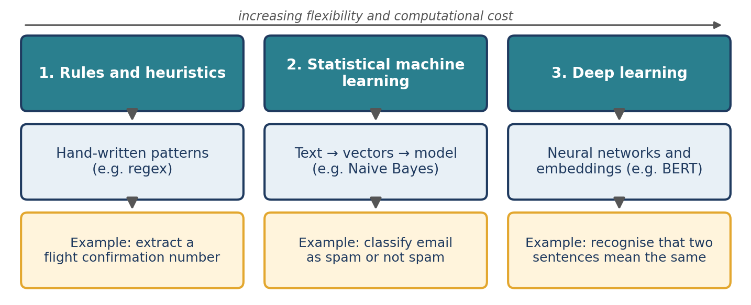
Figure 1.2 The three fundamental approaches to NLP, with an example of each.
1.4.1 Rules and heuristics
A rule-based system uses manually defined rules and patterns, often written as regular expressions (Chapter 5), to extract or identify information.
Example: extract a flight confirmation number from an email by writing a pattern that describes what such numbers look like.
- Advantage: predictable and accurate when the text follows a fixed pattern.
- Limitation: difficult to maintain when the language varies in complex ways.
1.4.2 Statistical machine learning
A statistical approach converts text into numerical vectors using techniques such as a count vectoriser (Chapter 16) and then trains an algorithm such as Naive Bayes to classify or predict. The system learns patterns from labelled examples instead of relying on hand-written rules.
Example: classify emails as spam or not spam.
- Advantage: learns patterns from data and copes with more variation than fixed rules.
- Limitation: depends on the quality of the training data and may struggle with unseen words or with context.
1.4.3 Deep learning
Deep learning uses neural networks. Models such as BERT produce sentence embeddings, numerical representations that capture the meaning and context of text.
Example: recognise that “I love this movie” and “This film is excellent” have similar meanings by comparing their embeddings with cosine similarity (Chapter 14).
- Advantage: captures semantic relationships and complex language patterns.
- Limitation: needs more computing resources, and either a large training set or a suitable pre-trained model.
1.4.4 Choosing between them
 | Rules | Statistical ML | Deep learning
Knowledge comes from | Human-written patterns | Labelled examples | Very large text collections and labelled examples
Handles variation | Poorly | Moderately | Well
Needs training data | No | Yes | Yes (or a pre-trained model)
Computing cost | Very low | Low to moderate | High
Easy to explain | Yes | Often | Difficult
Table 1.2 Comparison of the three approaches.
The approaches are not rivals in practice. A customer-support system might use a regular expression to pull out an order number, a classifier to decide the topic of the message, and a pre-trained language model to draft the reply. Choosing the simplest approach that solves the problem is usually good engineering.

1.5 Ten Fundamental NLP Tasks
Most NLP applications are built from a small set of fundamental tasks. This section defines ten of them; later chapters teach the techniques used to perform them.
1. Text classification
Text classification assigns text to predefined labels. Examples: classifying customer support tickets as high, medium or low priority; detecting hate speech; identifying spam messages; detecting fake profiles on social media platforms.
2. Text similarity
Text similarity measures how closely two pieces of text are related in meaning. Examples: matching job descriptions with candidate résumés; finding similar documents; detecting duplicate questions; comparing customer queries.
3. Information extraction
Information extraction automatically identifies specific, structured information in unstructured text. Examples: extracting a flight number, date and location from an email; extracting names, organisations and locations from news articles; identifying important details in documents.
4. Information retrieval
Information retrieval searches a large collection of documents and ranks them by relevance to a user’s query. Google Search retrieving and ranking web pages is the best-known example. Others include searching documents inside an organisation, finding relevant research papers and searching products in an online store.
5. Chatbots
Chatbots are automated conversational systems that interact with users through text or voice. They range from simple to advanced:
- FAQ-based chatbots match a question to a stored answer.
- Flow-based chatbots follow a predefined conversation.
- Context-aware chatbots remember previous messages.
- Open-ended assistants generate human-like responses.
Examples: customer-support bots, food-ordering chatbots, banking assistants and personal AI assistants.
6. Machine translation
Machine translation automatically converts text from one language to another. Google Translate, which converts between languages such as English, Tamil, Hindi and French, is a familiar example.
7. Language modelling
A language model predicts the next word, or sequence of words, from the words that came before. Given the prefix “I am going to the…”, a model may rank words such as “office”, “market” or “college” as likely continuations. Language modelling underlies Gmail autocomplete, smartphone keyboard suggestions, predictive text and text-generation systems.
8. Text summarisation
Summarisation reduces a long document to a shorter version while preserving its main meaning. Examples: summarising news articles, creating headlines, summarising research papers and generating short reports from lengthy documents.
9. Topic modelling
Topic modelling discovers hidden or abstract themes in a large collection of documents. Examples: finding financial topics in news articles, identifying medical topics in research papers, discovering common themes in customer reviews, and organising documents into categories such as finance, medicine and technology.
10. Voice assistants
Voice assistants process spoken language and carry out tasks in response to voice commands. They generally involve three stages: speech recognition, language understanding and response generation. Examples include Siri, Alexa, Google Assistant and voice-controlled smart devices.
# | Task | One-line definition | Typical output
1 | Text classification | Assign a label to text | A category
2 | Text similarity | Measure closeness in meaning | A score
3 | Information extraction | Pull structured facts from text | Fields and values
4 | Information retrieval | Find and rank relevant documents | A ranked list
5 | Chatbots | Converse with a user | A reply
6 | Machine translation | Convert between languages | Text in another language
7 | Language modelling | Predict the next word(s) | Probable continuations
8 | Text summarisation | Shorten while keeping the meaning | A shorter text
9 | Topic modelling | Discover themes in a collection | Topics
10 | Voice assistants | Act on spoken commands | Actions and spoken replies
Table 1.3 The ten fundamental NLP tasks at a glance.

1.6 Key Terminology
Term | Meaning
Corpus | A collection of text documents used for analysis or training (plural: corpora).
Document | A single unit of text in a corpus, such as an email, a ticket or a review.
Token | A small unit of text, usually a word or a punctuation mark (see Chapter 7).
Vector | A list of numbers that represents a piece of text so that a computer can compute with it.
Model | A mathematical system, learned from data or defined by rules, that maps input text to an output.
Pre-trained model | A model that has already learned from a large amount of data and can be reused (see Chapter 2).
NLU / NLG | Natural Language Understanding / Natural Language Generation.
Table 1.4 Terms used throughout the book. The full glossary appears at the end.

1.7 Common Misconceptions
- “NLP is just chatbots.” Chatbots are one of ten fundamental tasks. Classification, extraction, retrieval and translation are at least as common in industry.
- “If the system gives a sensible answer, it understands.” A system may produce good answers by recognising statistical patterns without any human-like understanding. Judge systems by measured performance on realistic data, not by a few impressive examples.
- “Newer is always better.” A regular expression can outperform a neural network on a narrowly defined pattern, at a tiny fraction of the cost.
- “Voice assistants are only NLP.” They combine speech recognition, NLP and speech synthesis.

1.8 Chapter Summary
- NLP enables computers to understand, process and generate human language.
- Ambiguity, variation and context make language hard for computers.
- NLP systems are built with rules, statistical machine learning or deep learning; each trades flexibility against cost and effort.
- Ten fundamental tasks recur across applications: classification, similarity, information extraction, information retrieval, chatbots, machine translation, language modelling, summarisation, topic modelling and voice assistants.

1.9 Review Questions and Exercises
- Define NLP in one sentence, without using the word “language”.
- Give one example each of ambiguity, variation and context affecting a sentence of your choice.
- A bank wants to extract IFSC codes from customer emails. Which of the three approaches would you try first, and why?
- Classify each as one of the ten tasks: (a) suggesting the next word on a phone keyboard; (b) showing the five most relevant articles for a query; (c) grouping 10,000 reviews into themes without predefined labels.
- Exercise. List five NLP-powered products you used this week. For each, name the task from Table 1.3 that it performs and the approach (rules, statistical ML or deep learning) you think it uses. Explain your reasoning.

Editorial note — remove before publication
From your notes: Introduction, What can NLP do, Real-life applications, Three Fundamental NLP Techniques, 10 Fundamental NLP Tasks (all examples retained).
Added: the “why is language hard” discussion, NLU/NLG definitions, comparison Table 1.2, task summary Table 1.3, terminology table, misconceptions, review questions. The notes’ “Diagram: Three approaches to NLP” was redrawn as Figure 1.2.

Chapter 2 Why NLP Is Everywhere Now
Learning objectives
After studying this chapter you will be able to:
• explain why NLP moved from research laboratories into everyday business use;
• describe the five factors behind its adoption;
• define a pre-trained model and explain why reusing one saves time and money;
• state the limits of the “easy to adopt” story.

2.1 From Research Field to Industry Standard
NLP was once primarily a research and academic field. Over the last decade it has become an important technology in businesses, consumer applications and intelligent systems. The main reason is that NLP has become easier to develop, more affordable and more accessible to organisations of all sizes.
Five factors explain most of this growth. They reinforce one another, which is why the change has been so rapid.

2.2 Five Factors Driving NLP Adoption
Factor | In one sentence | Section
Pre-trained models | Powerful models already exist and can be reused. | 2.3
Open-source ecosystem | Python libraries make NLP easier to develop. | 2.4
Affordable computing | Cloud services provide powerful hardware on demand. | 2.5
Accessible learning | Anyone can learn NLP from online resources. | 2.6
Big-tech investment | Industry success encourages more businesses to adopt AI. | 2.7
Table 2.1 The five adoption factors.

2.3 Pre-Trained Models
What is a pre-trained model?
A pre-trained model is an AI model that has already learned patterns from a large amount of data. Instead of training a model from the beginning, a developer reuses an existing one for a new application.
For example, a language model can be trained on a very large collection of text to learn grammar, relationships between words and patterns of usage. A developer can then adapt that model, or call it through an interface, for tasks such as text classification, translation or generating responses. Figure 2.1 shows the three stages.
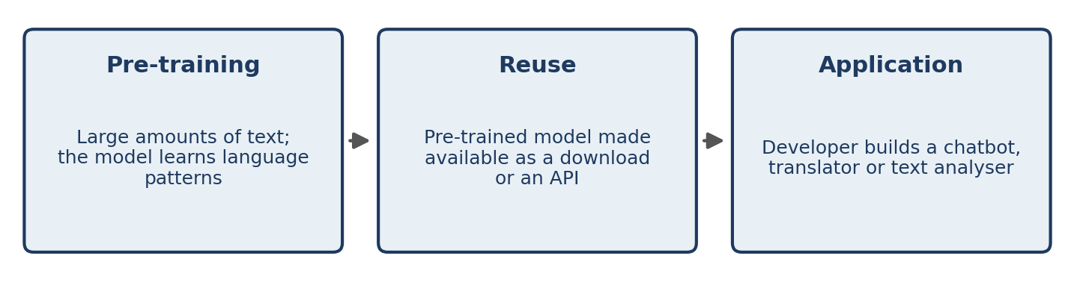
Figure 2.1 Pre-train once, reuse widely: how a pre-trained language model reaches an application.
Models you will meet
Model | Developed by | Description
BERT | Google | A language model widely used for understanding text; one of the models used in search technology.
fastText | Facebook AI (now Meta) | A tool for learning word representations and for text classification.
GPT-3 | OpenAI | A large language model that can generate and process text.
Table 2.2 Three influential pre-trained models. GPT-3 is one example of a much larger family of generative models.
Companies such as Google, Meta and OpenAI accelerated the adoption of NLP by releasing powerful models and developer interfaces. Smaller organisations can therefore benefit from this technology without bearing the full cost of training a large model from scratch.
Main benefit: developers can concentrate on building applications rather than spending years and very large sums developing a language model from the ground up.
Since these models were introduced, larger general-purpose language models have become available through commercial APIs and through open model hubs such as Hugging Face. Chapter 21 explains how they work.

2.4 A Robust Open-Source Ecosystem
In the past, implementing NLP algorithms often meant complex programming and a strong grasp of low-level languages such as C++. Modern Python libraries have made many NLP tasks far simpler.
 | Earlier development | Modern Python development
Effort | Complex implementation and a great deal of manual coding | Ready-made libraries and simple APIs
Code size | Many lines for each algorithm | Few lines for common tasks
Skill needed | Strong low-level programming skills | Basic Python
Table 2.3 How open-source libraries changed NLP development.
Two libraries are used throughout this book. spaCy is a Python library for efficient NLP tasks such as tokenisation, part-of-speech tagging and named entity recognition. NLTK is a Python toolkit used for teaching, research and text-processing tasks such as stemming and tokenisation. Chapter 3 compares them.
Tokenisation, splitting text into smaller units such as words, illustrates the change. Instead of implementing the whole algorithm by hand, a library lets you do it in a few lines of code. You will do exactly that in Chapter 3.

2.5 Affordable Computing Power
Training large NLP models needs substantial computing resources, particularly GPUs. In the past, organisations often had to buy and maintain expensive hardware. Cloud computing has changed this: companies and students can rent computing resources from platforms such as AWS, Microsoft Azure and Google Cloud.
How cloud computing helps NLP
- Choose the required computing resources, such as a CPU or a GPU.
- Run the model-training or inference workload in the cloud.
- Pay for the resources you use instead of buying an entire hardware system.
Example. A start-up developing a customer-service chatbot can rent cloud hardware to train or run its model without building its own data centre.
Note the two kinds of workload. Training teaches a model from data and is usually the expensive step. Inference uses a trained model to make predictions and is usually much cheaper. Reusing a pre-trained model (Section 2.3) lets many organisations skip most of the training cost.

2.6 Accessible Learning Resources
NLP education is no longer limited to universities and specialised research laboratories. The internet has made it easier for beginners to learn programming, machine learning and AI.
Resource | What it offers
YouTube | Free tutorials, lectures and practical demonstrations.
Coding bootcamps | Structured training and project-based learning.
Kaggle | Datasets, competitions, notebooks and machine-learning practice.
Stack Overflow and online forums | A place to ask questions, solve programming problems and learn from developers worldwide.
Table 2.4 Where beginners learn NLP.
These resources reduce the barrier to entry, so students can gain practical skills without relying exclusively on expensive courses or formal degrees.

2.7 Big-Tech Investment and the Adoption Cycle
The fifth factor is a feedback loop. When large technology companies invest in AI and release successful products, other businesses take notice. FOMO — fear of missing out — describes the worry that a company will fall behind its competitors if it does not adopt AI. If one company uses an AI chatbot to give faster customer support, its competitors feel pressure to improve their own service with NLP.
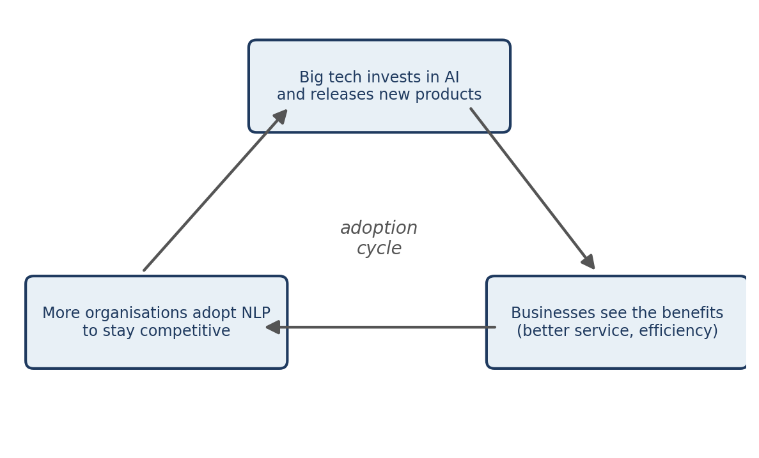
Figure 2.2 The adoption cycle: investment, visible benefits and competitive pressure feed one another.
Each turn of the cycle produces more tools, more models and more learners, which lowers the cost of the next turn.

2.8 What Easy Adoption Does Not Mean
It is easier than ever to start an NLP project, but several things remain hard:
- Evaluation. A model that looks impressive in a demonstration may fail on your real data. You must measure performance on realistic examples (Chapter 22).
- Data quality and privacy. Your data may contain personal or confidential information. Think carefully before sending it to an external service.
- Fit. A general pre-trained model may not know your domain’s vocabulary, such as legal or medical terms.
- Maintenance. Language changes. Deployed systems need monitoring and, sometimes, retraining (Chapter 24).

2.9 Chapter Summary
- NLP has moved from research to mainstream use because it has become easier, cheaper and more accessible.
- Five factors drive adoption: pre-trained models, open-source libraries, affordable cloud computing, accessible learning resources and big-tech investment.
- A pre-trained model has already learned from large amounts of data and can be reused, so developers do not train from scratch.
- Ease of adoption does not remove the need for evaluation, careful data handling and maintenance.

2.10 Review Questions and Exercises
- List the five factors behind NLP adoption and explain how any two of them reinforce each other.
- What is the difference between pre-training a model and using one? Who bears the main cost in each case?
- Why does a start-up benefit more from renting cloud GPUs than from buying its own? Name one situation in which buying might make sense.
- Explain FOMO in the context of AI adoption, using an example from an industry you know.
- Exercise. Choose one product from Table 1.1 and write a half-page note on which of the five factors made it possible to build that product today at much lower cost than ten years ago.

Editorial note — remove before publication
From your notes: “Why NLP is becoming an industry standard”, five factors, pre-trained models, open source, affordable computing, accessible learning, FOMO.
Reworded: all references to “the video” were removed so the text reads as a standalone book.
Added: the training-versus-inference distinction, Section 2.8, comparison tables, and the note on modern language models. Figure 2.1 and Figure 2.2 redraw the notes’ diagrams.

Chapter 3 The NLP Toolkit
Learning objectives
After studying this chapter you will be able to:
• match common NLP problems to the Python libraries that solve them;
• explain the design difference between spaCy and NLTK, and choose between them;
• install and verify the tools used in this book;
• run your first tokenisation example in both libraries.

3.1 Choosing Tools by Problem
No single library covers every NLP need. Practitioners choose different tools depending on the problem. Table 3.1 lists the families of tools used in this book.
Category | Used for | Libraries
NLP libraries | Text processing and linguistic analysis | NLTK, spaCy, Gensim
Machine learning | Traditional machine-learning algorithms | Scikit-learn
Deep learning | Neural networks and modern language models | TensorFlow, PyTorch, Hugging Face
Table 3.1 Library families used in this book.
Why are multiple libraries needed?
Each library has a different purpose. NLTK can tokenise a sentence into words, scikit-learn can train a text-classification model, and PyTorch or TensorFlow can build deep-learning models. Gensim is best known for training word embeddings such as Word2Vec (Chapter 19), and Hugging Face provides access to pre-trained transformer models (Chapter 21). A real project typically uses two or three of them together.

3.2 spaCy and NLTK Compared
spaCy and NLTK are the two most popular Python libraries for basic NLP. Both support tokenisation, stemming, tagging and text analysis, but they differ in design and intended use.
3.2.1 Design philosophy
spaCy is object-oriented. It provides high-level objects such as Doc that hold the processed text and its linguistic information. A single Doc can contain tokens, sentences, part-of-speech tags, named entities and dependency relationships, which makes spaCy code easy to read and extend.
NLTK is a string-processing library. It works mainly with strings, lists and other basic Python data structures: you pass text in and receive processed text or lists back. This gives you direct control but can require more manual coding.
3.2.2 Efficiency versus customisation
A useful analogy is photography. spaCy is like a smartphone camera: easy to use, good results quickly, optimised algorithms by default, little configuration. It suits production applications, industry projects, fast development and large-scale text processing.
NLTK is like a manual DSLR camera: more control, detailed customisation and more configuration. It suits research, academic learning, experiments with different algorithms and understanding each NLP step individually.
3.2.3 Comparison table
Feature | spaCy | NLTK
Design | Object-oriented | String processing
Main focus | Efficiency and practical applications | Flexibility and experimentation
Best suited for | Application developers | Researchers and learners
Performance | Optimised algorithms by default | Depends on the selected methods
Customisation | Less manual control | Highly customisable
User experience | Simple and user-friendly | Requires more configuration
Typical use | Production-ready NLP systems | Education, research and experiments
Table 3.2 spaCy versus NLTK.
3.2.4 Your first example in each library
The same task, splitting a sentence into tokens, looks like this in NLTK:
import nltk

nltk.download("punkt_tab") # one-time download of tokenizer data

text = "Natural Language Processing is useful."
tokens = nltk.word_tokenize(text)
print(tokens)

Output
['Natural', 'Language', 'Processing', 'is', 'useful', '.']

nltk.word_tokenize() takes the input string and returns a plain Python list of strings. Nothing else is stored.
And in spaCy:
import spacy

nlp = spacy.load("en_core_web_sm")

text = "Natural Language Processing is useful."
doc = nlp(text)

for token in doc:
print(token.text)

Output
Natural
Language
Processing
is
useful
.

spacy.load() creates a language-processing pipeline called nlp. Calling nlp(text) returns a Doc object. Each item in the Doc is a Token object that carries the word and also attributes such as its part of speech. We printed only token.text; Chapters 7 and 10 explore the rest.
Both programs produce the same six tokens. The difference lies in what you get back: a list of strings from NLTK, a rich Doc from spaCy.
3.2.5 Which should you choose?
- Choose spaCy to build efficient, production-ready applications quickly. In short: easy, fast, application-oriented.
- Choose NLTK when you need detailed control over algorithms or want to experiment with different techniques. In short: flexible, customisable, research-oriented.
This book uses both: NLTK where seeing an individual algorithm helps learning (for example, the stemmers in Chapter 9) and spaCy for pipelines and linguistic analysis.

3.3 Setting Up Your Environment
You need Python 3 and an internet connection for the one-time downloads. Create an isolated environment so that this book’s packages do not interfere with other projects:
python -m venv nlp-env
source nlp-env/bin/activate # Windows: nlp-env\Scripts\activate

pip install spacy nltk scikit-learn gensim
python -m spacy download en_core_web_sm

The last command downloads a small English pipeline named en_core_web_sm. Pre-trained pipelines are separate downloads from the library itself; Chapter 10 explains the difference.
Verifying the installation
import spacy
nlp = spacy.load("en_core_web_sm")
print(nlp.pipe_names)

Output
['tok2vec', 'tagger', 'parser', 'attribute_ruler', 'lemmatizer', 'ner']

Versions used in this chapter
The examples in Section 3.2.4 and this section were run with spaCy 3.8 and its en_core_web_sm 3.8.0 pipeline, and with a recent NLTK 3 release. Component names and some outputs can differ between spaCy versions and pipelines. If NLTK raises a LookupError that names a missing resource, download the resource named in the message.

3.4 Common Mistakes
- Forgetting the model download. spacy.load("en_core_web_sm") fails with an error if the pipeline was never downloaded.
- Shadowing a library. Naming your own file spacy.py or nltk.py makes Python import your file instead of the library.
- Installing in the wrong environment. If import spacy fails after installation, the package was probably installed for a different Python than the one running your code.
- Using deep learning for everything. Start with the simplest tool that meets the need (Section 1.4.4).

3.5 Chapter Summary
- Different libraries serve different purposes: NLTK, spaCy and Gensim for text processing; scikit-learn for classical machine learning; TensorFlow, PyTorch and Hugging Face for deep learning.
- spaCy is object-oriented, efficient and application-oriented; NLTK works with strings and lists and favours flexibility and learning.
- A spaCy pipeline returns a Doc of Token objects; NLTK returns plain Python lists.
- Pre-trained spaCy pipelines are separate downloads and must be installed before use.

3.6 Review Questions and Exercises
- Name the library you would use for (a) training a Naive Bayes classifier, (b) training Word2Vec embeddings, (c) loading a pre-trained transformer.
- Explain the smartphone-versus-DSLR analogy in your own words. Which tool matches which, and why?
- What is the type of the object returned by nltk.word_tokenize()? By nlp(text)?
- Exercise. Install the tools, then tokenise the sentence “Dr. Rao doesn’t live in New York.” with both libraries. Compare the token lists. Which differences do you notice, and which library’s output do you prefer for this sentence?
- Exercise. Print nlp.pipe_names for your installation. Do you see the same six components shown above?

Editorial note — remove before publication
From your notes: Recommended technology stack, “Why are multiple libraries needed?”, spaCy vs NLTK (design, efficiency vs customisation, comparison table, examples, conclusion).
Added: installation steps, verification, version note, common mistakes, review questions. The two code examples and the pipeline component list were run (spaCy 3.8.16, en_core_web_sm 3.8.0, NLTK 3.x) and the outputs shown are the real outputs. The notes’ comparison table (an image in the .docx) was retyped as Table 3.2.

Chapter 4 The NLP Pipeline: An Overview
Learning objectives
After studying this chapter you will be able to:
• describe the three-stage NLP workflow: preprocessing, vectorisation and modelling;
• walk through the seven stages of an end-to-end pipeline using a support-ticket classifier;
• explain accuracy, precision, recall and F1, and why recall matters for urgent tickets;
• explain deployment, monitoring and concept drift;
• find which later chapter teaches each stage.

4.1 The Common NLP Workflow
Most NLP tasks follow the same general workflow, which has three major stages. Figure 4.1 shows how they connect.
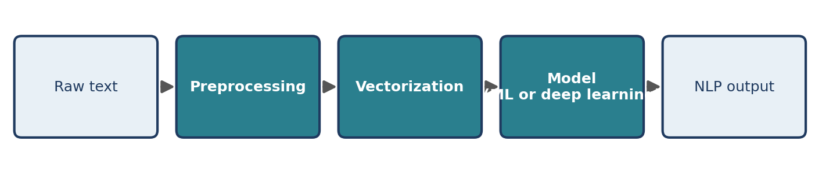
Figure 4.1 The three-stage NLP workflow.
Stage 1: Preprocessing
Raw text is cleaned and prepared for further processing. Common steps include:
- removing unnecessary symbols and noise;
- converting text to lowercase;
- removing unwanted spaces;
- tokenisation;
- removing stop words;
- stemming or lemmatisation.
Stage 2: Vectorisation
Computers cannot process raw text the way humans do, so text is converted into numerical representations called vectors. Common methods include Bag of Words, TF-IDF, word embeddings and sentence transformers.
Stage 3: Modelling
The vectors are given to a machine-learning or deep-learning model that performs the required task. Common models include Naive Bayes, logistic regression, support vector machines, decision trees, neural networks and transformer-based models.
Not every project uses every step. For example, modern transformer models usually do their own tokenisation and need little of the traditional cleaning, whereas a Bag-of-Words classifier often benefits from all of it. Part III explains when each step helps.

4.2 An End-to-End Example: Support-Ticket Classification
The workflow above is a summary. A real project has more stages. We follow one running example: a company wants to classify customer support tickets by priority (High, Medium or Low) so that urgent problems are handled first. Figure 4.2 shows the seven stages of the pipeline.
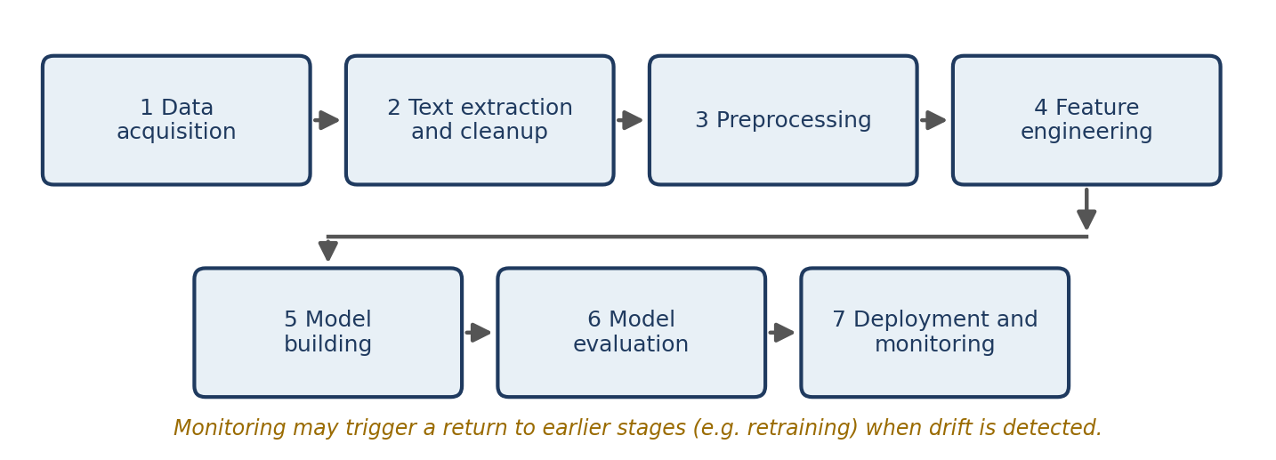
Figure 4.2 The seven stages of an end-to-end NLP pipeline.
4.2.1 Data acquisition
Data acquisition is the process of collecting the data the project needs. In our example, historical tickets are read from a production database such as MongoDB and then copied to a secure cloud storage service such as Amazon S3. Working from a separate copy avoids slowing down or accidentally changing the live database.
A typical record looks like this:
Field | Value
Ticket ID | 1025
Title | Payment failed
Description | I tried to complete the payment, but the transaction was unsuccessful.
Priority | High
Table 4.1 An example support-ticket record. Priority is the label the model will learn to predict.
4.2.2 Text extraction and cleanup
The collected data may contain unnecessary information, formatting problems or several text fields. These must be cleaned before further processing. Typical steps are:
- removing irrelevant fields such as timestamps and author names;
- combining the ticket title and description;
- correcting spelling mistakes;
- removing unnecessary line breaks and formatting;
- handling missing or duplicate values;
- removing unwanted symbols and extra spaces.
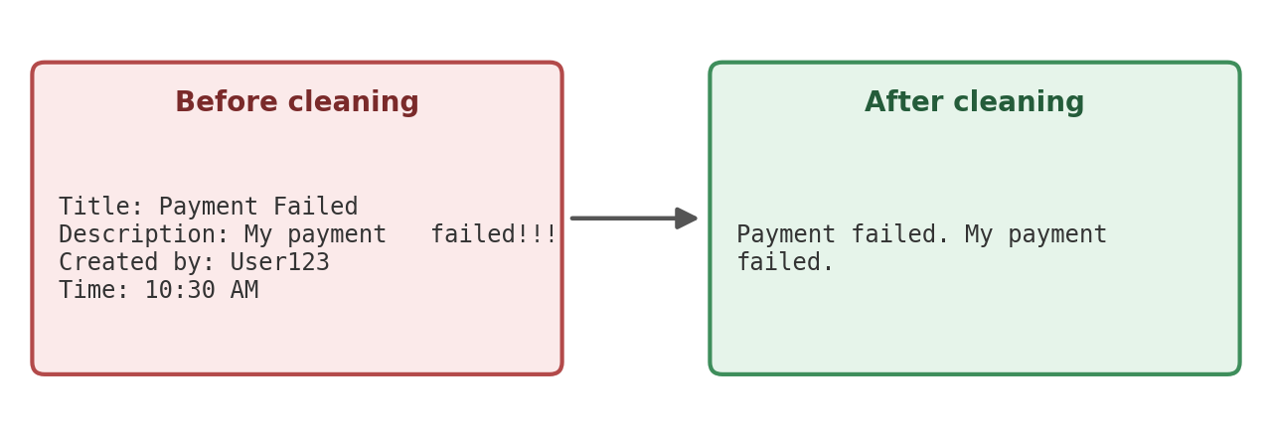
Figure 4.3 Text extraction and cleanup: irrelevant fields are dropped and the text is tidied.
A first version of this step can be written with Python’s re module (Chapter 5 explains regular expressions in detail):
import re

def clean_ticket(title, description):
text = f"{title}. {description}" # combine the two text fields
text = re.sub(r"\s+", " ", text) # collapse runs of whitespace
text = re.sub(r"([!?.])\1+", r"\1", text) # "!!!" becomes "!"
return text.strip()

print(clean_ticket("Payment Failed", "My payment failed!!! "))

Output
Payment Failed. My payment failed!

The function drops the author and time fields simply by not using them, joins title and description, and tidies spacing and repeated punctuation. The cleaned example in Figure 4.3 also normalises capital letters and the exclamation mark; Chapter 6 shows how.
4.2.3 Preprocessing
Preprocessing turns cleaned text into a form that models can use. Four operations are typical.
Sentence segmentation divides a paragraph into sentences.
# Input: The payment failed. Please check my account.
# Output: ["The payment failed.", "Please check my account."]

Word tokenisation divides a sentence into words or tokens: "The payment failed" becomes ["The", "payment", "failed"]. Chapter 7 teaches both operations in spaCy.
Stemming reduces words to a base form using simple rules. It is fast, but it may produce strings that are not real words.
Lemmatisation reduces words to their dictionary form using grammatical information. It is usually more accurate than stemming but needs more processing.
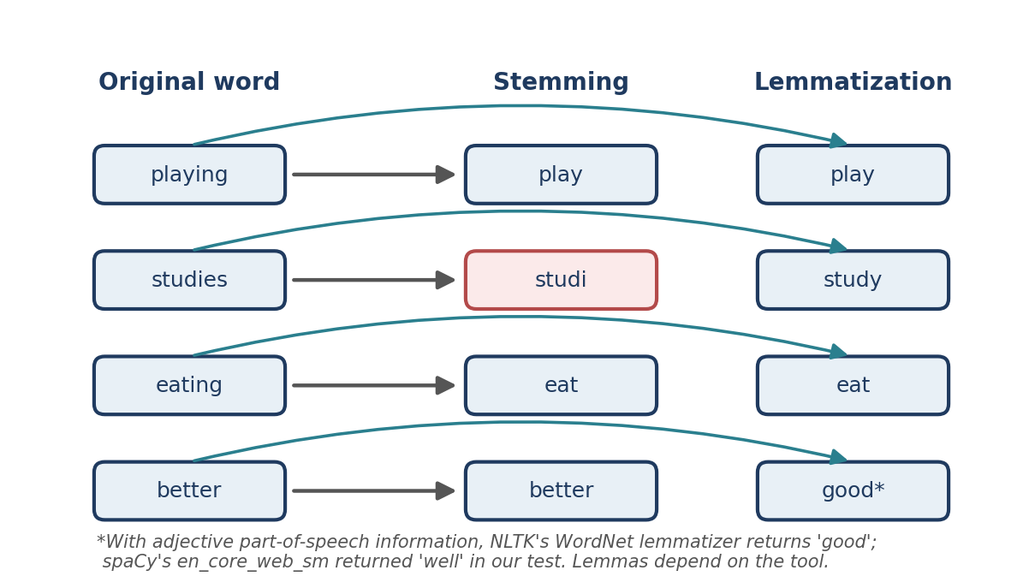
Figure 4.4 Stemming and lemmatisation applied to the same words. Stemming can produce non-words such as “studi”.
Figure 4.4 contrasts the two on four words. Playing, studies and eating are handled sensibly by both techniques, except that the stemmer turns “studies” into “studi”. The word “better” is left unchanged by the stemmer, whereas a lemmatiser that knows “better” is an adjective can map it to “good”. The stems in the figure are the output of NLTK’s Porter stemmer. Whether and how a lemmatiser maps “better” depends on the tool, which is why the figure carries a footnote. Chapter 9 covers both techniques properly.
4.2.4 Feature engineering
Machine-learning models cannot read raw text, so we convert it into numerical features. Two families of technique are common.
TF-IDF gives each word an importance score by comparing how often it appears in one document with how often it appears across the whole collection. Words common to all documents receive low scores; words specific to a document receive high scores (Chapter 18).
Word embeddings represent words as vectors that capture relationships between them. Examples include Word2Vec, GloVe, fastText and sentence transformers (Chapters 19 to 21).
4.2.5 Model building
The features are used to train a model. For our example, the model learns to predict one of three classes: High, Medium or Low priority. Common classification algorithms include Naive Bayes, support vector machines, random forests, logistic regression and neural networks. Chapter 23 builds and compares several of them.
4.2.6 Model evaluation
Evaluation measures how well the model performs on data it has not seen. A common tool is the confusion matrix, which compares actual labels with predicted labels. Four metrics are derived from it:
Metric | Question it answers | Definition
Accuracy | What share of all predictions are correct? | Correct predictions ÷ all predictions
Precision | Of the tickets predicted as a class, how many truly belong to it? | True positives ÷ (true positives + false positives)
Recall | Of the tickets that truly belong to a class, how many did we find? | True positives ÷ (true positives + false negatives)
F1 score | How well do precision and recall balance? | 2 × (Precision × Recall) ÷ (Precision + Recall)
Table 4.2 The four standard classification metrics.
Worked example (hypothetical numbers). Suppose 10 tickets are truly High priority. The model labels 12 tickets as High, and 8 of those 12 really are High. Then precision = 8 ÷ 12 ≈ 0.67, recall = 8 ÷ 10 = 0.80, and F1 = 2 × (0.67 × 0.80) ÷ (0.67 + 0.80) ≈ 0.73. Two urgent tickets were missed.
For support-ticket classification, recall on the High class is especially important, because missing an urgent issue can have serious consequences. This shows why accuracy alone is not enough: a model that labelled every ticket “Low” could still have high accuracy if most tickets are Low, while missing every urgent one. Chapter 22 treats evaluation in depth.
4.2.7 Deployment and monitoring
After evaluation, the trained model is deployed as a service that other applications can call. Common tools include FastAPI, Flask, cloud hosting platforms and Docker-based services. When a new ticket arrives, the service applies the same preprocessing and feature extraction used in training and returns a predicted priority (Figure 4.5).
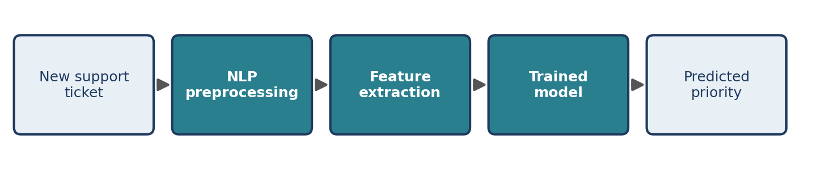
Figure 4.5 The deployed system processes each new ticket with the same steps used in training.
Monitoring continues after deployment. It helps detect:
- reduced prediction accuracy;
- changes in the input data;
- missing or invalid data;
- slow response times;
- changes in customers’ writing patterns.
Concept drift occurs when the relationship between the input text and the target output changes over time. For example, customers may start using new words or describe problems differently after a product update, so a model trained on older tickets becomes less accurate. When drift is detected, the model may need to be retrained on recent data.

4.3 A Map of the Book
The pipeline is also a map of what lies ahead. Table 4.3 shows where each stage is taught.
Pipeline stage | Chapters
Data acquisition, cleanup | 4 (this chapter), 6
Rule-based extraction | 5
Preprocessing: segmentation, tokenisation, stop words, stemming, lemmatisation | 7, 8, 9
Linguistic analysis: pipelines, POS tagging, parsing, named entities | 10 to 13
Feature engineering and text representation | 14 to 18
Word embeddings and contextual models | 19 to 21
Model building and evaluation | 22, 23
Deployment and monitoring | 24
Table 4.3 Where each pipeline stage is taught.
Real pipelines are iterative, not linear. Evaluation often sends you back to cleaning or feature engineering, and monitoring after deployment can send you back to data collection.

4.4 Common Mistakes
- Different preprocessing in training and in production. If you lowercase and lemmatise during training but forget to do so for live tickets, the model sees text unlike anything it learned from. Share one preprocessing function between both.
- Judging a model by accuracy alone. On imbalanced data, as in our ticket example, accuracy can look excellent while the important class is ignored.
- Learning from the test data. Fitting a vectoriser or choosing settings using the test set leaks information and inflates results (Chapters 22 and 23).
- Treating deployment as the end. Language changes, so models need monitoring and maintenance.

4.5 Chapter Summary
- NLP workflows have three core stages: preprocessing, vectorisation and modelling.
- An end-to-end pipeline has seven stages: data acquisition, text extraction and cleanup, preprocessing, feature engineering, model building, evaluation, and deployment and monitoring.
- Accuracy, precision, recall and F1 describe different aspects of performance; recall is critical when missing a case is costly.
- Deployed models must be monitored for degraded accuracy and concept drift, and retrained when necessary.

4.6 Review Questions and Exercises
- Name the three stages of the common NLP workflow and give two techniques belonging to each.
- Why does the pipeline in Section 4.2 copy production data to cloud storage before using it?
- In the worked example in Section 4.2.6, change the model so that it labels 15 tickets as High and 9 of them are truly High. Recompute precision, recall and F1. Did the model improve?
- Describe a realistic case of concept drift for a spam filter.
- Exercise. Extend clean_ticket() so that it also converts the text to lowercase and removes the phrase “Created by: …” if it appears. Test it on three invented tickets.
- Exercise. Draw the pipeline for a different problem of your choice, for example classifying product reviews as positive or negative. Label each stage with the technique you would use.

Editorial note — remove before publication
From your notes: Common NLP Workflow; End-to-End NLP Pipeline (all seven stages, support-ticket example, metrics, deployment, monitoring, concept drift).
Added: the runnable clean_ticket() function (output verified), the worked precision/recall example (hypothetical numbers, labelled as such), Table 4.3 book map, common mistakes, review questions.
Correction for review: your notes show “better → good” as a lemmatisation example. This holds for NLTK’s WordNet lemmatiser given an adjective tag, but spaCy’s en_core_web_sm returned “well” for “better” in our test. The text and Figure 4.4 now say the result depends on the tool. Stemming outputs were checked with NLTK’s Porter stemmer.

