NATURAL LANGUAGE PROCESSING FUNDAMENTALS
From Text Preprocessing to Word Embeddings, with Python
Draft manuscript — Part VII: Building and Evaluating NLP Systems
Chapters 22–24 · Evaluation, Text Classification End to End, Deployment and Drift
[Author name — to be supplied]
Contents
Part VII Building and Evaluating NLP Systems 3
Chapter 22 Evaluating NLP Models 4
22.1 Why Evaluate, and Evaluate What? 4
22.2 Splitting the Data 4
22.3 Always Start with a Baseline 6
22.4 The Confusion Matrix 6
22.5 More than Two Classes: Micro, Macro and Weighted Averages 8
22.6 Choosing a Decision Threshold 9
22.7 Cross-Validation 10
22.8 Data Leakage 11
22.9 How Sure Are We? Uncertainty in a Test Score 11
22.10 Error Analysis 12
22.11 Metrics for Other NLP Tasks 12
22.12 Common Mistakes 13
22.13 Chapter Summary 13
22.14 Review Questions and Exercises 13
Chapter 23 Text Classification End to End 15
23.1 The Workflow 15
23.2 Project 1: Spam Detection 15
23.3 Project 2: News Classification 19
23.4 Comparing Eight Classifiers 20
23.5 A Closer Look at the Selected Model 22
23.6 Choosing a Classifier 24
23.7 Good Practice with Pipelines 24
23.8 Common Mistakes 25
23.9 Chapter Summary 25
23.10 Review Questions and Exercises 25
Chapter 24 Deployment, Monitoring and Concept Drift 27
24.1 From Notebook to Production 27
24.2 Saving the Model and Its Metadata 27
24.3 Serving the Model as a Web API 28
24.4 Packaging, Versioning and Infrastructure 29
24.5 Monitoring 30
24.6 Data Drift and Concept Drift 31
24.7 Retraining and Release 33
24.8 Responsible Deployment 35
24.9 A Deployment Checklist 35
24.10 Common Mistakes 36
24.11 Chapter Summary 36
24.12 Review Questions and Exercises 36

Part VII Building and Evaluating NLP Systems
The earlier parts taught the components of NLP systems. Part VII joins them and asks the question that decides whether a system is useful: does it work, on data it has not seen, for the people who will rely on it? Chapter 22 teaches evaluation. Chapter 23 builds and compares complete text classifiers on two real datasets. Chapter 24 deals with what happens after a model is trained: deployment, monitoring and concept drift.

Chapter 22 Evaluating NLP Models
Learning objectives
After studying this chapter you will be able to:
• split data into training and test sets correctly, and explain what data leakage is;
• read a confusion matrix and compute accuracy, precision, recall and F1;
• explain why accuracy misleads on imbalanced data, and use baselines to detect it;
• choose a decision threshold, and use macro, micro and weighted averages for several classes;
• use cross-validation, estimate uncertainty with a bootstrap, and analyse a model’s errors;
• name suitable metrics for other NLP tasks.

22.1 Why Evaluate, and Evaluate What?
Chapter 4 introduced model evaluation as one stage of the pipeline and explained four metrics for the support-ticket example. This chapter treats evaluation in depth. A model that scores well on the data it was trained on may fail on new data, because it can memorise the training examples. Evaluation therefore always measures performance on held-out data, and it always asks a more specific question than “is it accurate?”: which mistakes matter, how often do they occur, and how sure are we of the answer?
Throughout this chapter we use one running example: classifying SMS text messages as spam or ham (legitimate). The data is the SMS Spam Collection assembled for research by Almeida, Hidalgo and Yamakami and distributed through the UCI Machine Learning Repository; we use a copy that is mirrored on GitHub. It contains 5,574 messages, of which 747 (13.4 per cent) are spam.

22.2 Splitting the Data
The standard protocol divides the labelled data into two or three parts:
- a training set, used to fit the model;
- a validation set (or cross-validation folds, Section 22.7), used to compare models and settings;
- a test set, kept aside and used once, at the end, to report final performance.
The test set must play the role of future, unseen data. If you tune a model by repeatedly checking the test score, the test set quietly becomes part of training, and the final number becomes optimistic. Figure 22.1 shows the arrangement used in this chapter.
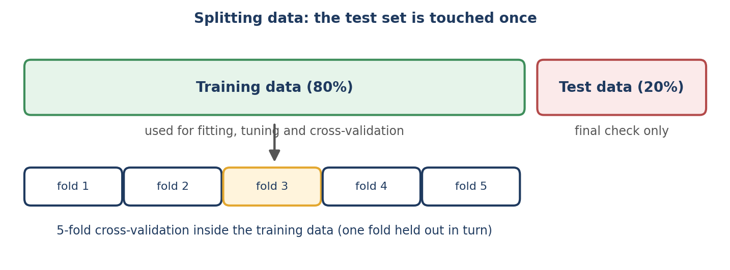
Figure 22.1 Fit, tune and cross-validate inside the training data; use the test data once.
import numpy as np, pandas as pd
from sklearn.model_selection import train_test_split, StratifiedKFold, cross_val_score
from sklearn.pipeline import Pipeline
from sklearn.feature_extraction.text import CountVectorizer, TfidfVectorizer
from sklearn.naive_bayes import MultinomialNB
from sklearn.linear_model import LogisticRegression
from sklearn.svm import LinearSVC
from sklearn.dummy import DummyClassifier
from sklearn.metrics import (accuracy_score, precision_score, recall_score, f1_score,
confusion_matrix, classification_report)

# Download once from
# https://raw.githubusercontent.com/justmarkham/pycon-2016-tutorial/master/data/sms.tsv
# (a mirror of the UCI "SMS Spam Collection")
# quoting=3 (csv.QUOTE_NONE): messages contain quote characters
df = pd.read_csv("sms.tsv", sep="\t", header=None, names=["label", "text"], quoting=3)
df["spam"] = (df["label"] == "spam").astype(int)

print(df.shape, df["spam"].mean().round(3))

X_train, X_test, y_train, y_test = train_test_split(
df["text"], df["spam"], test_size=0.2, random_state=42, stratify=df["spam"])
print(len(X_train), len(X_test), int(y_test.sum()))

Output
(5574, 3) 0.134
4459 1115 149

stratify= keeps the proportion of spam (about 13 per cent) the same in both parts, and random_state=42 makes the split reproducible. The test set holds 1,115 messages, of which 149 are spam.

22.3 Always Start with a Baseline
Before judging a model, ask what a trivial model would achieve. DummyClassifier always predicts the most frequent class:
baseline = DummyClassifier(strategy="most_frequent").fit(X_train, y_train)
pred = baseline.predict(X_test)
print("baseline accuracy:", round(accuracy_score(y_test, pred), 3),
"| recall:", recall_score(y_test, pred))

Output
baseline accuracy: 0.866 | recall: 0.0

A classifier that never flags any message as spam is 86.6 per cent accurate and catches no spam. This is the accuracy paradox: on imbalanced data, accuracy can look excellent for a useless model (Figure 22.2). Every result in this chapter should be read against this baseline.
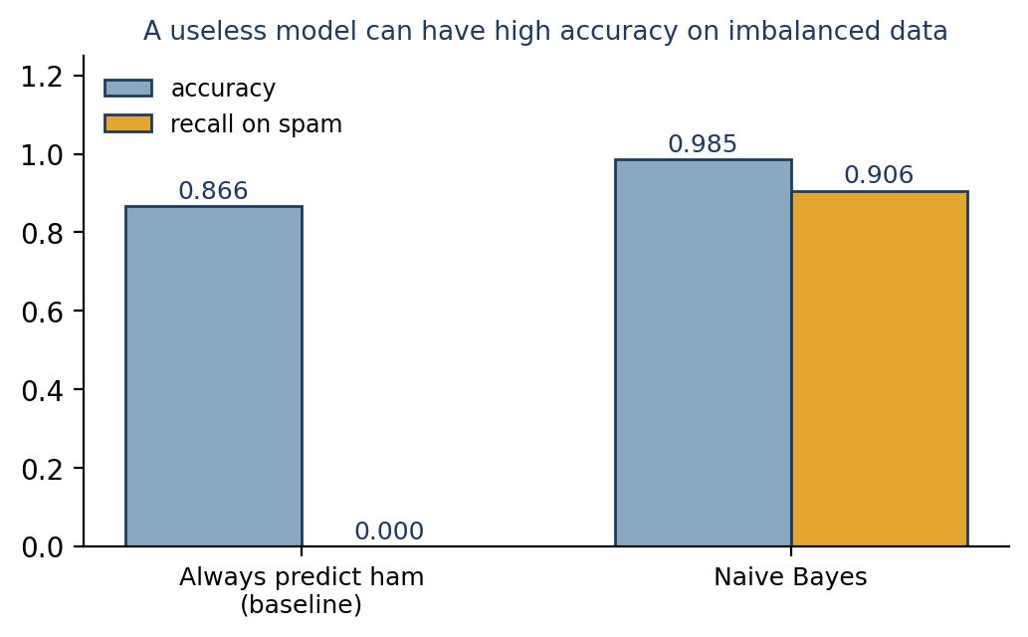
Figure 22.2 Accuracy alone cannot distinguish a useless model from a good one when one class dominates.

22.4 The Confusion Matrix
A confusion matrix counts predictions in four cells. Calling spam the positive class:
 | Predicted ham | Predicted spam
Actual ham | True negative (TN): ham correctly passed | False positive (FP): ham wrongly flagged as spam
Actual spam | False negative (FN): spam missed | True positive (TP): spam correctly flagged
Table 22.1 The four outcomes of a binary classifier.
We train a Bag-of-Words Naive Bayes classifier (Chapter 16) and compute the matrix:
model = Pipeline([("vec", CountVectorizer()), ("clf", MultinomialNB())]).fit(X_train, y_train)
pred = model.predict(X_test)

cm = confusion_matrix(y_test, pred)
tn, fp, fn, tp = cm.ravel().tolist()
print(cm.tolist(), (tn, fp, fn, tp))

print("accuracy :", round((tp + tn) / (tp + tn + fp + fn), 3))
print("precision:", round(tp / (tp + fp), 3))
print("recall :", round(tp / (tp + fn), 3))
p, r = tp / (tp + fp), tp / (tp + fn)
print("F1 :", round(2 * p * r / (p + r), 3))
print(round(f1_score(y_test, pred), 3))

Output
[[963, 3], [14, 135]] (963, 3, 14, 135)
accuracy : 0.985
precision: 0.978
recall : 0.906
F1 : 0.941
0.941

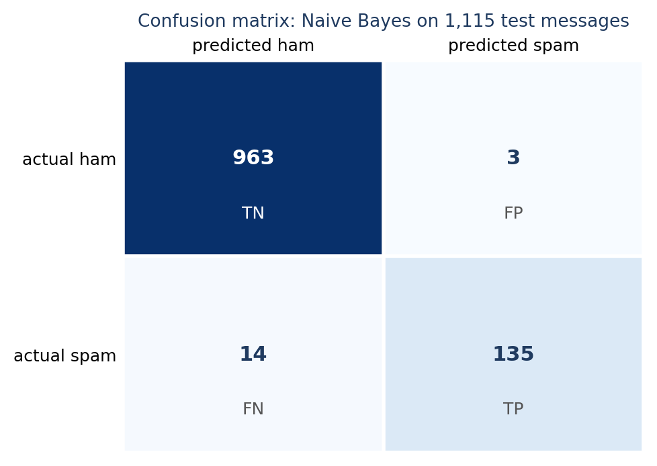
Figure 22.3 The confusion matrix of the Naive Bayes classifier on 1,115 test messages.
Metric | Formula | Meaning here | Value
Accuracy | (TP + TN) ÷ all | Share of all messages classified correctly | 0.985
Precision | TP ÷ (TP + FP) | When the model says spam, how often is it right? | 0.978
Recall | TP ÷ (TP + FN) | What share of the spam does it catch? | 0.906
F1 | 2PR ÷ (P + R) | Harmonic mean of precision and recall | 0.941
Table 22.2 Metrics for the spam classifier. The final line of the code confirms that scikit-learn’s `f1_score` agrees with the hand calculation.
The model flagged three legitimate messages as spam (false positives) and missed 14 spam messages (false negatives). Which error is worse depends on the application. For a spam filter, a false positive (a real message lost) is often considered worse than a false negative (a spam message in the inbox), so precision matters. For the support-ticket classifier of Chapter 4, missing an urgent ticket is worse than escalating a routine one, so recall on the urgent class matters. The F1 score balances the two, but it hides the trade-off, so always report precision and recall as well.
classification_report prints all of this for both classes at once:
print(classification_report(y_test, pred, target_names=["ham", "spam"], digits=3))

Output
precision recall f1-score support

ham 0.986 0.997 0.991 966
spam 0.978 0.906 0.941 149

accuracy 0.985 1115
macro avg 0.982 0.951 0.966 1115
weighted avg 0.985 0.985 0.985 1115

22.5 More than Two Classes: Micro, Macro and Weighted Averages
With several classes, precision, recall and F1 are computed for each class (treating it as “positive” and the rest as “negative”) and then averaged. There are three common ways:
- Macro average: the plain mean over classes. Every class counts equally, so poor performance on a small class is visible.
- Weighted average: the mean weighted by class size (support).
- Micro average: pool all decisions before computing the metric. For single-label classification, micro-averaged F1 equals accuracy.
A tiny example with three classes shows the difference. Ten items, with true labels a×6, b×3, c×1:
y_true = ["a"]*6 + ["b"]*3 + ["c"]*1
y_hat = ["a"]*5 + ["b"] + ["b"]*2 + ["a"] + ["c"]

print(confusion_matrix(y_true, y_hat).tolist())
for avg in ["micro", "macro", "weighted"]:
print(avg, round(f1_score(y_true, y_hat, average=avg), 3))
print(f1_score(y_true, y_hat, average=None).round(3).tolist())

Output
[[5, 1, 0], [1, 2, 0], [0, 0, 1]]
micro 0.8
macro 0.833
weighted 0.8
[0.833, 0.667, 1.0]

By hand: class a has 5 correct, 1 false positive and 1 false negative, so precision = recall = 5/6 and F1 = 0.833; class b gives 2/3 = 0.667; class c is perfect (1.0). The macro average is (0.833 + 0.667 + 1.0) ÷ 3 = 0.833. The micro average is the overall accuracy, 8 ÷ 10 = 0.8. The weighted average is (6 × 0.833 + 3 × 0.667 + 1 × 1.0) ÷ 10 = 0.8. When classes are imbalanced and the small classes matter, report the macro average (Section 23.4 shows a case in which it exposes a failure that accuracy hides).

22.6 Choosing a Decision Threshold
Most classifiers can output a probability of the positive class, and predict simply applies a threshold of 0.5. Changing the threshold trades precision against recall:
lr = Pipeline([("vec", TfidfVectorizer()), ("clf", LogisticRegression(max_iter=1000))]).fit(X_train, y_train)
proba = lr.predict_proba(X_test)[:, 1]

print("threshold precision recall F1")
for t in [0.5, 0.4, 0.3, 0.2, 0.1]:
pr = (proba >= t).astype(int)
print(f"{t:>9} {precision_score(y_test, pr):>9.3f} {recall_score(y_test, pr):>6.3f} {f1_score(y_test, pr):>5.3f}")

Output
threshold precision recall F1
0.5 1.000 0.812 0.896
0.4 0.992 0.872 0.929
0.3 0.971 0.913 0.941
0.2 0.903 0.940 0.921
0.1 0.638 0.980 0.772

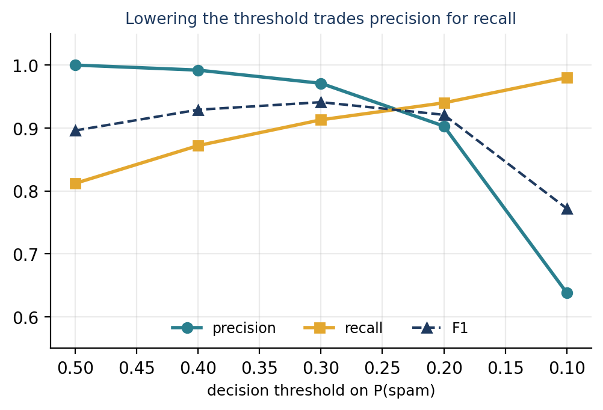
Figure 22.4 Precision and recall as the threshold is lowered (logistic regression on TF-IDF features).
At the default threshold of 0.5 the model is perfectly precise (never wrongly flags a message) but misses about one spam message in five (recall 0.81). Lowering the threshold to 0.3 raises recall to 0.91 at a small cost in precision (0.971) and gives the best F1 (0.941). Lowering it to 0.1 catches 98 per cent of spam, but more than a third of the messages it flags are legitimate. The right threshold is a business decision, set by the relative costs of the two errors, and it must be chosen on validation data, not on the test set.
Probabilities are not always calibrated
Naive Bayes tends to produce extreme probabilities (close to 0 or 1), so its probabilities are poor guides for threshold choice. Logistic regression is usually better calibrated. If you must rely on probabilities, check calibration, for example with sklearn.calibration.CalibratedClassifierCV and calibration curves.

22.7 Cross-Validation
A single train/validation split can be lucky or unlucky. K-fold cross-validation divides the training data into k parts (folds), trains on k − 1 of them and evaluates on the remaining one, in turn, then averages. Stratified folds preserve the class proportions. Because the vectorizer is part of the pipeline, it is refitted inside each fold and never sees the held-out fold. Here are three candidate models, compared by F1:
cv = StratifiedKFold(n_splits=5, shuffle=True, random_state=42)
candidates = {
"Count + Naive Bayes": Pipeline([("vec", CountVectorizer()), ("clf", MultinomialNB())]),
"TF-IDF + LogReg": Pipeline([("vec", TfidfVectorizer()), ("clf", LogisticRegression(max_iter=1000))]),
"TF-IDF + LinearSVC": Pipeline([("vec", TfidfVectorizer()), ("clf", LinearSVC())]),
}
for name, pipe in candidates.items():
scores = cross_val_score(pipe, X_train, y_train, cv=cv, scoring="f1")
print(f"{name:22} F1 = {scores.mean():.3f} ± {scores.std():.3f}")

Output
Count + Naive Bayes F1 = 0.944 ± 0.015
TF-IDF + LogReg F1 = 0.860 ± 0.013
TF-IDF + LinearSVC F1 = 0.942 ± 0.010

The ± is the standard deviation across the five folds. Naive Bayes and the linear SVM are indistinguishable (0.944 and 0.942, with spreads of 0.010 to 0.015), and logistic regression with default settings is clearly behind (0.860), which agrees with its low recall at the 0.5 threshold above. The lesson from the spread: differences smaller than the fold-to-fold variation should not be treated as real.

22.8 Data Leakage
Data leakage is any way in which information from the test data influences training, making evaluation optimistic. Common forms are:
- fitting a vectorizer, scaler or feature selector on all the data before splitting (avoid by using a Pipeline, as above);
- tuning hyperparameters on the test set;
- duplicates present in both training and test data;
- features that encode the answer (for example a column derived from the label), or information from the future in time-ordered data.
Duplicates are common in text collections, and this dataset has them: 403 messages are exact repeats of an earlier message. Does that inflate our test score? We can measure it by evaluating separately on test messages whose text never appears in training:
train_texts = set(X_train)
dup_mask = X_test.isin(train_texts)
print("test messages whose exact text is also in training:", int(dup_mask.sum()), "of", len(X_test))

for name, mask in [("all test messages", np.ones(len(X_test), bool)),
("unseen texts only", ~dup_mask.values)]:
print(f"{name:20} n={int(mask.sum()):4} F1={f1_score(y_test[mask], pred[mask]):.3f} accuracy={accuracy_score(y_test[mask], pred[mask]):.3f}")

Output
test messages whose exact text is also in training: 135 of 1115
all test messages n=1115 F1=0.941 accuracy=0.985
unseen texts only n= 980 F1=0.927 accuracy=0.984

In this case 135 of the 1,115 test messages (12 per cent) have an identical copy in the training data. Removing them lowers F1 from 0.941 to 0.927: a modest effect, but a real one, and in other datasets duplicates can matter much more. The safe practice is to remove exact duplicates before splitting (for example with df.drop_duplicates("text")), so that no message can appear on both sides.

22.9 How Sure Are We? Uncertainty in a Test Score
The test set contains only 149 spam messages, so the recall of 0.906 is an estimate with sampling error. A bootstrap resamples the test results with replacement many times to show how much the score could vary:
rng = np.random.default_rng(0)
spam_idx = np.where(y_test.values == 1)[0]
hits = (pred[spam_idx] == 1).astype(int) # 1 where a spam message was caught
boot = [rng.choice(hits, size=len(hits), replace=True).mean() for _ in range(2000)]
print("recall:", round(hits.mean(), 3), "95% interval:", np.percentile(boot, [2.5, 97.5]).round(3).tolist())

Output
recall: 0.906 95% interval: [0.859, 0.946]

The recall could plausibly lie anywhere between about 0.86 and 0.95. A claim that one model beats another by half a percentage point on a test set this size is therefore not supported by the evidence. Report intervals, or at least the size of the test set, with every score.

22.10 Error Analysis
Numbers tell you how much a model errs; reading the errors tells you why. List the false negatives and false positives and look for patterns:
fn_idx = np.where((y_test.values == 1) & (pred == 0))[0]
for i in fn_idx[:4]:
print("-", X_test.iloc[i][:75].replace("\n", " "))

Output
- Ever thought about living a good life with a perfect partner? Just txt back
- Hi ya babe x u 4goten bout me?' scammers getting smart..Though this is a re
- ROMCAPspam Everyone around should be responding well to your presence since
- Sorry I missed your call let's talk when you have the time. I'm on 07090201

Several missed messages are written to look like personal messages (“Hi ya babe x u 4goten bout me?”, “Sorry I missed your call…”), and others read like dating offers or a horoscope. Typical remedies are: add training examples of that style; add features such as the presence of a long digit string (a premium-rate number, found with a regular expression, Chapter 5); change the threshold; or accept that some errors are inherent. Error analysis also finds data problems: mislabelled examples, encoding artefacts and duplicates. In the next chapter we will notice that the tokens gt and lt are strong signals of legitimate messages, which is an artefact of HTML-escaped characters (&gt;, &lt;) rather than meaning, and the cleaning steps of Chapter 6 would remove it.

22.11 Metrics for Other NLP Tasks
Task | Common metrics | Notes
Text classification | Accuracy, precision, recall, F1 (macro or weighted), confusion matrix, ROC-AUC | Choose by class balance and error costs
Named entity recognition | Span-level precision, recall, F1 (span and label must both match) | Chapter 13; also report per entity type
Retrieval and search | Precision@k, recall@k, mean reciprocal rank (MRR), nDCG | Judged on ranked lists, with relevance labels
Similarity and embeddings | Correlation with human similarity judgements; downstream task performance | Raw cosine values are not comparable across models
Machine translation and summarisation | BLEU, ROUGE, learned metrics, human evaluation | Overlap metrics are imperfect; people remain the reference
Language modelling | Perplexity | Lower is better; comparable only on the same data and tokenization
Clustering and topic modelling | Topic coherence, silhouette score, human inspection | No ground truth is available in many cases
Generative and conversational systems | Human ratings, task success, factuality checks, safety tests | Automatic metrics alone are rarely sufficient
Table 22.3 Metrics by task. These are starting points, not complete evaluation plans.

22.12 Common Mistakes
- Reporting accuracy on imbalanced data without a baseline (Section 22.3).
- Tuning on the test set, even indirectly by checking it repeatedly (Section 22.2).
- Fitting preprocessing on all data before splitting; use a Pipeline.
- Leaving duplicates or near-duplicates across the split (Section 22.8).
- Using micro averages when small classes matter (Section 22.5).
- Reporting a single number with no interval, split description or test size (Section 22.9).
- Never reading the errors (Section 22.10).
- Optimising a metric that does not match the real cost of mistakes.

22.13 Chapter Summary
- Evaluate on held-out data; split with stratification, tune with cross-validation, and use the test set once.
- Always compare with a trivial baseline; accuracy is misleading when classes are imbalanced.
- The confusion matrix gives TP, FP, FN and TN; precision, recall and F1 summarise it. The costs of the two kinds of error decide which matters more.
- For several classes use macro averages when small classes matter, and per-class reports.
- Thresholds trade precision against recall; choose them on validation data.
- Cross-validation estimates the spread of a score; bootstrap intervals show the uncertainty of a test score.
- Prevent leakage, remove duplicates, and always inspect errors.

22.14 Review Questions and Exercises
- A model for a rare disease flag (1 per cent prevalence) is 99 per cent accurate. Is it a good model? What would you compute next?
- Compute precision, recall and F1 from this confusion matrix: TN = 90, FP = 10, FN = 5, TP = 45.
- Why must the vectorizer be fitted inside each cross-validation fold?
- Give one situation in which you would lower the decision threshold and one in which you would raise it.
- Exercise. Remove exact duplicates from the SMS data before splitting, then rerun Sections 22.4 and 22.7. How do the scores change?
- Exercise. Plot a precision–recall curve with sklearn.metrics.precision_recall_curve for the logistic-regression model, and mark the point for the default threshold.
- Exercise. Compute a bootstrap interval for the precision of the Naive Bayes model. Why is it wider or narrower than the interval for recall?
- Exercise. For the false positives of the best model, categorise each error as (a) a labelling mistake, (b) a message that genuinely looks like spam, or (c) a model weakness. What does the split tell you?

Editorial note — remove before publication
From your notes: the model-evaluation part of the End-to-End NLP Pipeline unit (confusion matrix, accuracy, precision, recall, F1, why accuracy alone is insufficient, why recall matters for urgent tickets), and the evaluation parts of the NER, Bag-of-N-grams (class imbalance) and spam-detection sections. As the topic map says, these scattered passages are consolidated here and expanded.
Added: baselines and the accuracy paradox with real numbers, micro/macro/weighted averaging with a hand-checked example, threshold analysis, cross-validation with spreads, duplicate leakage measured on real data (12 per cent of the test messages have an identical copy in training; effect on F1: 0.941 → 0.927), a bootstrap interval, error analysis, a metrics-by-task table, Figures 22.1 to 22.4, common mistakes and exercises. The data is the SMS Spam Collection (Almeida, Hidalgo and Yamakami, 2011; UCI repository), read from a GitHub mirror; check the licence and citation requirements of the original source before publication. All code was run (scikit-learn 1.8.0, pandas, NumPy 2.4.4) and every output shown is real.
Note on reading the file: the file has one message per line, and some messages contain quotation marks. With pandas’ default quote handling, two lines were swallowed (5,572 rows); quoting=3 reads all 5,574 messages (4,827 ham and 747 spam). The code in the book uses quoting=3.

Chapter 23 Text Classification End to End
Learning objectives
After studying this chapter you will be able to:
• carry out a complete text-classification project: inspect, split, baseline, vectorize, tune, evaluate, interpret and save;
• use Pipeline and GridSearchCV so that vectorizer settings are tuned without leakage;
• choose a model by cross-validation on the training data and report one final test result;
• handle a multi-class, imbalanced problem and read per-class results;
• compare Naive Bayes, logistic regression, linear SVM, random forest and k-nearest neighbours on real data and explain the differences.

23.1 The Workflow
This chapter applies everything from Parts II to VII to two complete projects: spam detection (two classes) and news classification (eight classes). Both follow the workflow of Figure 23.1, which makes the discipline of Chapter 22 concrete: all decisions are made with training data and cross-validation, and the test set is used once at the end.
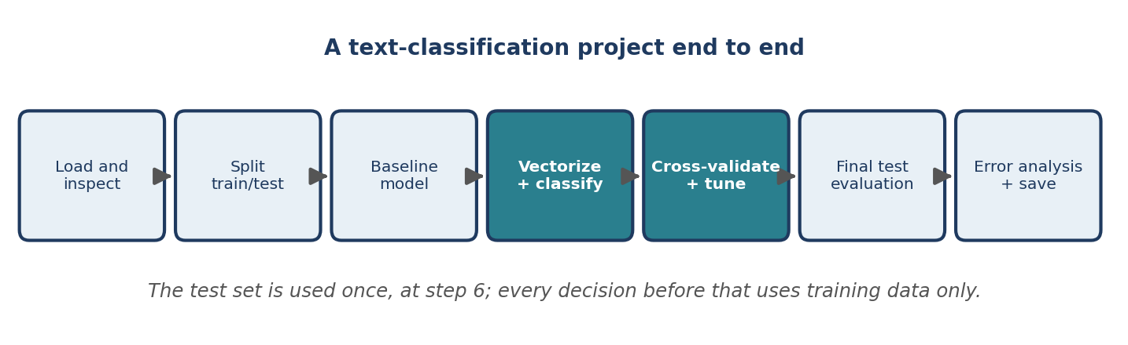
Figure 23.1 The stages of a text-classification project.

23.2 Project 1: Spam Detection
Step 1: load, inspect and split
We use the same SMS data and the same split as in Chapter 22, so that results are comparable (the first listing repeats the setup).
import numpy as np, pandas as pd, joblib
from sklearn.model_selection import train_test_split, StratifiedKFold, GridSearchCV
from sklearn.pipeline import Pipeline
from sklearn.feature_extraction.text import CountVectorizer, TfidfVectorizer
from sklearn.naive_bayes import MultinomialNB
from sklearn.linear_model import LogisticRegression
from sklearn.svm import LinearSVC
from sklearn.metrics import classification_report, confusion_matrix

df = pd.read_csv("sms.tsv", sep="\t", header=None, names=["label", "text"], quoting=3)
df["spam"] = (df["label"] == "spam").astype(int)

X_train, X_test, y_train, y_test = train_test_split(
df["text"], df["spam"], test_size=0.2, random_state=42, stratify=df["spam"])

Recall from Chapter 22 that 13.4 per cent of the messages are spam, that a trivial “always ham” model reaches 86.6 per cent accuracy with zero recall, and that Naive Bayes with default settings reaches F1 = 0.941 on the test set. Those are the numbers to beat.
Step 2: define candidate pipelines and search their settings
A Pipeline bundles the vectorizer and the classifier, so GridSearchCV can tune settings of both together, for example whether to use bigrams, while refitting the vectorizer inside every cross-validation fold. Parameter names use the step name, two underscores and the parameter: vec__ngram_range, clf__C. We search three model families, handling the class imbalance in the two linear models with class_weight="balanced", which increases the penalty for mistakes on the rarer class:
cv = StratifiedKFold(n_splits=5, shuffle=True, random_state=42)

searches = {
"Naive Bayes": GridSearchCV(
Pipeline([("vec", CountVectorizer()), ("clf", MultinomialNB())]),
{"vec__ngram_range": [(1, 1), (1, 2)], "vec__min_df": [1, 2],
"vec__lowercase": [True, False], "clf__alpha": [0.1, 0.5, 1.0]},
cv=cv, scoring="f1", n_jobs=-1),
"Logistic regression": GridSearchCV(
Pipeline([("vec", TfidfVectorizer()),
("clf", LogisticRegression(max_iter=1000, class_weight="balanced"))]),
{"vec__ngram_range": [(1, 1), (1, 2)], "vec__min_df": [1, 2], "clf__C": [1, 10, 30]},
cv=cv, scoring="f1", n_jobs=-1),
"Linear SVM": GridSearchCV(
Pipeline([("vec", TfidfVectorizer()), ("clf", LinearSVC(class_weight="balanced"))]),
{"vec__ngram_range": [(1, 1), (1, 2)], "vec__min_df": [1, 2], "clf__C": [0.3, 1, 3]},
cv=cv, scoring="f1", n_jobs=-1),
}

for name, search in searches.items():
search.fit(X_train, y_train)
print(f"{name:20} best CV F1 = {search.best_score_:.3f} {search.best_params_}")

winner = max(searches, key=lambda n: searches[n].best_score_)
print("selected:", winner)

Output
Naive Bayes best CV F1 = 0.958 {'clf__alpha': 0.1, 'vec__lowercase': False, 'vec__min_df': 1, 'vec__ngram_range': (1, 1)}
Logistic regression best CV F1 = 0.947 {'clf__C': 10, 'vec__min_df': 2, 'vec__ngram_range': (1, 2)}
Linear SVM best CV F1 = 0.951 {'clf__C': 1, 'vec__min_df': 1, 'vec__ngram_range': (1, 2)}
selected: Naive Bayes

GridSearchCV tried 24 settings for Naive Bayes, 12 for logistic regression and 12 for the SVM, each with five-fold cross-validation, and kept the best combination of each family. Selection used only the training data. Naive Bayes wins narrowly (0.958 against 0.951 and 0.947), but the differences between families are about as large as the fold-to-fold spread we measured in Chapter 22 (0.010 to 0.015), so we should not claim that it is truly better.
Step 3: evaluate the selected model once on the test set
best = searches[winner].best_estimator_
pred = best.predict(X_test) # the test set is used here, once
print(classification_report(y_test, pred, target_names=["ham", "spam"], digits=3))
print(confusion_matrix(y_test, pred).tolist())

Output
precision recall f1-score support

ham 0.989 0.995 0.992 966
spam 0.965 0.926 0.945 149

accuracy 0.986 1115
macro avg 0.977 0.960 0.968 1115
weighted avg 0.986 0.986 0.986 1115

[[961, 5], [11, 138]]

The tuned model reaches F1 = 0.945 on the test set. The cross-validated estimate (0.958) was slightly higher than the test result: choosing the best of many settings on the same folds always makes the validation score a little optimistic, which is why we keep the separate test set. Tuning improved the test F1 from 0.941 (default settings) to 0.945, which is within the uncertainty of Section 22.9. Tuning rarely transforms a model; the representation and the data matter more.
Step 4: look inside the model
Naive Bayes keeps, for every word, the log-probability of seeing it in each class. The words with the biggest difference are the model’s strongest evidence:
vec, clf = best.named_steps["vec"], best.named_steps["clf"]
names = vec.get_feature_names_out()
score = clf.feature_log_prob_[1] - clf.feature_log_prob_[0] # spam minus ham
order = np.argsort(score)
print("spam:", [names[i] for i in order[::-1][:8]])
print("ham: ", [names[i] for i in order[:8]])

Output
spam: ['claim', 'prize', '150p', '18', 'co', 'Cs', '500', 'Nokia']
ham: ['gt', 'lt', 'he', 'home', 'lor', 'da', 'Ok', 'later']

The spam words (claim, prize, 150p, 18, 500) are what we would expect from prize and premium-rate offers. Two features of the ham list show why inspection matters. The tokens gt and lt are leftovers of HTML-escaped characters (&gt; and &lt;, produced when “>” and “<” are written in messages), so the model has learned an artefact of how the data was stored, not language; and the best settings turned lower-casing off, so “Ok” and “Nokia” are case-sensitive features. A cleaning step (Chapter 6’s html.unescape) is the obvious next experiment.
Step 5: error analysis, saving and reuse
fp = np.where((y_test.values == 0) & (pred == 1))[0]
fn = np.where((y_test.values == 1) & (pred == 0))[0]
print(len(fp), len(fn))
for i in fp:
print("FP:", X_test.iloc[i][:70])

Output
5 11
FP: "GRAN ONLYFOUND OUT AFEW DAYS AGO.CUSOON HONI"
FP: Alright i have a new goal now
FP: "CHEERS FOR CALLIN BABE.SOZI CULDNT TALKBUT I WANNATELL U DETAILS LATE
FP: We have sent JD for Customer Service cum Accounts Executive to ur mail
FP: Nokia phone is lovly..

Five legitimate messages were flagged as spam, among them informal text in capital letters, a message about a job application and a message mentioning “Nokia”, one of the model’s spam words. Eleven spam messages were missed (examples in Section 22.10). Because the whole workflow is a single Pipeline, saving and reloading it saves the vectorizer’s vocabulary and the classifier together:
joblib.dump(best, "spam_model.joblib")
loaded = joblib.load("spam_model.joblib")

new = ["WINNER!! You have won a 1000 prize. Call 09061234567 now to claim",
"Are we still meeting for lunch tomorrow?",
"Congratulations! Free entry to win tickets, text WIN to 80085"]
print(loaded.predict(new).tolist(), loaded.predict_proba(new)[:, 1].round(3).tolist())

Output
[1, 0, 1] [1.0, 0.0, 1.0]

The model classifies the three new messages sensibly. Note the probabilities of exactly 1.0 and 0.0: Naive Bayes is typically over-confident (Section 22.6). Chapter 24 turns this saved file into a web service.

23.3 Project 2: News Classification
The second project has eight classes and a strong imbalance. The Reuters-21578 collection of newswire articles, with the standard ModApte train/test division, is available through NLTK (nltk.download("reuters")). Articles can carry several topic labels; we keep those with exactly one label among the eight most useful topics: earn (company earnings), acq (acquisitions), crude (oil), trade, money-fx (foreign exchange), interest (interest rates), ship and grain.
import collections
import nltk
from nltk.corpus import reuters

nltk.download("reuters", quiet=True)

categories = ["earn", "acq", "crude", "trade", "money-fx", "interest", "ship", "grain"]

def load(prefix):
texts, labels = [], []
for file_id in reuters.fileids():
if file_id.startswith(prefix):
cats = reuters.categories(file_id)
if len(cats) == 1 and cats[0] in categories: # keep single-label articles
texts.append(reuters.raw(file_id))
labels.append(cats[0])
return texts, labels

X_train, y_train = load("training/")
X_test, y_test = load("test/")
print(len(X_train), len(X_test))
print(collections.Counter(y_train).most_common())

Output
5501 2190
[('earn', 2840), ('acq', 1596), ('crude', 253), ('trade', 250), ('money-fx', 222), ('interest', 191), ('ship', 108), ('grain', 41)]

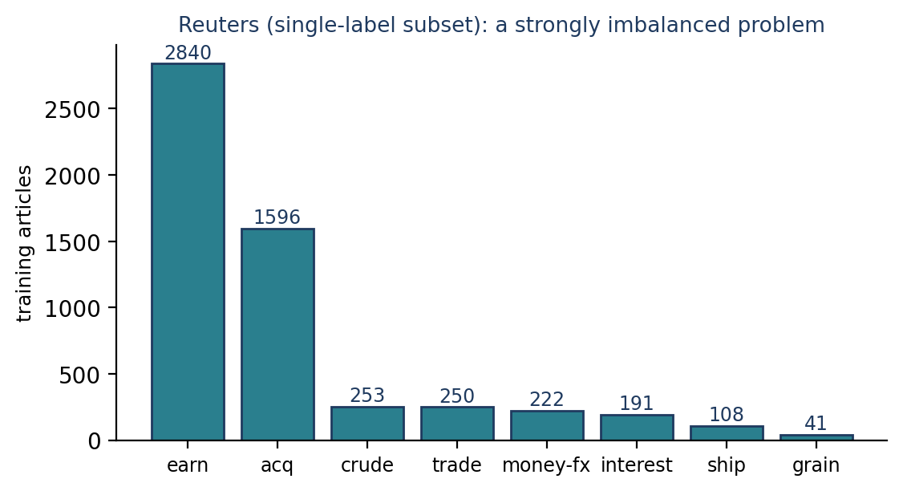
Figure 23.2 The training articles by topic: two classes make up 81 per cent of the data.
There are 5,501 training articles and 2,190 test articles. Earnings and acquisitions articles dominate; grain has only 41 training examples and 10 test examples. As the raw text still contains markup remnants such as &lt;CPML> (a company ticker in angle brackets), a production system would clean it; we leave the text unchanged to keep the comparison simple. A model that always predicted “earn” would be about 49 per cent accurate on the test set (1,083 of 2,190), which is the baseline here.

23.4 Comparing Eight Classifiers
As in Chapter 22, we select with cross-validation on the training data, now scored by macro-F1 because small classes matter. The test results are shown for all models for illustration, after the selection has been made:
from sklearn.naive_bayes import ComplementNB
from sklearn.ensemble import RandomForestClassifier
from sklearn.neighbors import KNeighborsClassifier
from sklearn.model_selection import cross_val_score
from sklearn.metrics import accuracy_score, f1_score

def tfidf():
return TfidfVectorizer(stop_words="english")

models = {
"Naive Bayes (counts)": Pipeline([("v", CountVectorizer(stop_words="english")), ("c", MultinomialNB())]),
"Naive Bayes (TF-IDF)": Pipeline([("v", tfidf()), ("c", MultinomialNB())]),
"Complement NB (TF-IDF)": Pipeline([("v", tfidf()), ("c", ComplementNB())]),
"Logistic regression": Pipeline([("v", tfidf()), ("c", LogisticRegression(max_iter=1000))]),
"Linear SVM": Pipeline([("v", tfidf()), ("c", LinearSVC())]),
"Linear SVM (balanced)": Pipeline([("v", tfidf()), ("c", LinearSVC(class_weight="balanced"))]),
"Random forest": Pipeline([("v", tfidf()), ("c", RandomForestClassifier(n_estimators=200, random_state=42, n_jobs=-1))]),
"k-NN (cosine)": Pipeline([("v", tfidf()), ("c", KNeighborsClassifier(metric="cosine"))]),
}

cv = StratifiedKFold(n_splits=5, shuffle=True, random_state=42)
cv_scores = {name: cross_val_score(m, X_train, y_train, cv=cv, scoring="f1_macro").mean()
for name, m in models.items()}
winner = max(cv_scores, key=cv_scores.get)
print("selected by cross-validation:", winner)

print(f"{'model':26}{'CV macro-F1':>12}{'accuracy':>10}{'macro-F1':>10}")
for name, model in models.items():
model.fit(X_train, y_train)
pred = model.predict(X_test)
print(f"{name:26}{cv_scores[name]:>12.3f}{accuracy_score(y_test, pred):>10.3f}{f1_score(y_test, pred, average='macro'):>10.3f}")

Output
selected by cross-validation: Linear SVM (balanced)
model CV macro-F1 accuracy macro-F1
Naive Bayes (counts) 0.864 0.958 0.839
Naive Bayes (TF-IDF) 0.461 0.843 0.440
Complement NB (TF-IDF) 0.866 0.948 0.837
Logistic regression 0.818 0.945 0.810
Linear SVM 0.924 0.971 0.924
Linear SVM (balanced) 0.928 0.971 0.933
Random forest 0.810 0.945 0.823
k-NN (cosine) 0.859 0.879 0.822

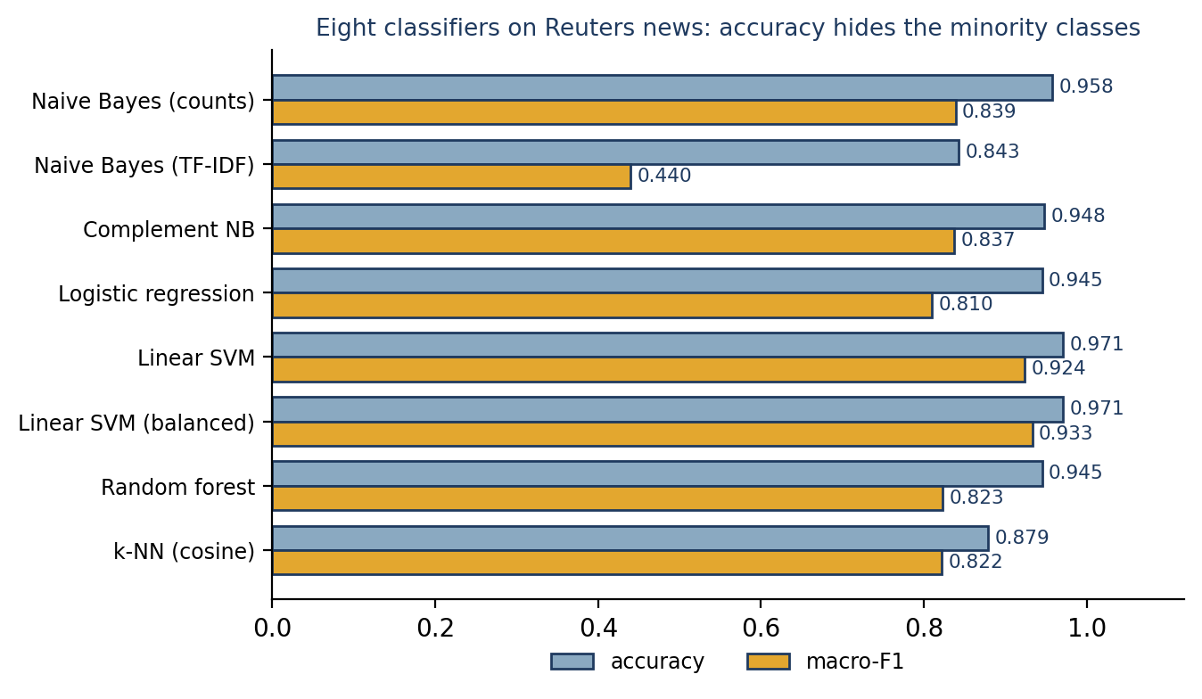
Figure 23.3 Test accuracy and macro-F1 of eight classifiers on the Reuters subset.
Several lessons follow from this table.
- Accuracy hides the minority classes. Multinomial Naive Bayes on TF-IDF features has an accuracy of 0.843 but a macro-F1 of 0.440: it largely ignores the small classes. The same algorithm on raw counts reaches 0.839, and Complement Naive Bayes, a variant designed for imbalanced text, reaches 0.837. TF-IDF weights are not count data, and the standard multinomial model assumes counts.
- Linear models are strong baselines for sparse text. The linear SVM is the best family (macro-F1 0.924 without, and 0.933 with, balanced class weights), ahead of logistic regression with default settings (0.810).
- Random forests and k-NN lag here. With thousands of sparse features, trees see few informative splits and nearest-neighbour search is dominated by common words. This agrees with the general advice of Section 18.7, but it is a result on one dataset, not a rule.
- Cross-validation and test results agree on the ranking of the top models (SVMs first), which gives some confidence in the selection; the differences within the top group are small.
- Settings matter as much as algorithms. Logistic regression’s weak showing is mostly the result of default regularisation and class balance, as in the spam example.

23.5 A Closer Look at the Selected Model
best = models["Linear SVM (balanced)"]
pred = best.predict(X_test)
print(classification_report(y_test, pred, digits=3))

Output
precision recall f1-score support

acq 0.974 0.984 0.979 696
crude 0.958 0.950 0.954 121
earn 0.992 0.987 0.989 1083
grain 1.000 1.000 1.000 10
interest 0.930 0.815 0.868 81
money-fx 0.819 0.885 0.851 87
ship 0.909 0.833 0.870 36
trade 0.926 0.987 0.955 76

accuracy 0.971 2190
macro avg 0.939 0.930 0.933 2190
weighted avg 0.972 0.971 0.971 2190

The large classes are almost perfect (earn F1 0.989, acq 0.979). The weakest are money-fx (0.851), interest (0.868) and ship (0.870). Grain scores a perfect 1.000, but on only 10 test articles, so the estimate is very uncertain (Section 22.9). The confusion matrix shows where the errors lie (Figure 23.4):
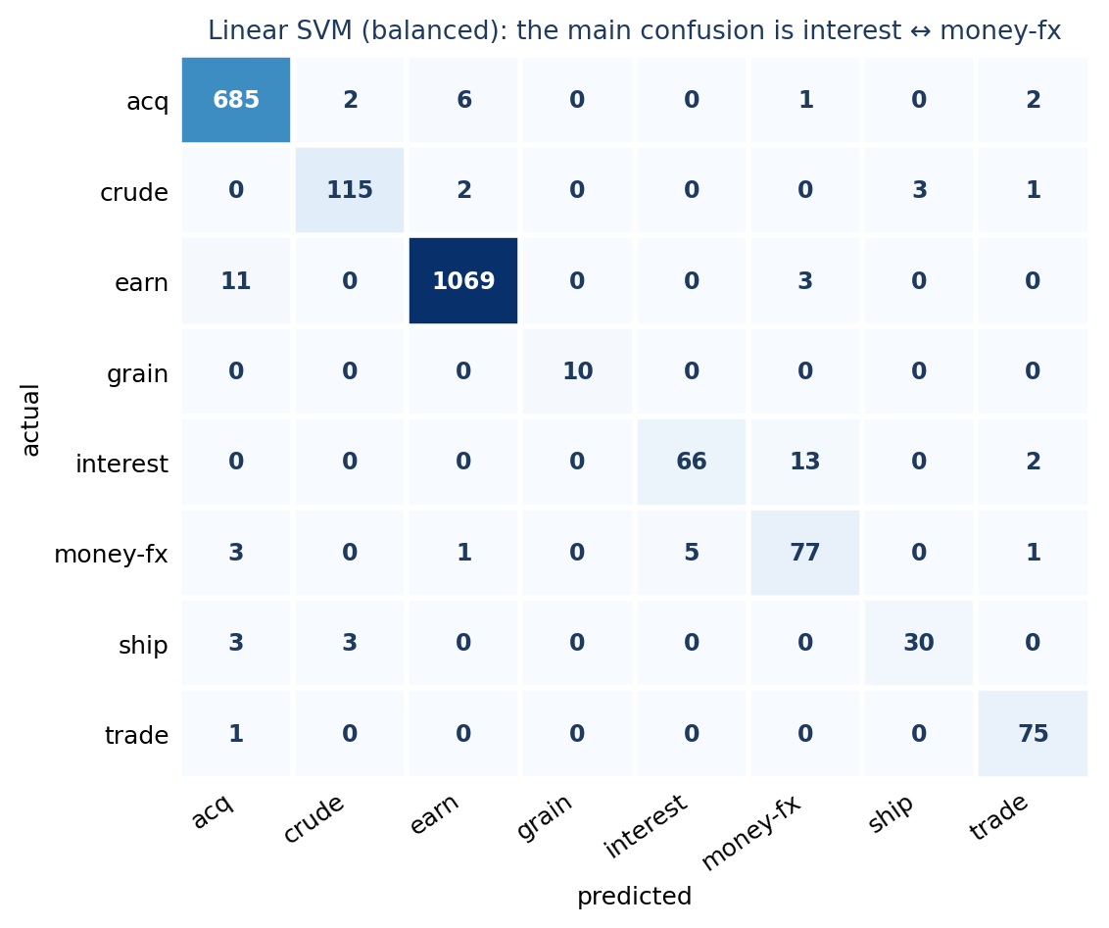
Figure 23.4 Confusion matrix of the selected model. The largest off-diagonal count (13) is interest articles predicted as money-fx.
Interest-rate and foreign-exchange news are closely related topics, and 13 interest articles were classified as money-fx. The classifier’s mistakes are the ones a human would find hardest to resolve. What does the model use as evidence? The coefficients of the linear model give the highest-weighted words per class:
vec, clf = best.named_steps["v"], best.named_steps["c"]
names = vec.get_feature_names_out()
for cls, row in zip(clf.classes_, clf.coef_):
print(cls, [names[i] for i in np.argsort(row)[::-1][:6]])

Output
acq ['stake', 'acquisition', 'merger', 'sell', 'lt', 'acquire']
crude ['oil', 'crude', 'refinery', '29', 'barrels', 'opec']
earn ['vs', 'dividend', 'split', 'earnings', 'net', 'cts']
grain ['grain', 'minus', 'cbt', 'farm', 'crops', 'certificates']
interest ['rate', 'rates', 'prime', 'pct', 'bundesbank', 'gros']
money-fx ['dollar', 'currency', 'exchange', 'monetary', 'currencies', '26']
ship ['shipping', '13', 'port', 'ships', 'strike', 'canal']
trade ['trade', '31', 'goods', 'exports', 'ec', 'export']

Most evidence is sensible (stake, merger, acquisition for acq; oil, barrels, opec for crude; rate, prime for interest). Some is an artefact: “lt” (from &lt;, the markup around company tickers) points to acquisitions, and bare numbers (29, 13, 31, 26) appear for several classes, probably because of the way articles in these categories were written (for instance, price and quantity details). Such features may not generalise to other news sources. This is the kind of finding that error analysis should lead to: look at the data before trusting the score.

23.6 Choosing a Classifier
Classifier | Strengths for text | Cautions
Multinomial Naive Bayes | Very fast; works with little data; strong baseline on word counts | Over-confident probabilities; sensitive to imbalance and to TF-IDF weighting; Complement NB can help
Logistic regression | Good probabilities; interpretable coefficients; strong on TF-IDF | Needs tuning of regularisation (C) and class weights
Linear SVM | Often the best accuracy for sparse text at low cost | No native probabilities; tune C
k-nearest neighbours | Simple; no training | Slow prediction on large data; affected by common words
Random forest | Handles non-linear patterns; little preprocessing | Slow and less effective on very high-dimensional sparse text
Fine-tuned transformer | Can capture context and word order (Chapter 21) | Needs more data, compute and care; compare with a linear baseline first
Table 23.1 Classifiers for text classification: a practical summary. These are tendencies, not guarantees.

23.7 Good Practice with Pipelines
- Put every step that learns from data (vectorizer, scaler, feature selector) inside the Pipeline.
- Tune with GridSearchCV or RandomizedSearchCV on the training data only; keep the grid small enough to run.
- Set random_state wherever randomness enters (splits, folds, forests), and record versions of Python, scikit-learn and the data.
- Score with the metric that reflects the real costs (macro-F1, recall on the critical class), not the default accuracy.
- Keep a trivial baseline and a simple strong baseline (TF-IDF with a linear model) in every project.
- Save the whole pipeline, not just the classifier, so that training and production preprocessing cannot diverge.

23.8 Common Mistakes
- Choosing the model by test score, or retuning after looking at it (Section 22.2).
- Reporting accuracy for imbalanced multi-class data (Section 23.4).
- Comparing models with different preprocessing and attributing the difference to the algorithm.
- Using default settings for every model and declaring a winner (logistic regression in this chapter).
- Ignoring artefacts in the data, such as the gt/lt tokens or the markup remnants.
- Trusting small classes’ scores (grain: 10 test articles).
- Over-interpreting a 0.5 to 1 point difference between top models.

23.9 Chapter Summary
- A text-classification project follows a fixed discipline: inspect, split, baseline, pipeline, cross-validate and tune on training data, evaluate once on the test set, inspect errors and features, save the pipeline.
- Pipeline plus GridSearchCV tunes vectorizer and classifier settings together without leakage.
- On both datasets, a Naive Bayes or linear model with sensible settings was a strong baseline; tuning gave small gains compared with the effect of the representation and the data.
- For imbalanced multi-class data, macro-F1, per-class reports and the confusion matrix reveal failures that accuracy hides.
- Interpretation of features and error analysis uncover data artefacts and guide the next experiment.

23.10 Review Questions and Exercises
- Why does GridSearchCV take a Pipeline rather than a pre-computed feature matrix?
- Why does multinomial Naive Bayes perform much worse on TF-IDF features than on raw counts in the Reuters experiment?
- What does class_weight="balanced" change, and why did it help the linear models?
- In Table 23.1, give one reason you might still choose Naive Bayes over a linear SVM.
- Exercise. Remove exact duplicates from the SMS data before splitting (Section 22.8) and rerun the spam project. Do the selected model and the test F1 change?
- Exercise. Add html.unescape and lower-casing to the spam pipeline with a custom preprocessing function (preprocessor= in the vectorizer). Do gt and lt disappear from the feature lists?
- Exercise. For the Reuters data, combine the three smallest classes into one class “other” and compare the macro-F1 of the selected model before and after. What does the change tell you about the small classes?
- Exercise. Choose a text dataset of your own (product reviews, support tickets, news headlines). Apply the full workflow of this chapter and write a one-page report with the baseline, the selected model, per-class results and three observations from error analysis.

Editorial note — remove before publication
From your notes: the spam-detection pipeline (Chapters 16 and 14), the news-classification pipeline (Chapter 17), the product-classification example and the comparison of K-nearest neighbours, Naive Bayes and random forest (Chapter 18) — consolidated and extended here, as planned.
Datasets: SMS Spam Collection (Almeida, Hidalgo and Yamakami, 2011; UCI repository), read from a GitHub mirror, and Reuters-21578 with the ModApte split, via NLTK. Check the licence and citation requirements of both before publication. All code was run (scikit-learn 1.8.0, NLTK 3.x, pandas, NumPy 2.4.4) and every output is real. Run times are not given because they depend on hardware.
Corrections and honest findings: (1) Our first run compared classifiers on the test set; the chapter now selects by cross-validation on the training data, as Chapter 22 requires, and reports test results for all models only after selection. (2) Tuning improved the Naive Bayes test F1 only from 0.941 to 0.945, and the winner by cross-validation is not clearly better than the alternatives, which the text says. (3) Naive Bayes on TF-IDF features performs badly on the imbalanced Reuters data (macro-F1 0.440), a result that differs from the usual advice to use TF-IDF everywhere. (4) The gt/lt and numeric-token artefacts are real findings in the models, not assumptions.

Chapter 24 Deployment, Monitoring and Concept Drift
Learning objectives
After studying this chapter you will be able to:
• save a trained pipeline with its metadata and serve it as a web API;
• explain what packaging, versioning and logging add to a deployment;
• monitor inputs, outputs and (when labels arrive) performance;
• distinguish data drift from concept drift, and demonstrate the effect of drift on a classifier;
• describe retraining strategies and the safeguards around them, and name the responsibilities that come with deployment.

24.1 From Notebook to Production
A model in a notebook has not yet helped anyone. Deployment makes a trained model available to other software or to users, for example as a web service that receives text and returns a prediction. The seven-stage pipeline of Chapter 4 ended with deployment and monitoring, and this chapter returns to them. After deployment, language and users change, so the work does not end; it moves into operation. Three questions guide the chapter: How do we serve the model reliably? How do we know when it stops working? What do we do then?

24.2 Saving the Model and Its Metadata
In Chapter 23 we saved the entire pipeline with joblib. Saving the pipeline, not only the classifier, guarantees that the live preprocessing is the same code as the training preprocessing, which prevents the train/serve skew warned about in Section 4.4. A model file is only useful if you can later tell what it is. A small metadata file records what is needed to reproduce and audit it:
import json, platform, sklearn

metadata = {
"model_file": "spam_model.joblib",
"trained_on": "SMS Spam Collection, 4,459 training messages",
"sklearn_version": sklearn.__version__,
"python_version": platform.python_version(),
"test_f1": 0.945,
"decision_threshold": 0.5,
}
with open("spam_model_card.json", "w") as f:
json.dump(metadata, f, indent=2)
print(open("spam_model_card.json").read())

Output
{
"model_file": "spam_model.joblib",
"trained_on": "SMS Spam Collection, 4,459 training messages",
"sklearn_version": "1.8.0",
"python_version": "3.12.3",
"test_f1": 0.945,
"decision_threshold": 0.5
}

Compatibility warning
Files saved with joblib (or pickle) are tied to the library versions that created them. Load them with the same versions of scikit-learn and Python, which is why the versions are recorded above. Never load a pickle file from an untrusted source: loading can execute arbitrary code.

24.3 Serving the Model as a Web API
A common pattern is a small web service that loads the model once at start-up and exposes an endpoint. The following uses FastAPI, one of the tools named in your pipeline notes (others are Flask and cloud-hosting platforms). Install it with pip install fastapi uvicorn.
# app_demo.py
import joblib
from fastapi import FastAPI
from pydantic import BaseModel, Field

model = joblib.load("spam_model.joblib") # the Pipeline saved in Chapter 23
app = FastAPI(title="SMS spam classifier")

class Message(BaseModel):
text: str = Field(..., min_length=1, max_length=1000)

@app.post("/predict")
def predict(message: Message):
probability = float(model.predict_proba([message.text])[0, 1])
return {"label": "spam" if probability >= 0.5 else "ham",
"spam_probability": round(probability, 3)}

@app.get("/health")
def health():
return {"status": "ok"}

- The model is loaded once, when the module is imported, not on every request.
- Message declares the expected input. FastAPI validates it automatically and rejects empty or overly long texts.
- /predict returns the label and the probability, so the client can apply its own threshold.
- /health lets a load balancer or monitoring tool check that the service is running.
To run the service you would start it with uvicorn app_demo:app --port 8000 and send requests to http://localhost:8000/predict. Here we test the same application in-process with FastAPI’s test client, which needs no network:
from fastapi.testclient import TestClient
from app_demo import app

client = TestClient(app)
print(client.get("/health").json())

r = client.post("/predict", json={"text": "WINNER!! You have won a 1000 prize. Call 09061234567 now to claim"})
print(r.status_code, r.json())

r = client.post("/predict", json={"text": "Are we still meeting for lunch tomorrow?"})
print(r.status_code, r.json())

r = client.post("/predict", json={"text": ""})
print(r.status_code, r.json()["detail"][0]["type"])

Output
{'status': 'ok'}
200 {'label': 'spam', 'spam_probability': 1.0}
200 {'label': 'ham', 'spam_probability': 0.0}
422 string_too_short

The service returns a spam label for the prize message and ham for the lunch message, and it rejects the empty text with HTTP status 422 (“unprocessable”), because the validation rule min_length=1 fails. (FastAPI 0.162 and httpx 0.28 were used here; the test client’s exact module paths have changed between versions, so check the documentation for yours.)
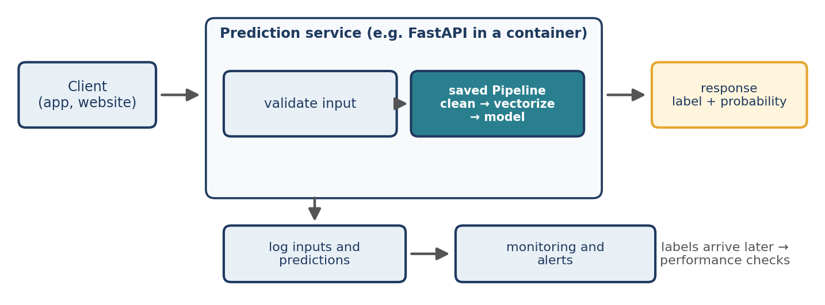
Figure 24.1 A typical deployment: a prediction service wrapping the saved pipeline, with logging and monitoring.

24.4 Packaging, Versioning and Infrastructure
Moving from your computer to a server raises the question of how to reproduce the environment. Common practices are:
- Pin dependencies in a requirements.txt file (scikit-learn==1.8.0, and so on), so that the same versions are installed everywhere.
- Containerise the service with Docker: a container image holds the code, the model file and the exact libraries, and runs the same way on a laptop, a server or a cloud platform (AWS, Azure, Google Cloud).
- Version the model, the training data and the code together, and give each model a version identifier that is returned with predictions or at least logged.
- Choose the serving mode to fit the use: online (one request at a time, with a latency target) or batch (score a file or database table periodically).
- Plan for scale and cost: how many requests per second, how much memory the model needs, and whether a GPU is required (large transformer models often need one; the linear models of this chapter run comfortably on a small CPU).
# Dockerfile (illustrative; not executed in this book's tests)
FROM python:3.12-slim
WORKDIR /app
COPY requirements.txt .
RUN pip install --no-cache-dir -r requirements.txt
COPY app_demo.py spam_model.joblib .
CMD ["uvicorn", "app_demo:app", "--host", "0.0.0.0", "--port", "8000"]

The Dockerfile above is a template and was not built or run for this book. Adapt it to your environment and test it before relying on it.

24.5 Monitoring
Monitoring means continuously checking that a deployed system is healthy. There are three layers:
Layer | What to watch | Examples
Operational | Is the service up and fast? | Error rate, latency, memory, throughput, failed requests
Data | Do the inputs still look like the training data? | Text length, share of words never seen in training (out-of-vocabulary rate), language mix, missing or invalid inputs, new vocabulary
Model quality | Are the predictions still right? | Accuracy, precision, recall and F1 once true labels arrive; the distribution of predicted classes and probabilities in the meantime
Table 24.1 Three layers of monitoring.
Model quality is the hardest to observe, because true labels often arrive late or never (a user may never report that a message was misclassified). Data and prediction statistics are therefore the early-warning layer. The following function computes simple batch statistics for the spam model, including the share of tokens that its vocabulary has never seen:
import re, numpy as np, pandas as pd
from sklearn.model_selection import train_test_split
from sklearn.pipeline import Pipeline
from sklearn.feature_extraction.text import CountVectorizer
from sklearn.naive_bayes import MultinomialNB
from sklearn.metrics import recall_score, precision_score, f1_score

df = pd.read_csv("sms.tsv", sep="\t", header=None, names=["label", "text"], quoting=3)
df["spam"] = (df["label"] == "spam").astype(int)
X_train, X_test, y_train, y_test = train_test_split(
df["text"], df["spam"], test_size=0.2, random_state=42, stratify=df["spam"])

model = Pipeline([("vec", CountVectorizer()), ("clf", MultinomialNB())]).fit(X_train, y_train)

def batch_stats(model, texts):
vec = model.named_steps["vec"]
analyzer = vec.build_analyzer()
tokens = [tok for t in texts for tok in analyzer(t)]
oov = np.mean([tok not in vec.vocabulary_ for tok in tokens])
proba = model.predict_proba(texts)[:, 1]
return {"messages": len(texts),
"mean_length": round(float(np.mean([len(t) for t in texts])), 1),
"oov_rate": round(float(oov), 3),
"predicted_spam_rate": round(float((proba >= 0.5).mean()), 3)}

print("training :", batch_stats(model, list(X_train)))
print("test :", batch_stats(model, list(X_test)))

Output
training : {'messages': 4459, 'mean_length': 80.0, 'oov_rate': 0.0, 'predicted_spam_rate': 0.133}
test : {'messages': 1115, 'mean_length': 82.5, 'oov_rate': 0.066, 'predicted_spam_rate': 0.124}

The training data has an out-of-vocabulary (OOV) rate of 0.0 by construction. The test messages, which come from the same source, have an OOV rate of 6.6 per cent, because even without any change in language, some words were simply not in the training set. This 6.6 per cent is the baseline against which later batches are compared; what matters is a change, not the absolute value. The predicted spam rate (12.4 per cent) is also stable and close to the true rate (13.4 per cent).

24.6 Data Drift and Concept Drift
Over time, the world a model was trained on changes, and a model that performed well at deployment degrades. Two related ideas describe this:
- Data drift (covariate shift): the distribution of the inputs changes: new words, new topics, longer messages, a new customer segment. The relationship between input and label may be unchanged, but the model sees input unlike its training data.
- Concept drift: the relationship between the input and the correct output changes. A word that used to indicate one class comes to indicate another, or the definition of the labels changes. In the support-ticket example of Chapter 4, customers may start using new words, or describe problems differently after a product update, so a model trained on older tickets becomes less accurate.
In practice they occur together, and a third kind, a change in the class proportions (more spam this month), is also common. All are reasons to monitor and retrain. We now simulate the problem for the spam filter.
A simulation: spammers change their wording
Spammers adapt to filters. We simulate this by rewriting a few key spam words in the spam test messages (free → fr33, win → w1n, claim → cl4im, and so on), leaving the ham messages unchanged. This is an artificial illustration, not a record of real spam behaviour.
swaps = {"free": "fr33", "win": "w1n", "won": "w0n", "prize": "pr1ze", "claim": "cl4im",
"urgent": "urg3nt", "txt": "t3xt", "call": "c4ll", "reply": "r3ply", "stop": "st0p",
"mobile": "m0bile", "text": "t3xt", "now": "n0w", "cash": "c4sh", "service": "s3rvice"}

def disguise(text):
return re.sub(r"[A-Za-z]+", lambda m: swaps.get(m.group().lower(), m.group()), text)

X_test_drift = X_test.copy()
is_spam = (y_test == 1).values
X_test_drift[is_spam] = X_test[is_spam].map(disguise)

example = [i for i in np.where(is_spam)[0]
if "prize" in X_test.iloc[i].lower() and "claim" in X_test.iloc[i].lower()][0]
print(X_test.iloc[example][:70])
print(X_test_drift.iloc[example][:70])

print("drifted :", batch_stats(model, list(X_test_drift)))
for name, texts in [("before drift", X_test), ("after drift ", X_test_drift)]:
p = model.predict(texts)
print(name, "precision", round(precision_score(y_test, p), 3),
"recall", round(recall_score(y_test, p), 3), "F1", round(f1_score(y_test, p), 3))

Output
URGENT! We are trying to contact U. Todays draw shows that you have wo
urg3nt! We are trying to contact U. Todays draw shows that you have w0
drifted : {'messages': 1115, 'mean_length': 82.5, 'oov_rate': 0.091, 'predicted_spam_rate': 0.119}
before drift precision 0.978 recall 0.906 F1 0.941
after drift precision 0.977 recall 0.872 F1 0.922

The model’s recall on spam falls from 0.906 to 0.872 and its F1 from 0.941 to 0.922, although nothing in the model has changed. The input monitor sees a rise in the OOV rate from 0.066 to 0.091, while the predicted spam rate barely moves (0.124 to 0.119). The disguised words are now unknown words; the model has lost some of its best evidence. The effect here is modest, because the other words in the messages still carry information, but a stronger change would give a larger fall.
Detecting the drift
A simple alert rule compares a new batch with the baseline from the test period:
baseline = batch_stats(model, list(X_test))

def check(stats, baseline, oov_factor=1.5):
alerts = []
if stats["oov_rate"] > baseline["oov_rate"] * oov_factor:
alerts.append("OOV rate high")
if abs(stats["predicted_spam_rate"] - baseline["predicted_spam_rate"]) > 0.03:
alerts.append("spam rate shifted")
return alerts or ["ok"]

drift_stats = batch_stats(model, list(X_test_drift))
print(check(drift_stats, baseline))
print(check(drift_stats, baseline, oov_factor=1.2))

Output
['ok']
['OOV rate high']

With the factor 1.5, the rule raises no alarm even though the model has degraded: the OOV rate rose by 38 per cent (0.066 to 0.091), not 50 per cent. With a more sensitive factor of 1.2, it does raise the alert. This is a general difficulty: thresholds for drift alerts must be calibrated on past data, balancing missed warnings against false alarms, and an unlabelled signal such as the OOV rate is only a hint. The reliable check is to measure performance on freshly labelled samples, which is why teams sample some live predictions for human labelling.

24.7 Retraining and Release
When monitoring shows a problem, the usual response is to retrain with recent data. Continuing the simulation, we label half of the drifted messages, add them to the training data and retrain; we then compare the old and the new models on the other half, which neither has seen:
Xd_train, Xd_hold, yd_train, yd_hold = train_test_split(
X_test_drift, y_test, test_size=0.5, random_state=1, stratify=y_test)

retrained = Pipeline([("vec", CountVectorizer()), ("clf", MultinomialNB())]).fit(
pd.concat([X_train, Xd_train]), pd.concat([y_train, yd_train]))

for name, m in [("old model ", model), ("retrained model", retrained)]:
p = m.predict(Xd_hold)
print(name, "recall", round(recall_score(yd_hold, p), 3),
"precision", round(precision_score(yd_hold, p), 3), "F1", round(f1_score(yd_hold, p), 3))
print("retrained model on the original test messages: F1", round(f1_score(y_test, retrained.predict(X_test)), 3))

Output
old model recall 0.88 precision 0.957 F1 0.917
retrained model recall 0.92 precision 0.958 F1 0.939
retrained model on the original test messages: F1 0.955

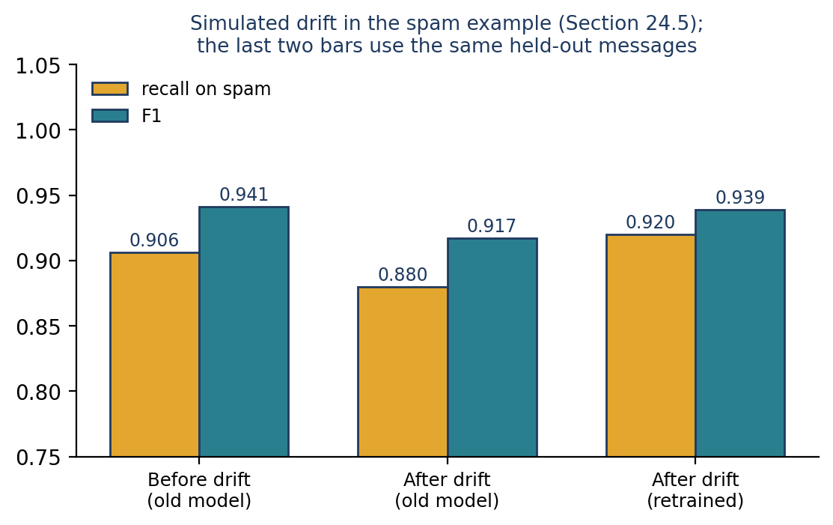
Figure 24.2 Simulated drift: the old model loses recall on the new wording; the retrained model recovers it.
On the held-out drifted messages the retrained model recovers recall (0.88 to 0.92) and F1 (0.917 to 0.939). Its F1 on the original messages is 0.955, so it did not forget the old behaviour. Caution: the original test messages include the very messages that were rewritten and used for retraining, so that figure is optimistic; in a real project you would keep a separate, never-used test set. The simulation is also easy to learn because the same substitutions occur in training and test, which real drift seldom allows.
Retraining policies
- Scheduled: retrain every week or month with the latest data; simple and predictable.
- Triggered: retrain when monitoring raises an alert or measured quality falls below a threshold.
- Human-in-the-loop: route uncertain or high-impact predictions to people, and use their labels as new training data.
Safeguards around retraining
- Evaluate before release. The new model must beat the current one on a recent, held-out test set, not only on the old one.
- Release gradually. Run the new model in shadow mode (predicting alongside the old one without affecting users), then to a small share of traffic (a canary or A/B test), then to everyone.
- Keep the old version so that you can roll back quickly.
- Watch for feedback loops. If the model’s own predictions decide which examples get labelled, the new training data is biased by the old model’s mistakes.
- Version everything: code, data snapshot, model, metrics and the decision to release.
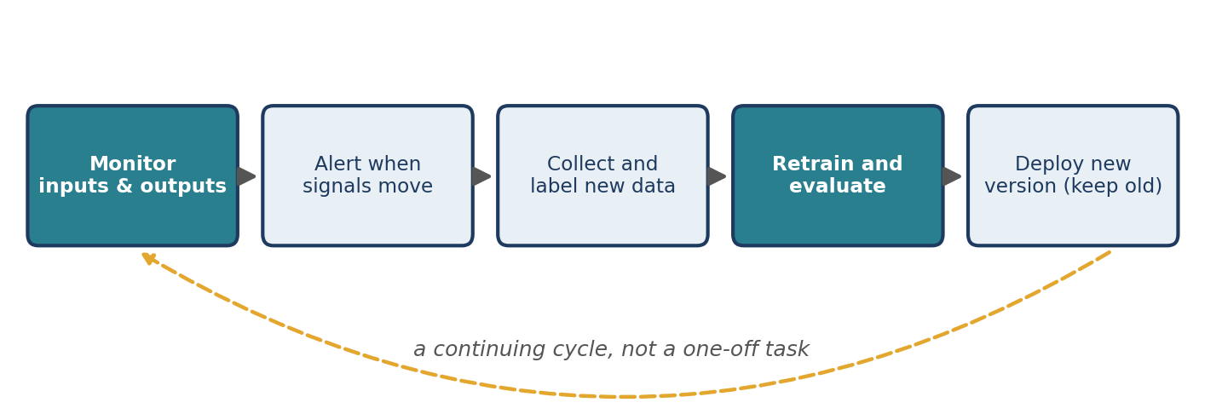
Figure 24.3 Monitoring and retraining form a continuing cycle.

24.8 Responsible Deployment
A deployed NLP system affects real people, and that brings responsibilities beyond accuracy:
- Privacy and security. Text often contains personal information. Collect and store only what you need; protect logs; check legal requirements for your region and sector; and be careful before sending text to external services.
- Fairness. A model can perform differently for different groups, dialects or languages. Evaluate on slices of the data and not only overall.
- Transparency and documentation. Record what the model is for, how it was trained and evaluated, its known limits and its version. The metadata file in Section 24.2 is a minimal start; a fuller “model card” records more.
- Human oversight. Decide who handles errors and appeals. For high-stakes decisions, a model should assist people, not replace them.
- Robustness. Users, and sometimes attackers, can submit unusual or adversarial text. Validate input and limit its size, as the API above does.
- Generative systems. If your deployment uses a large language model (Chapter 21), the same ideas apply, with additional care: track the exact model version and prompt, because both can change behaviour; evaluate outputs on a fixed set of test cases regularly; and monitor cost and token usage.

24.9 A Deployment Checklist
Question | Done?
Is the whole pipeline (preprocessing + model) saved as one object, with versions and metadata recorded? | ☐
Does the service validate inputs and return clear errors? | ☐
Are dependencies pinned and the environment reproducible (for example, a container)? | ☐
Are requests, predictions and the model version logged, with privacy in mind? | ☐
Are input statistics (length, OOV rate, language) and the prediction mix monitored against a baseline? | ☐
Is there a plan to obtain labels for a sample of live data? | ☐
Are alert thresholds calibrated on past data? | ☐
Is there a retraining policy and a safe release process with rollback? | ☐
Is there documentation of intended use, limits and responsibilities? | ☐
Table 24.2 A short checklist.

24.10 Common Mistakes
- Treating deployment as the end of the project (Figure 24.3).
- Different preprocessing in training and production (train/serve skew). Save one Pipeline.
- Loading the model on every request instead of once at start-up.
- Monitoring only uptime, not data and prediction quality.
- Uncalibrated alerts, which either miss real drift or cry wolf (Section 24.6).
- Retraining on data labelled by the model itself without human verification.
- Releasing a retrained model without comparing it to the current one.
- Mismatched library versions when loading a saved model, or loading files from untrusted sources.

24.11 Chapter Summary
- Deployment makes the saved pipeline available, often as an API; the pipeline, its versions and its metadata should be saved and recorded together.
- Packaging (pinned dependencies, containers) and versioning make deployments reproducible.
- Monitor three layers: the service, the inputs and the model’s quality; labels arrive late, so input and prediction statistics are early-warning signals.
- Data drift changes the inputs; concept drift changes the relationship between input and output. Both can degrade a model that has not changed.
- Retrain on recent data, evaluate before release, release gradually and keep a rollback.
- Responsible deployment includes privacy, fairness, documentation and human oversight.

24.12 Review Questions and Exercises
- What is train/serve skew? Give one cause and one way to prevent it.
- Explain the difference between data drift and concept drift with an example from a customer-support classifier.
- Why can an alert based on the OOV rate fail to detect a drop in recall? Give a case in which it fires but the model is fine.
- Why does the retrained model’s F1 of 0.955 on the original test messages overstate its quality?
- Exercise. Add a /predict_batch endpoint to the FastAPI application that accepts a list of messages and returns one prediction for each, with a maximum list length. Test it with the test client.
- Exercise. Extend batch_stats with two more monitoring statistics (for example, the fraction of messages containing digits, and the average predicted probability) and check how they change under the simulated drift.
- Exercise. Design a stronger drift simulation: replace the spelling of 15 spam words with synonyms that never appeared in the training data. How large is the fall in recall? How many labelled drifted messages must be added before the model recovers?
- Exercise. Write a one-page deployment plan for a model you have built: serving mode, hardware, versions, monitoring signals and thresholds, retraining policy, and the people responsible.

Editorial note — remove before publication
From your notes: the model-deployment, monitoring and concept-drift parts of the End-to-End NLP Pipeline unit — deployment as a service with FastAPI, Flask, cloud platforms and Docker; the new-ticket example; the monitoring list (reduced accuracy, changes in input data, missing or invalid data, slow response times, changes in customer writing patterns); concept drift with retraining.
Added: saving with metadata, a FastAPI service tested in-process (real output), packaging and versioning advice, the monitoring layers, batch statistics with an out-of-vocabulary rate, a drift simulation on the SMS data with real measurements (recall 0.906 → 0.872, F1 0.941 → 0.922; retraining recovers recall to 0.92 on held-out drifted messages), an alert rule whose threshold has to be tuned (it misses the drift at factor 1.5, and fires at 1.2), release safeguards, responsible deployment and a checklist.
Not run or verified: the Dockerfile and the uvicorn server command are templates; they were not built or started in the test environment. The simulation uses invented word substitutions and is an illustration, not evidence about real spam. The retrained-model F1 on the original test messages is optimistic, as the text explains. All other code was run (scikit-learn 1.8.0, FastAPI 0.162, httpx 0.28, pandas, NumPy 2.4.4).

