NATURAL LANGUAGE PROCESSING FUNDAMENTALS
From Text Preprocessing to Word Embeddings, with Python
Draft manuscript — Part VI: Word Embeddings
Chapters 19–21 · Word2Vec, Word Vectors in spaCy, Contextual Embeddings and LLMs
[Author name — to be supplied]
Contents
Part VI Word Embeddings 3
Chapter 19 Word Embeddings and Word2Vec 4
19.1 What Are Word Embeddings? 4
19.2 Why Do We Need Word Embeddings? 5
19.3 Families of Embedding Techniques 5
19.4 Word2Vec: The Distributional Idea 6
19.5 Architecture 1: CBOW 7
19.6 Architecture 2: Skip-Gram 7
19.7 How Does Word2Vec Learn the Numbers? 8
19.8 Training Word2Vec with gensim 10
19.9 Similarity, Analogies and What Embeddings Learn 13
19.10 Word2Vec versus BERT 13
19.11 Customising Embeddings for a Domain 14
19.12 Common Mistakes 14
19.13 Chapter Summary 14
19.14 Review Questions and Exercises 15
Chapter 20 Word Vectors and Similarity in spaCy 16
20.1 What Are Word Vectors? 16
20.2 Which spaCy Pipelines Contain Word Vectors? 16
20.3 Accessing Word Vectors 17
20.4 Word Similarity 18
20.5 Similarity Does Not Mean Synonymy 19
20.6 Document and Sentence Vectors 20
20.7 Vector Arithmetic 21
20.8 Static Vectors versus Contextual Embeddings 22
20.9 Using Document Vectors as Classifier Features 23
20.10 Common Mistakes 24
20.11 Chapter Summary 24
20.12 Review Questions and Exercises 24
Chapter 21 From Static to Contextual Embeddings: Transformers and LLMs 26
21.1 The Limits of Static Embeddings 26
21.2 Subword Tokenization 27
21.3 Self-Attention in Miniature 29
21.4 Transformers, Pre-training and Fine-tuning 31
21.5 Using Pre-trained Models in Python 31
21.6 Choosing a Representation 33
21.7 Where to Go Next 34
21.8 Common Mistakes 34
21.9 Chapter Summary 34
21.10 Review Questions and Exercises 35

Part VI Word Embeddings
The count-based representations of Part V treat every word as an unrelated column. Part VI introduces word embeddings: dense vectors, learned from text, in which words used in similar ways receive similar vectors. Chapter 19 explains the most influential algorithm, Word2Vec, and trains it. Chapter 20 uses pre-trained word vectors in spaCy. Chapter 21 shows why a single vector per word is not enough and introduces contextual embeddings, transformers and large language models.

Chapter 19 Word Embeddings and Word2Vec
Learning objectives
After studying this chapter you will be able to:
• define word embeddings and explain how they differ from Bag of Words and TF-IDF;
• describe the distributional idea behind Word2Vec and the CBOW and Skip-Gram architectures;
• generate training pairs from a context window and follow the learning loop in a small NumPy example;
• train a Word2Vec model with gensim and query it;
• explain why a tiny corpus gives unreliable vectors and why word arithmetic is not guaranteed.

19.1 What Are Word Embeddings?
Word embeddings are numerical representations of words as dense vectors that can capture semantic and linguistic relationships. Machine-learning models cannot directly understand words such as king, queen, help or assistance, so embeddings represent them as lists of numbers from which a model can learn patterns. A simplified illustration with four dimensions:
Word | Dim 1 | Dim 2 | Dim 3 | Dim 4
king | 0.82 | 0.21 | 0.75 | 0.10
queen | 0.79 | 0.25 | 0.72 | 0.18
apple | -0.31 | 0.91 | -0.12 | 0.66
Table 19.1 Illustrative embedding values. These numbers are invented for explanation; they are not from a trained model.
King and queen have similar values; apple is quite different. In a real model the dimensions usually have no simple human-readable meaning. The goal is that words used in similar contexts develop related vectors (Figure 19.1).
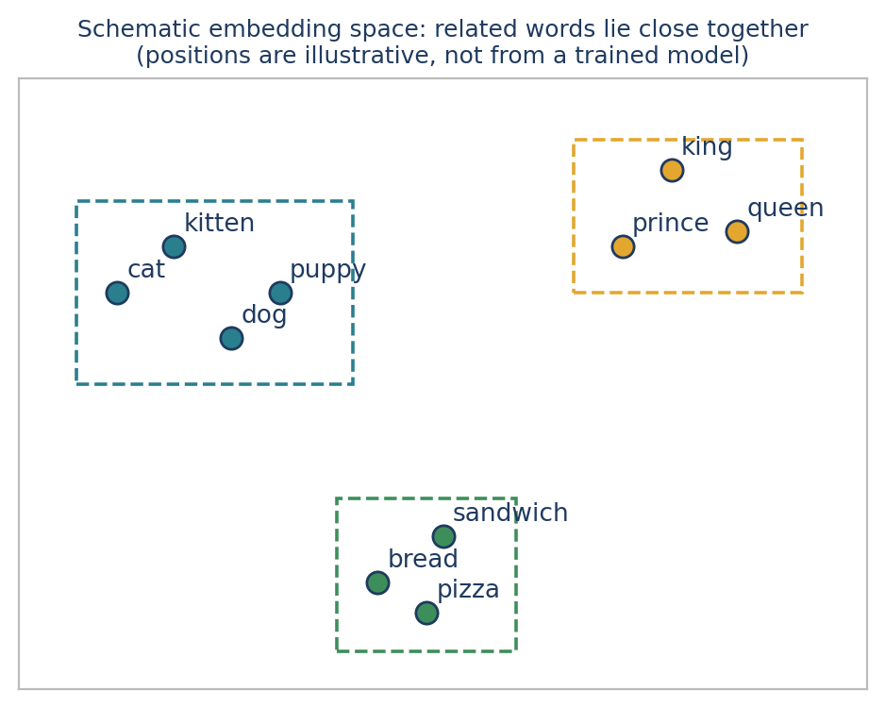
Figure 19.1 A schematic embedding space. Related words form neighbourhoods; positions are illustrative.

19.2 Why Do We Need Word Embeddings?
Count-based representations have three limitations that embeddings address.
- High dimensionality. With a vocabulary of 100,000 words, a Bag-of-Words or TF-IDF vector has 100,000 features per document. Embeddings commonly use 100, 300 or another chosen number of dimensions, regardless of vocabulary size.
- Sparsity. Count vectors are mostly zeros because each document uses a small part of the vocabulary. Embeddings are generally dense.
- Semantic relationships. For “I need help” and “I need assistance”, a count-based model treats help and assistance as different features. A well-trained embedding model can represent them as related, because they occur in similar contexts.
Embeddings do not automatically understand every synonym, sentence or intention. Their quality depends on the training data and the model. Table 16.3 compared Bag of Words, TF-IDF and embeddings side by side.

19.3 Families of Embedding Techniques
Technique | Developed by (year) | Idea | Type
Word2Vec | Google (2013) | Predict words from context, or context from a word | Static
GloVe | Stanford (2014) | Factorise global word co-occurrence statistics | Static
fastText | Facebook AI Research (2016) | Use character n-grams, helping with rare and unseen word forms | Static
ELMo | Allen Institute for AI (2018) | Context-sensitive vectors from a bidirectional LSTM | Contextual
BERT | Google (2018) | Transformer encoder trained with masked language modelling | Contextual
GPT family | OpenAI (from 2018) | Transformer trained for next-token prediction | Contextual
Table 19.2 Some embedding techniques. “Static” means one vector per vocabulary word; “contextual” means the vector depends on the surrounding text.
This chapter and the next treat static embeddings; Chapter 21 treats contextual ones.

19.4 Word2Vec: The Distributional Idea
Word2Vec is a neural-network-based technique that learns word embeddings by predicting relationships between words and their surrounding context. It was introduced by researchers at Google and became a widely used way to learn word vectors from large text corpora. Its central idea is the distributional hypothesis:
The idea in one line
Words that appear in similar contexts tend to have similar vector representations.

If a model repeatedly sees “The cat drinks milk”, “The kitten drinks milk”, “The cat sleeps” and “The kitten sleeps”, it can learn similar vectors for cat and kitten, because they occur in similar contexts. Word2Vec is never given a dictionary definition. It learns from patterns of co-occurrence.
The training sentence and the context window
To follow the algorithm, suppose the whole corpus is one sentence: “the cat sits on the mat”. The vocabulary has five unique words: the, cat, sits, on, mat. Word2Vec starts with random vectors for these words and trains on examples extracted with a context window: the number of words considered on each side of a target word. With a window of 2, the context of sits is the, cat (left) and on, the (right); mat is too far away (Figure 19.2).
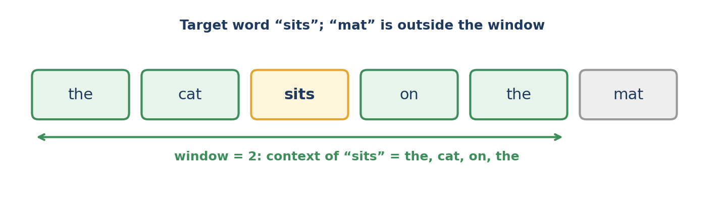
Figure 19.2 A context window of 2 around the target word “sits”.
The following functions generate the training examples for both architectures:
sentence = "the cat sits on the mat".split()

def skipgram_pairs(tokens, window):
return [(tokens[i], tokens[j])
for i in range(len(tokens))
for j in range(max(0, i - window), min(len(tokens), i + window + 1))
if j != i]

def cbow_examples(tokens, window):
return [([tokens[j] for j in range(max(0, i - window), min(len(tokens), i + window + 1)) if j != i],
tokens[i])
for i in range(len(tokens))]

print(skipgram_pairs(sentence, 1))
print(cbow_examples(sentence, 1))

Output
[('the', 'cat'), ('cat', 'the'), ('cat', 'sits'), ('sits', 'cat'), ('sits', 'on'), ('on', 'sits'), ('on', 'the'), ('the', 'on'), ('the', 'mat'), ('mat', 'the')]
[(['cat'], 'the'), (['the', 'sits'], 'cat'), (['cat', 'on'], 'sits'), (['sits', 'the'], 'on'), (['on', 'mat'], 'the'), (['the'], 'mat')]

The ten Skip-Gram pairs match the list in the original notes. The CBOW list has six examples; the notes listed the four interior ones, and the first and last words (“the” and “mat”, which have only one neighbour) give the shorter first and last examples.

19.5 Architecture 1: CBOW
CBOW (Continuous Bag of Words) uses the surrounding context words to predict the target word. It asks: given the nearby words, which word is likely to appear in the middle? For the target sits with the context the, cat, on, the, the model learns {the, cat, on, the} → sits. The context vectors are combined, often averaged, before the target is predicted. The architecture is: context words → word vectors → combine → predict the target (Figure 19.3, left).

19.6 Architecture 2: Skip-Gram
Skip-Gram does the opposite: it uses a target word to predict its surrounding context words. It asks: given this word, which words are likely to appear nearby? For the target sits with window 1: sits → {cat, on}. Each target–context pair is a separate training example. The architecture is: target word → word vector → predict each context word (Figure 19.3, right).
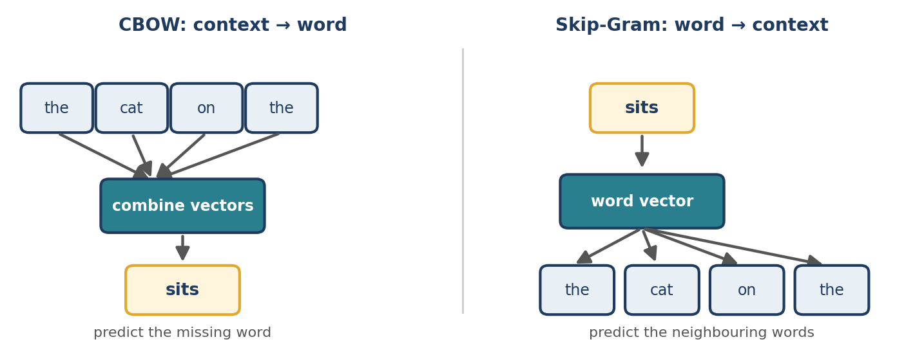
Figure 19.3 CBOW predicts a word from its context; Skip-Gram predicts the context from a word.
Feature | CBOW | Skip-Gram
Input | Surrounding context words | One target word
Prediction | The target word | The surrounding words
Example | cat, on → sits | sits → cat, on
General tendency | Often faster to train | Often useful for learning rare-word representations
Memory aid | Context → Word | Word → Context
Table 19.3 CBOW versus Skip-Gram. The tendencies are general; outcomes depend on the data and settings.

19.7 How Does Word2Vec Learn the Numbers?
This is the most important part. Consider Skip-Gram with the target word cat, whose real neighbours are the and sits. Training proceeds in five steps (Figure 19.4).
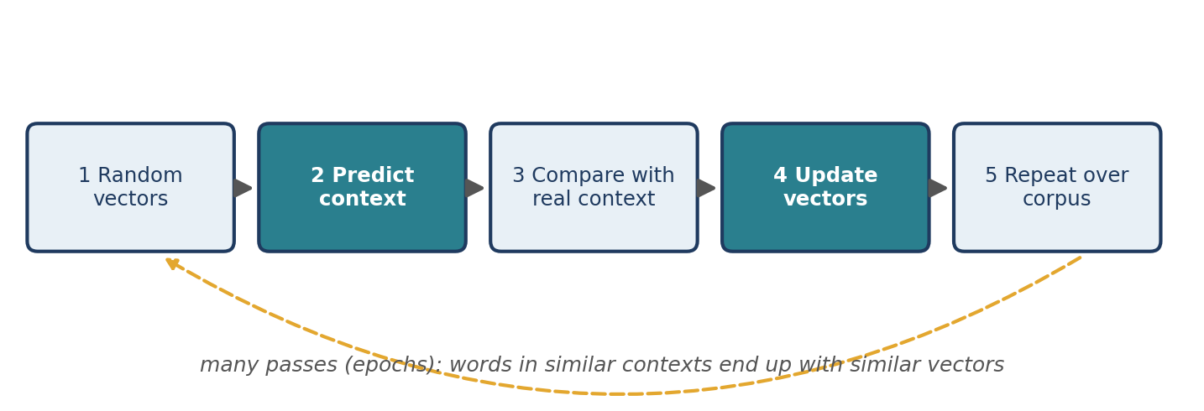
Figure 19.4 The Word2Vec learning loop.
- Assign initial vectors. Every word gets small random numbers as its starting vector.
- Predict context words. The score of a candidate context word c for an input word w is the dot product of the input vector of w and a separate output vector of c. A higher score means a more compatible pair. The scores are turned into probabilities with a softmax function (or, in large-scale training, approximated efficiently with negative sampling).
- Compare with the real context. If the observed neighbours (the, sits) receive low probability, the loss is high.
- Update the vectors. Backpropagation with gradient-based optimisation adjusts the input and output vectors so that the observed pairs become more probable.
- Repeat over every target–context pair, many times.
The following NumPy program carries out exactly these steps on the five-word corpus, with three-dimensional vectors and a full softmax. It is a teaching sketch, not an efficient implementation:
import numpy as np

sentence = "the cat sits on the mat".split()
vocab = sorted(set(sentence))
index = {w: i for i, w in enumerate(vocab)}

# Skip-Gram training pairs (target, context) with window 1
pairs = [(index[sentence[i]], index[sentence[j]])
for i in range(len(sentence))
for j in range(max(0, i - 1), min(len(sentence), i + 2)) if j != i]

rng = np.random.default_rng(0)
dim = 3
W_in = rng.normal(0, 0.1, (len(vocab), dim)) # input (word) vectors
W_out = rng.normal(0, 0.1, (len(vocab), dim)) # output (context) vectors

def softmax(z):
e = np.exp(z - z.max())
return e / e.sum()

def average_loss():
return np.mean([-np.log(softmax(W_out @ W_in[t])[c]) for t, c in pairs])

print("initial loss:", round(float(average_loss()), 3))

learning_rate = 0.5
for epoch in range(300):
for t, c in pairs:
h = W_in[t]
probs = softmax(W_out @ h) # predicted context probabilities
error = probs.copy()
error[c] -= 1 # gradient of the cross-entropy loss
grad_in = W_out.T @ error
W_out -= learning_rate * np.outer(error, h)
W_in[t] -= learning_rate * grad_in

print("final loss: ", round(float(average_loss()), 3))

probs = softmax(W_out @ W_in[index["cat"]])
print({w: round(float(p), 2) for w, p in zip(vocab, probs)})

Output
initial loss: 1.611
final loss: 0.793
{'cat': 0.0, 'mat': 0.0, 'on': 0.0, 'sits': 0.49, 'the': 0.49}

The loss falls from 1.611 to 0.793, and for the input word cat the model now assigns almost all its probability to the two words that really occur next to it in the corpus, the and sits (0.49 each). The loss cannot reach zero because cat has two different correct answers and the model must split its probability between them. Real Word2Vec does the same on billions of examples, and the useful by-product is the set of learned input vectors.

19.8 Training Word2Vec with gensim
The gensim library trains Word2Vec efficiently. Install it with pip install gensim. We first use the tiny corpus from the original notes, in which cats chase mice and dogs chase balls:
from gensim.models import Word2Vec

sentences = [
["cat", "drinks", "milk"], ["kitten", "drinks", "milk"],
["cat", "chases", "mouse"], ["kitten", "chases", "mouse"],
["dog", "chases", "ball"], ["puppy", "chases", "ball"],
["dog", "drinks", "water"], ["puppy", "drinks", "water"],
["king", "rules", "kingdom"], ["queen", "rules", "kingdom"],
]

model = Word2Vec(sentences=sentences, vector_size=50, window=2, min_count=1,
sg=1, epochs=200, seed=42, workers=1)

vector = model.wv["cat"]
print("Dimensions:", len(vector), "| vocabulary size:", len(model.wv))
print([round(float(x), 3) for x in vector[:3]])
print([(w, round(s, 3)) for w, s in model.wv.most_similar("cat", topn=4)])

Output
Dimensions: 50 | vocabulary size: 14
[0.012, -0.004, 0.013]
[('queen', 0.306), ('water', 0.197), ('kitten', 0.191), ('kingdom', 0.076)]

Parameter | Meaning
sentences | The corpus as a list of tokenised sentences (lists of strings)
vector_size=50 | Each word gets a 50-dimensional vector (named size in gensim 3.x)
window=2 | Maximum distance between the target and a context word
min_count=1 | Include words appearing at least once
sg=1 | Use Skip-Gram (sg=0 selects CBOW)
epochs=200 | Number of passes over the corpus (named iter in gensim 3.x)
seed=42, workers=1 | Reproducibility; one worker thread avoids ordering effects
Table 19.4 Parameters of gensim’s Word2Vec (gensim 4.4).
model.wv holds the trained word vectors; model.wv["cat"] returns the 50-number vector for cat, and most_similar returns the words with the highest cosine similarity (Section 14.6).
The result is poor, and that is the point
The nearest neighbour of “cat” is “queen”, with “kitten” only third. The model has not learned that cats and kittens are alike, because ten three-word sentences do not contain enough evidence. The original notes warned that this dataset is only for demonstrating the code; the output shows why. The results are also unstable: running the same code with different random seeds gives different similarities.

for seed in (1, 2, 3, 42):
m = Word2Vec(sentences=sentences, vector_size=50, window=2, min_count=1,
sg=1, epochs=200, seed=seed, workers=1)
print(seed, round(float(m.wv.similarity("cat", "kitten")), 3))

Output
1 0.069
2 -0.242
3 0.191
42 0.191

Enough data changes the picture
To see Word2Vec work as intended we need more evidence. The following code generates 1,500 short sentences from templates, in which cats and kittens share activities, dogs and puppies share others, and kings and queens share others. It is artificial, but it shows the effect of data quantity:
import random

random.seed(7)
groups = [
(["cat", "kitten"], [("drinks", "milk"), ("chases", "mouse"), ("purrs", "softly"), ("sleeps", "quietly")]),
(["dog", "puppy"], [("chases", "ball"), ("barks", "loudly"), ("drinks", "water"), ("sleeps", "quietly")]),
(["king", "queen"], [("rules", "kingdom"), ("wears", "crown"), ("lives", "castle"), ("sleeps", "quietly")]),
]
sentences = []
for _ in range(1500):
subjects, actions = random.choice(groups)
verb, obj = random.choice(actions)
sentences.append(["the", random.choice(subjects), verb, obj])

print(len(sentences), sentences[0])

model = Word2Vec(sentences, vector_size=50, window=2, min_count=1,
sg=1, epochs=20, seed=42, workers=1)

for word in ["cat", "dog", "queen"]:
print(word, "->", model.wv.most_similar(word, topn=1)[0][0])
print(model.wv.doesnt_match(["cat", "kitten", "king"]))

for seed in (1, 2, 3):
m = Word2Vec(sentences, vector_size=50, window=2, min_count=1, sg=1, epochs=20, seed=seed, workers=1)
print(seed, m.wv.most_similar("cat", topn=1)[0][0])

cbow = Word2Vec(sentences, vector_size=50, window=2, min_count=1, sg=0, epochs=20, seed=42, workers=1)
print("CBOW:", cbow.wv.most_similar("cat", topn=1)[0][0])

Output
1500 ['the', 'puppy', 'barks', 'loudly']
cat -> kitten
dog -> puppy
queen -> king
king
1 kitten
2 kitten
3 kitten
CBOW: kitten

Now the nearest neighbour of cat is kitten, of dog is puppy, and of queen is king; doesnt_match correctly picks king as the odd one out of cat, kitten and king; the answer is stable across seeds; and CBOW agrees with Skip-Gram. Figure 19.5 contrasts the two training sets.
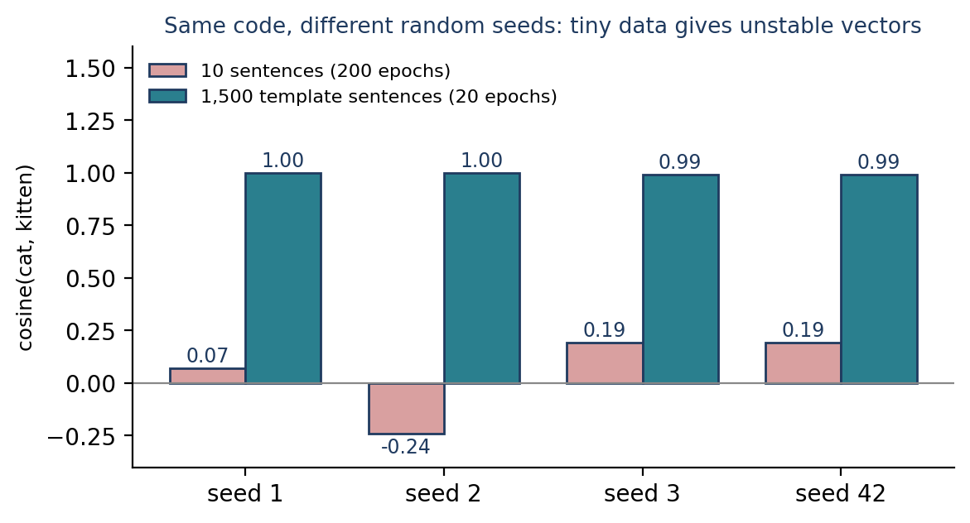
Figure 19.5 The cat–kitten similarity with different random seeds, for a tiny corpus and for a larger one.
Reading the numbers
In this small vocabulary, almost all cosine similarities are very high (above 0.95), so absolute values are not informative. What matters is the ranking. Real embeddings are trained on corpora with billions of words, which is why practitioners usually use pre-trained vectors (Chapter 20) rather than train their own.

Saving and loading
Once trained, you can save the vectors alone (smaller and sufficient for lookup) and load them later:
model.wv.save("animals.kv")

from gensim.models import KeyedVectors
vectors = KeyedVectors.load("animals.kv")
print(len(vectors), vectors.most_similar("dog", topn=1)[0][0])

Output
25 puppy

19.9 Similarity, Analogies and What Embeddings Learn
Word2Vec typically compares vectors with cosine similarity, which lies between −1 and 1 for non-zero vectors: near 1 means the vectors point in similar directions, near 0 means they are roughly orthogonal, near −1 means they point in opposite directions. A high similarity for cat and kitten does not mean the model understands their definitions; it means they have similar patterns of use.
Word arithmetic
A famous example is king − man + woman ≈ queen. The idea is that some relationships correspond to directions in vector space: subtracting man and adding woman moves king towards the region of queen. With gensim and a suitable pre-trained vector set, you would try most_similar(positive=["king", "woman"], negative=["man"]). The tiny models of this chapter lack the words and the data to show it, so Chapter 20 demonstrates it with spaCy’s pre-trained vectors. Treat it as an illustration, not a law: the result depends on the corpus, may not return queen, and can reflect biases in the training text.
The distributional principle, and its bias
Imagine a large corpus in which “doctor” and “nurse” both occur near treats, patients, works and hospital. Training pushes their vectors together. A word such as “banana”, rarely found in those contexts, receives a different vector. Word2Vec therefore learns associations from text, not guaranteed facts about the world; because the text may contain stereotypes or errors, the vectors can reproduce them.

19.10 Word2Vec versus BERT
Feature | Word2Vec | BERT
Architecture | Shallow neural network for word prediction | Transformer encoder
Representation | One learned vector per vocabulary word | Context-dependent token representation
Meaning of “bank” | Generally one fixed vector | Can differ by sentence
Training | Predicts context or target words | Masked language modelling and related objectives
Common use | Word similarity; features for traditional NLP | Context-sensitive tasks and downstream models
Table 19.5 Word2Vec compared with BERT. Chapter 21 develops the right-hand column.

19.11 Customising Embeddings for a Domain
A general-purpose embedding may not capture specialised vocabulary. Options include BioBERT (adapted to biomedical text), FinBERT (financial language), embeddings trained on Twitter data (slang, hashtags and informal language), and a custom Word2Vec model trained on your own corpus, such as engineering reports or product descriptions. For Word2Vec you can train a new model or, when the setup supports it, continue training an existing one. For transformer models, fine-tuning or choosing an appropriate pre-trained model is often more effective than training from scratch. The best choice depends on the data, the computing resources and the task.

19.12 Common Mistakes
- Training on a tiny corpus and trusting the neighbours (Section 19.8).
- Judging by absolute similarity values instead of rankings.
- Forgetting that vectors are static: one vector per word, whatever the sentence.
- Not setting `seed` and `workers=1` when you need reproducible results.
- Using words missing from the vocabulary. gensim raises a KeyError for an unseen word, so test with word in model.wv first.
- Assuming analogies always work, or that embeddings are free of bias.
- Mixing vectors trained on different corpora or at different dimensions.

19.13 Chapter Summary
- Word embeddings are dense vectors learned from text so that words in similar contexts have similar vectors.
- Word2Vec has two architectures: CBOW predicts a word from its context; Skip-Gram predicts the context from a word.
- Training produces target–context pairs from a context window and adjusts vectors to make observed pairs more probable.
- gensim trains Word2Vec; with too little data the vectors are unreliable, with enough data neighbours become meaningful.
- Static embeddings give one vector per word and can reflect biases of their training data.

19.14 Review Questions and Exercises
- State the distributional hypothesis, and use it to explain why “cat” and “kitten” may receive similar vectors.
- For the sentence “I like deep learning” and window 1, list the Skip-Gram pairs and the CBOW examples.
- Why does the NumPy example’s final loss stay above zero?
- Explain why most_similar("cat") returned “queen” for the ten-sentence corpus.
- Exercise. Change window, vector_size and sg in the template-corpus example. Record how the neighbours of “cat” change.
- Exercise. Write your own template corpus with two groups of professions (for example, teacher/professor and driver/pilot) and train Word2Vec. Do the groups separate?
- Exercise. Extend the NumPy program to use the corpus “the cat sits on the mat the dog sits on the rug”, and inspect the cosine similarity of the learned input vectors for cat and dog before and after training.

Editorial note — remove before publication
From your notes: all 17 sections of “Word Embeddings in NLP” — what embeddings are, why needed, comparison with BoW/TF-IDF, types of techniques, Word2Vec, the training sentence, CBOW, Skip-Gram, their comparison, how Word2Vec learns the numbers, gensim implementation, similarity, word arithmetic, what CBOW and Skip-Gram learn, Word2Vec versus BERT, domain customisation and revision.
Changes for review: (1) The notes’ gensim code was truncated in the source file; it was completed with the parameters your parameter table describes. (2) With that code the real output does not match the notes’ expectation that “cat” is closest to “kitten”: “queen” comes first and results change with the seed. Your notes already warned that the dataset is too small; the chapter now demonstrates the warning and then shows a larger template corpus that works. (3) The notes’ CBOW example table lists four examples; the code in Section 19.4 shows all six. (4) The notes’ BoW/TF-IDF/embeddings table is not repeated; see Table 16.3.
Added: the context-window code, the from-scratch NumPy Skip-Gram demonstration (real output), seed-stability test, template-corpus experiment, saving and loading vectors, parameter table, Figures 19.1 to 19.5, common mistakes and exercises. All code was run (gensim 4.4.0, NumPy 2.4.4). The years and developers in Table 19.2 are from general knowledge of the original publications; please check them against the references you cite in the final book.

Chapter 20 Word Vectors and Similarity in spaCy
Learning objectives
After studying this chapter you will be able to:
• identify which spaCy pipelines contain static word vectors and what the small model does instead;
• read token.vector, token.has_vector and token.is_oov;
• compute word and sentence similarity and interpret the scores, including what they do not mean;
• find nearest neighbours and perform vector arithmetic with spaCy’s vector table;
• use document vectors as features for a classifier and recognise their limits.

20.1 What Are Word Vectors?
Word vectors are numerical representations of words that let NLP models measure relationships between words mathematically. Each word is a vector of numbers learned from text, which can encode patterns of meaning and usage. Chapter 19 trained such vectors; here we use vectors that have already been trained on very large corpora and shipped inside spaCy pipelines.
In a simplified space, bread and sandwich might lie close together and automobile far away. We will measure this on real vectors in Section 20.3. As always, individual dimensions of real vectors have no clear human-readable meaning.

20.2 Which spaCy Pipelines Contain Word Vectors?
Not every spaCy pipeline contains pre-trained static word vectors, that is, one fixed vector per vocabulary word. The three standard English pipelines differ:
Pipeline | Static vector table | Install
en_core_web_sm | None: shape (0, 0) | python -m spacy download en_core_web_sm
en_core_web_md | 20,000 unique vectors, 300 dimensions | python -m spacy download en_core_web_md
en_core_web_lg | 342,918 unique vectors, 300 dimensions | python -m spacy download en_core_web_lg
Table 20.1 Word-vector tables in the English pipelines (spaCy 3.8, pipeline version 3.8.0).
import spacy

for name in ["en_core_web_sm", "en_core_web_md", "en_core_web_lg"]:
nlp = spacy.load(name)
print(name, nlp.vocab.vectors.shape)

Output
en_core_web_sm (0, 0)
en_core_web_md (20000, 300)
en_core_web_lg (342918, 300)

The first number is the count of unique vectors and the second the dimensionality. Vector counts and dimensions depend on the pipeline and its version. The large pipeline is a download of several hundred megabytes and takes noticeably longer to load.
The small model does not have word vectors, even though `has_vector` says True
The small pipeline has an empty vector table, yet token.has_vector returns True for ordinary words. In that case spaCy reports the pipeline’s own internal, context-sensitive representation: it is 96-dimensional and, in our test, different for the same word in different sentences. That is not a static word vector, and similarity computed from it is not reliable. To check for real word vectors, inspect nlp.vocab.vectors.shape as above.

A pitfall in the medium model
The medium pipeline keeps only 20,000 unique vectors, and many different words share one of them. Consequently, in our test md reports a similarity of exactly 1.0 for the pairs cat–dog and good–bad, which the large model scores 0.80 and 0.74. Use the large model, or a dedicated vector set, when the quality of word similarity matters.

The remainder of this chapter uses en_core_web_lg.

20.3 Accessing Word Vectors
Attribute | Purpose
token.vector | The token’s vector, as a NumPy array
token.has_vector | Whether a vector is available
token.is_oov | Whether the token is outside the pipeline’s vector vocabulary
token.similarity(other) | Cosine similarity between two tokens, spans or documents
doc.vector | A vector for the whole document (Section 20.6)
Table 20.2 Vector attributes in spaCy.
import numpy as np

nlp = spacy.load("en_core_web_lg")
doc = nlp("bread sandwich automobile")

for token in doc:
print(token.text, token.has_vector, token.is_oov,
token.vector.shape, np.round(token.vector[:5], 3).tolist())

Output
bread True False (300,) [-0.177, -0.169, 0.68, -0.227, -0.358]
sandwich True False (300,) [0.066, -0.57, 0.723, 0.429, 0.132]
automobile True False (300,) [0.303, 0.542, 0.08, -0.265, 0.264]

- nlp(text) creates a Doc; each token carries its vector.
- token.vector.shape is (300,): a 300-dimensional vector. Only the first five values are printed for readability.
- has_vector is True and is_oov is False because the words are in the vector vocabulary.
Unknown words
for token in nlp("cat kitten covid unfriendlyish"):
print(token.text, token.has_vector, token.is_oov)

t = nlp("Zorblax")[0]
print(t.vector.shape, float(np.linalg.norm(t.vector)))

Output
cat True False
kitten True False
covid False True
unfriendlyish False True
(300,) 0.0

A word that is not in the vector table gets a vector of all zeros, so every similarity involving it is meaningless. “covid” appears to date from after these vectors were trained. (In some pipelines an out-of-vocabulary token can still receive a vector from a fallback mechanism, so check has_vector and is_oov separately.) A zero vector in a classifier’s input simply says “unknown”; check how many of your tokens are affected.

20.4 Word Similarity
token.similarity() computes the cosine similarity of two vectors (Section 14.6): the cosine of the angle between them, not a comparison of lengths.
word1, word2, word3 = (nlp(w)[0] for w in ["bread", "sandwich", "automobile"])

print("bread vs sandwich: ", round(word1.similarity(word2), 3))
print("bread vs automobile:", round(word1.similarity(word3), 3))

Output
bread vs sandwich: 0.687
bread vs automobile: 0.097

As expected, related concepts score higher than unrelated ones. Exact scores depend on the pipeline and version. A correction worth remembering: cosine similarity can range from −1 to 1; pre-trained word embeddings merely tend to give positive scores for many word pairs.
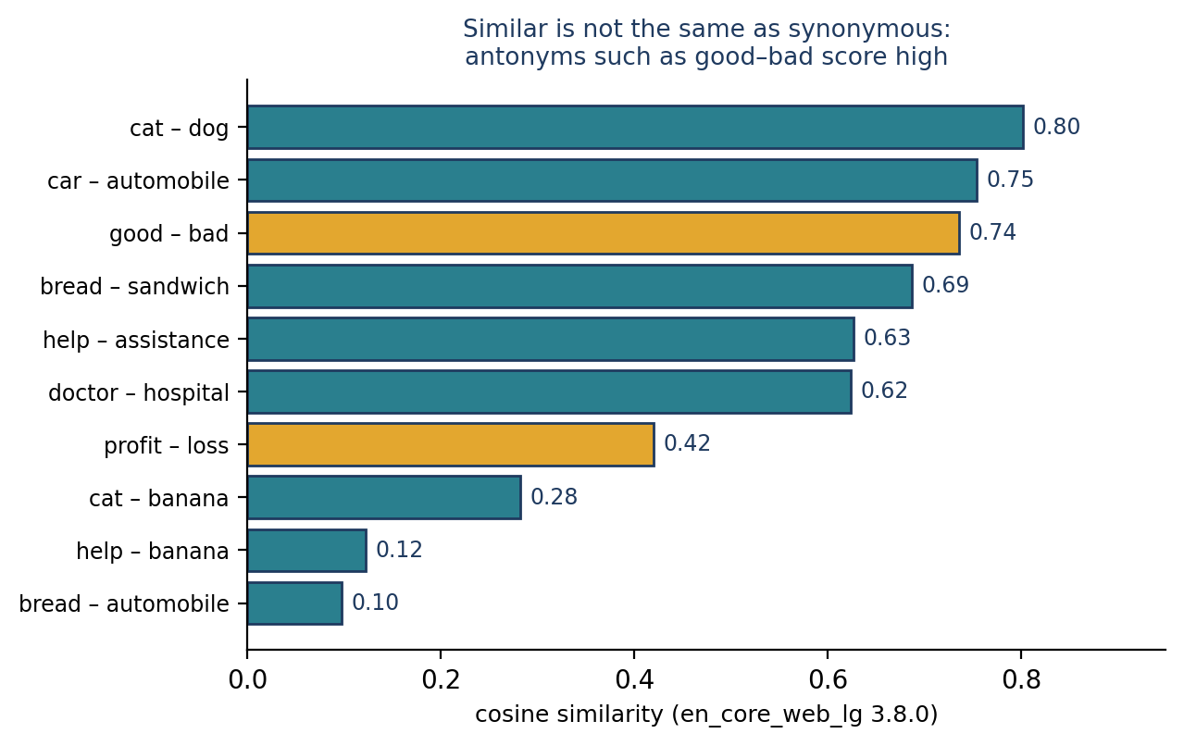
Figure 20.1 Cosine similarities from en_core_web_lg 3.8.0. Gold bars are antonym or opposite-sense pairs.
Figure 20.1 collects more pairs. Notice good and bad (0.74) and profit and loss (0.42): opposites score higher than unrelated pairs such as cat and banana (0.28).

20.5 Similarity Does Not Mean Synonymy
Two words can have similar vectors because they occur in related contexts, even if their meanings differ. Consider:
- profit and loss are opposites but occur in the same financial contexts.
- doctor and hospital are related concepts, not synonyms (0.62).
- bread and sandwich are related, one being an ingredient of the other.
It helps to separate three ideas. Semantic similarity: related meaning or usage patterns. Synonymy: the same or nearly the same meaning. Contextual association: frequently occurring in related situations. Word-vector similarity mixes all three, so it cannot tell you which relation holds. A sentiment system that treated “good” and “bad” as interchangeable because their vectors are close would be badly wrong.
Nearest neighbours
The vector table can be searched for the words closest to a given word. The large vocabulary contains many case variants and spellings, so the function below skips the query word and duplicates that differ only in case:
def neighbours(nlp, word, n=5):
query = nlp.vocab[word].vector.reshape(1, -1)
ids, _, scores = nlp.vocab.vectors.most_similar(query, n=n * 3)
out = []
for i, s in zip(ids[0], scores[0]):
w = nlp.vocab.strings[i]
if w.lower() != word and w.lower() not in [x[0].lower() for x in out]:
out.append((w, round(float(s), 3)))
return out[:n]

print(neighbours(nlp, "bread"))
print(neighbours(nlp, "hospital"))

Output
[('LOAF', 0.818), ('BREADS', 0.784), ('BAKED', 0.771), ('CHEESE', 0.757), ('LOAVES', 0.746)]
[('HOSPITALS', 0.78), ('MediCal', 0.745), ('CLINIC', 0.701), ('AMBULANCE', 0.686), ('NURSING', 0.686)]

The neighbours of bread are loaf, baked goods and cheese; those of hospital are clinic, ambulance and nursing. They are associated words, not synonyms, and the capitalised forms show that the vector table was built from text with its original casing.

20.6 Document and Sentence Vectors
A spaCy Doc also has a .vector. For pipelines with static word vectors, spaCy computes it as the average of the token vectors (Figure 20.2). For “bread tastes good” with token vectors V1, V2 and V3, the sentence vector is (V1 + V2 + V3) ÷ 3.
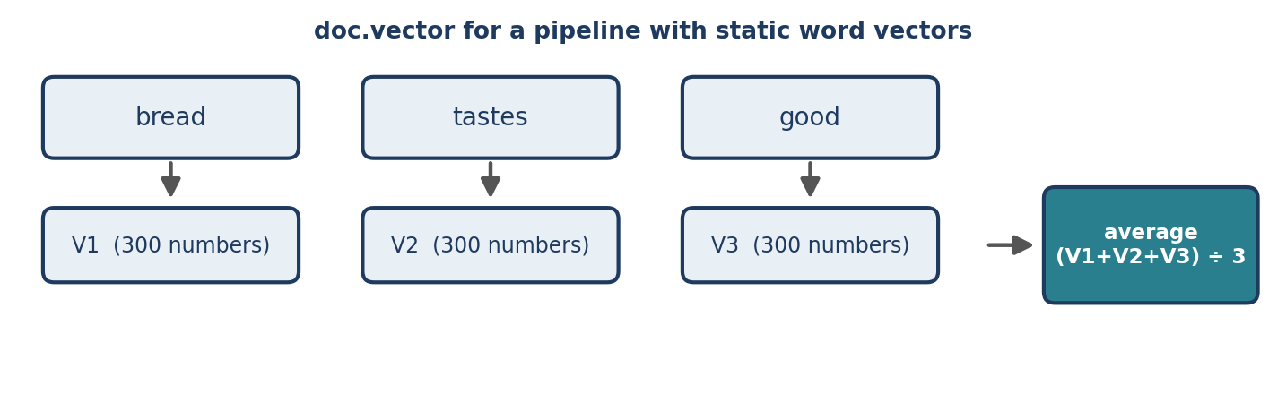
Figure 20.2 A document vector as the average of its token vectors.
doc = nlp("Bread tastes good")
print(doc.vector.shape)
print(np.allclose(doc.vector, np.mean([t.vector for t in doc], axis=0)))

Output
(300,)
True

The document vector has the same 300 dimensions as a word vector, and it is exactly the mean of the token vectors. Averaging makes it simple and useful for rough comparisons. Whole documents can be compared with .similarity():
doc1 = nlp("I need help")
doc2 = nlp("I need assistance")
doc3 = nlp("The car is parked outside")

print("similar sentences: ", round(doc1.similarity(doc2), 3))
print("unrelated sentences:", round(doc1.similarity(doc3), 3))

Output
similar sentences: 0.931
unrelated sentences: 0.526

The related pair scores much higher, as the notes predicted. Even the unrelated pair scores above 0.5 because many words in short sentences (such as “I”, “the” and “is”) have similar vectors, so a similarity score should be judged relative to other pairs, not against a fixed threshold.
What averaging cannot capture
Because the average ignores word order and compositional meaning, some very different sentences look identical or nearly so:
print(round(nlp("The dog bites the man").similarity(nlp("The man bites the dog")), 3))
print(round(nlp("I love this movie").similarity(nlp("I hate this movie")), 3))
print(round(nlp("I love this movie").similarity(nlp("This film is excellent")), 3))

Output
1.0
0.962
0.75

“The dog bites the man” and “The man bites the dog” are exactly the same (1.0) because they contain the same words; “I love this movie” and “I hate this movie” score 0.962 even though their sentiment is opposite; and the genuine paraphrase “This film is excellent” scores lower (0.75) than the opposite-sentiment pair. For nuanced sentence similarity, dedicated sentence-embedding models are usually more suitable (Chapter 21).

20.7 Vector Arithmetic
Embeddings sometimes encode relationships as directions: subtracting the vector for man and adding that for woman may move king towards queen. This is an approximate relationship learned from a particular corpus, not an identity.
king, man, woman, queen = (nlp(w)[0].vector for w in ["king", "man", "woman", "queen"])
result = king - man + woman

def cos(a, b):
return float(np.dot(a, b) / (np.linalg.norm(a) * np.linalg.norm(b)))

print("result vs queen:", round(cos(result, queen), 3))
print("king vs queen: ", round(cos(king, queen), 3))

Output
result vs queen: 0.788
king vs queen: 0.725

The arithmetic result is closer to queen (0.788) than king alone is (0.725). To search the vocabulary for the nearest words to the result, compare it with candidate vectors and exclude the query words:
ids, _, scores = nlp.vocab.vectors.most_similar(result.reshape(1, -1), n=40)
seen, found = set(), []
for i, s in zip(ids[0], scores[0]):
w = nlp.vocab.strings[i]
if w.lower() in {"king", "man", "woman"} or w.lower() in seen:
continue
seen.add(w.lower())
found.append((w, round(float(s), 3)))
print(found[:5])

Output
[('QUEEN', 0.788), ('PRINCE', 0.64), ('KINGS', 0.621), ('PRINCESS', 0.613), ('ROYAL', 0.58)]

Here the nearest word, once the input words are excluded, is indeed “QUEEN”. Without the exclusion step, variants of “king” itself rank first, a common source of overstated claims about analogies. As with any embedding arithmetic, the outcome depends on the vectors, it is not guaranteed, and it can reflect biases present in the training text.

20.8 Static Vectors versus Contextual Embeddings
A static vector table has one vector per entry. The word bank therefore gets the same vector whether the sentence is about money or a river:
a = nlp("I deposited money at the bank.")
b = nlp("We sat on the river bank.")

bank_a = [t for t in a if t.text == "bank"][0]
bank_b = [t for t in b if t.text == "bank"][0]
print(np.allclose(bank_a.vector, bank_b.vector))

Output
True

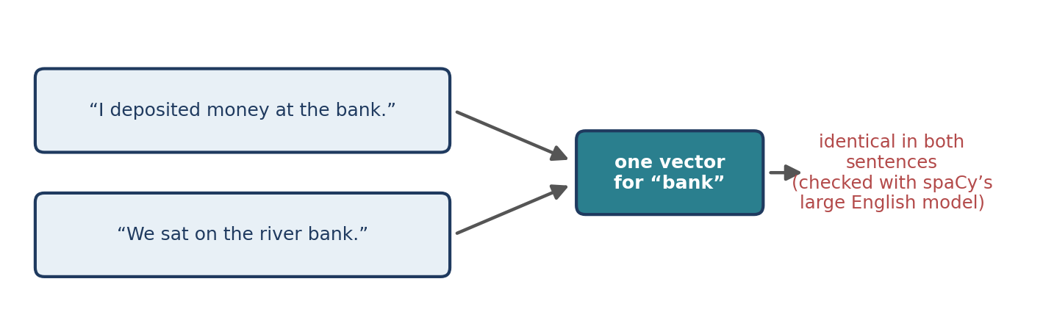
Figure 20.3 A static vector table cannot distinguish the two senses of “bank”.
Feature | Static word vectors in spaCy | Contextual embeddings
Representation | One main vector per vocabulary entry | Depends on the surrounding text
Example | “bank” has one vector | “bank” differs between financial and river contexts
Typical models | Word2Vec, GloVe-style vectors | BERT and other transformer models
Out-of-vocabulary words | Zero vector or fallback | Handled through subword pieces
Table 20.3 Static versus contextual representations; Chapter 21 develops the right-hand column.

20.9 Using Document Vectors as Classifier Features
Document vectors are dense, fixed-length inputs that any scikit-learn classifier accepts. Here the product-classification task of Chapter 18 is solved with 300-dimensional spaCy vectors and logistic regression:
from sklearn.linear_model import LogisticRegression

products = ["smartphone with high resolution camera", "laptop with powerful processor",
"cotton shirt for daily wear", "comfortable cotton trousers",
"mobile phone with excellent battery", "lightweight laptop for students",
"silk saree with golden border", "wireless headphones with long battery life",
"denim jeans for casual wear", "tablet with bright display and fast processor",
"woollen sweater for winter", "formal shirt in blue cotton"]
labels = ["electronics", "electronics", "clothing", "clothing", "electronics", "electronics",
"clothing", "electronics", "clothing", "electronics", "clothing", "clothing"]

X = np.array([nlp(p).vector for p in products])
print(X.shape)

clf = LogisticRegression(max_iter=1000).fit(X, labels)

new = ["gaming laptop with fast processor", "cotton shirt for summer",
"phone with big battery", "leather jacket for winter",
"bluetooth speaker with deep bass"]
print(clf.predict(np.array([nlp(t).vector for t in new])).tolist())

Output
(12, 300)
['electronics', 'clothing', 'electronics', 'clothing', 'electronics']

The classifier labels the two items that share no words with the training data (“leather jacket for winter”, “bluetooth speaker with deep bass”) correctly. A TF-IDF model would have no features for those two items, because leather, jacket, bluetooth and speaker are not in its vocabulary, so it could only guess from the few words they share with the training data. This is the practical benefit of embeddings: similarity of meaning transfers knowledge to unseen words. As before, five test items prove nothing about accuracy; evaluate on realistic held-out data (Chapter 22).

20.10 Common Mistakes
- Using `en_core_web_sm` for similarity. It has no static word vectors (Section 20.2).
- Trusting `en_core_web_md` for word pairs without checking for shared vectors.
- Reading similarity as synonymy (Section 20.5).
- Treating zero vectors as meaningful. Check has_vector for unknown words.
- Using averaged vectors for word-order or sentiment-sensitive questions (Section 20.6).
- Forgetting to exclude the query words in nearest-neighbour and analogy searches.
- Comparing scores against fixed thresholds instead of ranking candidates.

20.11 Chapter Summary
- Static word vectors are available in the medium and large English pipelines (the small one has none); the large one has 342,918 unique 300-dimensional vectors.
- token.vector, token.has_vector, token.is_oov and token.similarity() expose vectors and cosine similarity; unknown words have zero vectors.
- Similarity mixes relatedness, synonymy and association; opposites such as good and bad score high.
- doc.vector averages token vectors, which is quick and useful but ignores word order and cannot separate opposite sentiments.
- Vector arithmetic is approximate, and a static vector cannot distinguish senses of a word; contextual embeddings address this.

20.12 Review Questions and Exercises
- Why does en_core_web_lg give a vector for “cat” but not for “covid”? What vector does an unknown word receive?
- Why does a sentence vector for “The dog bites the man” equal that of “The man bites the dog”?
- Explain why “good” and “bad” can have high cosine similarity, and what that implies for sentiment analysis.
- Why must the query words be excluded when searching for the result of king − man + woman?
- Exercise. Compute similarities for fifteen word pairs of your own with en_core_web_lg and sort them. Which pairs surprise you?
- Exercise. Use neighbours() for five words from a field you know (medicine, law, cricket). Do the neighbours make sense for that field?
- Exercise. Build a classifier for ten sentences each of two topics using spaCy vectors and logistic regression, and compare it with a TF-IDF classifier using five-fold cross-validation.

Editorial note — remove before publication
From your notes: all 10 sections of “Word Vectors in spaCy” — what word vectors are, which models contain them, accessing vectors, similarity, “similarity does not mean synonymy”, sentence vectors, sentence similarity, vector arithmetic, static versus contextual, quick revision.
Corrections and additions for review: (1) The notes use en_core_web_md for the examples. With en_core_web_md 3.8.0 many different words share a vector (only 20,000 unique vectors), so cat–dog and good–bad score exactly 1.0; the chapter therefore uses en_core_web_lg and explains the pitfall. (2) The notes say the small model “does not provide the same full pretrained word-vector table”; in fact its table is empty (shape (0, 0)), and has_vector is nevertheless True because spaCy reports a 96-dimensional context-sensitive tensor. (3) Your notes’ nearest-word suggestion for arithmetic is implemented, with the query-exclusion step; in the large model, variants of “king” otherwise rank first. (4) Expected similarities in the notes (“the first pair may receive a higher score”) are replaced with real values.
Added: neighbour search, zero-vector and out-of-vocabulary checks, the averaging proof, the word-order and sentiment failures of averaged vectors, the classifier on document vectors, Figures 20.1 to 20.3, common mistakes and exercises. All code was run (spaCy 3.8.16, en_core_web_lg 3.8.0, scikit-learn 1.8.0).

Chapter 21 From Static to Contextual Embeddings: Transformers and LLMs
Learning objectives
After studying this chapter you will be able to:
• explain why one vector per word is not enough and what contextual embeddings change;
• describe subword tokenization and run a small byte-pair-encoding example;
• explain the idea of self-attention with a runnable toy example;
• distinguish encoder, decoder and encoder–decoder models, and explain pre-training and fine-tuning;
• use pre-trained transformers and sentence-embedding models in Python, and choose between the representations of this book.

This chapter is a bridge. It introduces the ideas behind modern language models at a level that builds directly on the rest of this book, and it stops short of the mathematics and engineering that a full treatment of deep learning would require. Where a claim concerns fast-moving products, it describes the general principle and points to the documentation.

21.1 The Limits of Static Embeddings
Chapters 19 and 20 gave each word one fixed vector. That design has four consequences that we have already seen:
- Polysemy. “bank” has one vector whether it means a financial institution or a river’s edge (Section 20.8).
- No word order. Averaging word vectors gives “dog bites man” and “man bites dog” the same sentence vector, and “I love this movie” and “I hate this movie” a similarity of 0.962 (Section 20.6).
- Unseen words. A word outside the vector table has no meaningful vector (Section 20.3).
- Fixed knowledge. Meaning is frozen at training time.
Contextual models address all four. They give each occurrence of a word its own vector, computed from the whole sentence; they read words in order; and they break rare words into known pieces. Figure 21.1 places them in the history of the field.
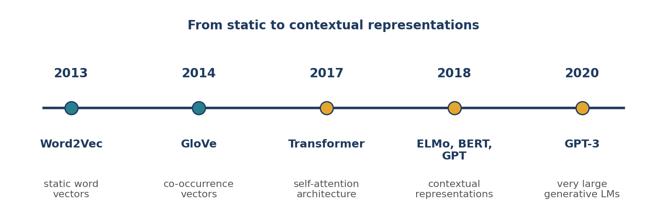
Figure 21.1 From static word vectors to contextual models. Years refer to the original publications.

21.2 Subword Tokenization
Modern models rarely treat each whole word as a token. They use subword tokenizers, which build a fixed vocabulary of frequent pieces (whole common words, parts of rarer words, and single characters) so that any word, including one never seen before, can be written as a sequence of known pieces. Two widely used families are byte-pair encoding (BPE) and WordPiece.
BPE starts with single characters and repeatedly merges the most frequent adjacent pair of symbols into a new symbol. The following program runs this idea on a toy corpus of four words with their frequencies:
import re
from collections import Counter

corpus = {"low": 5, "lower": 2, "newest": 6, "widest": 3} # word -> frequency
vocab = {" ".join(word) + " </w>": freq for word, freq in corpus.items()}

def count_pairs(vocab):
pairs = Counter()
for word, freq in vocab.items():
symbols = word.split()
for a, b in zip(symbols, symbols[1:]):
pairs[(a, b)] += freq
return pairs

def merge_pair(pair, vocab):
pattern = re.compile(r"(?<!\S)" + re.escape(" ".join(pair)) + r"(?!\S)")
return {pattern.sub("".join(pair), word): freq for word, freq in vocab.items()}

merges = []
for _ in range(10):
pairs = count_pairs(vocab)
best = max(pairs, key=lambda p: (pairs[p], p)) # most frequent pair
merges.append(best)
vocab = merge_pair(best, vocab)

print(merges)

def tokenize(word):
symbols = list(word) + ["</w>"]
for a, b in merges:
i = 0
while i < len(symbols) - 1:
if symbols[i] == a and symbols[i + 1] == b:
symbols[i:i + 2] = [a + b]
else:
i += 1
return symbols

for w in ["low", "lowest", "newer"]:
print(w, tokenize(w))

Output
[('t', '</w>'), ('s', 't</w>'), ('e', 'st</w>'), ('o', 'w'), ('l', 'ow'), ('w', 'est</w>'), ('n', 'e'), ('ne', 'west</w>'), ('low', '</w>'), ('w', 'i')]
low ['low</w>']
lowest ['low', 'est</w>']
newer ['ne', 'w', 'e', 'r', '</w>']

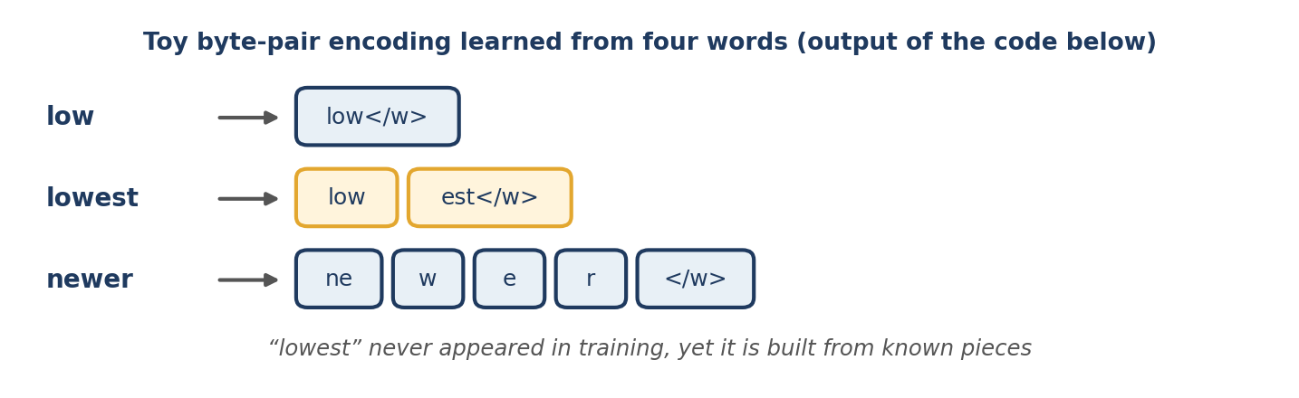
Figure 21.2 The learned merges split an unseen word into familiar pieces.
The merges begin with the most frequent pair (“t” followed by the end-of-word marker) and quickly assemble “est</w>” and “low”. The word “lowest” never occurred in the corpus, yet it is represented as “low” plus “est</w>”, two pieces learned from other words. The word “newer” is only partly covered by the merges and falls back to smaller pieces. Real tokenizers learn tens of thousands of merges from enormous corpora, so common words become single tokens and rare words split into a few pieces.
Two practical consequences follow. A token is not a word: the number of tokens in a text is usually larger than its number of words, and model limits on input length and the cost of commercial language-model services are counted in tokens. And out-of-vocabulary words largely disappear as a problem, because everything can be spelled out from pieces.

21.3 Self-Attention in Miniature
The key idea of the transformer architecture (introduced in 2017) is self-attention. When the model builds the representation of one word, it looks at every word in the sentence, assigns each a weight according to how relevant it is, and forms a weighted average. The resulting vector for “bank” therefore depends on its neighbours (Figure 21.3).
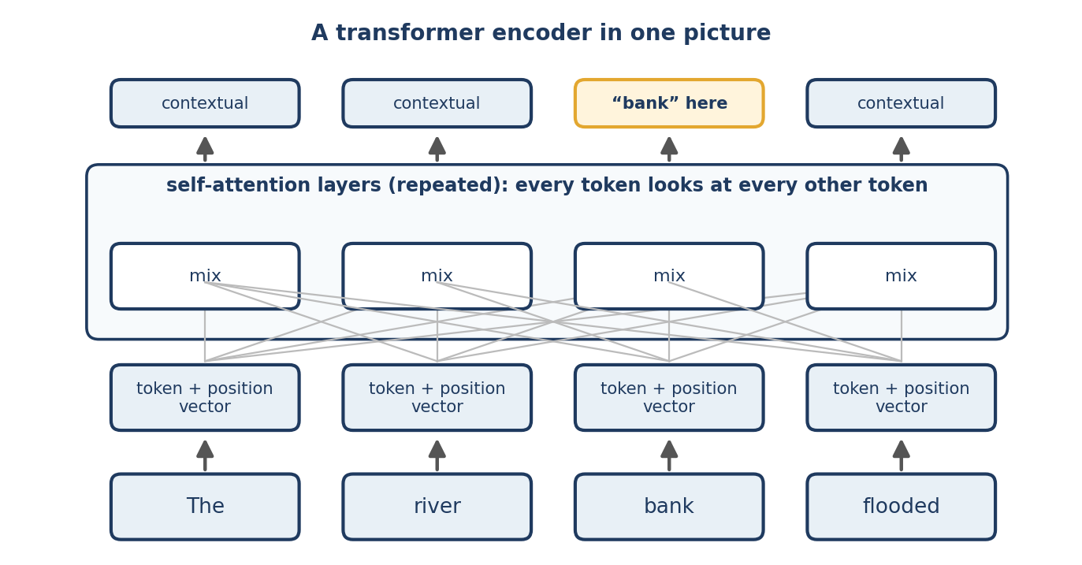
Figure 21.3 A transformer encoder in one picture: token vectors are mixed by repeated self-attention layers into contextual vectors.
The following toy program shows the principle. The four-dimensional “static” vectors are invented for illustration, and real models use learned query, key and value projections, many attention heads, many layers and hundreds of dimensions. We use the plain dot product so that the mechanism stays visible:
import numpy as np

# Invented 4-dimensional "static" embeddings, for illustration only
emb = {
"deposit": [1, 0, 0, 1], "money": [1, 0, 1, 0],
"river": [0, 1, 0, 1], "water": [0, 1, 1, 0],
"bank": [0.5, 0.5, 0.5, 0.5],
"at": [0.1, 0.1, 0.1, 0.1], "the": [0.1, 0.1, 0.1, 0.1],
}

def contextual_vector(words, i):
"""One step of simplified self-attention for the word at position i."""
X = np.array([emb[w] for w in words], dtype=float)
scores = X @ X[i] / np.sqrt(X.shape[1]) # similarity of word i to every word
weights = np.exp(scores) / np.exp(scores).sum() # softmax
return weights, weights @ X # weighted average of all vectors

def cos(a, b):
return float(a @ b / (np.linalg.norm(a) * np.linalg.norm(b)))

s1 = ["deposit", "money", "at", "the", "bank"]
s2 = ["river", "water", "at", "the", "bank"]

w1, bank1 = contextual_vector(s1, 4)
w2, bank2 = contextual_vector(s2, 4)

print("static vector of 'bank': ", emb["bank"])
print("bank near money:", bank1.round(2).tolist())
print("bank near river:", bank2.round(2).tolist())
print("attention weights (money sentence):", dict(zip(s1, w1.round(2).tolist())))

money, river = np.array(emb["money"]), np.array(emb["river"])
print("cos(bank1, bank2) =", round(cos(bank1, bank2), 2))
print("money sentence: cos with money =", round(cos(bank1, money), 2), ", with river =", round(cos(bank1, river), 2))
print("river sentence: cos with money =", round(cos(bank2, money), 2), ", with river =", round(cos(bank2, river), 2))

Output
static vector of 'bank': [0.5, 0.5, 0.5, 0.5]
bank near money: [0.61, 0.15, 0.38, 0.38]
bank near river: [0.15, 0.61, 0.38, 0.38]
attention weights (money sentence): {'deposit': 0.23, 'money': 0.23, 'at': 0.15, 'the': 0.15, 'bank': 0.23}
cos(bank1, bank2) = 0.68
money sentence: cos with money = 0.85 , with river = 0.45
river sentence: cos with money = 0.45 , with river = 0.85

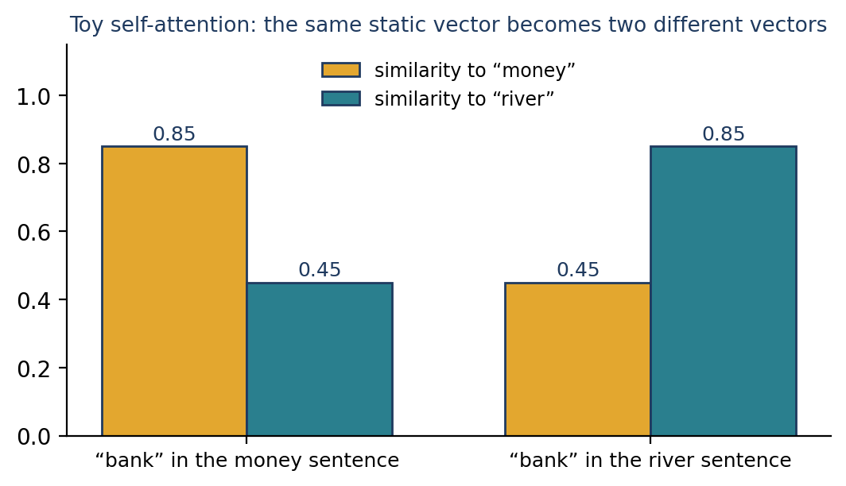
Figure 21.4 After one attention step, the same static vector becomes two different vectors, each closer to the sense suggested by its neighbours.
The static vector for “bank” is [0.5, 0.5, 0.5, 0.5] in both sentences. After attention, “bank” in the money sentence leans towards the money-related dimensions (it is more similar to “money”, 0.85, than to “river”, 0.45), and in the river sentence the reverse holds. Stacking many such layers, each with learned projections, is what lets a transformer represent “bank” differently in “I deposited money at the bank” and “We sat on the river bank”.

21.4 Transformers, Pre-training and Fine-tuning
Transformer models are trained in two phases, the pre-train-and-reuse pattern of Section 2.3. Pre-training teaches a model general properties of language from very large amounts of unlabelled text. Fine-tuning (or prompting) adapts it to a specific task with much less labelled data. The pre-training objective determines the family:
Family | Architecture | Pre-training objective | Typical uses | Examples
Encoder | Transformer encoder; reads the whole sentence in both directions | Masked language modelling: predict hidden words from both sides | Classification, entity recognition, sentence embeddings, search | BERT and its relatives
Decoder | Transformer decoder; reads left to right | Next-token prediction | Text generation, dialogue, summarisation, coding assistance | The GPT family and most chat-style large language models
Encoder–decoder | Both parts | Reconstruct or translate sequences | Translation, summarisation | T5, BART and others
Table 21.1 The three main transformer families.
A large language model (LLM) is a very large decoder-style model, pre-trained on huge text collections and then often tuned to follow instructions. Because it can be directed with a written prompt, one model can classify, extract, summarise, translate and answer questions without a separate model for each task. That generality is what made the techniques of Parts II to V partly replaceable in many applications, and also what makes them still worth knowing: they remain the cheaper, faster and more transparent tool for many well-defined problems.
What contextual and generative models do not guarantee
They can produce fluent but incorrect statements (“hallucinations”), reflect biases in their training data, behave differently from one version to the next, and reveal or leak sensitive data if used carelessly. They are expensive to run at scale and measured in tokens. Treat their output as something to evaluate (Chapter 22) rather than trust.

21.5 Using Pre-trained Models in Python
Not executed in this manuscript’s test environment
The code in this section downloads pre-trained models from the Hugging Face Hub, which was not reachable from the environment used to test the other chapters’ code. It follows the libraries’ current documentation, but no output is shown and none was verified. Run it yourself before relying on it, and check the documentation of the library versions you install.

The Hugging Face Transformers library
The Hugging Face transformers library provides thousands of pre-trained models. Its documentation recommends the Auto classes, which choose the right architecture from a model’s name, and a high-level `pipeline` for common tasks. At the time of writing, the library is in its 5.x series; install it with pip install -U transformers together with PyTorch. A base model returns raw hidden states, so task-specific code adds a “head” (for example, a classification layer) on top.
from transformers import pipeline

# Downloads a default model for the task and caches it
classifier = pipeline("sentiment-analysis")
print(classifier(["I love this movie", "I hate this movie"]))

A pipeline returns a label and a score for each text. Unlike the averaged spaCy vectors of Section 20.6, such a model is trained for the task, so the two sentences should receive opposite labels; you should confirm this on your own examples, and note that the default model for a task may change between library versions, so specify model="..." for reproducible work.
To obtain contextual token vectors, load a tokenizer and a base model. The tokenizer applies subword tokenization (Section 21.2) and returns tensors; the model returns one vector per token:
import torch
from transformers import AutoTokenizer, AutoModel

name = "bert-base-uncased"
tokenizer = AutoTokenizer.from_pretrained(name)
model = AutoModel.from_pretrained(name)

def bank_vector(sentence):
inputs = tokenizer(sentence, return_tensors="pt")
with torch.no_grad():
hidden = model(**inputs).last_hidden_state[0] # one vector per token
tokens = tokenizer.convert_ids_to_tokens(inputs["input_ids"][0])
return hidden[tokens.index("bank")]

v1 = bank_vector("I deposited money at the bank.")
v2 = bank_vector("We sat on the river bank.")
print(torch.cosine_similarity(v1, v2, dim=0).item())

Unlike spaCy’s static vectors, where the two “bank” vectors were identical (Section 20.8), the cosine similarity of these two vectors is below 1, because each is computed from its sentence. The function assumes that “bank” is a single token in the tokenizer’s vocabulary, which is true for common English words in this model; for a rare word, you would have to combine its subword pieces.
Sentence embeddings
Averaging contextual token vectors does not necessarily give good sentence vectors. Models trained specifically to place similar sentences close together are better, and the sentence-transformers library makes them simple to use. Its documentation uses the compact all-MiniLM-L6-v2 model, which produces 384-dimensional vectors and truncates input beyond 256 word pieces:
from sentence_transformers import SentenceTransformer

model = SentenceTransformer("all-MiniLM-L6-v2")

documents = ["How do I reset my password?",
"Steps to recover a forgotten login",
"Quarterly revenue grew by ten per cent"]
query = "I can't sign in to my account"

doc_vectors = model.encode(documents)
query_vector = model.encode([query])

scores = model.similarity(query_vector, doc_vectors) # cosine similarity by default
print(scores)
best = int(scores.argmax())
print(documents[best])

Here we expect the two account-related documents to score far higher than the revenue sentence, even though they share almost no words with the query. That is the capability that bag-of-words search lacks (Section 18.7) and that averaged static vectors approximate only crudely. The library’s own quickstart illustrates the same behaviour: it reports a similarity of roughly 0.67 between “The weather is lovely today.” and “It’s so sunny outside!” against about 0.10 to 0.14 for each compared with “He drove to the stadium.”. Verify such numbers on your own data.

21.6 Choosing a Representation
The techniques in this book form a ladder, not a ranking in which the top rung always wins. Figure 21.5 gives a rule of thumb.
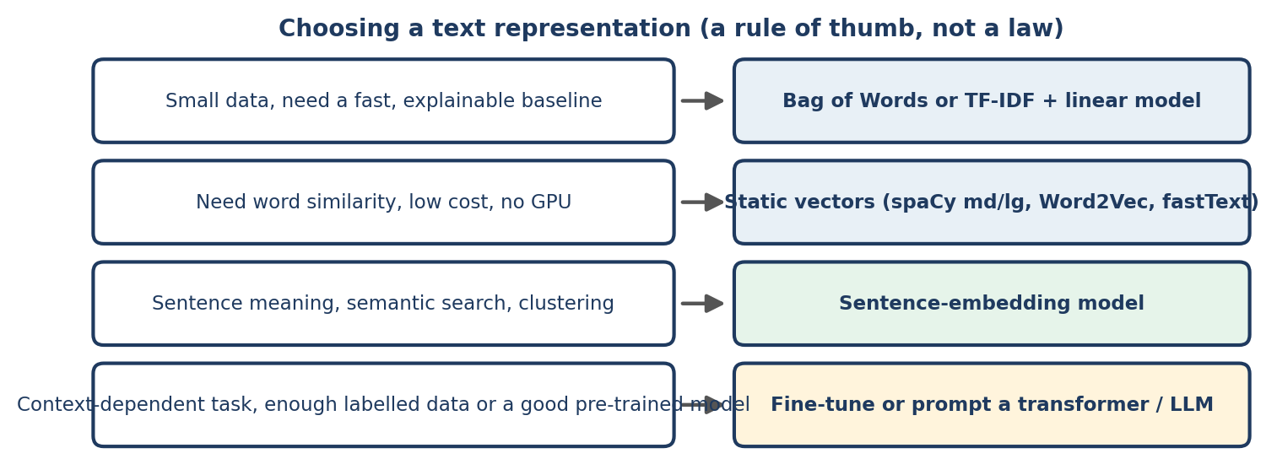
Figure 21.5 A rule of thumb for choosing a text representation.
- Start simple. A TF-IDF model with a linear classifier trains in seconds, is easy to explain and is often surprisingly strong. It is the baseline any more complex model should beat (Chapters 18 and 23).
- Add embeddings when you need similarity of meaning, when your vocabulary at deployment will differ from your training data, or when you have little labelled data.
- Use a transformer or LLM when the task depends on context, order or reasoning, or when pre-trained knowledge is the main source of accuracy. Prefer a pre-trained model, fine-tuned if necessary, to training from scratch.
- Measure. Compare candidates on held-out data with the metrics of Chapter 22, and weigh accuracy against cost, speed, privacy and explainability.
A common modern architecture for question answering over private documents is retrieval-augmented generation (RAG): the documents are split into passages and embedded with a sentence-embedding model; the passages nearest to a user’s question (found by cosine similarity, exactly as in Section 18.7) are retrieved; and a generative model is asked to answer using them. The components are the ones introduced in this book: preprocessing, vector representations, similarity search, and evaluation.

21.7 Where to Go Next
This book has taught the fundamentals: the pipeline, text preparation, linguistic analysis, representation and evaluation. Natural next steps are: working through the Hugging Face and sentence-transformers documentation with real datasets; learning the basics of neural networks and PyTorch; studying fine-tuning and parameter-efficient adaptation; learning prompt design and evaluation for LLMs; and reading the original papers on Word2Vec, the transformer and BERT, which are listed in the references. The fundamentals of this book will keep applying: every one of those systems still needs clean data, a sound split of training and test data, sensible metrics and monitoring after deployment.

21.8 Common Mistakes
- Using an LLM for everything. Check whether a rule, a regex or a TF-IDF classifier solves the problem more cheaply and transparently (Section 1.4.4).
- Believing fluent output is correct. Evaluate on your own data.
- Ignoring token limits and costs. Texts longer than a model’s limit are truncated or rejected.
- Mixing tokenizers and models. Always load the tokenizer that belongs to the model.
- Sending sensitive data to external services without considering privacy.
- Assuming results are reproducible when a library, model version or default model changes.
- Using averaged token vectors as sentence embeddings when a sentence-embedding model is available.

21.9 Chapter Summary
- Static embeddings give one vector per word; contextual embeddings compute a vector for each occurrence from its sentence.
- Subword tokenization (BPE, WordPiece) represents any word as pieces from a fixed vocabulary, largely removing the out-of-vocabulary problem.
- Self-attention builds each word’s representation as a weighted average of all words in the sentence; transformers stack many such layers.
- Encoder models (BERT-style), decoder models (GPT-style, most LLMs) and encoder–decoder models are pre-trained with different objectives and then fine-tuned or prompted.
- Hugging Face transformers and sentence-transformers give practical access; verify their behaviour and versions.
- Choose the simplest representation that meets the requirement, and compare candidates with proper evaluation.

21.10 Review Questions and Exercises
- Give two reasons why averaging static word vectors is a poor sentence representation.
- What does BPE merge at each step? Why does “lowest” tokenize into two pieces in Section 21.2?
- In the toy attention example, why does the vector for “bank” change between the two sentences?
- Explain the difference between an encoder-style and a decoder-style model, with one use of each.
- Exercise. Change the invented vectors in the toy attention program so that “bank” sits closer to the “river” dimensions. How do the cosine similarities change?
- Exercise. Run the BPE program on a corpus of ten words you choose, with 15 merges. Which merges look linguistically meaningful (suffixes, prefixes)? Which do not?
- Exercise (requires internet access). Reproduce Section 21.5 with pipeline and SentenceTransformer. Compare the sentence similarities with those of spaCy’s doc.similarity for the sentence pairs in Section 20.6. Which model separates “love” from “hate”?

Editorial note — remove before publication
From your notes: the “Word2Vec vs BERT”, “contextual embedding models” (ELMo, BERT, GPT), “static word vectors versus contextual embeddings” and “customising embeddings for a domain” passages, and the repeated bank example. As planned, this is a mostly new bridge chapter: the notes mention contextual models only in comparison tables.
What was verified and what was not: the BPE program, the self-attention toy and every output in Sections 21.2 and 21.3 were run (Python 3, NumPy 2.4.4). The code in Section 21.5 (Hugging Face transformers and sentence-transformers) was not executed, because the Hugging Face Hub was unreachable from the test environment; no output is shown for it. Its API usage was checked against the libraries’ current documentation: the Auto classes, pipeline, from_pretrained and the version 5 series of transformers; SentenceTransformer("all-MiniLM-L6-v2"), encode, similarity, 384-dimensional output, and the 256-word-piece limit. The similarity values quoted from the sentence-transformers quickstart are from its documentation, not from our run.
Statements to confirm before publication: the publication years in Figure 21.1 and the descriptions in Table 21.1 are from general knowledge of the original papers; cite the papers in the references. The library version numbers move quickly; update them when the manuscript is finalised.

