NATURAL LANGUAGE PROCESSING FUNDAMENTALS
From Text Preprocessing to Word Embeddings, with Python
Draft manuscript — Part V: Representing Text as Numbers
Chapters 14–18 · Text Representation, Encoding, Bag of Words, Bag of N-grams, TF-IDF
[Author name — to be supplied]
Contents
Part V Representing Text as Numbers 4
Chapter 14 Features, Text Representation and the Vector Space Model 5
14.1 Introduction 5
14.2 What Are Features? 5
14.3 What Is Feature Engineering? 6
14.4 What Is Text Representation? 7
14.5 The Vector Space Model 7
14.6 Measuring Similarity: Cosine Similarity 8
14.7 Common Text Representation Techniques 10
14.8 Why Representation Matters 11
14.9 Preview: E-mail Spam Detection 11
14.10 Common Mistakes 11
14.11 Chapter Summary 12
14.12 Review Questions and Exercises 12
Chapter 15 Label Encoding and One-Hot Encoding 13
15.1 Introduction 13
15.2 Label Encoding 13
15.3 One-Hot Encoding 15
15.4 Label Encoding versus One-Hot Encoding 16
15.5 Problems with Primitive Encodings 17
15.6 Modern Alternatives 19
15.7 Common Mistakes 19
15.8 Chapter Summary 20
15.9 Review Questions and Exercises 20
Chapter 16 Bag of Words 21
16.1 What Is Bag of Words? 21
16.2 How Bag of Words Works 22
16.3 Bag of Words with CountVectorizer 22
16.4 Useful Options 23
16.5 Application: E-mail Spam Detection 25
16.6 What Is a Pipeline, and Why Use One? 27
16.7 Limitations of Bag of Words 27
16.8 Bag of Words versus Other Representations 28
16.9 Common Mistakes 29
16.10 Chapter Summary 29
16.11 Review Questions and Exercises 29
Chapter 17 Bag of N-grams 31
17.1 What Is Bag of N-grams? 31
17.2 Bag of Words as a Special Case 32
17.3 How Bag of N-grams Works 32
17.4 Bag of N-grams with CountVectorizer 33
17.5 Why N-grams Help: A Negation Example 34
17.6 Advantages of Bag of N-grams 35
17.7 Limitations of Bag of N-grams 35
17.8 Preprocessing for N-gram Models 36
17.9 Application: News Classification 36
17.10 Bag of Words, Bag of N-grams and TF-IDF 37
17.11 Common Mistakes 37
17.12 Chapter Summary 37
17.13 Review Questions and Exercises 38
Chapter 18 TF-IDF 39
18.1 What Is TF-IDF? 39
18.2 Why Do We Need TF-IDF? 39
18.3 The Two Components of TF-IDF 39
18.4 Why the Logarithm? 40
18.5 A Worked Example 40
18.6 TF-IDF with scikit-learn 42
18.7 Using TF-IDF 44
18.8 Preprocessing: Stop Words and Lemmatization 46
18.9 Limitations of TF-IDF 46
18.10 Bag of Words, TF-IDF and Embeddings 47
18.11 Common Mistakes 47
18.12 Chapter Summary 47
18.13 Review Questions and Exercises 47

Part V Representing Text as Numbers
Parts II to IV worked with text as text: patterns, tokens, tags and entities. Most machine-learning algorithms, however, cannot read words. They compute with numbers. Part V introduces the classical ways of converting text into numerical form: the general ideas of features and vector spaces (Chapter 14), the simplest encodings of words (Chapter 15), and the count-based representations Bag of Words (Chapter 16), Bag of N-grams (Chapter 17) and TF-IDF (Chapter 18). Part VI then turns to learned representations, word embeddings.

Chapter 14 Features, Text Representation and the Vector Space Model
Learning objectives
After studying this chapter you will be able to:
• define features, feature engineering and text representation (vectorization);
• explain the Vector Space Model and how documents become vectors;
• compute and interpret cosine similarity by hand and with scikit-learn;
• name the main text representation techniques and their limitations;
• explain why the choice of representation affects every later result.

14.1 Introduction
Natural language processing enables computers to process and analyse human language. Yet most traditional machine-learning algorithms cannot work with raw text; they require numerical input. Text representation converts text into numerical form, and feature engineering is the broader process of creating, selecting or transforming useful features from data to improve a model’s performance.
Take the sentence “This movie is excellent.” A model cannot understand the words as a human does. We must first turn the text into numbers it can process. This chapter lays the conceptual foundation; the following chapters implement specific techniques.

14.2 What Are Features?
Features are measurable attributes of the data that a machine-learning model uses to find patterns and make predictions. The same idea applies to every kind of data:
Task | Typical features
House price prediction | Area (1,200 sq. ft.), bedrooms (3), location (Chennai), age of house (5 years)
Image recognition | Edges, shapes, colours, textures and parts such as eyes and nose
Text classification | Number of words, presence of “good”, presence of “bad”, frequency of individual words, numerical representations of words
Table 14.1 Features for three kinds of data.
Figure 14.1 shows how a few hand-chosen features turn the sentence “The movie was very good.” into a vector.
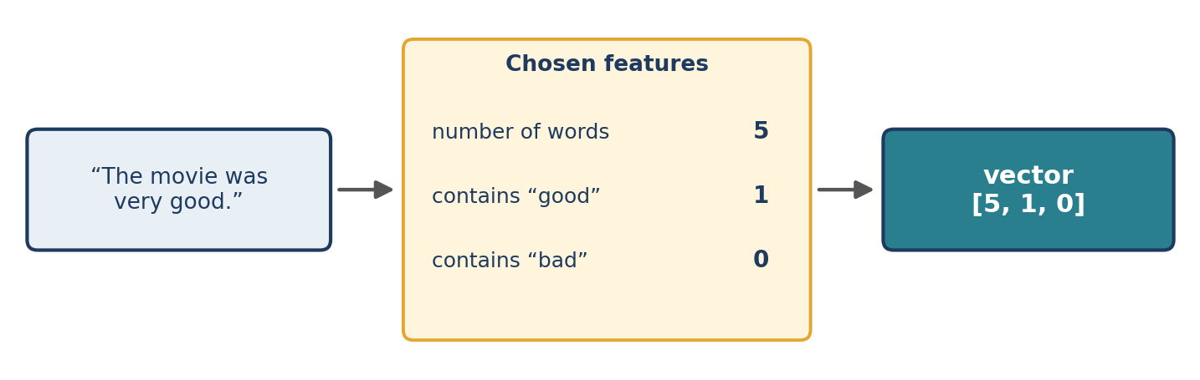
Figure 14.1 Three hand-chosen features turn a sentence into the vector [5, 1, 0].

14.3 What Is Feature Engineering?
Feature engineering is the process of creating, transforming, selecting or extracting useful features from raw data. In NLP it converts unstructured text into structured numerical features through these steps:
- Collect text data: e-mails, reviews, articles.
- Preprocess the text with suitable cleaning and normalisation (Part III).
- Extract features: useful words, phrases or other properties.
- Represent the text numerically as vectors.
- Select useful features and remove irrelevant or redundant ones, where appropriate.
- Train the model on the resulting numerical features.
Example
Original text: “The product is good.” After preprocessing (with stop words removed, Chapter 8) it might become the tokens ["product", "good"]. Suppose we have chosen the four-word vocabulary ["product", "price", "good", "bad"]. A binary vector records which of those words appear:
vocabulary = ["product", "price", "good", "bad"]
tokens = ["product", "good"]

vector = [1 if word in tokens else 0 for word in vocabulary]
print(vector)

Output
[1, 0, 1, 0]

The exact values depend on the vocabulary and the extraction method, so the same sentence yields different vectors under different choices. Good feature engineering improves the usefulness of the input, helps a model find relevant patterns, can remove irrelevant information, and may improve accuracy and efficiency.
Feature engineering is not a guarantee
Poorly chosen features can introduce noise or discard useful information. Treat every feature-engineering decision as a hypothesis to be tested on held-out data (Chapter 22).

14.4 What Is Text Representation?
Text representation is the process of converting words, sentences or documents into numerical formats that machine-learning algorithms can process. When the result is a vector it is called text vectorization. A vector is an ordered collection of numerical values, for example [0, 1, 0, 1], in which each number describes a selected characteristic of the text.
Computers can store text as characters, but numerical algorithms need numeric inputs. Representing text numerically makes it possible to classify documents, detect spam, analyse sentiment, compare documents, measure similarity between words or sentences, and build information-retrieval systems.
A category-based example
Suppose we define three features: Person, Location and Organization. Entities can then be represented with binary values:
Entity | Person | Location | Organization
Dhoni | 1 | 0 | 0
Chennai | 0 | 1 | 0
Microsoft | 0 | 0 | 1
Table 14.2 A simplified category-based encoding.
The vectors are Dhoni = [1, 0, 0], Chennai = [0, 1, 0] and Microsoft = [0, 0, 1]. This shows how information can be made numerical, but the vectors capture no deeper relationships: they cannot say that Dhoni and Chennai are connected through cricket, or that two different people have similar jobs.

14.5 The Vector Space Model
The Vector Space Model (VSM) represents words, sentences or documents as numerical vectors in a multidimensional space. Each dimension corresponds to a feature, and depending on the technique a feature may stand for a word, a word frequency, a category or a learned semantic property.
Suppose a vocabulary contains three words: ["good", "bad", "excellent"]. A document can be represented as D = [1, 0, 1]: “good” appears once, “bad” does not appear, and “excellent” appears once. The numbers may be counts or simple presence indicators, depending on the method.
How the VSM works
- Collect the text documents.
- Build a vocabulary or feature set.
- Assign a numerical value to each feature.
- Represent every document as a vector.
- Apply machine-learning or mathematical operations to the vectors.
Applications include document classification, search engines, information retrieval, document similarity, spam detection and text clustering. Because documents are points (or arrows) in a space, we can measure how close they are. Figure 14.2 shows documents with two features, so that they can be drawn on a page; real vectors have thousands of dimensions.
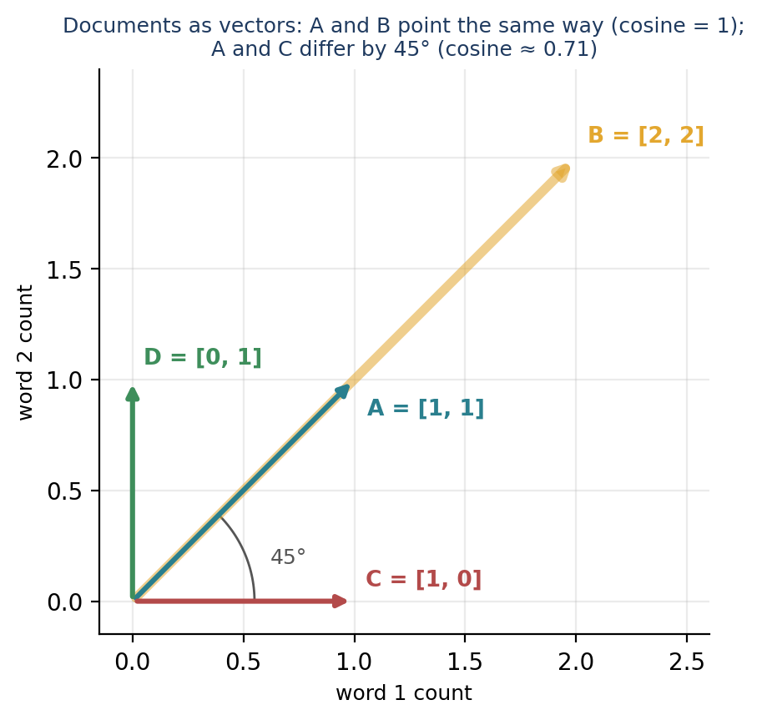
Figure 14.2 Documents as vectors in a two-dimensional space. Direction, not length, determines cosine similarity.

14.6 Measuring Similarity: Cosine Similarity
Once text is in vector form, mathematical operations can compare it. A widely used measure is cosine similarity, the cosine of the angle between two non-zero vectors. It compares the orientation of vectors rather than their length:
cos_sim(A, B) = (A · B) / (‖A‖ × ‖B‖)

- A and B are vectors.
- A · B is their dot product: multiply matching entries and add the results.
- ‖A‖ and ‖B‖ are their magnitudes (lengths): the square root of the sum of squared entries.
For vectors with no negative values, such as word counts, cosine similarity lies between 0 and 1. For vectors that can contain negative values, such as the word embeddings of Chapter 19, it lies between −1 and 1.
A worked example
Let A = [1, 1, 0] and C = [1, 0, 0]. The dot product is 1×1 + 1×0 + 0×0 = 1. The magnitudes are ‖A‖ = √2 ≈ 1.414 and ‖C‖ = 1. So cos_sim(A, C) = 1 ÷ 1.414 ≈ 0.707, which corresponds to an angle of 45° (Figure 14.2).
import numpy as np
from sklearn.metrics.pairwise import cosine_similarity

A = [[1, 1, 0]]
B = [[1, 1, 0]]
C = [[0, 0, 1]]

print(cosine_similarity(A, B)) # identical vectors
print(cosine_similarity(A, C)) # vectors with nothing in common

Output
[[1.]]
[[0.]]

Identical vectors score 1; vectors that share no features score 0. cosine_similarity expects two-dimensional input, which is why each vector is wrapped in an extra pair of brackets. The same quantity can be computed directly:
a, b, c = np.array([1, 1, 0]), np.array([2, 2, 0]), np.array([1, 0, 0])

def cos(x, y):
return x @ y / (np.linalg.norm(x) * np.linalg.norm(y))

print(round(cos(a, b), 4), round(cos(a, c), 4))
print(round(float(np.linalg.norm(a - b)), 4))

Output
1.0 0.7071
1.4142

Vector b is a doubled, as if a document contained the same words twice as often. Their cosine similarity is 1 because they point in the same direction, whereas their straight-line (Euclidean) distance is 1.414. This length-independence is why cosine similarity suits text: a long document and a short one about the same topic should count as similar.
Cosine similarity of real texts
from sklearn.feature_extraction.text import CountVectorizer

docs = ["good movie", "good food"]
vec = CountVectorizer()
X = vec.fit_transform(docs)

print(vec.get_feature_names_out())
print(X.toarray())
print(cosine_similarity(X))

Output
['food' 'good' 'movie']
[[0 1 1]
[1 1 0]]
[[1. 0.5]
[0.5 1. ]]

The two documents share one of their two words, so their similarity is 0.5. (CountVectorizer is introduced in Chapter 16.)
A limitation: similarity of vectors is not similarity of meaning
Cosine similarity measures similarity between the supplied vectors, not necessarily between the meanings of words. If “Dhoni” and “Cummins” (both cricketers) are encoded as separate one-hot categories, their vectors are [1, 0, ...] and [0, 1, ...] and their cosine similarity is exactly 0. A representation trained to capture meaning may place them close together. The quality of any similarity calculation therefore depends on the representation that feeds it.

14.7 Common Text Representation Techniques
Several techniques convert text into numerical features. They differ in how much information they keep (Figure 14.3 and Table 14.3).
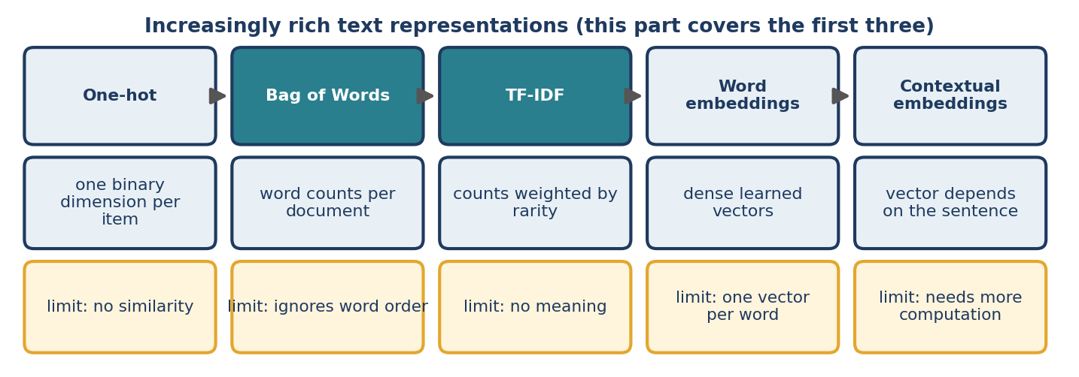
Figure 14.3 From simple to rich text representations.
Technique | Description | Main limitation | Chapter
One-hot encoding | A separate binary dimension for each item | Captures no semantic similarity | 15
Bag of Words (BoW) | Word presence or frequency in a document | Ignores word order | 16
Bag of N-grams | Counts of short word sequences | Large, sparse vocabularies | 17
TF-IDF | Weights words by frequency and document rarity | Limited semantic understanding | 18
Word embeddings | Dense, learned vectors for words | Quality depends on model and training data | 19–20
Contextual embeddings | Vectors that depend on the surrounding words | Need more computation | 21
Table 14.3 Common text representation techniques.
A quick preview. One-hot encoding gives each word a vector with a single 1: with the vocabulary cat, dog, bird, cat is [1, 0, 0], dog is [0, 1, 0] and bird is [0, 0, 1]. Bag of Words represents a document by counts: with the vocabulary [good, movie, food], “good movie” is [1, 1, 0] and “good food” is [1, 0, 1]. TF-IDF gives greater weight to terms frequent in one document but uncommon across the collection. Word embeddings such as Word2Vec and GloVe place related words close together in vector space. Contextual embeddings, such as those from BERT, give a word different vectors in different sentences: “bank” in a loan application differs from “bank” of a river.

14.8 Why Representation Matters
The quality of the representation can strongly influence the performance of an NLP system. Compare two approaches to sentiment analysis. In approach A, a complex model receives poorly prepared features that do not capture the relevant information. In approach B, a simpler model receives well-designed features that clearly separate positive from negative reviews. Approach B may well perform better, because its input is more informative.
This is not a universal rule. Model architecture, training data, preprocessing, optimisation and evaluation all matter too. The key principle is that a suitable representation helps a model learn the relevant patterns more effectively, so choosing the representation is part of system design, not an afterthought.

14.9 Preview: E-mail Spam Detection
Consider two e-mails: “Congratulations! You have won a free prize.” and “The meeting is scheduled for tomorrow.” A spam detector can convert them into vectors with Bag of Words or TF-IDF and train a classifier on many labelled examples. The workflow is: collect labelled e-mails; preprocess the text; convert to vectors; train a classification model; evaluate on unseen e-mails; use the model to classify new messages. Chapter 16 builds this system with real code, and Chapter 23 compares classifiers.

14.10 Common Mistakes
- Comparing vectors made with different vocabularies. Position j must mean the same feature in every vector you compare.
- Fitting the vocabulary on all the data, including the test set. Fit on training data only (Section 16.5).
- Reading cosine similarity as semantic similarity for count-based vectors (Section 14.6).
- Using raw Euclidean distance on counts, which penalises long documents.
- Assuming more features means a better model. Extra features add noise and cost.
- Treating representation as a fixed step. Test alternatives (Chapters 16 to 21).

14.11 Chapter Summary
- Features are measurable attributes; feature engineering creates and selects them; text representation (vectorization) converts text into numerical vectors.
- The Vector Space Model represents documents as vectors whose dimensions correspond to features such as words.
- Cosine similarity, A·B ÷ (‖A‖‖B‖), compares the direction of vectors and ignores their length.
- Techniques range from one-hot encoding and Bag of Words to TF-IDF, word embeddings and contextual embeddings, each with trade-offs.
- The representation limits what any model can learn; similarity measured on weak vectors says little about meaning.

14.12 Review Questions and Exercises
- Explain the difference between a feature and feature engineering, using a house-price example and a text example.
- Compute by hand the cosine similarity of [1, 2, 0] and [2, 4, 0], and of [1, 0, 1] and [0, 1, 0]. Explain each result.
- Why does cosine similarity treat a document and the same document repeated twice as identical?
- Why are “help” and “assistance” dissimilar under one-hot representation?
- Exercise. Build count vectors for “dog bites man” and “man bites dog” with CountVectorizer. What is their cosine similarity? What does it tell you about the representation?
- Exercise. Choose five short product reviews. Define by hand six features (for example, contains “good”, contains “not”, number of words) and build the feature matrix. Which reviews are closest by cosine similarity?

Editorial note — remove before publication
From your notes: all 10 sections of “Feature Engineering and Text Representation in NLP” — introduction, features, feature engineering, text representation, Vector Space Model, cosine similarity (formula, example, Python, limitation), common techniques, importance of representation, spam-detection application and quick revision.
Added: the worked cosine calculation by hand, the length-invariance demonstration with Euclidean distance, a real-text cosine example, the one-line vocabulary vector code, Figures 14.1 to 14.3, common mistakes and exercises. The notes’ comparison table became Table 14.3 with chapter pointers. All code was run (scikit-learn 1.8.0, NumPy 2.4.4); the outputs shown are real, formatted as they appear when printed.

Chapter 15 Label Encoding and One-Hot Encoding
Learning objectives
After studying this chapter you will be able to:
• encode words as integers (label encoding) and as binary vectors (one-hot encoding);
• use scikit-learn’s LabelEncoder and OneHotEncoder;
• explain why label encoding implies a false order and why one-hot vectors are long and sparse;
• describe the out-of-vocabulary problem and the problem of variable-length sentences, and name remedies;
• explain why these primitive encodings do not capture meaning.

15.1 Introduction
Most machine-learning algorithms require numerical inputs. Text encoding converts text into numbers, and two of its simplest forms are label encoding and one-hot encoding. They are the most basic ways to represent words numerically. They are useful for understanding the fundamentals, and they also show clearly why richer representations (Chapters 16 to 21) were developed.

15.2 Label Encoding
Definition
Label encoding assigns a unique integer to each category or word in a vocabulary. Each word maps to a number, so text can be written as a list of integers. Consider the vocabulary ["add", "auto", "can", "hey"]:
words = ["add", "auto", "can", "hey"]
vocab = {word: index for index, word in enumerate(words)}

print(vocab)
print([vocab[w] for w in "hey can add".split()])

Output
{'add': 0, 'auto': 1, 'can': 2, 'hey': 3}
[3, 2, 0]

The sentence “hey can add” becomes [3, 2, 0]. The assigned numbers are arbitrary identifiers. This example starts counting at 0, as Python and scikit-learn do; starting at 1 (so that 0 can be reserved for padding, Section 15.5) is equally valid.
Label encoding with scikit-learn
from sklearn.preprocessing import LabelEncoder

words = ["add", "auto", "can", "hey"]

encoder = LabelEncoder()
encoder.fit(words)
encoded = encoder.transform(words)

for word, number in zip(words, encoded):
print(word, "->", int(number))

print(encoder.classes_)
print(encoder.transform(["hey", "can", "add"]).tolist())
print(encoder.inverse_transform([3, 2, 0]).tolist())

Output
add -> 0
auto -> 1
can -> 2
hey -> 3
['add' 'auto' 'can' 'hey']
[3, 2, 0]
['hey', 'can', 'add']

- fit() learns the set of distinct words and sorts them alphabetically. encoder.classes_ shows this ordering, which is why the integers follow alphabetical order.
- transform() converts words to integers, and inverse_transform() converts integers back to words.
A note on LabelEncoder
scikit-learn designed LabelEncoder for encoding target labels (the y of a classification problem), such as converting “spam”/“ham” to 0/1. For input features, scikit-learn provides OrdinalEncoder and OneHotEncoder. We use LabelEncoder here because it makes the idea of integer encoding easy to see.

Advantages and disadvantages
Advantages | Disadvantages
Simple to implement | May introduce a false sense of order between words
Needs far less storage than dense one-hot vectors | Captures no semantic relationships
Convenient for categorical identifiers and for indexing | Similar words receive unrelated integers
Integers are convenient for data processing | Unknown words need a separate handling strategy
Table 15.1 Label encoding: advantages and disadvantages.
The main limitation
In our vocabulary add = 0 and hey = 3. The number 3 is larger than 0, but that does not make “hey” more important or meaningful than “add”; the numbers are identifiers, not linguistic quantities. A model that treats the integers as continuous values may wrongly interpret differences between them, for example concluding that “can” (2) is halfway between “auto” (1) and “hey” (3).

15.3 One-Hot Encoding
Definition
One-hot encoding represents each word as a binary vector that contains a single 1 and zeros everywhere else. For a vocabulary of N unique words, each word receives a vector of length N.
Word | One-hot vector
add | [1, 0, 0, 0]
auto | [0, 1, 0, 0]
can | [0, 0, 1, 0]
hey | [0, 0, 0, 1]
Table 15.2 One-hot vectors for a four-word vocabulary.
Mathematically, if a word occupies position i in a vocabulary of size N, its vector x has x_j = 1 when j = i and x_j = 0 for every other position j, where j runs from 1 to N.
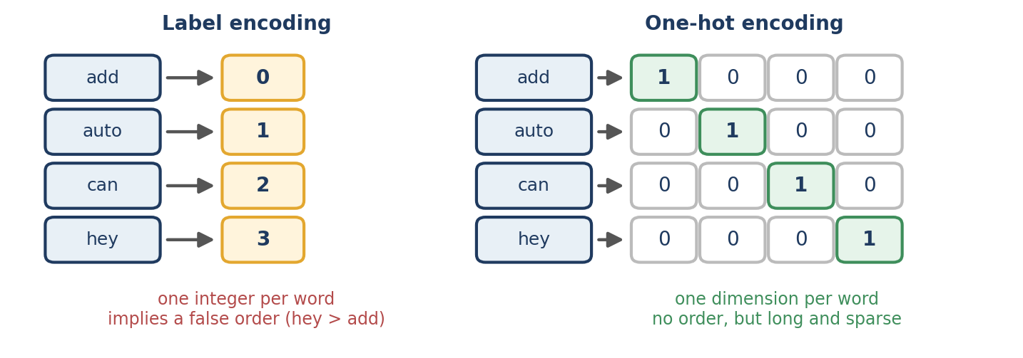
Figure 15.1 Label encoding gives each word one integer; one-hot encoding gives each word its own dimension.
A sentence is represented word by word. Using the vocabulary above, “add can auto” becomes three one-hot vectors:
import numpy as np

vocab = {"add": 0, "auto": 1, "can": 2, "hey": 3}
sentence = "add can auto".split()

one_hot = np.eye(len(vocab), dtype=int)[[vocab[w] for w in sentence]]
print(one_hot)

Output
[[1 0 0 0]
[0 0 1 0]
[0 1 0 0]]

np.eye(4) is the 4 × 4 identity matrix, whose rows are exactly the one-hot vectors, and the list of word indices selects the rows we need. Each word is represented independently of the others.
One-hot encoding with scikit-learn
from sklearn.preprocessing import OneHotEncoder
import numpy as np

words = np.array([["add"], ["auto"], ["can"], ["hey"]])

encoder = OneHotEncoder(sparse_output=False)
encoded = encoder.fit_transform(words)

print(encoded)
print(encoder.categories_[0].tolist())

Output
[[1. 0. 0. 0.]
[0. 1. 0. 0.]
[0. 0. 1. 0.]
[0. 0. 0. 1.]]
['add', 'auto', 'can', 'hey']

The input must be two-dimensional (a column of words), hence the nested brackets. sparse_output=False returns an ordinary dense array instead of the default sparse matrix. In versions of scikit-learn before 1.2 this argument was named sparse.
Advantages and disadvantages
Advantages | Disadvantages
No artificial numerical ordering between words | High-dimensional vectors when the vocabulary is large
A clear, unique representation for each item | Mostly zeros, so the representation is sparse
Simple to understand and implement | Captures no semantic similarity between words
Useful for small categorical feature sets | Needs a vocabulary and a strategy for unknown words
 | A single word’s vector says nothing about sentence meaning or word order
Table 15.3 One-hot encoding: advantages and disadvantages.

15.4 Label Encoding versus One-Hot Encoding
Feature | Label encoding | One-hot encoding
Representation | A single integer | A binary vector
Length per word | 1 | Vocabulary size
Memory (stored densely) | Low | High
Artificial ordering risk | Yes, if the numbers are read as quantities | No ordering between categories
Semantic information | Not captured | Not captured
Best use | Identifiers and indexing | Small categorical feature sets
Main limitation | Misleading numerical relationships | High-dimensional sparse vectors
Table 15.4 Label encoding versus one-hot encoding.

15.5 Problems with Primitive Encodings
Both techniques are useful for learning the basics, but each has important weaknesses when applied to real language.
1. No semantic meaning
“Help”, “assistance” and “support” mean similar things. Label encoding gives them unrelated integers. One-hot encoding gives them different independent vectors, and the vectors are completely dissimilar:
from sklearn.metrics.pairwise import cosine_similarity

vocab = ["help", "assistance", "support"]
vectors = np.eye(3, dtype=int) # one-hot vectors
print(cosine_similarity(vectors).tolist())

Output
[[1.0, 0.0, 0.0], [0.0, 1.0, 0.0], [0.0, 0.0, 1.0]]

Every word is similar only to itself (1.0), and the similarity between any two different words is exactly 0.0.
2. Memory inefficiency
Suppose the vocabulary has 100,000 unique words. Each one-hot vector then contains 100,000 values although only one of them is non-zero. A dense matrix holding one vector per word would contain 100,000 × 100,000 = 10¹⁰ values. At 4 bytes per value, that is about 40 gigabytes, excluding overhead. Sparse storage, which records only the non-zero entries, reduces this enormously. A smaller version of the same idea shows the effect:
from scipy import sparse

n = 10_000
identity = sparse.identity(n, format="csr", dtype=np.float32)
sparse_bytes = identity.data.nbytes + identity.indices.nbytes + identity.indptr.nbytes
dense_bytes = n * n * 4

print(sparse_bytes, dense_bytes)

Output
120004 400000000

For a 10,000-word vocabulary the sparse matrix needs about 120 kilobytes, whereas the dense one would need 400 megabytes. This is why scikit-learn’s vectorizers return sparse matrices by default.
3. The out-of-vocabulary (OOV) problem
An out-of-vocabulary word is a word that was not in the vocabulary built from the training data. If the vocabulary contains cat, dog and bird, the word “rabbit” has no entry. A basic encoder cannot give it a valid representation unless a strategy has been chosen (Figure 15.2).
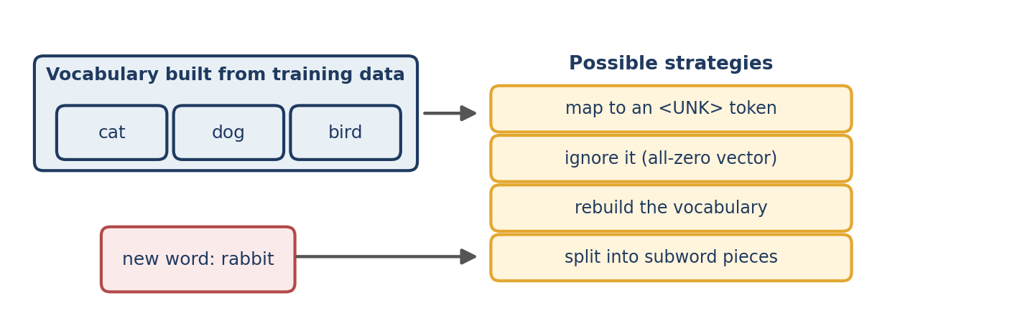
Figure 15.2 An unseen word needs an explicit strategy.
try:
encoder_le = LabelEncoder().fit(["add", "auto", "can", "hey"])
encoder_le.transform(["rabbit"])
except ValueError as error:
print(error)

ohe = OneHotEncoder(sparse_output=False, handle_unknown="ignore")
ohe.fit(np.array([["add"], ["auto"], ["can"], ["hey"]]))
print(ohe.transform(np.array([["can"], ["rabbit"]])).tolist())

Output
y contains previously unseen labels: np.str_('rabbit')
[[0.0, 0.0, 1.0, 0.0], [0.0, 0.0, 0.0, 0.0]]

LabelEncoder raises an error for the unseen word. OneHotEncoder with handle_unknown="ignore" encodes it as an all-zero row, which means “none of the known words”. (The exact wording of the error message can vary between scikit-learn versions.) Other solutions are to map unknown words to a special <UNK> token, to rebuild the vocabulary and retrain, or to use subword tokenization, as modern language models do (Chapter 21).
4. Variable-length sentences
“I like NLP.” has three words and “I like learning NLP.” has four. If each word becomes a vector and the vectors are concatenated, the two sentences produce representations of different lengths. Many models need inputs of a fixed shape within a batch. Common remedies are padding short sequences, truncating long ones, pooling word vectors into one fixed-size vector, and using sequence models or transformers that accept variable lengths.
sentences = ["I like NLP", "I like learning NLP"]

words = sorted({w.lower() for s in sentences for w in s.split()})
index = {w: i + 1 for i, w in enumerate(words)} # 0 is kept for padding
index["<UNK>"] = len(index) + 1
print(index)

sequences = [[index.get(w.lower(), index["<UNK>"]) for w in s.split()]
for s in sentences]
print(sequences)

longest = max(len(seq) for seq in sequences)
padded = [seq + [0] * (longest - len(seq)) for seq in sequences]
print(padded)

print([index.get(w.lower(), index["<UNK>"]) for w in "I like rabbits".split()])

Output
{'i': 1, 'learning': 2, 'like': 3, 'nlp': 4, '<UNK>': 5}
[[1, 3, 4], [1, 3, 2, 4]]
[[1, 3, 4, 0], [1, 3, 2, 4]]
[1, 3, 5]

The code builds an integer vocabulary that reserves 0 for padding and the largest index for <UNK>, converts sentences to integer sequences, pads the shorter sequence with zeros so that both have four entries, and shows that the unseen word “rabbits” maps to <UNK> (index 5). Variable length is therefore not an unavoidable problem for all NLP methods; it is a problem for representations that require a fixed shape.

15.6 Modern Alternatives
Technique | Description | Main advantage | Chapter
Bag of Words | Word occurrence or frequency per document | Simple document representation | 16
Bag of N-grams | Counts of word sequences | Captures local word order | 17
TF-IDF | Weights words by frequency and rarity | Highlights informative words | 18
Word embeddings | Dense numerical vectors for words | Capture semantic relationships | 19–20
Contextual embeddings | Vectors influenced by surrounding text | Handle context-dependent meaning | 21
Subword tokenization | Splits words into smaller units | Helps with unseen words and word variants | 21
Table 15.5 Richer alternatives to primitive encodings.
Even so, integer IDs are not obsolete: modern neural models begin by converting tokens to integer IDs and then look those IDs up in a table of learned vectors, which is exactly how word embeddings work (Chapter 19).

15.7 Common Mistakes
- Feeding label-encoded words into a model as numbers. The model will treat 3 as greater than 1 (Section 15.2).
- Fitting the encoder on the test data. Learn the vocabulary from training data only.
- Forgetting handling for unseen words, which crashes or silently drops them.
- Converting a large vocabulary to a dense array. Keep matrices sparse.
- Using `LabelEncoder` for input features instead of OrdinalEncoder or OneHotEncoder.
- Expecting similarity from one-hot vectors. All distinct words are equally dissimilar.

15.8 Chapter Summary
- Label encoding assigns one integer to each word; one-hot encoding assigns each word a binary vector with a single 1.
- Label encoding implies a false order; one-hot encoding removes the order but is high-dimensional and sparse.
- Neither captures meaning: all distinct words are equally different.
- Practical problems include memory, out-of-vocabulary words and variable-length sentences, handled with sparse storage, <UNK> tokens and padding.
- Richer representations follow: Bag of Words, TF-IDF and embeddings.

15.9 Review Questions and Exercises
- Explain why label-encoded integers should not be used directly as numerical input features.
- What does OneHotEncoder(handle_unknown="ignore") do with an unseen word?
- A vocabulary has 50,000 words. How many values are in a dense one-hot matrix with one row per word? How many bytes at 4 bytes per value?
- Give two ways to give sentences of different lengths the same shape.
- Exercise. Encode the sentence “the cat sat on the mat” with a hand-built vocabulary, as integers and as one-hot vectors. How many distinct words and how many tokens are there?
- Exercise. Use OneHotEncoder on a column of five city names and inspect categories_. Then add a sixth, unseen city at transform time with and without handle_unknown="ignore".

Editorial note — remove before publication
From your notes: all 7 sections of “Label Encoding and One-Hot Encoding in NLP” — definition, scikit-learn code, advantages and disadvantages, comparison table, the four disadvantages (semantics, memory, OOV, variable length) and the modern-alternatives table.
Corrections and changes for review: the notes show label values starting at 1 for the hand-made table (add = 1 … hey = 4) and at 0 for the scikit-learn output; both are valid, and the chapter explains that the numbering is arbitrary. “Possible output” lines were replaced with real output (scikit-learn 1.8.0). The note that LabelEncoder is intended for target labels is added. The “modern alternatives” list repeated the Bag of Words and TF-IDF material of Chapters 16 and 18, so here it is a short table with chapter pointers.
Added: dictionary-based encoding, the np.eye one-hot construction, categories_, the sparse-versus-dense memory demonstration (output real), handle_unknown, a full integer-sequence and padding example, Figures 15.1 and 15.2, common mistakes and exercises.

Chapter 16 Bag of Words
Learning objectives
After studying this chapter you will be able to:
• explain the Bag-of-Words idea and build count vectors by hand;
• use CountVectorizer and interpret its vocabulary and matrix;
• control its behaviour with options such as binary, stop_words, min_df and a custom tokenizer;
• train and apply a spam classifier with a scikit-learn Pipeline;
• describe the limitations of Bag of Words: sparsity, lost word order, no semantics and a fixed vocabulary.

16.1 What Is Bag of Words?
Bag of Words (BoW) is a text-representation technique that converts documents into numerical vectors by counting how many times each word appears. Machine-learning algorithms work with numbers, so BoW turns text into numbers a model can process.
Key idea
BoW considers the frequency of words but ignores word order, grammar and context. A document is treated like a bag of words shaken out of its sentence: we know what is in the bag and how many of each, but not the order.

A worked example
Take two documents: D1 = “I love machine learning” and D2 = “I love deep learning”.
- Build the vocabulary by listing every unique word across the documents: I, love, machine, learning, deep.
- Create a count vector for each document, with one position per vocabulary word:
Word | Document 1 | Document 2
I | 1 | 1
love | 1 | 1
machine | 1 | 0
learning | 1 | 1
deep | 0 | 1
Table 16.1 Word counts for the two documents.
The vectors are therefore D1 = [1, 1, 1, 1, 0] and D2 = [1, 1, 0, 1, 1], where each position corresponds to a vocabulary word and its value is the number of times that word occurs. Written in plain Python, the whole procedure is short:
docs = ["I love machine learning", "I love deep learning"]

vocabulary = ["I", "love", "machine", "learning", "deep"]

for doc in docs:
words = doc.split()
print([words.count(w) for w in vocabulary])

Output
[1, 1, 1, 1, 0]
[1, 1, 0, 1, 1]

16.2 How Bag of Words Works
- Collect documents. Gather the text you want to represent. A collection of documents is a corpus.
- Build the vocabulary. Identify the unique terms in the corpus.
- Create count vectors. Count the occurrences of each vocabulary word in every document.
- Feed the vectors to a model. Use them for tasks such as spam detection or sentiment classification.

16.3 Bag of Words with CountVectorizer
scikit-learn’s CountVectorizer builds the vocabulary and the count vectors automatically. Install scikit-learn with pip install scikit-learn.
from sklearn.feature_extraction.text import CountVectorizer

documents = [
"I love machine learning",
"I love deep learning",
"Machine learning is useful",
]

vectorizer = CountVectorizer()
X = vectorizer.fit_transform(documents)

print("Vocabulary:")
print(vectorizer.get_feature_names_out())
print("\nBoW Matrix:")
print(X.toarray())

Output
Vocabulary:
['deep' 'is' 'learning' 'love' 'machine' 'useful']

BoW Matrix:
[[0 0 1 1 1 0]
[1 0 1 1 0 0]
[0 1 1 0 1 1]]

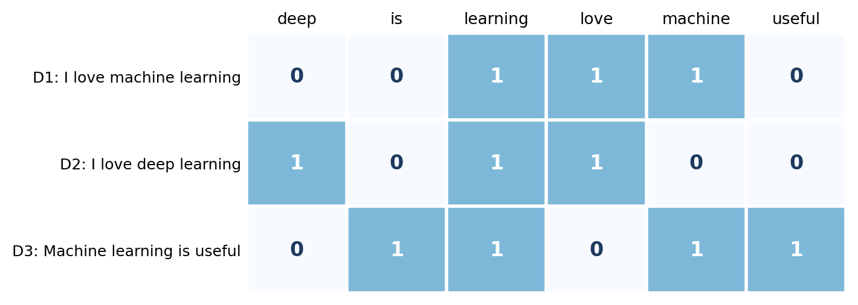
Figure 16.1 The Bag-of-Words matrix for the three documents: one row per document, one column per vocabulary word.
Code explanation
- CountVectorizer() creates the BoW vectorizer.
- fit_transform() first fits (learns the vocabulary from the documents) and then transforms (converts the documents to count vectors).
- get_feature_names_out() returns the vocabulary in column order. It is sorted alphabetically.
- toarray() converts the sparse result into an ordinary NumPy array for viewing. Rows are documents and columns are words.
Why is “I” missing?
The matrix has no column for “I”. By default CountVectorizer lower-cases the text and uses a token pattern that ignores single-character tokens, so “I” is dropped. “is” (two letters) is kept. To keep single characters, change the pattern: CountVectorizer(token_pattern=r"(?u)\b\w+\b") gives the vocabulary ['deep' 'i' 'learning' 'love' 'machine'] for the first two documents.

Inspecting the vectorizer
print(vectorizer.vocabulary_)
print(type(X).__name__, X.shape, X.nnz)

Output
{'love': 3, 'machine': 4, 'learning': 2, 'deep': 0, 'is': 1, 'useful': 5}
csr_matrix (3, 6) 10

vocabulary_ maps each word to its column index. X is a compressed sparse row matrix with 3 rows and 6 columns, of which only nnz = 10 entries are non-zero.

16.4 Useful Options
CountVectorizer has many parameters. The most useful ones for a first project are:
Parameter | Effect | Example
lowercase=True | Lower-case text before counting (default) | “Machine” and “machine” are one feature
binary=True | Record presence (1) instead of counts | “good good movie” → good = 1
stop_words="english" | Remove scikit-learn’s English stop words | drops is, the, a, …
max_features=n | Keep only the n most frequent words | max_features=3
min_df=k | Ignore words found in fewer than k documents | min_df=2 removes rare words
ngram_range=(1, 2) | Add word sequences (Chapter 17) | features such as “machine learning”
tokenizer=function | Use your own tokenizer (with token_pattern=None) | spaCy lemmas
Table 16.2 Frequently used CountVectorizer options.
docs2 = ["good good movie", "good food"]
print(CountVectorizer().fit_transform(docs2).toarray().tolist())
print(CountVectorizer(binary=True).fit_transform(docs2).toarray().tolist())
print(CountVectorizer(stop_words="english").fit(documents).get_feature_names_out())
print(CountVectorizer(min_df=2).fit(documents).get_feature_names_out())

Output
[[0, 2, 1], [1, 1, 0]]
[[0, 1, 1], [1, 1, 0]]
['deep' 'learning' 'love' 'machine' 'useful']
['learning' 'love' 'machine']

Counts record that “good” appears twice in the first document; binary mode records only that it appears. With English stop words removed, “I” and “is” disappear. With min_df=2, only words that occur in at least two documents survive.
Using spaCy inside CountVectorizer
CountVectorizer can call your own function to produce tokens, which lets you combine the spaCy preprocessing of Part III with Bag of Words. Here the function returns the lemma of each token:
import spacy

nlp = spacy.load("en_core_web_sm", exclude=["parser", "ner"])

def lemma_tokens(text):
return [t.lemma_.lower() for t in nlp(text)
if not t.is_punct and not t.is_space]

vec = CountVectorizer(tokenizer=lemma_tokens, lowercase=False, token_pattern=None)
X = vec.fit_transform(["The cars were running", "A car runs"])
print(vec.get_feature_names_out())
print(X.toarray())

Output
['a' 'be' 'car' 'run' 'the']
[[0 1 1 1 1]
[1 0 1 1 0]]

“cars” and “car” are now one feature, and “running” and “runs” are one feature, so the two documents share more of their vocabulary. The pipeline excluded the parser and entity recogniser, which are not needed for lemmas (Section 10.9).

16.5 Application: E-mail Spam Detection
BoW is commonly used to convert e-mails into features for a spam classifier. The goal is to label each e-mail as spam or ham (legitimate). The workflow follows the pipeline of Chapter 4 (Figure 16.2).
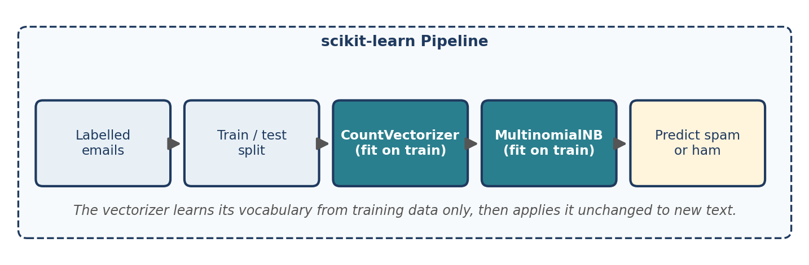
Figure 16.2 A Bag-of-Words spam classifier as a scikit-learn Pipeline.
Step 1: prepare the dataset
A small illustrative dataset of ten e-mails, with spam = 1 and ham = 0 (the numeric mapping is a convention; the model only needs the labels to be consistent):
emails = [
"Win a free prize now", # spam
"Meeting scheduled for tomorrow", # ham
"Claim your free reward", # spam
"Please send the meeting notes", # ham
"Congratulations you won a prize", # spam
"Can we reschedule the project meeting", # ham
"Free cash offer click now", # spam
"Lunch tomorrow with the team", # ham
"Urgent claim your free gift card", # spam
"Please review the attached report", # ham
]
labels = [1, 0, 1, 0, 1, 0, 1, 0, 1, 0]

Step 2: split into training and test sets
The training set teaches the model; the test set measures performance on unseen e-mails. Typical splits keep 70 to 80 per cent for training; with only ten e-mails we hold out three.
from sklearn.model_selection import train_test_split

X_train, X_test, y_train, y_test = train_test_split(
emails, labels, test_size=0.3, random_state=42, stratify=labels)

print(len(X_train), len(X_test))
print(X_test, y_test)

Output
7 3
['Meeting scheduled for tomorrow', 'Lunch tomorrow with the team', 'Urgent claim your free gift card'] [0, 0, 1]

random_state=42 makes the split reproducible, and stratify=labels keeps the spam proportion the same in both sets.
Step 3: vectorize and classify with a Pipeline
A popular combination is CountVectorizer with Multinomial Naive Bayes, a classifier that suits word-count features because it models how often each word occurs in each class. It is fast, and a strong baseline for text. A scikit-learn `Pipeline` chains the steps into a single object:
from sklearn.naive_bayes import MultinomialNB
from sklearn.pipeline import Pipeline
from sklearn.metrics import accuracy_score

model = Pipeline([
("vectorizer", CountVectorizer()),
("classifier", MultinomialNB()),
])

model.fit(X_train, y_train)
predictions = model.predict(X_test)

print(predictions.tolist(), accuracy_score(y_test, predictions))

Output
[0, 0, 1] 1.0

This accuracy means almost nothing
The model classified all three test e-mails correctly, but a test set of three e-mails cannot show how well it would work on real mail. The dataset is for illustration only. Chapters 22 and 23 show how to evaluate a classifier properly, with larger data, cross-validation and precision and recall.

Step 4: predict on new messages
new = ["Free prize waiting for you", "Agenda for the meeting", "Claim your reward now"]
print(model.predict(new).tolist())
print(model.predict_proba(new).round(3).tolist())

Output
[1, 0, 1]
[[0.033, 0.967], [0.904, 0.096], [0.033, 0.967]]

predict_proba returns the probability of each class (ham first, then spam). The first message is judged 96.7 per cent likely to be spam. We can also ask which words the model associates most strongly with spam by comparing the learned log-probabilities of each word in the two classes:
import numpy as np

vec = CountVectorizer().fit(emails)
nb = MultinomialNB().fit(vec.transform(emails), labels)

names = vec.get_feature_names_out()
score = nb.feature_log_prob_[1] - nb.feature_log_prob_[0] # spam minus ham
for i in np.argsort(score)[::-1][:3]:
print(names[i], round(float(score[i]), 2))

Output
free 1.64
your 1.13
now 1.13

“free” is the strongest spam indicator in this tiny dataset. With so little data, such weights reflect the examples we happened to write rather than spam in general.

16.6 What Is a Pipeline, and Why Use One?
A Pipeline combines several machine-learning steps into one workflow. Here it joins CountVectorizer, which converts text to word-count vectors, and MultinomialNB, which classifies those vectors. Instead of transforming training and test data by hand, the pipeline guarantees that the vectorizer is fitted on the training data only and then applied identically to any new text. This prevents data leakage, the accidental use of information from the test set during training, and it keeps the code easy to maintain. The same object can be saved and used in production (Chapter 24), so training and deployment cannot drift apart.

16.7 Limitations of Bag of Words
A. Sparsity
A corpus may contain thousands of unique words, but each document uses only a few. A vocabulary of 10,000 words creates a 10,000-dimensional vector for every document, even if the document has only 20 distinct words, so most entries are zero. Even our ten e-mails produce a 10 × 34 matrix with 48 non-zero entries, which is 86 per cent zeros. CountVectorizer stores the matrix sparsely; converting it with toarray() on a large corpus can use huge amounts of memory.
B. Loss of word order
“Dog bites man” and “man bites dog” contain the same words with the same counts, so BoW gives them identical vectors although their meanings differ:
vec = CountVectorizer()
print(vec.fit_transform(["Dog bites man", "Man bites dog"]).toarray().tolist())
print(vec.get_feature_names_out())

Output
[[1, 1, 1], [1, 1, 1]]
['bites' 'dog' 'man']

C. No semantic understanding
BoW treats each word as a separate feature even when words mean similar things. “help” and “assistance” are as different as “help” and “banana”.
D. A fixed vocabulary
A word that did not occur in the training data is silently ignored when new text is transformed:
vectorizer = CountVectorizer().fit(documents)
print(vectorizer.transform(["I love quantum computing machine"]).toarray().tolist())

Output
[[0, 0, 0, 1, 1, 0]]

Only “love” and “machine” were found; “quantum” and “computing” contributed nothing. The fixed vocabulary limits how well BoW represents text with new words, and it is why vocabularies need rebuilding as language changes (Chapter 24).

16.8 Bag of Words versus Other Representations
Feature | Bag of Words | TF-IDF | Word embeddings
Main idea | Counts words | Weights words by importance | Dense vectors learned from text
Uses word frequency | Yes | Yes, adjusted by document frequency | Not directly
Captures semantic similarity | No | No (not inherently) | Often, depending on the model
Word order | Ignored | Ignored in standard form | Depends on the model
Typical form | Sparse | Sparse | Dense
Table 16.3 Three representations compared. TF-IDF is the subject of Chapter 18 and embeddings of Chapter 19.
BoW is one of the simplest and most important foundations of text representation. TF-IDF extends it by reducing the relative weight of words that occur in many documents, and embeddings can represent semantic relationships much more effectively.

16.9 Common Mistakes
- Fitting the vectorizer on all the data before splitting (leakage). Use a Pipeline or fit on the training set only (Section 16.6).
- Forgetting that single-letter words are dropped by default.
- Calling `fit_transform` on test data. Use transform, so the training vocabulary is reused.
- Converting a large sparse matrix to a dense array.
- Judging a model on a tiny test set (Section 16.5).
- Using different preprocessing for training and for new messages.

16.10 Chapter Summary
- Bag of Words represents a document as a vector of word counts over a vocabulary, ignoring order, grammar and context.
- CountVectorizer builds the vocabulary and sparse count matrix; its options control case, binarisation, stop words, rare words, n-grams and tokenization.
- A Pipeline of CountVectorizer and MultinomialNB is a simple, strong baseline for spam detection and prevents data leakage.
- BoW is sparse, loses word order, has no notion of meaning, and ignores unseen words.

16.11 Review Questions and Exercises
- Write the BoW vectors for “the cat sat” and “the cat saw the dog” over the vocabulary [the, cat, sat, saw, dog].
- Why does CountVectorizer ignore “I” by default, and how can you change that?
- What is the difference between fit_transform on training data and transform on test data?
- Give two reasons why “dog bites man” and “man bites dog” cannot be told apart by BoW.
- Exercise. Extend the spam dataset to 20 messages of your own, rerun the pipeline and examine the words with the highest spam score. Do they make sense?
- Exercise. Compare CountVectorizer() with CountVectorizer(stop_words="english") and CountVectorizer(binary=True) on the ten e-mails. How does the vocabulary size change? Does the test accuracy change?
- Exercise. Build a BoW sentiment classifier for ten short movie reviews that you write. Which reviews are hardest to classify, and why?

Editorial note — remove before publication
From your notes: all 8 sections of “Bag of Words (BoW) in NLP” — definition, worked example, how BoW works, CountVectorizer, limitations (sparsity, word order, semantics, vocabulary), spam-detection application (dataset, split, Naive Bayes, Pipeline), comparison table and quick revision.
Changed: the notes’ spam example was truncated in the source file, so a complete ten-message dataset and a full runnable pipeline were written; every output is real (scikit-learn 1.8.0). The notes’ remark that CountVectorizer drops “I” is kept and explained. The BoW/TF-IDF/embeddings comparison table appears once, here, and Chapter 18 refers back to it, as the repeated copies in your notes were removed.
Added: plain-Python BoW, vocabulary_ and sparse-matrix inspection, the options table, spaCy lemmas inside CountVectorizer, the spam-word weights, the unseen-word demonstration, the warning about tiny test sets, common mistakes, exercises and Figures 16.1 and 16.2.

Chapter 17 Bag of N-grams
Learning objectives
After studying this chapter you will be able to:
• define n-grams and compute their number for a sentence;
• explain how Bag of N-grams extends Bag of Words and recovers some word order;
• use ngram_range in CountVectorizer and choose a setting;
• describe vocabulary explosion, sparsity and the other limits of n-grams;
• build an n-gram news classifier and explain how preprocessing choices interact with n-grams.

17.1 What Is Bag of N-grams?
Bag of N-grams is a text-representation technique that converts text into numerical vectors using the frequency of consecutive sequences of words. Unlike basic Bag of Words (Chapter 16), which counts individual words, it can capture short word sequences and therefore some local word order.
An n-gram is a contiguous sequence of n items, such as words or tokens, from a text. For the sentence “I love machine learning” (Figure 17.1):
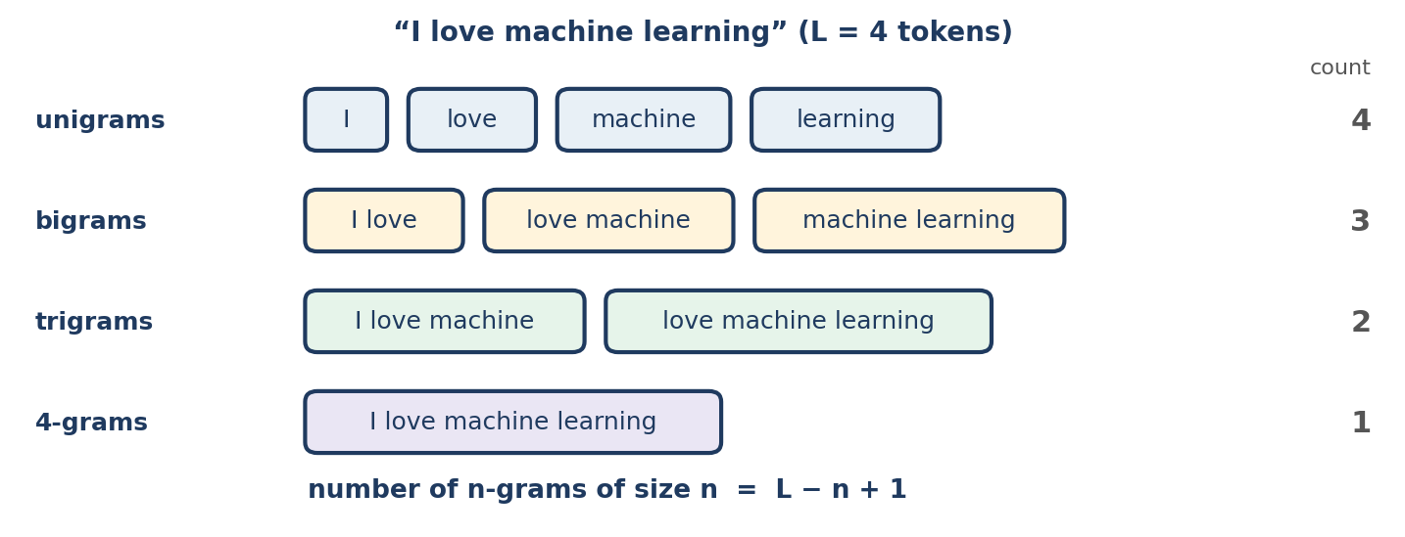
Figure 17.1 All the n-grams of “I love machine learning”.
Type | n | Example from “I love machine learning”
Unigram | 1 | love
Bigram | 2 | love machine
Trigram | 3 | I love machine
Four-gram | 4 | I love machine learning
Table 17.1 Types of n-gram.
For a sentence with L tokens, the number of contiguous n-grams of a fixed size n is L − n + 1 (for 1 ≤ n ≤ L). A four-word sentence therefore contains 4 unigrams, 3 bigrams, 2 trigrams and 1 four-gram. The following function generates them in plain Python:
def ngrams(tokens, n):
return [" ".join(tokens[i:i + n]) for i in range(len(tokens) - n + 1)]

tokens = "I love machine learning".split()

for n in (1, 2, 3, 4):
print(n, len(ngrams(tokens, n)), ngrams(tokens, n))

Output
1 4 ['I', 'love', 'machine', 'learning']
2 3 ['I love', 'love machine', 'machine learning']
3 2 ['I love machine', 'love machine learning']
4 1 ['I love machine learning']

The slice tokens[i:i + n] takes a window of n consecutive tokens, and the window slides one position at a time.

17.2 Bag of Words as a Special Case
Bag of Words is the special case of Bag of N-grams in which n = 1. Consider “dog bites man” and “man bites dog”. With unigrams alone, both contain the same words and their vectors are identical. With bigrams they differ:
 | Bigrams
Document 1: dog bites man | dog bites, bites man
Document 2: man bites dog | man bites, bites dog
Table 17.2 The two documents share no bigrams.
from sklearn.feature_extraction.text import CountVectorizer

vec = CountVectorizer(ngram_range=(1, 2))
X = vec.fit_transform(["dog bites man", "man bites dog"])

print(vec.get_feature_names_out())
print(X.toarray())

Output
['bites' 'bites dog' 'bites man' 'dog' 'dog bites' 'man' 'man bites']
[[1 0 1 1 1 1 0]
[1 1 0 1 0 1 1]]

The unigram columns (bites, dog, man) are identical for the two rows, but the bigram columns (bites dog, bites man, dog bites, man bites) differ, so the two sentences now have different vectors. N-grams capture local word order, but they do not understand grammar or meaning.

17.3 How Bag of N-grams Works
- Collect the documents.
- Generate the n-grams of the chosen sizes.
- Build the vocabulary of unique n-grams across the corpus.
- Create vectors by counting each n-gram in each document.
With the documents “I love NLP” and “I love AI”, a unigram-plus-bigram vocabulary is: I, love, NLP, AI, I love, love NLP, love AI. Each column of the feature matrix is an n-gram and each row is a document.

17.4 Bag of N-grams with CountVectorizer
Bigrams only
documents = [
"I love machine learning",
"I love deep learning",
"Machine learning is useful",
]

vectorizer = CountVectorizer(ngram_range=(2, 2))
X = vectorizer.fit_transform(documents)

print("Vocabulary:")
print(vectorizer.get_feature_names_out())
print("\nFeature Matrix:")
print(X.toarray())

Output
Vocabulary:
['deep learning' 'is useful' 'learning is' 'love deep' 'love machine'
'machine learning']

Feature Matrix:
[[0 0 0 0 1 1]
[1 0 0 1 0 0]
[0 1 1 0 0 1]]

ngram_range=(2, 2) generates only bigrams. Note that “machine learning” appears in documents 1 and 3, so its column has a 1 in both of those rows. (The single-letter “I” is dropped by the default tokenizer, which is why there is no “I love”; see Section 16.3.)
Unigrams and bigrams together
vectorizer = CountVectorizer(ngram_range=(1, 2))
X = vectorizer.fit_transform(["I love machine learning", "I love deep learning"])

print(vectorizer.get_feature_names_out())
print(X.toarray())

Output
['deep' 'deep learning' 'learning' 'love' 'love deep' 'love machine'
'machine' 'machine learning']
[[0 0 1 1 0 1 1 1]
[1 1 1 1 1 0 0 0]]

ngram_range=(1, 2) includes both individual words and word pairs. This keeps useful phrases while retaining single-word information.
Understanding ngram_range
ngram_range | Features generated | Vocabulary size for the three documents above
(1, 1) | Unigrams only | 6
(2, 2) | Bigrams only | 6
(3, 3) | Trigrams only | 4
(1, 2) | Unigrams and bigrams | 12
(1, 3) | Unigrams, bigrams and trigrams | 16
Table 17.3 The ngram_range parameter. Vocabulary sizes were measured on the three-sentence corpus of this section.
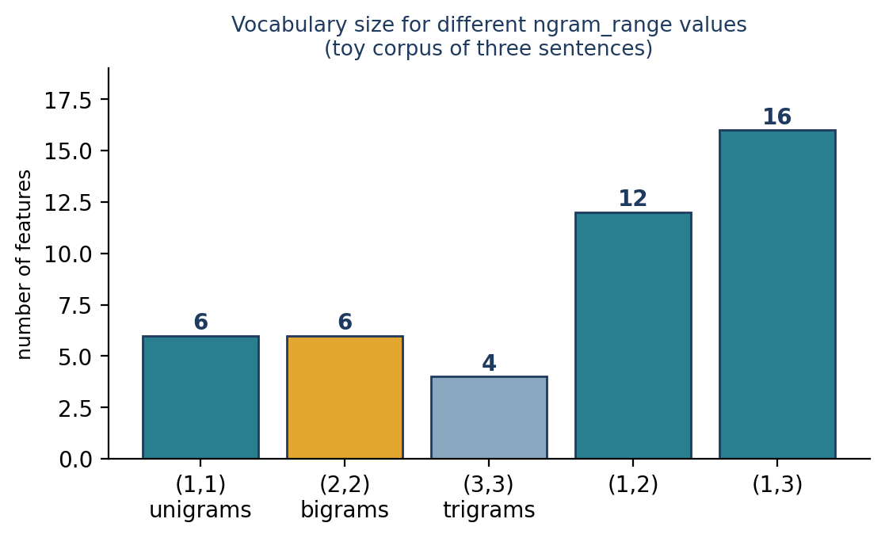
Figure 17.2 Allowing longer n-grams enlarges the vocabulary.
For many basic classification tasks, (1, 2) is a useful starting point; the best setting depends on the dataset and the task.

17.5 Why N-grams Help: A Negation Example
Unigram features cannot represent “not good” as different from “good”. N-grams can. Here is a deliberately tiny sentiment dataset (1 = positive, 0 = negative):
from sklearn.naive_bayes import MultinomialNB
from sklearn.pipeline import Pipeline

reviews = ["not good at all", "very good product", "not bad at all",
"very bad product", "good value", "bad quality"]
sentiment = [0, 1, 1, 0, 1, 0]

for rng in [(1, 1), (1, 2)]:
model = Pipeline([("vec", CountVectorizer(ngram_range=rng)),
("nb", MultinomialNB())]).fit(reviews, sentiment)
print(rng, model.predict(["not good", "not bad"]).tolist())

Output
(1, 1) [1, 0]
(1, 2) [0, 1]

With unigrams only, the model predicts the reverse of the truth: it sees “good” and says positive for “not good”, and sees “bad” and says negative for “not bad”. With bigrams, the features “not good” and “not bad” exist in the training data, and the predictions become correct (negative for “not good”, positive for “not bad”).
A caution about toy results
This dataset has six examples, so the outcome shows how the representation can help in principle. It is not evidence about how well either model performs in practice. Real conclusions need real data and held-out test sets.

17.6 Advantages of Bag of N-grams
- Captures local word order. Bigrams and trigrams represent short sequences.
- Captures useful phrases. “not good”, “credit card” and “machine learning” can become single features.
- Improves some classification tasks. Phrase-level features can help distinguish sentiment, topics and categories.
- Simple to implement. scikit-learn supports it through CountVectorizer.
- Works with traditional models such as Naive Bayes and logistic regression.

17.7 Limitations of Bag of N-grams
- Vocabulary explosion. As n grows, the number of possible sequences grows rapidly (Figure 17.2). On the three-sentence corpus of Section 17.4 the vocabulary doubles from 6 to 12 features when bigrams are added; on large corpora the growth is far bigger in absolute terms.
- Sparsity. Most documents contain only a tiny fraction of all possible n-grams, so vectors are mostly zeros. scikit-learn keeps them sparse.
- Limited context. An n-gram captures a fixed-length window. A bigram model cannot connect words that are far apart.
- Rare long n-grams. Longer n-grams may occur only once, so the model cannot learn reliable patterns from them.
- No deep semantics. “happy” and “joyful” are unrelated features.

17.8 Preprocessing for N-gram Models
Preprocessing can help, but its choice should depend on the task:
Technique | Effect on n-grams | Caution
Lower-casing | Merges “Machine learning” and “machine learning” | Loses capitalisation clues (Section 6.3)
Stop-word removal | Shrinks the vocabulary | Can destroy meaningful n-grams: removing “not” from “not good” leaves “good”
Lemmatization | Merges “running”, “runs” into “run” | Changes which phrases are extracted
Punctuation handling | Removes symbols that carry no information | Punctuation can carry sentiment
Table 17.4 Preprocessing and n-grams.
Compare preprocessing choices experimentally; more cleaning is not always better.

17.9 Application: News Classification
Bag of N-grams can classify news articles into categories such as sports, politics, business and technology. The workflow is: load the data and labels; inspect the class distribution and clean the text appropriately; split into training and test sets; fit the vectorizer on training text; train a classifier such as Multinomial Naive Bayes; and evaluate on the test set. A minimal pipeline:
news = ["The team won the football match",
"The government announced a new policy",
"The player scored a goal",
"The parliament discussed the policy"]
labels = ["sports", "politics", "sports", "politics"]

model = Pipeline([
("vectorizer", CountVectorizer(ngram_range=(1, 2))),
("classifier", MultinomialNB()),
]).fit(news, labels)

print(len(model.named_steps["vectorizer"].vocabulary_))
print(model.predict(["The striker scored in the match",
"The minister announced a policy"]).tolist())

Output
30
['sports', 'politics']

The pipeline learns 30 unigram and bigram features from just four sentences and uses them to predict the category of new articles. This tiny dataset only demonstrates the workflow; it cannot show real accuracy. Chapter 23 builds a news classifier on a realistic scale.
What about class imbalance?
If one category has far more examples than another, a model may favour the majority class. Possible remedies: collect more examples of the minority class; use class weights where the model supports them; resample the training data only; and judge the model with precision, recall, F1 and a confusion matrix rather than accuracy alone (Chapter 22). Always split the data before resampling, and never resample the test set.

17.10 Bag of Words, Bag of N-grams and TF-IDF
Feature | Bag of Words | Bag of N-grams | TF-IDF
Main representation | Individual-word counts | Counts of word sequences | Importance weights for words or n-grams
Local word order | No | Yes, for n > 1 | Only if combined with n-grams
Typical form | Sparse | Sparse | Sparse
Semantic understanding | None | None | None
Typical use | Basic text classification | Phrase-sensitive classification | Down-weighting terms common across documents
Table 17.5 Count-based representations compared.
TF-IDF is a weighting method, not a replacement for choosing unigrams or n-grams. TfidfVectorizer(ngram_range=(1, 2)) produces TF-IDF weights for unigrams and bigrams together (Chapter 18).

17.11 Common Mistakes
- Choosing a large `ngram_range` by default. Vocabulary and memory grow quickly; start with (1, 2).
- Removing stop words before building n-grams when negations matter.
- Fitting on test data (Section 16.6).
- Forgetting that n-grams cross sentence boundaries when text has several sentences; split sentences first if this matters.
- Trusting results from tiny datasets (Section 17.5).
- Counting n-grams of unnormalised text, so “Machine learning” and “machine learning” are separate features.

17.12 Chapter Summary
- An n-gram is a contiguous sequence of n tokens; a sentence of L tokens has L − n + 1 of them.
- Bag of N-grams counts n-grams and so retains local word order; Bag of Words is the case n = 1.
- CountVectorizer(ngram_range=(1, 2)) builds unigram-plus-bigram features and often improves phrase-sensitive tasks such as sentiment.
- Longer n-grams enlarge the vocabulary, increase sparsity and become rare, and none of this adds semantic understanding.
- Preprocessing, especially stop-word removal, can destroy n-grams; compare choices experimentally.

17.13 Review Questions and Exercises
- How many bigrams and trigrams does a ten-word sentence contain?
- Why can bigrams distinguish “dog bites man” from “man bites dog” but unigrams cannot?
- What is vocabulary explosion, and what practical steps limit it?
- Why can removing stop words damage the features of a sentiment model?
- Exercise. Using CountVectorizer, compute the vocabulary size for ngram_range values (1, 1), (1, 2) and (1, 3) on twenty sentences of your choice. Plot or tabulate how the vocabulary grows.
- Exercise. Extend the sentiment dataset of Section 17.5 to twenty reviews that you write, including negations. Compare unigram and bigram models on a held-out set of five reviews.

Editorial note — remove before publication
From your notes: all 11 sections of “Bag of N-grams in NLP” — definition, types of n-gram, relationship to Bag of Words (the dog/man example), how it works, CountVectorizer (bigrams and unigrams plus bigrams), the ngram_range table, advantages, limitations, preprocessing, news classification with a Pipeline, class imbalance and the BoW/N-grams/TF-IDF comparison.
Changed: the notes’ outputs were not shown, so real output is given (scikit-learn 1.8.0), including the vocabulary sizes in Table 17.3. The notes’ news pipeline code was truncated in the source file, so it was rewritten as a complete, runnable example; its output is real.
Added: the plain-Python n-gram function, the bigram demonstration of the dog/man example, the negation experiment (unigrams give the reversed answer on this toy data), Figures 17.1 and 17.2, the preprocessing table, common mistakes and exercises. The notes’ statement that “(1, 2) is a useful starting point” is kept, with the caveat that the best setting depends on the data.

Chapter 18 TF-IDF
Learning objectives
After studying this chapter you will be able to:
• explain term frequency (TF), inverse document frequency (IDF) and why they are combined;
• compute TF-IDF by hand for a small corpus;
• reproduce scikit-learn’s TfidfVectorizer output and explain why it differs from the textbook formula;
• use TF-IDF for classification, term ranking and document search with cosine similarity;
• state the limitations of TF-IDF.

18.1 What Is TF-IDF?
TF-IDF stands for Term Frequency–Inverse Document Frequency. It converts text into numerical vectors by estimating how important a word is to one document compared with an entire collection of documents. The main idea:
- A word is important to a document if it appears relatively often in that document.
- A word is less informative if it appears in almost every document in the collection.
In a collection of technology news, words such as “market” and “company” occur in many articles. A word such as “iPhone” is more useful for identifying a particular article. TF-IDF lowers the relative weight of widely distributed terms and raises the weight of terms distinctive to particular documents.

18.2 Why Do We Need TF-IDF?
Bag of Words (Chapter 16) counts words. If common words occur throughout a corpus, raw counts give them substantial weight even though they do not help to tell documents apart. TF-IDF addresses this by considering both the frequency of a word in a document and how widely it appears across the corpus.
Key difference
Bag of Words measures word counts. TF-IDF adjusts those counts according to how the words are distributed across documents.

18.3 The Two Components of TF-IDF
A. Term frequency (TF)
Term frequency measures how often a term appears in a particular document. A common formula divides the count of the term by the total number of tokens in the document:
TF(t, d) = f(t, d) / N(d)

Here t is the term, d the document, f(t, d) the number of times t occurs in d, and N(d) the total number of tokens in d. For the document “apple banana apple orange” there are four tokens. “apple” occurs twice, so TF(apple) = 2/4 = 0.5, and “banana” occurs once, so TF(banana) = 1/4 = 0.25. Some implementations use raw counts or other TF variants instead.
B. Inverse document frequency (IDF)
Inverse document frequency measures how informative a term is across the collection. A simple formula is:
IDF(t) = ln( N / df(t) )

Here N is the total number of documents and df(t) is the number of documents that contain t. A term in many documents gets a low IDF; a term in few documents gets a high IDF. If a corpus has 100 documents and “market” occurs in 80 of them, IDF = ln(100/80) ≈ 0.223. If “gigafactory” occurs in only 5, IDF = ln(100/5) ≈ 2.996.
import math

print(round(math.log(100 / 80), 3), round(math.log(100 / 5), 3))

Output
0.223 2.996

C. The TF-IDF score
The basic score is the product of the two components:
TF-IDF(t, d) = TF(t, d) × IDF(t)

A word scores high when it appears relatively often in one document but in comparatively few documents overall.

18.4 Why the Logarithm?
The logarithm compresses the range of IDF values so that the weighting is not extreme. With natural logarithms, ln(10) ≈ 2.303 and ln(100) ≈ 4.605: a term ten times rarer than another gets an IDF only about 2.3 higher, not ten times higher. The logarithm applies to the document-frequency ratio in the IDF formula; it does not compare how many times a word occurs within a single document.

18.5 A Worked Example
Consider three documents: D1 = “cat dog cat”, D2 = “cat dog” and D3 = “dog bird”. We use the normalised TF formula and the basic IDF with natural logarithms. N = 3.
Step 1: term frequencies
Term | D1 TF | D2 TF | D3 TF
cat | 2/3 | 1/2 | 0
dog | 1/3 | 1/2 | 1/2
bird | 0 | 0 | 1/2
Table 18.1 Term frequencies.
Step 2: inverse document frequencies
Term | df | Calculation | IDF
cat | 2 (D1, D2) | ln(3/2) | 0.405
dog | 3 (all) | ln(3/3) | 0
bird | 1 (D3) | ln(3/1) | 1.099
Table 18.2 Inverse document frequencies.
Step 3: TF-IDF
For D1: TF-IDF(cat) = 2/3 × 0.405 ≈ 0.270; TF-IDF(dog) = 1/3 × 0 = 0; TF-IDF(bird) = 0 × 1.099 = 0. So the D1 vector is approximately [0.270, 0, 0] over the terms (cat, dog, bird). A word found in every document gets an IDF of zero under the basic formula, so it carries no weight at all.
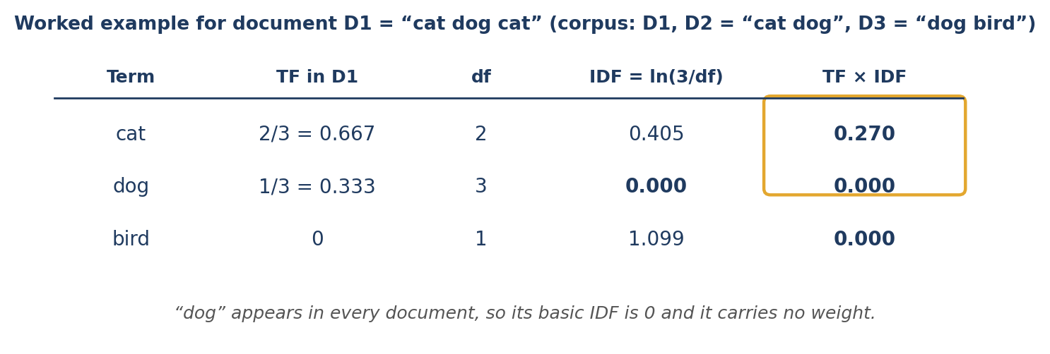
Figure 18.1 The worked example for document D1.
import math

docs = ["cat dog cat", "cat dog", "dog bird"]
terms = ["cat", "dog", "bird"]
N = len(docs)

idf = {t: math.log(N / sum(t in d.split() for d in docs)) for t in terms}
print({t: round(v, 3) for t, v in idf.items()})

for i, d in enumerate(docs, start=1):
words = d.split()
tfidf = {t: round(words.count(t) / len(words) * idf[t], 3) for t in terms}
print(f"D{i}", tfidf)

Output
{'cat': 0.405, 'dog': 0.0, 'bird': 1.099}
D1 {'cat': 0.27, 'dog': 0.0, 'bird': 0.0}
D2 {'cat': 0.203, 'dog': 0.0, 'bird': 0.0}
D3 {'cat': 0.0, 'dog': 0.0, 'bird': 0.549}

18.6 TF-IDF with scikit-learn
TfidfVectorizer learns the vocabulary, computes TF-IDF weights and returns a sparse matrix. Take three short technology documents:
from sklearn.feature_extraction.text import TfidfVectorizer

documents = [
"Tesla builds an electric car factory",
"Apple launches a new iPhone",
"Tesla develops battery technology",
]

vectorizer = TfidfVectorizer()
X = vectorizer.fit_transform(documents)

print(vectorizer.get_feature_names_out())
print(X.toarray().round(3))

Output
['an' 'apple' 'battery' 'builds' 'car' 'develops' 'electric' 'factory'
'iphone' 'launches' 'new' 'technology' 'tesla']
[[0.423 0. 0. 0.423 0.423 0. 0.423 0.423 0. 0. 0. 0.
0.322]
[0. 0.5 0. 0. 0. 0. 0. 0. 0.5 0.5 0.5 0.
0. ]
[0. 0. 0.529 0. 0. 0.529 0. 0. 0. 0. 0. 0.529
0.402]]

Each row is a document and each column a vocabulary term. The values are TF-IDF weights, not counts. Compare the first document with its Bag-of-Words vector, in which every word counted once. The weights are now unequal: “tesla” (0.322) is lower than the other words (0.423) because it also appears in the third document, whereas the other words are unique to the first document (Figure 18.2).
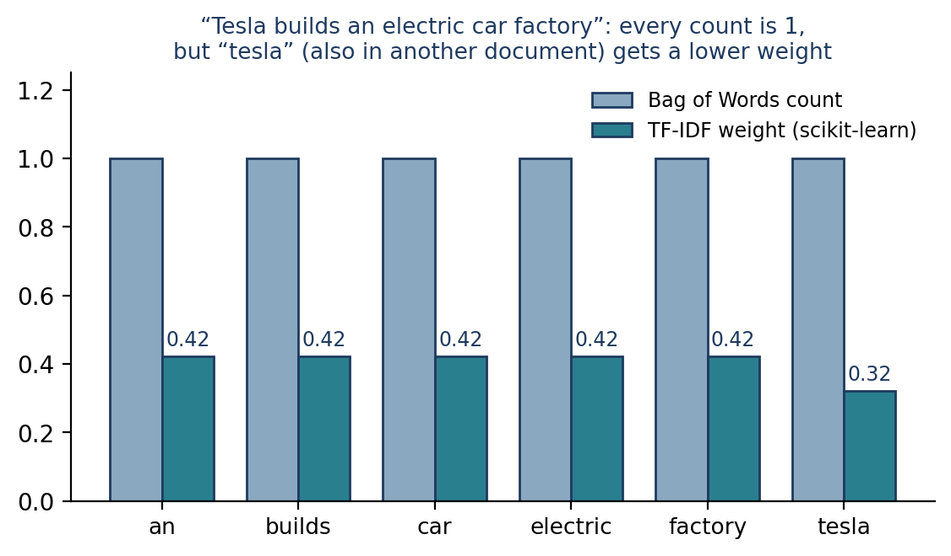
Figure 18.2 Bag-of-Words counts are all 1; TF-IDF down-weights the term shared with another document.
Why scikit-learn’s numbers differ from the textbook formula
Run the same vectorizer on the cat/dog/bird corpus of Section 18.5 and the values differ from our hand calculation:
v = TfidfVectorizer()
M = v.fit_transform(["cat dog cat", "cat dog", "dog bird"])

print(v.get_feature_names_out())
print(v.idf_.round(3))
print(M.toarray().round(3))

Output
['bird' 'cat' 'dog']
[1.693 1.288 1. ]
[[0. 0.932 0.362]
[0. 0.79 0.613]
[0.861 0. 0.509]]

Two differences explain this. First, scikit-learn uses smoothed IDF by default, idf(t) = ln((1 + N) / (1 + df(t))) + 1. For “dog”, which is in all three documents, this gives ln(4/4) + 1 = 1, not 0, so a term found in every document still has some weight. For “bird” it gives ln(4/2) + 1 = 1.693. Second, each row is L2-normalised to length 1, which makes documents of different lengths comparable and makes cosine similarity equivalent to a dot product. Also, scikit-learn multiplies the raw count by IDF rather than dividing by document length, and normalisation then removes the length effect.
We can verify this by reproducing the third row of the technology matrix by hand:
import numpy as np

names = vectorizer.get_feature_names_out()
n_docs = len(documents)
doc3 = documents[2].lower().split()

vec = []
for w in names:
df = sum(w in d.lower().split() for d in documents)
idf = math.log((1 + n_docs) / (1 + df)) + 1
vec.append(doc3.count(w) * idf)

vec = np.array(vec)
vec = vec / np.linalg.norm(vec)

print(vec.round(3))
print(np.allclose(vec, X.toarray()[2]))

Output
[0. 0. 0.529 0. 0. 0.529 0. 0. 0. 0. 0. 0.529
0.402]
True

The hand computation (smoothed IDF, then L2 normalisation) matches scikit-learn exactly. Parameters smooth_idf=False, norm=None and sublinear_tf=True change these defaults, which is useful when you want to reproduce a textbook formula.

18.7 Using TF-IDF
Finding the most characteristic terms of a document
def top_terms(i, k=3):
row = X[i].toarray()[0]
names = vectorizer.get_feature_names_out()
return [(names[j], round(float(row[j]), 3)) for j in row.argsort()[::-1][:k]]

print(top_terms(2))

Output
[('technology', 0.529), ('battery', 0.529), ('develops', 0.529)]

The words that are unique to document 3 receive the highest weights. (Ties are broken arbitrarily, so the order of equal weights can differ.) Ranking terms this way supports keyword extraction and summarisation.
Searching documents with cosine similarity
A query can be vectorised with the same vectorizer, and the documents ranked by cosine similarity (Section 14.6):
from sklearn.metrics.pairwise import cosine_similarity

query = vectorizer.transform(["tesla battery"])
print(cosine_similarity(query, X).round(3))

Output
[[0.195 0. 0.664]]

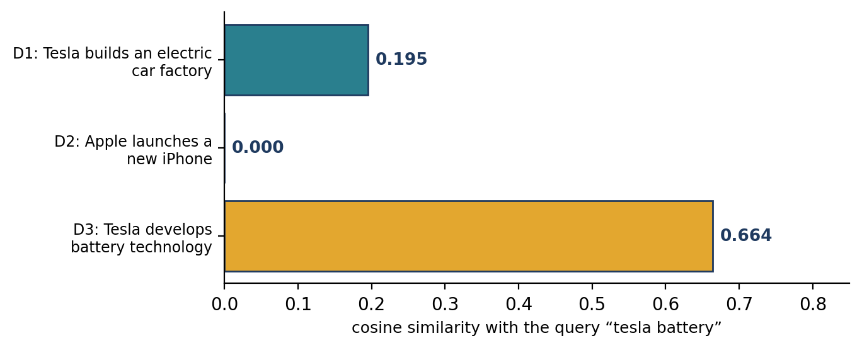
Figure 18.3 Ranking documents against the query “tesla battery”.
Document 3 (“Tesla develops battery technology”) matches both query words and ranks first with 0.664; document 1 matches only “tesla” and scores 0.195; document 2 shares nothing and scores 0. This is the essence of a simple search engine: vectorize, compare, rank.
Text classification
TF-IDF is widely used for news categorisation, spam detection, sentiment analysis, product categorisation and document classification. An e-commerce site might classify product descriptions as electronics or clothing:
from sklearn.naive_bayes import MultinomialNB
from sklearn.pipeline import Pipeline

products = [
"smartphone with high resolution camera", "laptop with powerful processor",
"cotton shirt for daily wear", "comfortable cotton trousers",
"mobile phone with excellent battery", "lightweight laptop for students",
"silk saree with golden border", "wireless headphones with long battery life",
"denim jeans for casual wear", "tablet with bright display and fast processor",
"woollen sweater for winter", "formal shirt in blue cotton",
]
labels = ["electronics", "electronics", "clothing", "clothing",
"electronics", "electronics", "clothing", "electronics",
"clothing", "electronics", "clothing", "clothing"]

model = Pipeline([("tfidf", TfidfVectorizer()), ("nb", MultinomialNB())])
model.fit(products, labels)

new = ["gaming laptop with fast processor", "cotton shirt for summer", "phone with big battery"]
print(model.predict(new).tolist())
print(model.classes_.tolist(), model.predict_proba(new).round(3).tolist())

Output
['electronics', 'clothing', 'electronics']
['clothing', 'electronics'] [[0.257, 0.743], [0.749, 0.251], [0.298, 0.702]]

The pipeline has two stages: TfidfVectorizer converts descriptions to TF-IDF features and MultinomialNB predicts a category. Probabilities are listed in the order of model.classes_ (clothing, then electronics). This is a small demonstration of the workflow, not a measure of expected accuracy. Adding bigrams (TfidfVectorizer(ngram_range=(1, 2))) grows the vocabulary from 43 to 89 features on this data.
Comparing classifiers
Algorithm | How it works | Consideration with TF-IDF
K-nearest neighbours | Classifies by the nearest training examples | Often benefits from a suitable distance such as cosine
Multinomial Naive Bayes | Estimates class probabilities from feature statistics | A common baseline; works with non-negative TF-IDF values
Random forest | Combines many decision trees | Can work, but very high-dimensional sparse text can make it slower than linear models
Logistic regression, linear SVM | Learn a linear boundary | Strong, fast baselines for high-dimensional text
Table 18.3 Classifiers commonly paired with TF-IDF.
No classifier is universally best: a random forest may win on one e-commerce dataset and lose on another. Compare several on a held-out test set using precision, recall, F1 and accuracy. Chapter 23 does this on a realistic dataset.

18.8 Preprocessing: Stop Words and Lemmatization
Preprocessing changes the TF-IDF features. Stop-word removal can shrink the vocabulary, but removing words such as “not” can change sentiment; note that TF-IDF already gives very common words low weights, so removal is often unnecessary. Lemmatization merges forms such as running → run and cars → car into fewer features, but it does not always improve accuracy. Compare approaches on validation data rather than assuming that every cleaning step helps.

18.9 Limitations of TF-IDF
- No semantic understanding. “car” and “automobile” are unrelated features.
- Sparse, high-dimensional vectors. A large vocabulary gives vectors of thousands of mostly-zero entries; scikit-learn stores them sparsely.
- Limited context. Standard TF-IDF ignores word order and long-distance relations. It may struggle to separate “good” from “not good” unless n-grams are added.
- Corpus-dependent scores. IDF values depend on the documents used to fit the vectorizer; if the corpus changes significantly, so do the weights.
- No understanding of meaning or intent. TF-IDF is based on statistical frequency, not on a language model, so it cannot resolve ambiguous language.

18.10 Bag of Words, TF-IDF and Embeddings
Table 16.3 compared Bag of Words, TF-IDF and word embeddings. In short: TF-IDF improves on raw counts when you want to reduce the influence of terms common across a corpus, but it is not a full semantic representation like the embeddings of Part VI.

18.11 Common Mistakes
- Fitting `TfidfVectorizer` on the whole dataset before splitting; the IDF values then leak information from the test set. Fit on training data only.
- Comparing hand-calculated values with scikit-learn’s without allowing for smoothing and normalisation (Section 18.6).
- Calling `fit_transform` on a query. Use transform so that the query uses the corpus vocabulary and IDF.
- Assuming TF-IDF captures meaning.
- Using TF-IDF values as probabilities. They are weights.
- Refitting the vectorizer after the corpus changes without refitting the model that depends on it.

18.12 Chapter Summary
- TF-IDF weights a term by its frequency in a document (TF) times its rarity across the collection (IDF).
- The basic IDF is ln(N/df); scikit-learn uses a smoothed IDF and L2 normalisation, so its numbers differ from the textbook values but can be reproduced exactly.
- TF-IDF vectors support classification, keyword extraction and search by cosine similarity.
- TF-IDF is sparse, ignores order and meaning, and depends on the corpus used to fit it.

18.13 Review Questions and Exercises
- Why does a term that appears in every document get a basic IDF of zero?
- For a corpus of 50 documents, a term appears in 5 of them. Compute its basic IDF with natural logarithms.
- List two differences between the basic TF-IDF formula and scikit-learn’s default.
- Why should a search query be vectorized with transform rather than fit_transform?
- Exercise. Use TfidfVectorizer on ten paragraphs of text from different topics. Print the top five terms of each paragraph. Do they describe the topic?
- Exercise. Build a search function that takes a query and returns the three most similar documents from a corpus of twenty short texts, using TF-IDF and cosine similarity. Test it with queries that use words not in the corpus.
- Exercise. Compare Bag of Words and TF-IDF with Multinomial Naive Bayes on the spam dataset of Chapter 16 using five-fold cross-validation (cross_val_score). Which performs better, and by how much?

Editorial note — remove before publication
From your notes: all 11 sections of “TF-IDF in NLP” — definition, why it is needed, TF, IDF, TF-IDF score, why the logarithm, the cat/dog/bird worked example, TfidfVectorizer, text classification with Naive Bayes, comparison of KNN, Naive Bayes and Random Forest, preprocessing, limitations and the comparison with BoW and embeddings.
Changed: the notes’ worked example is retained and verified (D1 = [0.270, 0, 0]); a plain-Python version reproduces D1 to D3. Your notes’ remark that scikit-learn differs because of smoothing and normalisation is now demonstrated and proved by reproducing a row exactly. The notes’ product-classification code was truncated in the source file, so a twelve-product dataset was written; outputs are real (scikit-learn 1.8.0).
Added: the by-hand reproduction of scikit-learn’s output, term ranking, document search with cosine similarity, the bigram vocabulary comparison, Figures 18.1 to 18.3, common mistakes and exercises. The repeated BoW/TF-IDF/embeddings table of your notes is replaced by a pointer to Table 16.3. The notes’ classifier comparison is kept as Table 18.3 without performance claims.

