Download from blackboard the \tp_images_fonts.zip. You should find inside 2 folders containing the fonts and the images used in this webpage.

The goal of this exercise is to reproduce the image given later in this document. I give you the HTML and you should write all the needed CSS.

First create a html file containing the following.

**HTML :**

<!DOCTYPE html>

<html>

<head>

<meta charset="utf-8" />

<link rel="stylesheet" href="style.css" />

<title>Zozor - Travel diaries</title>

</head>

<body>

<div id="main_wrapper">

<header>

<div id="main_title">

<img src="images/zozor_logo.png" alt="Logo de Zozor" id="logo" />

<h1>Zozor</h1>

<h2>Travel diariese</h2>

</div>

<nav>

<ul>

<li><a href="#">Home</a></li>

<li><a href="#">Blog</a></li>

<li><a href="#">Resume</a></li>

<li><a href="#">Contact</a></li>

</ul>

</nav>

</header>

<div id="banner_image">

<div id="banner_description">

Reflections on my holiday in the United States...

<a href="#" class="red_button">See article <img src="images/small_arrow.png" alt="" /></a>

</div>

</div>

<section>

<article>

<h1><img src="images/pin.png" alt="Travel category" class="ico_categorie" />I'm a great traveller</h1>

<p>Lorem ipsum dolor sit amet...</p>

<p>Vivamus sed libero nec mauris pulvinar facilisis ut non sem...</p>

<p>Phasellus ligula massa, congue ac vulputate non, dignissim at augue...</p>

</article>

<aside>

<h1>About the author</h1>

<img src="images/arrow.png.png" alt="" id="arrow" />

<p id="zozor_picture"><img src="images/images/zozor.png" alt="Zozor Picture" /></p>

<p>Let me introduce myself: My name's Zozor. I was born on 23 November 2005.</p>

<p>A bit meager, is it not? This is why I've now decided to write my biography to let my readers know who I really am.</p>

<p><img src="images/facebook.png" alt="Facebook" /><img src="images/twitter.png" alt="Twitter" /><img src="images/vimeo.png" alt="Vimeo" /><img src="images/flickr.png" alt="Flickr" /><img src="images/rss.png" alt="RSS" /></p>

</aside>

</section>

<footer>

<div id="tweet">

<h1>My last tweet</h1>

<p>Hee-haw!</p>

<p>12/05 23:12</p>

</div>

<div id="my_pictures">

<h1>My pictures</h1>

<p><img src="images/pic1.jpg" alt="Picture" /><img src="images/pic2.jpg" alt="Picture" /><img src="images/pic3.jpg" alt="Picture" /><img src="images/pic4.jpg" alt="Picture" /></p>

</div>

<div id="my_friends">

<h1>My friends</h1>

<ul>

<li><a href="#">Pupi the rabbit</a></li>

<li><a href="#">Mr Baobab</a></li>

<li><a href="#">Kaiwaii</a></li>

<li><a href="#">Perceval.eu</a></li>

</ul>

<ul>

<li><a href="#">Ji</a></li>

<li><a href="#">Super cucumber</a></li>

<li><a href="#">Prince</a></li>

<li><a href="#">Mr Fan</a></li>

</ul>

</div>

</footer>

</div>

</body>

</html>

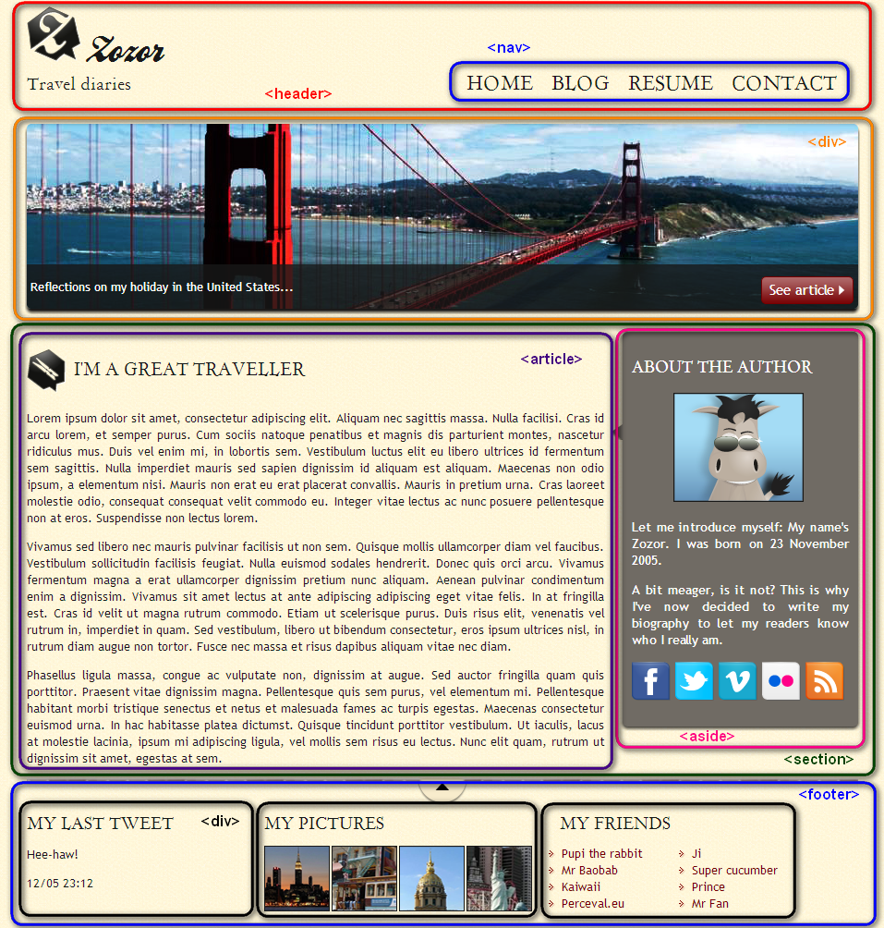

**CSS : Now create a css file and name it style.css**

To format the design, I'm going to proceed in several steps. I'm going to deal with the following items, in the order indicated:

1. Custom fonts.
2. Define the page's main styles (website width, background color, default text color).
3. Header and browsing links.
4. Banner (representing the San Francisco bridge).
5. Main section of the page's body, in the center.
6. Footer.

#### Custom fonts

For the purposes of the design, my graphic designer used three fonts on his mockup:

* Trebuchet MS(normal font);
* BallparkWeiner(exotic font);
* Day Roman(exotic font).

Most computers are provided withTrebuchet MS. The other two can be downloaded from special sites like <https://www.dafont.com/>

Here they are already given in the fonts folder.

In order to add a new font in CSS, you should use the @font-face property. Here is an example how to declare a new font in the CSS section of your page. Multiple src are used in order to support as many browsers as possible.

/* Define custom fonts */

@font-face

{

font-family: 'BallparkWeiner';

src: url('fonts/ballpark.eot');

src: url('fonts/ballpark.eot?#iefix') format('embedded-opentype'),

url('fonts/ballpark.woff') format('woff'),

url('fonts/ballpark.ttf') format('truetype'),

url('fonts/ballpark.svg#BallparkWeiner') format('svg');

font-weight: normal;

font-style: normal;

}

1. **Now try to do the same for the Day Roman font.**
2. **Define the background image of the page to be yellow_background.png that you have in the images folder. The font-family is ‘Trebuchet MS’, Arial, sans-serif. The color is #181818.**
3. **We want the content of the page to cover all the page and to be centered.**
4. **The titles in the section and the footer and the navigation are written in Day Rom and in uppercase and the font weight is normal.**

**Now for the Header.**

1. **Start by adding the line at the bottom of the header. You have an image line.png in the photos folder.**
2. **For the zozor title, its font family is BallParkWeiner and font size is 2.5 em and the font weight to normal.**
3. **Make the zozor title and the image Z be next to each other :**
4. **Make the travel diariese title be styled with the font Dayrom. Size to 1.1em. weight to normal.**

**NAVIGATION**

1. **Make the navigation links sit next to the zozor and put them to the right.**
2. **Remove the circle dots in the unordered list .**
3. **Make the list items of the unordered list sit next to each others.**
4. **Remove the underline of the links. Make the font size to 1.3em and the color to #181818;**
5. **Add on hover over the links and change their colors to #760001 and add a bottom border with 3px solid and color #760001.**

**BANNER IMAGE OF THE BRIDGE**

1. **Add a background image sanfrancisco.jpg. Make it have round corners. Do the necessary change of dimensions and spacing.**

**Description :**

1. **Add the description. The description should have a background-color rgb(24,24,24,0.8). The font size is 0.8em Do the necessary styling.**
2. **Red button :**

Add a background image to red_background.png. Make it at the right bottom of the image. Add the necessary spacing and styling. Font size is 1.2em and border is 1px solid #760001;

**BODY :**

1. **Do the necessary styling to section which contains the article and the aside. Attention the article and aside should share the width of the page. For example if the width of the main block is 900, the width of the article should be around 650 and the width of the aside should be around 250. Don’t forget the padding and the margins in case they existed.**

**Do a background color for the aside of #706b64;**

**The paragraph inside of the article font size is 0.8em.**

1. **Make the cat icon vertically aligned in the middle**
2. **Style the aside. Circle borders, background color to #**706b64… Shadow color to #1c1a19.
3. **Make arrow image appear as shown in the image of the aside.**
4. **Style the zozor image in the aside and do the spacing between the images.**

**FOOT** :

1. The background images to use top.png and line.png. top. The font size of the paragraph and the unorder list is 0.8em. The font size of the title is 1.1em.
2. **Style the tweet, my pictures and myfriends to be next to each other. Control their widths to take as much as shown in the picture.**
3. **The Two unordered list inside of my friends should also be next to each other. In order to give a customized image for the bullets of the list my friends use this property:**

**list-style-image: url('images/external_link.png');**