**Homework #4 (30 points)**

*You must not use the default package to create java classes for your Web project. Moreover, you must name your package using your Texas State net ID (such as edu.txstate.bc99, where bc99 is a student’s Texas State net ID). Failing to follow this requirement will cause a 10-point deduction.*

Case Project: Registration

Application title: Online Course Registration

Purpose: An online learning site (Web application) provides a page for students (users) to select/register for a single course from a list of courses. The website can remember the selected course when it is not yet registered by the students. The application uses a database (cis4318_students) available in the server: **sql.mccoy.txstate.edu**.

Algorithm: 1. An opening JSP page displays a login form, which is used to send a request to **the login servlet** to verify the user input (id & password). **Note that the users’ data are available in the database.** For a user logging into the site, *a* ***User bean*** *is created and used to secure the Web application* and the servlet processes the request as follows.

* The second page is displayed if the student has not yet selected their course or the selected course has been submitted (registered).
* Otherwise, the third page is displayed, and **the selected course is included in the page**.

**Note that, the courses’ data are available in the database.**

2. The second JSP page displays the list of courses available for students.

a. This page displays the course number (int), name, cost per day (double) of each course.

b. This page provides a Select button (Link) for each course. The students click the button to select the course. Moreover, **the site remembers the selection**.

3. The third JSP page displays the **selected course**. Note that only one course can be selected. It also provides an input field: duration and two buttons: Back and Submit.

a. The duration is an integer, which means # of days available to the students.

b. The Back button is clicked to go to the second page. The students can replace the selected course.

c. The Register button is clicked for the students to submit (register) the selected course with its duration. The registration data **that include the current date (registration date) and duration** must be saved in the database. After this submission, the fourth page is returned with a confirmation message.

4. The fourth page displays the confirmation information, including the course number, name, cost per day, duration, and the total payment (cost per day × duration). This page has a link to go the second page.

5. You must use the MVC pattern to develop this web application. Your app must have three bean classes.

* + The User bean that includes the id and password.
  + The Course bean that includes the course number, name, cost per day.
  + The Registration bean used to store its user id, course number, course name, registration date, and total payment.

Database: The database includes three tables: User, Courses, and Registration (see the figure below).

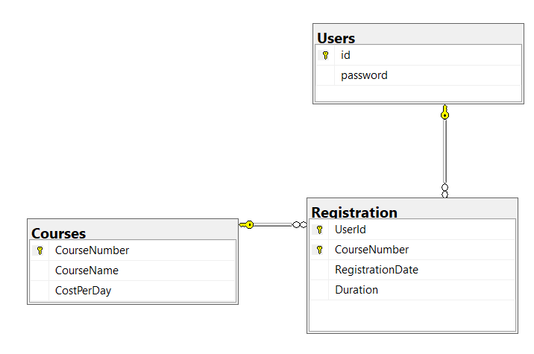

**Bonus (10 points):** In the second page, add a link **View All Registrations.** The link is clicked to request a servlet, which retrieves all the user’s registration data and open a JSP page to display the data (by course number, registration date, and duration).

**You must turn in your project as a zip file and turn it in using the Assignments tool (HW4) on CANVAS.**