Name : Engr. Muhammad Mohsin Zafar

Degree Program : Master’s in computer science

Department : DCIS

Session : 2018-2020

Roll No. : 504826

***“In the Name of ALLAH, The Rehman, The Raheem”***

**Answer: Q1**

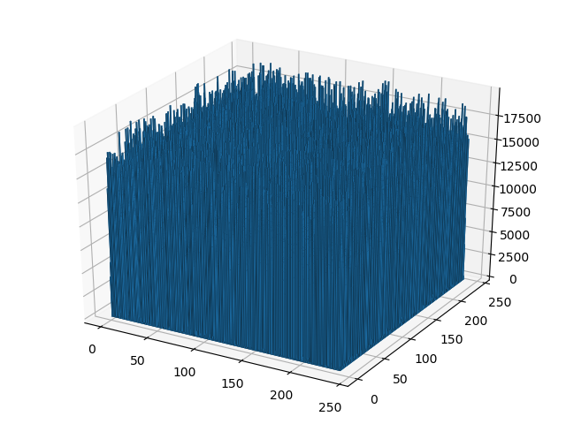

**Answer: Q3**

Closest of All ('Vatican', 'Rome', Distance = 2.720705550238529)

**Answer: Q4**

Farthest of All ('Taipei', ' Asunción', Distance = 19927.05728016978)

**Answer: Q5**

Isolated of All ('Wellington', Mean Distance = 13369.55295928008)

*Mean Distance was taken as a measure and capital was found for maximum mean value of distance

**Answer: Q6**

Close to Most Capitals ('Sarajevo', Mean Distance = 6390.720120527662)

*Mean Distance was taken as a measure and capital was found for minimum mean value of distance

**Answer: Q7**

Equidistant to Most Capitals ('Willemstad', Standard Deviation = 2616.79239786711)

*Standard Deviation for Distances was taken as a measure and capital was found for minimum Deviation value of distance