Manasa Awards Application
GDFRA (General Directorate of Residency and Foreign Affairs)
Department: Strategic Department
Prepared By: Syed Misbah Irfan
Date: August 27, 2021

- Introduction: Al Manasa application is developed on the request of GDFRA strategic department to automate awards among the employees of GDFRA, Using this application will allow GDFRA to create awards and its categories for employees to participate using this application.
- Purpose: Currently award process is manual with the help of Al Manasa application complete award cycle will be automated.
- Intended audience: Employees of GDFRA
- Objective: Automate Award competition among the employees of GDFRA (General Directorate of Residency and Foreign Affairs)
- Detail Scope: In this application there will be 6 different type of user and each user will have its own level of access to preform activity as defined
Type of users:
- Super Admin
- Admin
- Quality Section Manager
- Employee
- Assessor manager
- Assessor
- Jury

Super Admin
Super admin has important roles like create awards, for the award, allocation of the award to the sectors, announce winner and give user permission based on roles
Admin: admin has important roles like create category, Assign category to QSM and Sector, submit category for the award assign team and manage team.

Quality Section Manager
QSM will be responsible for assign awards to employees under his/her sectors
Employee
Employee is the participant of the award category
Assessor manager
Assessor manager will be responsible for distribute award entry for evaluation from participants (Employees) to assessor
Assessor
Assessor will be responsible for reviewing award entry, give marks and feedback
Jury
Jury has final authority to review and give approval for award winners and admin will finalized and published

User Types & Functionalities
Super Admin
- Login
- Create Awards
- Create Users
- Create Audit Team
- Create Department
- Allocate category to sectors
- Allocate Assessor Team For Evaluation
Quality Section Manager
- Login
- Participate in Awards
- Assign Awards to Employees
- Communication Between QSM and Employees on Award Assigned to Employee, entry acceptance
- Accept Award Entry From Employee

Employee
- Register
- Login
- Participate In Awards
- Communication between QSM and employee and scheduling between assessor and employee for marking
Assessor Manager
- Login
- Assign Award Entries for Evaluation to assessor.
Auditor
- Login
- Evaluate Award assigned by Audit Manager
Jury
- Login
- View Result
- View award Entries
- Approve, Reject & Announce Winners.

Functionalities & Modules

- Registration
- Login
- Create Award
- Create award Category
- Create Departments
- Create users
- Create Audit Teams
- Assign Award to Departments
- Assign Award To Employees
- Fill award Application
- Submit award application entry for evaluation
- Distribute Award application entry for evaluation
- Review Award Entry and give score
- Result
- Generate Report
- Approve winners
- Email Notification
- Profile
- Logout
Registration

All employee comes under HRMS will be automatically register and will be able to login using there LDAP authentication
- Name
- Image
- Email
- Position and Rank
- GRP ID
Above information will be available for the user to view and this information is coming from HRMS and LDAP
Login
LDAP authentication
Create Award
Create Award with following details
- Award name
- Award symbol (Picture)
- Opening dates and closing date
- Award details
- Award description
- Supporting documents
Create Award Category
Create award with following details
- Select award name
- Select award type from three (Individual , Group Individual , Corporate)
- Name
- Title
- Create criteria
- Create sub-criteria with maximum words and marks
- Add supporting documents

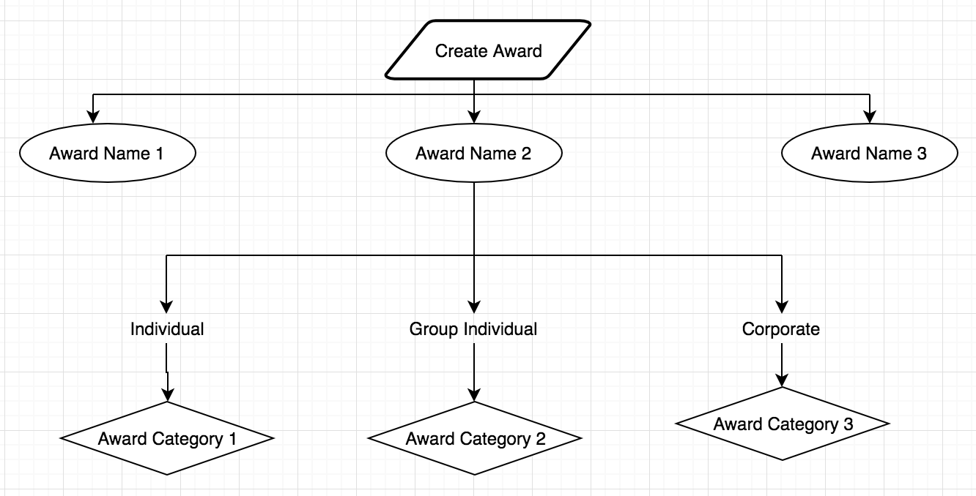

Create Team
Creation of team will be done by admin and will select users from Assessor and assessor manager.

- Sector assigning
Assign Award to Sector
After Creating Award Category Assign Award category to sectors
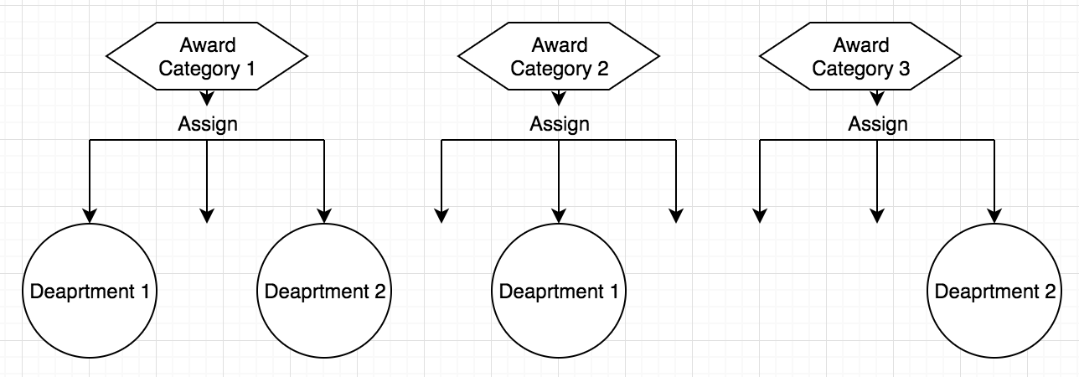

Assign To Employee
After Award assigned to (QSM) need to assign award to selected employees in his sector

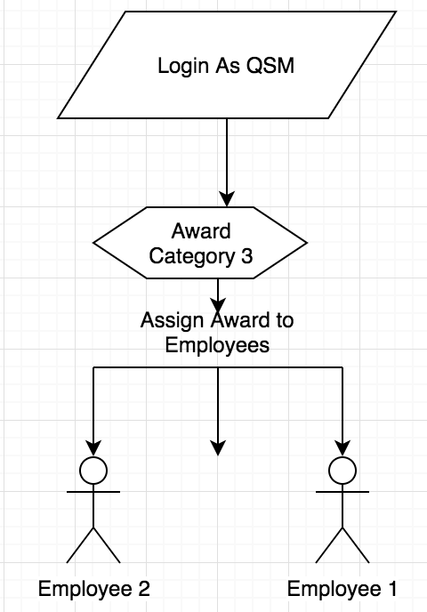

Fill Award Application
The award Application is done by participants, participants should fill text corresponding to each sub criteria with in maximum words limit.
Submit award application entry for evaluation
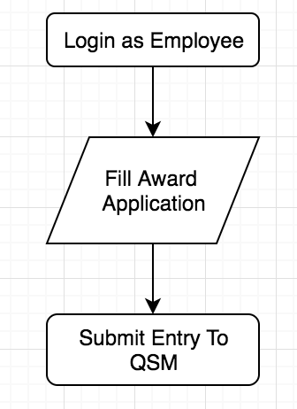
Participants will submit award application entry to The QSM, once QSM Accept Award Entry, award entry will goes to super admin to evaluation.

Distribute Award application entry for evaluation
Once Award Entry Filled by participants Received by super admin through QSM, This Entry should distribute among teams for Evaluation and assessor managers will assign his team members
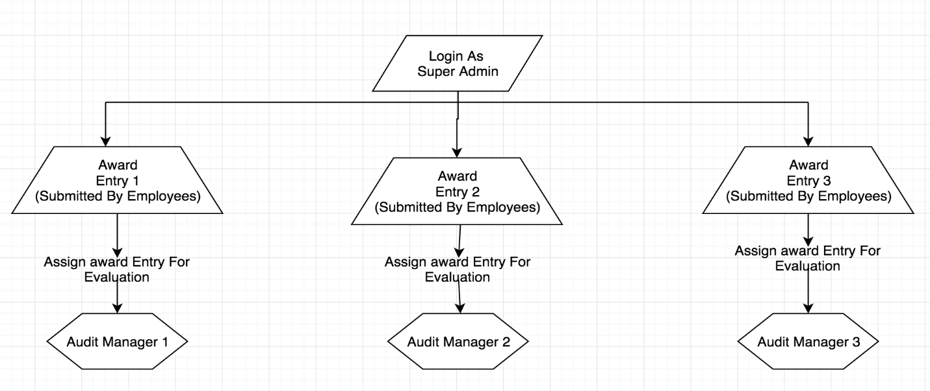
Assignment from Super Admin to Audit Manager

Assignment from Assessor Manager to assessor
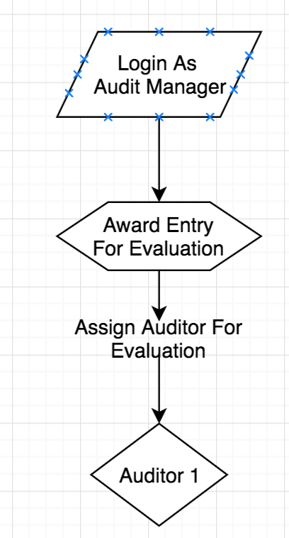

Review Award Entry and give score
Assessor will view Award Entries Submitted by Participants with each sub-criteria, auditor should enter comments & score under each sub-criteria entered by participants
Result
Super admin and jury will be able to view marks obtained by participants, list of participants should sorted by marks obtained.
Report
Corresponding to each there should report button which will generate detailed reports including participant’s details and award details, marks obtained etc.

Approve winners
This feature is exclusively for Jury and admin can view award entries submitted by participants, and jury’s and admin will finalized winner and announced
Email Notification
Email Notification should be sent to appropriate users related to the event in the application.

Technical Details:

Application Front End: Razor
Backend: C#
Database: SQL Server
Framework: Dot Net core 3.1 framework
Deliverables to DNRD:
Implementation and training of Manasa application
User based training will be provided
Supporting documents to manage application smoothly
Application Sources code
1 year support will be provided by Micro Aegis International Technologies LLC.

Regards
Syed Misbah Irfan
Software consultant
+971 588979925
irfan@mait.ae

