**XAMPP Software:**

**XAMPP Package**: XAMPP is a software bundle that includes Apache (a web server), MySQL (a database server), PHP (a scripting language), and other components for developing web applications locally. XAMPP makes it easy to install and use MySQL for development purposes without the need to configure everything manually.

**Pre-configured**: MySQL in XAMPP is pre-configured to work with other XAMPP components like Apache and PHP, making it very easy to get started with local development, but it may not offer the full flexibility of a standalone installation.

**Use Case**: Typically used for **local development** and testing. XAMPP is a great choice if you are building a website or web application locally and need an easy-to-use development environment.

Note:

**MySQL (Separate Installation)**

* **Standalone MySQL**: This refers to a MySQL server that is installed separately on your system, outside of XAMPP. It runs as a service, and you can configure it independently of any other software like XAMPP.
* **Flexibility**: It gives you more control over configuration and management. For instance, you can choose specific versions, configure advanced settings, and manage your databases directly.
* **Use Case**: Often used in production environments or when you want to run MySQL on a server or work with a specific version of MySQL that is different from what XAMPP provides.

**What is Apache Web Server?**

**Apache HTTP Server**, commonly referred to simply as **Apache**, is one of the most widely used web server software. It is an open-source and free web server that serves HTTP content (websites) to clients (users). Apache is designed to be flexible, secure, and extendable, supporting a wide variety of modules and configurations for different use cases.

**Key Features of Apache Web Server:**

1. **Serving Web Pages**: Apache handles HTTP requests from clients (web browsers), retrieves web content (HTML files, images, etc.), and sends it back to the client.
2. **Configurability**: Apache is highly configurable, allowing developers and system administrators to adjust server settings to optimize performance, security, and functionality.
3. **Modular Architecture**: Apache supports numerous modules that extend its capabilities, including modules for security (mod_security), URL rewriting (mod_rewrite), authentication (mod_auth), etc.
4. **Open Source**: Apache is free to use and modify, with a large community that contributes to its development.
5. **Cross-platform**: Apache can run on various operating systems, including Linux, Windows, and macOS.
6. **Virtual Hosting**: Apache can host multiple websites on a single server using virtual hosts, which allows you to serve different websites on different domain names from the same machine.
7. **SSL/TLS Support**: Apache can handle secure communication (HTTPS) using SSL/TLS encryption.

**Today workout**:

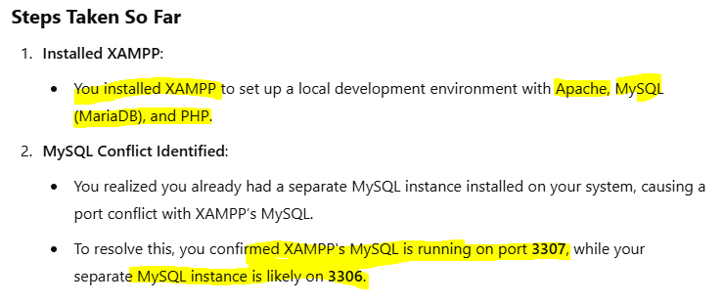

**Day 2 Work out:**

**What is a Host?**

In computing, a *host* refers to a computer or server that provides services, resources, or applications to other devices (clients) over a network. The term applies to both local and remote environments.

**What is Localhost?**

* **Definition**:
  + Localhost refers to your own computer used as a server. It is the loopback network interface that allows your machine to communicate with itself.
  + In technical terms, localhost resolves to the IP address 127.0.0.1 or ::1 (for IPv6).
* **Purpose**:
  + Used for testing and development purposes.
  + Allows developers to run and test web applications locally before deploying them to live servers.
* **Example**:
  + When you type http://localhost or http://127.0.0.1 into a browser, it serves content hosted on your machine.

**Local Host (Local Server)**:

* A server running on your own computer.
* Tools like XAMPP, WAMP, or MAMP create a local server environment for development.
* Common Use: Testing websites or applications before deploying them online.

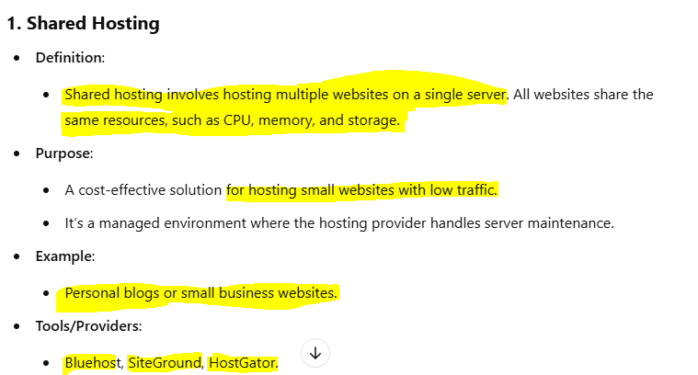

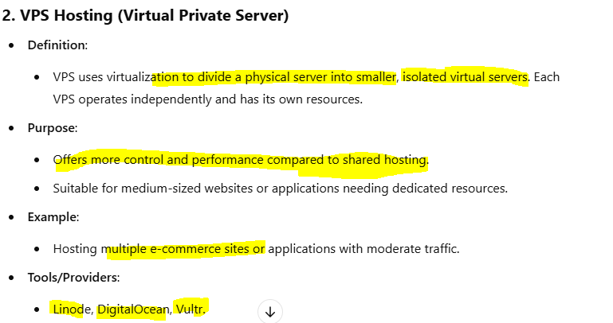

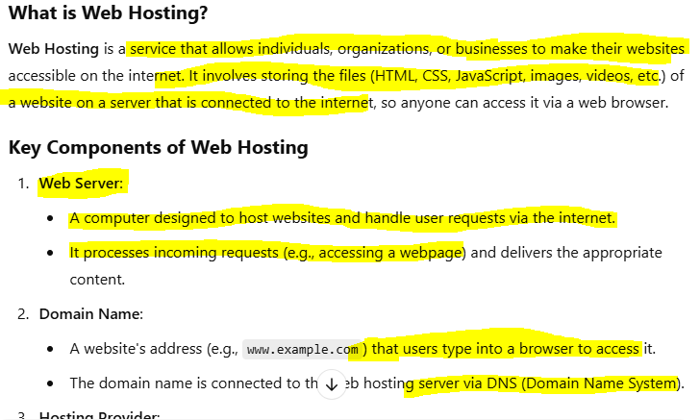

**Login to WordPress:**

