PROJECT REPORT
E-LEARNING PLATFORM
Name | Mohit Sharma
Enrollment No. | 2023BTCSE014
Subject | Software Engineering
Submitted to | Dr. Gaurav Somani

Project Overview
- A full-stack E-learning platform supports three roles: students, course admins (instructors), and global admins.
- The frontend is a Reactjs + Redux toolkit with role-based dashboards and feature-rich course pages.
- The backend is an Express + MongoDB API with JWT cookie auth, role-based access control, uploads, payments, reviews, and logging.

Frontend (Vite + React)

Routing & Auth
- Client-side routes split public pages (Home, Explore, About, Contact, Login/Signup, OTP flows) and protected sections.
- ProtectedRoute gates role-specific pages; users are routed to their dashboard based on role after login.
- Enroll pages are wrapped in the StudentDashboard shell for a consistent in-app experience.

Student Experience
- StudentDashboard: navigation for courses, progress, certificates, transactions, and profile.
- Enroll: shows course details, price, payment options, and "Pay Now" flow; once successful, allows invoice download.
- Course Page: lesson list + video/doc content; active lesson details; now includes a Review section (rating + comment).

Course Admin Experience
- CourseAdminDashboard: manages courses, lessons, uploads, and feedback.
- Admin can create, edit, delete courses and lessons, and set lesson preview availability.
- Reviews are displayed with fetched backend data.

Global Admin Experience
- Broader administrative insights (system performance, flags, moderation) and top-level oversight.

Backend (Express + MongoDB)

Authentication & Authorization
- JWT in HttpOnly cookies; protect middleware validates tokens.
- restrictTo enforces role-based access for routes (student, course_admin, admin).
- OTP email flows for account verification and password reset.

Core Domain Models
- Users, Students, Instructors, Courses, Lessons, Enrollments, Payments, Reviews, Notifications, and more.
- Course-lesson relationships are managed via Mongoose population.
- Reviews store rating (1-5) and comment, linked to user + course.

Course & Lesson Management
- Course creation/updating with thumbnail + overview video uploads to Cloudinary.
- Lessons can include video or documents; preview flag supports controlled access.
- Enrollment APIs link students to courses.

Payments & Invoices
- Payments are stored with course, amount, method, and status.
- Invoice PDFs are generated and uploaded to Cloudinary; client receives a URL.
- Student dashboard shows transaction history and allows invoice download for completed payments.

Reviews
- POST /api/review/:courseId creates review with integer rating and comment.
- GET /api/reviews/:courseId fetches course reviews (used by students and admins).

Logging
- Winston with daily rotating logs, capturing key events:
  - Registration, login
  - Course upload/delete
  - Lesson create/edit/delete
  - Payment creation/history access
- Passwords are never logged.

Key User Flows

1. Student Enrollment
Student selects a course → Enroll page → payment submitted → payment saved → invoice generated and stored → download slip enabled.

2. Course Consumption
Student opens course → lesson list and active content displayed → review submission available post-enrollment.

3. Course Admin Management
Instructor uploads courses and lessons → edits preview flags/content → sees incoming reviews in dashboard.

4. Authentication
Signup → OTP verification → login → dashboard routing based on role.

Security & Data Integrity
- JWT verification, stored tokens in cookies to avoid XSS and CSRF and role-based access control.
- Two Step verification, by using crypto for forming otp, nodemailer.
- Storing hash Passwords in DB using Bcrypt.
- Rate Limiting to avoid DDoS attack.
- Input and File upload sanitization + optional virus scanning.
- Storing Logged out tokens in blocked tokens in DB for avoiding the use of these tokens by any external, checking if the requested token is whether stored in blocked tokens or not. If yes then simply discarding the user to login.
- Protected invoice access (must belong to the user).
- Input validation for ratings, IDs, and forms.

Application Screenshots

Landing Page



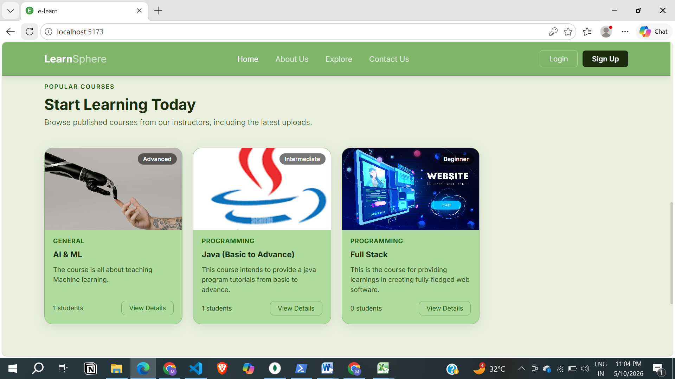

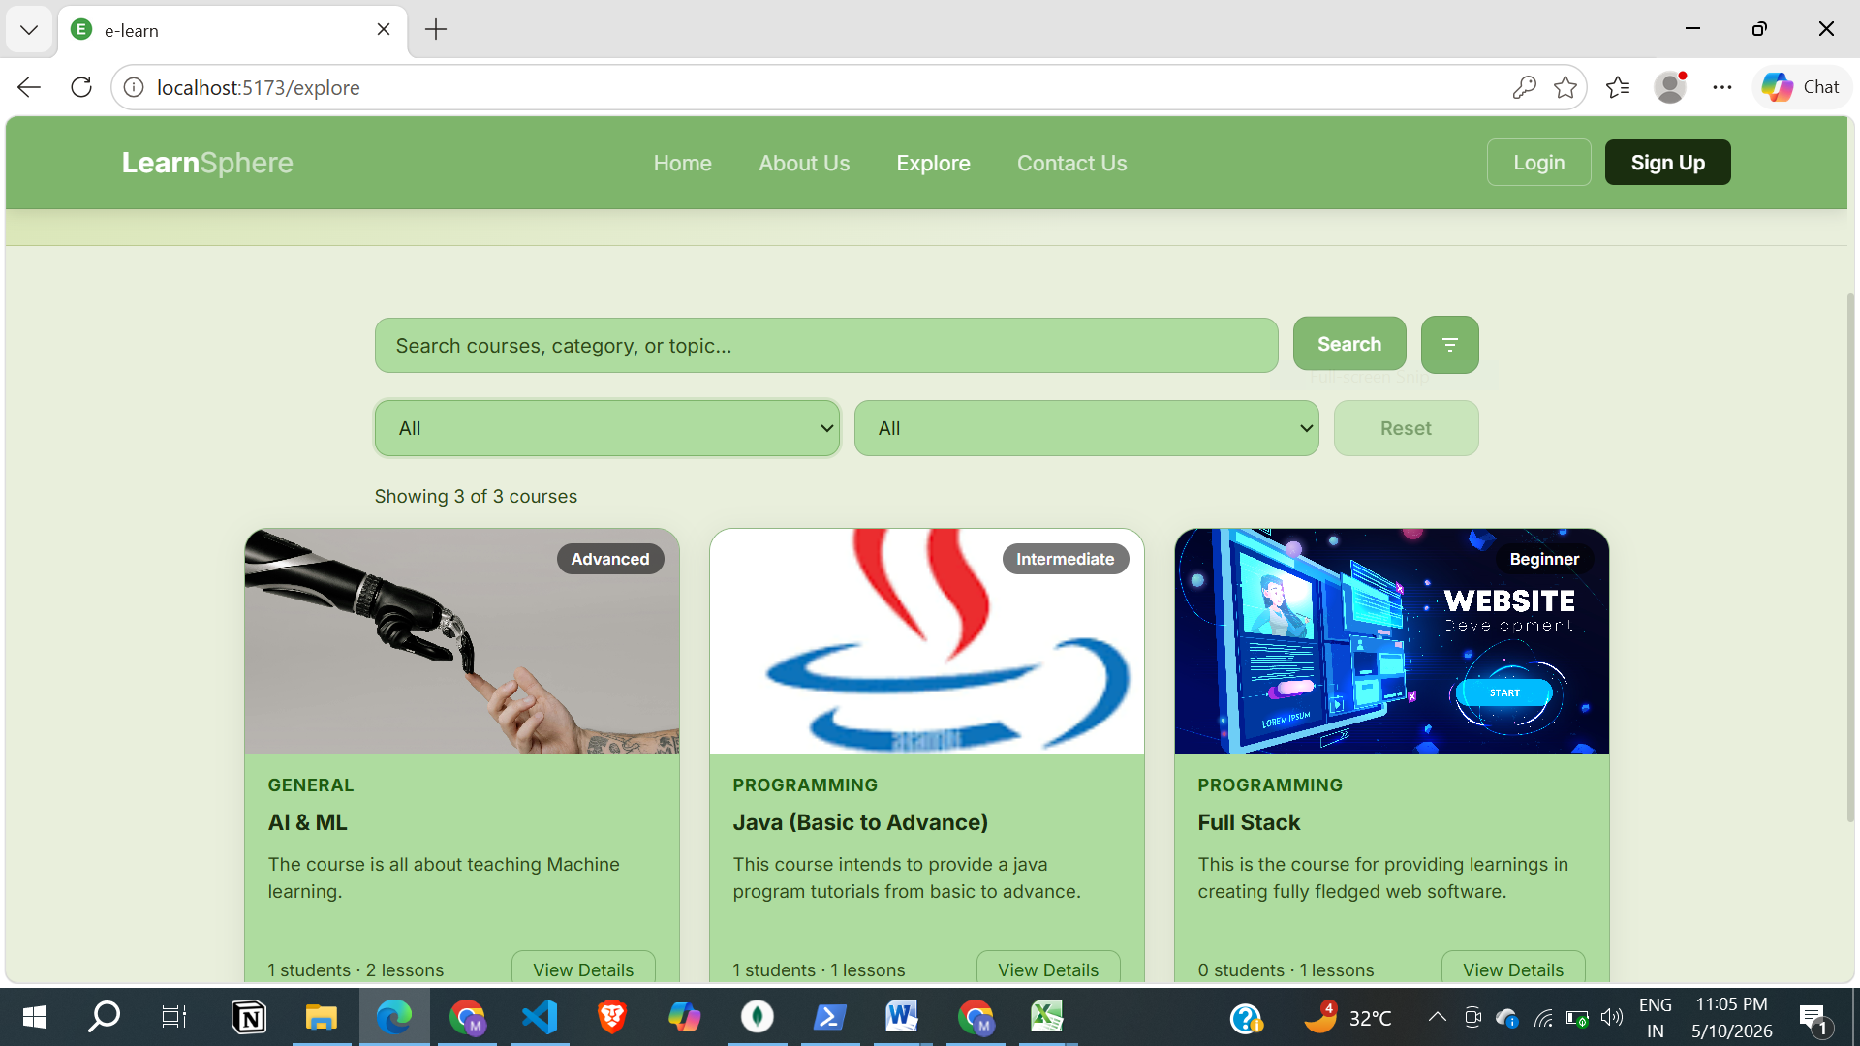

Student Dashboard Page
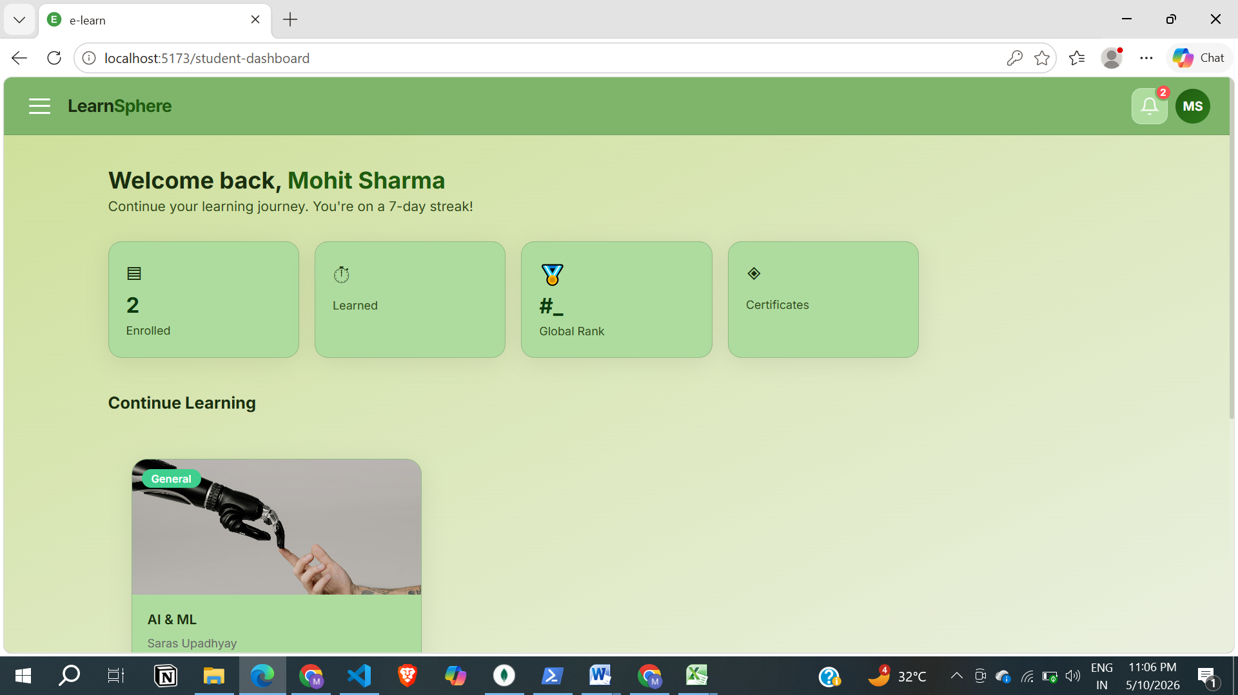
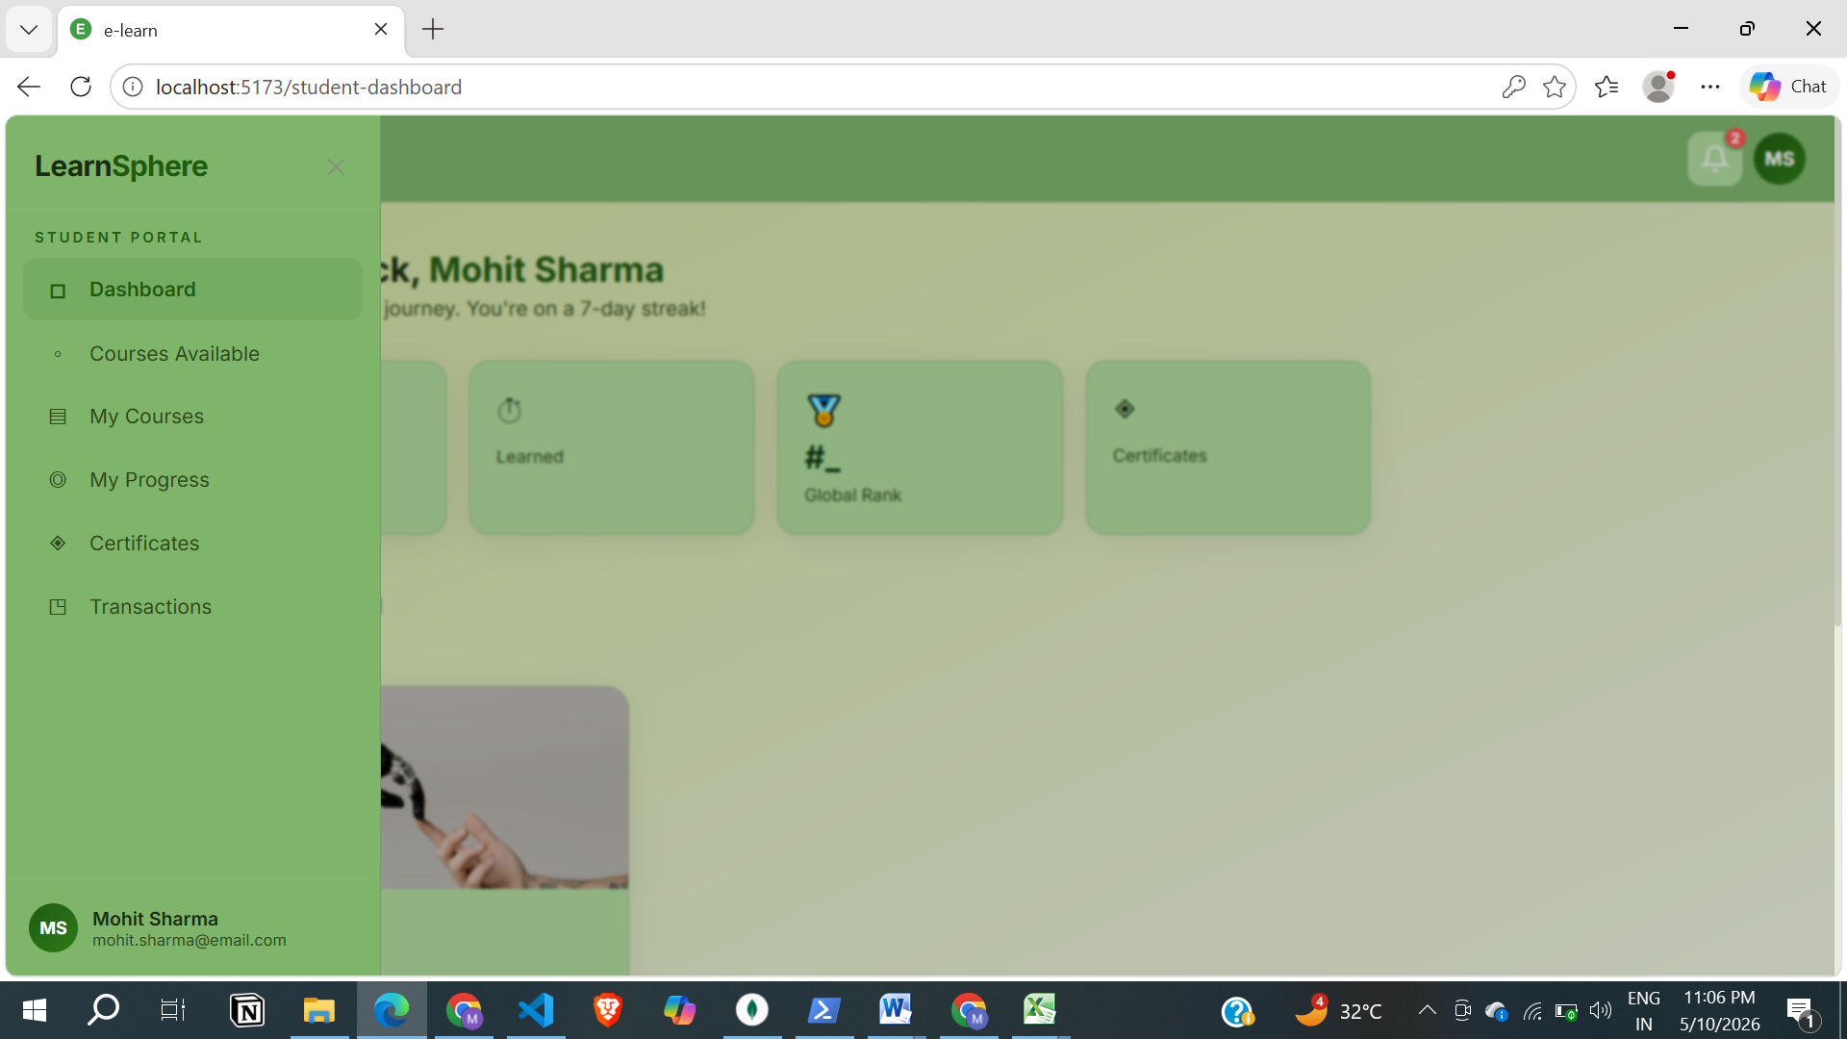

View My Courses

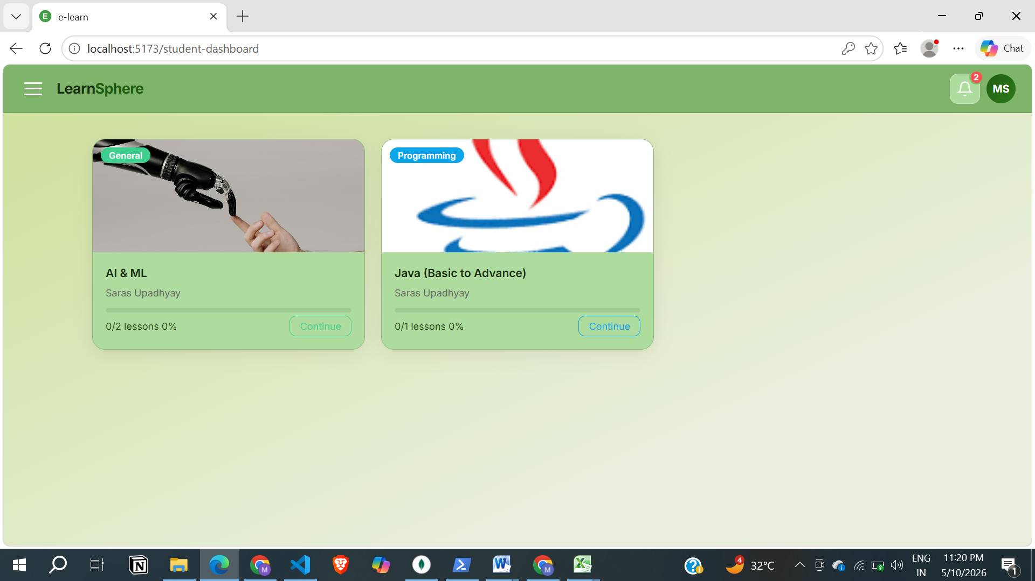

Payment Page

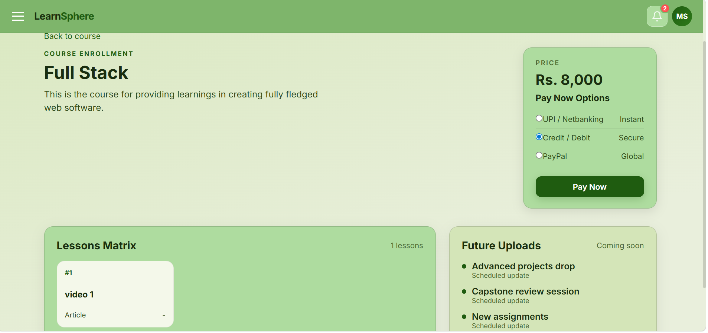

Payment Transaction History Page

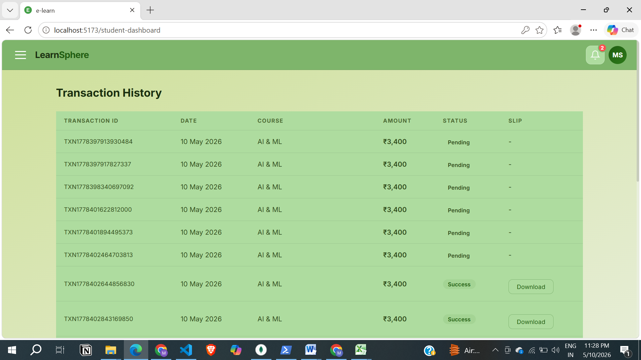

Course Page
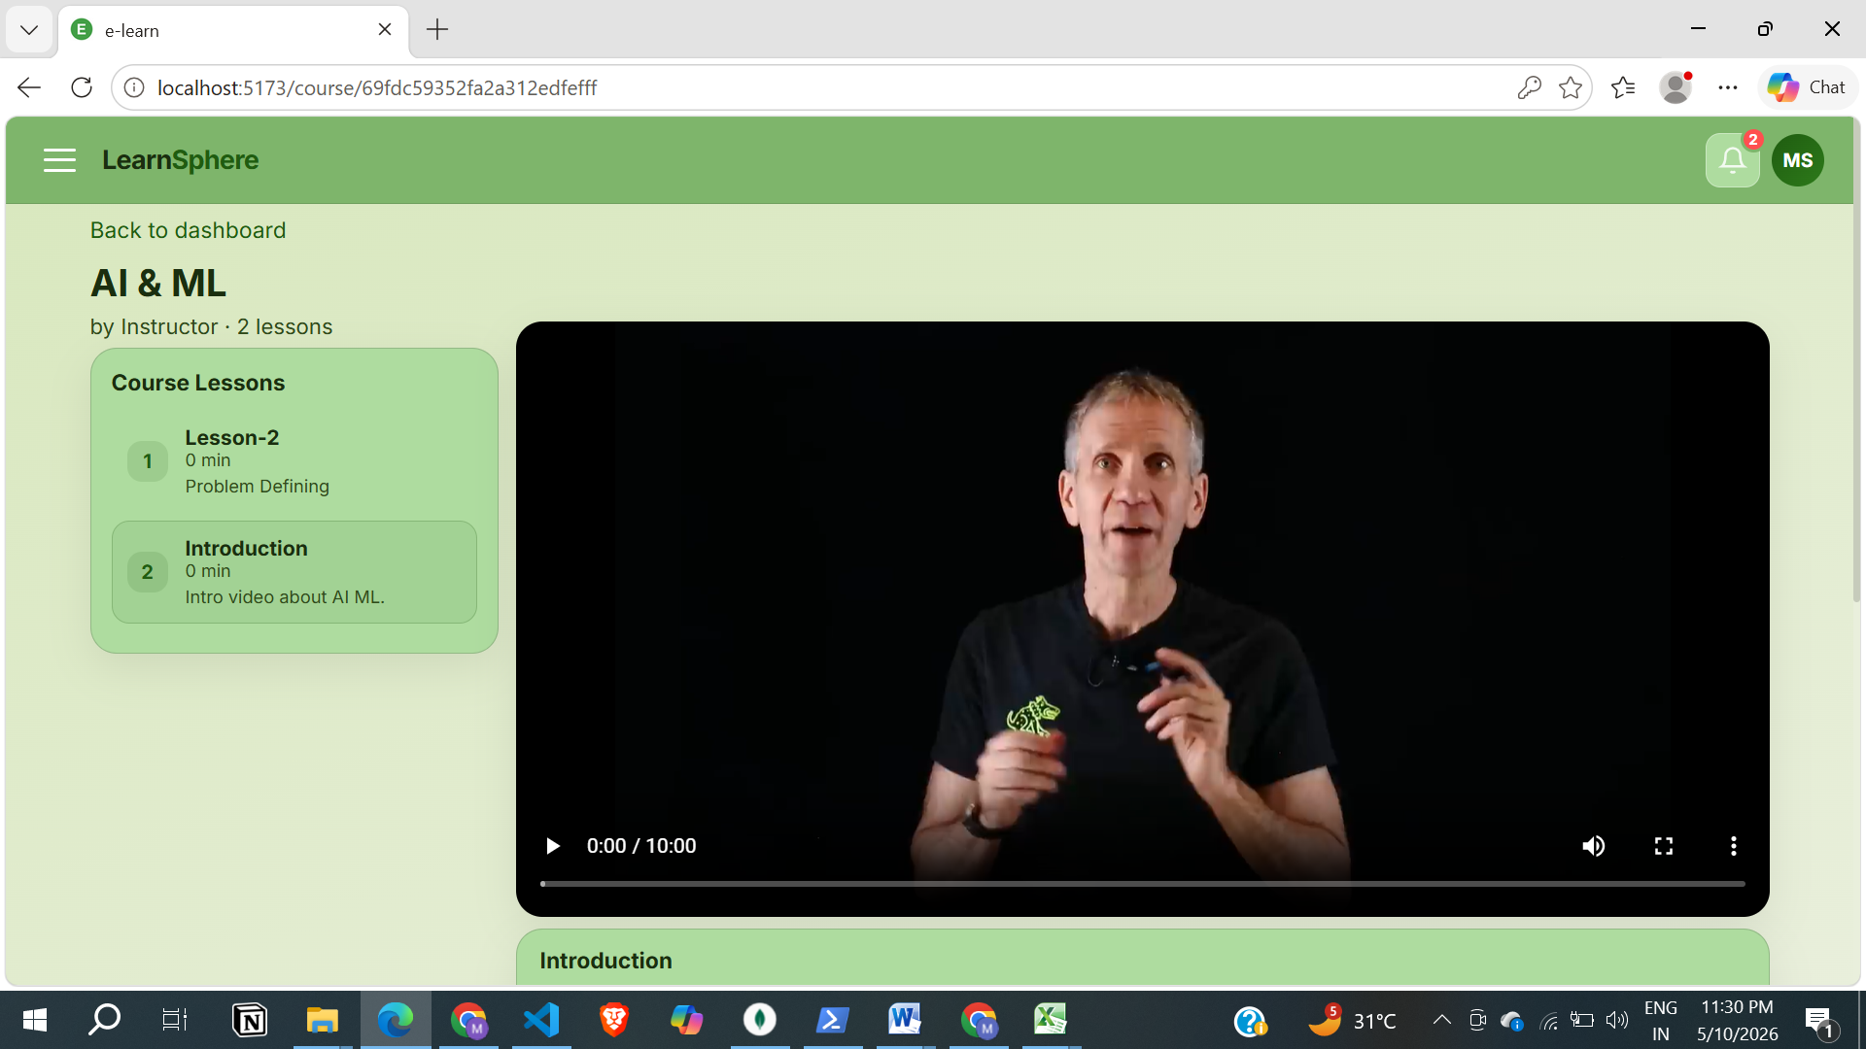

Review System
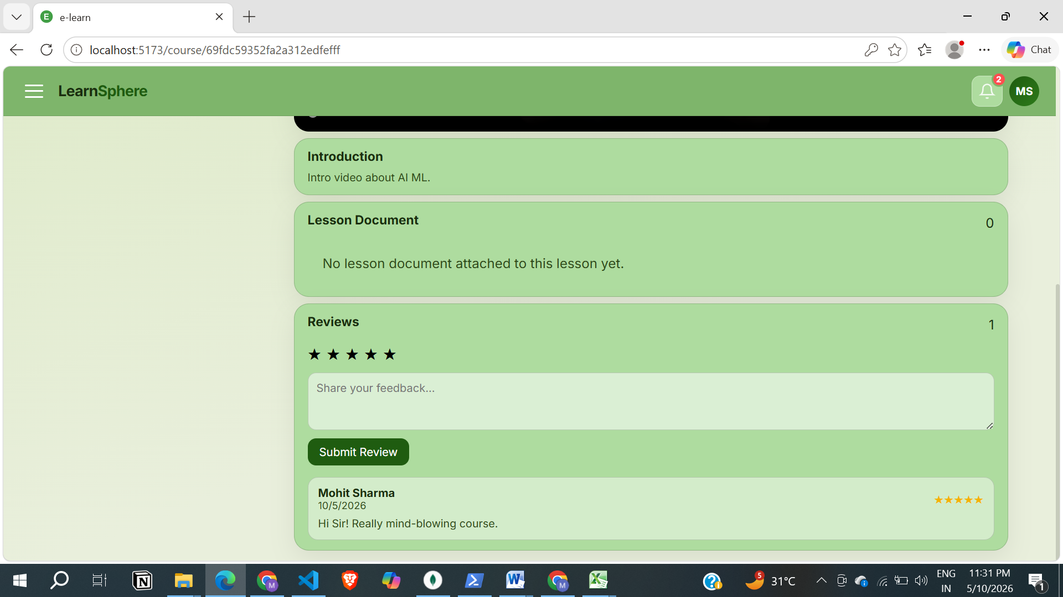

Course Admin Dashboard

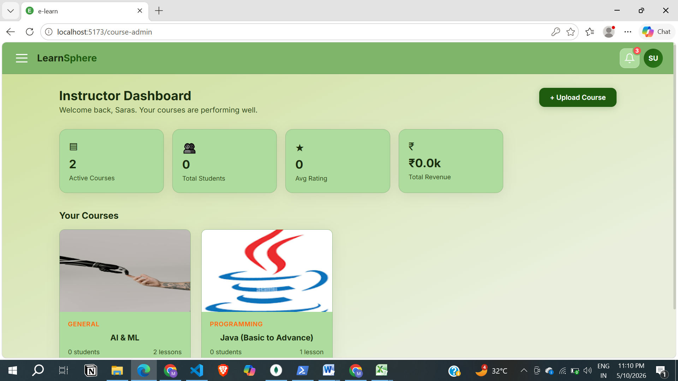

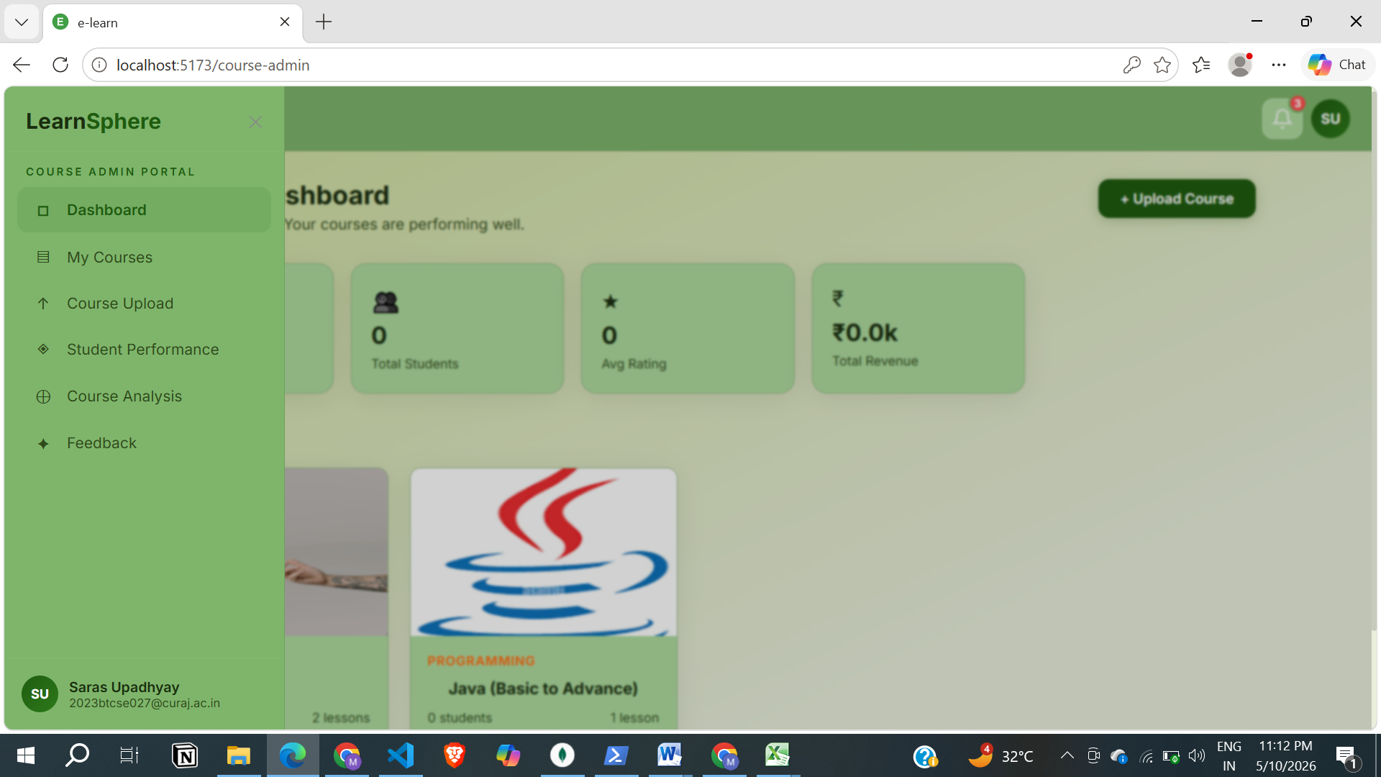

Course Edit
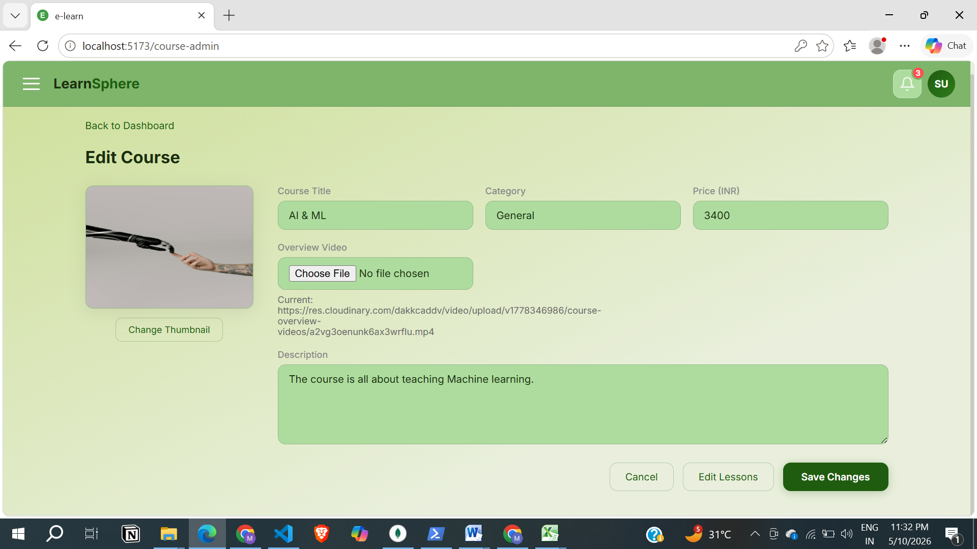

Upload New Course
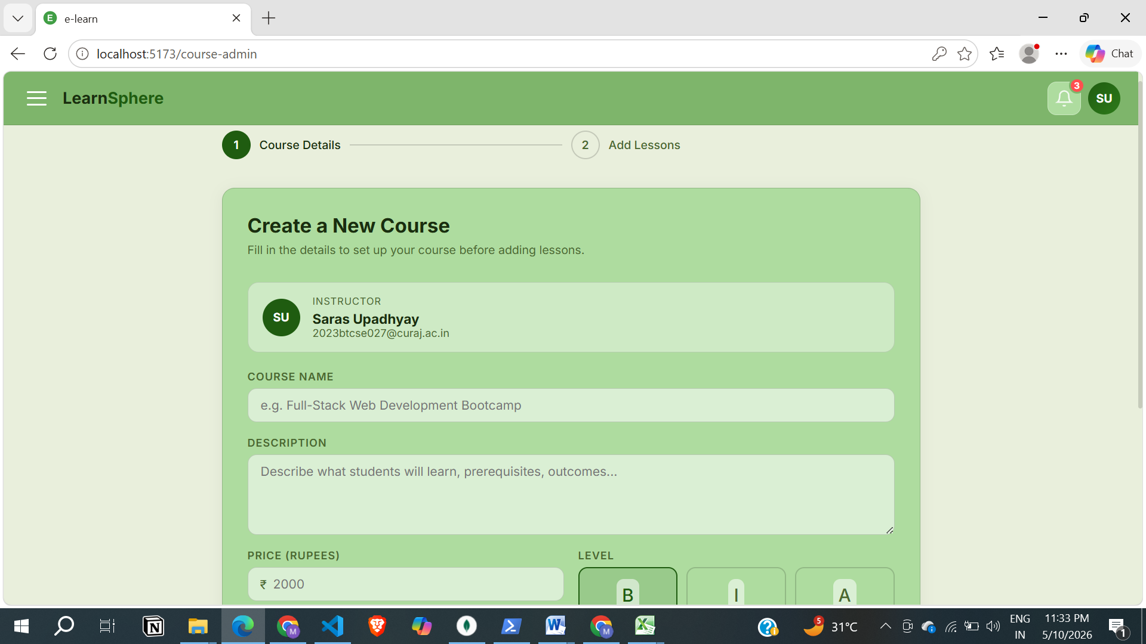

Review System (Admin View)
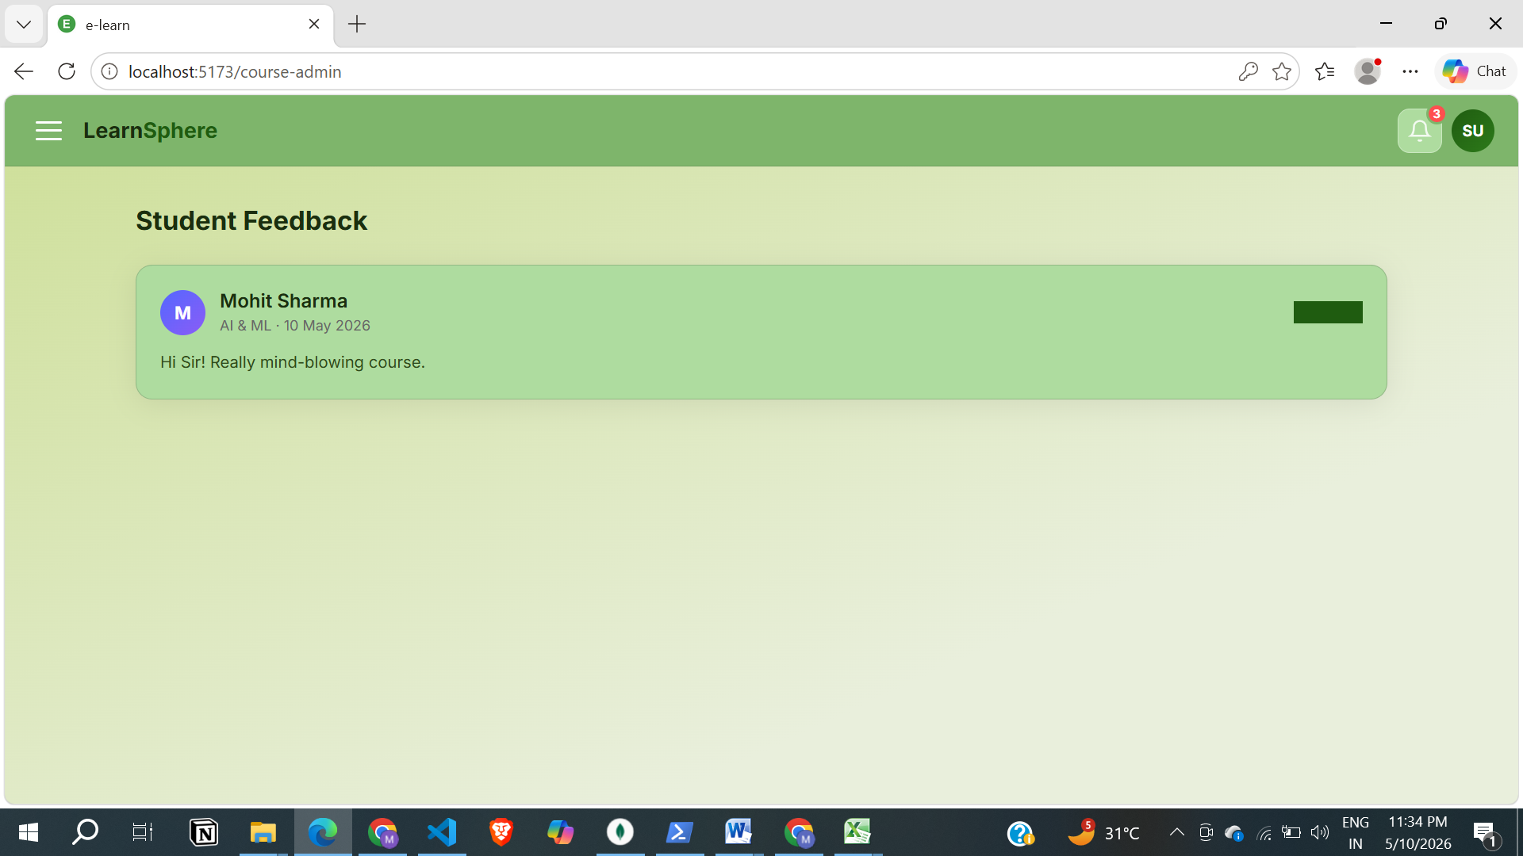

Benchmarking of the Frontend
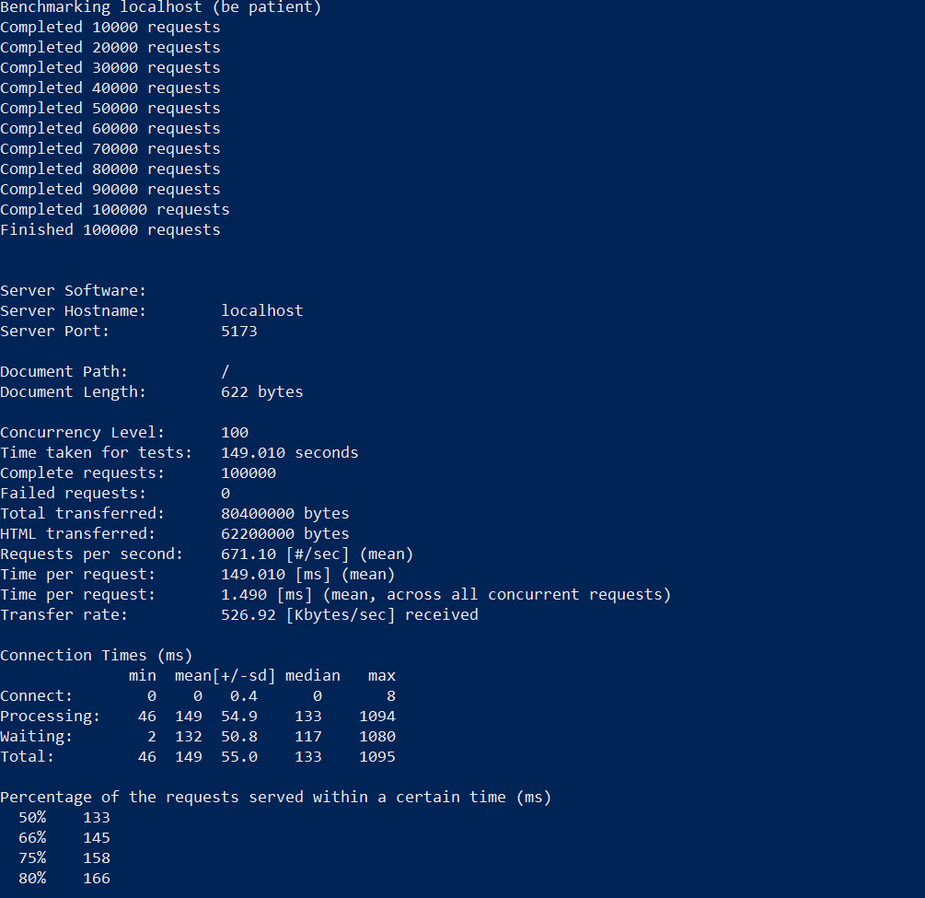

Benchmarking of Backend

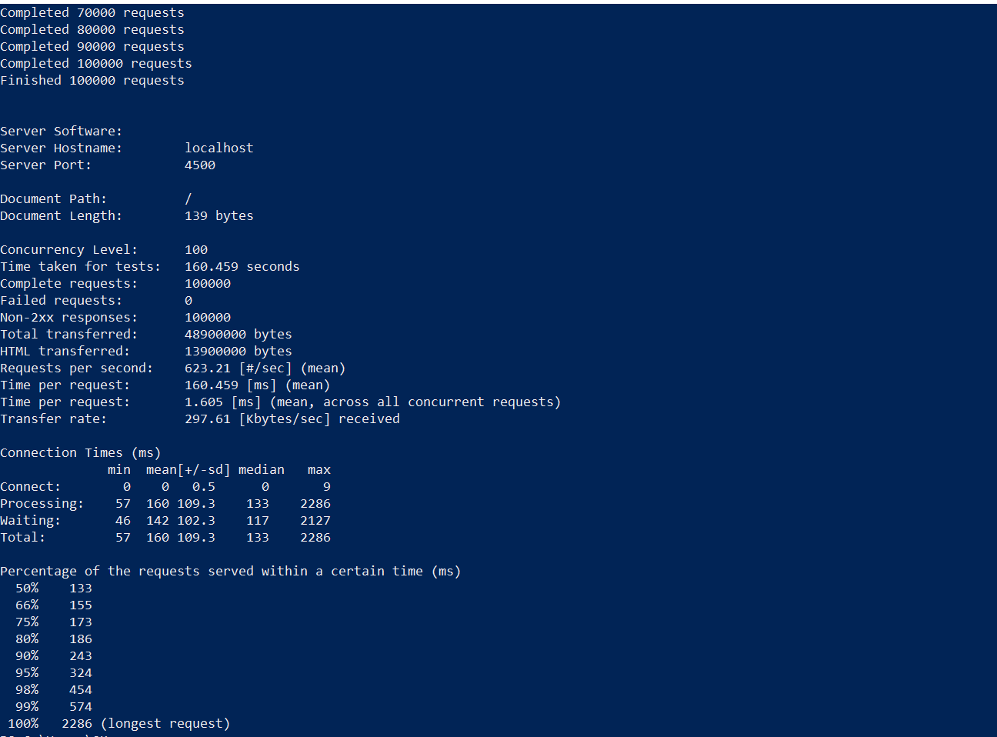

Functionalities Remaining

No Redis / Caching Layer
- There is no in-memory cache for sessions, rate-limit counters, OTPs, or hot data like course catalogs.
- All reads/writes hit MongoDB directly; there's no distributed cache or pub/sub mechanism.
- This means high-traffic performance and multi-instance consistency are not optimized yet.

No Real Payment Gateway Integration
- Payments are stored as records in MongoDB, but no actual gateway (Razorpay/Stripe/PayPal, etc.) is integrated.
- There's no payment intent creation, webhook verification, refund workflow, or transaction reconciliation.
- Payment status is currently set internally, so it is not verifiable against a real provider.
- Invoices are generated internally and uploaded to Cloudinary, but not tied to external payment confirmation.

No Quiz System
- There's no API or UI for instructors to create quizzes, upload question banks, or set scoring rules.
- Students cannot take quizzes; there is no submission, grading, or attempt tracking flow wired into courses.
- Any quiz-related models or components present are not connected to the course learning path or dashboards.

Other Missing Features
- No Notification System
- No Global Admin portal
- No Performance Analysis of student as per the quiz attempt

Challenges Faced

Frontend UX Mismatch
- The UI often assumes an upload succeeded (progress/preview), but backend errors may only surface after the request finishes, leading to "success" state with no real file stored.
- This causes confusion and requires clear error surfacing + retry paths.

