Housing Price Analysis: Linear Regression vs. Random Forest
Exploratory analysis and predictive modeling on the Housing Prices dataset (housing.csv)
The dataset contains 545 house listings described by area, bedrooms, bathrooms, stories, parking spots, and furnishing status, with price as the target variable. Two regression models, Linear Regression and Random Forest, were trained to predict price from these features, and their predictions were evaluated against actual sale prices on a held-out test set.
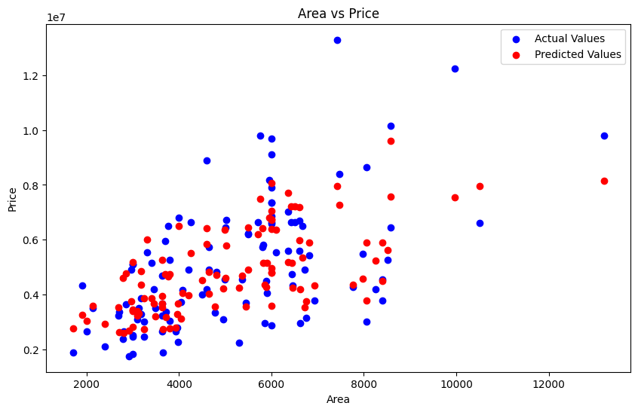  Fig. 1 — Linear Regression: Actual vs. Predicted Price | 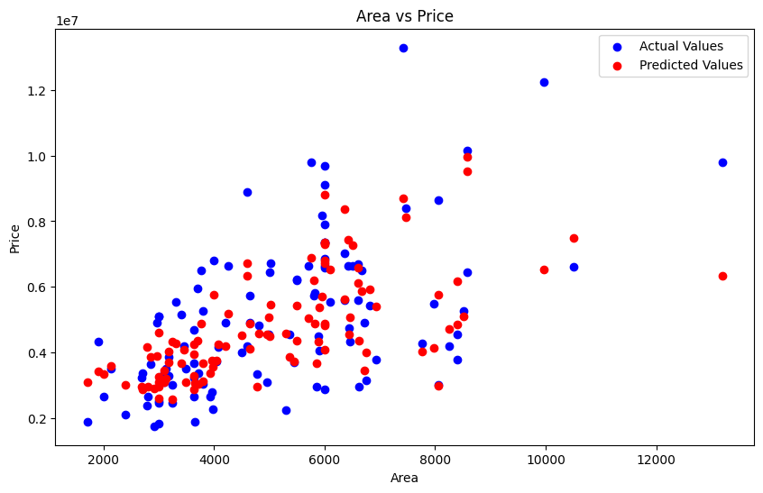  Fig. 2 — Random Forest: Actual vs. Predicted Price
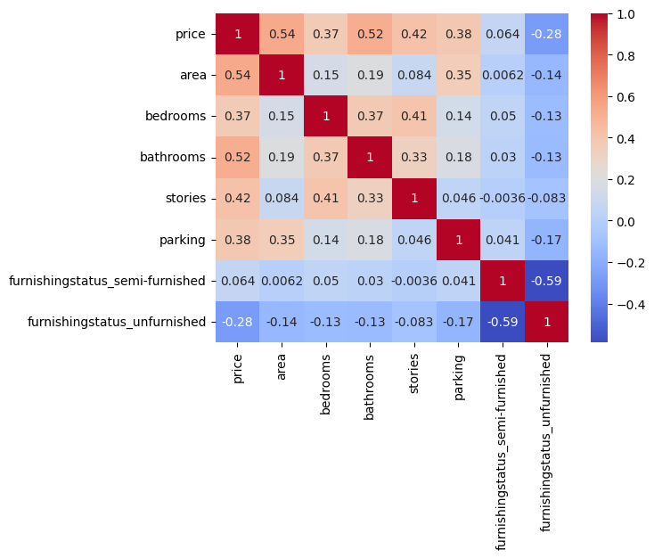  Fig. 3 — Correlation Heatmap of Housing Features | 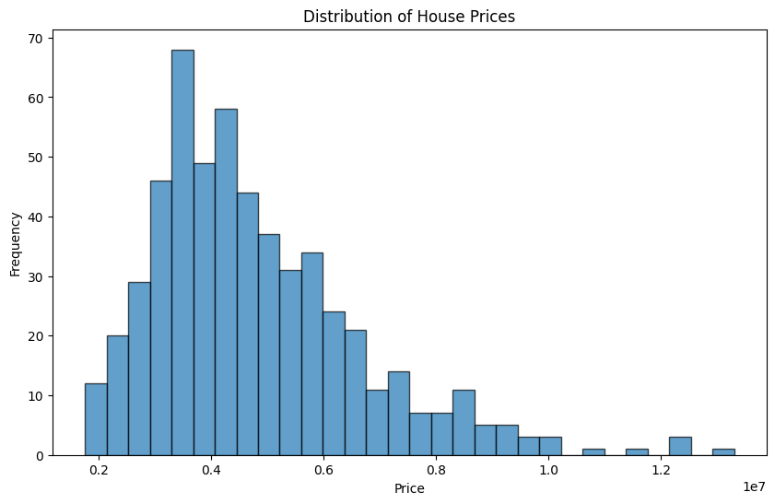  Fig. 4 — Distribution of House Prices
Model Performance
Metric | Linear Regression | Random Forest
Mean Squared Error (MSE) | 1,754,318,687,330.66 | 1,964,193,399,645.33
Root Mean Squared Error (RMSE) | ₹1,324,506.96 | ₹1,401,496.84
R² Score | 0.653 | 0.611
Key Insights
• Area shows the strongest correlation with price (0.54), followed by bathrooms (0.52) and stories (0.42); bedrooms and parking are weaker but still positive predictors. Furnishing status also matters: unfurnished homes correlate negatively with price (-0.28), while semi-furnished status shows almost no relationship (0.064) (Fig. 3).
• Prices are right-skewed, clustering between ₹3M and ₹6M, with a long tail of higher-value properties above ₹8M (Fig. 4).
• Linear Regression achieved a higher R² (0.653 vs. 0.611) and lower RMSE than Random Forest, suggesting that price in this dataset is largely driven by linear, additive relationships rather than complex non-linear interactions; with only ~545 rows and 5 numeric features, Random Forest likely gains little from its added flexibility and may be slightly overfitting.
• Both models systematically under-predict the highest-priced homes (Figs. 1–2), indicating that area, bedrooms, bathrooms, stories, parking, and furnishing status alone do not fully capture what drives premium pricing (e.g., location or lot quality, which are not present in this dataset).

